Graphene Oxide as a sustainable and efficient adsorbent for Pharmaceuticals from aqueous solution

Tuhin Bhattacharjee,^{1,5} Arnab Bhattacharjee,^{1,5} Gitanjali Majumdar,^{1,5} Mihir Kumar Purkait,^{2,4} Deepmoni Deka,^{2,4} Devasish Chowdhury ³

1 Department of Chemistry, Assam Engineering College, Guwahati, Assam, 781013, India,
2 Department of Chemical Engineering, Indian Institute of Technology Guwahati,Assam, 781039, India
3 Material Nanochemistry Laboratory, Physical Science Division, Institute of Advanced Studies in Science and Technology, Paschim Boragaon, Guwahati, Assam, 781035, India
4 Centre for the Environment, Indian Institute of Technology Guwahati, Assam, 781039, India
5 Assam Science and Technology University, Tetelia Road, Jalukbari, Guwahati, Assam, 781013, India
E-mail: tuhin92chem@gmail.com

Abstract
With the advancement of technology, although human lives have improved to a considerable degree, there has been a rapid increase in the detrimental effects in the environment, especially in the aquatic environment. The aqueous habitat has been affected tremendously by various pollutants like heavy metals, polyaromatic hydrocarbons etc. In the recent years, pharmaceutical compounds have emerged as a pollutant of high concern due to the rapid disposal of such compounds from industries, hospitals and households. After covid-19 pandemic, the consumption of pharmaceuticals compounds has increased in an alarming rate. Pharmaceutical compounds have complex molecular structures, varied functionalities and unique stereochemistry. Many pharmaceutical compounds have high half life time and low metabolism in human body. Due to this fact, removal of such compounds from aqueous environment is a great challenge. Hence, special materials with unique functionalities are required for efficient removal of such compounds. Graphene oxide (GO) is a 2D nanomaterial with many unique properties such as high theoretical surface area (2630 m² g⁻¹), very high mechanical strength, good optical property and electrical conductivity. High surface area and in addition to the presence of high functional moieties gives an added advantage in removal of such pharmaceutical molecules. Our group has used both graphene oxide and cyclic polysaccharide functionalised graphene oxide for removal of two pharmaceutical compounds, namely, cetirizine (antihistamine drug) and atenolol (beta-blocker). Graphene oxide was characterised using various instrumental techniques like SEM, TEM, Zeta potential, BET etc. Adsorption characteristics of pharmaceutical were also evaluated, like kinetics, effect of concentration, interaction studies, pH studies etc. Reusability studies of adsorbent were also studied for sustainability of the adsorbent. Such studies will help us create a robust adsorption system for removal of complex emerging compounds like pharmaceuticals.
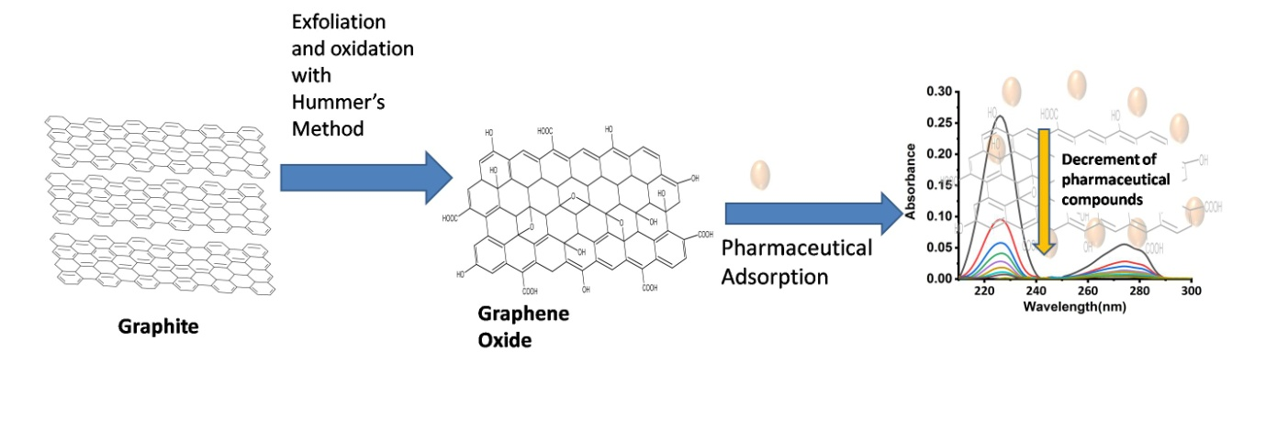
References:
- T. Bhattacharjee, S. Rahman, D. Deka, M.K. Purkait, D. Chowdhury, G. Majumdar, Synthesis and characterization of exfoliated beta-cyclodextrin functionalized graphene oxide for adsorptive removal of atenolol, Mater. Chem. Phys. 288 (2022) 126413. https://doi.org/10.1016/j.matchemphys.2022.126413.

