Generation of green and sustainable bio-electricity by indoor plant based microbial fuel cell (PMFC) to power Smart watch and Wireless Ear Pods
Pranab Jyoti Sarma¹*, Barasa Malakar¹, Kaustubha Mohanty^{1,2}
1School of Energy Science and Engineering, Indian Institute of Technology Guwahati, Guwahati - 781039, India
2Department of Chemical Engineering, Indian Institute of Technology Guwahati, Guwahati - 781039, India
* Corresponding author, e-mail: s.pranab@iitg.ac.in

Abstract
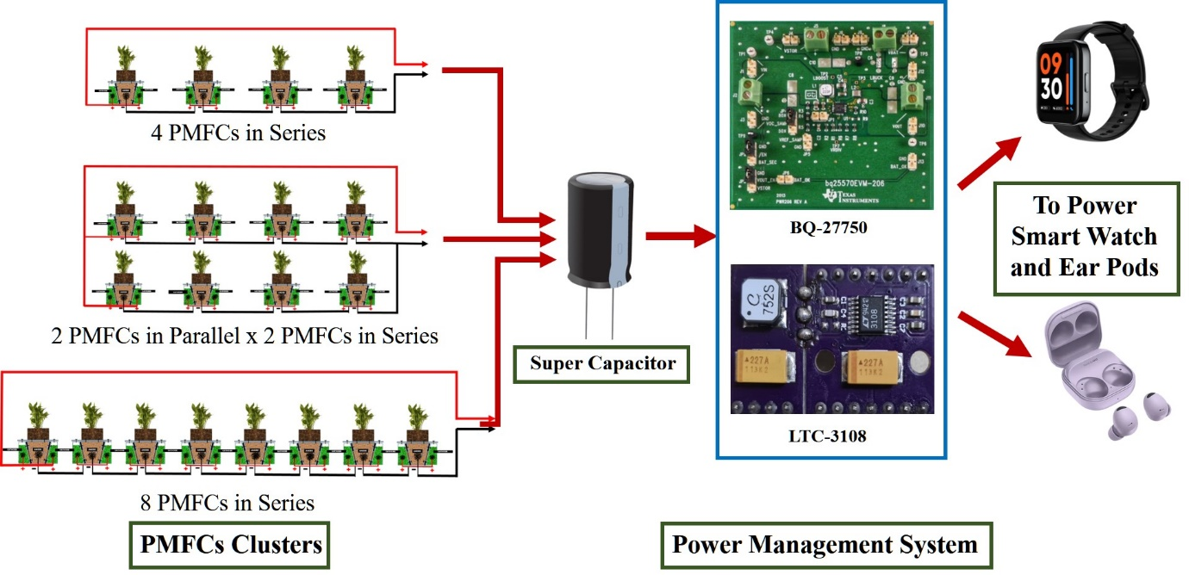
Research & Industrial Conclave 2023 "An amalgamation of Academia, Industry & Start-up”
"

Plant microbial fuel cell is a promising renewable, self-sustainable, eco-friendly and green technology that offers long-term power generation by harnessing the photosynthetic ability of plants. Different indoor plants viz., Epipremnum aureum, Philodendron erubescens and Anthurium andreanum has the potential to generate electricity. Therefore, we have developed a indoor plant based PMFC cluster which can generate electricity to be able to power a LED bulb or charge a smart watch and wireless ear pods. The electricity generated by PMFC cluster is stored in a rechargeable Lithium-Polymer battery which is used to glow a LED bulb or charge a smart watch.

Keywords: Bioelectricity; PMFC; Power management system; Renewable power source

Student Academic Board (SAB), Indian Institute of Technology Guwahati, Guwahati, Assam, India

