Lettuce Yield Prediction — Progress Report

07-10-2026

1. Executive Summary
This report summarizes the completed image segmentation comparison, tray- and plant-level yield-prediction baselines, and a new mechanistic crop-model + residual hybrid ML stage for hydroponic lettuce fresh-weight prediction. We compared three segmentation methods on matched timelapse frames, selected FastSAM for feature extraction, evaluated multiple regressors on harvest checkpoints, and then introduced a physics-based Van Henten / Farquhar crop model whose residuals are a target for image and sensor ML. Crop-model fit metrics and ML LODO / hold-out results are reported separately in Section 7; trajectory overlays are in the figures.

2. Segmentation: Methods and Results

2.1 Methods Compared
We compared the following segmentation approaches (no dataset-specific fine-tuning):
- FastSAM (Fast Segment Anything): zero-shot instance segmentation optimized for speed.
- SAM (Segment Anything Model): zero-shot foundation-model segmentation.
- ExGR + Otsu + connected components: classical vegetation-index thresholding baseline.

2.2 Evaluation Setup
All three methods were evaluated on the same 53 matched frames (one frame per trial-day). Identical post-processing was applied to all methods (mask-size filtering and plant/pipe rejection heuristics) to ensure a fair comparison. Reported overlap metrics (Dice/IoU) quantify agreement between methods, not absolute accuracy against manual ground truth.

2.3 Quantitative Segmentation Results (Aggregate Means)
Segmentation comparison summary:
method | n_images | mean_time_sec | mean_raw_masks | mean_plant_crops | mean_plant_coverage_frac | mean_plant_color_frac | composite_score
fastsam | 53 | 1.525 | 32.00 | 20.98 | 0.1286 | 0.6414 | 0.7465
exgr | 53 | 0.600 | 23.04 | 17.11 | 0.0614 | 0.7105 | 0.6908
sam | 53 | 4.552 | 31.60 | 21.68 | 0.1123 | 0.6709 | 0.6633

2.4 Pairwise Mask Agreement (Dice and IoU)
Dice and IoU were computed on the union of accepted plant masks for each frame, comparing methods pairwise across the same 53 images. These values measure inter-method agreement (how similarly two methods label plant regions), not accuracy against manual ground truth.
Mean Dice and IoU between segmentation methods:
method_pair | mean_dice | mean_iou | n_frames
FastSAM vs SAM | 0.603 | 0.452 | 53
FastSAM vs ExGR | 0.133 | 0.074 | 53
ExGR vs SAM | 0.187 | 0.106 | 53

FastSAM and SAM show substantially higher agreement with each other (Dice 0.603, IoU 0.452) than either does with the classical ExGR baseline (IoU below 0.11 for both pairs).

2.5 Segmentation Conclusion
FastSAM was selected for downstream yield prediction because it achieved the highest canopy coverage while maintaining strong agreement with SAM and substantially faster runtime than SAM. ExGR was kept as a classical baseline but captured lower canopy coverage in dense tray imagery.

3. Yield Prediction: Models and Results
We evaluated multiple regressors using leave-one-out (LOO) validation on 8 harvest checkpoints per trial. Results are exploratory due to small sample size.
Three input feature sets were compared: image-only (FastSAM canopy size, color, and window growth); compact image + sensors (those image features plus window-average climate, nutrient, and actuator signals); and the full feature set (the same sources with window min/max/std statistics in addition to means).

3.1 Results for Trial1

Image-only features
Best model: XGBoost (MAE=42.00 g, R²=0.399).
Leave-one-out validation results (image-only features):
model | n_features | mae_g | rmse_g | r2
XGBoost | 68 | 42.00 | 54.48 | 0.399
GradBoost | 68 | 43.67 | 59.29 | 0.288
RandomForest | 68 | 50.68 | 64.61 | 0.154
ElasticNet | 68 | 54.23 | 70.81 | -0.016
SVR-RBF | 68 | 56.30 | 79.72 | -0.288
Ridge | 68 | 56.32 | 71.23 | -0.028

Compact (image + sensors)
Best model: GradBoost (MAE=36.72 g, R²=0.493).
Leave-one-out validation results (compact (image + sensors)):
model | n_features | mae_g | rmse_g | r2
GradBoost | 153 | 36.72 | 50.04 | 0.493
RandomForest | 153 | 44.50 | 59.02 | 0.294
Ridge | 153 | 47.12 | 65.22 | 0.138
ElasticNet | 153 | 49.29 | 67.31 | 0.082
XGBoost | 153 | 55.64 | 59.60 | 0.280
SVR-RBF | 153 | 57.94 | 81.11 | -0.333

Full feature set
Best model: XGBoost (MAE=31.71 g, R²=0.640).
Leave-one-out validation results (full feature set):
model | n_features | mae_g | rmse_g | r2
XGBoost | 557 | 31.71 | 42.14 | 0.640
ElasticNet | 557 | 31.93 | 50.43 | 0.485
Ridge | 557 | 32.83 | 54.69 | 0.394
GradBoost | 557 | 42.12 | 59.40 | 0.285
RandomForest | 557 | 45.67 | 60.58 | 0.256
SVR-RBF | 557 | 57.92 | 80.75 | -0.321

3.2 Results for Trial2

Image-only features
Best model: GradBoost (MAE=40.80 g, R²=-0.044).
Leave-one-out validation results (image-only features):
model | n_features | mae_g | rmse_g | r2
GradBoost | 68 | 40.80 | 71.79 | -0.044
RandomForest | 68 | 50.59 | 73.68 | -0.100
SVR-RBF | 68 | 57.84 | 82.17 | -0.368
XGBoost | 68 | 65.09 | 88.28 | -0.579
Ridge | 68 | 122.56 | 166.34 | -4.606
ElasticNet | 68 | 238.20 | 345.67 | -23.208

Compact (image + sensors)
Best model: XGBoost (MAE=28.37 g, R²=0.633).
Leave-one-out validation results (compact (image + sensors)):
model | n_features | mae_g | rmse_g | r2
XGBoost | 46 | 28.37 | 42.56 | 0.633
Ridge | 46 | 46.46 | 71.71 | -0.042
GradBoost | 46 | 47.29 | 77.77 | -0.225
SVR-RBF | 46 | 56.59 | 81.92 | -0.360
RandomForest | 46 | 62.08 | 79.59 | -0.283
ElasticNet | 46 | 71.29 | 90.04 | -0.643

Full feature set
Best model: GradBoost (MAE=31.84 g, R²=0.146).
Leave-one-out validation results (full feature set):
model | n_features | mae_g | rmse_g | r2
GradBoost | 557 | 31.84 | 64.93 | 0.146
XGBoost | 557 | 40.54 | 70.43 | -0.005
RandomForest | 557 | 41.97 | 66.64 | 0.100
SVR-RBF | 557 | 56.81 | 80.93 | -0.327
Ridge | 557 | 62.62 | 85.41 | -0.478
ElasticNet | 557 | 73.51 | 97.89 | -0.942

4. Selected Configuration for Next Phase
For direct ML yield prediction (Sections 3–6), we recommend the compact feature set (image + sensors) as the primary configuration, with image-only as an ablation and FastSAM as the segmentation method. For the physics + ML path (Section 7), keep the crop model as the tray-level baseline and report hybrid residual ML with compact features, using LODO within a trial and Trial-1→Trial-2 hold-out as the generalization check.

5. Notes / Limitations
- Only 8 labeled harvest checkpoints are available per trial; metrics are therefore high-variance and should be interpreted as exploratory.
- Segmentation overlap metrics (Dice/IoU) reported here measure agreement between methods; manual ground-truth masks are required for absolute segmentation accuracy (mIoU/Dice vs ground truth).
- Trial 2 labels may be protocol-shifted relative to Trial 1; cross-trial comparisons should be interpreted cautiously.
- Crop-model absolute grams depend on assumed bench area, dry-matter fraction (4.5%), and reconstructed PPFD (not logged). See Section 7.

08-29-2026

6. Plant-Level Yield Prediction (Trial 1)
Sections 3–5 report tray-median models (one row per harvest day). This section adds a follow-on experiment that uses each weighed plant as its own training example. Existing checkpoint tables and the results in Section 3 were not modified.

6.1 Setup
The fresh-weight tracker already records New Fresh Weight (g) for Plant-IDs 1–10 on harvest days 0, 4, 8, 12, 16, 20, 24, and 28. The tray-median pipeline collapsed those 10 weights to one number per day (8 rows). Here, each plant-day is kept as a separate row. The target is that plant’s own fresh weight (target_fw_g), not the tray median.
This yields 79 labeled rows for Trial 1 (10 plants × 8 harvest days, except Day 8 is missing Plant 10, and a duplicate Plant-6 entry on Day 8 was averaged). Climate, nutrient, and actuator features are shared across plants on the same day (one tent). A plant-specific FastSAM cup image was attached when Plant-ID matched a camera cup_id in the same 4-day window (38 of 79 rows). Trial 2 is not included: it has no independent per-plant weights.
Four input sets were exported (new files only, under ml/plant/):
- Sensors: climate, nutrient, and actuator window features, plus plant ID and experimental day.
- Image: tray-level FastSAM canopy features plus plant-level cup image features when available.
- Compact: image features plus window-average sensors (same recipe as Section 3, expanded to plants).
- Full: all numeric window statistics plus plant-level image columns.

6.2 Validation
Two splits were run. Leave-one-out (LOO) hides one plant on one day but still shows the other plants from that same harvest day and the same plant on neighboring days, so it can look unrealistically good. Leave-one-harvest-day-out (LODO) hides all plants from one weighing day and trains on the other seven days. LODO is the fairer test of predicting a harvest that has not yet been seen, and is the result that should be used for comparison with Section 3.
A mean baseline (predict the average weight of the training plants) has LODO MAE ≈ 67 g. Model MAE should be read against that number.

6.3 Leave-One-Harvest-Day-Out Results (Fair Comparison)

Image-only features
Best model: XGBoost (plant MAE=28.64 g, R²=0.672, day-median MAE=28.32 g).
Leave-one-harvest-day-out results (image-only features):
model | n_features | mae_g | rmse_g | r2 | day_median_mae_g
XGBoost | 78 | 28.64 | 40.05 | 0.672 | 28.32
GradBoost | 78 | 45.04 | 60.23 | 0.258 | 44.96
ElasticNet | 78 | 49.43 | 59.89 | 0.267 | 49.40
Ridge | 78 | 51.07 | 62.23 | 0.208 | 50.61
RandomForest | 78 | 52.19 | 65.13 | 0.133 | 52.37
SVR-RBF | 78 | 58.03 | 72.25 | -0.067 | 57.42

Sensors-only features
Best model: XGBoost (plant MAE=23.60 g, R²=0.754, day-median MAE=23.74 g).
Leave-one-harvest-day-out results (sensors-only features):
model | n_features | mae_g | rmse_g | r2 | day_median_mae_g
XGBoost | 217 | 23.60 | 34.66 | 0.754 | 23.74
RandomForest | 217 | 35.02 | 50.74 | 0.473 | 35.81
GradBoost | 217 | 35.74 | 55.93 | 0.360 | 35.99
ElasticNet | 217 | 42.28 | 68.33 | 0.045 | 42.75
Ridge | 217 | 42.39 | 69.94 | -0.000 | 42.41
SVR-RBF | 217 | 59.52 | 72.38 | -0.071 | 59.22

Compact (image + sensors)
Best model: XGBoost (plant MAE=23.34 g, R²=0.752, day-median MAE=23.57 g).
Leave-one-harvest-day-out results (compact (image + sensors)):
model | n_features | mae_g | rmse_g | r2 | day_median_mae_g
XGBoost | 163 | 23.34 | 34.80 | 0.752 | 23.57
RandomForest | 163 | 35.89 | 53.92 | 0.406 | 35.71
GradBoost | 163 | 43.81 | 63.08 | 0.186 | 44.64
ElasticNet | 163 | 49.74 | 64.12 | 0.159 | 50.14
Ridge | 163 | 50.24 | 65.62 | 0.119 | 50.41
SVR-RBF | 163 | 62.03 | 75.81 | -0.175 | 62.27

Full feature set
Best model: XGBoost (plant MAE=23.15 g, R²=0.766, day-median MAE=23.25 g).
Leave-one-harvest-day-out results (full feature set):
model | n_features | mae_g | rmse_g | r2 | day_median_mae_g
XGBoost | 294 | 23.15 | 33.83 | 0.766 | 23.25
GradBoost | 294 | 35.27 | 49.48 | 0.499 | 35.92
ElasticNet | 294 | 35.51 | 53.25 | 0.420 | 36.17
RandomForest | 294 | 36.17 | 54.47 | 0.393 | 35.66
Ridge | 294 | 36.79 | 55.61 | 0.368 | 36.46
SVR-RBF | 294 | 65.35 | 77.75 | -0.236 | 65.51

6.4 Comparison with Tray-Median Models
On LODO, compact / sensors / full are essentially tied (best plant MAE 23.2–23.6 g, R² ≈ 0.75). Image-only is weaker (28.6 g), consistent with missing cup matches on many harvest windows. The extra columns in the full set do not improve accuracy over compact. Relative to Section 3.1 tray-median LOO (compact MAE 36.7 g; full MAE 31.7 g), the plant-level LODO error is lower, mainly because 79 plant-days provide more labeled rows than 8 tray medians.
Plant-level leave-one-out (optimistic; not used for model selection):
input | model | mae_g | r2
Image-only | GradBoost | 5.31 | 0.987
Sensors-only | XGBoost | 3.38 | 0.995
Compact | GradBoost | 5.37 | 0.987
Full | GradBoost | 5.34 | 0.987

Those LOO figures (MAE ≈ 3–5 g) should not be treated as the headline result: the model can still see other plants from the same day and the same plant on adjacent harvests, so it is largely interpolating the growth curve.

6.5 Interpretation and Selected Configuration
For the next phase we keep the compact (image + sensors) set as the primary plant-level configuration, with XGBoost and leave-one-harvest-day-out as the reported metric. Compact matches the recommendation in Section 4, remains as accurate as the full dump, and still includes both cameras and environment. Sensors-only should be retained as an ablation: it is nearly identical to compact on LODO, which suggests that much of the plant-level signal is environment plus plant age rather than the extra photo columns. Image-only is kept only as a vision baseline.
- Plant-ID is used as a feature, so these models describe the 10 weighed plants rather than unseen cups.
- Cup image attachment assumes Plant-ID equals camera cup_id; that mapping has not been verified on the bench.
- All 10 plants share the same tent climate on a given day, so extra rows help image-to-weight modeling more than they create independent environment experiments.
- The target is still same-window (current harvest) weight, not a forecast of the next checkpoint.

6.6 Summary: Best Model by Feature Set
The table below lists only the best model for each input set. The 8-row results are the tray-median leave-one-out numbers from Section 3. The 79-row results are the plant-level leave-one-harvest-day-out numbers from Section 6.3 (the fair plant-level split). Trial 2 8-row targets are the protocol-shifted Trial 1 medians.
Best model per feature set:
dataset | feature_set | split | best_model | n_features | mae_g | r2
Trial 1 tray-median (8 rows) | Image-only | LOO | XGBoost | 68 | 42.00 | 0.399
Trial 1 tray-median (8 rows) | Compact | LOO | GradBoost | 153 | 36.72 | 0.493
Trial 1 tray-median (8 rows) | Full | LOO | XGBoost | 557 | 31.71 | 0.640
Trial 2 tray-median (8 rows) | Image-only | LOO | GradBoost | 68 | 40.80 | -0.044
Trial 2 tray-median (8 rows) | Compact | LOO | XGBoost | 46 | 28.37 | 0.633
Trial 2 tray-median (8 rows) | Full | LOO | GradBoost | 557 | 31.84 | 0.146
Trial 1 plant-level (79 rows) | Image-only | LODO | XGBoost | 78 | 28.64 | 0.672
Trial 1 plant-level (79 rows) | Sensors-only | LODO | XGBoost | 217 | 23.60 | 0.754
Trial 1 plant-level (79 rows) | Compact | LODO | XGBoost | 163 | 23.34 | 0.752
Trial 1 plant-level (79 rows) | Full | LODO | XGBoost | 294 | 23.15 | 0.766

MAE is in grams. Lower MAE and higher R² are better. LOO and LODO are different tests, so 8-row and 79-row MAE values are not strictly interchangeable; the table is a compact scoreboard, not a claim that the splits are identical.
09-04-2026

7. Mechanistic Crop Model and Residual Hybrid ML
Sections 3 and 6 train ML models to predict fresh weight directly from images and sensors. This section adds a different baseline: a physics-based lettuce crop model (Van Henten growth structure with Farquhar–von Caemmerer–Berry photosynthesis) that predicts expected tray-median weight from light, temperature, CO₂, and humidity only. Nutrients/EC are deliberately left out of the crop model so that the residual (observed − modelled) is a clean target for image and EC analysis. We then compare three approaches on the same harvest checkpoints: crop model alone, ML predicting raw weight, and hybrid ML that predicts the residual and adds it back to the crop prediction.

7.1 Crop Model Setup
Daily driver tables were built from Mycodo exports in Data collection/ (with CO₂ QC that drops implausible readings). PPFD was reconstructed from the documented light schedule because no PAR sensor was logged. One free parameter (canopy_efficiency) was fitted per trial by least squares in log fresh weight against the 4-day weigh-ins; all other physiology coefficients stay at literature or measured values.
- Trial 1: adaptive EC steering; PPFD step 200 → 445 µmol m⁻² s⁻¹ at DAT 12.
- Trial 2: fixed EC 1.4–1.6 mS/cm; constant ~445 µmol m⁻² s⁻¹.
- Outputs: Lettuce_model/Python/outputs/ (simulation CSVs, fit tables, growth_trajectories.png, summary.json).

7.2 Crop Model Fit Metrics
Crop-model calibration and checkpoint metrics (DAT 4–28; DAT 0 excluded from fit):
trial | canopy_efficiency | MAE_g | RMSE_g | MAPE_pct | R2 | bias_g | harvest_obs_g | harvest_model_g
Trial 1 | 1.416 | 9.39 | 10.94 | 18.9 | 0.976 | -0.70 | 219.8 | 201.4
Trial 2 | 0.992 | 10.49 | 13.29 | 21.2 | 0.945 | 2.20 | 179.8 | 150.9

Observed harvest difference (Trial 1 − Trial 2) is +40.0 g; the crop model difference is +50.5 g. So the light schedule alone is enough for the physics model to explain the full cross-trial harvest gap before EC is invoked. Both trials show the same residual shape: model ahead mid-cycle (DAT 16–20) and behind at harvest — a repeatable miss that residual ML is asked to explain.

7.3 Checkpoint Residuals (Observed − Modelled)
Trial 1 crop-model fit at harvest checkpoints:
DAT | observed_g | modelled_g | residual_g | residual_pct | target_mid_g
0 | 4.7 | 4.5 | 0.2 | 3.8 | 3.5
4 | 13.1 | 8.2 | 4.9 | 37.7 | 8.8
8 | 19.8 | 14.0 | 5.8 | 29.5 | 22.2
12 | 27.3 | 26.0 | 1.3 | 4.9 | 56.0
16 | 42.3 | 53.9 | -11.6 | -27.4 | 98.8
20 | 80.8 | 96.2 | -15.4 | -19.1 | 141.5
24 | 139.3 | 147.6 | -8.3 | -5.9 | 184.3
28 | 219.8 | 201.4 | 18.4 | 8.4 | 227.0

Trial 2 crop-model fit at harvest checkpoints:
DAT | observed_g | modelled_g | residual_g | residual_pct | target_mid_g
0 | 4.7 | 4.5 | 0.2 | 3.8 | 3.5
4 | 17.8 | 9.4 | 8.4 | 47.2 | 8.8
8 | 20.8 | 17.4 | 3.4 | 16.6 | 22.2
12 | 26.3 | 31.9 | -5.6 | -21.2 | 56.0
16 | 41.8 | 53.6 | -11.8 | -28.3 | 98.8
20 | 70.8 | 82.4 | -11.6 | -16.4 | 141.5
24 | 119.3 | 115.6 | 3.7 | 3.1 | 184.3
28 | 179.8 | 150.9 | 28.9 | 16.1 | 227.0

7.4 Crop Model Trajectory Figures
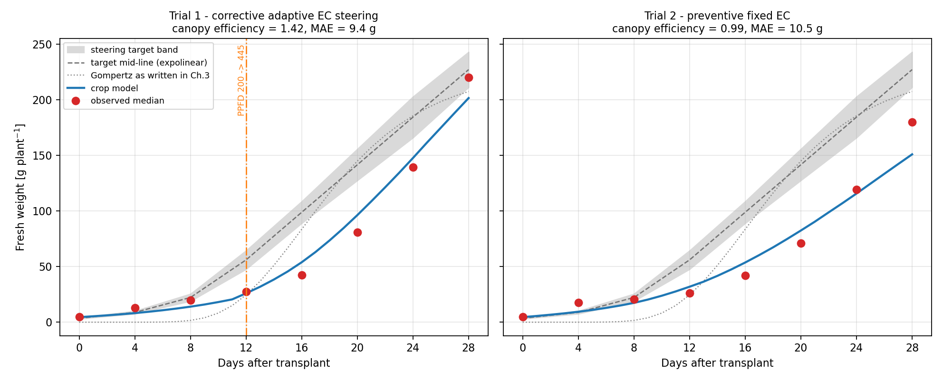
Figure 7.1. Crop-model growth trajectories vs observed medians and steering band
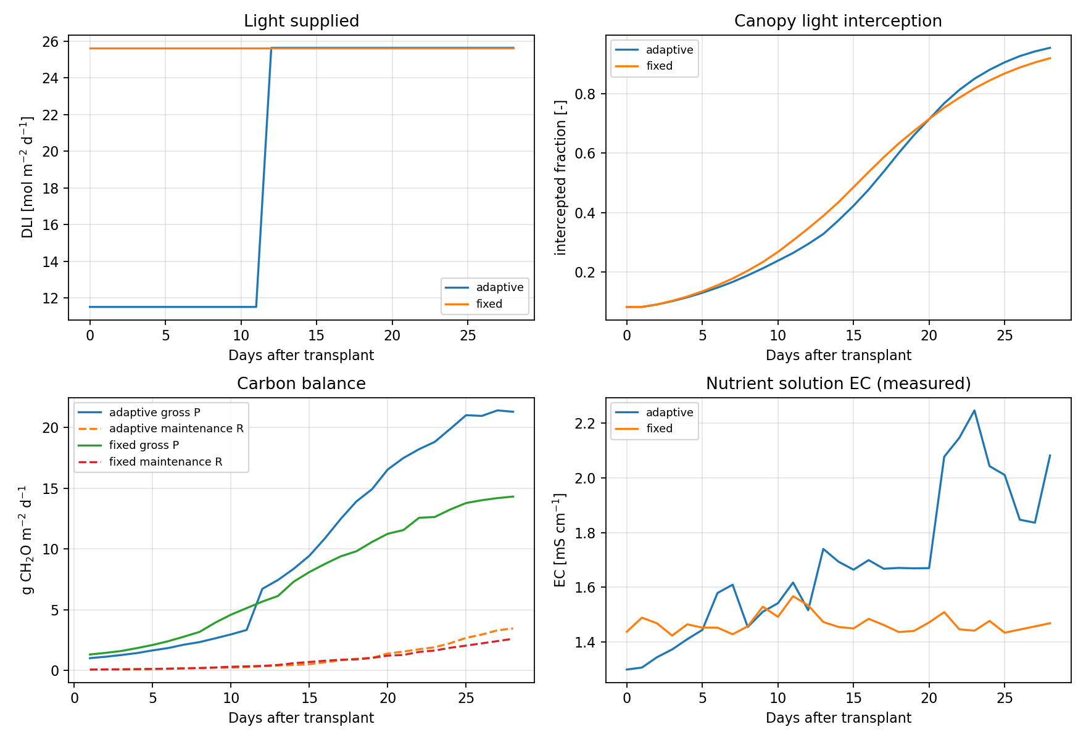
Figure 7.2. Crop-model carbon balance and related drivers

7.5 Tray-Level ML Results (8 Checkpoints, LODO)
Crop-model metrics for these same checkpoints are reported in Section 7.2 (Trial 1 MAE 9.39 g; Trial 2 MAE 10.49 g). The tables below list ML results only. Visual side-by-side trajectories and error plots are in Section 7.8.
Two ML setups were trained with leave-one-harvest-day-out (LODO): (1) raw weight — ML predicts observed grams from image/sensor window features; (2) hybrid residual — ML predicts residual_g, then final weight = modelled_g + predicted residual. Feature variants: image-only, compact (image + sensors), and sensors-only. Each row is the best model (lowest MAE) for that trial × feature set.
ML predicting raw fresh weight (LODO; best model per feature set):
trial | feature_set | best_model | n_features | mae_g | rmse_g | r2
trial1 | image | XGBoost | 68 | 28.30 | 39.74 | 0.684
trial1 | compact | XGBoost | 153 | 24.40 | 36.19 | 0.738
trial1 | sensors | XGBoost | 216 | 23.69 | 35.38 | 0.749
trial2 | image | GradBoost | 66 | 32.74 | 57.85 | -0.037

Hybrid residual ML (LODO; best model per feature set):
trial | feature_set | best_model | n_features | mae_g | rmse_g | r2
trial1 | image | SVR-RBF | 68 | 9.41 | 11.35 | 0.974
trial1 | compact | SVR-RBF | 153 | 9.67 | 11.41 | 0.974
trial1 | sensors | SVR-RBF | 216 | 9.56 | 11.46 | 0.974
trial2 | image | RandomForest | 66 | 9.02 | 13.42 | 0.944

7.6 Hold-Out Results (Train Trial 1 → Test Trial 2)
Models were trained on all Trial 1 checkpoints and evaluated on Trial 2 using compact (image + sensor) features. Crop-model Trial 2 MAE is again the Section 7.2 value (10.49 g). ML results for this hold-out are listed below; see Figure 7.7 for trajectories.
Hold-out Trial 2 — ML predicting raw fresh weight (compact features):
model | n_features | mae_g | rmse_g | r2
XGBoost | 153 | 3.76 | 5.02 | 0.992
SVR-RBF | 153 | 42.95 | 62.92 | -0.226
RandomForest | 153 | 45.87 | 62.81 | -0.222
GradBoost | 153 | 50.66 | 67.12 | -0.395
Ridge | 153 | 54.46 | 62.79 | -0.221
ElasticNet | 153 | 55.66 | 64.14 | -0.274

Hold-out Trial 2 — hybrid residual ML (compact features):
model | n_features | mae_g | rmse_g | r2
ElasticNet | 153 | 7.92 | 11.52 | 0.959
Ridge | 153 | 7.99 | 11.51 | 0.959
XGBoost | 153 | 8.78 | 11.23 | 0.961
GradBoost | 153 | 8.96 | 12.18 | 0.954
RandomForest | 153 | 9.15 | 12.60 | 0.951
SVR-RBF | 153 | 9.75 | 13.06 | 0.947

7.7 Plant-Level ML Results (79 Rows, Trial 1 LODO)
Each row is one weighed plant on one harvest day (target_fw_g). The crop prior used inside the hybrid setup is the tray-level modelled_g from Section 7.2 (crop-model Trial 1 MAE 9.39 g on tray medians). Tables below report ML metrics only.
Plant-level LODO — ML predicting raw plant fresh weight:
feature_set | best_model | n_features | mae_g | rmse_g | r2
image | XGBoost | 78 | 29.74 | 42.73 | 0.627
compact | XGBoost | 163 | 24.99 | 35.07 | 0.748
sensors | XGBoost | 219 | 24.58 | 34.34 | 0.759

Plant-level LODO — hybrid residual ML:
feature_set | best_model | n_features | mae_g | rmse_g | r2
image | RandomForest | 78 | 9.19 | 13.12 | 0.965
compact | RandomForest | 163 | 8.97 | 12.66 | 0.967
sensors | SVR-RBF | 219 | 9.47 | 12.48 | 0.968

Plant leave-one-out (LOO) MAE values of roughly 4–5 g appear in earlier plant-level runs but are optimistic (same-day plants remain visible) and are not used as the headline metric.

7.8 Figures (Crop Model and ML Together)
The following figures show crop-model and ML predictions on the same axes for visual comparison. Numeric results remain in the separate tables above.
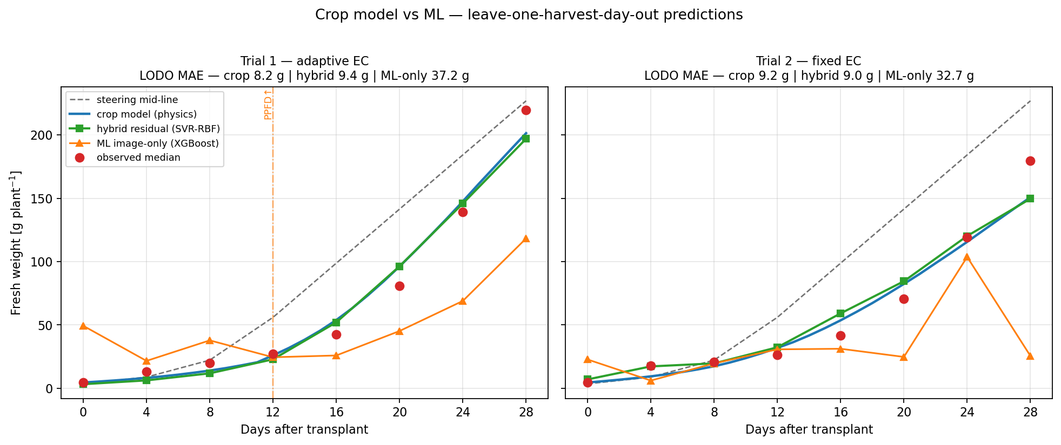
Figure 7.3. Growth trajectories: observed vs crop model vs hybrid residual ML vs image-only ML (leave-one-harvest-day-out).

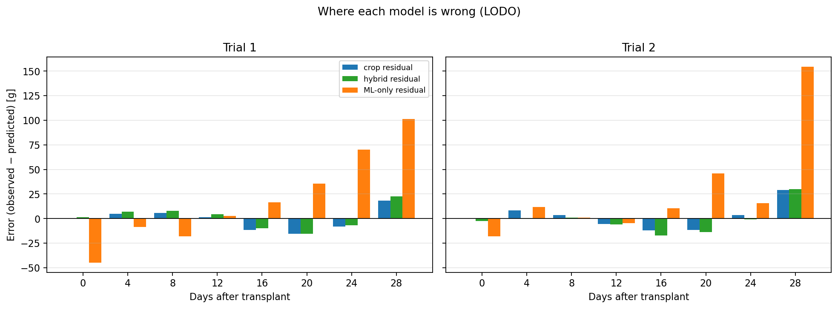
Figure 7.4. Prediction residuals by harvest day for crop, hybrid, and ML-only models.

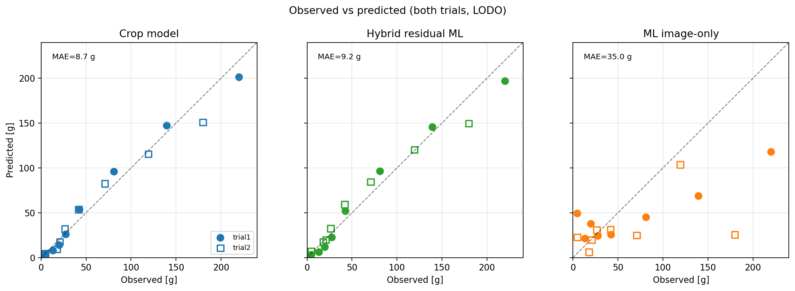
Figure 7.5. Observed vs predicted scatter for crop, hybrid, and ML-only (both trials, LODO).

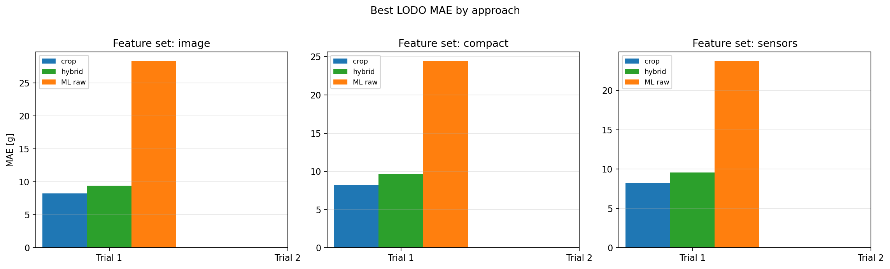
Figure 7.6. Best LODO MAE by feature set (image / compact / sensors).

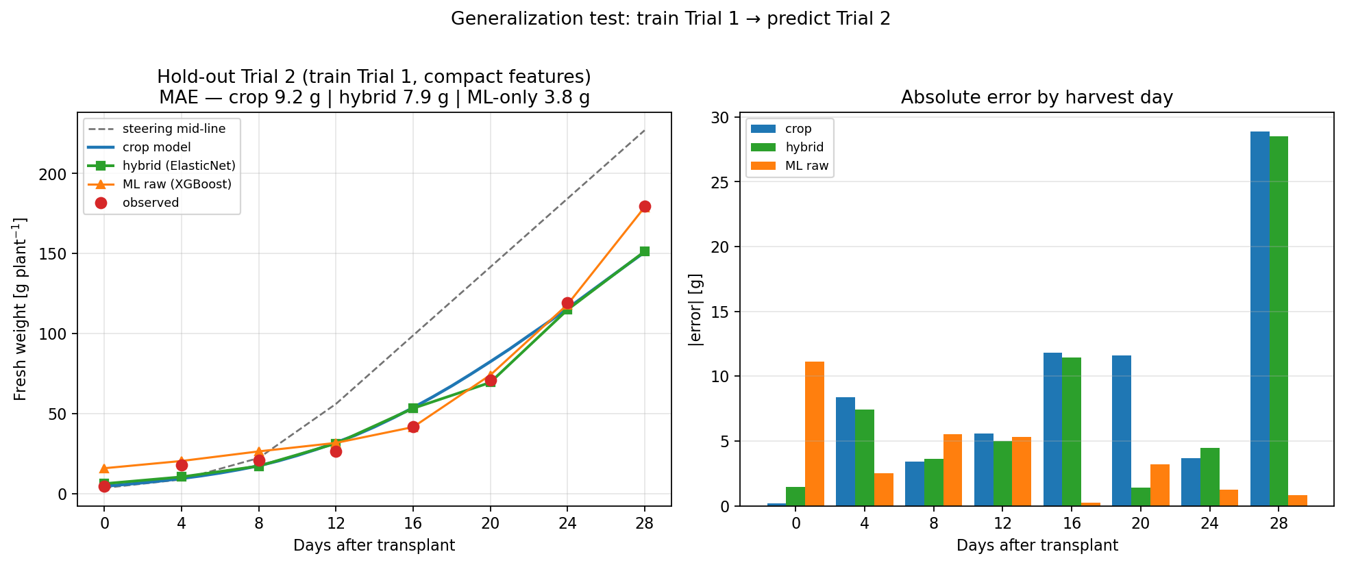
Figure 7.7. Hold-out: train Trial 1 → predict Trial 2 (compact features).

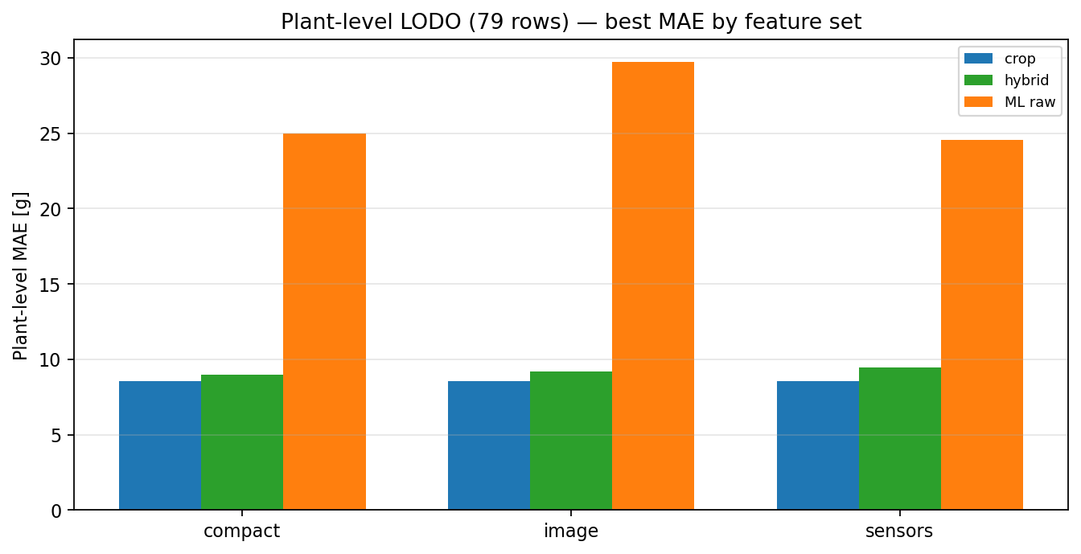
Figure 7.8. Plant-level LODO MAE by feature set (79 plant-days).

7.9 Interpretation
- Crop model (Section 7.2): tray-level MAE ~8–10 g, R² ≈ 0.95–0.98, without images or EC.
- ML raw weight models: higher LODO MAE on 8 tray checkpoints; see tables in 7.5.
- Hybrid residual ML: LODO and hold-out results in 7.5–7.6; trajectory overlays in 7.8.

8. Early-Warning Classification (DAT ≤ 12)
This section addresses Aim 3 from the project direction: at DAT 12, can the system identify plants that will finish well below the 227 g target? Features use only information available by DAT ≤ 12 (early fresh weights at DAT 0/4/8/12, DAT-12 crop-model residual, and gap to the steering mid-line). The harvest-day label is not used as an input.

8.1 Label Definition
Shortfall label: harvest fresh weight ≤ 227 × (1 − pct_below). The professor definition uses pct_below = 20% (threshold ≈ 181.6 g). Trial 1 plant harvests never meet that cut (lightest plant ≈ 185.8 g, about 18% below target), so classifiers are also compared at 10% (≤ 204.3 g) and 15% (≤ 193.0 g), where positive examples exist.
Trial 1 plant-level shortfall counts (n = 10 plants):
threshold | cut_g | n_shortfall | n_ok | shortfall_plants
10% below | 204.3 | 2 | 8 | 5, 6
15% below | 193.0 | 1 | 9 | 5
20% below (official) | 181.6 | 0 | 10 | —

8.2 Methods
Validation is leave-one-plant-out. Two modes are compared: (1) direct classifiers (Dummy most-frequent, Logistic Regression, SVM-RBF, Random Forest, Gradient Boosting, XGBoost); (2) regress-then-threshold — predict DAT-28 grams from DAT ≤ 12 features, then apply the shortfall cut. Feature variants: compact, image, and sensors. Within a single trial, tent climate at DAT 12 is identical across plants, so plant discrimination is driven mainly by early weights and the crop-model residual.

8.3 Classifier Comparison (10% Below Target)
Primary comparable setting: 10% below 227 g (≤ 204.3 g; plants 5 and 6 labeled shortfall). Compact feature set; leave-one-plant-out.
Direct classifiers @ 10% shortfall threshold (compact features):
model | accuracy | precision | recall | f1 | balanced_acc | roc_auc
RandomForest | 0.90 | 1.00 | 0.50 | 0.67 | 0.75 | 0.50
GradBoost | 0.90 | 1.00 | 0.50 | 0.67 | 0.75 | 0.50
LogisticRegression | 0.80 | 0.50 | 0.50 | 0.50 | 0.69 | 0.75
DummyMostFrequent | 0.80 | — | 0.00 | — | 0.50 | 0.50
XGBoost | 0.80 | — | 0.00 | — | 0.50 | 0.00
SVM-RBF | 0.70 | 0.00 | 0.00 | — | 0.44 | 0.12

8.4 Regress-then-Threshold (10% Below Target)
Same label and split, but the model first predicts harvest grams from DAT ≤ 12 features, then warns if the prediction is ≤ 204.3 g. Harvest MAE is the leave-one-plant-out error of that gram forecast.
Regress-then-threshold @ 10% shortfall (compact features):
model | accuracy | precision | recall | f1 | roc_auc | harvest_mae_g
XGBoost | 0.90 | 1.00 | 0.50 | 0.67 | 0.88 | 6.77
Ridge | 0.90 | 1.00 | 0.50 | 0.67 | 0.75 | 7.47
RandomForest | 0.90 | 1.00 | 0.50 | 0.67 | 0.69 | 6.32
GradBoost | 0.90 | 1.00 | 0.50 | 0.67 | 0.69 | 6.87
ElasticNet | 0.70 | 0.33 | 0.50 | 0.40 | 0.88 | 10.22
SVR-RBF | 0.80 | — | 0.00 | — | 0.00 | 11.45

8.5 Official 20% Threshold and Tray Check
At the official ≥20% below-target rule, Trial 1 has zero shortfall plants, so plant-level precision/recall are undefined and “accuracy = 1.0” only means every model predicted no warning. Trial 2’s tray median (179.8 g) does meet the 20% shortfall label. Simple DAT-12 tray rules:
Tray-level descriptive rules at DAT 12 (20% shortfall label):
trial | harvest_observed_g | shortfall_20pct_label | dat12_observed_g | dat12_modelled_g | dat12_residual_g | rule_warn_if_dat12_below_target_mid_56 | rule_warn_if_dat12_residual_neg
trial1 | 219.8 | 0 | 27.3 | 26.0 | 1.3 | 1 | 0
trial2 | 179.8 | 1 | 26.3 | 31.9 | -5.6 | 1 | 1

Both trials are below the DAT-12 steering mid (56 g), so that rule alone false-alarms on Trial 1. A negative DAT-12 crop-model residual flags Trial 2 only, matching the true 20% harvest shortfall.

8.6 Interpretation and Next Steps
- Best direct classifier at 10%: RandomForest (F1=0.6667, precision=1.0, recall=0.5). Best regress-then-threshold: XGBoost (F1=0.6667, ROC-AUC=0.875, harvest MAE=6.7702 g).
- At 10%, top models catch 1 of 2 light plants with no false alarms (precision 1.0, recall 0.5, F1 ≈ 0.67).
- At 15% (only plant 5 positive), classifiers generally fail to recover that single case under leave-one-plant-out.
- The official 20% Aim-3 definition needs more shortfall examples (e.g. Trial 2 plant weights, or a third trial) before it can be scored as a plant-level classifier.
- Outputs: ml/early_warning/ (results_early_warning_comparison.csv, predictions_early_warning_loo.csv).

- Build an early feature set
Only use info available by DAT 12 (images + sensors up to then; optional crop-model state at DAT 12). No later weights.
- Train a classifier / risk model
Predict “will be short” vs “on track,” with plant LOO or trial hold-out where possible.
- Report early-warning performance
Precision/recall, how many true shortfalls caught, false alarms — add to the progress report.
- (Later) Plan Trial 3
Same light, vary EC; logged PAR; measure bench area and dry matter — so Aim 2 can be tested cleanly.

09-08-2026

9. Future Growth Forecasting (t → t+4)
Sections 3–7 predict fresh weight at the same harvest checkpoint (nowcast). This section starts a true forecast module: given information available at DAT t, predict what happens at DAT t+4. Three steps are reported: (1) next-checkpoint fresh weight, (2) canopy size (mask area), and (3) Phase A future-image generation with a climate-conditioned Pix2Pix model (training underway / setup complete).

9.1 Next-Checkpoint Weight Forecast
Pairs are built from consecutive harvest checkpoints four days apart. Features at day t (image / sensors / compact) predict fresh weight at day t+4. Baselines: Persist (same weight in 4 days) and GrowMean (add the mean 4-day gain from training folds). Script: ml/train_next_checkpoint_forecast.py. Outputs: ml/forecast_next_checkpoint/.
Plant-level Trial 1: 68 pairs. Fair validation is leave-one-target-day-out (lodo_target_day). Leave-one-plant-out is also reported but is optimistic because the same harvest day can appear in both train and test. Tray-level: 14 pairs across trials; sensors ElasticNet is strongest on both tray splits.
Plant-level fair split (leave-one-target-day-out; n = 68 pairs). Best model per feature set:
variant | model | mae_g | rmse_g | r2 | mae_vs_persist
(baseline) | Persist | 30.59 | 40.10 | 0.676 | 0.00
(baseline) | GrowMean | 27.35 | 30.21 | 0.816 | 3.24
sensors | ElasticNet | 20.48 | 28.78 | 0.833 | 10.11
image | GradBoost | 20.66 | 29.37 | 0.826 | 9.93
compact | GradBoost | 21.94 | 35.57 | 0.745 | 8.64

Tray-level (leave-one-target-day-out; n = 14 pairs). Best model per feature set:
variant | model | mae_g | rmse_g | r2 | mae_vs_persist
(baseline) | Persist | 27.87 | 36.92 | 0.671 | 0.00
(baseline) | GrowMean | 24.71 | 28.11 | 0.809 | 3.16
sensors | ElasticNet | 6.29 | 7.90 | 0.985 | 21.59
image | ElasticNet | 8.28 | 10.73 | 0.972 | 19.59
compact | ElasticNet | 14.42 | 17.28 | 0.928 | 13.45

9.1.1 Interpretation
- Best fair plant forecast: sensors ElasticNet (MAE 20.5 g vs Persist 30.6 g; R² 0.833).
- Best fair tray forecast: sensors ElasticNet (MAE 6.3 g vs Persist 27.9 g).
- Sensors alone beat image/compact on the fair plant split; current weight and recent climate carry most of the 4-day signal.
- Plant leave-one-plant-out MAE ~3 g is not the headline number (same-day leakage). Use leave-one-target-day-out (~20.5 g) for claims.

9.2 Canopy Size Forecast
Same t → t+4 pairing, but the target is FastSAM mask area (pixels) instead of grams. Cup-level is the main result (same camera FOV within a cup). Tray leave-one-trial is weak because Trial 1 vs Trial 2 camera framing changed. Script: ml/train_canopy_forecast.py. Outputs: ml/forecast_canopy/.
Cup-level canopy forecast (leave-one-cup-out; n = 121 pairs; mean target ≈ 39220 px):
model | mae_px | rmse_px | r2 | mae_vs_persist | mae_pct_of_mean
Persist | 5222.9 | 6885.8 | 0.694 | 0.0 | 13.3
GrowMean | 5359.6 | 6928.6 | 0.690 | -136.7 | 13.7
RandomForest | 4192.6 | 5667.3 | 0.793 | 1030.3 | 10.7
GradBoost | 4237.0 | 5603.8 | 0.797 | 985.8 | 10.8
XGBoost | 4662.3 | 7163.2 | 0.669 | 560.6 | 11.9
ElasticNet | 4954.9 | 6710.3 | 0.709 | 268.0 | 12.6
Ridge | 4945.1 | 6697.6 | 0.710 | 277.8 | 12.6

Cup-level fair day split (leave-one-target-day-out; n = 121):
model | mae_px | rmse_px | r2 | mae_vs_persist | mae_pct_of_mean
Persist | 5222.9 | 6885.8 | 0.694 | 0.0 | 13.3
GrowMean | 5385.3 | 6973.9 | 0.686 | -162.5 | 13.7
RandomForest | 4012.0 | 5396.1 | 0.812 | 1210.9 | 10.2
GradBoost | 4129.3 | 5482.8 | 0.806 | 1093.5 | 10.5
XGBoost | 4308.9 | 6128.2 | 0.757 | 914.0 | 11.0
ElasticNet | 4422.6 | 5710.7 | 0.789 | 800.3 | 11.3
Ridge | 4402.1 | 5753.1 | 0.786 | 820.8 | 11.2

9.2.1 Interpretation
- Best cup leave-one-cup-out: RandomForest MAE ≈ 4193 px (~10.7% of mean future mask area), beating Persist (≈ 5223 px).
- Best cup leave-one-target-day-out: RandomForest MAE ≈ 4012 px (~10.2% of mean), R² ≈ 0.81.
- Cross-trial cup / tray splits do not beat Persist reliably — FOV and lighting differ between trials.
- Outputs: ml/forecast_canopy/results_canopy_forecast.csv, cup_pairs_mask_area.csv.

9.3 Future Image Generation (Pix2Pix Phase A)
Goal: given a cup crop at day t plus the next-4-day climate summary, generate what the same cup should look like at day t+4. Phase A uses a conditional Pix2Pix (U-Net generator + PatchGAN discriminator) with climate tiled into extra input channels. Trial 1 FastSAM cup crops only; horizon +4 days. Scripts: ml/forecast_images/build_pix2pix_pairs.py, ml/forecast_images/train_pix2pix.py.
Why Pix2Pix first (not SD/ControlNet yet): only 43 Trial-1 pairs where both days exist. A small paired translator is the right smoke-test before a heavier diffusion stack. SDXL + ControlNet remains a planned Phase B quality upgrade if Phase A proves the pairing.
Trial 1 Pix2Pix pairs split by cup_id (no cup appears in two splits; 128×128 crops):
split | cups | n_pairs | role
train | 1, 2, 4, 5, 6, 7, 8 | 25 | fit G/D; climate normalization
val | 9, 11 | 13 | select best.pt (lowest val L1)
test | 12, 14 | 5 | held-out once after training

Climate features (12): current and 4-day-mean T_air, RH, CO₂, EC, PPFD, DLI. Normalization statistics are computed from the train split only.

9.3.1 Training Setup
Pix2Pix Phase A training configuration:
item | value
Model | Pix2Pix (climate-conditioned; λ_L1 = 100)
Image size | 128 × 128
Batch size | 8
Epochs | 300
Device | CUDA

9.3.2 Interpretation and Next Steps
- Dataset and split discipline are in place; climate is train-normalized only.
- Full 300-epoch training writes best.pt from val L1, then scores the 5 test pairs once.
- Inspect samples/*.png for visual growth plausibility; numeric L1/SSIM alone is not enough on n=5 test.
- After Phase A finishes: optional Phase B (SD/ControlNet), recover more cup-days, then append final image metrics / grids to this report (append-only).
- Outputs: ml/forecast_images/dataset/trial1_128/, ml/forecast_images/runs/pix2pix_t1_128_*/.
09-10-2026

9.4 Pix2Pix Results: Trial 1 vs Trial 2
Phase A training finished for both trials under the same recipe (128×128, 300 epochs, batch size 8, λ_L1 = 100, climate-conditioned Pix2Pix, cup-level train/val/test split). Trial 2 was trained alone (not mixed with Trial 1) as a same-camera check with more pairs. Lower L1 is better; higher SSIM is better.
Training setup comparison:
item | trial1 | trial2
Train / val / test pairs | 25 / 13 / 5 | 59 / 15 / 4
Cups (train / val / test) | 1,2,4–8 / 9,11 / 12,14 | 1–6 / 7,8 / 9,12

Validation and held-out test metrics (best.pt selected by val L1):
metric | trial1 | trial2 | winner
Best epoch (min val L1) | 79 | 48 | —
Best val L1 (↓ better) | 0.2929 | 0.2375 | Trial 2
Best val SSIM (↑ better) | 0.0553 | 0.2601 | Trial 2
Held-out test L1 (↓ better) | 0.4483 | 0.3634 | Trial 2
Held-out test SSIM (↑ better) | -0.0574 | 0.3686 | Trial 2

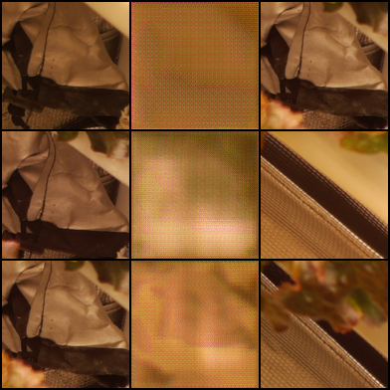
Figure 9.2. Trial 1 held-out test grid (input | generated | real). Generated frames remain blurry / unstructured (test SSIM negative).

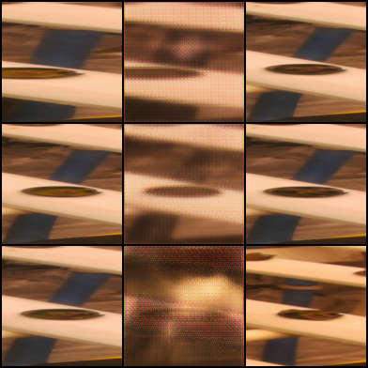
Figure 9.3. Trial 2 held-out test grid (input | generated | real). Numerically better than Trial 1, but still far from sharp plant structure.

9.4.1 Interpretation
- Trial 2 beats Trial 1 on every reported metric (test L1 0.363 vs 0.448; test SSIM 0.369 vs −0.057), consistent with more train pairs (59 vs 25).
- Neither run produces usable future-plant photos yet: generated images stay soft / artifacted. Treat Phase A as a negative result on image quality, with Trial 2 the stronger of two weak runs.
- Next data levers: recover missing cup-days, combine trials carefully (FOV differs), then optional Phase B (e.g. ControlNet). Do not expect more epochs alone to fix n≈25–59.
- Outputs: ml/forecast_images/runs/pix2pix_t1_128_20260908_105032/, ml/forecast_images/runs/pix2pix_t2_128_20260908_130245/ (test_metrics.json, samples/test_grid.png).
09-11-2026

9.5 ControlNet Results: Trial 1 vs Trial 2
Phase B uses pretrained Stable Diffusion v1.5 with a ControlNet fine-tuned on the same cup-level t → t+4 pairs as Pix2Pix. Images were preprocessed (RGBA→RGB on white, ExGR vegetation bbox crop with padding, resize to 256×256). Conditioning = day-t crop; target = day-t+4 crop; prompt includes a short climate summary. Only ControlNet weights were trained (SD frozen). Same cup train/val/test split as Section 9.4; 300 epochs. Lower L1 is better; higher SSIM is better.
Training setup comparison:
item | trial1 | trial2
Train / val / test pairs | 25 / 13 / 5 | 59 / 15 / 4
Cups (train / val / test) | 1,2,4–8 / 9,11 / 12,14 | 1–6 / 7,8 / 9,12

Validation and held-out test metrics (best ControlNet by val L1):
metric | trial1 | trial2 | winner
Best step (min val L1) | 260 | 2100 | —
Best val L1 (↓ better) | 0.7629 | 0.8303 | Trial 1
Best val SSIM (↑ better) | 0.0826 | 0.0109 | Trial 1
Held-out test L1 (↓ better) | 0.8789 | 0.7651 | Trial 2
Held-out test SSIM (↑ better) | 0.0300 | 0.0929 | Trial 2

Reference vs Pix2Pix (same cup split; not a strict apples-to-apples score — Pix2Pix is 128px raw crops, ControlNet is 256px preprocessed):
setting | pix2pix_128 | controlnet_256
Trial 1 test L1 | 0.4483 | 0.8789
Trial 1 test SSIM | -0.0574 | 0.0300
Trial 2 test L1 | 0.3634 | 0.7651
Trial 2 test SSIM | 0.3686 | 0.0929

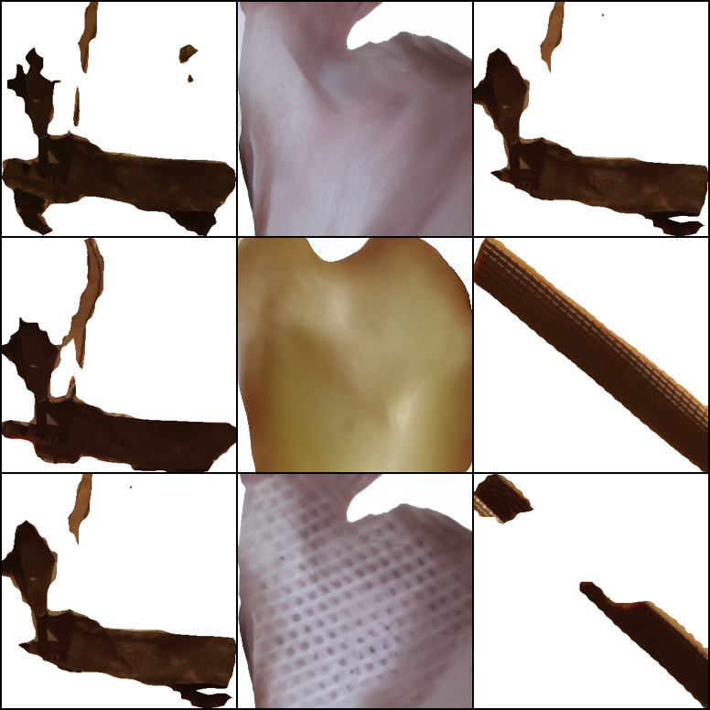
Figure 9.4. ControlNet Trial 1 held-out test grid (input | generated | real). Test SSIM remains near zero (~0.03).

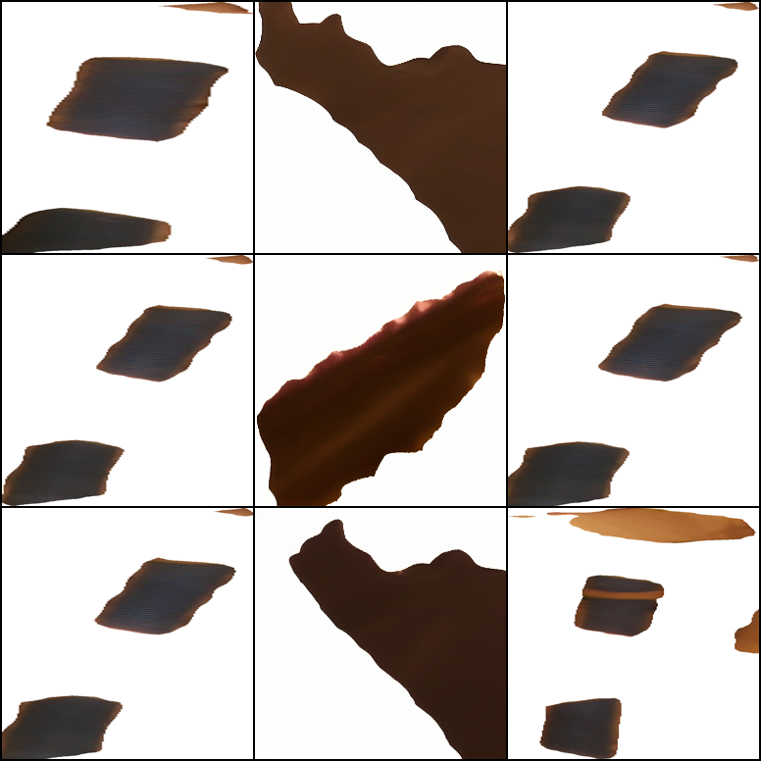
Figure 9.5. ControlNet Trial 2 held-out test grid (input | generated | real). Slightly better test L1/SSIM than Trial 1 ControlNet, still not sharp plant structure.

9.5.1 Interpretation
- Within ControlNet, Trial 2 wins held-out test (L1 0.765 vs 0.879; SSIM 0.093 vs 0.030), again consistent with more train pairs (59 vs 25).
- Phase B did not solve the image-forecast problem on this data: ControlNet test SSIM stays low (≪ Pix2Pix Trial 2’s 0.37 on its own 128px metric). Absolute L1/SSIM should not be over-compared across pipelines because resolution and preprocessing differ.
- Main takeaway for the meeting: a stronger pretrained model + preprocessing still fails to produce usable future-plant photos at n≈25–59 — supporting the need for more paired cup-days (recover missing days / Trial 3), not only a different architecture.
- Outputs: ml/forecast_images/runs/controlnet_t1_256_20260910_112537/, ml/forecast_images/runs/controlnet_t2_256_20260910_130342/ (test_metrics.json, samples/test_grid.png).
09-24-2026

10. Aim 1 Update: Segmentation Lock and Plant Fresh-Weight Ablation
This section records the Aim 1 work after Sections 6–9: (i) attempted FastSAM fine-tuning against research GT masks, (ii) decision to lock zero-shot vanilla FastSAM for production cup features, (iii) a refreshed plant-level fresh-weight ablation on Trial 1, and (iv) a Trial 2 tray-aggregate sanity check (Trial 2 has no per-plant weights).

10.1 FastSAM Fine-Tune Attempt (Abandoned)
Inspired by FLAsH-style plant instance work, we tried dataset-specific FastSAM fine-tuning on research GT under segmentation/research/. Take: practical FastSAM cup pipeline. Skip: full FT as the production segmenter. Improve attempt: train against our GT and push lettuce IoU/Dice; if FT does not beat vanilla drafts, keep vanilla.
Test-set lettuce mask quality vs research GT (n=137 frames):
method | mean_iou | mean_dice
Vanilla FastSAM drafts (production) | 0.517 | 0.660
Fine-tuned FastSAM (best.pt) | 0.344 | 0.491

Fine-tuning reduced lettuce IoU by ~0.173 versus vanilla drafts (goal was IoU≥0.60 / Dice≥0.70). Likely bottleneck: noisy / incomplete GT rather than model capacity. We therefore lock vanilla FastSAM cup drafts as the Aim 1 segmenter and leave FT checkpoints under segmentation/research/ only.

10.2 Plant Fresh-Weight Ablation (Trial 1, seed=42)
After locking vanilla FastSAM, plant ML tables were re-exported from daily_cup_features and the full ablation grid was re-run: feature sets {sensors, image, compact, full} × models {MeanBaseline, Ridge, ElasticNet, SVR-RBF, RandomForest, GradBoost, XGBoost} × splits {LOO, LODO, LOPO}. Dataset size: 79 plant-days (Trial 1). Primary metric remains LODO plant MAE (g). LOO/LOPO are optimistic and reported only as context.
Best model per feature set — LODO (seed=42, single run):
feature_set | best_model | n_features | mae_g | rmse_g | r2 | day_median_mae_g
full | XGBoost | 294 | 23.15 | 33.83 | 0.766 | 23.25
compact | XGBoost | 163 | 23.34 | 34.80 | 0.752 | 23.57
sensors | XGBoost | 217 | 23.60 | 34.66 | 0.754 | 23.74
image | XGBoost | 78 | 28.64 | 40.05 | 0.672 | 28.32

Context only — best LOO / LOPO (optimistic; not for model selection):
feature_set | split | best_model | mae_g | r2
full | loo | GradBoost | 5.34 | 0.987
full | lopo | RandomForest | 5.29 | 0.986
compact | loo | GradBoost | 5.37 | 0.987
compact | lopo | RandomForest | 5.29 | 0.986
sensors | loo | XGBoost | 3.38 | 0.995
sensors | lopo | RandomForest | 4.62 | 0.989
image | loo | GradBoost | 5.31 | 0.987
image | lopo | RandomForest | 5.27 | 0.986

Multi-seed mean ± SD (seeds 42–46, n_jobs=1 / OMP_NUM_THREADS=1 to avoid nested-thread thrashing) is reported below. Primary metric remains LODO plant MAE.

10.3 Trial 2 Tray-Aggregate Check
Trial 2 has tray-level fresh weights only (no Plant-ID weights). We trained XGBoost on Trial 1 plant rows, predicted each Trial 2 cup, then aggregated cup predictions to a tray mean/median and compared to observed Trial 2 tray medians (7 days).
Trial 2: cup→tray aggregate vs observed tray median (MAE, g):
feature_set | mae_pred_mean_g | mae_pred_median_g | n_days
sensors | 2.74 | 2.62 | 7
full | 2.82 | 2.81 | 7
compact | 3.42 | 3.55 | 7
image | 5.12 | 5.12 | 7

Best tray-aggregate MAE is ~2.6 g (sensors, median aggregate). This is a sanity check only: it collapses many cups and does not replace Trial 1 LODO plant MAE (~23 g) as the Aim 1 headline metric.

10.4 Interpretation and Next Steps
- Production segmenter for Aim 1: vanilla FastSAM cup drafts (no further FT planned unless GT quality improves).
- Headline plant FW: LODO XGBoost ≈ 23.2–23.6 g MAE on full/compact/sensors (seed=42); image-only weaker (~28.6 g).
- LOO MAE of ~3–5 g remains optimistic (same-day plants visible) and must not be quoted as the main result.
- Trial 2 tray check (~2.6 g) supports cross-trial transfer at tray scale but does not prove per-plant accuracy on Trial 2.
- Required next experiment: genuine 5-seed LODO mean±SD via ml/run_aim1_plant_fw_multiseed.sh (~35 min). Then optionally deepen multimodal fusion / cup tracking rather than more FT.
- Outputs: ml/plant/ablation_aim1_plant_fw*.csv, ml/plant/t2_tray_aggregate_*.csv, segmentation/research/runs/fastsam_ft_vanilla_hq/eval_test.json.
Best model per feature set — LODO mean ± SD (5 seeds 42–46):

feature_set | best_model | mae_g_mean_pm_sd | r2_mean | r2_sd
compact | XGBoost | 23.44 ± 0.07 | 0.766 | 0.008
full | XGBoost | 23.75 ± 0.52 | 0.754 | 0.015
sensors | XGBoost | 23.81 ± 0.45 | 0.754 | 0.009
image | XGBoost | 29.19 ± 1.14 | 0.662 | 0.021

Headline: compact XGBoost LODO MAE = 23.44 ± 0.07 g (most stable). Full/sensors similar (~23.8 g). Image-only weaker (29.19 ± 1.14 g).
09-24-2026

11. Aim 2: Phenotype-Consistency Forecast (Phase A)
Aim 2 here is not a new diffusion paper. Take (FGTD / Agricrafter / Drees): an intermediate future phenotype before biomass. Skip: retraining Pix2Pix/ControlNet in this phase. Improve: classical ML bridge under LODO and leave-one-trial-out, judged by FW MAE and canopy MAE, using sensors + FastSAM canopy features.

11.1 Phenotype Bridge (what it is)
Two classical ML stages (not deep learning): (1) forecast canopy mask area at t+4 from features at t; (2) map that predicted canopy (+ sensors + current FW) to fresh weight at t+4. Tuned run selected RandomForest for canopy and ElasticNet for the FW bridge on plant LODO.
- Direct route: features@t → FW@t+4 (ElasticNet).
- Phenotype bridge: features@t → mask@t+4 (RF) → FW@t+4 (ElasticNet).
- Baselines: Persist (FW@t) and GrowMean (FW@t + mean 4-day gain from other folds).

11.2 Plant LODO Results (Trial 1, tuned, 5 seeds)
Plant t→t+4 LODO (68 pairs, seeds 42–46):
route | model | mae_g_mean_pm_sd | canopy_mae_px_mean_pm_sd
persist | Persist | 30.59 ± 0.00 | 10135.65 ± 0.00
grow_mean | GrowMean | 27.35 ± 0.00 | —
direct_fw | ElasticNet | 20.82 ± 1.05 | —
phenotype_bridge | ElasticNet←RandomForest | 19.33 ± 1.18 | 8097.00 ± 269.84
canopy_only | RandomForest | — | 8097.00 ± 269.84

Headline: phenotype bridge FW MAE = 19.33 ± 1.18 g vs persist 30.59 g and direct 20.82 ± 1.05 g. Canopy forecast beats persist on pixels (~8097 vs ~10136).

11.3 Leave-One-Trial-Out Tray Test (hard generalization)
Tray-level t→t+4 pairs (7 per trial). Train one trial, test the other. N=2 cycles only — honest hard test, not definitive. Camera FOV differs between trials, so canopy transfer is expected to struggle.
Tray LOTO t→t+4 (5 seeds):
fold | route | model | mae_g_mean_pm_sd | canopy_mae_px_mean_pm_sd
t1_to_t2 | direct_fw | ElasticNet | 11.72 ± 0.00 | —
t1_to_t2 | grow_mean | GrowMean | 19.30 ± 0.00 | —
t1_to_t2 | persist | Persist | 25.01 ± 0.00 | 95489.53 ± 0.00
t1_to_t2 | phenotype_bridge | ElasticNet←ElasticNet | 15.04 ± 0.00 | 117825.31 ± 0.00
t2_to_t1 | direct_fw | ElasticNet | 5.74 ± 0.00 | —
t2_to_t1 | grow_mean | GrowMean | 23.56 ± 0.00 | —
t2_to_t1 | persist | Persist | 30.73 ± 0.00 | 73034.95 ± 0.00
t2_to_t1 | phenotype_bridge | ElasticNet←XGBoost | 6.46 ± 0.05 | 145823.84 ± 7257.87

T1→T2: direct ElasticNet 11.72 g beats bridge 15.04 g; both beat persist 25.01 g. T2→T1: direct 5.74 g, bridge 6.46 g vs persist 30.73 g. Cross-trial canopy MAE is worse than persist (FOV / scale shift) — FW still transfers via sensors + current weight.

11.4 Interpretation and Next Steps
- Phase A success: within Trial 1, phenotype bridge is the best FW forecast among tested routes.
- Cross-trial: prefer direct FW (sensors + fw_t); do not rely on raw mask-area transfer without FOV normalization.
- Next (Phase B): score existing Pix2Pix/ControlNet generations with phenotype consistency (vegetation / mask-area agreement vs real t+4), not only L1/SSIM.
- Outputs: ml/aim2_phenotype_tuned/, ml/aim2_loto/.

11.5 Aim 2 Phase B: Pix2Pix Phenotype Consistency
Existing Pix2Pix best checkpoints were re-scored on held-out test cups with an ExGR vegetation-fraction phenotype metric (fake vs real t+4), compared to a persist baseline (input@t veg fraction vs real@t+4). No new image training.
Pix2Pix test phenotype consistency:
trial | n_test | test_l1 | test_ssim | veg_mae_persist | veg_mae_fake | fake_beats_persist
trial1 | 5 | 0.448 | -0.057 | 0.098 | 0.174 | no
trial2 | 4 | 0.363 | 0.369 | 0.044 | 0.107 | no

Phase B finding: Pix2Pix generations are worse than persist on vegetation-fraction MAE for both trials (fake loses by ~0.06–0.08). Pixel SSIM remains poor on Trial 1. Prefer Aim 2 Phase A tabular phenotype bridge for forecasting; treat image generation as unsolved.
09-24-2026

11.6 Aim 2 Phase B v2: Future-Mask CNN / Tiny Transformer
Instead of RGB generation, we trained compact models to forecast the t+4 ExGR vegetation mask from cup RGB@t + current mask + climate. Models: U-Net (CNN) and TinyTransformer (patch encoder + CNN decoder; SegFormer-inspired, small). Same cup splits as Pix2Pix. Primary scores: Dice vs persist (mask@t) and vegetation-fraction MAE.
Future-mask absolute prediction (test):
trial | model | test_dice | persist_dice | test_veg_mae | persist_veg_mae | beats_persist_dice | beats_persist_veg_mae
trial1 | tinyt | 0.0746 | 0.4129 | 0.1794 | 0.0983 | False | False
trial1 | unet | 0.2273 | 0.4129 | 0.1654 | 0.0983 | False | False
trial2 | tinyt | 0.1015 | 0.1975 | 0.0625 | 0.0444 | False | False
trial2 | unet | 0.1815 | 0.1975 | 0.0307 | 0.0444 | False | True

Only Trial 2 U-Net beat persist on vegetation-fraction MAE; Dice remained below persist for all four runs. Absolute future-mask prediction does not reliably beat “same canopy in 4 days.”

11.7 Aim 2 Phase B v3: FOV-Aware Δ-Mask Residual
Follow-on experiment: predict soft ExGR growth residual Δ and reconstruct soft̂_{t+4} = clip(soft_t + Δ, 0, 1), with percentile-normalized soft ExGR maps (more stable under illumination / framing). Same U-Net and TinyTransformer backbones.
Δ-mask residual forecast (test):
trial | model | test_dice | persist_dice | test_veg_mae | persist_veg_mae | test_soft_l1 | persist_soft_l1 | beats_dice | beats_veg | beats_soft_l1
trial1 | tinyt | 0.4205 | 0.5977 | 0.0357 | 0.0523 | 0.2646 | 0.1921 | False | True | False
trial1 | unet | 0.4944 | 0.5977 | 0.1326 | 0.0523 | 0.2861 | 0.1921 | False | False | False
trial2 | tinyt | 0.4429 | 0.5306 | 0.0384 | 0.0174 | 0.2658 | 0.2614 | False | False | False
trial2 | unet | 0.4865 | 0.5306 | 0.0168 | 0.0174 | 0.2465 | 0.2614 | False | True | True

Residual training improved mass/soft error in places (Trial 1 TinyT and Trial 2 U-Net beat persist on veg MAE; Trial 2 U-Net also on soft L1), but Dice still lost to persist in every run. Shape overlap at t+4 remains largely explained by the current mask.

11.8 Aim 2 Overall Takeaway
- Primary Aim 2 result: Phase A tabular phenotype bridge (plant LODO FW MAE ≈ 19.3 ± 1.2 g).
- Cross-trial tray LOTO: prefer direct sensors+FW; canopy pixels do not transfer cleanly (FOV).
- Image / mask generation (Pix2Pix, absolute mask CNN/Transformer, Δ-mask residual) does not beat persist on Dice; treat visual Aim 2 as a negative / secondary finding until more data or FOV-calibrated pairs exist.
- Outputs: ml/aim2_phenotype_tuned/, ml/aim2_loto/, ml/forecast_images/aim2_phase_b/, aim2_phase_b_mask/, aim2_phase_b_delta/.
10-02-2026

12. Aim 1 FW Methodology Refine (Publishable Ablations)
After locking vanilla FastSAM and the Section 10 compact/sensors LODO baseline (~23 g MAE), we ran a paper-facing Aim 1 refine on Trial 1 plant-days (n=79). Take (Lin 2022): compact canopy + climate trait fusion. Take (tomato FGTD 2026): classical/XGBoost models under sparse harvest labels. Take (Zhang 2026): physiology-lite extras (day², log mask area). Skip: Chen/Drees-scale image GANs as the FW estimator. Improve: curated low-dim packs, nested LODO model selection, optional log1p(FW), and explicit day-only / MeanBaseline controls so gains are not over-claimed.

12.1 Setup
- Source table: ml/plant/plant_checkpoint_trial1_compact.csv (vanilla FastSAM cup features + sensors).
- Feature packs: lin_phy (~41 curated canopy+climate), canopy (~49), climate (~25), compact (~166).
- Primary split: leave-one-harvest-day-out (LODO). LOO/LOPO recorded only as optimistic checks.
- Seeds 42–46. Models: Ridge, ElasticNet, RF, GradBoost, XGBoost (+ depth variants).
- Protocols: (i) fixed models; (ii) nested LODO model selection per held-out day; (iii) ± log1p(FW).
- Scripts: ml/refine_aim1_fw.py, ml/run_aim1_fw_refine.sh → ml/plant/fw_refine/.

12.2 Fixed-Model LODO Results (5 seeds)
Headline table uses the best model name chosen per seed when aggregating “Best:*” rows; for XGBoost we also report the fixed XGBoost row mean±SD across all five seeds. ElasticNet/Ridge are deterministic: identical MAE across seeds → SD = 0 (seed-invariant), not a failed multi-seed run.
Fixed-model LODO (Trial 1, seeds 42–46) — selected paper rows:
pack | model | log_target | n_features | n_seeds | mae_g_mean_pm_sd | r2_mean | note
lin_phy | ElasticNet | true | 41 | 5 | 10.33 ± 0.00 | 0.949 | seed-invariant
canopy | ElasticNet | true | 49 | 5 | 14.93 ± 0.00 | 0.897 | seed-invariant
compact | XGBoost | false | 166 | 5 | 23.99 ± 1.13 | 0.748
lin_phy | XGBoost_d2 | false | 41 | 5 | 26.08 ± 0.67 | 0.670
canopy | XGBoost_d2 | false | 49 | 5 | 27.42 ± 0.25 | 0.698
climate | XGBoost | false | 25 | 5 | 27.44 ± 0.07 | 0.714
lin_phy | MeanBaseline | false | 0 | 10 | 66.65 ± 0.00 | -0.306 | seed-invariant

Sanity check (same LODO protocol): day-only Ridge on log1p(FW) achieves ~12.6 g MAE. Thus lin_phy ElasticNet log (10.33 g, seed-invariant) is largely a growth-curve + log-scale effect; plant canopy features add a modest gain over day-only (~2 g). MeanBaseline LODO remains ~66.7 g. The Section 10-comparable stochastic headline remains compact XGBoost on raw FW (~24.0 ± 1.13 g across five seeds; best single seed ~22.97 g).

12.3 Nested LODO Selection
Nested LODO model selection — mean ± SD over seeds:
pack | log_target | n_features | mae_g_mean_pm_sd | r2_mean
lin_phy | True | 41 | 10.33 ± 0.00 | 0.949
canopy | True | 49 | 21.91 ± 0.00 | 0.789
compact | False | 166 | 25.32 ± 2.03 | 0.732
canopy | False | 49 | 27.55 ± 0.43 | 0.694
climate | False | 25 | 30.81 ± 0.10 | 0.683
climate | True | 25 | 33.33 ± 0.49 | 0.471
lin_phy | False | 41 | 33.47 ± 4.28 | 0.590
compact | True | 166 | 35.32 ± 0.48 | 0.349

Nested selection did not beat a well-chosen fixed model on this n=79 setting and can inflate variance (e.g. compact NestedSelect ~25.3 ± 2.0 g vs fixed XGBoost ~24.0 ± 1.1 g). We keep nested results as a negative / cautionary ablation for the paper Methods.

12.4 Interpretation (paper claims)
- Do not quote “10.33 ± 0.00” as multi-seed uncertainty: ElasticNet is seed-invariant; report as 10.33 g (deterministic) and show day-only (~12.6 g).
- For stochastic models, quote mean±SD (compact XGBoost ~24.0 ± 1.1 g LODO).
- Curated lin_phy is interpretable and competitive under log+linear models; compact+XGBoost remains the robust raw-FW baseline aligned with Section 10.
- Image-generation Aim 2 paths stay secondary for FW; this tabular refine is the publishable Aim 1 direction given sample size.
- Outputs: ml/plant/fw_refine/fw_refine_summary_fixed.csv, fw_refine_summary_nested.csv, lin_phy_features.json, fw_refine_run.log.
10-02-2026

13. Future Fresh-Weight Forecast and Factor Attribution
This section addresses unknown future weights (harvest at t+4 days) and which factors drive predictions. Take (FGTD / Aim 2 Phase A): dense sensors + sparse labels with a phenotype bridge and classical ML. Take (Lin): multimodal climate + canopy. Skip: image GANs as the FW estimator. Improve: multi-seed nested LODO for future FW, explicit Persist/GrowMean baselines, and publishable factor attribution (permutation importance + partial dependence; SHAP unavailable under the current NumPy/shap binary mismatch).

13.1 Future-FW LODO (Trial 1, n=68 pairs, horizon=4 d)
Leave-one-target-harvest-day-out on plant pairs (features @ t → FW @ t+4). Seeds 42–46 with nested model selection. Routes: Persist, GrowMean, direct FW (sensors + fw_t + prior gain), phenotype bridge (RF canopy@t+4 → ElasticNet FW).
Future FW LODO mean ± SD (5 seeds):
route | model | mae_g_mean_pm_sd | r2_mean_pm_sd | mae_vs_persist
phenotype_bridge | ElasticNet←RandomForest | 19.33 ± 1.18 | 0.84 ± 0.01 | 11.25 ± 1.18
direct_fw | ElasticNet | 20.82 ± 1.05 | 0.82 ± 0.01 | 9.77 ± 1.05
grow_mean | GrowMean | 27.35 ± 0.00 | 0.82 ± 0.00 | 3.24 ± 0.00
persist | Persist | 30.59 ± 0.00 | 0.68 ± 0.00 | 0.00 ± 0.00

Headline: phenotype bridge 19.33 ± 1.18 g beats direct ElasticNet 20.82 ± 1.05 g; both beat GrowMean 27.35 g and Persist 30.59 g (~11 g and ~10 g MAE reduction vs persist). This is the publishable future-weight result for Trial 1.
Supporting next-checkpoint ablation (plant LODO): best variant=sensors model=ElasticNet MAE=20.48 g (persist 30.59 g). LOO plant splits remain optimistic and are not used as the headline.

13.2 Factor Attribution
Because tray climate is nearly constant across plants on a given harvest day, within-day LODO permutation cannot credit climate drivers. We therefore report (i) full-fit row-wise permutation importance and (ii) day-block permutation (shuffle whole harvest days) as explanatory rankings, while predictive skill stays the LODO table above. Figures: ml/fw_attribution/*_importance.png and *_partial_dependence.png.
Future FW (t→t+4) — top permutation importances (MAE increase if shuffled, g):
feature | mae_increase_mean | mae_increase_sd
fw_t | 20.60 | 1.31
gain_prev_4d | 13.51 | 1.07
exp_day_wmean | 11.67 | 0.99
nutrient_ec_us_cm_mean_wmean | 11.01 | 0.85
env_night_air_temp_c_mean_wmean | 7.68 | 0.76
env_day_air_temp_c_mean_wmean | 5.09 | 0.52
env_day_vpd_pa_mean_wmean | 2.89 | 0.47
env_day_humidity_pct_mean_wmean | 1.76 | 0.34

Future FW — day-block importances (credits tray climate):
feature | mae_increase_mean | mae_increase_sd
fw_t | 21.14 | 6.43
gain_prev_4d | 13.18 | 5.01
exp_day_wmean | 11.43 | 3.37
nutrient_ec_us_cm_mean_wmean | 10.98 | 3.10
env_night_air_temp_c_mean_wmean | 7.57 | 3.00
env_day_air_temp_c_mean_wmean | 4.87 | 1.87
env_day_vpd_pa_mean_wmean | 2.76 | 1.04
env_day_humidity_pct_mean_wmean | 1.80 | 0.71

Nowcast FW — top permutation importances:
feature | mae_increase_mean | mae_increase_sd
day | 57.73 | 4.21
img_mask_area_sum_wmean | 5.35 | 0.55
img_coverage_frac_wmean | 2.93 | 0.32
img_mask_area_mean_wmean | 2.63 | 0.25
plant_id | 1.97 | 0.21
plant_img_plant_color_frac_last | 0.84 | 0.18
plant_img_mask_area_px_last | 0.69 | 0.16
plant_img_plant_color_frac_wmean | 0.62 | 0.11

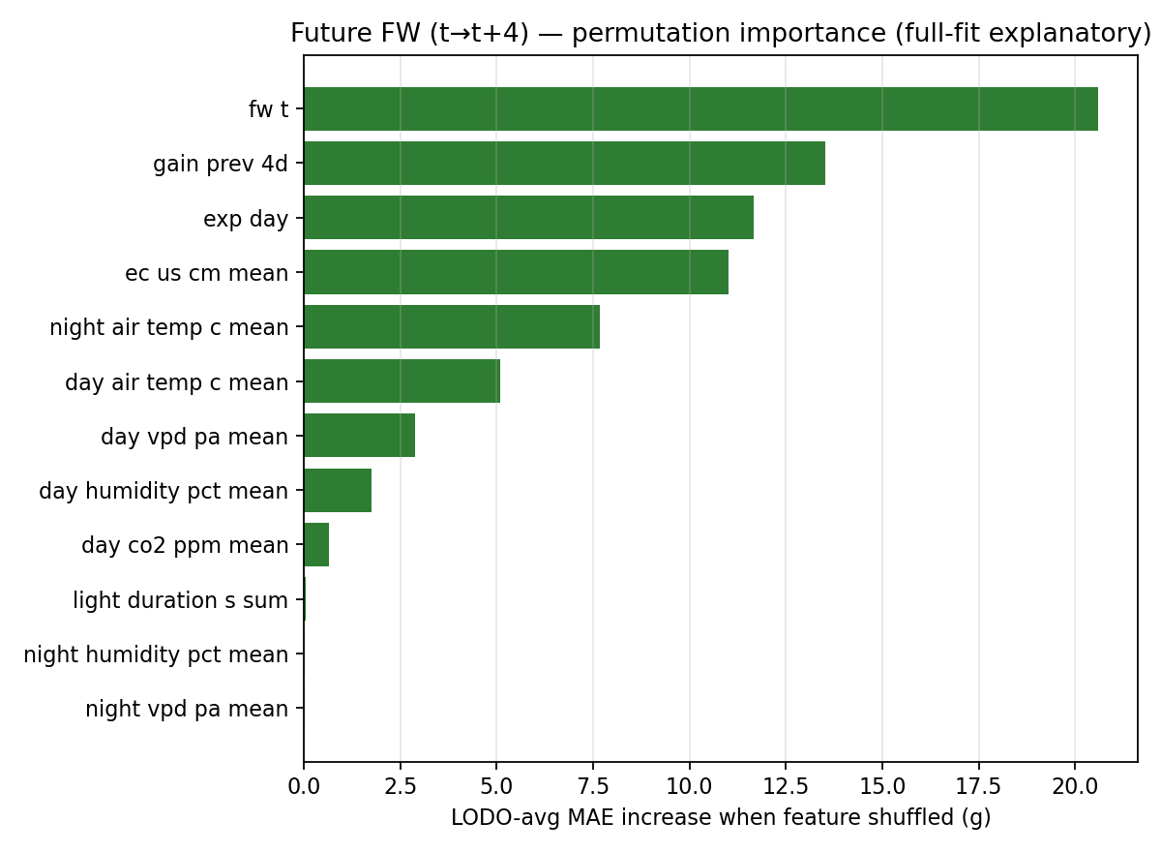
Figure: future-FW permutation importance (explanatory full fit).

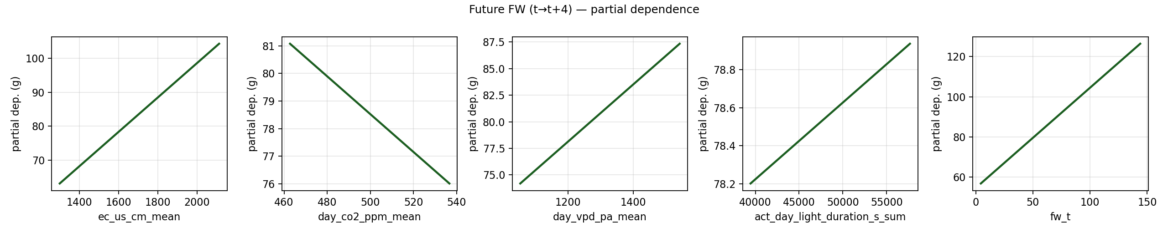
Figure: future-FW partial dependence (EC, CO2, VPD, light, fw_t).

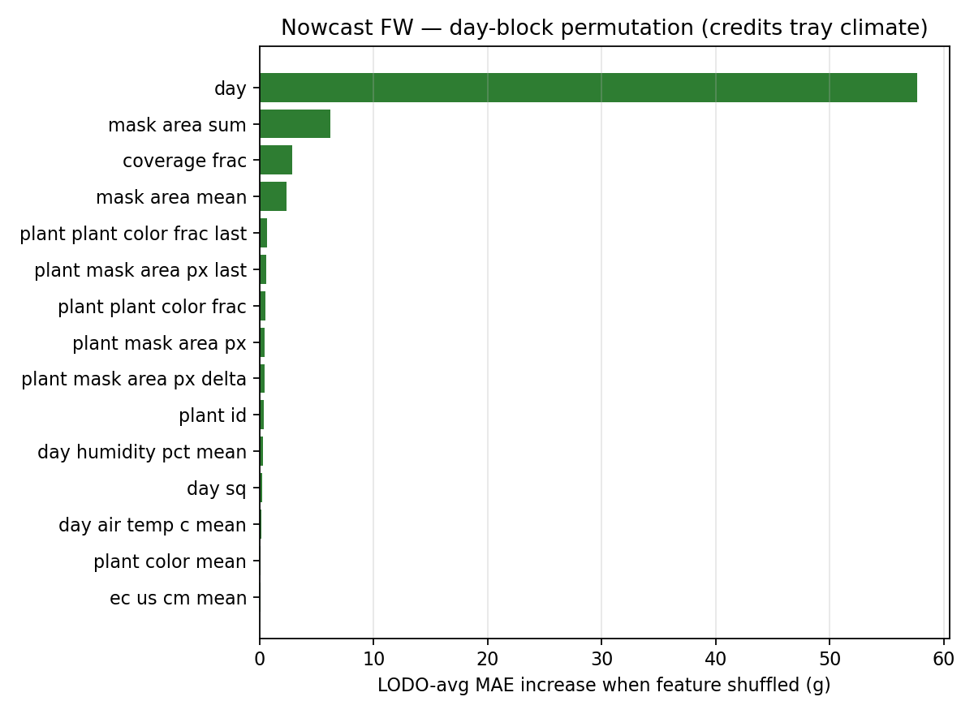
Figure: nowcast day-block importance (DAT dominates; then canopy area).

13.3 Interpretation (paper claims)
- Unknown future weights: phenotype bridge is best among tested routes (19.33 ± 1.18 g LODO MAE, 5 seeds).
- Actionable drivers for future FW (after current weight / prior gain / DAT): EC, night/day air temperature, VPD, humidity — candidate set-points for controlled experiments, not automatic closed-loop claims.
- Nowcast attribution: DAT/day dominates (growth stage); canopy mask area/coverage next — consistent with Lin-style canopy traits.
- Do not claim deficiency diagnosis from these rankings; they explain model sensitivity, not causal plant pathology.
- Outputs: ml/future_fw_paper/, ml/fw_attribution/, ml/forecast_next_checkpoint/, ml/future_fw_paper_pipeline.log.
10-03-2026

14. Autoregressive Future-FW and Grower Recommendation Layer
This section upgrades the future-weight route to match the requested autoregressive framing (learn change; optionally step day-to-day) and adds a grower-facing recommendation CLI with SHAP-grounded plain-English summaries. Take (professor note / FGTD-style forecasting): change models and multi-step roll. Skip: closed-loop RL and causal deficiency diagnosis. Improve vs Section 13 direct level model: AR-Δ (fw_t + predicted Δ) and daily roll t→t+1→…→t+4, plus Trial 2 transfer testing.

14.1 Why autoregressive (and the label constraint)
Fresh weight is measured only every 4 days. Therefore we report two AR routes: (i) label-honest AR-Δ over the 4-day weigh-in step; (ii) daily Δ on log1p-interpolated mid-interval weights, then roll t→t+1→…→t+4 (secondary / optimistic because mid-days are synthetic). Primary predictive metric remains LODO MAE (g) on true weigh-in endpoints.

14.2 Trial 1 plant LODO (primary within-trial result)
Trial 1 plant future-FW LODO (n=68 pairs, seeds 42–46):
route | mae_g_mean_pm_sd | r2_mean | note
ar_delta_4d | 9.07 ± 0.00 | 0.961 | true weigh-in labels
ar_daily_roll4 | 12.49 ± 0.00 | 0.959 | secondary (interp labels)
direct_level | 17.26 ± 0.00 | 0.850 | true weigh-in labels
persist | 30.59 ± 0.00 | 0.676 | true weigh-in labels

Headline: AR-Δ (ar_delta_4d) reaches 9.07 g LODO MAE vs 17.26 g for the older direct level model and 30.59 g Persist. Daily roll is second (12.49 g) and is kept as a secondary timeline tool because mid-interval FW is interpolated.

14.3 Trial 2 (tray median) and T1→T2 transfer
Trial 2 does not have per-plant fresh-weight labels in the plant checkpoint tables (only tray-median FW on harvest days). Checkpoint sensor window features for Trial 2 are largely empty, so tray climate for pairs is filled from daily drivers / daily sensor files. Within-Trial-2 LODO uses only ~7 pairs and is secondary; the primary Trial-2 generalization check is train Trial 1 plant → test Trial 2 tray.
Trial 2 tray LODO (n=7 pairs; small-n caveat):
route | mae_g_mean_pm_sd | r2_mean
ar_daily_roll4 | 9.79 ± 0.00 | 0.956
ar_delta_4d | 16.25 ± 0.00 | 0.871
direct_level | 24.66 ± 0.00 | 0.628
persist | 25.01 ± 0.00 | 0.673

Primary Trial 2 check — train Trial 1 plant → test Trial 2 tray:
route | mae_g_mean_pm_sd | r2_mean
ar_delta_4d | 16.41 ± 0.00 | 0.897
persist | 25.01 ± 0.00 | 0.673
direct_level | 33.67 ± 0.00 | 0.603

Transfer headline: AR-Δ 16.41 g beats Persist 25.01 g and direct level 33.67 g on Trial 2 tray endpoints. This supports AR-Δ as the more transferable parameterization, while acknowledging tray-only labels and climate fill.
Trial 1 tray LODO (fair unit match to Trial 2; n=7):
route | mae_g_mean_pm_sd
ar_delta_4d | 7.96 ± 0.00
ar_daily_roll4 | 11.52 ± 0.00
direct_level | 20.91 ± 0.00
persist | 30.51 ± 0.00

14.4 Grower recommendation CLI (decision support)
CLI: ml/recommend_growth.py. Commands: status, what_if, reach_target, when, report. Primary +4d engine is now AR-Δ; timelines use daily AR roll when artifacts exist. Set-point suggestions stay inside observed Trial 1 p05–p95 ranges. Local SHAP (LinearExplainer) explains which factors help/slow the expected change; template NLP turns those numbers into a short plant-focused Summary (clearer wording, not higher numerical accuracy).
- status — expected weight in ~4 days, likely range, helping/slowing factors, summary
- what_if — counterfactual EC / temperature / CO₂ / … changes
- reach_target — suggested tweaks for next weigh-in + days-to-goal (current vs suggested)
- when — days-to-goal under current settings only
- report — tray table for all plants on a day
Example (Trial 1 plant 3, day 12): AR-Δ expected ~49.3 g vs measured 49.8 g (much tighter than the old direct ~47 g ±17 g framing). Example (plant 5, day 16 → 100 g): day-by-day path and ~7-day timeline under current settings, with optimistic flag if a 4-day jump exceeds past growth.
Latest CLI text snapshot saved under ml/recommendations/last_*.txt (human-readable; JSON also stored).

14.5 Paper claims and limitations
- Primary within-Trial-1 future-FW route for the recommender: AR-Δ LODO MAE 9.07 g (vs Persist 30.59 g).
- Professor autoregressive request: implemented as AR-Δ (label-honest) + daily roll t→t+1→…→t+4 (secondary).
- Trial 2: no per-plant FW labels; primary T2 result is T1→T2 tray transfer (AR-Δ 16.41 g vs Persist 25.01 g).
- SHAP/NLP are explanatory layers for grower answers; they do not replace LODO metrics.
- Recommendations are decision support inside observed ranges — not automatic greenhouse control or proven causal effects.
- Outputs: ml/future_fw_ar/ (trial1_plant, trial1_tray, trial2_tray, transfer_t1_to_t2), ml/recommend_growth.py, ml/recommendations/.

14.6 Trial 2 plant-mean vs tray-median (future unknown)
When today’s plant weight is known (or today’s tray median is known and split across cups by relative canopy size) but future per-plant weight is unknown, we forecast each plant with the Trial-1 AR-Δ model, then take the mean of plant predictions and compare it to the observed Trial-2 tray-median FW at t+4. This is a proxy accuracy check because Trial 2 has no per-plant FW labels.
Trial 2 proxy accuracy (mean plant pred vs tray median @ t+4):
route | mae_g_mean_pm_sd
canopy-scaled today → AR-Δ → mean plants | 16.93 ± 0.00
image nowcast today → AR-Δ → mean plants | 19.78 ± 0.00
persist tray median | 25.01 ± 0.00

Headline: canopy-scaled AR plant-mean MAE 16.93 ± 0.00 vs persist 25.01 ± 0.00 (aligned with T1→T2 tray AR-Δ transfer). CLI for single-plant deploy (today known): ml/recommend_growth.py predict --plant-id … --day … --horizon 4 [--fw-today …]. Outputs: ml/future_fw_ar/trial2_plant_mean_vs_tray/.

14.7 Recommendation-system accuracy (offline)
The recommender’s numerical accuracy is evaluated in layers. Forecast skill uses real future weigh-ins. Timeline calibration compares predicted vs actual days to a later measured weight. Set-point suggestions are checked for model-internal consistency (do tweaks move the model toward the goal?). Causal proof that changing EC/temperature in the greenhouse would realize those gains still requires a controlled experiment.
Offline recommender accuracy summary:
check | result
Forecast LODO (status/predict vs true FW@t+4) | 9.07 ± 0.00 MAE; R²=0.961; 84% within ±17 g
Days-to-target calibration (vs actual 4 d interval) | MAE 1.60 d (median |err| 0.80 d)
reach_target consistency (model-internal) | 100% improved; mean goal-error drop 14.6 g
Trial 2 plant-mean vs tray (proxy) | 16.93 ± 0.00 vs persist 25.01 ± 0.00

Outputs: ml/recommendations/accuracy/. We have not run controlled experiments that apply recommended EC/temp and re-weigh plants. Causal accuracy of recommendations needs a real A/B or before/after trial.

14.7.1 Accuracy in percentage (how to read it)
Weight prediction is regression, so there is no single official “accuracy %” like classification. We therefore report: (i) approximate accuracy vs mean weight = 100×(1 − MAE/mean true FW) ≈ 88.5%; (ii) percent of predictions within an error band — 83.8% within ±17 g, 67.6% within ±10 g, 75% within 20% relative error; (iii) MAPE ≈ 14.1%. Timeline: 69% of days-to-target estimates are within 1 day of truth, 84% within 2 days. Recommendation consistency: 100% of sampled reach_target cases moved the model closer to the goal (internal consistency only — not a greenhouse A/B test).

14.7.2 Accuracy table (plain-language guide)
This table is the one to use when discussing “how accurate is the system?” Each row is a different way of scoring. Read the “What it means in plain English” column first.
Recommendation / forecast accuracy (Trial 1 primary; Trial 2 proxy last row):
Metric | Number | What it means in plain English
Average error (MAE) | 9.07 g | On a typical held-out weigh-in, the predicted weight is off by about 9 grams. Example: true 50 g → prediction often around 41–59 g.
Approx. accuracy % | 88.5% | Compared with the average plant weight in the test set (~79 g), a 9 g mistake is about 11.5% of that average, so roughly 88.5% “right” in a loose sense: 100% − 11.5%. This is NOT like exam score accuracy; it is just 100×(1 − MAE/mean weight).
% of cases within ±10 g | 67.6% | In about 68 out of 100 predictions, the error is 10 g or less. The other ~32% miss by more than 10 g.
% of cases within ±17 g | 83.8% | In about 84 out of 100 predictions, the error is 17 g or less. 17 g is the older “typical error” band we used in the CLI (±17 g).
% of cases within ±20 g | 86.8% | In about 87 out of 100 predictions, the error is 20 g or less.
% within 20% relative error | 75.0% | For a 50 g plant, 20% means ±10 g; for a 100 g plant, ±20 g. In 75% of cases the prediction stays inside that plant-specific band.
MAPE (avg % error) | 14.1% | Average of |error|/true weight across plants. About 14% means if the plant is 50 g, a typical miss is around 7 g; if 100 g, around 14 g. Smaller is better.
R² | 0.96 | How well predictions track the real up/down pattern of weights across plants and days. 1.00 = perfect tracking; 0 = no better than always guessing the average. 0.96 is strong.
Timeline within 1 day | 69.1% | When we ask “how many days until it reaches the weight we later measured?”, 69% of answers are off by at most 1 day.
Timeline within 2 days | 83.8% | 84% of days-to-target answers are off by at most 2 days.
Suggestion consistency | 100% | When we ask for setting changes toward a goal, the computer’s new prediction moves closer to that goal 100% of the time in our sample. This only tests the software logic — not that the real greenhouse will gain those grams.
Trial 2 plant-mean vs tray | 16.9 g MAE (vs 25 g persist) | On Trial 2 we have no per-plant future weights. We predict each plant, average them, and compare to the tray median. Average miss ~17 g, better than “assume no growth” (~25 g).

How to explain this in one minute to a non-ML person:
- The system guesses next weigh-in weight. On average it misses by about 9 g.
- That is roughly 88–89% “accurate” if you compare the miss to a typical plant size (~79 g).
- About 84% of guesses are within 17 g of the true weight; about 68% are within 10 g.
- “When will it reach X?” is usually right within 1–2 days.
- Suggested EC/temp changes make the software’s own forecast move toward the goal — we still need a real greenhouse test to prove the plants respond the same way.

