DEPARTMENT MANAGER

Analysis and Design Document

Student:Galan Maria Narcisa

**Group:30234**

Revision History

|  |  |  |  |
| --- | --- | --- | --- |
| **Date** | **Version** | **Description** | **Author** |
| 23/03/19 | 01 | <details> | Galan Maria Narcisa |
|  |  |  |  |
|  |  |  |  |
|  |  |  |  |

Table of Contents

I. Project Specification 4

II. Elaboration – Iteration 1.1 4

1. Domain Model 4

2. Architectural Design 4

2.1 Conceptual Architecture 4

2.2 Package Design 4

2.3 Component and Deployment Diagrams 4

III. Elaboration – Iteration 1.2 4

1. Design Model 4

1.1 Dynamic Behavior 4

1.2 Class Design 4

2. Data Model 4

3. Unit Testing 4

IV. Elaboration – Iteration 2 4

1. Architectural Design Refinement 4

2. Design Model Refinement 4

V. Construction and Transition 5

1. System Testing 5

2. Future improvements 5

VI. Bibliography 5

# Project Specification

The application is desinged towards emplyees that are using a large number of applications and need a reliable tool to manage their interaction with them.So this project is design to manage the users and the applications that they use.

# Elaboration – Iteration 1.1

# Domain Model

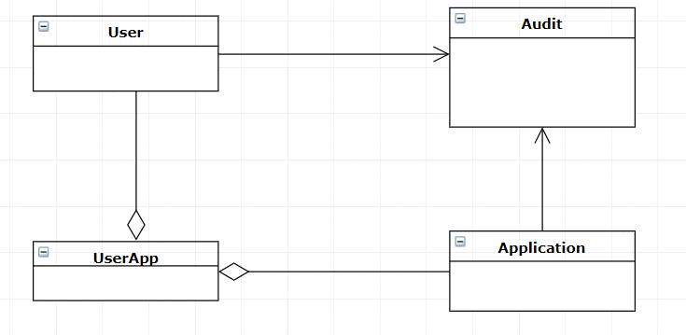

# Architectural Design

## Conceptual Architecture

## The application was designed for the user to can perform a variety of actions like:add update or delete users,add apps that are used by the user.Same actions can be performed in the case of apps(add,update,delete,add users to app).

## Package Design

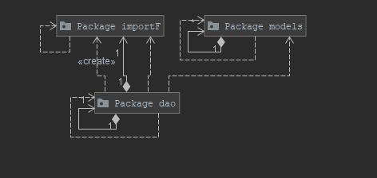

## Component and Deployment Diagrams

# 

# Elaboration – Iteration 1.2

# Design Model

## Dynamic Behavior

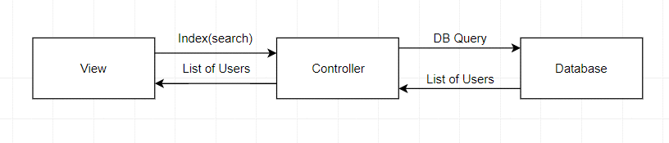

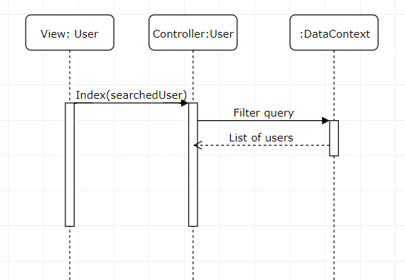

## Class Design

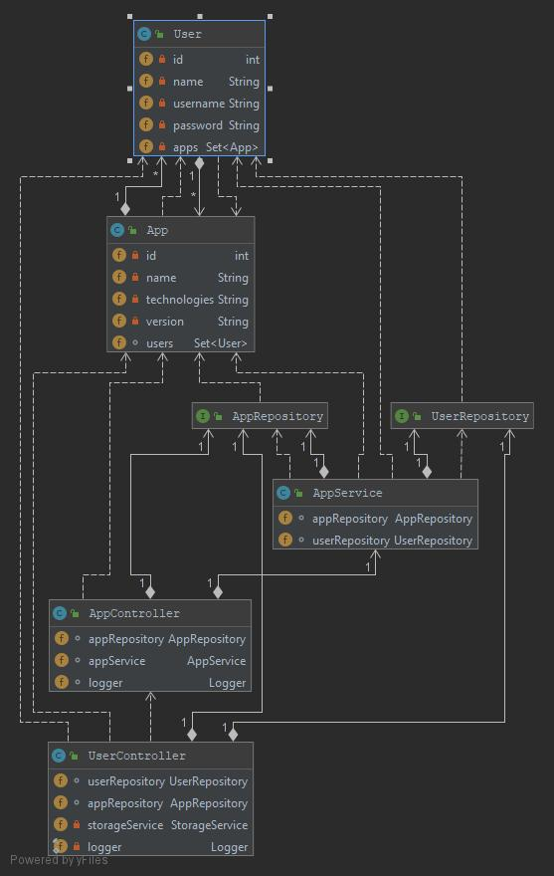

# Unit Testing

Unit testing is a form of coding that breaks our software down into specific functions then tests each individually for any logic flaws. The goal is to find bugs before your customers find them.In this project we will test the implemented methods from the service.

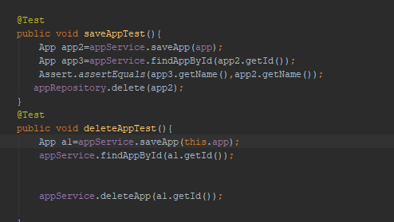

# Elaboration – Iteration 2

# Construction and Transition

# System Testing

System testing means testing the system as a whole. All the modules/components are integrated in order to verify if the system works as expected or not.

System testing is done after integration testing. This plays an important role in delivering a high-quality product.

# Future improvements

1. Improving the UI.
2. Adding data encryption for security.
3. Adding different user types and accounts.

# Bibliography

<https://dev.to/chrisvasqm/introduction-to-unit-testing-with-java-2544>

<https://www.smartdraw.com/uml-diagram/>

<https://docs.microsoft.com/en-us/aspnet/core/mvc/controllers/routing?view=aspnetcore-2.2>