**BANK LOAN REPORT QUERY DOCUMENT**

**Converting text date column → DATE (exact steps)**

**If Workbench imported last_payment_date or other date columns as text, use the pattern from your Query Doc to safely convert:**

SELECT *

FROM financial_loan;

ALTER TABLE financial_loan

ADD COLUMN clast_payment_date DATE NULL;

UPDATE financial_loan

SET clast_payment_date = STR_TO_DATE(`last_payment_date`, '%Y-%m-%d')

WHERE `last_payment_date` IS NOT NULL;

ALTER TABLE financial_loan DROP COLUMN `last_payment_date`;

ALTER TABLE financial_loan CHANGE clast_payment_date `last_payment_date` DATE;

1. **BANK LOAN REPORT | SUMMARY**

**KPI’s:**

**Total Loan Applications:**

**Total number of loan records in the dataset.**

SELECT COUNT(ID) AS Total_Loan_Applications FROM financial_loan;



**MTD Loan Applications:**

**Month-to-date / previous-month-to-date counts (example uses specific month/year — make dynamic if needed).**

SELECT COUNT(id) AS Total_Loan_Applications FROM financial_loan

WHERE MONTH(issue_date) = 12 AND YEAR(issue_date) = 2021;



**PMTD Loan Applications**

SELECT COUNT(id) AS Total_Loan_Applications FROM financial_loan

WHERE MONTH(issue_date) = 11 AND YEAR(issue_date) = 2021;



**Total Funded Amount:**

**Total principal funded by the lender.**

SELECT SUM(loan_amount) AS Total_Funded_Amount FROM financial_loan; 

**MTD Total Funded Amount**

SELECT SUM(loan_amount) AS Total_Funded_Amount FROM financial_loan

WHERE MONTH(issue_date) = 12 AND YEAR(issue_date) = 2021;



**PMTD Total Funded Amount**

SELECT SUM(loan_amount) AS Total_Funded_Amount FROM financial_loan

WHERE MONTH(issue_date) = 11 AND YEAR(issue_date) = 2021;



**Total Amount Received:**

**All payments received (sum of total_payment).**

SELECT SUM(total_payment) AS Total_Amount_Received FROM financial_loan;

**MTD Total Amount Received**

SELECT SUM(total_payment) AS Total_Amount_Received FROM financial_loan

WHERE MONTH(issue_date) = 12 AND YEAR(issue_date) = 2021;



**PMTD Total Amount Received**

SELECT SUM(total_payment) AS Total_Amount_Received FROM financial_loan

WHERE MONTH(issue_date) = 11 AND YEAR(issue_date) = 2021;



**Average Interest Rate:**

**Interest rate and debt-to-income averaged across loans (multiplied by 100 to express in percentage)**

SELECT AVG(int_rate)*100 AS Avg_Interest_Rate FROM financial_loan;



**MTD Average Interest**

SELECT AVG(int_rate)*100 AS MTD_Avg_Interest_Rate FROM financial_loan

WHERE MONTH(issue_date) = 12 AND YEAR(issue_date) = 2021;



**PMTD Average Interest**

SELECT AVG(int_rate)*100 AS PMTD_Avg_Interest_Rate FROM financial_loan

WHERE MONTH(issue_date) = 11 AND YEAR(issue_date) = 2021;



**Avg DTI**

SELECT AVG(dti)*100 AS Avg_DTI FROM financial_loan;



**MTD Avg DTI**

SELECT AVG(dti)*100 AS MTD_Avg_DTI FROM financial_loan

WHERE MONTH(issue_date) = 12 AND YEAR(issue_date) = 2021;



**PMTD Avg DTI**

SELECT AVG(dti)*100 AS PMTD_Avg_DTI FROM financial_loan

WHERE MONTH(issue_date) = 11 AND YEAR(issue_date) = 2021;



**GOOD LOAN ISSUED**

**Good Loan Percentage**

* **Good loans = loan_status IN (Fully Paid, Current)**
* **Bad loans = loan_status = Charged Off**

SELECT

(COUNT(CASE WHEN loan_status = 'Fully Paid' OR loan_status = 'Current' THEN id END)*100)

/

COUNT(id) AS Good_loan_percentage

FROM financial_loan;



**Good Loan Applications**

SELECT COUNT(id) AS Good_Loan_Applications FROM financial_loan

WHERE loan_status = 'Fully Paid' OR loan_status = 'Current';



**Good Loan Funded Amount**

SELECT SUM(loan_amount) AS Good_Loan_Funded_Amount FROM financial_loan

WHERE loan_status = 'Fully Paid' OR loan_status = 'Current'; 

**Good Loan Amount Received**

SELECT SUM(total_payment) AS Good_Loan_Recieced_Amount FROM financial_loan

WHERE loan_status = 'Fully Paid' OR loan_status = 'Current'; 

**BAD LOAN ISSUED**

**Bad Loan Percentage**

SELECT

(COUNT(CASE WHEN loan_status = 'Charged Off' THEN id END)*100)

/

COUNT(id) AS Bad_Loan_Percentage

FROM financial_loan;



**Bad Loan Applications**

SELECT COUNT(id) AS Bad_Loan_Applications FROM financial_loan

WHERE loan_status = 'Charged Off';



**Bad Loan Funded Amount**

SELECT SUM(loan_amount) AS Bad_Loan_Funded_amount FROM financial_loan

WHERE loan_status = 'Charged Off';



**Bad Loan Amount Received**

SELECT SUM(total_payment) AS Bad_Loan_Funded_Recieved FROM financial_loan

WHERE loan_status = 'Charged Off';



**LOAN STATUS**

SELECT

loan_status,

COUNT(id) AS Total_Loan_Applications,

SUM(total_payment) AS Total_Amount_Received,

SUM(loan_amount) AS Total_Funded_Amount,

AVG(int_rate * 100) AS Interest_Rate,

AVG(dti * 100) AS DTI

FROM financial_loan

GROUP BY loan_status;

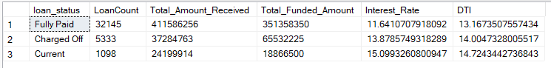

SELECT

loan_status,

SUM(total_payment) AS MTD_Total_Amount_Received,

SUM(loan_amount) AS MTD_Total_Funded_Amount

FROM financial_loan

WHERE MONTH(issue_date) = 12

GROUP BY loan_status;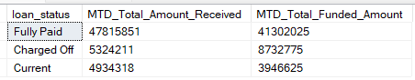

1. **BANK LOAN REPORT | OVERVIEW**

**MONTH**

SELECT

DATE(MONTH,issue_date),

COUNT(id) AS Total_Loan_Applications,

SUM(loan_amount) AS Total_Funded_Amount,

SUM(total_payment) AS Total_Received_Amount

FROM financial_loan

GROUP BY DATE(MONTH,issue_date)

ORDER BY DATE(MONTH,issue_date);

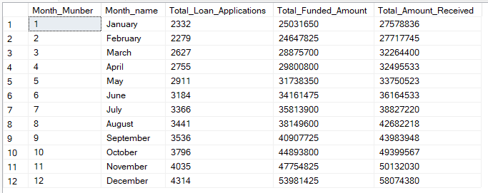

**STATE**

SELECT

address_state,

COUNT(id) AS Total_Loan_Applications,

SUM(loan_amount) AS Total_Funded_Amount,

SUM(total_payment) AS Total_Received_Amount

FROM financial_loan

GROUP BY address_state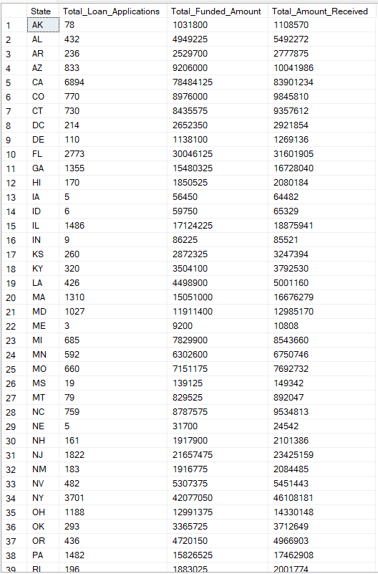

**TERM**

SELECT

Term AS Term,

COUNT(id) AS Total_Loan_Applications,

SUM(loan_amount) AS Total_Funded_Amount,

SUM(total_payment) AS Total_Received_Amount

FROM financial_loan

GROUP BY term

ORDER BY term;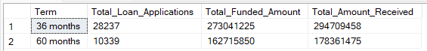

**EMPLOYEE LENGTH**

SELECT

emp_length AS Employee_Length,

COUNT(id) AS Total_Loan_Applications,

SUM(loan_amount) AS Total_Funded_Amount,

SUM(total_payment) AS Total_Received_Amount

FROM financial_loan

GROUP BY emp_length

ORDER BY emp_length;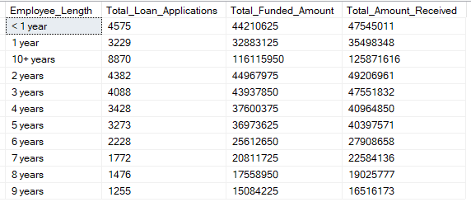

**PURPOSE**

SELECT

purpose AS PURPOSE,

COUNT(id) AS Total_Loan_Applications,

SUM(loan_amount) AS Total_Funded_Amount,

SUM(total_payment) AS Total_Received_Amount

FROM financial_loan

GROUP BY purpose

ORDER BY purpose;

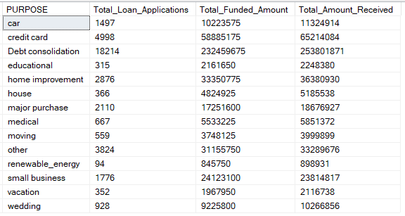

**HOME OWNERSHIP**

SELECT

home_ownership AS Home_Ownership,

COUNT(id) AS Total_Loan_Applications,

SUM(loan_amount) AS Total_Funded_Amount,

SUM(total_payment) AS Total_Received_Amount

FROM financial_loan

GROUP BY home_ownership

ORDER BY home_ownership;