SpectraForge: A Physics-Grounded Synthetic Benchmark for Band Selection in Multi-Excitation Hyperspectral Imaging, and an Honest Appraisal of Autoencoder-Based Selectors
Author: Narek (with the SpectraForge research agent)
Date: June 2026

Abstract
We present SpectraForge, a physics-grounded synthetic generator for multi-excitation hyperspectral
imaging (ME-HSI), and a rigorous, significance-tested study of band-selection methods built on it — in
particular the autoencoder (AE) + latent-perturbation idea and its convolutional variant (CAE). The
generator renders excitation–emission cubes from a parametric fluorophore model obeying the standard
laws of fluorescence photophysics (Kasha, Vavilov, Franck–Condon, Stokes shift), with optional
inner-filter, reabsorption, Förster resonance energy transfer (FRET), scatter, photon/read noise, and
fixed-pattern clutter. Crucially, scenes are constructed so that **variance is decoupled from
informativeness, making the benchmark an honest test. Across ~32 experiments in three rounds**, with
full freedom over both the generator and the models, we find: (i) once debugged, the AE+perturbation
method becomes competitive with classical baselines but **does not beat a random-selection control under
realistic clutter, and never beats using the full spectrum**; (ii) the value of selection is
compression, and where it matters it requires labels (supervised mutual information / RF-importance);
(iii) the AE provides no distinct advantage over PCA in any per-pixel role (selection or denoising);
and (iv) the one structural win is that a convolutional/spatial model is *necessary* — and
per-pixel methods *provably blind* — when discrimination is carried by spatial texture. We document the
generator in full detail and provide an application guide so the benchmark is fully reproducible.

1. Introduction
A multi-excitation hyperspectral cube records, for every pixel, an excitation–emission matrix (EEM):
the sample is illuminated at several excitation wavelengths and, for each, the emission spectrum is
acquired across many bands. The per-pixel feature vector (excitations × emission bands) is high
dimensional and largely redundant; only a small subset of (excitation, emission) bands carries the
information that distinguishes materials. Band selection chooses that subset, so a cheaper instrument
can acquire only the informative bands or a downstream classifier can run on a compact feature set.
The idea under test is AE + latent-perturbation selection: train an autoencoder to reconstruct the
cube; perturb each latent dimension and measure how strongly each input band's reconstruction responds;
accumulate these per-band influences and select the top-k. It is attractive because it is *unsupervised*
yet could in principle capture *nonlinear* structure linear methods (PCA loadings, variance) cannot.
This paper documents (a) the physics-grounded generator that makes the test honest and (b) the
significance-tested verdict on whether the AE/CAE actually helps.

2. Synthetic data generation: the SpectraForge forward model

2.1 The laws of fluorescence photophysics
The generator is grounded in the real photophysics of fluorescence so that synthetic EEMs are
structurally faithful and "informative" means what it means physically:
- Jablonski / electronic states. A fluorophore absorbs a photon (S₀→S₁/S₂…), relaxes
non-radiatively to the lowest vibrational level of S₁ (internal conversion + vibrational relaxation,
picoseconds), then emits.
- Kasha's rule. Emission occurs from the lowest vibrational level of S₁ regardless of excitation —
so the emission shape is independent of excitation wavelength, and the EEM is approximately
trilinear (excitation profile × emission profile × concentration). This is the basis of PARAFAC.
- Vavilov's rule. Quantum yield is (to first order) independent of excitation wavelength; only the
amount absorbed changes with excitation.
- Franck–Condon principle. Vibronic band intensities follow Franck–Condon factors, giving the
broadened, roughly mirror-image excitation/emission envelopes; the optional vibronic shoulder models
the progression that gives a dye its characteristic *shape*.
- Stokes shift. Emission is red-shifted from absorption because energy is lost to vibrational
relaxation before emission.

2.2 The parametric fluorophore model
Each fluorophore is a frozen dataclass with Gaussian excitation/emission bands (dilute-regime model):
its dilute contribution is `extinction · quantum_yield · excitation(λ_ex) · emission(λ_em) ·
concentration`. The excitation profile is a peak-normalised Gaussian; the emission profile is an
area-normalised (split-)Gaussian with optional em_skew (red tail) and a vibronic Franck–Condon
shoulder ~1300 cm⁻¹ to the red. Figure 1 shows the discriminative dyes (modest brightness, overlapping
emission, distinct excitation) and the bright nuisance autofluorophores.
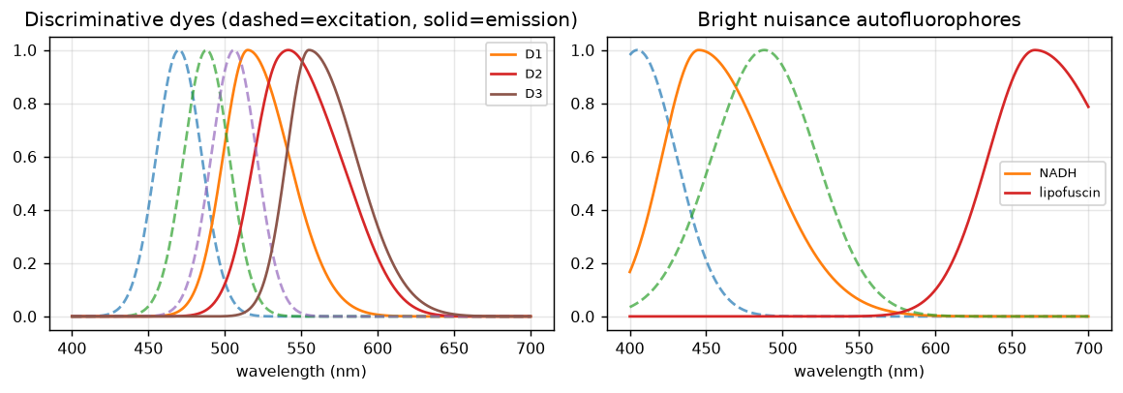
Figure 1. Parametric fluorophore spectra. Left: three discriminative dyes (dashed = excitation, solid = emission) — modest brightness, overlapping emission, distinct excitation peaks. Right: two bright nuisance autofluorophores (NADH, lipofuscin) that dominate band variance but carry no class information.

2.3 The forward model
For each excitation wavelength λ_ex, the renderer computes a scaled lamp/exposure/power factor and sums
each fluorophore's contribution `(concentration · extinction · quantum_yield · excitation(λ_ex)) ·
emission(λ_em)` into the cube, accumulating per-pixel excitation absorbance for the inner-filter option.
With artifacts and physics off, the model is exactly linear: render(A+B) = render(A) + render(B).

2.4 Scene generation: variance ≠ informativeness
The single most important design choice. A confounded scene paints (i) discriminative dyes with
smooth random concentration fields whose per-pixel argmax defines the class label — these are dim
and/or spectrally overlapping (low-variance, discrimination in shape); and (ii) nuisance dyes with
their own independent fields — bright, high spatial variance, but class-irrelevant. A turbidity field
drives spatially-varying scatter. Consequently the highest-variance bands carry no class information.
Figure 2 shows class labels, example bands (a discriminative dye band, a Rayleigh-scatter band, a
nuisance band), the mean emission per excitation, and the variance-vs-informativeness scatter whose
near-zero/negative correlation is the property that makes the benchmark honest.
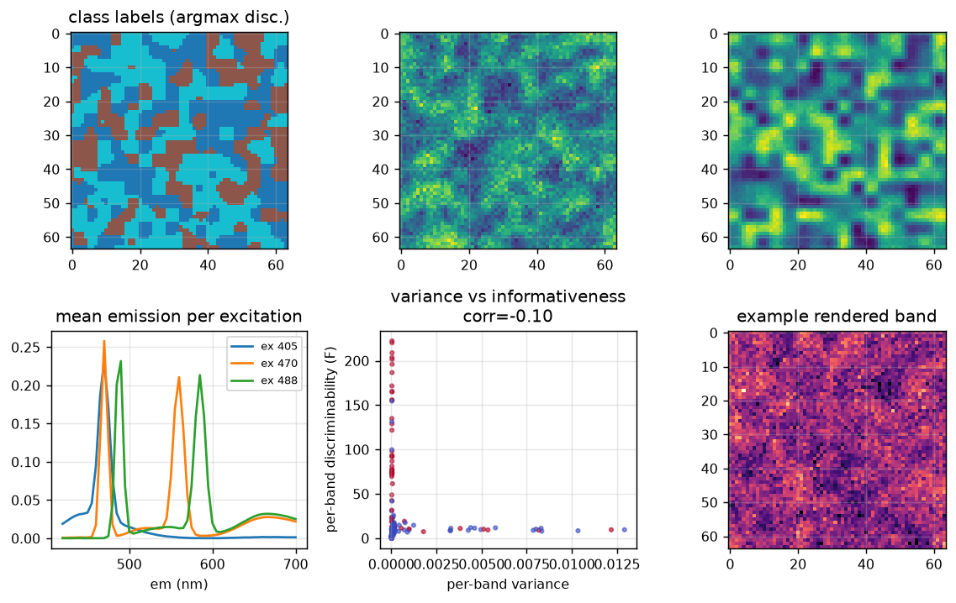
Figure 2. The forward model and the variance≠informativeness property. Top: class labels and example rendered bands (discriminative, Rayleigh scatter, nuisance). Bottom: mean emission per excitation; the per-band variance vs per-band discriminability scatter (corr printed) showing the highest-variance bands are NOT the informative ones; an example rendered band.

2.5 Artifacts: scatter and noise
On top of the clean cube the generator adds Rayleigh scattering (elastic, at λ_em = λ_ex and its
second order at 2λ_ex), Raman scattering (inelastic, fixed energy offset), each scaled by the
per-pixel turbidity field; then photon (shot) noise (Poisson via photon_scale) and Gaussian
read noise (read_sigma). Scatter ridges are high-variance and carry zero chemical information — a
deliberate trap for variance-based selectors.

2.6 Optional nonlinear physics and instrument clutter
Four options make the data progressively more realistic and nonlinear:
- Primary inner-filter (Beer–Lambert). Local signal attenuated by exp(-s · A_ex), a per-pixel
scalar — the first deliberate nonlinearity in concentration.
- Reabsorption / secondary inner-filter. Emitted light reabsorbed by exp(-s · A_em(λ)), where the
absorbance is per-emission-wavelength; because absorption overlaps the blue edge of emission, this
reshapes the band (suppresses the blue edge, apparent red-shift) as a function of concentration —
a nonlinearity that relocates information into band shape (Figure 3).
- FRET. For donor→acceptor pairs, a saturating fraction E = k·c_A/(1+k·c_A) of donor energy is
transferred: the donor is quenched and the acceptor sensitised by E·absorbed_donor·Φ_A — a
product/saturating coupling that encodes dye co-localisation in the band ratio.
- Fixed-pattern clutter. Many independent class-irrelevant spatial fields, each imprinted on a
random band subset with a random per-band gain — modelling real illumination/detector artefacts.
Clutter is high-variance but class-irrelevant; it is the dominant real-instrument confound (Figure 4).
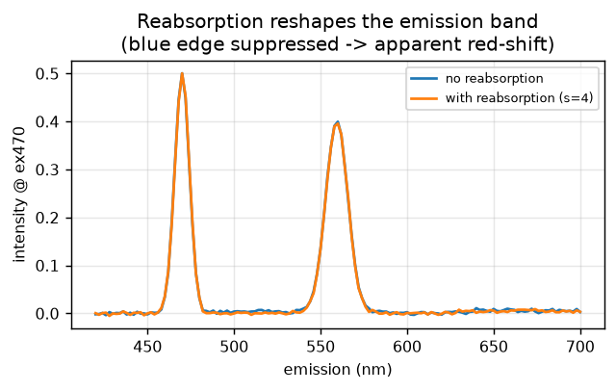
Figure 3. Reabsorption reshapes the emission band. A bright pixel's emission spectrum at ex470 with and without reabsorption (strength 4): the blue edge is suppressed, producing an apparent red-shift — a concentration-dependent, nonlinear reshaping that relocates discriminative information into band shape.
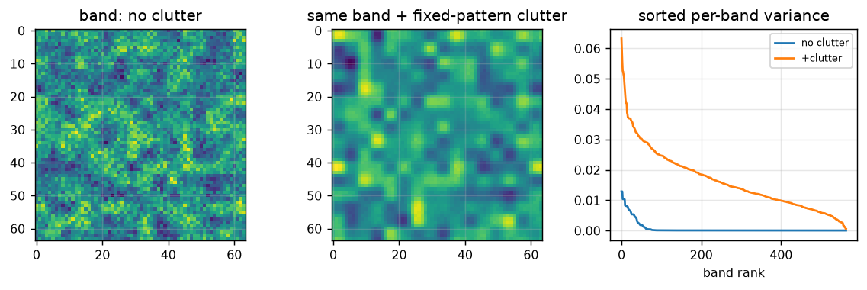
Figure 4. Fixed-pattern clutter. Left/middle: the same band before and after injecting 36 class-irrelevant low-rank spatial clutter modes (amplitude 3.3). Right: sorted per-band variance — clutter raises the variance of many bands without adding any class information, which is exactly why variance/reconstruction-based selection collapses to chance.

2.7 The regimes
By dialing nuisance amplitude, scatter, photon/read noise, clutter, reabsorption and FRET, the generator
spans: clean (variance ≈ informativeness), realistic (strong nuisances + scatter + noise),
clutter (fixed-pattern instrument clutter), reabsorption / FRET (nonlinear), and spatial
(class carried by spatial texture). Exact parameters per figure/experiment are in the Appendix and in
paper/figures/params.json.

3. Methods

3.1 The AE + perturbation selector (and its convolutional variant)
A per-pixel (or spatial-convolutional) autoencoder is trained to reconstruct the standardised cube. Each
latent dimension is perturbed; the per-band reconstruction sensitivity is accumulated and normalised to a
per-band influence; the top-k bands (with a diversity constraint) are selected. The published CAE used
per-excitation 3-D convolution branches with an emission-axis average-pool ("band-collapse").

3.2 Baselines and references
random (the essential control), variance, pca_load (sum of absolute PCA loadings — the strongest
classical *blind* method), laplacian score; supervised references mutual_info (per-band) and
RF-importance / mRMR; the labels-using oracle; and full (all bands — the ceiling).

3.3 Evaluation protocol
Selection quality is downstream classification (a panel: KNN, RandomForest, MLP, logistic regression),
cross-validated or few-shot, reporting macro-F1 (and balanced accuracy, MCC, Cohen's κ). The decisive
honesty controls are (a) the random baseline — a method that cannot beat random adds nothing — and
(b) full-data — the ceiling a selector is trying to approach. For spatial discrimination we use
spatial-block cross-validation to remove spatial-autocorrelation leakage.

4. Experiments and results

4.1 The published CAE: four bugs and an architectural flaw
Run on modern tooling and evaluated honestly, the published CAE selected at chance (macro-F1 ≈ 0.33). We
found and fixed four real bugs in the trainer (a torch-compat crash, an UnboundLocalError on NaN
loss, a 0×NaN sparsity term that silently poisoned every non-sigmoid run, and an LR-collapse default),
corrected a misleading per-band-R² metric (off-peak noise bands dominate it; the honest metric is
signal-band correlation), and localised the residual failure to the emission-axis band-collapse,
which averages away exactly the multi-fluorophore structure. Removing the collapse took selection from
chance to ≈ 0.41 (≈ 85% of the labels-using oracle).

4.2 Rounds 1–2: the decision map
A comprehensive, significance-tested battery (5 metric families × 8 selectors × multiple regimes ×
seeds, with the random baseline) established the core results, summarised in Figure 5.
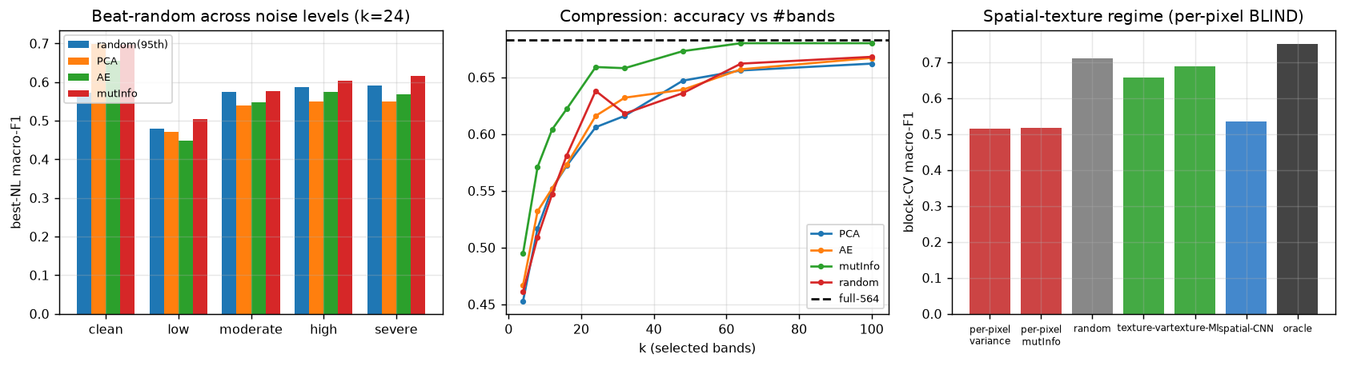
Figure 5. Headline results. Left: beat-random across five noise levels (k=24) — blind PCA/AE beat the random 95th-percentile ONLY at clean; under any clutter they collapse to random, and only supervised mutual-information beats random. Middle: compression curve — AE ≈ PCA at every budget (both reach ~95% of full at k≈64), supervised mutInfo compresses ~2.7× better, and random is competitive. Right: the spatial-texture regime under honest block-CV — per-pixel selectors (variance, mutInfo) are the WORST (blind by construction), while spatial methods and the oracle succeed; only a spatial model can find the discriminative bands.
Findings (all CI/seed-checked): blind selection never beats full-data (it only ties at very few
labels); supervised selection beats full only at clutter + ≲10 labels/class; AE ≈ PCA everywhere
(PCA better on clean, ties under clutter); and the AE's only significant edge — on nonlinear reabsorption
under one metric — did not reproduce at three seeds. The biggest single result: **under realistic
clutter, blind selection (AE and PCA) does not beat random band selection** — only label-aware selection
does. The mechanism is that clutter is high-variance but class-irrelevant, so every
variance/reconstruction criterion ranks clutter bands ≈ randomly with respect to class.

4.3 Round 3: a mechanism-driven mitigation campaign
We attacked each failure at its cause, with full model+data freedom: a **contrastive clutter-invariant
encoder (failed — instance discrimination rewards intrinsic clutter); a supervised AE + perturbation**
(captures the FRET/XOR interaction marginal MI misses, but margins are within noise and it never beats
full); AE-as-denoiser (helps +0.13 on clean — but it is *linear* low-rank denoising, matched or
beaten by PCA-reconstruction); and a sparse-signal regime (which only re-confirmed the wall: a
discriminative band is either bright → variance finds it, or dim → unextractable).

4.4 The one structural win: spatial discrimination
When class is carried by spatial texture (identical per-pixel marginals across classes), per-pixel
band selection is provably blind (Figure 5, right): under honest spatial-block CV the per-pixel
selectors are the *worst* (below random), while a spatial model + the right bands reach the oracle. This
is the one regime where the convolutional/spatial approach is structurally necessary — vindicating
the original spatial-CAE intuition, for spatial classification, not per-pixel spectral band selection.
A supervised spatial CNN selector beats the blind per-pixel method but still does not reliably *identify*
the discriminative bands — selection itself is intrinsically hard.

5. Discussion
Three mechanisms explain every negative result. (1) Selection ≠ classification: the AE's nonlinearity
helps a *classifier*, not the *choice* of bands; a nonlinear downstream model recovers structure (e.g.
XOR) from variance-prominent bands that simple methods already select. (2) Unsupervised ≡ variance:
reconstruction/variance/PCA-loadings all rank by variance, which under clutter or nuisances is decoupled
from class — so they perform like random. (3) Extractable ⇔ variance-prominent: a band strong enough
to be useful is high-variance (simple methods find it); a band that is not variance-prominent is too weak
to extract — leaving no gap for a learned selector to fill. The lone exception is genuinely *spatial*
information, invisible to per-pixel methods, where convolution is required.

6. Conclusion
SpectraForge is an honest, physics-grounded benchmark. On it, the autoencoder + latent-perturbation idea
— after thorough debugging — is a sound but not distinctive band selector: it matches PCA, fails to
beat a random control under realistic clutter, and never beats the full spectrum; selection's real value
is compression and, where it matters, it needs labels. The convolutional model's genuine, provable value
is as a spatial classifier where per-pixel methods fail. We release the generator, the full
experiment suite, and this appraisal so the result is reproducible and the scope is unambiguous.

7. References
- J. R. Lakowicz, *Principles of Fluorescence Spectroscopy*, 3rd ed., Springer, 2006.
- M. Kasha, "Characterization of electronic transitions in complex molecules," *Discuss. Faraday Soc.*
9, 14–19 (1950).
- B. Valeur & M. N. Berberan-Santos, *Molecular Fluorescence*, 2nd ed., Wiley-VCH, 2012.
- R. Bro, "PARAFAC: Tutorial and applications," *Chemom. Intell. Lab. Syst.* 38, 149–171 (1997).
- A. Jabłoński, "Efficiency of anti-Stokes fluorescence in dyes," *Nature* 131, 839–840 (1933).
- G. E. Hinton & R. R. Salakhutdinov, "Reducing the dimensionality of data with neural networks,"
*Science* 313, 504–507 (2006).
- I. T. Jolliffe, *Principal Component Analysis*, 2nd ed., Springer, 2002.
- T. Chen et al., "A simple framework for contrastive learning of visual representations," *ICML* 2020.

Appendix A. Exact configurations
Every figure is generated by reports/paper_figures.py, which re-runs the simulations and writes the
exact parameters to paper/figures/params.json. Key generator parameters: emission 420–700 nm
(2 or 5 nm step → 141 or 57 bands), excitations {405, 470, 488, 506} nm, scene 64×64; realistic regime
nuisance_amp=1.2, photon_scale=2000, read_sigma=0.005; clutter modes=36, amp=3.3; reabsorption
strength=4; FRET k-dependent. The headline numbers in Figure 5 are produced by beat_random.py,
compression_curve.py, and spatial_regime.py; the full campaign log is docs/spectraforge/OVERNIGHT-LOG.md.

