AI-Driven Lab Control — Technical Brief
How the system works, in plain language
labgate platform · PhotonicsAI Lab · companion to the detailed technical documentation

1. What this system is
A scientist should be able to say "print me a test grid at 25 % power and photograph it" and have that happen on a real femtosecond laser rig — without writing code, and without any chance that a misunderstood sentence damages the sample, the optics, or a person.
Those two goals pull in opposite directions. Language is loose; a laser is not. The whole design is the answer to that tension, and it comes down to a single rule:
The AI proposes. A separate, deterministic layer disposes. The AI writes down what it thinks should happen. A piece of ordinary, testable software — no AI in it — then decides whether that is allowed, shows a human what it would do, waits for a signature, and only then drives the instruments itself.

Everything else in this document is a consequence of that sentence.
The software that does the deciding is called labgate. It is the "API Gate" in the architecture the team has been discussing.

2. How the system is put together
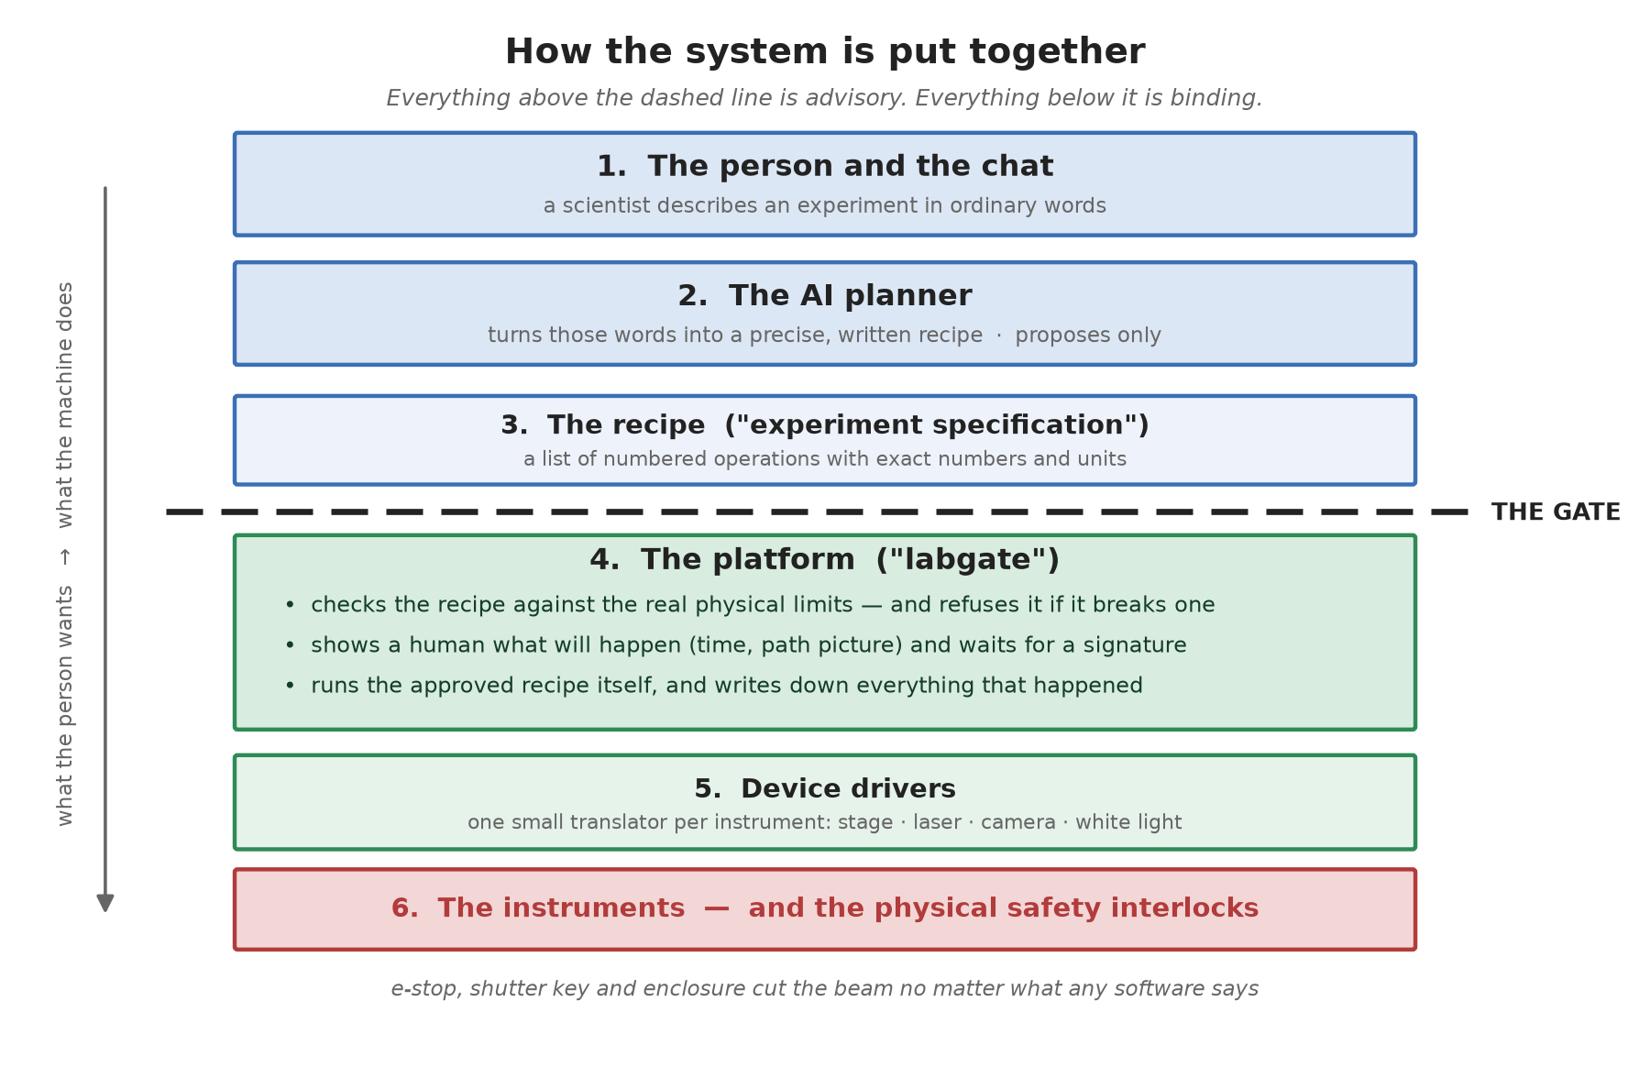
Figure 1 — How the system is put together — six layers and one boundary.
Read it top to bottom. A request starts as human intent and ends as motion.
The dashed line is the important part. Above it, everything is advice: a person's words, an AI's interpretation, a proposed recipe. Any of it can be wrong. Below it, everything is authority: fixed limits, recorded decisions, real motors.
The four things worth understanding about that line:
- Nothing crosses it except a written recipe. The AI never sends code, never sends a command, and never holds a connection to an instrument. It sends a document describing what it wants.
- The recipe is checked as if a stranger wrote it. The platform does not care that an AI produced it. It applies the same limits it would apply to a recipe typed by hand.
- A human authorises every physical run. And, deliberately, it cannot be the same person or agent that proposed it.
- The bottom layer is not software at all. The e-stop, the shutter key and the enclosure interlock cut the beam regardless of what any program believes. Software is the second line of defence; those are the first.

3. The journey of one request
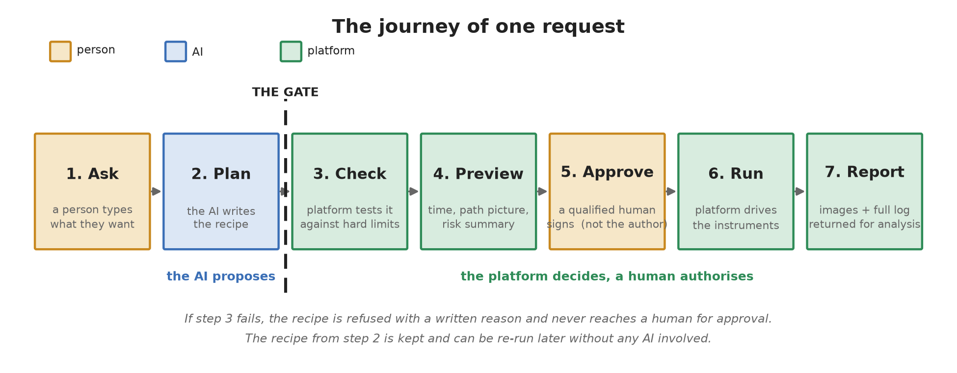
Figure 2 — The seven stages every experiment passes through.
1 — Ask. Someone types a sentence into the chat.
2 — Plan. The AI first asks the platform what this rig can actually do — which instruments exist, which operations they support, and what the hard limits are. It then writes a recipe using only that vocabulary. It cannot invent an operation, because it is composing from a list the platform published a moment earlier.
3 — Check. The platform tests the recipe against physical reality: is every power, speed and coordinate inside the permitted range; is the laser configured before it is asked to fire; is the white light off while the beam is on. A single hard failure refuses the whole recipe, and the refusal comes with a written reason.
4 — Preview. For a recipe that passes, the platform works out how long it will take, how far the stage will travel, how many times the beam will open, and draws a picture of the actual path. This is what a human is asked to look at.
5 — Approve. A qualified person reviews that and signs. The platform records who. If the signer is the same identity that proposed the recipe, it is refused.
6 — Run. The platform — not the AI — drives the instruments, one experiment at a time, writing down every step as it goes. It can be stopped mid-run.
7 — Report. Images and a complete log go back. The AI reads those and explains the outcome to the scientist, and the conversation continues.
A refused recipe never reaches step 5. A human is never asked to approve something the platform has already determined is unsafe — which means an approval click always means something.

4. What the system remembers
People often ask "what does the database look like?". The honest answer is that there is no database server. There is a folder on the lab computer holding four kinds of plain file.
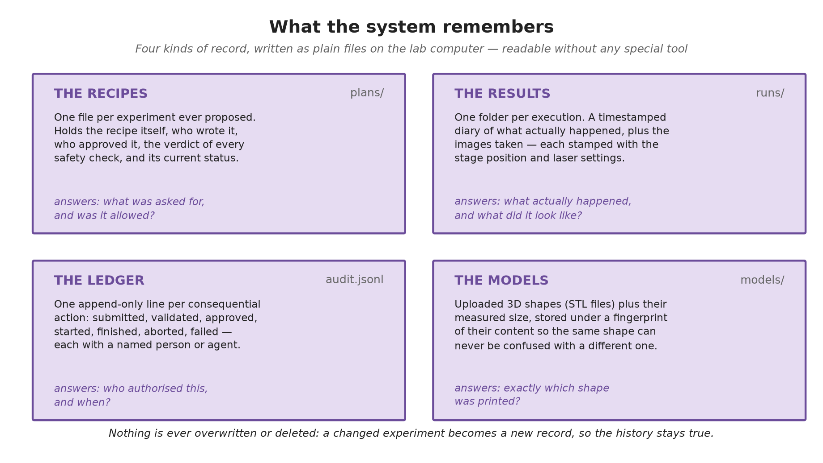
Figure 3 — The four kinds of record and the question each one answers.
That choice is deliberate. One rig runs one experiment at a time, so there is no crowd of simultaneous writers to coordinate — the classic reason to reach for a database engine simply does not apply here. Plain files survive a power cut, can be read years from now in any text editor, need nobody to administer them, and can be backed up by copying a folder.
Three properties matter more than the storage technology:
- Nothing is ever overwritten. A modified experiment becomes a new record; the old one stays as it was. The history of what was actually authorised cannot be edited after the fact.
- Every consequential action names a person or agent. Not "the system approved this" — a name, and a timestamp, in an append-only ledger.
- The recipe is kept separately from what happened. One file says what was asked for and permitted; another says what actually occurred. Comparing them is how you investigate a surprise.
If the lab ever outgrows this — several rigs on one platform, or questions asked across thousands of past runs — the code is already arranged so that swapping in a real database means rewriting three small classes and nothing else.

5. What can and cannot happen
These are the guarantees the design is built to provide. Each is enforced by code and covered by automated tests, not by convention or care.
It cannot happen that… | Because…
the AI drives an instrument directly | the AI's only channel is a request over the network; the platform owns every device connection
a recipe exceeding a hard limit runs | the checker runs on every submission, before a human is ever asked
someone approves their own proposal | the approval step compares the two identities and refuses if they match
an unapproved plan starts | the run engine refuses any plan not in the approved state
a fault leaves the beam on | every ending — success, fault, abort — runs the same closing sequence, laser first
two experiments collide on the rig | one worker thread executes; everything else queues in order
a run happens with nobody accountable | every state change appends a line naming the actor

And the honest converse — what the platform does not claim:
- It cannot stop a physically valid but scientifically pointless experiment. Judging whether an experiment is worth doing remains the scientist's job; the platform only judges whether it is permitted.
- It cannot protect against wrong limits. If the configured maximum power is wrong, the checker will enforce the wrong number faithfully. Those limits need a named owner who signs off on them.
- It is not the last line of defence. The hardware interlocks are.

6. Where the project actually stands
Working today, tested and running in simulation on any computer:
- The full platform: recipe format, checker, approval lifecycle, execution engine, results and audit trail.
- Ten operation types, including parameter sweeps, 2PP threshold ladders, and 3D printing from an uploaded STL model.
- The complete natural-language loop, demonstrated end to end: a plain-English request became a recipe, was checked, previewed, approved by a second identity, executed, and returned an image — while an unsafe request ("150 % power at x = 40 mm") was refused with specific reasons and never became approvable.
- Two independent adversarial code reviews, which found and fixed 43 defects — including two ways the laser could have been left on after a fault in the pre-existing lab code.
Not yet done, and each blocked on something specific:
Remaining work | Waiting on
camera and white-light drivers | the SDK documentation for those two units
first run on the real rig | scheduled access, plus two hardware checks flagged in the code
speed calibration at 1 and 3 mm/s | rig access (a measurement, not a code change)
connection to the chat platform | how user identity is passed through, and the network route to the rig

The engineering runway is clear. What remains is mostly conversations and a day on the instrument.

