Natural-Language Control of Laboratory Equipment
A reference architecture for safe, reproducible AI-assisted experimentation
Architecture proposal · for discussion & approval · Draft v1

1. Executive summary
Researchers want to operate lab equipment by describing what they want in plain language, typing or talking to an AI assistant rather than writing control scripts. This document proposes an architecture that makes that possible without surrendering the two things a laboratory cannot give up: safety and reproducibility.
The central design decision is a single, sharp separation of responsibilities. An AI layer interprets intent and proposes a plan; a separate, deterministic layer validates that plan against hard constraints and is the only thing permitted to drive hardware. The AI is a co-pilot and a compiler, it turns words into a checkable experiment recipe, never an autopilot wired directly to the instruments. Every physical run is approved by a qualified human before it executes, and independent hardware interlocks remain the ultimate safety floor beneath all software.
The result is a method that generalises across instruments and labs, and that can be adopted incrementally: the system becomes useful, scriptable and reproducible before any AI is introduced, and the AI is added last, where its blast radius is smallest.

2. The problem, and why the naïve version is dangerous
The naïve implementation, let the AI call the hardware directly through a set of device functions, is unsafe for a simple reason: a large language model is non-deterministic and occasionally, confidently wrong. The moment its output can directly actuate an instrument (open a shutter, fire a beam, drive a stage into its limits), a probabilistic component sits inside a safety-critical control path. No amount of prompt engineering removes that risk; it has to be removed architecturally.
This proposal keeps the model strictly outside the safety loop. The sections below give the principles, the architecture, the lifecycle of a single experiment, the industry precedents that validate the approach, the residual risks, and a phased plan to build it.

3. Four load-bearing principles
Everything in the architecture follows from four principles. If a future design decision conflicts with one of these, the decision is wrong.
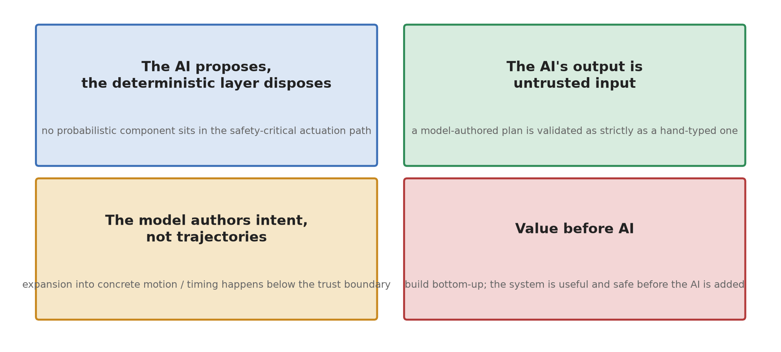
Figure 1 — The four principles that constrain every design choice.
- The AI proposes, the deterministic layer disposes: no probabilistic component may sit in the safety-critical actuation path.
- The AI's output is untrusted input: a model-authored plan is validated exactly as strictly as a plan a human typed by hand. The gateway trusts the validation, not the author.
- The model authors intent, not trajectories: the model chooses what to do; the expansion of that intent into concrete motion, timing and device commands happens below the trust boundary, deterministically.
- Value before AI: the system is built bottom-up and is useful, safe and reproducible before the AI exists. The AI is an enhancement, not a prerequisite.

4. Reference architecture
The system is a layered pipeline. Natural-language intent enters at the top and flows downward toward hardware, crossing exactly one trust boundary. Above the boundary everything is probabilistic and untrusted; below it everything is deterministic and is the system of record. The same shape applies to any instrument, only the drivers at the bottom change.
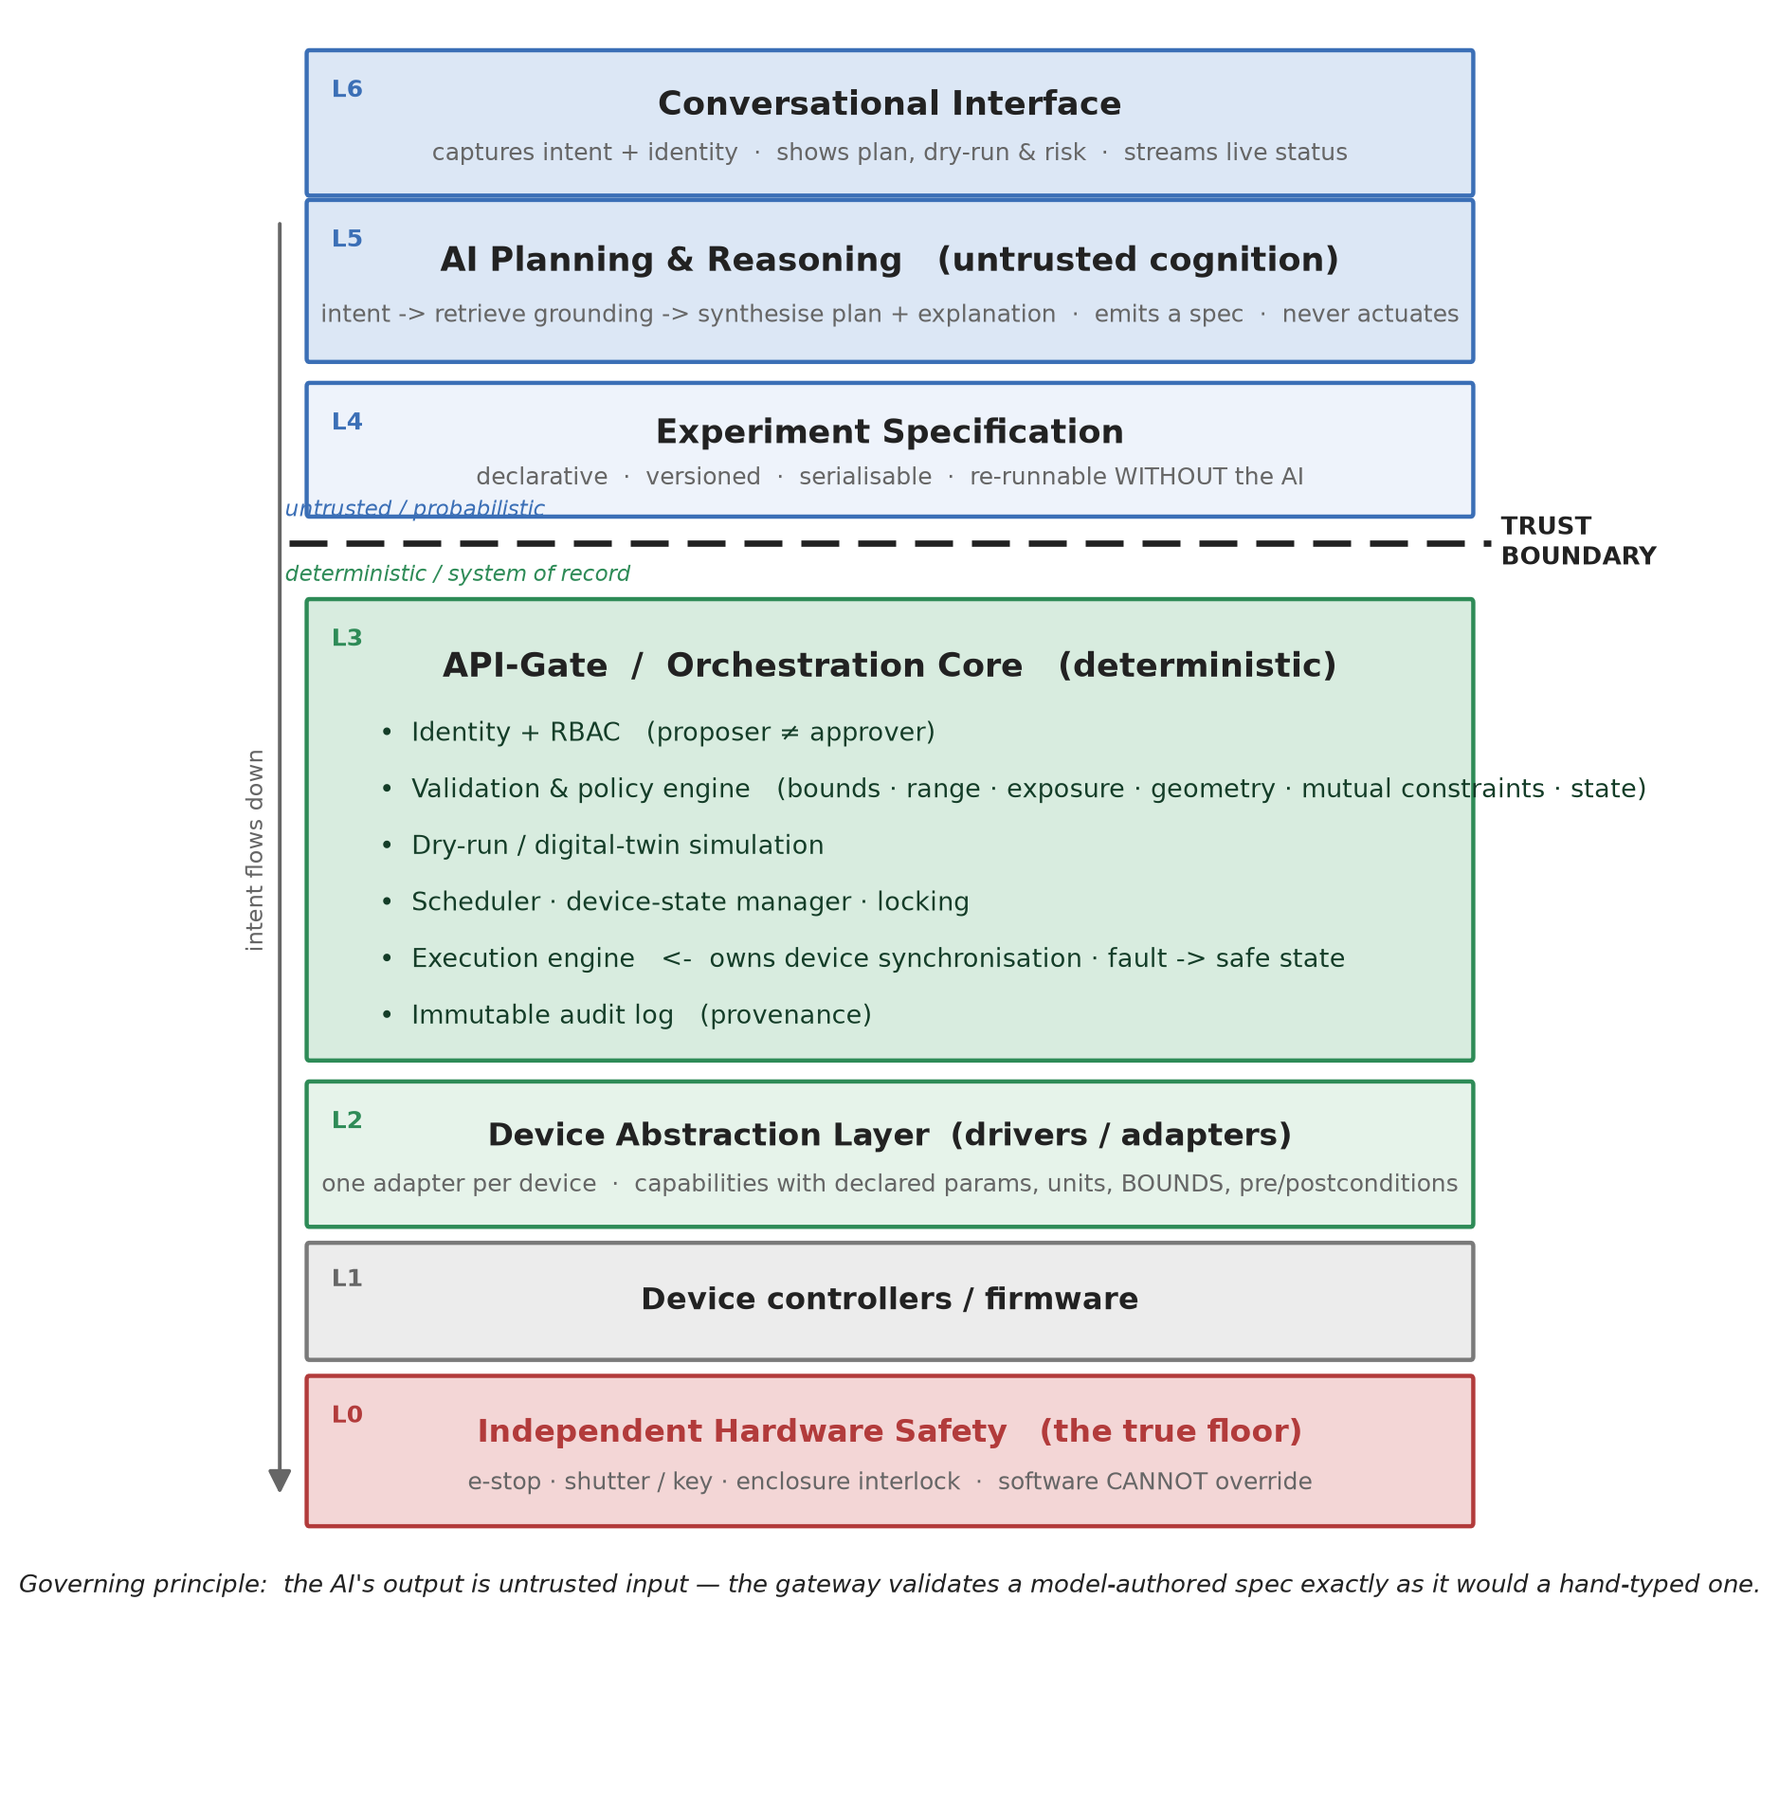
Figure 2 — The layered reference architecture. The trust boundary sits between the AI-authored specification (L4) and the deterministic gateway (L3).
Worked example — On a two-photon laser-printing rig (a motion stage plus a controlled-energy source), the bottom drivers wrap the stage controller and the laser API; everything above them is identical to what it would be for a different instrument. The architecture is the product; the rig is just one tenant of it.

5. What each layer does
- L6 — Conversational interface: the chat / text surface. Captures the user's intent and identity, shows the proposed plan with its predicted effects and risk, and streams live status during a run.
- L5 — AI planning & reasoning: interprets intent, retrieves grounding (available capabilities, current device state, constraints, the user's role), and synthesises a plan together with a plain-language explanation. It emits a specification and never actuates hardware.
- L4 — Experiment specification: a declarative, versioned, serialisable recipe — the single artifact that crosses the trust boundary, and the keystone of the design (see §7).
- L3 — API-Gate / orchestration core: the deterministic core — this is the “API-Gate.” It holds identity and role-based access control, the validation & policy engine, the dry-run simulator, the scheduler and device-state manager, the execution engine that expands intent into timed commands (and owns device synchronisation), and the immutable audit log.
- L2 — Device abstraction layer: one adapter per device, each exposing capabilities with declared parameters, units, bounds and pre/postconditions. Capability bounds live here, close to the hardware they protect.
- L1 / L0 — Controllers & independent safety: device controllers/firmware, and — beneath everything — independent hardware safety (e-stop, shutter/key, enclosure interlock) that software cannot override. This is the true safety floor.
Worked example — A hard, unsolved problem on a real rig — synchronising stage motion with the energy source so exposure is consistent — lives entirely inside the L3 execution engine, a deterministic component. The AI says “write this line at this power and speed”; it never decides when the shutter opens relative to acceleration. The architecture quarantines the hard timing problem in one tested place, and the AI cannot make it worse.

6. Lifecycle of a single experiment
Every experiment follows the same seven steps. The AI participates in exactly one of them (step 2). Everything after the trust boundary is deterministic, and a human gates the transition from plan to physical action.
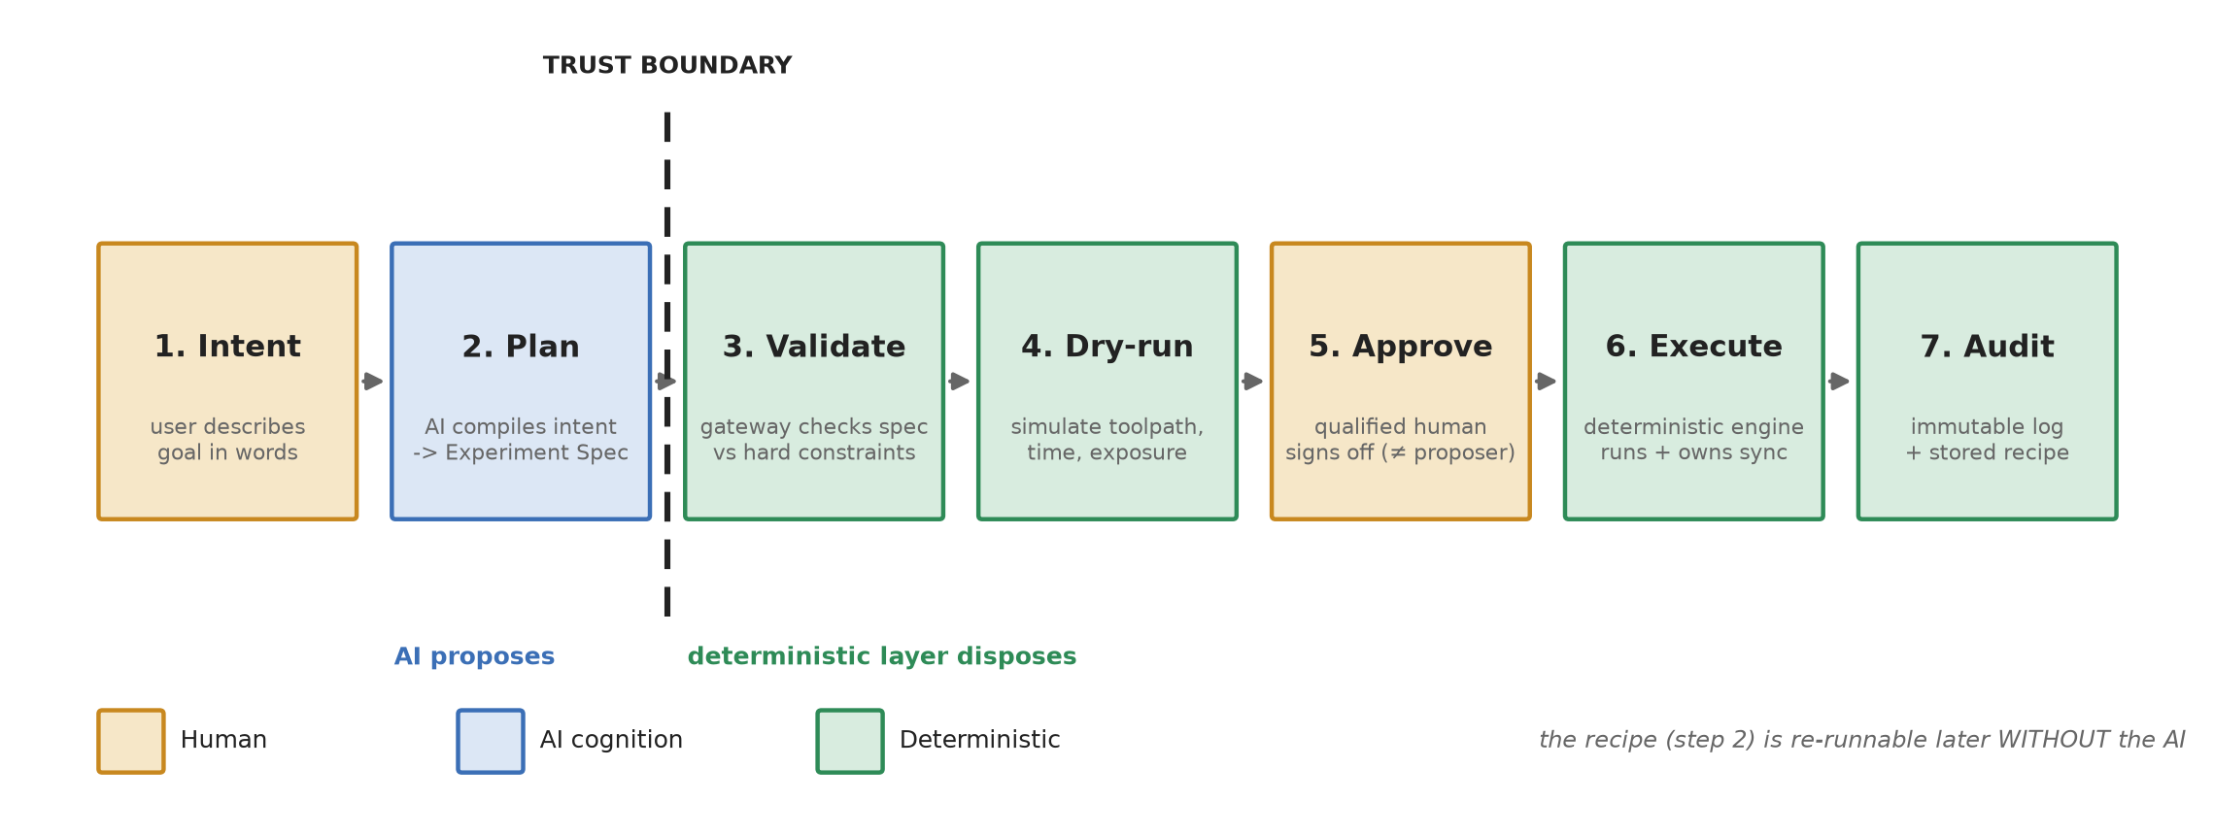
Figure 3 — From intent to audited result. The recipe produced in step 2 is re-runnable later without the AI.

7. The keystone: a declarative experiment specification
Forcing the AI to emit a declarative recipe — rather than call hardware — buys four properties at once: reproducibility (re-run the file), auditability (diff and store the file), safety review (validate the file), and a clean approval target (a human approves a document, not a black box). The same trick underlies declarative protocol languages in lab automation.
experiment:
author: alice # proposer (role: operator)
operations:
- write_array:
rows: 10 cols: 10 pitch_um: 5
power_sweep: [8, 16] speed_sweep: [4, 6]
# high-level INTENT only — no raw motion, no timing
Illustrative specification — small, human-readable, declarative. The gateway expands it into device commands; the model never writes trajectories.
A note on a real design choice: an alternative is to have the AI pre-resolve the full toolpath into the spec (every segment explicit). That is more auditable, but it moves motion-authoring above the trust boundary, where a probabilistic component should not be. We therefore keep expansion deterministic and below the boundary; the explicit-toolpath variant is noted only as a considered alternative.

8. Human-in-the-loop and roles
Every physical run is approved before it executes (a co-pilot model), and the proposer and the approver are deliberately separate roles. Non-experts may converse with the AI and propose experiments; only a qualified, safety-signed-off user may approve execution. Identity and role-based access control therefore live in the gateway as first-class features, not as an afterthought.
The approver is shown the proposed recipe, the validation result, the dry-run prediction (toolpath, time, exposure) and a risk summary — enough to give informed consent rather than a reflexive click. Guarding against automation complacency is itself a design requirement of the approval interface.

9. Industry grounding
This architecture is not speculative; each layer corresponds to an established standard or precedent. The proposal aligns with, rather than reinvents, the following:
Concern | Established standard / precedent
Device interfaces & abstraction | SiLA 2; OPC-UA / LADS companion spec
Declarative experiment protocols | Autoprotocol; Antha (lab-automation recipe languages)
Layered control hierarchy | ISA-95 / the Purdue model (planning never bypasses control)
Laser & functional safety | IEC 60825 (laser safety); IEC 61508 / ISO 13849
AI driving real lab hardware | Coscientist (Nature 2023); Berkeley A-Lab; Emerald Cloud Lab
AI tool boundary & schemas | Model Context Protocol (MCP); function-calling; HITL guardrails

A concrete implementation note: because each capability is a strictly-schema'd tool and the gateway enforces policy, the trust boundary maps almost one-to-one onto the Model Context Protocol — the gateway becomes an MCP server, each capability an MCP tool. This gives a modern, well-supported way to build the boundary instead of a bespoke layer.

10. Risks and mitigations
Risk | Mitigation (architectural)
LLM hallucination / wrong plan | Deterministic validation engine + mandatory human approval; the AI cannot actuate.
Prompt injection / adversarial intent | AI output treated as untrusted input; RBAC; hard bounds enforced in the gateway, not the prompt.
Automation complacency (rubber-stamping) | Approver UI shows dry-run prediction + risk, not just an “approve” button.
Spec drifts from hardware reality | Drivers are the single source of capability truth; device-state manager tracks live state.
Non-deterministic / slow / costly model in the loop | AI runs only at authoring time; execution is a deterministic engine with no model in the path.

11. Phased adoption roadmap
The system is built bottom-up so that each phase delivers standalone value and the AI arrives last, where its risk is smallest. Crucially, after Phase B the lab already has a scriptable, reproducible, synchronisation-correct system — worth having even if the AI work stopped there.
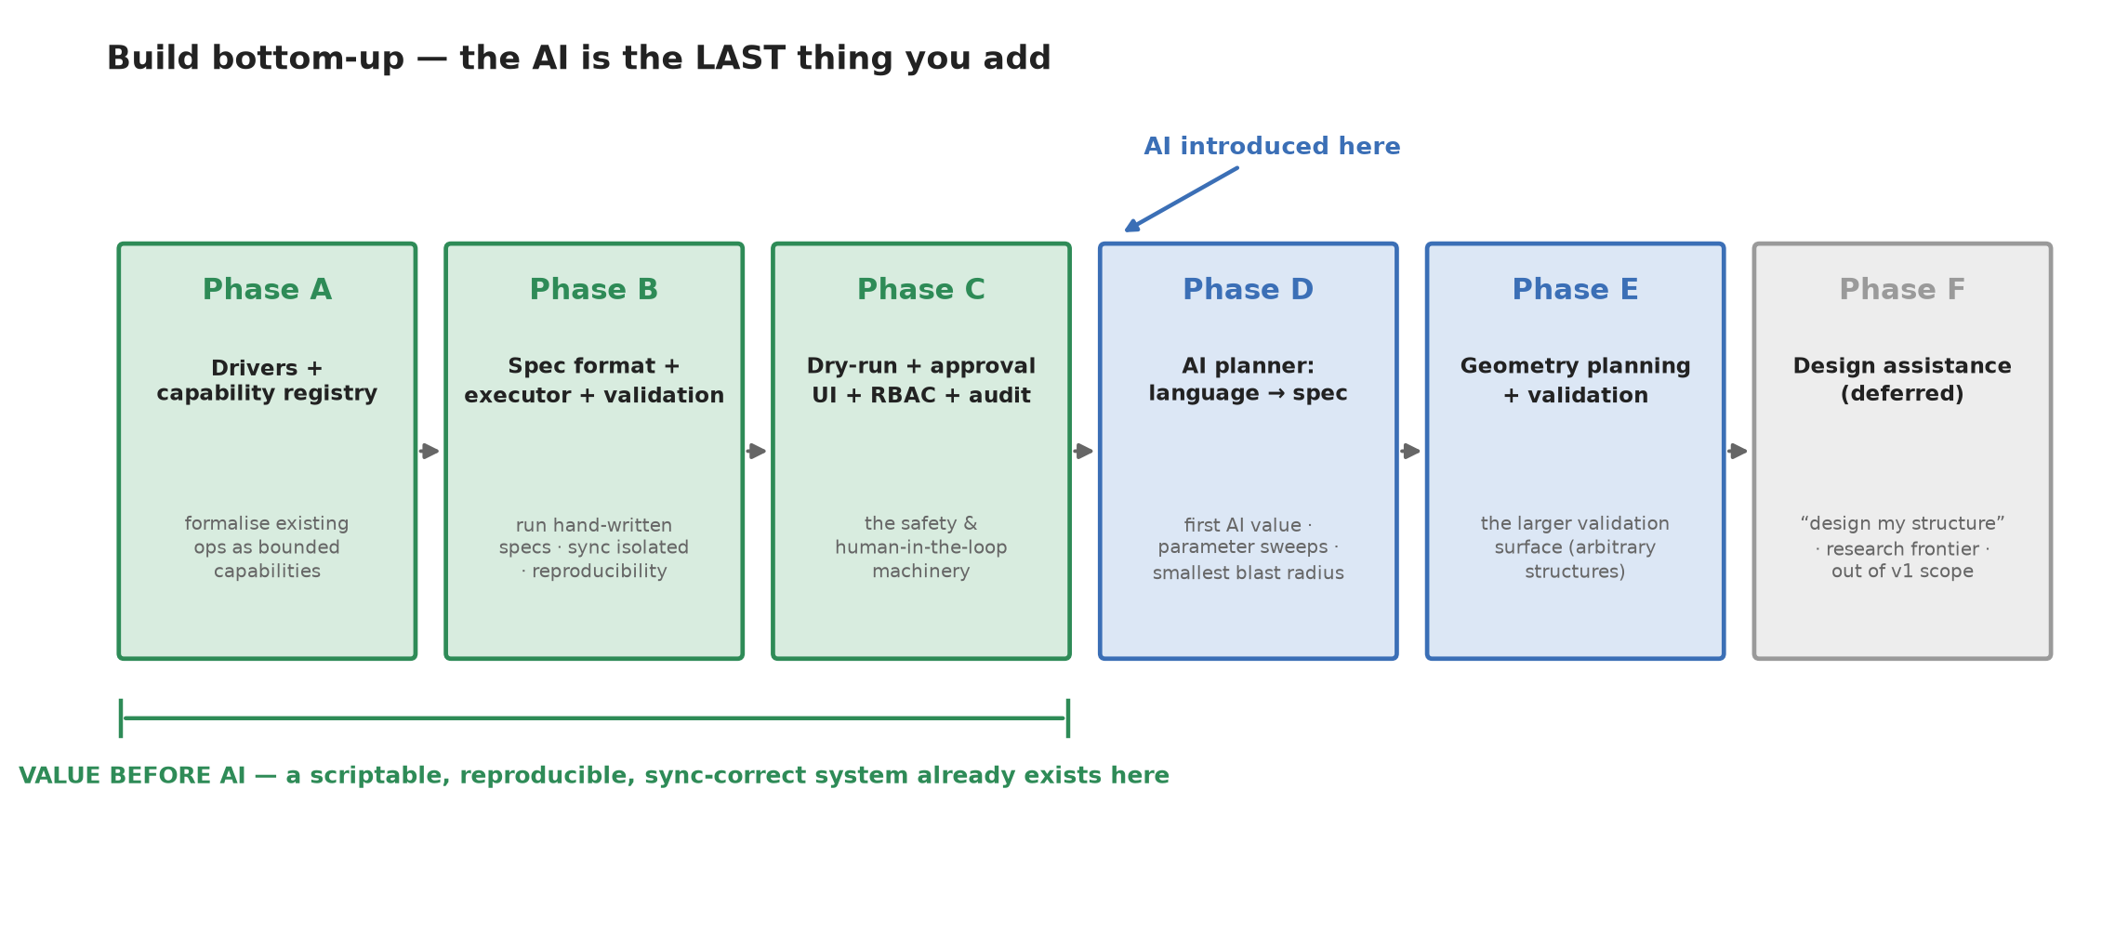
Figure 4 — Bottom-up adoption. Phases A–C deliver a safe, reproducible system before any AI; Phases D–E add planning; Phase F is deferred research.

12. Open questions for the team
- Capability scope: which existing operations become the first bounded capability vocabulary, and what are their declared safe envelopes?
- Approval authority: what is the formal mapping from user identity to “may propose” vs “may approve,” and who signs the safety training?
- Simulation fidelity: how faithful must the dry-run / digital twin be before its prediction is trusted to inform approval?
- Boundary technology: build the gateway as an MCP server, or a bespoke service boundary? (MCP is recommended.)
- Geometry handling: confirm the explicit-toolpath alternative (§7) is not needed for any instrument before standardising on deterministic expansion.

Draft for discussion. Diagrams are generated programmatically and can be revised on request.

