ME-HSI datasets in the Attention and RL drafts
Audit of what was used, what the drafts said, what is correct, and what is still open. Prepared 22 October 2026 for the team meeting of 23 October (Orbeli).

1. Summary
- Lichens 1 (used in both drafts) is the right-hand part (columns 3–6, 16 of 24 pieces) of the 250707 palette, Zenodo 18640119 (the WHISPERS 2025 / Autoencoder-paper data). Its 4 classes are R. sinensis lower surface, R. sinensis upper surface, F. soredica and R. fraxinea, 4 pieces each. It is not Palette 1 of the genera paper.
- Lichens 2 is a separate acquisition of 9 January 2026 (28 pieces in 4 rows of 7, 256×348 px, 8 excitations). It is not on Zenodo, its 5 class names are not recorded anywhere we have, and its 5th class is two edge fragments of one piece. It is not a reprocessing of Lichens 1, and it cannot contain the genera palettes (acquired 25 March 2026).
- Collagen Pepsin / Collagen Acetic are the 250929 acquisition, Zenodo 20677504: 9 sponges each, 3 glutaraldehyde crosslinker levels × 3 sponges.
- The genera-paper datasets (Zenodo 21210745 / 21210868, Palettes 1 and 2, 7 recorded excitations 310–415 nm, 425 nm filters) were not used in either draft.
- New problem found today: the processed files label the emission wavelengths of some excitations wrongly (by 15–40 nm), because the conversion step assumed the emission axis instead of reading it from the .im3 file. Affected: Lichens 1 at 385–430 nm, Lichens 2 at 415–430 nm, Collagen at 400 nm. This explains the "750 nm", the "5 nm offset grid" and M = 55/63 in the drafts. It also affects the 9-band wavelength list in the Autoencoder paper under revision at Scientific Reports.
- Also found: the Lichens 2 400 nm exposure is 12.5 ms in metadata.xlsx but 125 ms in the .im3 file (10× scaling error). The collagen LED powers for 365–400 nm look like a unit mix-up (µW vs mW).
- Baseline results (LR, SVM, RF, HGB, kNN, MLP, 1D-CNN, SpectralFormer) are unaffected by the wavelength labels, because their inputs are identical. The attention models use wavelength values; they were rerun tonight with the recorded wavelengths (Section 8). After the rerun no attention model is best on any dataset (gaps 0.2–0.5 points, none significant), and the earlier attention-vs-selection overlap result did not replicate and was withdrawn.
- Both drafts have been revised: dataset descriptions rewritten from the verified facts, all reviewer items addressed, and the remaining unknowns highlighted in red in the PDFs.

2. What happened
Date | Event
12 Oct | Review of Gevorg's ME SmartAttention branch; bugs found (emission alignment by index, folds not covering all classes).
18–19 Oct | Bugs fixed; overnight benchmark sweep on Collagen Pepsin, Lichens 1, Lichens 2; Attention draft (12 pp) and RL draft (5 pp) written with AI assistance. Dataset descriptions were written from the processed files and code, not checked against acquisition records or Zenodo.
21–22 Oct | Team member revised the Attention draft (Revised.pdf). Narine's AI review of the revision (docx) and of the RL draft (shared chat). Narine flagged that the dataset descriptions disagree with the lichen genera paper and Zenodo.
22 Oct (evening) | This audit: raw .im3 headers, processed files, masks, Zenodo records and the published/under-review papers compared; images rendered; drafts revised; attention models rerun with recorded wavelengths.

3. Which dataset is which
Our name | Acquisition / record | Image, excitations | Classes (what they are) | Pieces | Used in
Lichens 1 | 250707 palette, 2025-07-07  Zenodo 18640119  (columns 3–6 only) | 1040×925 px (full res.)  8 ex: 310–430 nm | R. sinensis lower surface; R. sinensis upper surface; F. soredica; R. fraxinea | 4/4/4/4 = 16 | Attention, RL, Autoencoder (SciRep)
Lichens 2 | 2026-01-09 acquisition  not on Zenodo | 256×348 px  8 ex: 310–430 nm | 5 classes, names not recorded ("Class 1 (Red)" … "Class 5 (Magenta)") | 28 pieces; 26 + 2 fragments of 1 piece (class 5) | Attention, RL
Collagen Pepsin | 250929 collagen, 2025-09-29  Zenodo 20677504 | 256×348 px  6 ex: 310–400 nm | Glutaraldehyde level 1 / 3 / 5 (0.002 / 0.0075 / 0.013 %) | 3/3/3 = 9 | Attention, RL, Autoencoder
Collagen Acetic | same record and session | 256×348 px, 6 ex | same three levels | 3/3/3 = 9 | Attention (dev set), RL
(not used) Genera Palette 1 / 2 | 260325, Zenodo 21210745 (full) / 21210868 (cropped) | binning 2; 7 ex recorded 310–415, paper used 6 | Ramalina, Physconia, Physcia, Peltigera (genus) | 16 + 12 = 28 specimens | Lichen genera paper only

Evidence: Lichens 1 was registered pixel-wise to the Zenodo Mask_Manual.png (column offset 466 px). Every pixel of each of our four classes falls on exactly one Zenodo mask value (50, 100, 150, 200). Acquisition dates come from the .im3 headers (Lichens 2) and the Zenodo files. Collagen layout and levels come from the Zenodo description and Description.docx.

4. Images
All images are also in docs/datasets/audit_2026-10-22/renders/ as separate PNG files, to send around.
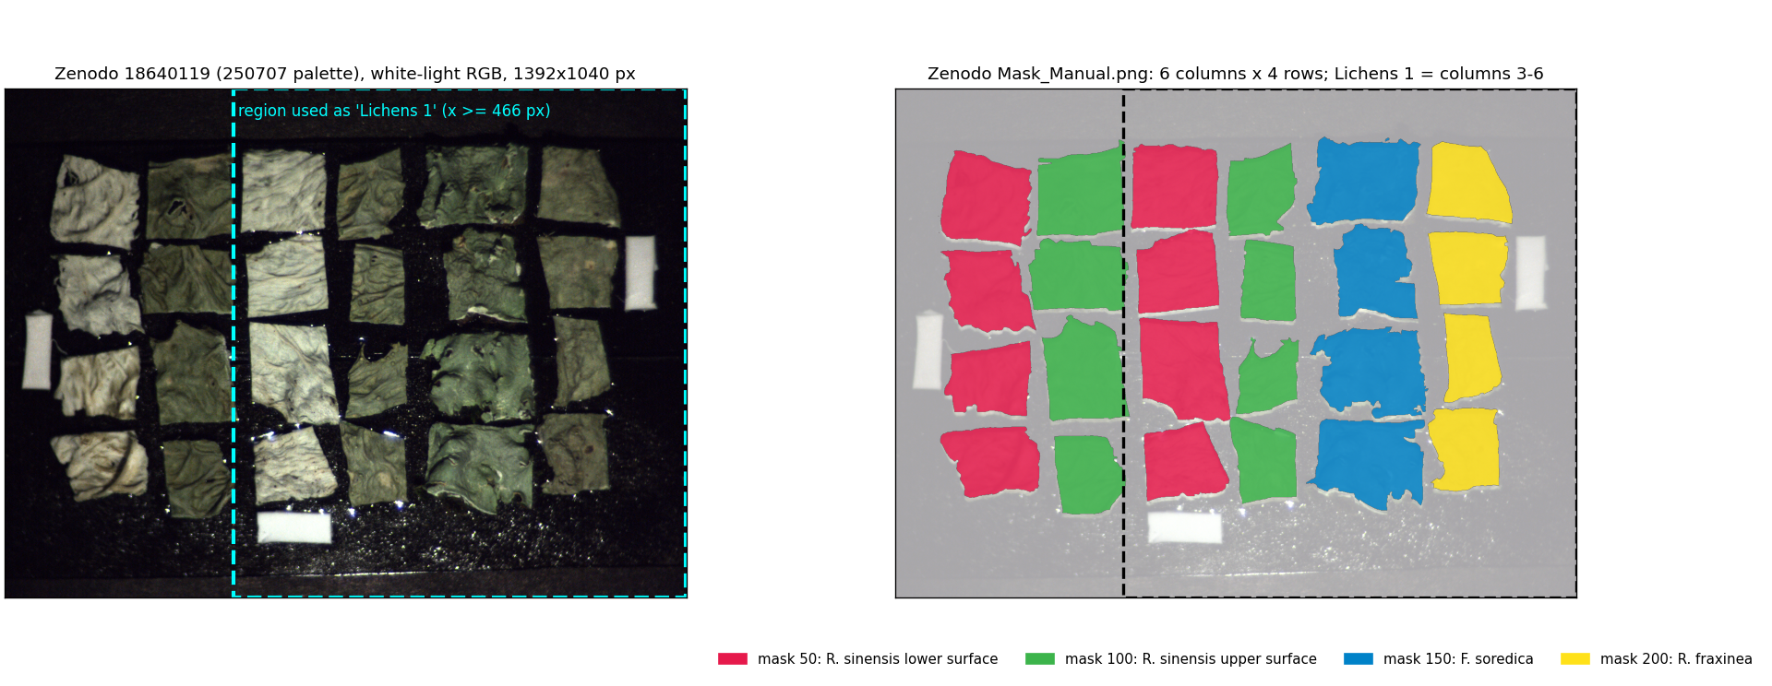
Lichens 1 inside the Zenodo 18640119 palette (left: white-light rendering from Zenodo; right: Zenodo mask). The dashed box is the region used as Lichens 1.
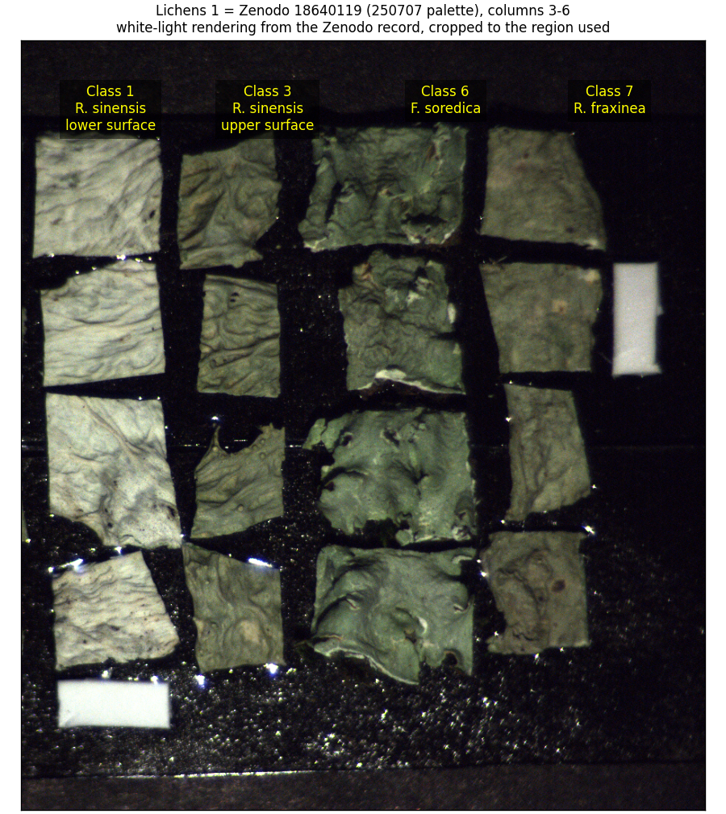
Lichens 1, white-light, with our class names → species.
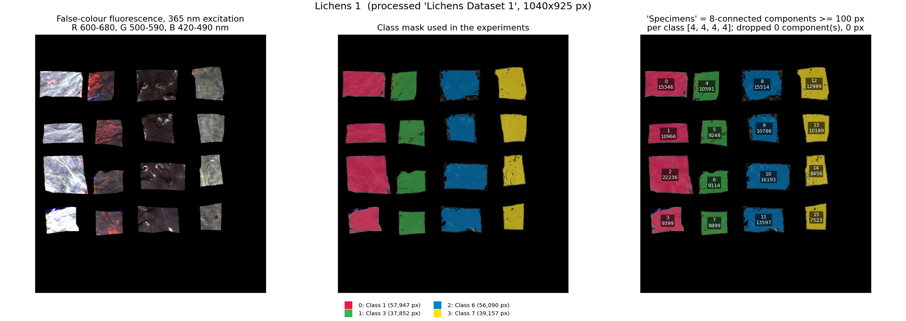
Lichens 1 as used in the experiments: false-colour fluorescence (365 nm excitation), class mask, and the 16 connected components treated as specimens.
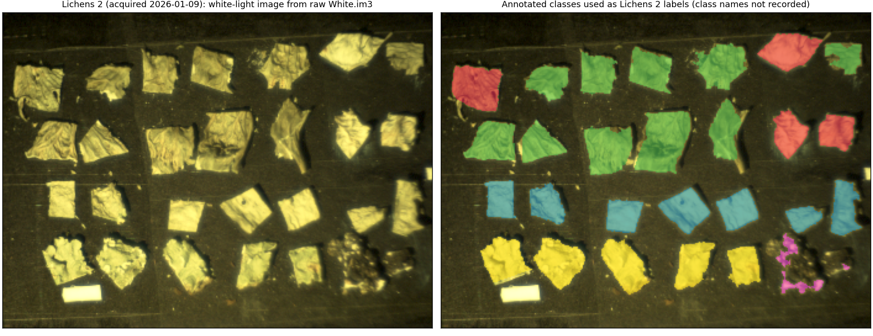
Lichens 2, white-light image decoded from the raw Reflectance/White.im3, and the 5 annotated classes. Class 5 (magenta) covers only edge fragments of one dark piece.
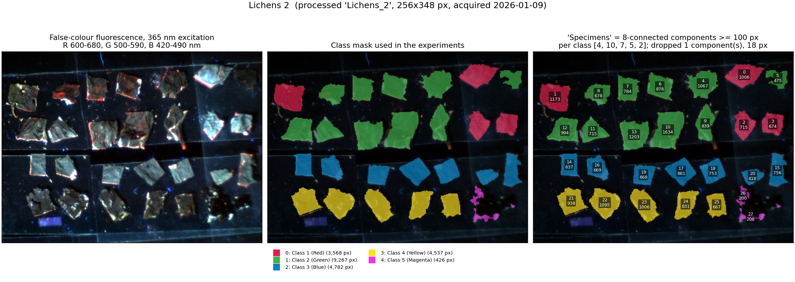
Lichens 2 as used in the experiments: 28 connected components (4/10/7/5/2 per class); components 26 and 27 are two fragments of the same piece.
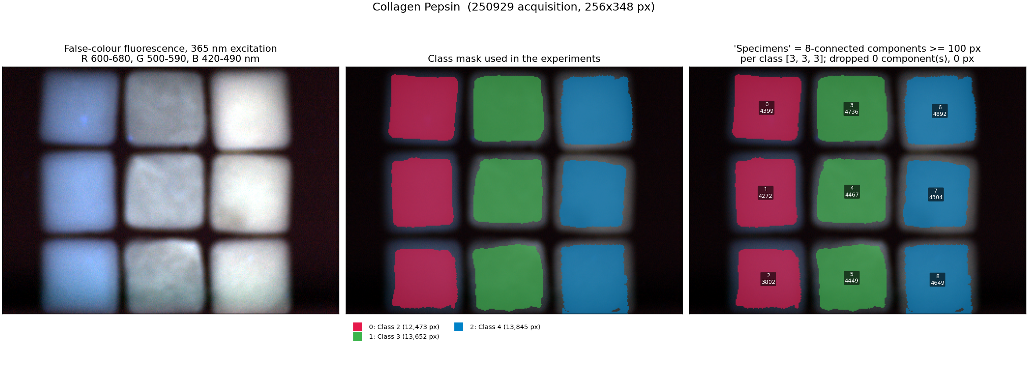
Collagen Pepsin: 3×3 sponges, columns = crosslinker level (to confirm: left→right = level 1, 3, 5).
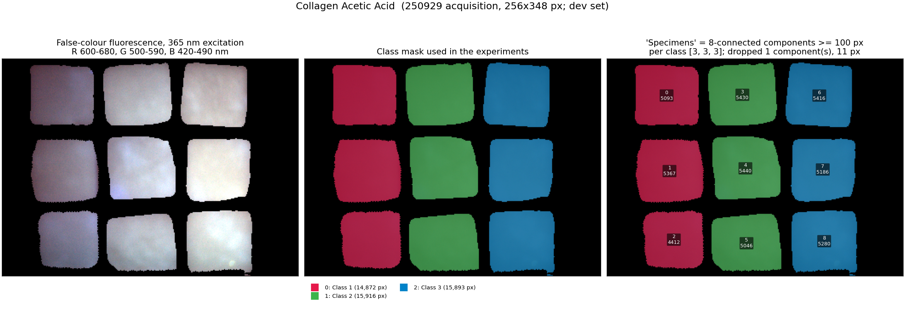
Collagen Acetic Acid (development set), same layout.

5. Narine's points, one by one
Point raised | What the data show | Change in the drafts
Excitations: genera paper 6 (310–400), RL draft 8 (310–430) | Both of our lichen sets come from 8-LED acquisitions (250707 and 260109) that include 415 and 430 nm. The genera palettes (260325) recorded 7 (310–415) and the paper used 6. The 425 nm short-pass/long-pass filters are listed only for the 260325 sessions. | Drafts now say which acquisition each set is. OPEN: confirm that no 425 nm short-pass filter was in the light path in 250707 and 260109 (430 nm excitation would be blocked).
M = 192 and 210 impossible with 6×31 | M counts our retained (excitation, emission) pairs on 8 excitations × up to 31 bands after removing bands near λex and 2λex. 192 and 210 are correct counts of features. The union-grid sizes 55/63 and the "750 nm" were artefacts of the wavelength-label error (Section 6). | Explained in both drafts; table of retained bands per excitation added to the Attention draft.
Lichens 1 = Palette 1? Lichens 2 (5 classes, 28) ≠ Palette 2 | Lichens 1 is not Palette 1; it is part of the 250707 palette (4 classes = 3 species, 2 surfaces of R. sinensis). Lichens 2 is a 2026-01-09 palette of 28 pieces; 26 single-piece components + 2 fragments of one piece = 28 "specimens". | Rewritten. OPEN: species of each Lichens 2 class and who annotated it.
Overlap / leakage between Lichens 1 and 2 (LODO) | Different sessions, resolutions, layouts and piece counts, so the two images are not the same data reprocessed. Whether pieces were cut from the same thalli is not recorded. | Wrong "same lichens / same material" statements removed. The RL draft now flags that LODO and S3 on lichen targets (and on collagen targets) are closer to in-domain. OPEN: shared thalli?
k = 2 folds for Lichens 2 implies a class with 2 specimens | Yes: class 5 has two connected components that are fragments of one piece. Folds put one fragment in training and the other in test. | Stated explicitly in both drafts; recall of that class is not a test on an unseen piece.
Data citation | Lichens 1 → 18640119 (correct, region of it). Collagen → 20677504. Lichens 2 → no record. 21210868 / 21210745 are not the data used. | Citations fixed; collagen record added to the RL draft. OPEN: deposit Lichens 2 or drop it.
"Tunable source", "Rayleigh-scatter rejection" | The source is the switchable LED unit (WheeLED WLS-23-A); the camera is the Nuance FX LCTF. Our preprocessing removes bands within 40 nm (30 nm for Collagen Pepsin) of λex and 2λex. The genera paper instead trimmed filter-leakage ranges. | Wording harmonised in both drafts; what was removed is stated exactly.

6. New problems found in this audit

6.1 Emission wavelengths mislabelled for some excitations
The processed .pkl files were made by a loader (src/mehsi_preprocessor/io/hyperspectral_loader.py, line 131) that does not read the emission axis from the .im3 file. It assumes the first band is 420 nm for excitations ≤ 400 nm and λex + 20 nm above, then counts up in 10 nm steps. The .im3 headers record the true axis:
Dataset | Excitation | Recorded axis (.im3) | Label in processed file | Label − recorded
Lichens 1 (250707) | 385 / 400 / 415 / 430 nm | 440 / 460 / 470 / 490 – 720 nm | 420 / 420 / 435 / 450 – … | −20 / −40 / −35 / −40 nm
Lichens 2 (260109) | 415 / 430 nm | 420 – 720 nm | 435 – 735 / 450 – 750 nm | +15 / +30 nm
Collagen Pepsin, Acetic | 400 nm | 450 – 720 nm | 420 – 690 nm | −30 nm
all others | 310–365 nm (all); 385, 400 nm (Lichens 2); 385 nm (collagen) | 420 – 720 nm | 420 – 720 nm | 0

Consequences. (a) The drafts' "420–750 nm", "415 nm on a 5 nm-offset grid", M = 55/63 and some importance-map axes are wrong; on the recorded axis every dataset sits on one 10 nm grid, 420–720 nm (M = 31). (b) The scatter cut-offs were applied to the wrong labels, so for Lichens 2 at 415/430 nm bands from 440 nm were kept (within 25/10 nm of the excitation), and for Lichens 1 at 385–430 nm more bands than intended were removed. (c) Feature values, the set of features and their order are unchanged, so the baselines are unaffected. Wavelength-aware models (attention family, SmartAttn v0, spatial attention, RL wavelength features) used shifted values. (d) Autoencoder paper (Scientific Reports, under revision): it uses the same Lichens 1 and Pepsin files. Its 9-band set "310/520, 385/500, 325/570, 430/610, 400/510, 340/500, 365/520, 415/615, 430/680" is, on the recorded axis, 310/520, 385/520, 325/570, 430/650, 400/550, 340/500, 365/520, 415/650, 430/720. Pepsin pairs at 400 nm are 30 nm higher than reported. This should be corrected before that paper is finalised.

6.2 Lichens 2: 400 nm exposure
metadata.xlsx lists 12.5 ms for 400 nm; the 400.im3 header records 125 ms. The radiometric correction (verified: processed = raw × t_max/t_ex × P_min/P_ex) therefore scaled the 400 nm block 10× too high. With per-pixel area normalisation this changes every feature of a pixel slightly; all Lichens 2 results carry this. Fix: correct metadata.xlsx and regenerate.

6.3 Collagen LED powers
The collagen TLS files give 365, 385, 400 nm powers of 6.36, 11.02, 1.27 µW (Pepsin) and 3.75, 6.29, 0.70 µW (Acetic), while 310–340 nm are 113–590 µW. The same LEDs in the lichen sessions measured 4–15 mW at 365–430 nm (e.g. Lichens 2: 10.25 mW at 365 nm; genera palettes: 6.2 mW). This looks like mW recorded as µW for 365–400 nm.
OPEN: confirm units with whoever measured the powers (Kristina?), and whether exposure/power correction was applied to the collagen and Lichens 1 processed files (the Lichens 1 file stores no exposure/power metadata).

6.4 Specimen definition
"Specimen" in our protocol is an 8-connected mask component ≥ 100 px. In Collagen and Lichens 1 each component is one physical piece. In Lichens 2 the 5th class is two edge fragments of one dark piece (200 + 208 px; an 18 px fragment on a neighbouring dark piece is dropped). In Lichens 1 two of four classes are two surfaces of the same species, and the four pieces of a class may come from one thallus. The autoencoder paper lists one voucher per species (LICH-840/841/842).
OPEN: how many thalli/collections are behind the 4 pieces of each Lichens 1 class? Which R. sinensis collection (Lori Margahovit 2021 or Tavush Dilijan) is in columns 3–4?

6.5 Attention draft: importance analysis details
The Pepsin heatmap title "r0 f1" names the sweep record whose hyperparameters were reused; the model was retrained and evaluated on repeat 0, fold 0, as the caption says. That record's training data contained the fold-0 test pieces, which is now disclosed. Attention was averaged over up to 20 000 test pixels (the draft said 4 000); corrected.

7. What was changed in the drafts

Attention draft (publications/me_attention/main.pdf)
- Started from the team member's revision (Revised.pdf), reproduced in LaTeX (main_team_revised_v1.tex), then edited.
- Data section rewritten: acquisition system, recorded emission axes, the exact band-removal rule, retained bands per excitation (new table), radiometric scale with the Lichens 2 400 nm error, the three datasets with species/levels and Zenodo records, specimen definition including the Lichens 2 fragment class, a new subsection on the wavelength-label error, and a new dataset figure.
- All "same underlying lichen material" statements removed; Limitations rewritten accordingly.
- Narine's review: repeats 1–5; "strongest within family" corrected for the Lichens 1 tie; Discussion no longer states a cause; Holm-Wilcoxon no longer called significant; 150–210 → 149–210; 2S explained (needed for the stride-2 convolution); importance pixel count and config source corrected; first person removed ("our own earlier prototype").
- Tables II–IV, Fig. 4–5 and all result statements now use the rerun with recorded wavelengths (Section 8); the importance-overlap contribution was rewritten because it did not replicate.

RL draft (publications/rl_band_selection/main.pdf)
- Every item of the shared AI review checked against the tables and raw result files; numbers corrected or pooling scope stated (e.g. look-ahead vs best-of-k: < 0.008 pooled, +0.028/+0.030/+0.007 at n = 8; SA at B = 400: 0.024/0.017 pooled, 0.009/0.016 at n = 8; CSS refinement on Lichens 2: −0.053/−0.029/−0.017 at n = 5/8/13).
- Claims narrowed: CSS strong at small n but below random at n = 13 on 3 of 4 targets; transferred policy "rarely significantly" beats CSS; refinement helps on Lichens 1 and hurts on Lichens 2; reversibility benefit is S2 only.
- Explained from the code: SFS+swap at small budgets is mostly CSS-filled; beam search at n = 13 is budget-truncated (†); per-instance PPO budget; telescoping and swap credit; excitation-cost result now with μ, n, folds and source.
- Data paragraph rewritten with the verified facts; "tunable source" and "Rayleigh" wording replaced; collagen Zenodo record added; LODO/S3 near-in-domain note; Fig. 3 re-plotted on recorded wavelengths.
- Corrected two numbers not raised by the reviewer but wrong in the draft (augmentation effect −0.014 not −0.024; training-speed figures taken from the digest).
- Length is now 7 pages (6 before the dataset text). OPEN: the venue page limit.
OPEN: RL: the augmented cross-family policies' logs show 400 updates while their config says 250; check which run produced the saved policy.

8. Rerun with recorded wavelengths (attention models)
Run 22 Oct 22:00–23:42 (results/me_attention/recwl/; combined with the baselines in results/me_attention/final_recwl/). Same folds, seeds, budget (T = 3, 25 epochs), repeats and preprocessing as the 19 Oct sweep. Only the wavelength-aware models are rerun: SmartAttn v0, ex_tokens_v2, hybrid_conv_attn, meas_tokens (spectral) and spatial attention. Baselines keep their 19 Oct results because their inputs are identical. Not corrected in this rerun: the Lichens 2 400 nm exposure (6.2).
Model (balanced acc., %) | Collagen Pepsin | Lichens 1 | Lichens 2
ex tokens v2 | 91.1 -> 90.0 (-1.1; n=15) | 98.8 -> 98.4 (-0.4; n=4) | 86.5 -> 86.1 (-0.3; n=10)
ME-Attn (meas.) | 85.2 -> 83.4 (-1.8; n=15) | 98.2 -> 98.0 (-0.1; n=4) | 83.1 -> 80.9 (-2.2; n=10)
SmartAttn v0 | 80.5 -> 81.1 (+0.7; n=15) | 98.8 -> 99.2 (+0.4; n=4) | 83.4 -> 84.5 (+1.1; n=10)
hybrid conv attn | 79.7 -> 78.1 (-1.6; n=15) | 95.5 -> 98.2 (+2.7; n=4) | 82.3 -> 84.7 (+2.4; n=10)
ME-Attn (spatial) | 87.9 -> 91.0 (+3.1; n=6) | 99.1 -> 99.1 (+0.0; n=4) | 85.6 -> 86.3 (+0.8; n=4)
Best spectral baseline (unchanged) | lr: 90.3 | spectralformer: 99.5 | rbfsvm: 86.6

- Format: 19 Oct sweep (shifted labels) -> rerun with recorded wavelengths (difference; matched repeat/fold units). Spectral models 15/4/10 units, spatial attention 6/4/4.
- Outcome: no attention model has the highest mean on any dataset any more. Best proposed vs best baseline: Pepsin ex_tokens 90.0 vs LR 90.3 (-0.3 [-4.7, +3.0]); Lichens 1 SmartAttn v0 99.2 vs SpectralFormer 99.5 (-0.2); Lichens 2 ex_tokens 86.1 vs RBF-SVM 86.6 (-0.5). No corrected-test p < 0.05 anywhere. The paper's conclusion (competitive, not superior) is unchanged; the 'highest overall mean on Pepsin' claim is removed.
- Spatial: spatial attention 91.0 vs patch-mean RF 86.4 on Pepsin (+4.5 [-0.8, +9.6], n.s.); below the 2D-CNN on both lichen sets.
- Importance: the earlier above-chance overlap between attention rankings and the Autoencoder-paper selection (Pepsin 13 of 30, p = 0.0005) did not replicate after retraining (2 of 30, p = 0.99; Lichens 1 1 of 13, last-layer 3 of 13, p = 0.047). This claim is withdrawn from the paper.
- The changes (-2.2 to +3.1 points) are within the fold-to-fold spread; GPU run-to-run variation was not measured separately.

9. Open questions for the meeting
- Lichens 2: which taxon is each of the 5 classes, who drew the mask, why class 5 covers only fragments of one dark piece, and are any pieces from the same thalli as Lichens 1? Deposit it, or drop it from both papers.
- Lichens 1: number of thalli/collections behind each class's 4 pieces; which R. sinensis collection is in columns 3–4; why only columns 3–6 were used (columns 1–2 are R. sinensis again).
- Filters: was the 425 nm short-pass filter absent in the 250707 and 260109 sessions (it would block 430 nm excitation)? Which filters were in place?
- Radiometric correction: applied to Lichens 1 and the collagen files? Collagen LED power units for 365–400 nm (µW vs mW)?
- Collagen layout: do image columns left → right correspond to crosslinker levels 1, 3, 5 (camera orientation)?
- Dataset choice for 26 Oct: (a) keep Lichens 1 + Collagen, drop Lichens 2; (b) keep all three with the caveats; (c) switch the lichen part to the public genera palettes (21210868: 28 specimens, genus labels, two sessions, voucher-tracked), which answers most concerns but needs a new loader and an overnight rerun.
- Autoencoder paper (SciRep): correct the reported wavelengths for the 385–430 nm (lichens) and 400 nm (collagen) excitations before the revision is finalised.
- Reprocessing: fix the loader to read wavelengths from the .im3 headers, fix the Lichens 2 400 nm exposure, regenerate the processed files, rerun all models (one night).
- Venue and anonymity: target venue and page limit; double-blind rules for the Zenodo records (author names) and self-citations.

10. Where things are
What | Path (repo: spectral-select, branch main)
This document + all images | docs/datasets/audit_2026-10-22/ (renders/ has every PNG)
Scripts that made the images | experiments/dataset_audit/render_datasets.py, lichens1_vs_zenodo.py, lichens2_whitelight_rgb.py
Attention draft (revised) | publications/me_attention/main.pdf; team version reproduced: main_team_revised_v1.tex
RL draft (revised) | publications/rl_band_selection/main.pdf; pre-dataset-fix copy: main_before_dataset_fix.tex
Wavelength correction | src/me_attention/data.py: RECORDED_WL_OFFSET, enabled with ME_ATTENTION_RECORDED_WL=1
Rerun results | results/me_attention/recwl/ and final_recwl/ (19 Oct sweep: results/me_attention/night/); paper inputs: publications/me_attention/generated_recwl/
Tracked-changes PDFs | publications/me_attention/main_diff_vs_team_revision.pdf; publications/rl_band_selection/main_diff_vs_sent.pdf (new tables/figures appear only in the clean PDFs)
Raw data | Data/Raw/ (Lichens_2, Collagen_Pepsin, Collagen_Acetic_Acid .im3); Lichens 1 raw: Zenodo 18640119 HSI.zip
Processed data | Data/processed/ (Lichens Dataset 1, Lichens_2, Collagen Pepsin, Collagen_Acetic_Acid)

