Dependency-Aware Dimensionality Reduction for Complex Sensor Data:
Capturing Conditional Channel Relevance
Narek Meloyan, Aleksandr Hayrapetyan, and Narine Sarvazyan
American University of Armenia, Yerevan, Armenia
{narek.meloyan, aleksandr.hayrapetyan, nsarvazyan}@aua.am

Abstract—Modern sensing systems—hyperspectral cameras, multimodal IoT arrays, and dense instrument suites—routinely produce hundreds of correlated channels per sample, most of which are redundant or noise-dominated. Reducing this dimensionality is essential for storage, transmission, real-time inference, and economical sensor design. Yet the dominant techniques—principal component analysis and filter-based ranking—evaluate channels by their marginal statistics and therefore overlook conditional relevance: the fact that a channel’s usefulness depends on which other channels are already retained. We present an unsupervised framework that captures this dependency directly. A neural encoder with a cross-group fusion mechanism learns a compact representation of the joint channel structure; a sensitivity-based attribution then quantifies each channel’s conditional contribution to that representation; and a relevance–redundancy criterion extracts a minimal, non-redundant subset. The method uses no labels and yields an ordered, interpretable ranking that can be thresholded to any target size. We benchmark on multi-excitation fluorescence imaging—a deliberately hard regime with strongly coupled channel groups—across biological and materials datasets, reducing channels by 80–95% while matching or exceeding full-data classification accuracy. A 10,000-trial randomized test confirms the selected channels are far more informative than chance (12σ separation). Modeling conditional rather than marginal relevance yields more efficient and more accurate reduction for complex sensor data.
Index Terms—dimensionality reduction, channel selection, conditional relevance, information-theoretic learning, unsupervised representation learning, sensor data analytics, interpretability, hyperspectral imaging.
I. INTRODUCTION
Contemporary sensing platforms generate data of rapidly growing dimensionality. A single hyperspectral frame, a multimodal IoT node, or an instrumented industrial process can report hundreds of measurement channels per sample. These channels are rarely independent: they are physically coupled, spatially or spectrally adjacent, and heavily redundant. Acquiring, storing, transmitting, and analyzing the full channel set is costly, and for real-time or embedded deployment it is often infeasible. Dimensionality reduction (DR)—retaining only the channels that carry decision-relevant information—is therefore a prerequisite for efficient and economical sensing.
The two dominant DR families both have structural limitations on such data. Projection methods such as principal component analysis (PCA) produce linear mixtures of all channels; they compress storage but do not reduce the number of channels that must be physically acquired, and the resulting components are not interpretable as instrument settings. Filter-based selection methods rank channels by marginal statistics—variance, entropy, or correlation with a target—and keep the top scorers. Both implicitly treat channels in isolation.
Isolation is precisely the wrong assumption for complex sensor data. The informativeness of a channel is conditional: a channel that is uninformative on its own can be highly discriminative when combined with another, while two individually strong channels may be mutually redundant. In information-theoretic terms, useful selection should maximize the joint relevance of a subset — closer to I(X_S; Y) than to the sum of marginal terms Σ I(X_i; Y). Conditional-mutual-information selectors (mRMR, CMIM, JMI) formalize this, but they are supervised and rely on density estimation that is unreliable for high-dimensional, continuous, unlabeled channels.
We address the empty cell in this design space: an unsupervised, dependency-aware DR method that (i) learns the joint channel structure with a neural representation, (ii) attributes a conditional relevance score to each channel through sensitivity analysis of that representation, and (iii) selects a minimal, non-redundant subset via a relevance–redundancy criterion. The method requires no labels, returns a discrete and ordered list of physical channels, and is interpretable. We evaluate it on multi-excitation fluorescence imaging — chosen as a benchmark because its channel groups are strongly coupled, making it a stress test for dependency-aware reduction.
II. BACKGROUND AND RELATED WORK
Marginal selection. Variance, entropy, and correlation filters score each channel independently. They are fast and unsupervised but blind to inter-channel dependency, so they over-select correlated channels and discard jointly informative ones.
Information-theoretic selection. mRMR [1], CMIM, and JMI explicitly trade relevance against redundancy using (conditional) mutual information. They capture dependency but are supervised and require MI estimation that degrades in high dimensions and is undefined without labels.
Projection and embedding. PCA, the minimum-noise fraction, autoencoders [2], and neighbor embeddings such as UMAP [3] yield mixtures or low-dimensional coordinates rather than channel subsets, with no path back to the physical channels an engineer must instrument.
Deep selection. Attention- and reconstruction-based selectors (e.g., BS-Net [4]) learn channel importance jointly with a task, but are typically supervised and assume a fixed input grid. None of these lines simultaneously offer unsupervised operation, conditional relevance, discrete channel output, and interpretability — the combination we target.
III. METHOD
A. Joint representation with cross-group fusion
The channels are partitioned into G groups that share an acquisition condition (in the benchmark, an excitation wavelength). As shown in Fig. 1, each group is encoded by an independent convolutional branch; the branch outputs are fused by averaging and refined by a shared convolution into a latent code z. Averaging in latent space—rather than concatenation—forces the encoder to find a representation useful across all groups simultaneously, which is what encodes cross-group dependency: a concatenated code could keep groups siloed, whereas the average can be reconstructed well only if it captures the structure shared across groups. The decoder is symmetric—a mirrored shared convolution expands z before per-group convolutional branches reconstruct every group; training minimizes masked reconstruction error and uses no labels. Group-wise branches also accommodate a variable number of valid channels per group without padding, and the model degrades gracefully if a group is missing at inference time.

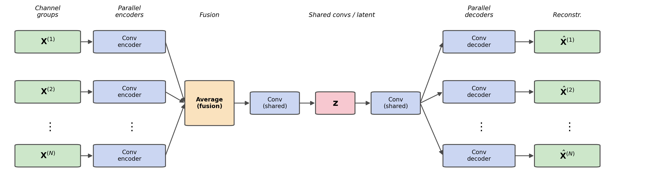
Fig. 1. Dependency-aware autoencoder. Each channel group is processed by a parallel convolutional branch; the branch outputs are fused by averaging, refined by a shared convolution into the latent code z, and symmetrically expanded by a mirrored shared convolution before parallel decoders reconstruct every group. Latent averaging is what forces the model to capture cross-group (conditional) structure.

B. Conditional attribution
After training, we probe the learned representation. For each high-variance latent dimension d we apply a small bipolar perturbation z ± εσ_d e_d, decode both, and measure the induced change at every input channel,
Δ_d(c) = | G(z + εσ_d e_d) − G(z − εσ_d e_d) | / (2εσ_d),
a finite-difference estimate of the decoder’s sensitivity |∂G/∂z_d| at channel c. Aggregating across dimensions, weighted by each dimension’s score, gives a per-channel influence value. Because z encodes the joint structure, this influence reflects a channel’s contribution in the context of all others — a conditional, rather than marginal, measure of relevance. Unlike variance ranking, it can surface low-variance channels that are decisive only in combination. Fig. 2 visualizes the resulting conditional-relevance scores across the full channel grid of the benchmark; the structure is concentrated and physically interpretable, not spread uniformly.

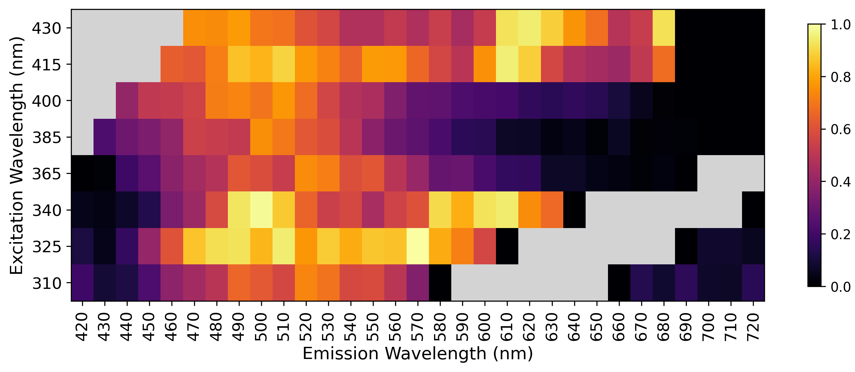
Fig. 2. Conditional-relevance map over the benchmark’s channel grid (here indexed by excitation and emission wavelength). Bright cells are channels the learned representation depends on most; grey cells are physically invalid. Relevance concentrates in a few coherent regions, showing the method isolates a compact, interpretable channel set.

C. Relevance–redundancy selection
Taking the top channels by influence alone yields tight clusters of mutually redundant channels. We instead select greedily with a maximum-marginal-relevance criterion [5]: at each step we add the channel maximizing λ·Rel(c) − (1−λ)·max_{c′∈S} Sim(c, c′), where Rel is the influence score, Sim is the cosine similarity between channel profiles, and λ=0.5 balances relevance against redundancy. This is an unsupervised, learned surrogate for the relevance–redundancy objective of conditional-MI selection, and it returns an ordered list thresholdable to any target dimensionality.
IV. BENCHMARK AND RESULTS
Why this benchmark. Multi-excitation fluorescence imaging records the same scene under several excitation conditions; each condition yields an emission spectrum, and the conditions probe overlapping but distinct populations of emitters. The channel groups are therefore strongly coupled and highly redundant, with a variable number of valid channels per group — an adversarial setting for marginal-scoring DR and a fair stress test for dependency-aware methods. We use two datasets: a biological-morphology set (192 channels, 4 classes) and a materials-chemistry set (158 channels, 3 classes). Selection is fully unsupervised; a downstream classifier is used only to measure how much decision-relevant information the retained channels preserve.
Accuracy under reduction. On the biological set the full 192-channel baseline reaches 88.2% accuracy; the method reaches 95.2% with 80 channels (+7.0 points, 58% reduction) and still 89.4% with only 9 channels (95% reduction). On the materials set the 158-channel baseline reaches 79.8%; the method reaches 85.6% with 30 channels (+5.8 points, 81% reduction). As Fig. 3 shows, accuracy peaks at intermediate sizes: beyond the peak, additional channels reintroduce noise and degrade performance — selection acts as denoising, not merely compression. Table I summarizes the operating points.
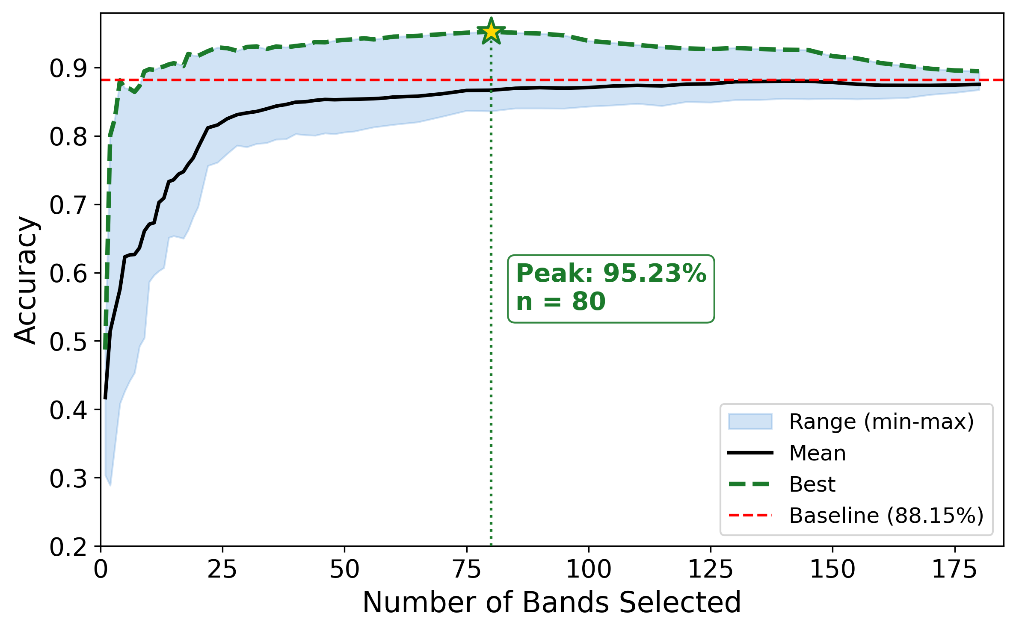
Fig. 3. Accuracy versus number of retained channels (biological benchmark). The selection (best, dashed) exceeds the full-channel baseline (red) across a wide range and peaks well below full dimensionality, confirming that conditional selection denoises rather than merely compresses.
TABLE I. Accuracy is maintained or improved under aggressive channel reduction.
Dataset | Channels | Reduction | Accuracy
Biological | 192 (all) | — | 88.2%
Biological | 80 | 58% | 95.2%
Biological | 9 | 95% | 89.4%
Materials | 158 (all) | — | 79.8%
Materials | 30 | 81% | 85.6%
Is the selection load-bearing? Against 10,000 random channel subsets of equal size, the learned selection scores 90.2% versus a random mean of 46.1% (max 57.9%), a separation of about 12 standard deviations. The retained channels are thus far from arbitrary.
Does it generalize? The identical pipeline, with no re-tuning, succeeds on both datasets despite their different physics. On the materials set, nine of ten downstream classifiers (k-NN, LDA, linear and RBF SVM, MLP, random forests, gradient boosting) benefit from the selection, indicating the retained information is classifier-agnostic rather than tuned to one model.
V. CONCLUSION
We argued that effective dimensionality reduction for complex sensor data must model conditional, not marginal, channel relevance, and we introduced an unsupervised framework that does so by learning the joint channel structure, attributing conditional importance through sensitivity analysis, and selecting a minimal non-redundant subset. On a deliberately coupled benchmark it reduced channels by 80–95% while matching or exceeding full-data accuracy, with selections that are statistically far from chance and robust across classifiers. The framework is modality-agnostic; future work will apply it to multimodal IoT and industrial sensor streams, automate the choice of target size, and tighten the link between the attribution score and conditional mutual information.
. ACKNOWLEDGEMENTS
The authors thank colleagues at the American University of Armenia for discussions and access to imaging data. In accordance with the CODASSCA 2026 policy on AI-generated content, the authors disclose that a large-language-model assistant (Anthropic Claude) was used for drafting and language editing of this manuscript; all research design, experiments, analyses, and results are the authors’ own and were verified by the authors.
. REFERENCES
[1] H. Peng, F. Long, and C. Ding, “Feature selection based on mutual information: criteria of max-dependency, max-relevance, and min-redundancy,” IEEE Trans. Pattern Anal. Mach. Intell., vol. 27, no. 8, pp. 1226–1238, 2005.
[2] G. E. Hinton and R. R. Salakhutdinov, “Reducing the dimensionality of data with neural networks,” Science, vol. 313, no. 5786, pp. 504–507, 2006.
[3] L. McInnes, J. Healy, and J. Melville, “UMAP: Uniform Manifold Approximation and Projection for dimension reduction,” arXiv:1802.03426, 2018.
[4] Y. Cai, X. Liu, and Z. Cai, “BS-Nets: An end-to-end framework for band selection of hyperspectral image,” IEEE Trans. Geosci. Remote Sens., vol. 58, no. 3, pp. 1969–1984, 2020.
[5] J. Carbonell and J. Goldstein, “The use of MMR, diversity-based reranking for reordering documents and producing summaries,” in Proc. ACM SIGIR, 1998, pp. 335–336.

