Dimensionality Reduction of Multi-Excitation Fluorescence Imaging of Pepsin-Digested Collagen Scaffolds
Narek Meloyan^{1,2}, Kristina Ghahramanyan², Narine Sarvazyan^{1,2,3}
¹American University of Armenia, Yerevan, Armenia
²L. A. Orbeli Institute of Physiology NAS RA, Yerevan, Armenia
³George Washington University, Washington, DC, USA
Multi-excitation hyperspectral imaging (ME-HSI) creates a 4D dataset by varying the excitation wavelength of an emission-based HSI acquisition, which improves the discrimination of materials that contain mixed fluorophores. The resulting cubes are rich but can potentially be highly redundant, and band selection methods developed for 3D HSI [1] usually fail to capture the nonlinear cross-excitation correlations specific to ME-HSI. In prior work we introduced a deep-learning framework that addresses this gap in three stages: (1) a 3D convolutional autoencoder [2] with parallel excitation branches learns a unified latent representation of the 4D cube, (2) perturbation-based attribution traces reconstruction sensitivity to individual excitation–emission wavelength pairs, and (3) Maximum Marginal Relevance (MMR) selection balances informativeness with spectral diversity [3]. Here we extend the framework to a new, chemical sample, applying the enhanced framework on pepsin-digested collagen scaffolds with three crosslinker concentrations (0.002%, 0.0075%, 0.013%), imaged at six excitations (310–400 nm) with emissions 420–720 nm (10 nm step), yielding 158 excitation–emission band pairs per pixel.
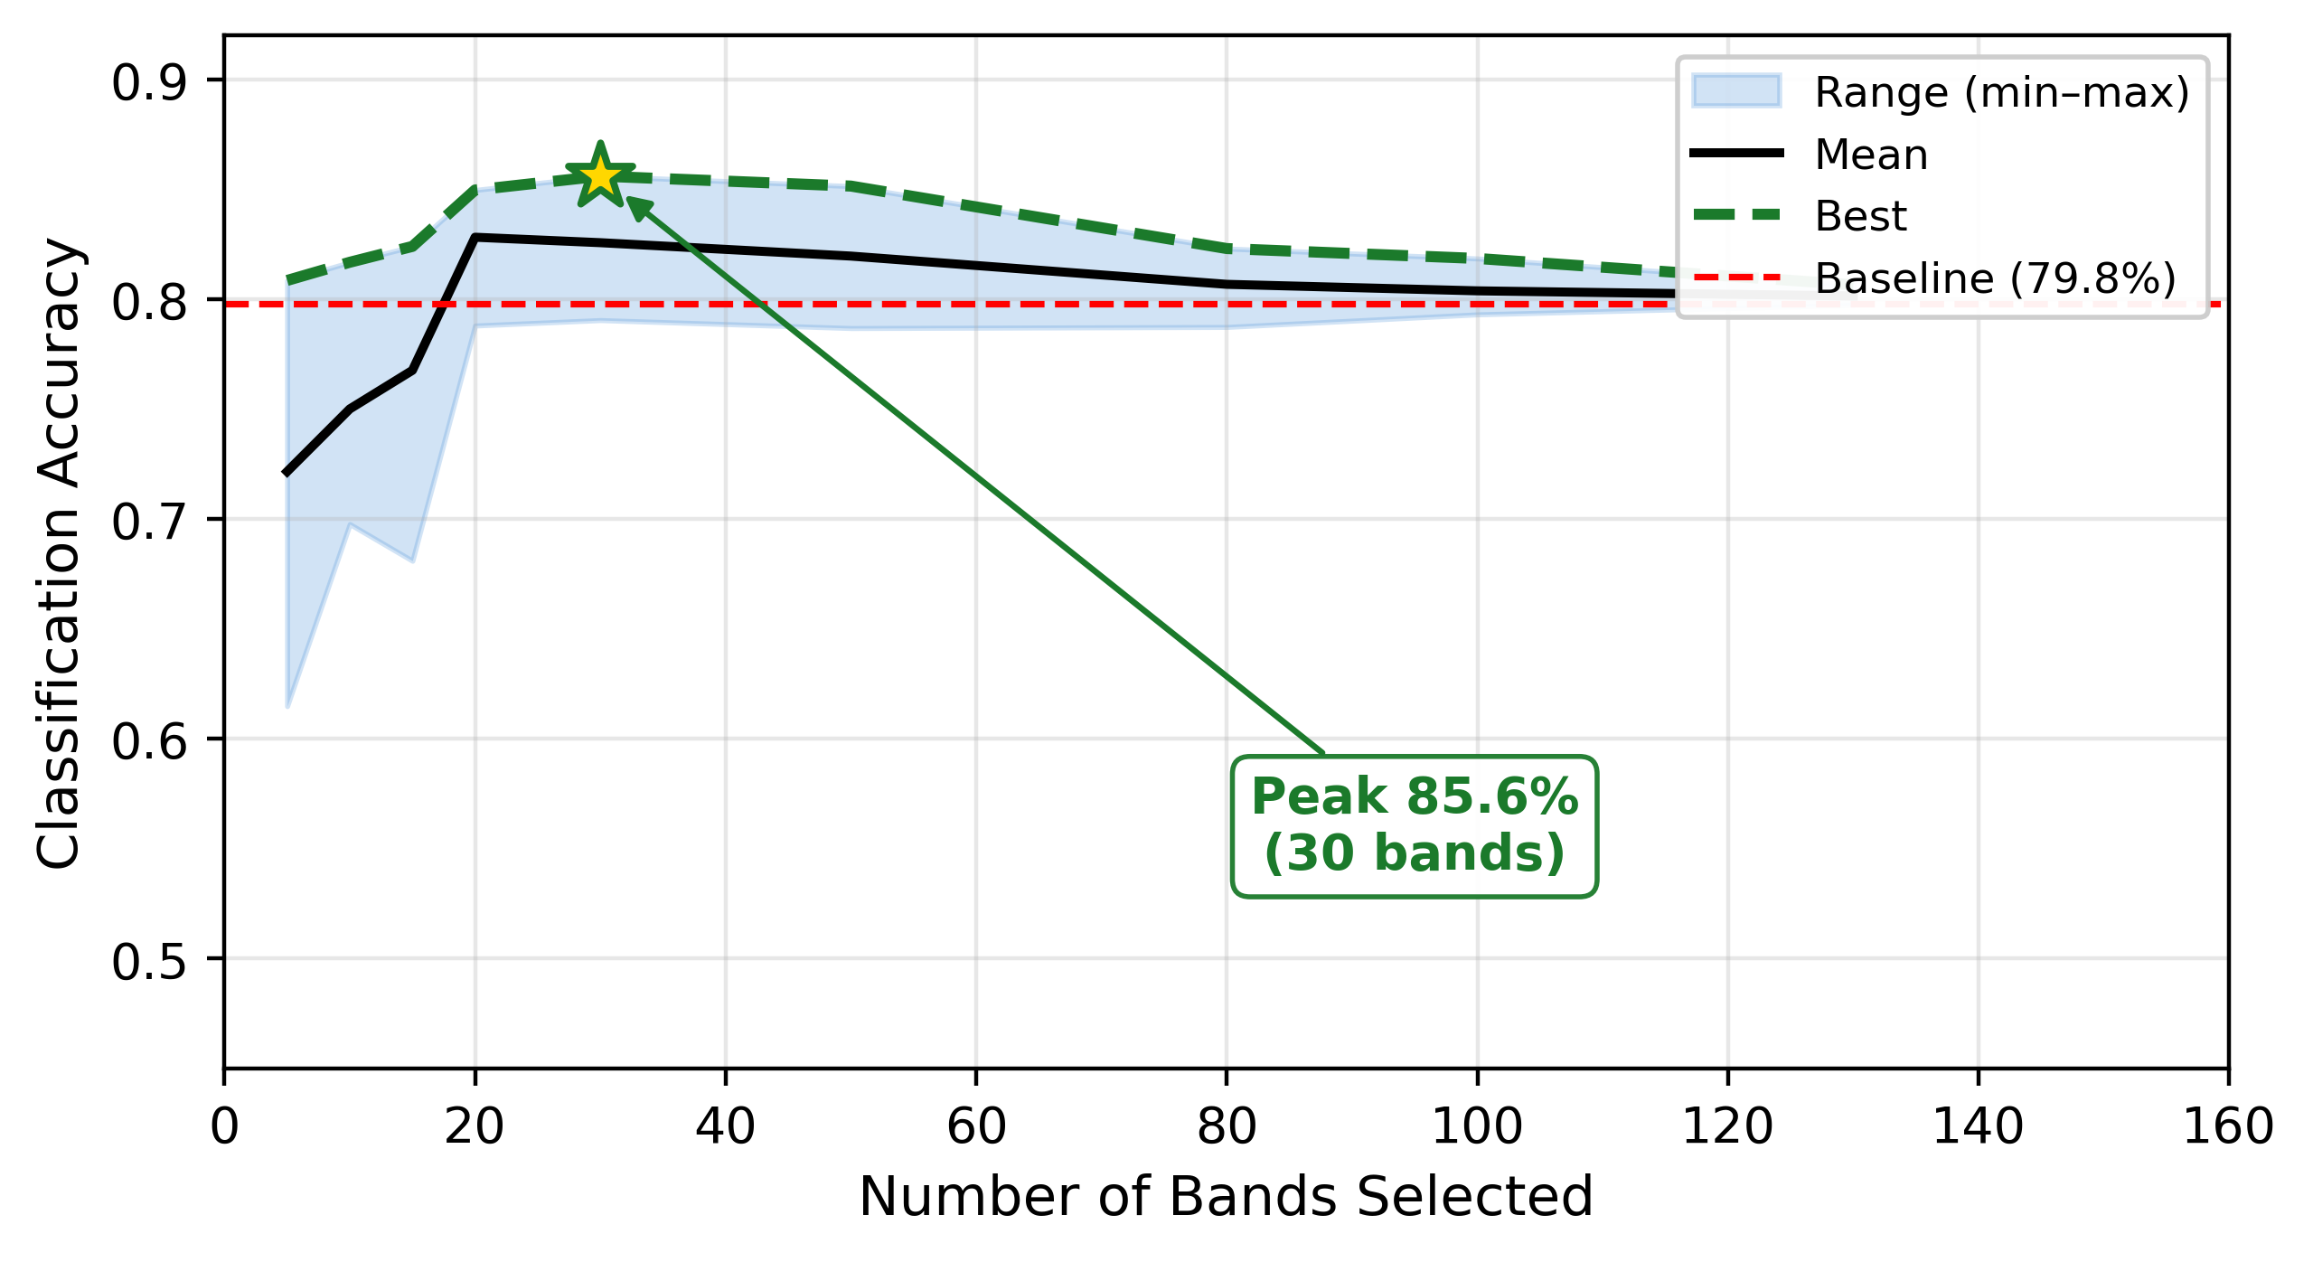
Fig. 1. Classification accuracy (KNN, k=5) versus number of selected bands across 432 configurations on the pepsin-digested collagen dataset. Blue band = min–max range; black = mean; green dashed = best per band count; red dashed = full-spectrum baseline (79.8%). Peak accuracy (85.6%) is reached at 30 bands - 81% data reduction.
Across 432 configurations, every band count between 5 and 130 exceeded the 158-band KNN baseline of 79.8%; peak accuracy reached 85.6% with 30 bands (81% compression, Fig. 1). The same selected wavelengths were evaluated with nine additional classifiers (LDA, linear and RBF SVM, random forests, gradient boosting, MLP). Linear Discriminant Analysis achieved 84.6% with only 5 bands (97% reduction) and 92.5% with 50 bands (68% reduction); all ten classifiers matched or exceeded their own baselines at 30–50 bands, confirming that the selected wavelengths carry classifier-independent discriminative information. These results demonstrate that the framework is generalizable, enabling shorter acquisitions with no loss of discriminative power and autonomous, unsupervised information detection pipeline.
References
1. W. Sun, Q. Du. Hyperspectral band selection: a review, IEEE Geosci. Remote Sens. Mag. 7 (2019) 118–139.
2. G. E. Hinton, R. R. Salakhutdinov. Reducing the dimensionality of data with neural networks, Science 313 (2006) 504–507.
3. J. Carbonell, J. Goldstein. The use of MMR, diversity-based reranking for reordering documents and producing summaries, Proc. ACM SIGIR (1998) 335–336.

