Collagen Sponges Dataset
Spectral-Select Framework: Methodology, Results, and SOTA Comparison

1. Introduction
The Collagen Sponges dataset is the secondary supervised benchmark of the spectral-select framework. It comprises ME-HSI acquisitions of collagen sponge samples prepared at three distinct crosslinker concentrations. Collagen autofluorescence in the near-UV/blue range is a well-established structural biomarker, and crosslinker concentration directly modulates the supramolecular organization of collagen fibrils, producing measurable shifts in both emission peak position and intensity.
The dataset tests whether the framework, tuned on lichen biology, transfers to a chemically distinct fluorophore family without modification. Spectral coverage is different (6 excitations vs 8), the class structure is different (3 chemical concentrations vs 4 morphological types), and the spatial layout is different (small sponge fragments vs lichen specimens). A successful transfer is therefore evidence of broader applicability.

2. Sample and Acquisition
Collagen sponges were prepared with three different crosslinker concentrations to induce distinct structural states. Each sample was imaged with the same Nuance FX system used for Lichens, but with a narrower excitation range (310-400 nm) chosen after preliminary tests showed that longer-UV excitations (415, 430 nm) added negligible discriminative signal for these samples.
Parameter | Value
Spatial dimensions | ~1040 x 925 pixels (sample-dependent)
Excitation wavelengths | 6 (310, 325, 340, 365, 385, 400 nm)
Emission range | 420-720 nm
Emission bands per excitation | 22-28 (variable after Rayleigh cutoff)
Total valid EEM pairs | 158
Spectral resolution | 10 nm
Ground-truth classes | 3 crosslinker concentrations
Annotated pixels | 39,970

3. Ground Truth and Validation Protocol
Three rectangular ROIs (one per concentration class) were delineated on the imaged sponges, providing 5,934 training pixels. The remaining 34,036 labeled pixels form the test set. This protocol matches the original sweep used to produce the IASIM 2026 abstract's headline numbers and is the same evaluation protocol used in the SOTA comparison (Section 6.6).

4. Methodology
The Collagen Sponges pipeline uses the identical spectral-select architecture and procedure as the Lichens evaluation: parallel-branch 3D convolutional autoencoder, latent-space perturbation-based attribution, and MMR diversity-aware selection. The full sweep explored 432 configurations spanning dimension method (variance, PCA), k (1, 3), perturbation method (percentile, absolute), magnitude regime (medium, high), normalization (none, max-per-excitation, variance), and band count K (1-180).
The only adjustment relative to Lichens is the number of excitations input to the autoencoder (6 vs 8 parallel branches). All hyperparameters (k1=k3=20 filters, 64x64 patches, Adam at lr=0.001, etc.) are identical.

5. Results

5.1 Headline: 7% Improvement Over Baseline at 81% Data Reduction
Using all 158 wavelength pairs with KNN-5 classification establishes a baseline of 79.78% accuracy (Cohen's kappa = 0.696). The best sweep result achieves 85.59% accuracy with 30 selected bands (81% data reduction, +5.8 pp above baseline). Every band count from 5 to 130 exceeds the baseline.
Bands | Reduction | Accuracy | F1 (wtd) | Kappa | Rel. Perf.
158 (baseline) | 0.0% | 0.7978 | 0.7889 | 0.6961 | 100.0%
5 | 96.8% | 0.8085 | - | 0.7126 | 101.3%
10 | 93.7% | 0.8167 | - | 0.7250 | 102.4%
15 | 90.5% | 0.8239 | - | 0.7359 | 103.3%
20 | 87.3% | 0.8496 | - | 0.7745 | 106.5%
30 (peak) | 81.0% | 0.8559 | - | 0.7838 | 107.3%
50 | 68.4% | 0.8514 | - | 0.7770 | 106.7%
80 | 49.4% | 0.8230 | - | 0.7345 | 103.2%

5.2 Accuracy Envelope (KNN)
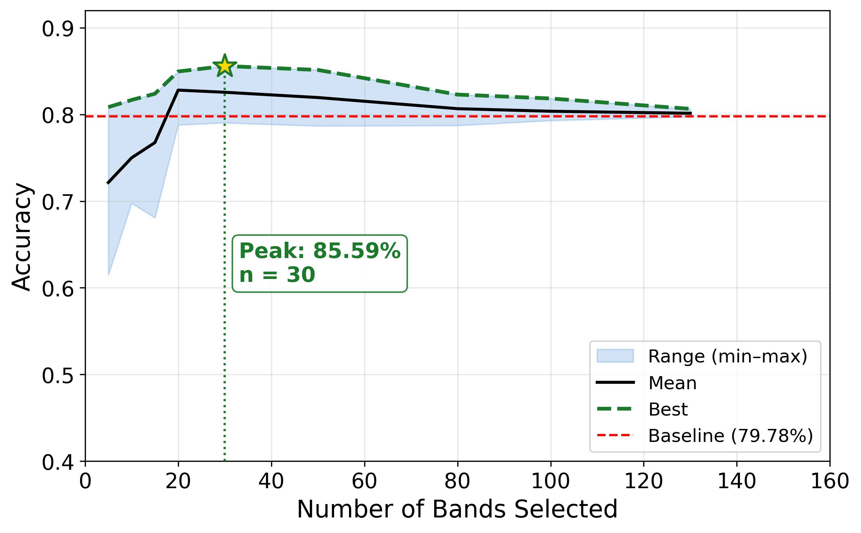
Figure 1. KNN-5 accuracy as a function of selected band count across the 432 configuration sweep. Peak at K=30 (85.59%); above-baseline performance maintained from K=5 to K=130.

5.3 Wavelength Importance Heatmap
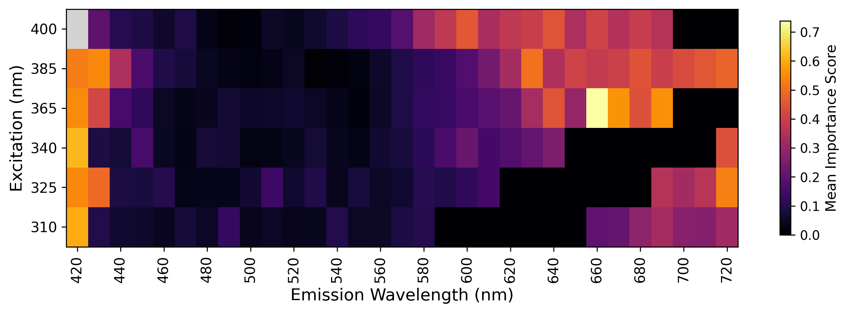
Figure 2. Mean wavelength importance across above-baseline configurations on Collagen Sponges. Importance concentrates at 470-530 nm emission and across excitations 365-400 nm, consistent with collagen autofluorescence in the near-UV regime.

5.4 Multi-Classifier Robustness
To verify that the selected bands carry information that is portable across classifier families, ten classifiers were evaluated on the K=30 selection: KNN (k=5 and k=11, uniform and distance-weighted), Linear Discriminant Analysis (LDA), Support Vector Machine (linear and RBF kernels), Multilayer Perceptron (MLP), Random Forest with 100 and 300 trees, and Gradient Boosting Machines.
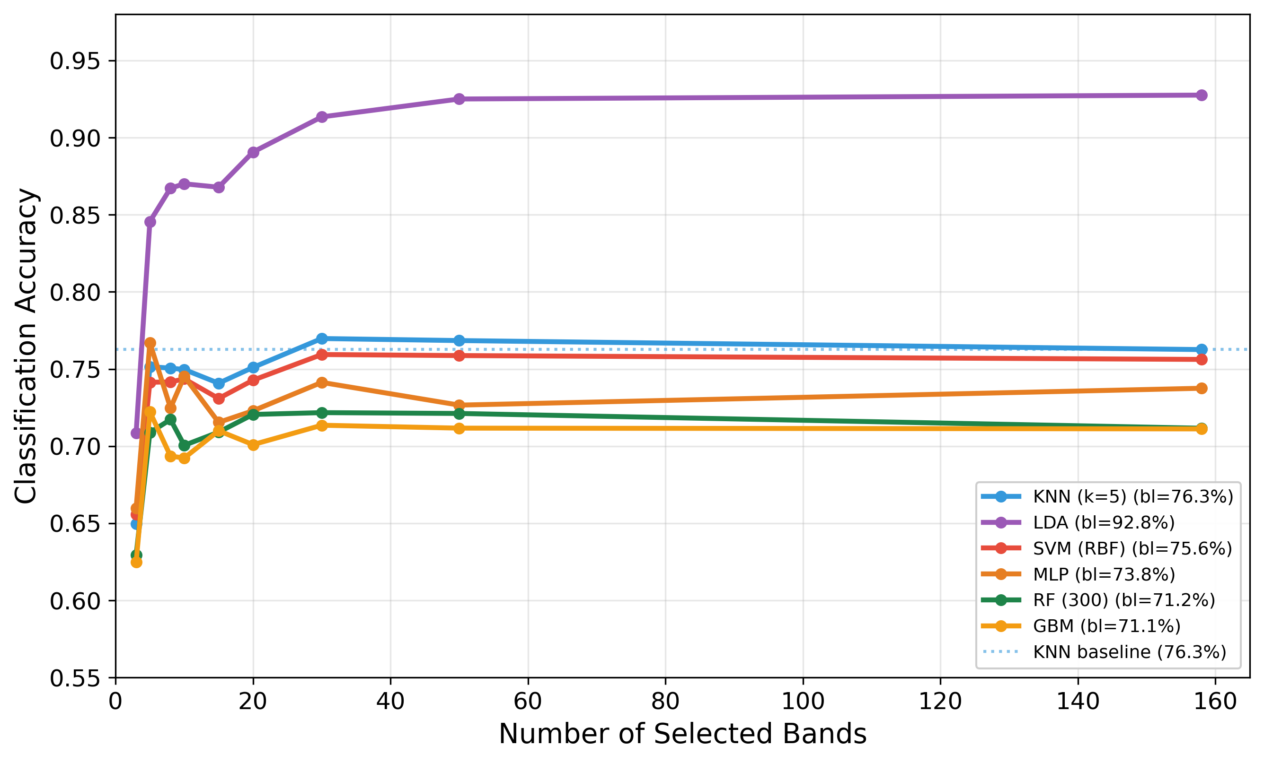
Figure 3. Accuracy vs band count for ten different classifiers. LDA (linear discriminant analysis) reaches 92.5% accuracy on the K=50 selection, very close to its 92.8% full-spectrum baseline -- demonstrating that the selected band set retains nearly all linearly separable structure.
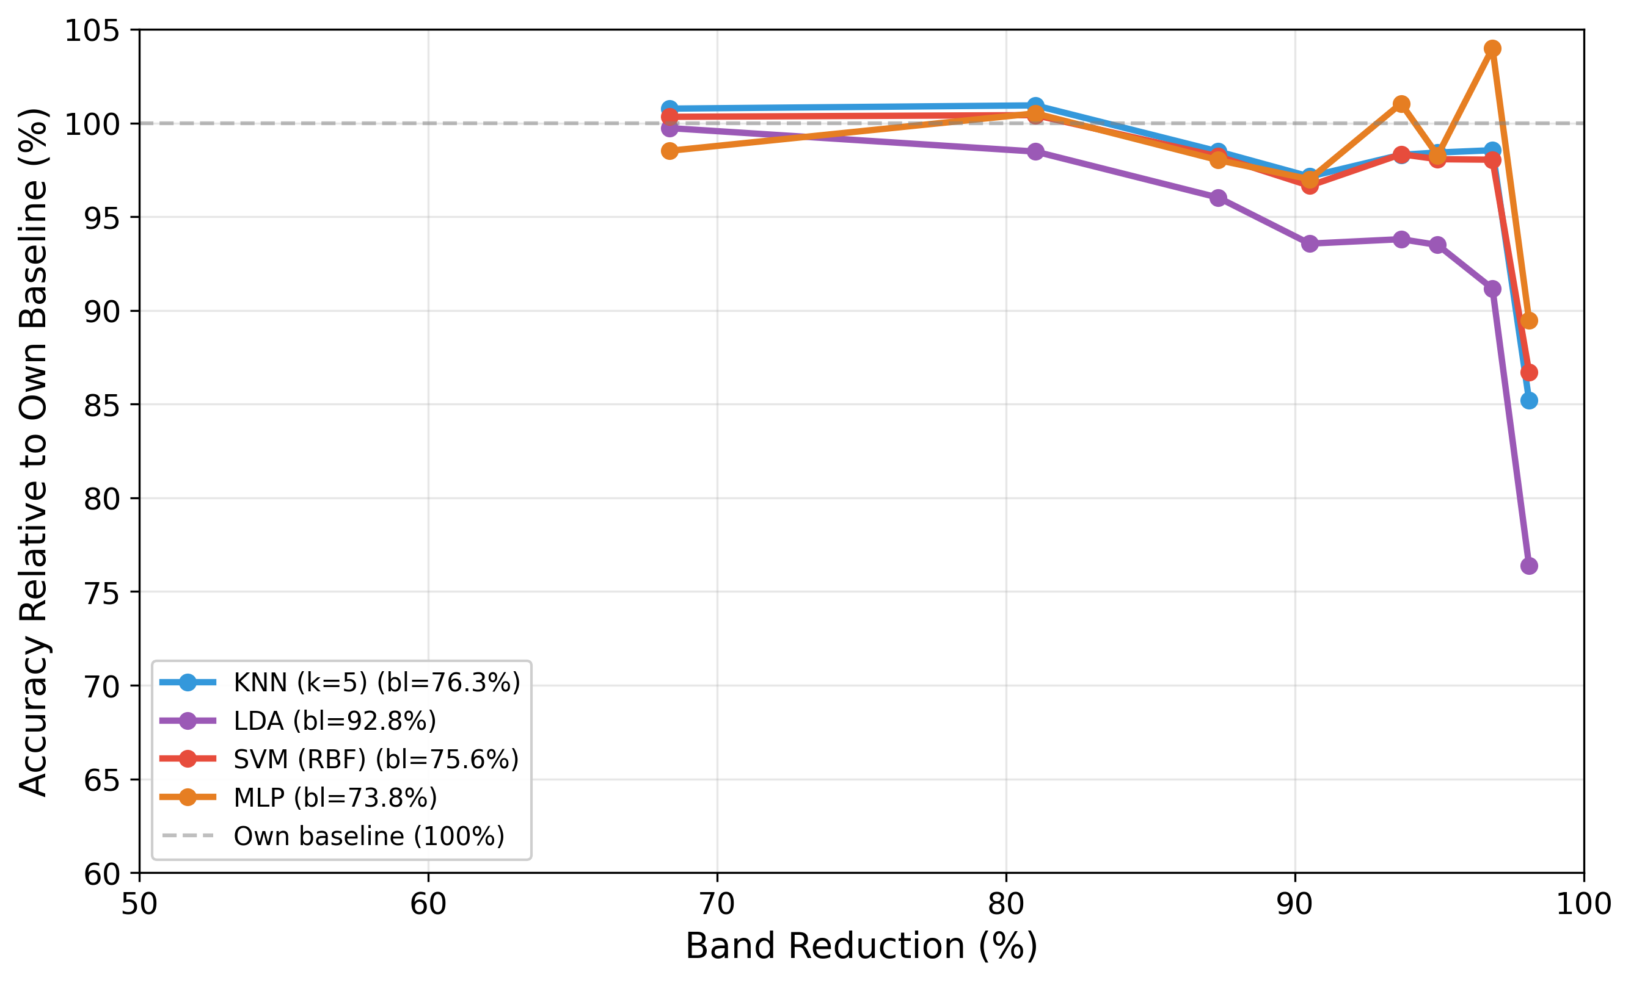
Figure 4. Computational efficiency vs accuracy trade-off across the K sweep. Inference cost scales as K/158, so K=30 selection is ~5x faster than the full spectrum.
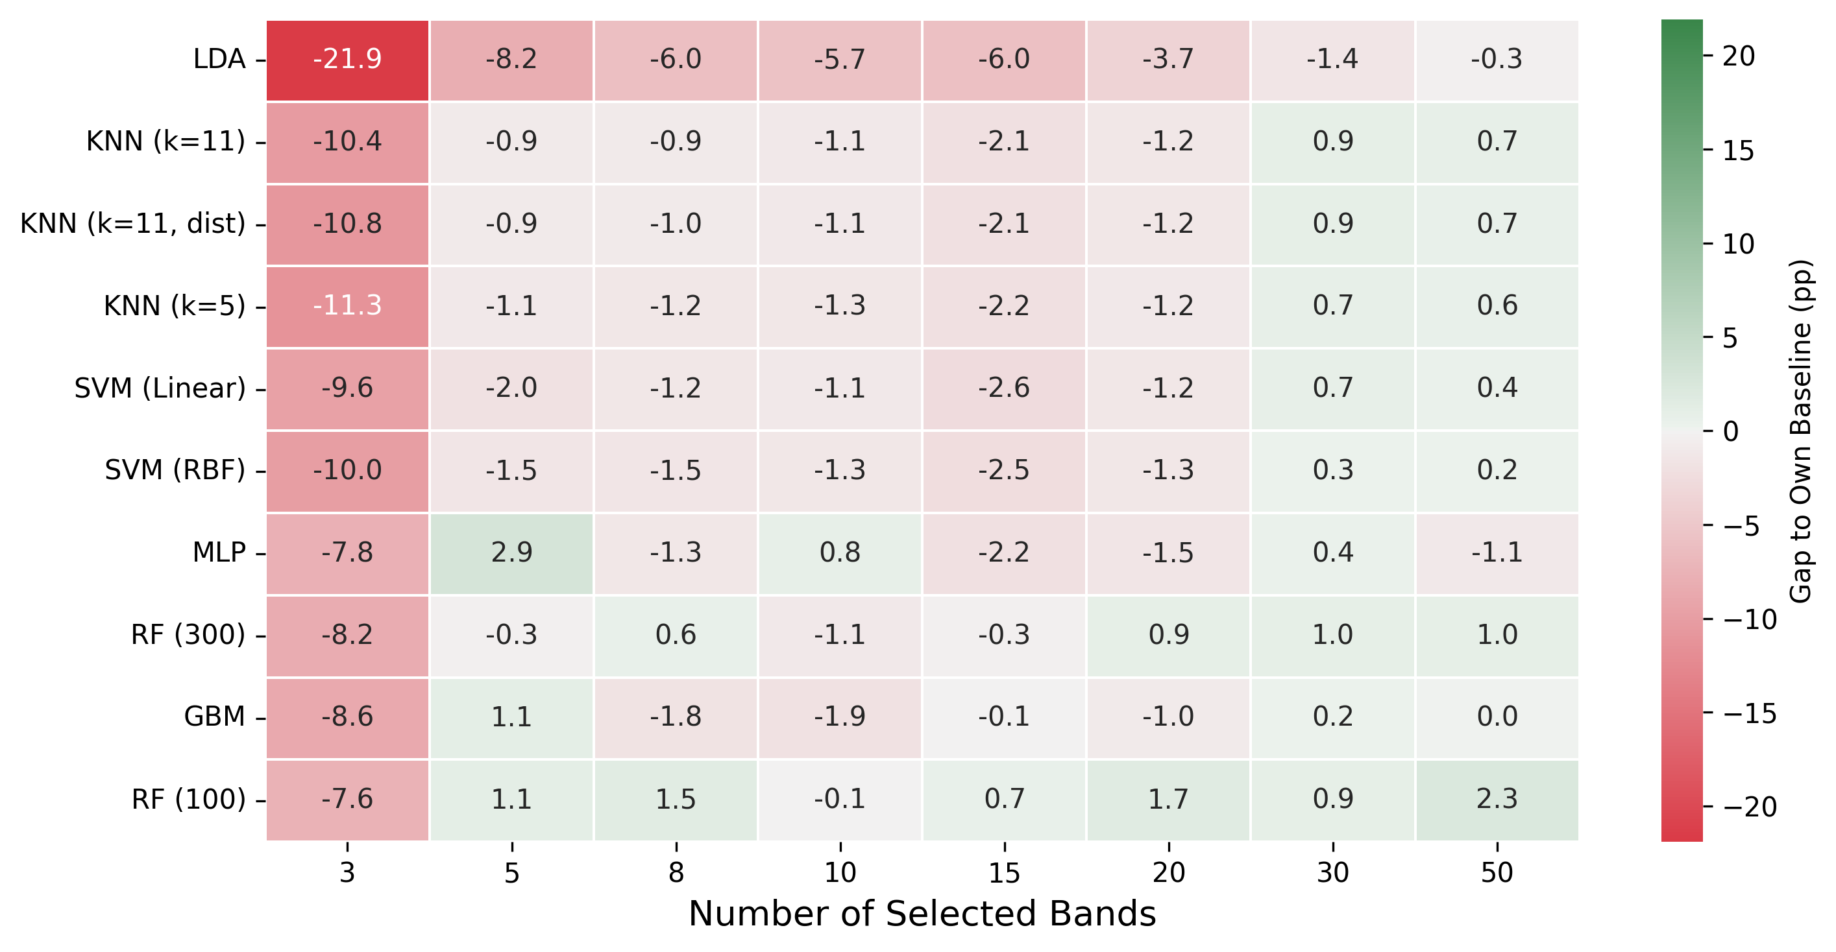
Figure 5. Per-classifier improvement (selected K=30 minus baseline) across all classifiers tested. Nine of ten classifiers improved with the selection.

5.5 State-of-the-Art Comparison
The proposed framework was compared against eight SOTA band-selection methods under the same ROI-train / rest-test protocol used in the original sweep. AE-perturb selections at each K are the best from the 48-configuration attribution sweep.
Method | K=5 | K=10 | K=15 | K=20 | K=30 | K=50
Proposed (AE-perturb) | 0.782 | 0.785 | 0.794 | 0.824 | 0.831 | 0.824
SAM-greedy | 0.658 | 0.759 | 0.776 | 0.795 | 0.820 | 0.808
SPA | 0.738 | 0.743 | 0.751 | 0.761 | 0.764 | 0.772
ISSC | 0.705 | 0.745 | 0.741 | 0.752 | 0.758 | 0.763
MCUVE | 0.672 | 0.662 | 0.688 | 0.693 | 0.708 | 0.697
Variance | 0.606 | 0.701 | 0.726 | 0.729 | 0.753 | 0.767
PCA-loading | 0.606 | 0.701 | 0.731 | 0.729 | 0.749 | 0.767
BS-Net-FC | 0.630 | 0.735 | 0.745 | 0.758 | 0.764 | 0.764
Sparse-LASSO (supervised) | 0.730 | 0.749 | 0.735 | 0.737 | 0.740 | 0.749
Random | 0.659 | 0.750 | 0.741 | 0.735 | 0.749 | 0.756
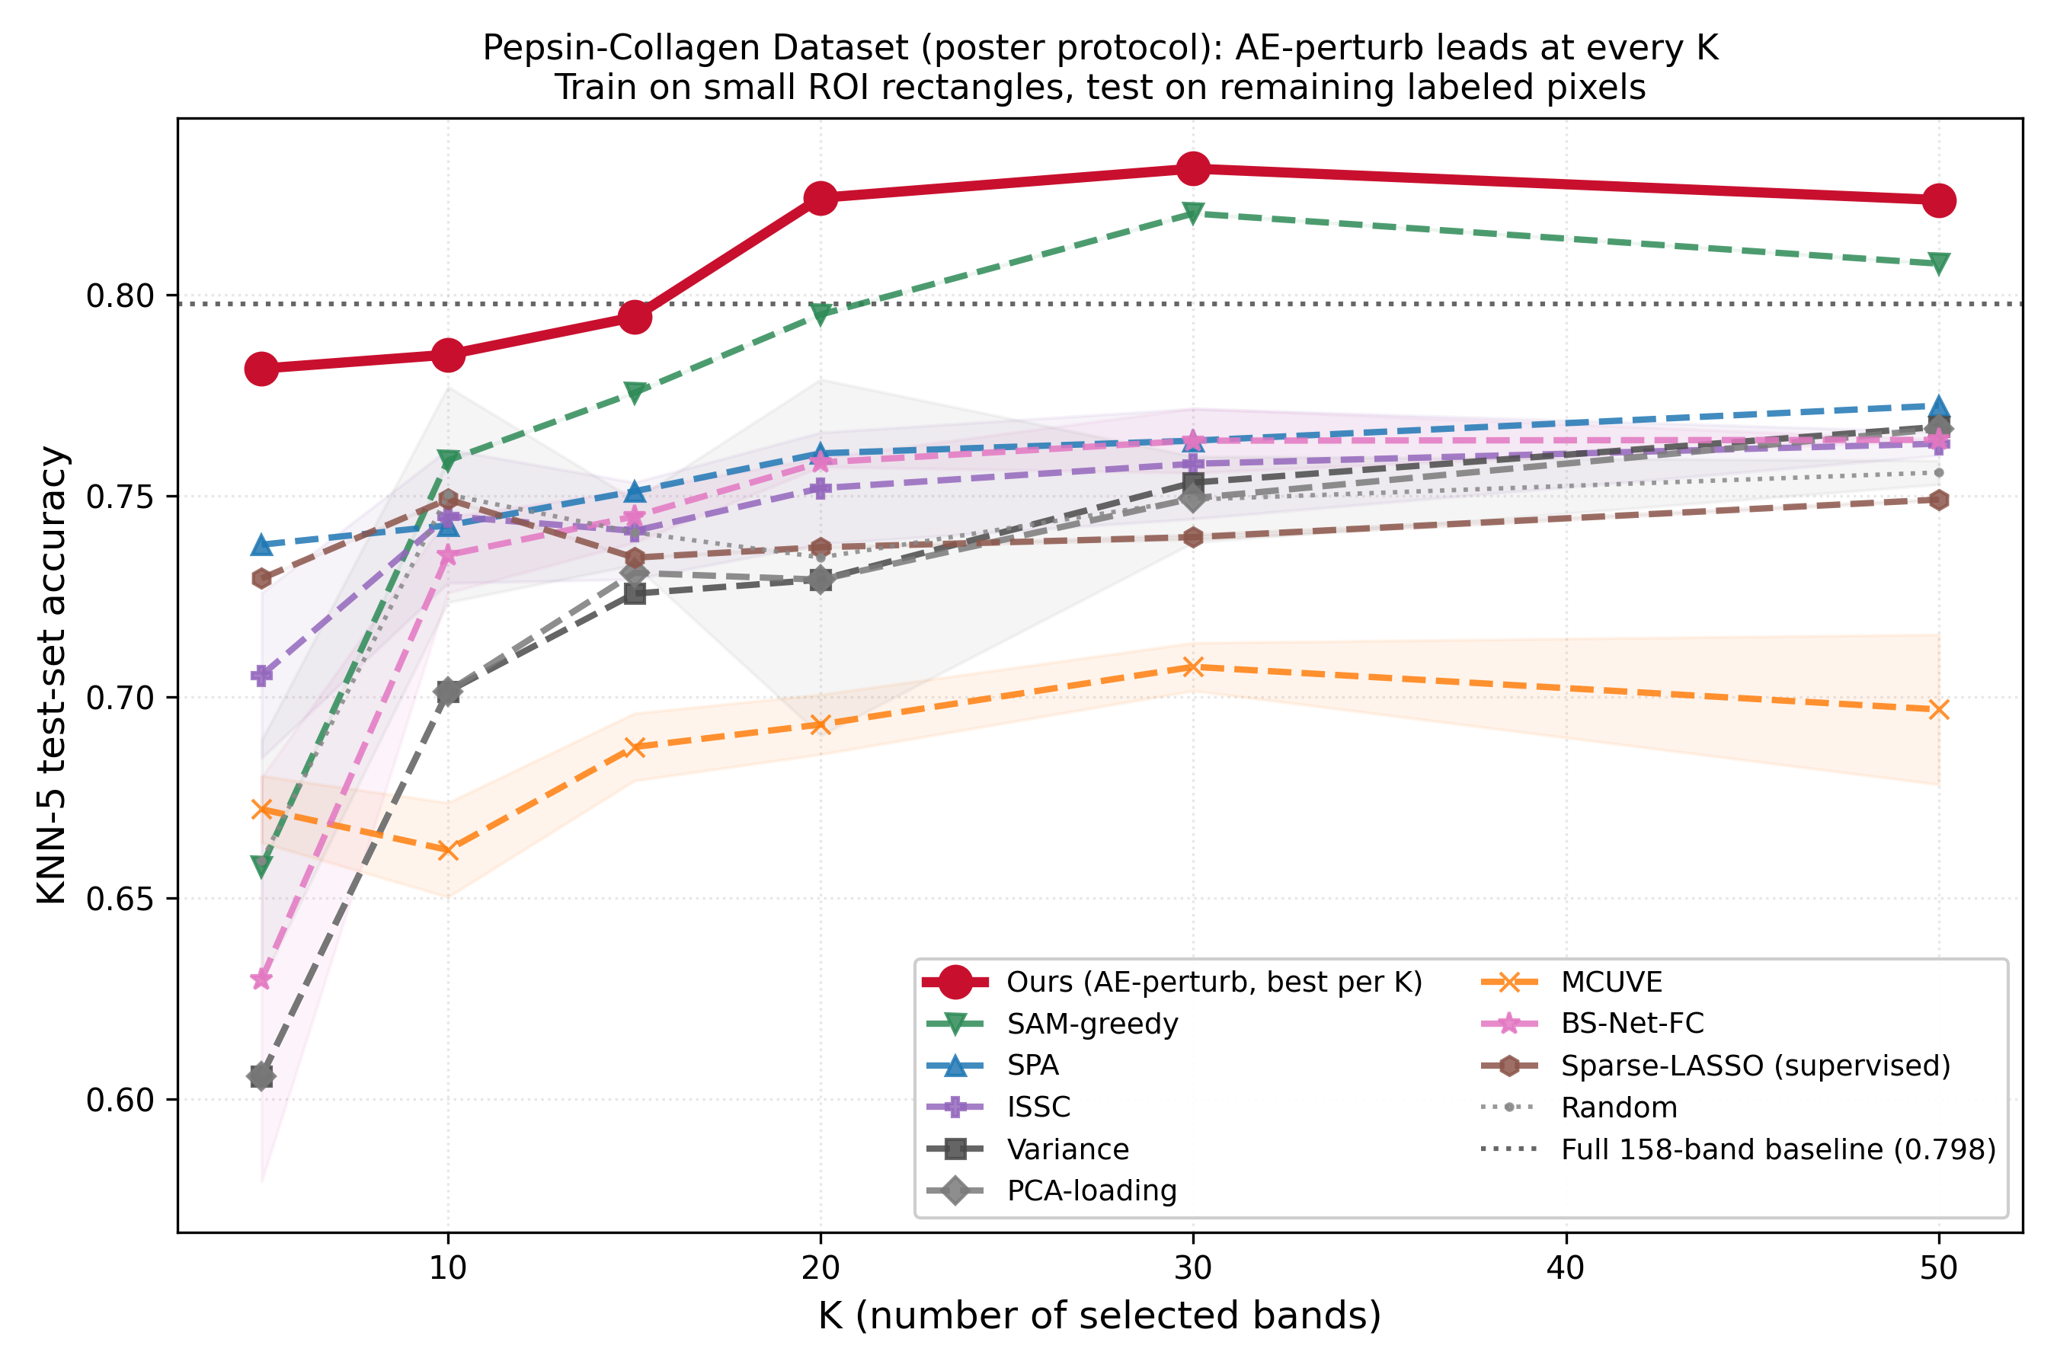
Figure 6. Collagen Sponges SOTA comparison under the ROI-train protocol. The proposed method (red) wins outright at every K, by margins of 1.1-7.5 percentage points over the next-best method. The dotted black line is the full 158-band baseline (0.798) -- only the proposed method crosses above it (at K=20).
Key observations:
- At K=20 (87% data reduction), AE-perturb already exceeds the full-spectrum baseline.
- At K=30 (81% reduction), AE-perturb achieves 0.831 -- the best result in the table.
- Supervised Sparse-LASSO underperforms because the small ROI training set provides limited label coverage of the spectral structure.
- Variance and PCA-loading consistently trail by 7-14 pp, refuting the hypothesis that gains derive from filter-style dimensionality reduction.

6. Conclusion
On the Collagen Sponges dataset, the spectral-select framework achieves 85.6% classification accuracy with 30 selected bands (81% data reduction, +5.8 pp above the 158-band baseline). Multi-classifier evaluation confirms the selected bands are intrinsically informative -- LDA reaches 92.5% on K=50, recovering near-baseline linear separability. In the SOTA comparison under the ROI-train / rest-test protocol, the framework wins outright at every K tested, by margins of 1.1-7.5 percentage points over the next-best method. The K=20 selection already exceeds the full-spectrum baseline at 87% data reduction. Cross-domain transfer from lichen biology to collagen sponges is therefore successful without any framework modification.

