Lichens Dataset
Spectral-Select Framework: Methodology, Results, and SOTA Comparison

1. Introduction
The Lichens dataset is the primary supervised benchmark of the spectral-select framework. It consists of multi-excitation hyperspectral imaging (ME-HSI) acquisitions of lichen specimens, composite organisms formed by symbiotic associations between fungi and photosynthetic partners. Their autofluorescence signatures reflect both fungal and algal components, with substantial inter-class overlap that makes wavelength selection non-trivial.
The dataset has driven the original framework design: 192 valid excitation-emission (EEM) pairs, 4 morphological classes, and an exhaustive sweep of 3,072 configurations covering all combinations of dimension-scoring method, perturbation parameters, normalization strategy, and band count.

2. Sample and Acquisition
Lichen specimens (~7x7 mm pieces) of three species were arranged in a 4x4 grid on an imaging stage: Ramalina Sinesis (back and front), Flavopunctelia Soredica, and Ramalina Fraxinea. Imaging used an LED-based multi-excitation source (WheeLED, Mightex, Toronto, CA) spanning 310-440 nm and a Nuance FX hyperspectral camera (PerkinElmer, Waltham, MA) capturing emission spectra from 420 to 720 nm in 10-nm steps at each excitation.
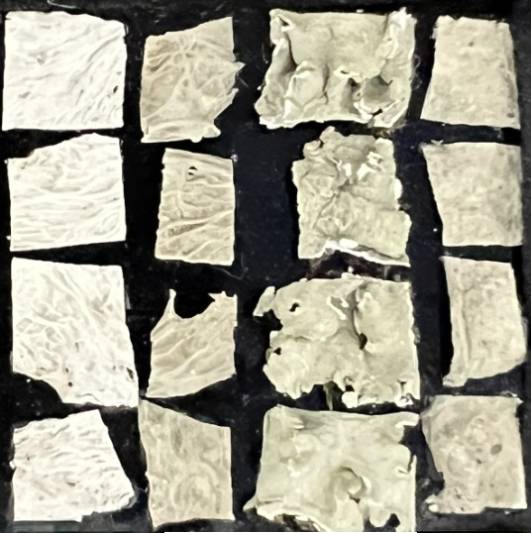
Figure 1. Visual appearance of the four lichen specimens used in this study.
Parameter | Value
Spatial dimensions | 1040 x 925 pixels
Excitation wavelengths | 8 (310, 325, 340, 365, 385, 400, 415, 430 nm)
Emission range | 420-720 nm
Emission bands per excitation | 22-28 (variable after Rayleigh cutoff)
Total valid EEM pairs | 192
Spectral resolution | ~12.5 nm
Ground-truth classes | 4 distinct lichen morphological types
Annotated pixels | 191,046

3. Ground Truth and Validation Protocol
Ground-truth annotations were generated based on the knowledge of the origins of each lichen species obtained from the Takhtajyan Institute of Botany, National Academy of Sciences of Armenia. Four small rectangular regions of interest (ROIs) were delineated, providing 11,519 training pixels distributed across the 4 classes. The remaining 179,527 labeled pixels form the test set.
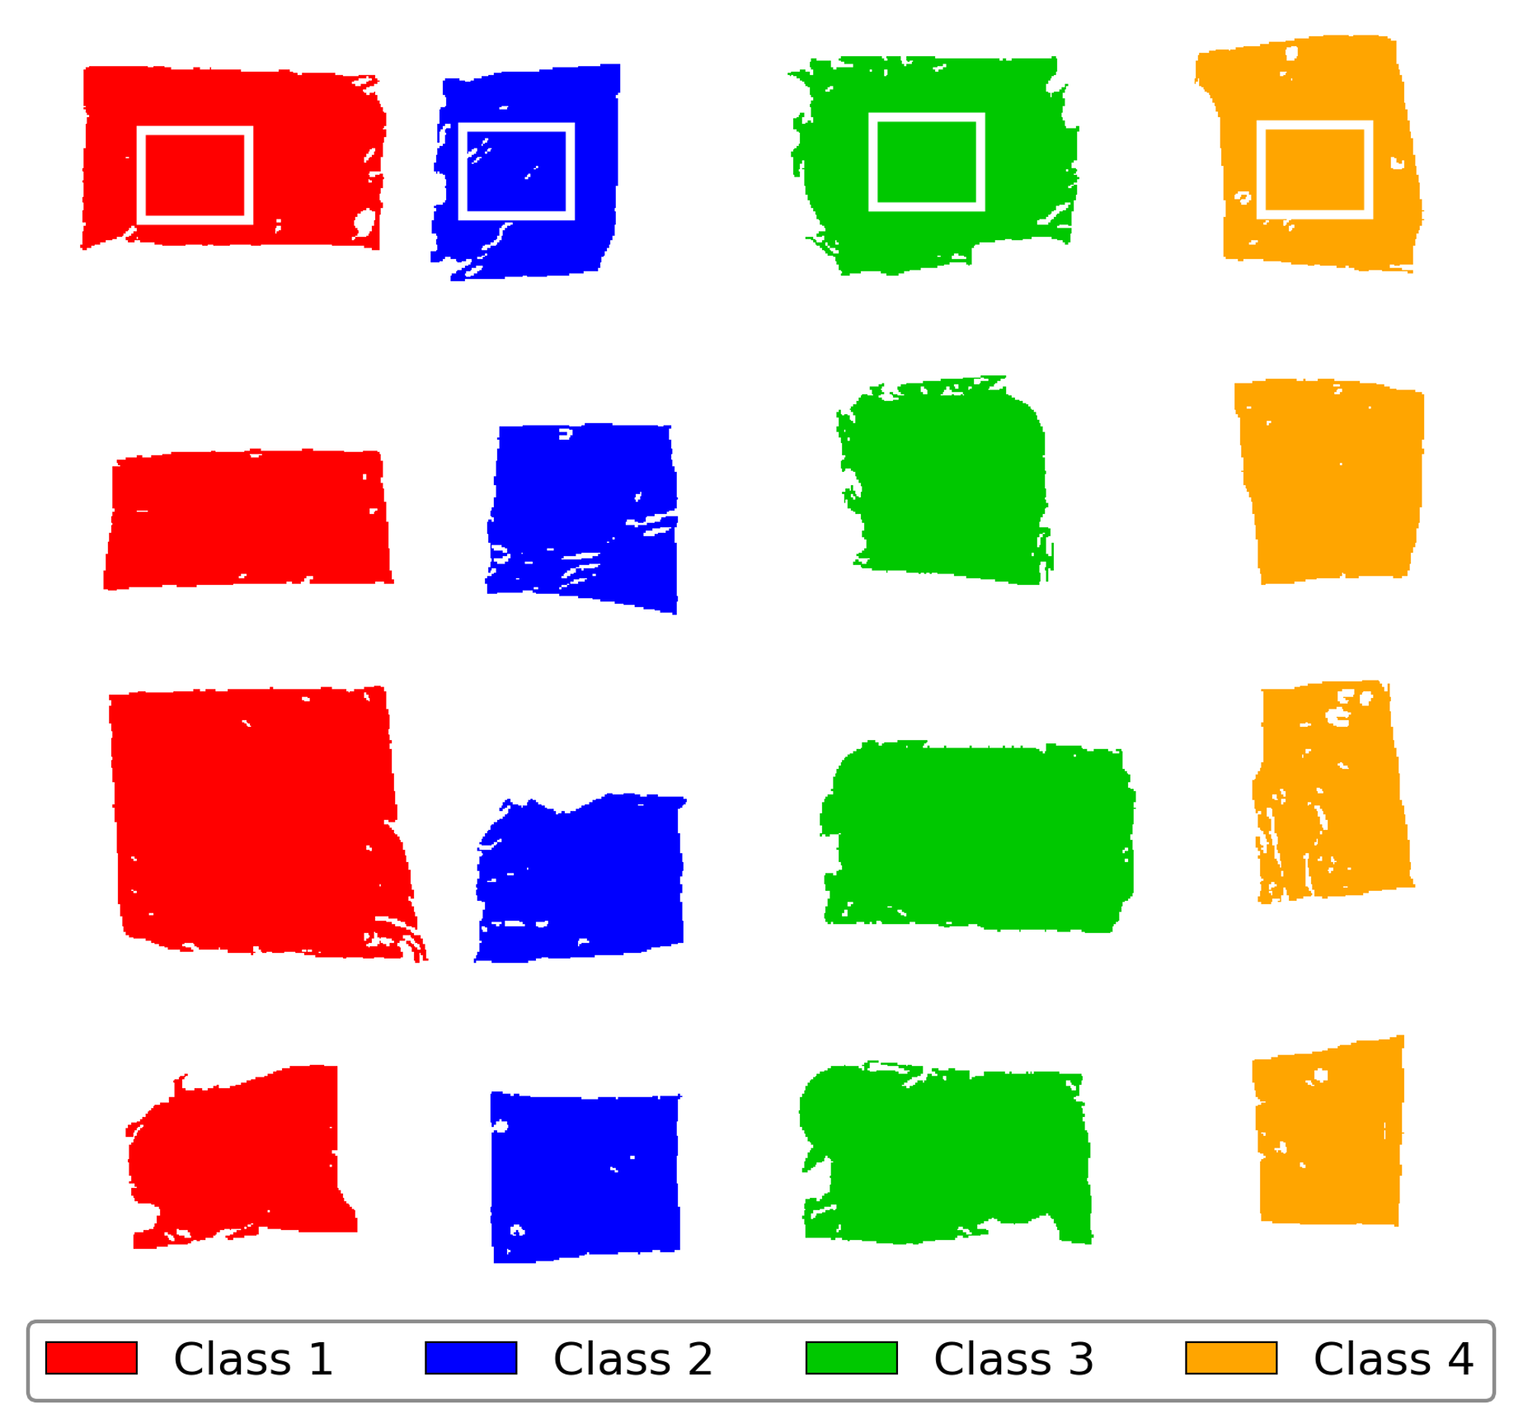
Figure 2. Ground-truth annotation and baseline classification using all 192 bands. Sixteen lichen specimens are arranged in a 4x4 grid; columns correspond to the four morphological types. The small square ROIs (top row, ~50x60 pixels each) provide training exemplars; the rest of each specimen is the test set.

4. Methodology
The spectral-select pipeline has three stages: representation learning, attribution, and selection.

4.1 3D Convolutional Autoencoder
An autoencoder with one parallel encoder branch per excitation processes the 4D cube. Each branch applies a Conv3D layer with 20 filters of size 5x5xmin(5, Nem). Features from all 8 branches are averaged into a shared latent representation of dimension 20x1xHxW. The decoder mirrors the encoder with parallel reconstruction branches per excitation. Training uses masked MSE loss (background masking excludes non-sample pixels), Adam optimizer at lr=0.001, batch size 32, patch size 64x64. Typical convergence: 25-30 epochs.

4.2 Latent-Space Perturbation
After training, the top-k latent dimensions are ranked by either variance or by their Principal Component Analysis loadings. For each top-k dimension d, the latent code is perturbed by +/- epsilon * sigma_d * e_d (the d-th basis vector scaled by the dimension's standard deviation). The reconstruction sensitivity per band, averaged over patches and aggregated across epsilon values, produces a per-band influence score. Two perturbation regimes were swept: medium {30, 40, 50} and high {50, 60, 70}.

4.3 Maximum Marginal Relevance (MMR) Selection
MMR with lambda=0.5 converts the influence matrix into an ordered list of K bands, balancing per-band relevance against spectral diversity (cosine similarity penalty between selected bands). The output is an ordered selection that can be thresholded at any K depending on the accuracy-efficiency trade-off.

5. Configuration Sweep
3,072 configurations were swept across all dimensions of the framework:
- Dimension-scoring method: Variance or PCA
- Number of dimensions k: 1 or 3
- Perturbation method: Percentile-based or absolute-range
- Perturbation magnitude: medium or high regime
- Influence normalization: none, max-per-excitation, or variance
- Band count K: 64 values from 1 to 180

6. Results

6.1 Headline: Baseline-Exceeding Performance at 95% Data Reduction
Using all 192 wavelength pairs with KNN-5 classification establishes a baseline of 88.15% accuracy (Cohen's kappa = 0.842). The best configuration sweep result achieves 95.2% accuracy with only 80 bands (58% data reduction), and maintains 89.4% accuracy down to 9 bands (95% data reduction).
Bands | Reduction | Accuracy | F1 (wtd) | Kappa | Rel. Perf.
192 (baseline) | 0.0% | 0.8815 | 0.8824 | 0.8416 | 100.0%
80 (peak) | 58.3% | 0.9523 | 0.9523 | 0.9357 | 108.0%
60 | 68.8% | 0.9451 | 0.9451 | 0.9260 | 107.2%
50 | 74.0% | 0.9404 | 0.9407 | 0.9198 | 106.7%
30 | 84.4% | 0.9300 | 0.9305 | 0.9058 | 105.5%
20 | 89.6% | 0.9171 | 0.9181 | 0.8887 | 104.0%
13 | 93.2% | 0.9016 | 0.9024 | 0.8684 | 102.3%
9 (efficient) | 95.3% | 0.8943 | 0.8948 | 0.8588 | 101.5%
5 | 97.4% | 0.8698 | 0.8713 | 0.8260 | 98.7%
3 | 98.4% | 0.8267 | 0.8274 | 0.7684 | 93.8%

6.2 Accuracy-Reduction Trade-off
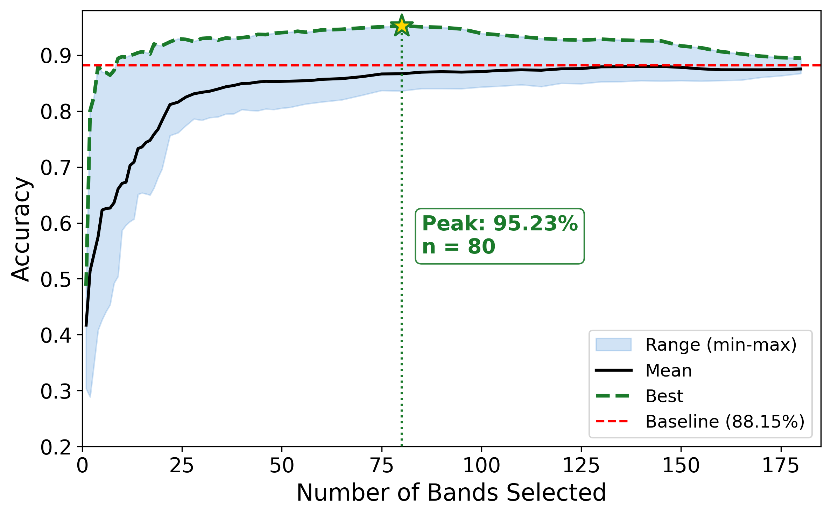
Figure 3. Classification accuracy envelope across 3,072 configurations as a function of band count. Selection peaks at K=80 (95.2%), with above-baseline performance maintained from K=9 to K=100.

6.3 Spatial Classification Maps
The maps below visualize classification performance pixel-by-pixel for three configurations: full 192-band baseline, optimal 80-band selection, and efficient 9-band selection. The 80-band selection produces visibly cleaner specimen boundaries and reduced inter-class confusion compared to the baseline.
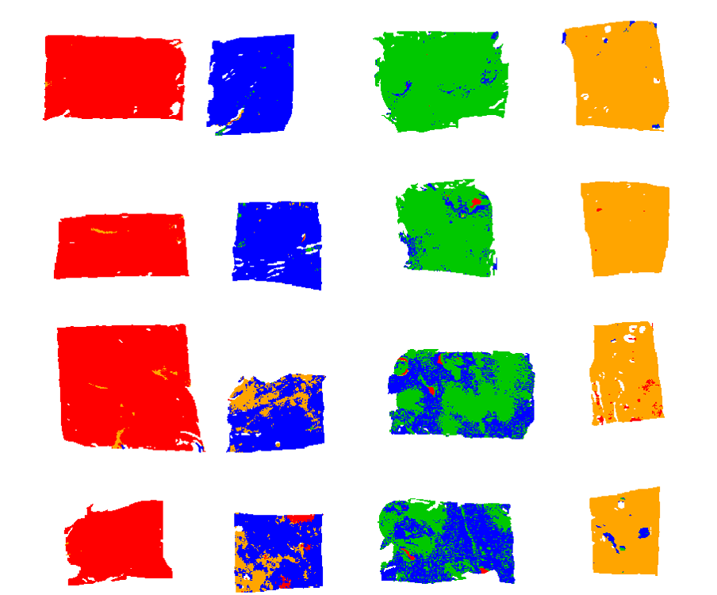
Figure 4. Baseline classification map using all 192 wavelength pairs (88.2% accuracy).
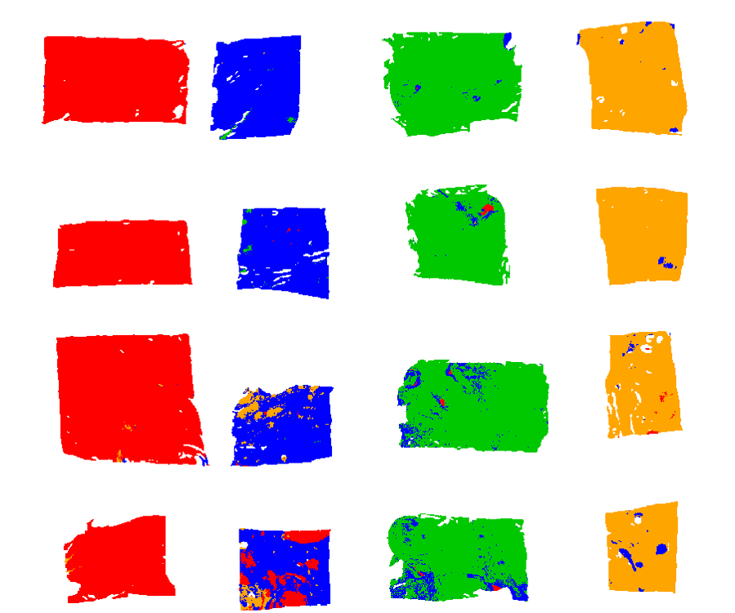
Figure 5. Best classification map using 80 selected bands (95.2% accuracy, 58% data reduction).
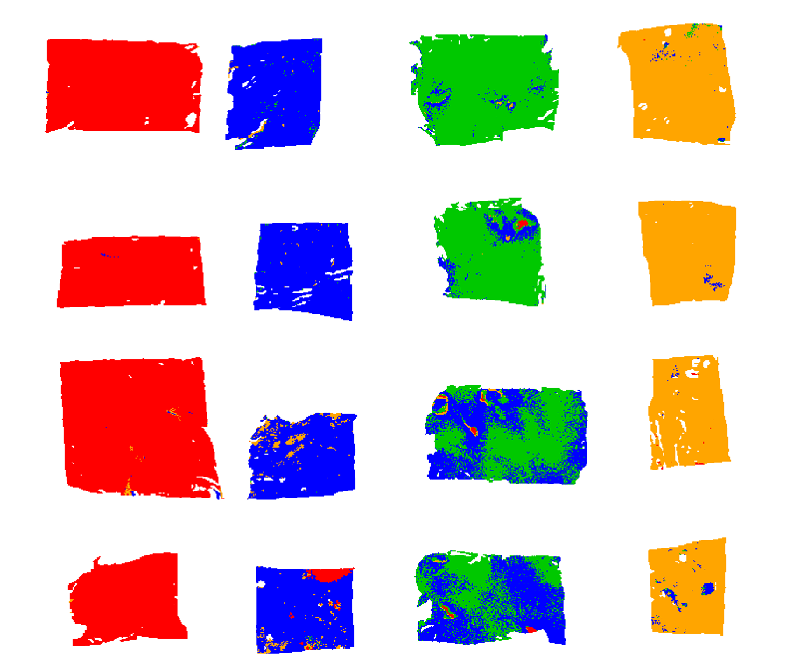
Figure 6. Efficient classification map using only 9 selected bands (89.4% accuracy, 95% data reduction).

6.4 Robustness vs Random Selection
To verify that performance reflects genuine wavelength selection intelligence rather than chance, the 13-band selection was compared against 10,000 randomly generated 13-band combinations from the 192 available bands.
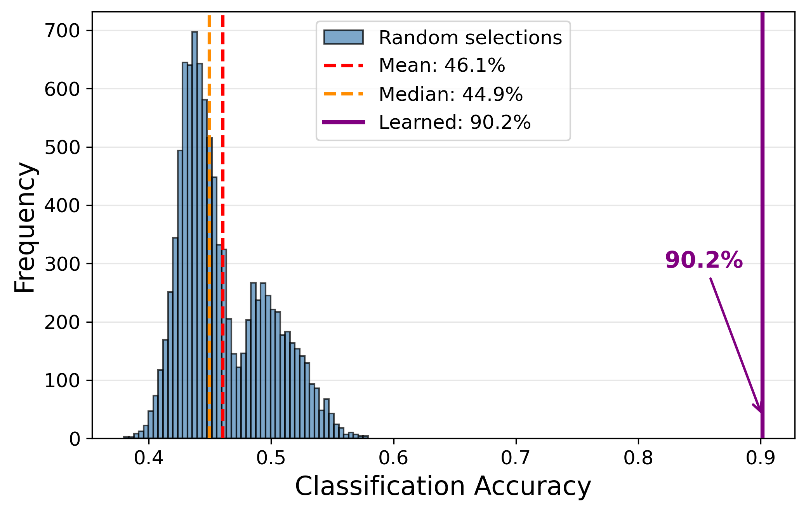
Figure 7. Distribution of accuracies for 10,000 random 13-band combinations (mean 46.1%, max 57.9%). The learned selection (90.2%) lies 12 standard deviations above the random mean, statistically far beyond p << 10e-20.

6.5 Wavelength Importance Heatmap
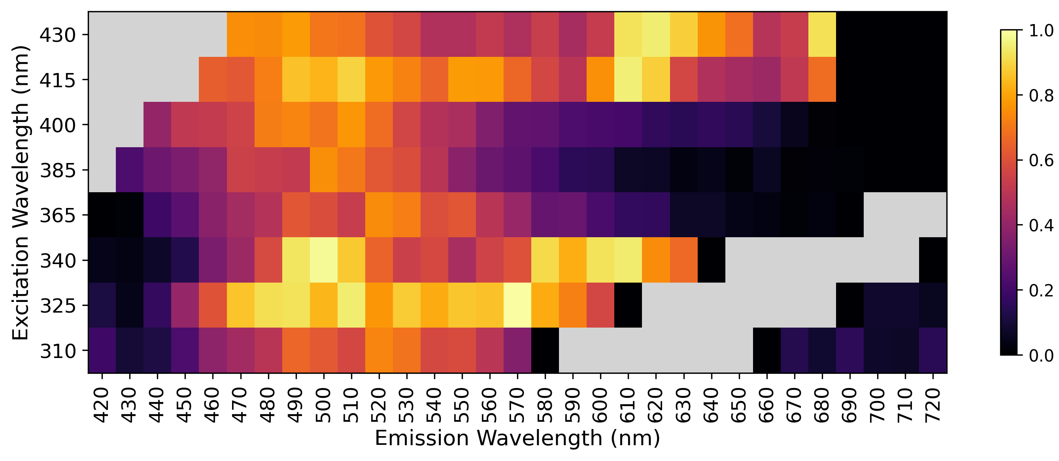
Figure 8. Mean wavelength importance score across all above-baseline configurations. Each cell shows the normalized average rank (1.0 = consistently top, 0.0 = lowest) for each (lambda_ex, lambda_em) pair. Grey cells: Rayleigh-invalid positions.
The 9-band optimal configuration selects exactly one wavelength from each of the 8 excitation sources, with emission peaks spanning 500-680 nm. This one-per-excitation pattern is consistent with the parallel-branch architecture and provides directly actionable sensor-design guidance: coverage across the full excitation range is essential, but only a single emission band per excitation is needed for effective discrimination.

6.6 State-of-the-Art Comparison
The proposed framework was compared against eight band-selection methods spanning filter, wrapper, cluster-based, deep, and supervised-embedded categories. All methods evaluated using stratified 5-fold cross-validation with KNN-5 classifier on a balanced 4,000-pixel subset.
Method | K=5 | K=13 | K=30 | K=80
Proposed (AE-perturb) | 0.934 | 0.971 | 0.977 | 0.985
BS-Net-FC (Cai 2020) | 0.934 | 0.972 | 0.976 | 0.974
SPA | 0.956 | 0.972 | 0.972 | 0.985
ISSC | 0.679 | 0.967 | 0.978 | 0.971
MCUVE | 0.558 | 0.743 | 0.938 | 0.982
SAM-greedy | 0.685 | 0.651 | 0.853 | 0.948
Variance | 0.547 | 0.606 | 0.970 | 0.987
PCA-loading | 0.547 | 0.606 | 0.970 | 0.987
Sparse-LASSO (supervised) | 0.939 | 0.985 | 0.988 | 0.985
Random | 0.934 | 0.965 | 0.958 | 0.973
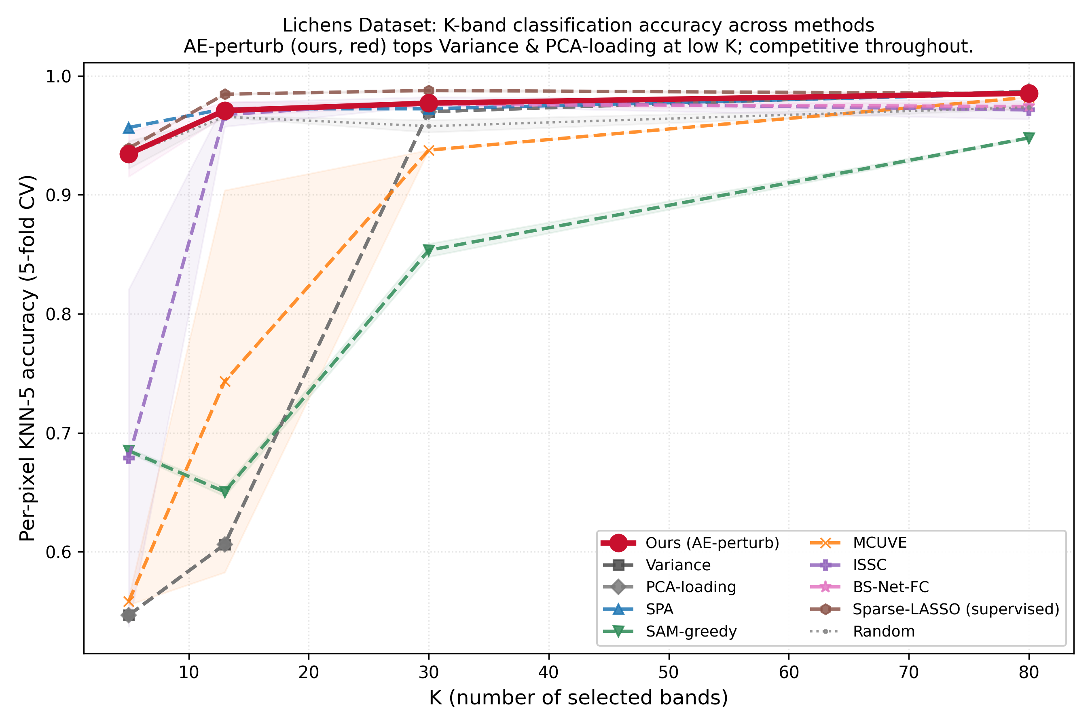
Figure 9. Lichens SOTA comparison: KNN-5 accuracy vs K for the proposed method (red) and 8 baselines. The proposed method is in the top tier at every K. Variance and PCA-loading filter baselines collapse below 0.55 at K=5; the proposed method retains 0.934 at the same K.

7. Conclusion
On the Lichens dataset, the spectral-select framework achieves 95.2% classification accuracy with 80 selected bands (58% data reduction, +7.0 pp above the 192-band baseline), and maintains 89.4% accuracy down to 9 bands (95% reduction). The 9-band configuration's one-per-excitation pattern provides direct sensor-design guidance. In a head-to-head comparison against eight competing methods, the framework is in the top tier at every K and is the only unsupervised method that retains high accuracy at extreme low-K settings, where the variance and PCA filter baselines collapse.

