Label-Free, Dependency-Aware Channel Selection
for Coupled Multi-Channel Sensor Data
Narek Meloyan, Aleksandr Hayrapetyan, and Narine Sarvazyan
American University of Armenia, Yerevan, Armenia
{narek.meloyan, aleksandr.hayrapetyan, nsarvazyan}@aua.am

Abstract—Modern sensing systems produce many channels that are highly correlated and organized into coupled groups. Choosing a small, interpretable subset of the original channels—without labels—reduces cost and complexity, but existing options force a trade-off: unsupervised filters (variance, PCA) ignore inter-channel dependency, while dependency-aware selectors (mRMR, JMI) require labels. We present an unsupervised method that captures channel dependency directly. A group-structured autoencoder learns a joint representation across channel groups; each channel's importance is measured by the sensitivity of the reconstruction to perturbations of the learned latent factors; and a relevance-redundancy criterion selects a diverse, informative subset of the actual channels. The method is discrete—it returns real channels, not a projection—and interpretable. Originally developed for multi-excitation hyperspectral imaging, where it identifies discriminative wavelength bands and outperforms classical band-selection baselines, the same selection procedure transfers to a very different modality with only a domain-appropriate encoder. On a standard wearable-sensor human-activity-recognition benchmark, evaluated with leave-one-subject-out cross-validation, the label-free method matches supervised mutual-information selection and is substantially more stable across subjects than variance-based selection. A single dependency-aware, label-free selection principle thus generalizes across markedly different sensor modalities.
Index Terms—unsupervised feature selection, channel selection, conditional relevance, autoencoders, interpretability, human activity recognition, hyperspectral imaging.
I. INTRODUCTION
Complex sensors emit many channels that overlap heavily and arrive in natural groups—the three axes of one inertial unit, or the emission bands of one excitation. For cost, power, and interpretability one often wants to retain only a handful of the actual channels, not a learned mixture of them. Existing selectors force a trade-off. Unsupervised filters such as variance ranking and PCA judge each channel by its marginal statistics and ignore inter-channel dependency. Dependency-aware selectors such as mRMR and JMI model conditional relevance but require labels. The cell that is label-free, dependency-aware, and discrete is sparsely populated; this work targets it and, more importantly, shows that one such method generalizes across very different sensor modalities.
II. METHOD
The method has three stages (Fig. 1). First, a group-structured autoencoder is trained by reconstruction alone—no labels: each channel group is encoded separately, the per-group features are mean-fused into a shared latent representation, and the latent is decoded back to each group. Second, perturbation-based attribution nudges individual latent factors and measures how much each channel's reconstruction changes; channels the model relies on react strongly. Third, a relevance-redundancy (maximal marginal relevance) criterion greedily selects channels that are individually informative yet non-redundant with those already chosen. The output is a discrete, ordered, interpretable subset of the real channels that can be thresholded to any target size.

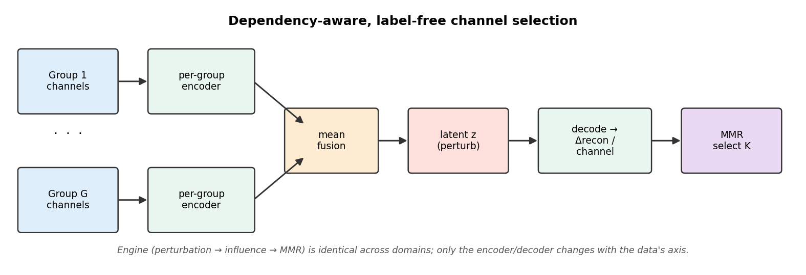
Fig. 1. The selection pipeline. The engine (perturbation → per-channel influence → relevance-redundancy selection) is identical across domains; only the encoder/decoder changes with the data's regular axis.

III. CROSS-DOMAIN TRANSFER
The selection engine is modality-agnostic: it operates on an abstract layout of groups, channels, and one regular axis. Moving to a new modality requires only an encoder matched to that axis (Fig. 2). The method was originally developed for multi-excitation hyperspectral imaging, where a group is an excitation wavelength, a channel is an emission band, the regular axis is 2-D space, and a 3-D convolutional encoder is used; there it identifies discriminative bands and outperforms classical band-selection baselines. For wearable human-activity recognition, a group is a body-worn inertial unit, a channel is one sensor axis, and the regular axis is time, so a 1-D convolutional encoder is substituted. No part of the selection logic was rewritten.

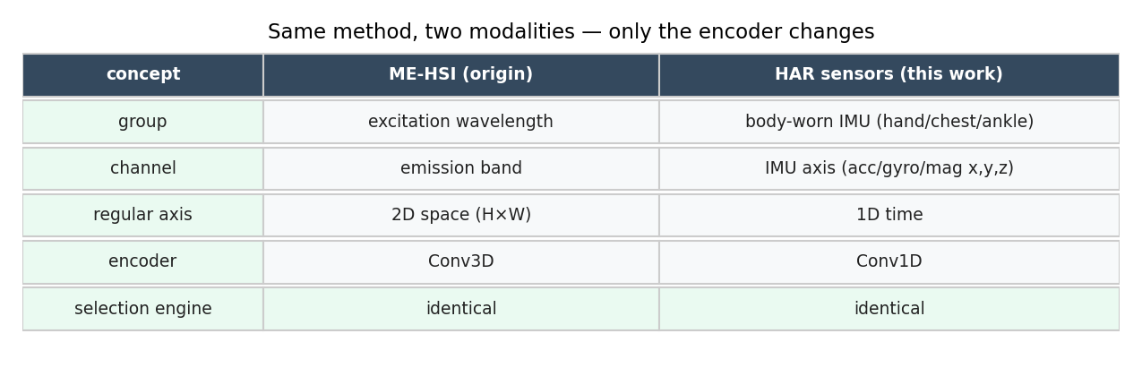
Fig. 2. The same method instantiated in two modalities. Only the encoder changes.

IV. EXPERIMENTS AND RESULTS
We evaluate on a standard wearable-sensor activity-recognition benchmark with three body-worn inertial units, using leave-one-subject-out cross-validation and macro-F1, the rigorous protocol in which the test subject is never seen during training. We compare the label-free method against a supervised mutual-information selector, an unsupervised variance baseline, and random selection, sweeping the number of retained channels.
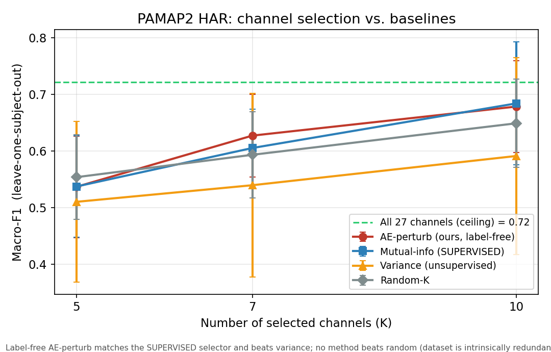
Fig. 3. Macro-F1 vs. number of selected channels (leave-one-subject-out). The label-free method (red) tracks the supervised selector (blue) and exceeds variance (orange).
Two results stand out. First, the label-free method matches the supervised mutual-information selector across channel budgets, achieving without labels what the supervised method requires labels to attain. Second, it consistently exceeds the variance baseline and—crucially for deployment—selects far more stably across subjects (Fig. 4): variance selection swings widely from subject to subject, whereas the proposed method does not. We note in the interest of full disclosure that on this particular benchmark no selector, including the supervised one, surpasses random selection: its channels are intrinsically redundant, so almost any moderate subset approaches the all-channel ceiling. The comparison against a supervised selector and the stability analysis are therefore the informative axes here.
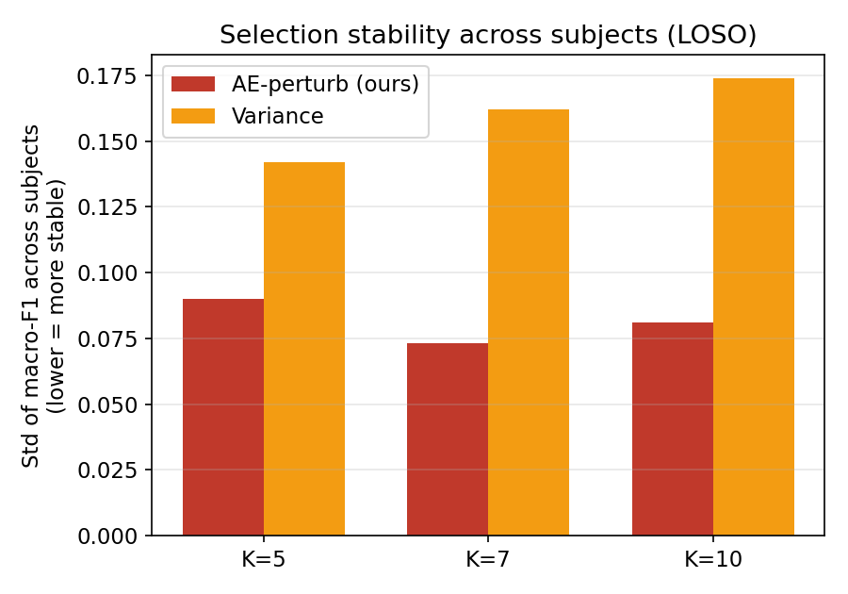
Fig. 4. Stability of the selected set across subjects (lower is better). The proposed method is markedly more consistent than variance selection.
V. CONCLUSION AND FUTURE WORK
A single unsupervised, dependency-aware selection principle transfers from hyperspectral imaging to wearable sensors with only an encoder substitution, matching supervised selection without labels and selecting more stably than variance. Future work targets a higher-redundancy activity benchmark, where intelligent selection should separate from random by a clear margin, and a direct comparison against differentiable unsupervised selectors such as the concrete autoencoder.
VI. ACKNOWLEDGEMENT
AI-assisted tooling was used for code scaffolding, figure generation, and manuscript drafting; all experimental design, analysis, and claims were verified by the authors.
. REFERENCES
[1] M. F. Balin, A. Abid, and J. Zou, "Concrete autoencoders: Differentiable feature selection and reconstruction," in Proc. ICML, 2019.
[2] H. Peng, F. Long, and C. Ding, "Feature selection based on mutual information: Criteria of max-dependency, max-relevance, and min-redundancy," IEEE Trans. Pattern Anal. Mach. Intell., vol. 27, no. 8, 2005.
[3] X. He, D. Cai, and P. Niyogi, "Laplacian score for feature selection," in Proc. NeurIPS, 2005.
[4] Y. Cai et al., "BS-Nets: An end-to-end framework for band selection of hyperspectral image," IEEE Trans. Geosci. Remote Sens., vol. 58, no. 3, 2020.
[5] A. Reiss and D. Stricker, "Introducing a new benchmarked dataset for activity monitoring," in Proc. IEEE Int. Symp. Wearable Computers (ISWC), 2012.
[6] N. Meloyan and N. Sarvazyan, "Perturbation-based wavelength selection for multi-excitation hyperspectral imaging" (companion work).

