Label-Free, Dependency-Aware Channel Selection
for Coupled Multi-Channel Sensor Data
Narek Meloyan, Aleksandr Hayrapetyan, and Narine Sarvazyan
American University of Armenia, Yerevan, Armenia
{narek.meloyan, aleksandr.hayrapetyan, nsarvazyan}@aua.am

Abstract—We present a method that picks a small, useful set of sensor channels without using any labels. A group-structured autoencoder first learns a shared representation of all the channels. We then perturb its latent factors and watch how each channel's reconstruction responds. A channel that responds strongly is one the model relies on, so this gives a label-free measure of relevance. A relevance and redundancy rule turns these scores into an ordered shortlist of the real channels, avoiding picks that merely repeat information already kept. The same method applies to very different sensors, and only the front-end encoder changes between them. On a wearable-sensor activity benchmark with three inertial units, keeping ten of twenty-seven channels holds accuracy to within 0.04 macro-F1 of the full set. It also equals a supervised selector that does use labels, and it is far more stable across people than variance ranking. On biomedical hyperspectral imaging the same method removes 58 to 95 percent of channels while holding or improving accuracy. Accuracy rises from 88.2 to 95.2 percent on lichen tissue and from 79.8 to 85.6 percent on collagen. One simple, label-free idea therefore reduces channels well across markedly different sensing modalities.
Index Terms—unsupervised feature selection, channel selection, conditional relevance, autoencoders, interpretability, human activity recognition, hyperspectral imaging.
I. INTRODUCTION
Complex sensors emit many channels that overlap heavily and arrive in natural groups, such as the three axes of one inertial unit or the emission bands measured under one excitation. For cost, power, transmission, and interpretability, one often wants to keep only a handful of the actual channels, not a learned mixture of them. The challenge is to decide which channels to keep without labels.
Existing selectors force a trade-off. Unsupervised filters such as variance ranking or PCA score each channel by its own statistics and ignore how channels depend on one another, so they tend to keep several channels that carry the same information. Dependency-aware selectors such as mRMR or JMI account for this redundancy but need labels. The cell that is at once label-free, dependency-aware, and discrete (returning real channels, not a projection) is sparsely occupied. This paper presents a method for that cell and, more importantly, shows that one such method works across two very different sensing modalities by changing only its front-end encoder.
II. METHOD
The method has three simple stages (Fig. 1). (1) A group-structured autoencoder is trained by reconstruction only, with no labels. Each channel group has its own small encoder, and the per-group features are averaged into one shared latent representation, which is then decoded back to every group. (2) We probe what the model learned. Nudging one latent factor and measuring how much each channel's reconstruction changes gives that channel's relevance, and channels the model depends on react strongly. (3) A relevance-redundancy rule (maximal marginal relevance) then picks channels one at a time, preferring those that are informative yet not already represented by a previously chosen channel. The output is an ordered, interpretable list of real channels that can be cut to any target size.

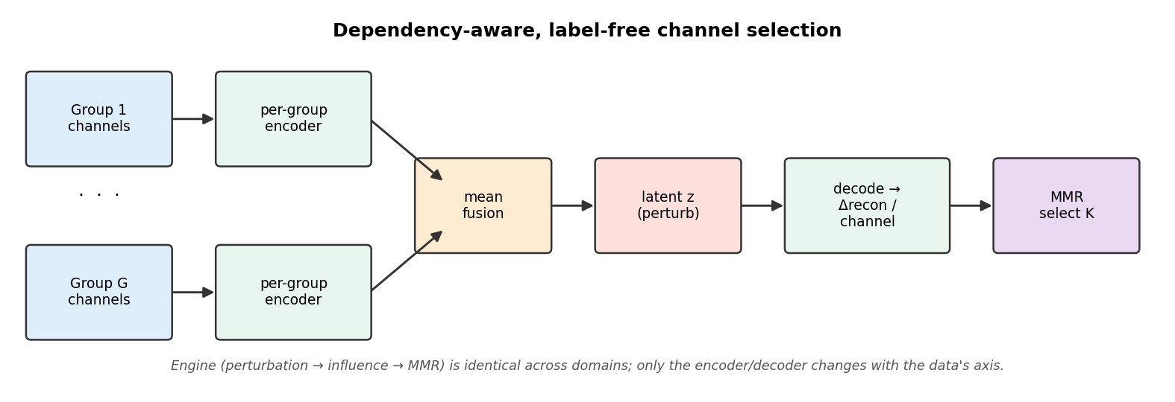
Fig. 1. The three-stage pipeline. The selection engine (perturbation -> per-channel relevance -> relevance-redundancy selection) is identical across domains; only the encoder/decoder changes to match the data's regular axis.

Crucially, the selection engine is modality-agnostic: it works on an abstract layout of groups, channels, and one regular axis (space or time). Moving to a new modality requires only an encoder matched to that axis (Fig. 2). We verify the same engine on two domains.

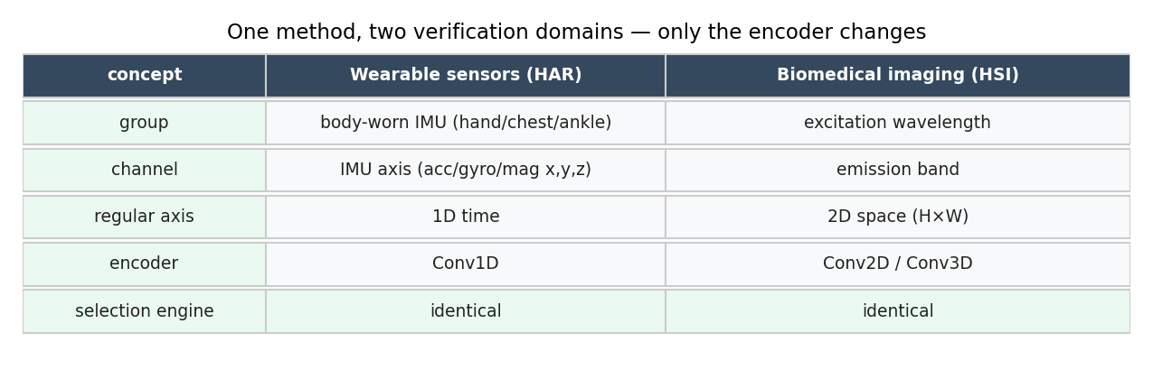
Fig. 2. One method, two verification domains. Only the encoder changes (1-D temporal convolutions for wearable sensors; 2-D/3-D spatial convolutions for imaging).

III. VERIFICATION 1: WEARABLE-SENSOR ACTIVITY RECOGNITION
Dataset. We use PAMAP2, a standard human-activity-recognition (HAR) benchmark recorded from three body-worn inertial measurement units (IMUs) placed on the hand, chest, and ankle, sampled at 100 Hz. Each IMU contributes nine channels (3-axis accelerometer, gyroscope, and magnetometer), giving 27 channels organized into three natural groups. We use the preprocessed release with fixed one-second windows, yielding 38,856 windows across eight subjects and twelve activity classes.
Protocol (the selection-then-verification flow). For each held-out subject we (i) train the group autoencoder unsupervised on the remaining subjects' windows, with one IMU per group and a 1-D temporal-convolution encoder; (ii) run the selection engine to obtain an ordered channel list; and (iii) verify the chosen subset by training a k-nearest-neighbour classifier on those channels and measuring macro-F1 on the held-out subject. All numbers use leave-one-subject-out (LOSO) cross-validation, the rigorous protocol in which the test subject is never seen during training. We compare against a supervised mutual-information selector, an unsupervised variance baseline, and random selection.
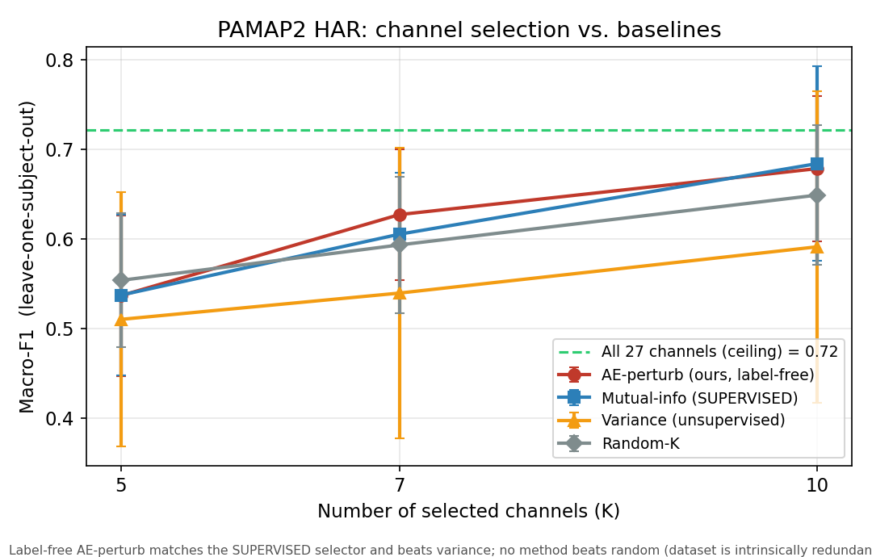
Fig. 3. Macro-F1 versus number of retained channels (LOSO). The label-free method (red) tracks the supervised selector (blue) and stays above variance (orange).
Results (Table I). Reducing from 27 to 10 channels (a 63% reduction) keeps macro-F1 within 0.04 of the full set, and the label-free method matches the supervised selector at every budget while clearly beating variance. It also selects far more consistently across subjects (Fig. 4). Variance swings widely from person to person, whereas our method does not, which matters when a single sensor set must be fixed before deployment. For full transparency, on this particular benchmark no selector, including the supervised one, surpasses random selection, because the 27 channels are highly redundant and almost any moderate subset approaches the full-set ceiling; the informative comparisons here are therefore against the supervised selector and on stability.

TABLE I. HAR macro-F1 under channel reduction (LOSO). Full set (27 ch) = 0.72.
Method | 10 ch (-63%) | 7 ch (-74%) | 5 ch (-81%)
Ours (label-free) | 0.68 | 0.63 | 0.54
Mutual info (supervised) | 0.68 | 0.61 | 0.54
Variance (unsupervised) | 0.59 | 0.54 | 0.51

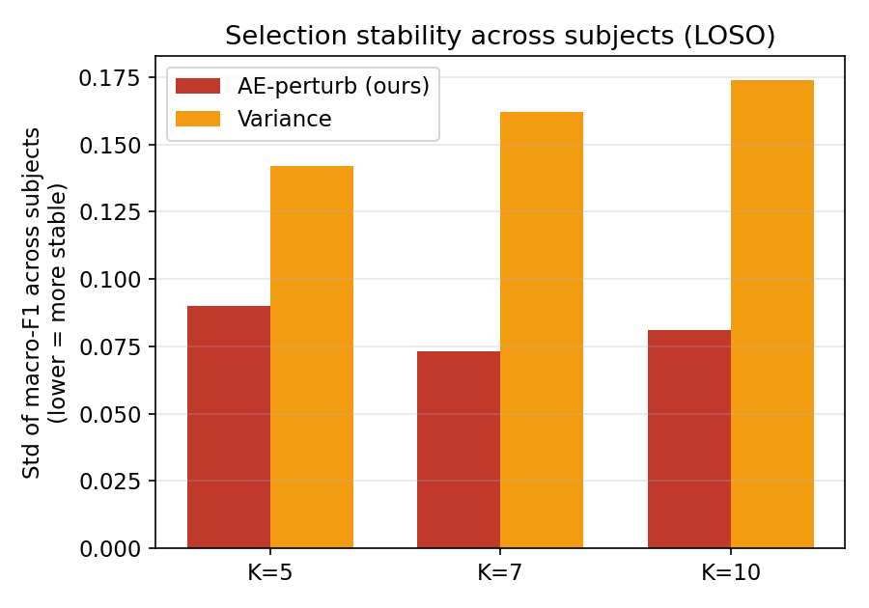
Fig. 4. Stability of the selected set across subjects (lower is better). The proposed method is markedly more consistent than variance selection.
IV. VERIFICATION 2: BIOMEDICAL HYPERSPECTRAL IMAGING
We verify the identical method on biomedical multi-excitation fluorescence hyperspectral imaging, where a group is an excitation wavelength, a channel is an emission band, and the regular axis is the 2-D image plane (a spatial-convolution encoder is substituted). On a lichen-tissue dataset (192 bands, four classes) the method reaches 95.2% classification accuracy using 80 of 192 bands, above the 88.2% obtained with all bands, and still achieves 89.4% using only nine bands (a 95% reduction). On a collagen dataset (158 bands, three classes), 30 bands raise accuracy from 79.8% to 85.6% (Table II, Fig. 5). In this high-redundancy imaging regime, intelligent selection clearly separates from trivial baselines, complementing the wearable-sensor result.

TABLE II. Biomedical HSI: aggressive reduction maintains or improves accuracy.
Dataset | Channels (all -> kept) | Reduction | Accuracy (all -> kept)
Lichens | 192 -> 80 | 58% | 88.2% -> 95.2%
Lichens | 192 -> 9 | 95% | 88.2% -> 89.4%
Collagen | 158 -> 30 | 81% | 79.8% -> 85.6%

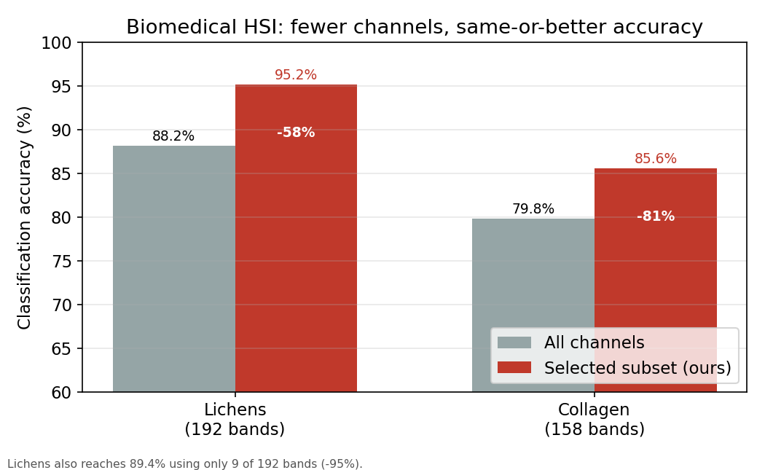
Fig. 5. Biomedical HSI: fewer channels, same-or-better accuracy.
V. CONCLUSION AND FUTURE WORK
A single unsupervised, dependency-aware selection principle delivers strong, interpretable channel reduction across two very different modalities, requiring only an encoder change. On wearable sensors it matches a supervised selector without labels and selects more stably than variance; on biomedical imaging it cuts 58-95% of channels while maintaining or improving accuracy. Future work targets a higher-redundancy activity benchmark, where selection should separate from random by a wide margin, and a direct comparison with differentiable unsupervised selectors such as the concrete autoencoder.
VI. ACKNOWLEDGEMENT
AI-assisted tooling was used for code scaffolding, figure generation, and manuscript drafting; all experimental design, analysis, and claims were verified by the authors.
REFERENCES
[1] M. F. Balin, A. Abid, and J. Zou, "Concrete autoencoders: Differentiable feature selection and reconstruction," in Proc. ICML, 2019.
[2] H. Peng, F. Long, and C. Ding, "Feature selection based on mutual information," IEEE Trans. Pattern Anal. Mach. Intell., vol. 27, no. 8, 2005.
[3] X. He, D. Cai, and P. Niyogi, "Laplacian score for feature selection," in Proc. NeurIPS, 2005.
[4] Y. Cai et al., "BS-Nets: An end-to-end framework for band selection of hyperspectral image," IEEE Trans. Geosci. Remote Sens., vol. 58, no. 3, 2020.
[5] A. Reiss and D. Stricker, "Introducing a new benchmarked dataset for activity monitoring," in Proc. IEEE Int. Symp. Wearable Computers (ISWC), 2012.
[6] A. Carbonneau et al., "The MONSTER benchmark for multivariate time-series classification," arXiv:2502.15122, 2025.

