C:\Users\LAPTA>docker exec -it cassandra cqlsh -u cassandra -p cassandra

Warning: Using a password on the command line interface can be insecure.
Recommendation: use the credentials file to securely provide the password.

Connected to Test Cluster at 127.0.0.1:9042
[cqlsh 6.2.0 | Cassandra 5.0.3 | CQL spec 3.4.7 | Native protocol v5]
Use HELP for help.
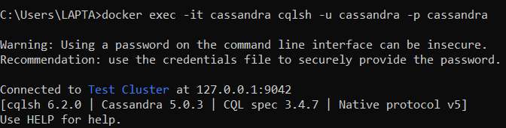
cassandra@cqlsh> CREATE KEYSPACE IF NOT EXISTS resto_NY
... WITH REPLICATION = { 'class' : 'SimpleStrategy', 'replication_factor': 1 };
cassandra@cqlsh>
cassandra@cqlsh> USE resto_NY;
cassandra@cqlsh:resto_ny> CREATE TABLE Restaurant (
... id INT, Name VARCHAR, borough VARCHAR, BuildingNum VARCHAR, Street
... VARCHAR,
... ZipCode INT, Phone text, CuisineType VARCHAR,
... PRIMARY KEY ( id )
... ) ;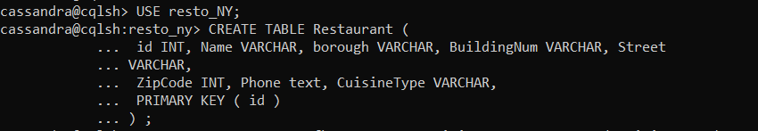
cassandra@cqlsh:resto_ny> CREATE TABLE Inspection (
... idRestaurant INT, InspectionDate date, ViolationCode VARCHAR,
... ViolationDescription VARCHAR, CriticalFlag VARCHAR, Score INT,
... GRADE VARCHAR,
... PRIMARY KEY ( idRestaurant, InspectionDate )
... ) ;
cassandra@cqlsh:resto_ny> CREATE INDEX fk_Inspection_Restaurant ON Inspection ( Grade ) ;
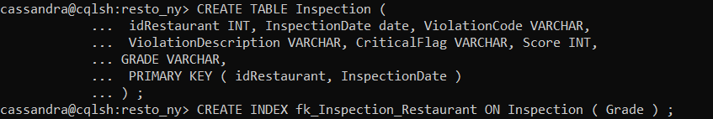
cassandra@cqlsh:resto_ny> DESC Restaurant;

CREATE TABLE resto_ny.restaurant (
id int PRIMARY KEY,
borough text,
buildingnum text,
cuisinetype text,
name text,
phone text,
street text,
zipcode int
) WITH additional_write_policy = '99p'
AND allow_auto_snapshot = true
AND bloom_filter_fp_chance = 0.01
AND caching = {'keys': 'ALL', 'rows_per_partition': 'NONE'}
AND cdc = false
AND comment = ''
AND compaction = {'class': 'org.apache.cassandra.db.compaction.SizeTieredCompactionStrategy', 'max_threshold': '32', 'min_threshold': '4'}
AND compression = {'chunk_length_in_kb': '16', 'class': 'org.apache.cassandra.io.compress.LZ4Compressor'}
AND memtable = 'default'
AND crc_check_chance = 1.0
AND default_time_to_live = 0
AND extensions = {}
AND gc_grace_seconds = 864000
AND incremental_backups = true
AND max_index_interval = 2048
AND memtable_flush_period_in_ms = 0
AND min_index_interval = 128
AND read_repair = 'BLOCKING'
AND speculative_retry = '99p';

CREATE INDEX fk_restaurant_cuisine ON resto_ny.restaurant (cuisinetype);
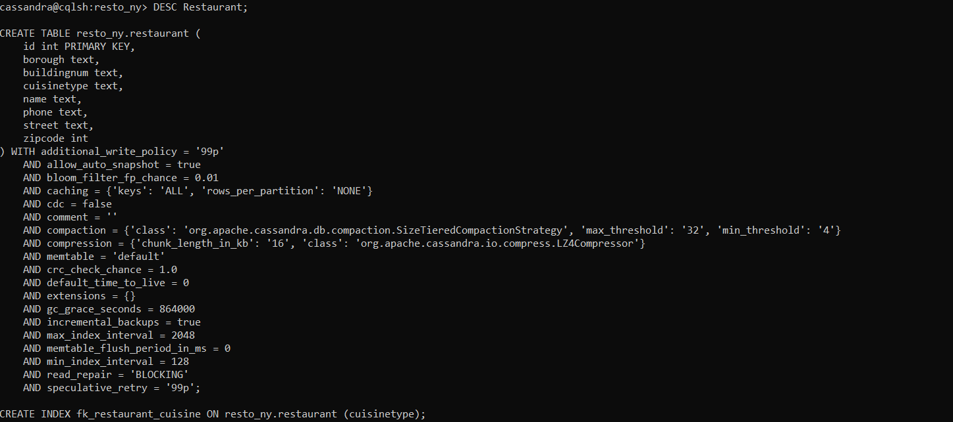
cassandra@cqlsh:resto_ny> DESC Inspection;

CREATE TABLE resto_ny.inspection (
idrestaurant int,
inspectiondate date,
criticalflag text,
grade text,
score int,
violationcode text,
violationdescription text,
PRIMARY KEY (idrestaurant, inspectiondate)
) WITH CLUSTERING ORDER BY (inspectiondate ASC)
AND additional_write_policy = '99p'
AND allow_auto_snapshot = true
AND bloom_filter_fp_chance = 0.01
AND caching = {'keys': 'ALL', 'rows_per_partition': 'NONE'}
AND cdc = false
AND comment = ''
AND compaction = {'class': 'org.apache.cassandra.db.compaction.SizeTieredCompactionStrategy', 'max_threshold': '32', 'min_threshold': '4'}
AND compression = {'chunk_length_in_kb': '16', 'class': 'org.apache.cassandra.io.compress.LZ4Compressor'}
AND memtable = 'default'
AND crc_check_chance = 1.0
AND default_time_to_live = 0
AND extensions = {}
AND gc_grace_seconds = 864000
AND incremental_backups = true
AND max_index_interval = 2048
AND memtable_flush_period_in_ms = 0
AND min_index_interval = 128
AND read_repair = 'BLOCKING'
AND speculative_retry = '99p';
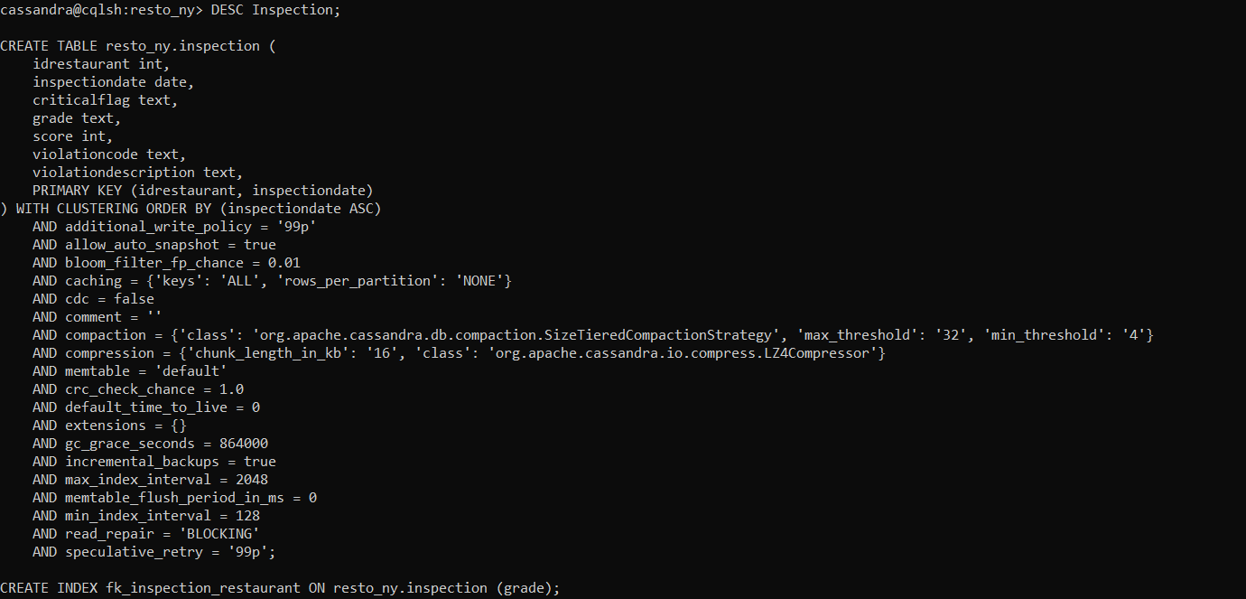

C:\Users\LAPTA>docker cp "C:\Users\LAPTA\Downloads\restaurants\restaurants.csv" cassandra:/
Successfully copied 2.11MB to cassandra:/

C:\Users\LAPTA>docker cp "C:\Users\LAPTA\Downloads\restaurants\restaurants_inspections.csv" cassandra:/
Successfully copied 82.5MB to cassandra:/

C:\Users\LAPTA>docker ps
CONTAINER ID IMAGE COMMAND CREATED STATUS PORTS NAMES
923f9ba11ff5 cassandra:latest "docker-entrypoint.s…" 32 minutes ago Up 32 minutes 7000-7001/tcp, 7199/tcp, 9160/tcp, 0.0.0.0:9042->9042/tcp cassandra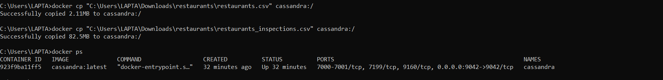
cassandra@cqlsh:resto_ny> COPY Restaurant (id, Name, borough, BuildingNum, Street, ZipCode, Phone, CuisineType) FROM '/restaurants.csv' WITH DELIMITER=',' AND MAXBATCHSIZE=100 AND MINBATCHSIZE=10 AND MAXATTEMPTS=10 AND NUMPROCESSES=1;
Using 1 child processes

Starting copy of resto_ny.restaurant with columns [id, name, borough, buildingnum, street, zipcode, phone, cuisinetype].
Processed: 25624 rows; Rate: 4991 rows/s; Avg. rate: 6093 rows/s
25624 rows imported from 1 files in 0 day, 0 hour, 0 minute, and 4.206 seconds (0 skipped).

cassandra@cqlsh:resto_ny> COPY Inspection (idRestaurant, InspectionDate, ViolationCode, ViolationDescription, CriticalFlag, Score, GRADE) FROM '/restaurants_inspections.csv' WITH DELIMITER=',' AND MAXBATCHSIZE=100 AND MINBATCHSIZE=10 AND MAXATTEMPTS=10 AND NUMPROCESSES=1;
Using 1 child processes

Starting copy of resto_ny.inspection with columns [idrestaurant, inspectiondate, violationcode, violationdescription, criticalflag, score, grade].
Processed: 441712 rows; Rate: 5659 rows/s; Avg. rate: 6754 rows/s
441712 rows imported from 1 files in 0 day, 0 hour, 1 minutes, and 5.404 seconds (0 skipped).
cassandra@cqlsh:resto_ny> SELECT count(*) FROM Restaurant;

count
-------
25624

(1 rows)

Warnings :
Aggregation query used without partition key

cassandra@cqlsh:resto_ny> SELECT count(*) FROM Inspection;

count
--------
149818

(1 rows)

Warnings :
Aggregation query used without partition key
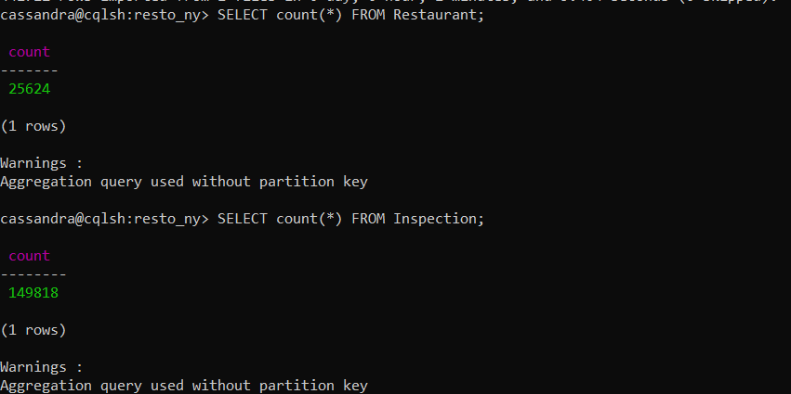
cassandra@cqlsh:resto_ny> SELECT * FROM Restaurant;
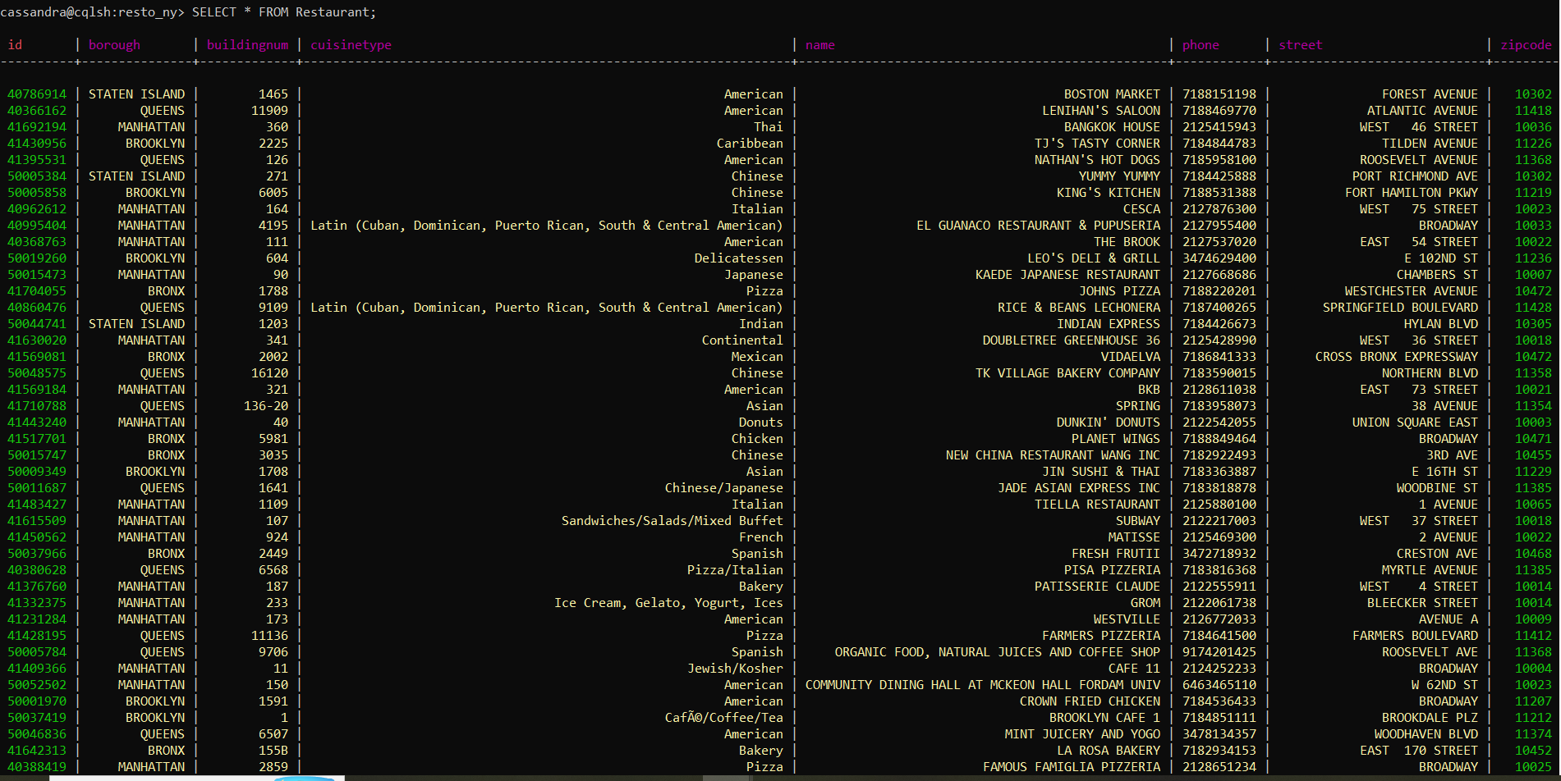
cassandra@cqlsh:resto_ny> SELECT * FROM Inspection;
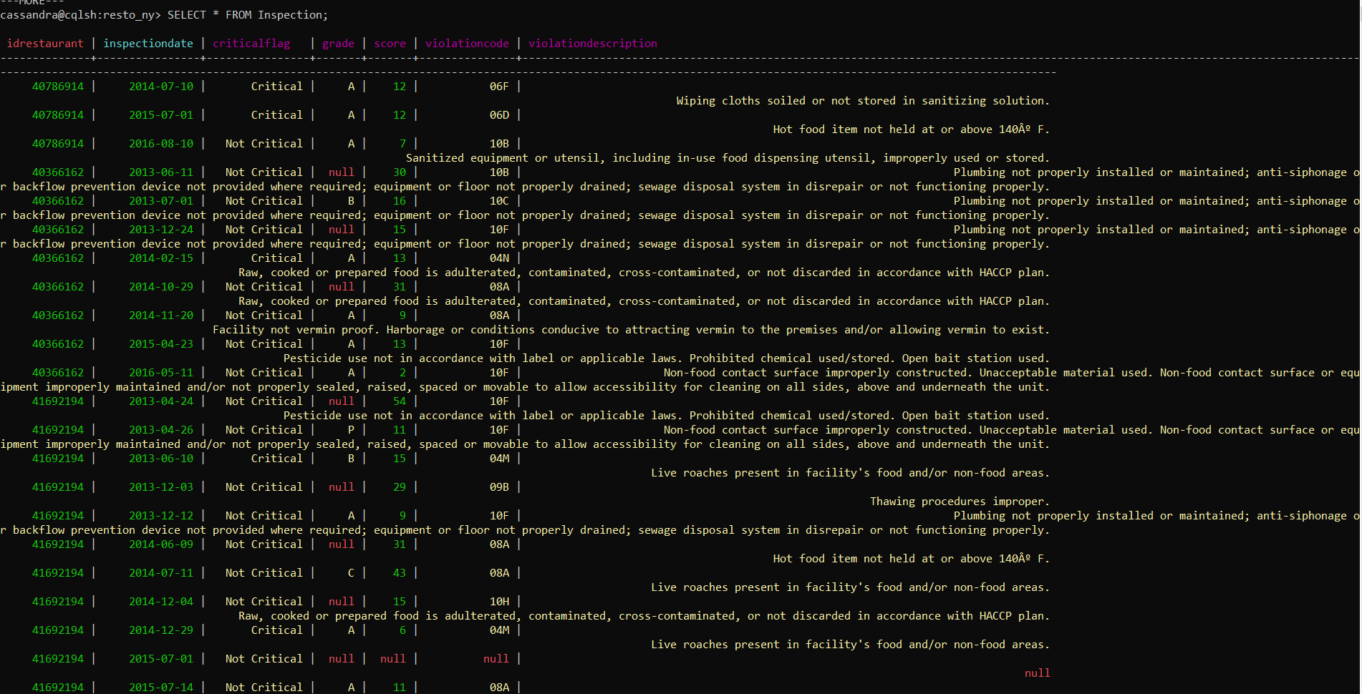
cassandra@cqlsh:resto_ny> SELECT Name FROM Restaurant;

name
--------------------------------------------------
BOSTON MARKET
LENIHAN'S SALOON
BANGKOK HOUSE
TJ'S TASTY CORNER
NATHAN'S HOT DOGS
YUMMY YUMMY
KING'S KITCHEN
CESCA
EL GUANACO RESTAURANT & PUPUSERIA
THE BROOK
LEO'S DELI & GRILL
KAEDE JAPANESE RESTAURANT
JOHNS PIZZA
RICE & BEANS LECHONERA
INDIAN EXPRESS
DOUBLETREE GREENHOUSE 36
VIDAELVA
TK VILLAGE BAKERY COMPANY
BKB
SPRING
DUNKIN' DONUTS
PLANET WINGS
NEW CHINA RESTAURANT WANG INC
JIN SUSHI & THAI
JADE ASIAN EXPRESS INC
TIELLA RESTAURANT
SUBWAY
MATISSE
FRESH FRUTII
PISA PIZZERIA
PATISSERIE CLAUDE
GROM
WESTVILLE
FARMERS PIZZERIA
ORGANIC FOOD, NATURAL JUICES AND COFFEE SHOP
CAFE 11
COMMUNITY DINING HALL AT MCKEON HALL FORDAM UNIV
CROWN FRIED CHICKEN
BROOKLYN CAFE 1
MINT JUICERY AND YOGO
LA ROSA BAKERY
FAMOUS FAMIGLIA PIZZERIA
FRANCESCO PIZZERIA
NO. 1 YUMMY TACO
CRESCENT COFFEE SHOP
LA ROYALE BEER BURGER HOUSE
FAY DA BAKERY
HILLTOP PERK DELI
CONNECTICUT MUFFIN
KENNEDY CHICKEN AND PIZZA
GREENSTREETS SALADS
BLUE BOTTLE COFFEE
THE TOPAZ
R & J LOUNGE
SPRINKLES CUPCAKES
LA GUARIDA BAR
MAMA ROZ SOUL FOOD
STARBUCK COFFEE
HONG KONG BAKERY
DAEJI DAEJI KOREAN BBQ
LUISA CHIMICHURRY
SCALINI FEDELI
GREEN APPLE FOOD COURT /LATIN MEXICAN GRILL
SUBWAY
AUNT BELLA'S REST OF LITTLE NECK
ALMANAC
BROOKLYN BRIDGE GARDEN BAR
HUMMUS KITCHEN
LA NUEVA CANASTA
DRAGON PALACE
LITTLE MUENSTER
KELLY COMMONS MARKETPLACE
PICANTERIA EL BOTECITO
THE CANTINE
BEDFORD CAFE & RESTAURANT
RUDY'S BAKERY
JUKAI
SIX BLOCKS BAKERY CAFE
FLUSHING BANGGANE
JUST SALAD
NATUREWORKS
SUBWAY
TOUT VA BIEN
FAME DINER
RESTAURANT ASSOCIATES LLC
NAAN & GRILL
YAKITORI TOTTO
NEW JING HUI RESTAURANT
TERREMOTO COFFEE
THE GUMBO BRO
CIBO EXPRESS GOURMET MARKET
LAZY POINT
SECRETS GENTLEMAN'S CLUB
BURGER KING, POPEYES LOUISIANA KITCHEN
BETWEEN THE BREAD
Sicilia Pizzeria
DAVEY'S ICE CREAM
THE LITTLE OWL
GARDEN CAFE
BEST ITALIAN PIZZA

---MORE---

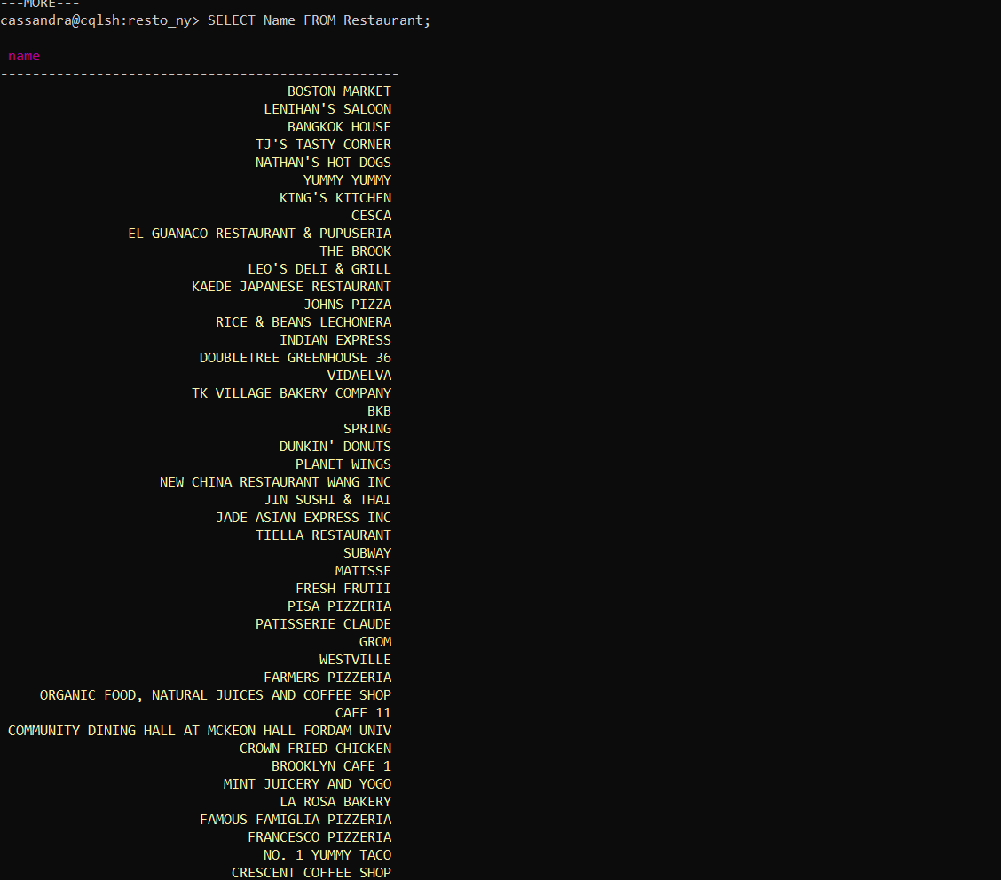

cassandra@cqlsh:resto_ny> SELECT Name, borough FROM Restaurant WHERE id = 41569764;

name | borough
---------+----------
BACCHUS | BROOKLYN

(1 rows)
cassandra@cqlsh:resto_ny> SELECT InspectionDate, GRADE FROM Inspection WHERE idRestaurant = 41569764;

inspectiondate | grade
----------------+-------
2013-06-27 | null
2013-07-08 | A
2013-12-26 | null
2014-02-05 | A
2014-07-17 | null
2014-08-06 | A
2015-01-08 | A
2016-02-25 | A

(8 rows)
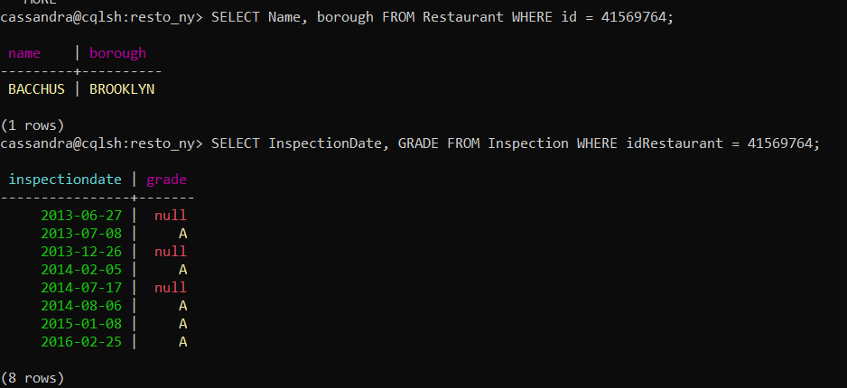
cassandra@cqlsh:resto_ny> SELECT Name FROM Restaurant WHERE CuisineType = 'French';

name
--------------------------------
MATISSE
ALMANAC
TOUT VA BIEN
FELIX
CREPES ON COLUMBUS
THE BARONESS BAR
THE SIMONE
FP BAKERY
VIN ET FLEURS
CAFE BOULUD/BAR PLEIADES
COCOTTE
Bourgeois Pig
DELICE & SARRASIN
LA TARTE FLAMBEE
JEAN GEORGES
MAISON MAY
DANIEL
SAJU BISTRO
LE PAIN QUOTIDIEN
CAFE CLUNY
BIN 71
CREPES CELSTES
JOYCE BAKESHOP
THE FOX AND THE CREPES
CAFE LOUP
ROUGE TOMATE
LE PERIGORD
NOGLU NEW YORK
BLISS 46 BISTRO
PASCALOU
BUVETTE
LE PAIN QUOTIDIEN
UNION CLUB OF CITY OF NEW YORK
CAFE LUXEMBOURG
TISSERIE
LE PAIN QUOTIDIEN
BAGATELLE
PARIS BAGUETTE
LE PAIN QUOTIDIEN
CAFE D'ALSACE
KING BEE
LA BERGAMOTE
TOCQUEVILLE RESTAURANT
BISTRO CHAT NOIR
MADISON BISTRO
57TH BELLE HOUSE
LA MIRABELLE RESTAURANT
LE TRAIN BLEU & B CAFE
HUDSON CLEARWATER
CHERI
VAUCLUSE
PARDON MY FRENCH
L' ANTAGONISTE
MADAME SOU SOU
THE BOUNTY
DUET BRASSERIE
MAISON KAYSER
DIRTY PIERRES BISTRO
L'AILE OU LA CUISSE (L'A.O.C)
ABC COCINA
FRENCH CAFE GOURMAND
BISTRO VENDOME
LE COQ RICO
THE LITTLE PRINCE
LE COUCOU
TURKS & FROGS
MAISON MAY
Le Village
DOMAINE WINE BAR
B CAFE
LUCIEN RESTAURAUNT
SEL ET POIVRE RESTAURANT
PETITE ABEILLE
RAMONA
BOULEY
QUATORZE BISTRO
BONJOUR CREPES & WINE
CAMAJE
CHICKEN PROVENCE
LAFAYETTE
VIVE LA CREPE
ORSAY
CHEZ NAPOLEAN
CHEZ JOSEPHINE
LA BONNE SOUPE BISTRO
BALTHAZAR RESTAURANT
LA MANGEOIRE
LA BOITE EN BOIS
PETIT OVEN
CHOKOLAT PATISSERIE
VAN LEEUWEN
CANNELLE PATISSERIE
BISTRO SK
MONTMARTRE
VIN SUR VINGT
HEADLESS HORSEMAN
PETROSSIAN BOUTIQUE
BREUKELEN BRASSERIE
GOLDEN CREPES
LE BARATIN

---MORE---
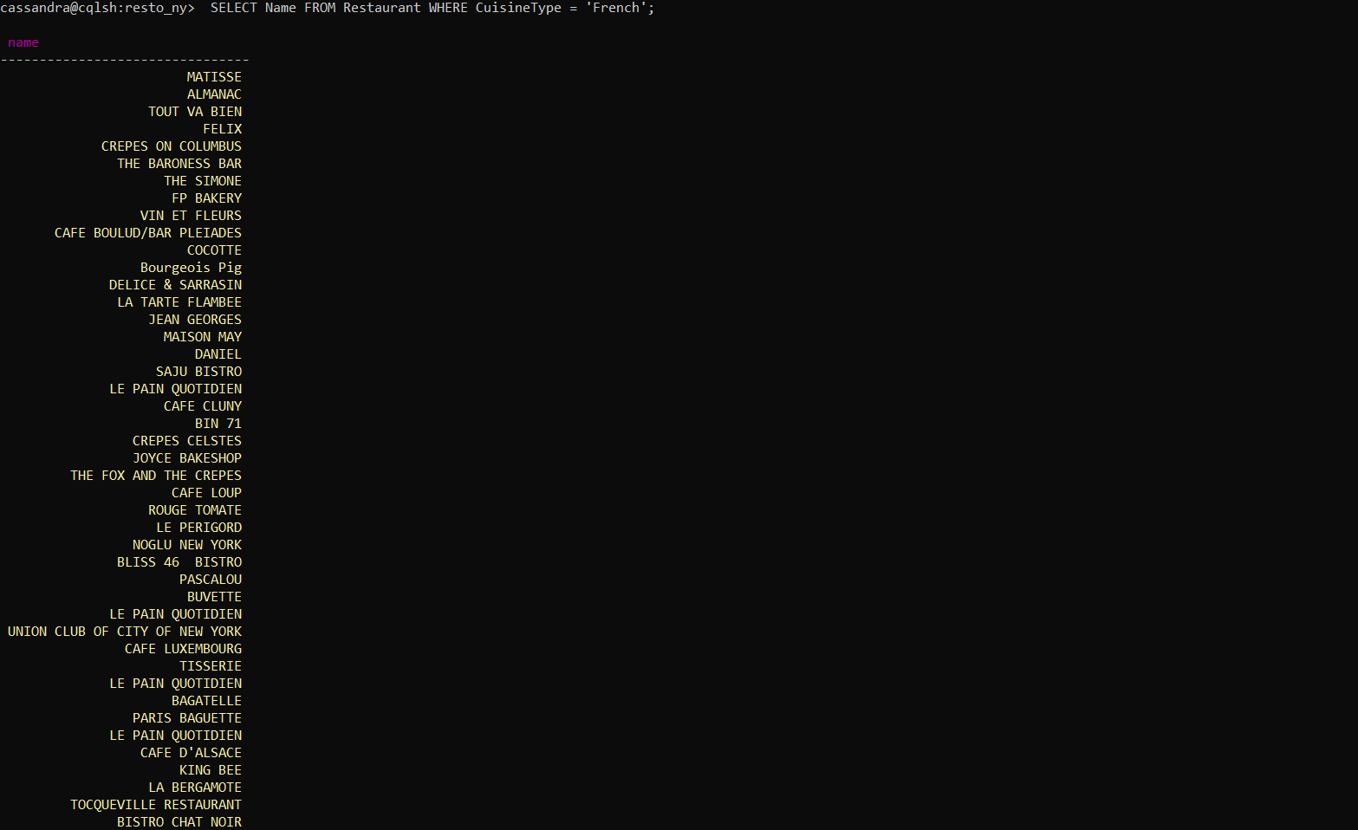
cassandra@cqlsh:resto_ny> SELECT Name FROM Restaurant WHERE borough = 'BROOKLYN' ALLOW FILTERING;

name
--------------------------------------------
TJ'S TASTY CORNER
KING'S KITCHEN
LEO'S DELI & GRILL
JIN SUSHI & THAI
CROWN FRIED CHICKEN
BROOKLYN CAFE 1
CRESCENT COFFEE SHOP
LA ROYALE BEER BURGER HOUSE
CONNECTICUT MUFFIN
GREENSTREETS SALADS
THE TOPAZ
LA GUARIDA BAR
MAMA ROZ SOUL FOOD
HONG KONG BAKERY
BROOKLYN BRIDGE GARDEN BAR
THE CANTINE
THE GUMBO BRO
DAVEY'S ICE CREAM
CROWN FRIED CHICKEN
THAI TONY'S
CHINA DRAGON
KNAPP BAGEL CAFE
SCHNITZI SCHNITZEL BAR
INDIGO MURPHY'S
EDDIE JR'S SPORT LOUNGE
EL GRAN MAR DE PLATA
MALAY BAKERY
EL NUEVO BARZOLA RESTAURANT
PURITAN RESTAURANT
EL CHARRO POBLANO
HOLIDAY INN EXPRESS
SUBWAY
BREUCKELEN COLONY
SILENT BARN
BATATA
WHITE CASTLE
BUBBLE TEA- B.B.Q
RED SUN RESTAURANT
OUTPOST
ROCCO'S PIZZERIA
SAPPORO JAPANESE CUISINE
CAMILA'S CAFE
ZOMBIE HUT
SUBWAY
EAST MET WEST
BOOMWICH
MCDONALD'S
KFC
NEW HONG KONG RESTAURANT II
SHAKE SHACK
NABLUS SWEETS
WOLF & LAMB
BARCEY'S COFFEE
KALINA RESTAURANT
ARMANDO'S PIZZA
SING WAH RESTAURANT
EL TEQUILERO BAR & RESTAURANT
KONDITORI
SWEETLEAF COFFEE
NEW ZHANG'S GARDEN
VAQUEROS
LIU'S SHANGHAI INC
LA CEMITA MEXICAN GRILL CORP
COURT ORDER
EL PASO MEXICAN GRILL
SCOPELLO
VETERANS OF FOREIGN WARS POST #107 CANTEEN
RASOI
MIRAKUYA
AGRA HEIGHTS
HAAGEN-DAZS
TYGERSHARK
COURT STREET GROCERS HERO SHOP
MUCHMORE'S
DUNKIN' DONUTS
FAMILY KITCHEN
ANARKALI INDIAN FOOD
GFC
TONY'S PIZZA, JERK CHICKEN AND FISH
PETITE FLEURY BAKERY
PIQUANT
CHEZ MACOULE RESTAURANT
FOOTPRINTS CAFE EXPRESS
PANDA
DUNKIN' DONUTS
KINARA INDIAN RESTAURANT
TEPANGO RESTAURANT
FRANNY'S
FRANKIES 457
re.union
JAM ROCK
983 BUSHWICK LIVING ROOM
PROPELLERHEAD
HOPE & ANCHOR
IKHOFI CAFE
THE VALE
YOSSIS GLATT SUSHI
BLANK CAFE
KI SUSHI
SUBWAY

---MORE---
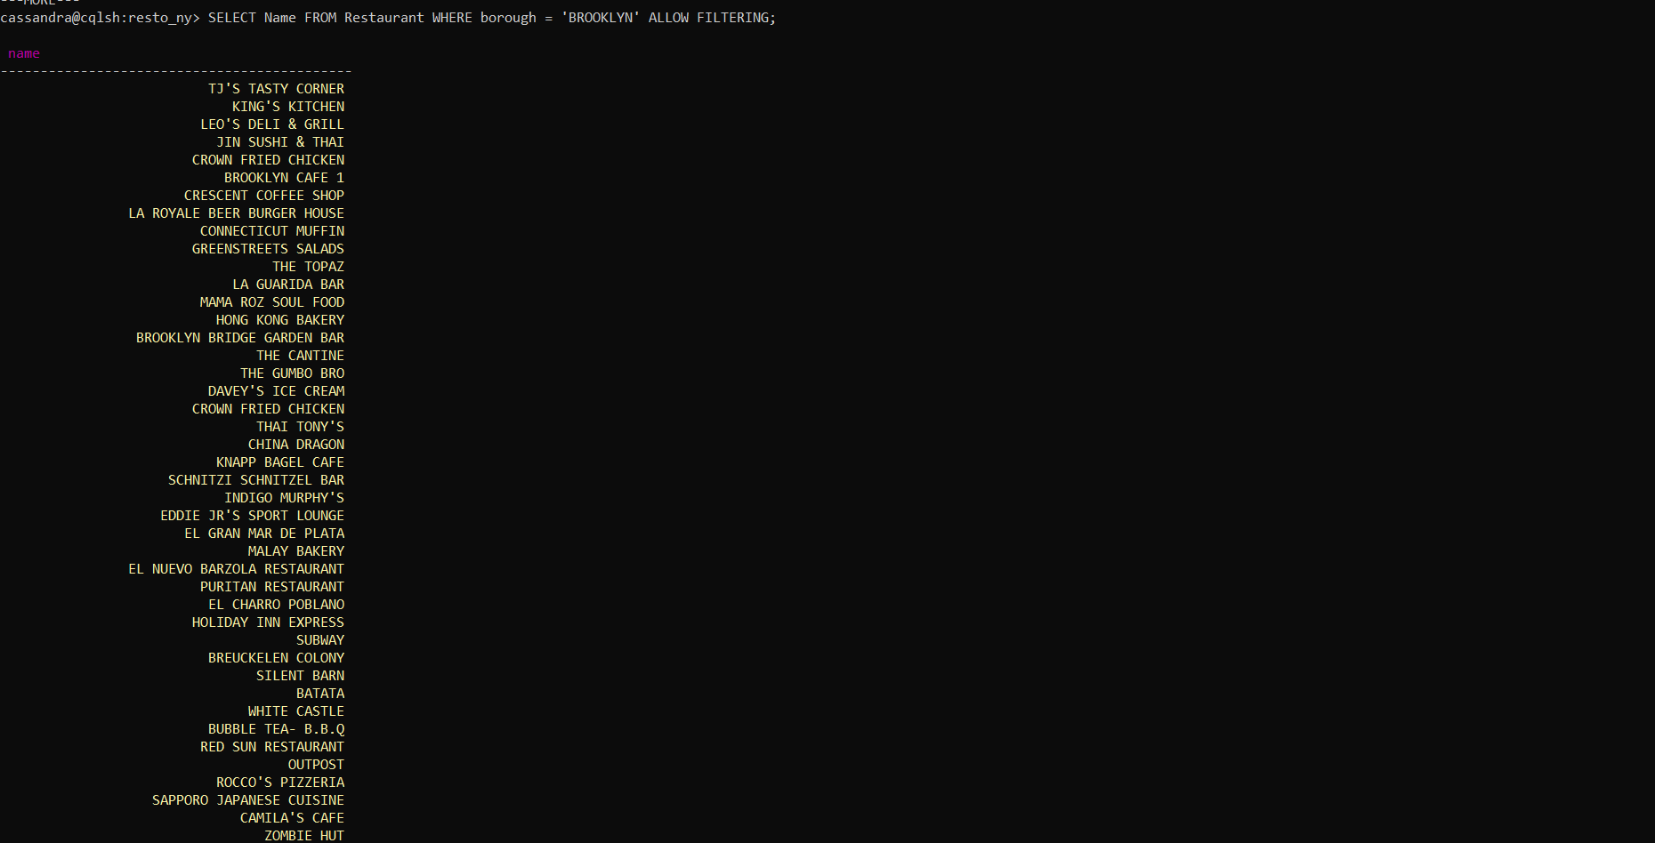
cassandra@cqlsh:resto_ny> SELECT GRADE, Score FROM Inspection WHERE idRestaurant = 41569764 AND Score >= 10 ALLOW FILTERING;

grade | score
-------+-------
null | 19
A | 10

(2 rows)
cassandra@cqlsh:resto_ny> SELECT GRADE FROM Inspection WHERE Score > 30 AND GRADE >= '' ALLOW FILTERING;

grade
----------------
C
C
C
Not Yet Graded
C
C
C
C
C
C
C
C
C
C
C
C
C
C
C
C
C
C
Z
C
Not Yet Graded
C
C
C
C
Z
C
C
C
Z
Not Yet Graded
C
C
C
C
C
C
C
C
C
C
C
C
C
C
C
C
C
Not Yet Graded
C
C
C
C
C
C
C
C
C
C
C
C
C
C
C
C
C
Not Yet Graded
C
C
C
C
C
C
C
Z
C
C
C
Not Yet Graded
C
C
C
C
C
C
C
Z
Z
Z
C
C
C
C
Z
Z
C
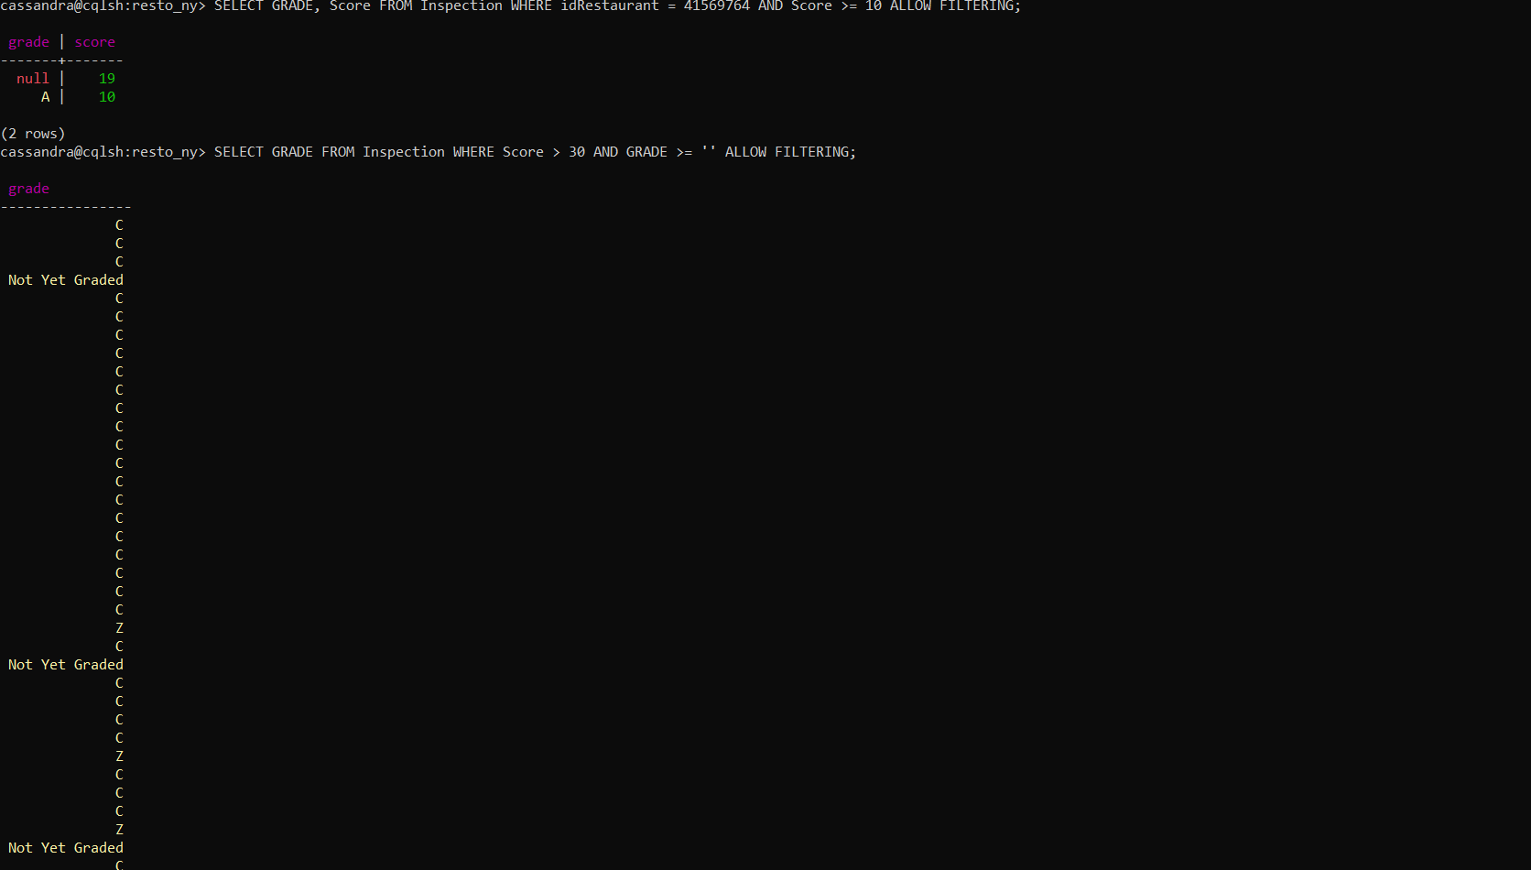
cassandra@cqlsh:resto_ny> SELECT count(*) FROM Inspection WHERE Score > 30 ALLOW FILTERING;

count
-------
8478

(1 rows)

Warnings :
Aggregation query used without partition key

Read 1749 live rows and 1217 tombstone cells for query SELECT score FROM resto_ny.inspection WHERE score > 30 LIMIT 100 ALLOW FILTERING; token -9002326121804454896 (see tombstone_warn_threshold)

Read 1861 live rows and 1420 tombstone cells for query SELECT score FROM resto_ny.inspection WHERE token(idrestaurant) >= token(40640495) AND score > 30 LIMIT 100 ALLOW FILTERING; token -8765556826827323550 (see tombstone_warn_threshold)

Read 1607 live rows and 1161 tombstone cells for query SELECT score FROM resto_ny.inspection WHERE token(idrestaurant) >= token(50000768) AND score > 30 LIMIT 100 ALLOW FILTERING; token -8550863161915528413 (see tombstone_warn_threshold)

Read 1783 live rows and 1265 tombstone cells for query SELECT score FROM resto_ny.inspection WHERE token(idrestaurant) >= token(41682591) AND score > 30 LIMIT 100 ALLOW FILTERING; token -8332102115261868191 (see tombstone_warn_threshold)

Read 1776 live rows and 1222 tombstone cells for query SELECT score FROM resto_ny.inspection WHERE token(idrestaurant) >= token(41457158) AND score > 30 LIMIT 100 ALLOW FILTERING; token -8125880159457192100 (see tombstone_warn_threshold)

Read 2017 live rows and 1423 tombstone cells for query SELECT score FROM resto_ny.inspection WHERE token(idrestaurant) >= token(41703865) AND score > 30 LIMIT 100 ALLOW FILTERING; token -7875654155419507528 (see tombstone_warn_threshold)

Read 1635 live rows and 1229 tombstone cells for query SELECT score FROM resto_ny.inspection WHERE token(idrestaurant) >= token(41144043) AND score > 30 LIMIT 100 ALLOW FILTERING; token -7692808174111285693 (see tombstone_warn_threshold)

Read 1858 live rows and 1252 tombstone cells for query SELECT score FROM resto_ny.inspection WHERE token(idrestaurant) >= token(41608118) AND score > 30 LIMIT 100 ALLOW FILTERING; token -7481018445663037683 (see tombstone_warn_threshold)

Read 1595 live rows and 1114 tombstone cells for query SELECT score FROM resto_ny.inspection WHERE token(idrestaurant) >= token(41433265) AND score > 30 LIMIT 100 ALLOW FILTERING; token -7256524649529314786 (see tombstone_warn_threshold)

Read 1576 live rows and 1183 tombstone cells for query SELECT score FROM resto_ny.inspection WHERE token(idrestaurant) >= token(40512865) AND score > 30 LIMIT 100 ALLOW FILTERING; token -7073297951836655784 (see tombstone_warn_threshold)

Read 2107 live rows and 1548 tombstone cells for query SELECT score FROM resto_ny.inspection WHERE token(idrestaurant) >= token(41607258) AND score > 30 LIMIT 100 ALLOW FILTERING; token -6799423959919832638 (see tombstone_warn_threshold)

Read 1555 live rows and 1180 tombstone cells for query SELECT score FROM resto_ny.inspection WHERE token(idrestaurant) >= token(41471528) AND score > 30 LIMIT 100 ALLOW FILTERING; token -6592595665266398627 (see tombstone_warn_threshold)

Read 1580 live rows and 1144 tombstone cells for query SELECT score FROM resto_ny.inspection WHERE token(idrestaurant) >= token(50000123) AND score > 30 LIMIT 100 ALLOW FILTERING; token -6409059996002019320 (see tombstone_warn_threshold)

Read 1585 live rows and 1032 tombstone cells for query SELECT score FROM resto_ny.inspection WHERE token(idrestaurant) >= token(40676541) AND score > 30 LIMIT 100 ALLOW FILTERING; token -6230372634648750897 (see tombstone_warn_threshold)

Read 1798 live rows and 1281 tombstone cells for query SELECT score FROM resto_ny.inspection WHERE token(idrestaurant) >= token(50045239) AND score > 30 LIMIT 100 ALLOW FILTERING; token -6020699065784721707 (see tombstone_warn_threshold)

Read 1703 live rows and 1239 tombstone cells for query SELECT score FROM resto_ny.inspection WHERE token(idrestaurant) >= token(50014469) AND score > 30 LIMIT 100 ALLOW FILTERING; token -5795955164355882346 (see tombstone_warn_threshold)

Read 1705 live rows and 1184 tombstone cells for query SELECT score FROM resto_ny.inspection WHERE token(idrestaurant) >= token(41690948) AND score > 30 LIMIT 100 ALLOW FILTERING; token -5605123407157433194 (see tombstone_warn_threshold)

Read 1719 live rows and 1225 tombstone cells for query SELECT score FROM resto_ny.inspection WHERE token(idrestaurant) >= token(41662070) AND score > 30 LIMIT 100 ALLOW FILTERING; token -5399270242095769220 (see tombstone_warn_threshold)

Read 1849 live rows and 1361 tombstone cells for query SELECT score FROM resto_ny.inspection WHERE token(idrestaurant) >= token(41238494) AND score > 30 LIMIT 100 ALLOW FILTERING; token -5166203648615123953 (see tombstone_warn_threshold)

Read 1735 live rows and 1255 tombstone cells for query SELECT score FROM resto_ny.inspection WHERE token(idrestaurant) >= token(41565544) AND score > 30 LIMIT 100 ALLOW FILTERING; token -4963355124070419893 (see tombstone_warn_threshold)

Read 1738 live rows and 1235 tombstone cells for query SELECT score FROM resto_ny.inspection WHERE token(idrestaurant) >= token(50010587) AND score > 30 LIMIT 100 ALLOW FILTERING; token -4731588233554670499 (see tombstone_warn_threshold)

Read 1814 live rows and 1204 tombstone cells for query SELECT score FROM resto_ny.inspection WHERE token(idrestaurant) >= token(41459743) AND score > 30 LIMIT 100 ALLOW FILTERING; token -4475253444340607503 (see tombstone_warn_threshold)

Read 1868 live rows and 1307 tombstone cells for query SELECT score FROM resto_ny.inspection WHERE token(idrestaurant) >= token(41590133) AND score > 30 LIMIT 100 ALLOW FILTERING; token -4243165790484314142 (see tombstone_warn_threshold)

Read 1565 live rows and 1052 tombstone cells for query SELECT score FROM resto_ny.inspection WHERE token(idrestaurant) >= token(41629291) AND score > 30 LIMIT 100 ALLOW FILTERING; token -4048296400637090526 (see tombstone_warn_threshold)

Read 1833 live rows and 1245 tombstone cells for query SELECT score FROM resto_ny.inspection WHERE token(idrestaurant) >= token(41681923) AND score > 30 LIMIT 100 ALLOW FILTERING; token -3818057602715191799 (see tombstone_warn_threshold)

Read 1795 live rows and 1212 tombstone cells for query SELECT score FROM resto_ny.inspection WHERE token(idrestaurant) >= token(41174075) AND score > 30 LIMIT 100 ALLOW FILTERING; token -3565275001517898487 (see tombstone_warn_threshold)

Read 1608 live rows and 1188 tombstone cells for query SELECT score FROM resto_ny.inspection WHERE token(idrestaurant) >= token(50014537) AND score > 30 LIMIT 100 ALLOW FILTERING; token -3385684676703474098 (see tombstone_warn_threshold)

Read 1639 live rows and 1108 tombstone cells for query SELECT score FROM resto_ny.inspection WHERE token(idrestaurant) >= token(41340437) AND score > 30 LIMIT 100 ALLOW FILTERING; token -3183811618473175067 (see tombstone_warn_threshold)

Read 1493 live rows and 1162 tombstone cells for query SELECT score FROM resto_ny.inspection WHERE token(idrestaurant) >= token(50019125) AND score > 30 LIMIT 100 ALLOW FILTERING; token -3005195483415617829 (see tombstone_warn_threshold)

Read 1785 live rows and 1263 tombstone cells for query SELECT score FROM resto_ny.inspection WHERE token(idrestaurant) >= token(50003139) AND score > 30 LIMIT 100 ALLOW FILTERING; token -2785557949796485448 (see tombstone_warn_threshold)

Read 1756 live rows and 1326 tombstone cells for query SELECT score FROM resto_ny.inspection WHERE token(idrestaurant) >= token(41647012) AND score > 30 LIMIT 100 ALLOW FILTERING; token -2579418076409854374 (see tombstone_warn_threshold)

Read 1821 live rows and 1262 tombstone cells for query SELECT score FROM resto_ny.inspection WHERE token(idrestaurant) >= token(41330647) AND score > 30 LIMIT 100 ALLOW FILTERING; token -2365394280012106709 (see tombstone_warn_threshold)

Read 1529 live rows and 1048 tombstone cells for query SELECT score FROM resto_ny.inspection WHERE token(idrestaurant) >= token(41164793) AND score > 30 LIMIT 100 ALLOW FILTERING; token -2189986473617193017 (see tombstone_warn_threshold)

Read 1545 live rows and 1143 tombstone cells for query SELECT score FROM resto_ny.inspection WHERE token(idrestaurant) >= token(41656483) AND score > 30 LIMIT 100 ALLOW FILTERING; token -1993416398343120225 (see tombstone_warn_threshold)

Read 1841 live rows and 1287 tombstone cells for query SELECT score FROM resto_ny.inspection WHERE token(idrestaurant) >= token(40597923) AND score > 30 LIMIT 100 ALLOW FILTERING; token -1781111516373188119 (see tombstone_warn_threshold)

Read 1582 live rows and 1133 tombstone cells for query SELECT score FROM resto_ny.inspection WHERE token(idrestaurant) >= token(41700508) AND score > 30 LIMIT 100 ALLOW FILTERING; token -1571331369479759918 (see tombstone_warn_threshold)

Read 1636 live rows and 1155 tombstone cells for query SELECT score FROM resto_ny.inspection WHERE token(idrestaurant) >= token(40362715) AND score > 30 LIMIT 100 ALLOW FILTERING; token -1176476765155397747 (see tombstone_warn_threshold)

Read 2096 live rows and 1420 tombstone cells for query SELECT score FROM resto_ny.inspection WHERE token(idrestaurant) >= token(41258116) AND score > 30 LIMIT 100 ALLOW FILTERING; token -904486328785204296 (see tombstone_warn_threshold)

Read 1786 live rows and 1223 tombstone cells for query SELECT score FROM resto_ny.inspection WHERE token(idrestaurant) >= token(50006464) AND score > 30 LIMIT 100 ALLOW FILTERING; token -677096677062172393 (see tombstone_warn_threshold)

Read 1697 live rows and 1211 tombstone cells for query SELECT score FROM resto_ny.inspection WHERE token(idrestaurant) >= token(41215164) AND score > 30 LIMIT 100 ALLOW FILTERING; token -482873288262137226 (see tombstone_warn_threshold)

Read 1803 live rows and 1294 tombstone cells for query SELECT score FROM resto_ny.inspection WHERE token(idrestaurant) >= token(41624458) AND score > 30 LIMIT 100 ALLOW FILTERING; token -272744355639506299 (see tombstone_warn_threshold)

Read 1697 live rows and 1174 tombstone cells for query SELECT score FROM resto_ny.inspection WHERE token(idrestaurant) >= token(41550400) AND score > 30 LIMIT 100 ALLOW FILTERING; token -89350499512700066 (see tombstone_warn_threshold)

Read 1948 live rows and 1395 tombstone cells for query SELECT score FROM resto_ny.inspection WHERE token(idrestaurant) >= token(40911185) AND score > 30 LIMIT 100 ALLOW FILTERING; token 150127898908171791 (see tombstone_warn_threshold)

Read 1999 live rows and 1384 tombstone cells for query SELECT score FROM resto_ny.inspection WHERE token(idrestaurant) >= token(41667262) AND score > 30 LIMIT 100 ALLOW FILTERING; token 408606841608857236 (see tombstone_warn_threshold)

Read 1936 live rows and 1435 tombstone cells for query SELECT score FROM resto_ny.inspection WHERE token(idrestaurant) >= token(41337363) AND score > 30 LIMIT 100 ALLOW FILTERING; token 651771644477517981 (see tombstone_warn_threshold)

Read 1705 live rows and 1159 tombstone cells for query SELECT score FROM resto_ny.inspection WHERE token(idrestaurant) >= token(50012426) AND score > 30 LIMIT 100 ALLOW FILTERING; token 883068896320933301 (see tombstone_warn_threshold)

Read 1741 live rows and 1227 tombstone cells for query SELECT score FROM resto_ny.inspection WHERE token(idrestaurant) >= token(40616388) AND score > 30 LIMIT 100 ALLOW FILTERING; token 1101608265589068450 (see tombstone_warn_threshold)

Read 2082 live rows and 1460 tombstone cells for query SELECT score FROM resto_ny.inspection WHERE token(idrestaurant) >= token(40368725) AND score > 30 LIMIT 100 ALLOW FILTERING; token 1356010718572152925 (see tombstone_warn_threshold)

Read 1816 live rows and 1298 tombstone cells for query SELECT score FROM resto_ny.inspection WHERE token(idrestaurant) >= token(40369775) AND score > 30 LIMIT 100 ALLOW FILTERING; token 1606049663913813324 (see tombstone_warn_threshold)

Read 2162 live rows and 1462 tombstone cells for query SELECT score FROM resto_ny.inspection WHERE token(idrestaurant) >= token(50032737) AND score > 30 LIMIT 100 ALLOW FILTERING; token 1859347305144896092 (see tombstone_warn_threshold)

Read 1730 live rows and 1321 tombstone cells for query SELECT score FROM resto_ny.inspection WHERE token(idrestaurant) >= token(40609934) AND score > 30 LIMIT 100 ALLOW FILTERING; token 2073261842654595488 (see tombstone_warn_threshold)

Read 1653 live rows and 1154 tombstone cells for query SELECT score FROM resto_ny.inspection WHERE token(idrestaurant) >= token(41413288) AND score > 30 LIMIT 100 ALLOW FILTERING; token 2264769805849916545 (see tombstone_warn_threshold)

Read 1873 live rows and 1300 tombstone cells for query SELECT score FROM resto_ny.inspection WHERE token(idrestaurant) >= token(50034342) AND score > 30 LIMIT 100 ALLOW FILTERING; token 2479149236762488599 (see tombstone_warn_threshold)

Read 1966 live rows and 1326 tombstone cells for query SELECT score FROM resto_ny.inspection WHERE token(idrestaurant) >= token(40392984) AND score > 30 LIMIT 100 ALLOW FILTERING; token 2714402818807279062 (see tombstone_warn_threshold)

Read 1809 live rows and 1298 tombstone cells for query SELECT score FROM resto_ny.inspection WHERE token(idrestaurant) >= token(41649157) AND score > 30 LIMIT 100 ALLOW FILTERING; token 2956317650454183401 (see tombstone_warn_threshold)

Read 1653 live rows and 1118 tombstone cells for query SELECT score FROM resto_ny.inspection WHERE token(idrestaurant) >= token(41239497) AND score > 30 LIMIT 100 ALLOW FILTERING; token 3164897348825460859 (see tombstone_warn_threshold)

Read 1694 live rows and 1180 tombstone cells for query SELECT score FROM resto_ny.inspection WHERE token(idrestaurant) >= token(50000526) AND score > 30 LIMIT 100 ALLOW FILTERING; token 3377943515484393817 (see tombstone_warn_threshold)

Read 1985 live rows and 1367 tombstone cells for query SELECT score FROM resto_ny.inspection WHERE token(idrestaurant) >= token(50012543) AND score > 30 LIMIT 100 ALLOW FILTERING; token 3603307461035968813 (see tombstone_warn_threshold)

Read 2050 live rows and 1415 tombstone cells for query SELECT score FROM resto_ny.inspection WHERE token(idrestaurant) >= token(41703786) AND score > 30 LIMIT 100 ALLOW FILTERING; token 3846719159535271594 (see tombstone_warn_threshold)

Read 2095 live rows and 1375 tombstone cells for query SELECT score FROM resto_ny.inspection WHERE token(idrestaurant) >= token(41433437) AND score > 30 LIMIT 100 ALLOW FILTERING; token 4103275074319037811 (see tombstone_warn_threshold)

Read 1802 live rows and 1302 tombstone cells for query SELECT score FROM resto_ny.inspection WHERE token(idrestaurant) >= token(41215734) AND score > 30 LIMIT 100 ALLOW FILTERING; token 4291088016342812788 (see tombstone_warn_threshold)

Read 1766 live rows and 1248 tombstone cells for query SELECT score FROM resto_ny.inspection WHERE token(idrestaurant) >= token(50004861) AND score > 30 LIMIT 100 ALLOW FILTERING; token 4502159778953312087 (see tombstone_warn_threshold)

Read 2119 live rows and 1493 tombstone cells for query SELECT score FROM resto_ny.inspection WHERE token(idrestaurant) >= token(41529681) AND score > 30 LIMIT 100 ALLOW FILTERING; token 4784461125114289628 (see tombstone_warn_threshold)

Read 1759 live rows and 1200 tombstone cells for query SELECT score FROM resto_ny.inspection WHERE token(idrestaurant) >= token(50001253) AND score > 30 LIMIT 100 ALLOW FILTERING; token 4993273355602029423 (see tombstone_warn_threshold)

Read 1788 live rows and 1246 tombstone cells for query SELECT score FROM resto_ny.inspection WHERE token(idrestaurant) >= token(41683838) AND score > 30 LIMIT 100 ALLOW FILTERING; token 5214652130646398989 (see tombstone_warn_threshold)

Read 2089 live rows and 1423 tombstone cells for query SELECT score FROM resto_ny.inspection WHERE token(idrestaurant) >= token(50002139) AND score > 30 LIMIT 100 ALLOW FILTERING; token 5659149509602057410 (see tombstone_warn_threshold)

Read 2087 live rows and 1437 tombstone cells for query SELECT score FROM resto_ny.inspection WHERE token(idrestaurant) >= token(41267359) AND score > 30 LIMIT 100 ALLOW FILTERING; token 5916976950212878011 (see tombstone_warn_threshold)

Read 1632 live rows and 1119 tombstone cells for query SELECT score FROM resto_ny.inspection WHERE token(idrestaurant) >= token(40391259) AND score > 30 LIMIT 100 ALLOW FILTERING; token 6137708569721188916 (see tombstone_warn_threshold)

Read 2012 live rows and 1443 tombstone cells for query SELECT score FROM resto_ny.inspection WHERE token(idrestaurant) >= token(50004964) AND score > 30 LIMIT 100 ALLOW FILTERING; token 6391386256315236947 (see tombstone_warn_threshold)

Read 1621 live rows and 1151 tombstone cells for query SELECT score FROM resto_ny.inspection WHERE token(idrestaurant) >= token(50006235) AND score > 30 LIMIT 100 ALLOW FILTERING; token 6613213606621888561 (see tombstone_warn_threshold)

Read 1811 live rows and 1274 tombstone cells for query SELECT score FROM resto_ny.inspection WHERE token(idrestaurant) >= token(40401837) AND score > 30 LIMIT 100 ALLOW FILTERING; token 6842384545080350052 (see tombstone_warn_threshold)

Read 1830 live rows and 1312 tombstone cells for query SELECT score FROM resto_ny.inspection WHERE token(idrestaurant) >= token(41139255) AND score > 30 LIMIT 100 ALLOW FILTERING; token 7069768826944158422 (see tombstone_warn_threshold)

Read 1938 live rows and 1332 tombstone cells for query SELECT score FROM resto_ny.inspection WHERE token(idrestaurant) >= token(41081943) AND score > 30 LIMIT 100 ALLOW FILTERING; token 7299851253400221212 (see tombstone_warn_threshold)

Read 1875 live rows and 1322 tombstone cells for query SELECT score FROM resto_ny.inspection WHERE token(idrestaurant) >= token(41194745) AND score > 30 LIMIT 100 ALLOW FILTERING; token 7524250970219736425 (see tombstone_warn_threshold)

Read 1502 live rows and 1027 tombstone cells for query SELECT score FROM resto_ny.inspection WHERE token(idrestaurant) >= token(41384428) AND score > 30 LIMIT 100 ALLOW FILTERING; token 7690262296759920867 (see tombstone_warn_threshold)

Read 1631 live rows and 1160 tombstone cells for query SELECT score FROM resto_ny.inspection WHERE token(idrestaurant) >= token(41504651) AND score > 30 LIMIT 100 ALLOW FILTERING; token 7878875518802187464 (see tombstone_warn_threshold)

Read 1666 live rows and 1146 tombstone cells for query SELECT score FROM resto_ny.inspection WHERE token(idrestaurant) >= token(41695327) AND score > 30 LIMIT 100 ALLOW FILTERING; token 8104205653734226862 (see tombstone_warn_threshold)

Read 1698 live rows and 1230 tombstone cells for query SELECT score FROM resto_ny.inspection WHERE token(idrestaurant) >= token(41633327) AND score > 30 LIMIT 100 ALLOW FILTERING; token 8285352009694717236 (see tombstone_warn_threshold)

Read 1554 live rows and 1158 tombstone cells for query SELECT score FROM resto_ny.inspection WHERE token(idrestaurant) >= token(40994534) AND score > 30 LIMIT 100 ALLOW FILTERING; token 8467876456467210926 (see tombstone_warn_threshold)

Read 1633 live rows and 1166 tombstone cells for query SELECT score FROM resto_ny.inspection WHERE token(idrestaurant) >= token(40390653) AND score > 30 LIMIT 100 ALLOW FILTERING; token 8677545174497319449 (see tombstone_warn_threshold)

Read 1855 live rows and 1304 tombstone cells for query SELECT score FROM resto_ny.inspection WHERE token(idrestaurant) >= token(41659433) AND score > 30 LIMIT 100 ALLOW FILTERING; token 8910917376632458049 (see tombstone_warn_threshold)

Read 1538 live rows and 1106 tombstone cells for query SELECT score FROM resto_ny.inspection WHERE token(idrestaurant) >= token(50017948) AND score > 30 LIMIT 100 ALLOW FILTERING; token 9078334545763458713 (see tombstone_warn_threshold)
