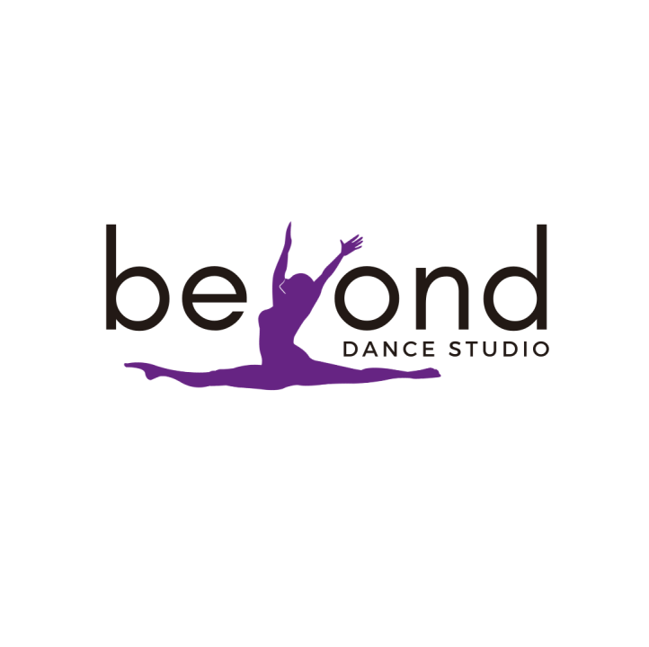

**Beyond Dance Studio RULES:**

1. **Lobby is CLOSED except for:**
2. Payments
3. Uniforms
4. Personal Matter

*Maximum 5 Parents/Guardians allowed in Studio Lobby*

1. **Parents will be asked to drop off their children on time and pick them up 5 minutes before class ends** 
   1. Drop Off: Beyond Dance Studio Main Door
   2. Pick Up: Beyond Dance Studio Main Door (Sign out)
2. **Masks are MANDATORY at all times in the studio ( Ages 6+ )**
   1. No mask, no service
3. **Students should bring their own reusable water bottles**

*If you have any questions or concerns please call us 0965757474*