MDM2 – Case Study: Assistive Robotics for
Improvement of Life Quality
One‑Page Proposal

Team | Group [no.]
Members | Narean Ravichandra; Guttikonda Ayyappa Reddy
Project Title | Fusion of sEMG, IMU, Gaze and Scene-Camera Data for Arm-Position-Robust Grip Selection in Transradial Myoelectric Prosthetic Hands
GitHub Repository URL | [GitHub link]
Contact Email | narean.0707@gmail.com
Industrial Application (target domain/use‑case) | Upper-limb prosthetics (medical-device sector): grip-selection controller for multi-grip myoelectric hands used by transradial (below-elbow) amputees in daily grasping tasks (Software & Simulation track)
Keywords (3–6) | Multimodal sensor fusion; myoelectric prosthesis; limb-position effect; grasp-type classification; eye tracking; Bayesian decision fusion
Submission Date (YYYY‑MM‑DD) | 2026-10-24
Gant Chart | 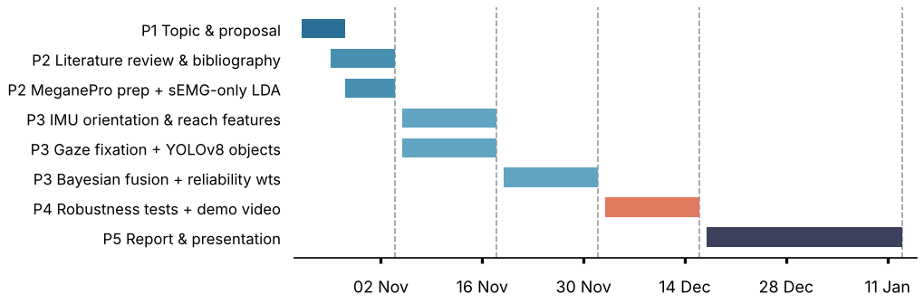

1) Problem Statement & Measurable Outcomes (3–4 sentences) | Multi-grip myoelectric hands classify forearm sEMG trained in one arm posture; when the amputee raises or extends the forearm, sEMG patterns shift (limb-position effect), the hand opens into the wrong grip and the object is dropped. We fuse 12-channel sEMG, forearm accelerometers, eye-tracker gaze and a head-mounted scene camera to select one of 5 grips (power, lateral, tripod, pinch, open palm).  KPIs (15 amputee subjects): (1) grip accuracy ≥ 90 % and ≥ 15 pp above sEMG-only; (2) accuracy drop between forearm-orientation bins ≤ 5 pp; (3) grip decided within the first 50 % of the reach phase; (4) ≤ 50 ms processing per decision.
2) Motivation & Assistive Relevance (2–3 sentences) | Roughly a quarter of adult users abandon electric upper-limb prostheses, with unreliable control a main cause (Biddiss & Chau, 2007). Reliable grip selection without muscle-trigger sequences lets transradial amputees eat, drink and dress with fewer drops and less mental effort; multi-grip hands and low-cost eye trackers exist, so control is now the bottleneck.
3) Related Work Snapshot (2–3 key references) | Fougner et al. (2011), IEEE TNSRE: limb-position effect; accelerometers reduced errors. Markovic et al. (2014), J. Neural Eng.: stereo vision + sEMG grasp pre-shaping, mainly able-bodied users. Cognolato et al. (2020), Sci. Data: MeganePro (sEMG, accelerometer, gaze, scene video; 15 amputees, 30 able-bodied).  Gap: no quantified four-modality (sEMG + IMU + gaze + vision) fusion targeting limb-position robustness on amputee data.
4) Method & Feasibility (≤6 sentences) | (1) Data: MeganePro (12-ch sEMG ≈ 2 kHz, electrode accelerometers, 100 Hz gaze, 25 fps scene video), leave-one-subject-out over 15 amputees. (2) sEMG: 20–450 Hz band-pass, 50 Hz notch, 200 ms windows / 50 ms step, MAV, WL, ZC, SSC features → LDA baseline. (3) IMU: forearm gravity vector gives orientation features and position bins; acceleration onset marks the reach phase. (4) Vision: ≥ 200 ms gaze fixation → 224×224 crop → YOLOv8 (COCO-pretrained, fine-tuned on ~500 labelled frames) → object-to-grip prior. (5) Fusion: P(grip) ∝ P_vision^wv · P_EMG+IMU^we, weights from validation reliability, sEMG+IMU fallback if vision drops out. (6) Artifacts: Python GitHub repo, confusion matrices, accuracy-vs-orientation plots, demo video.
5) Milestones & Timeline (short table/list) | P1 Oct 24 – Proposal (5 grips, 4 sensors, KPIs fixed)  P2 Nov 4 – Literature map, bibliography, sEMG-only LDA baseline, limb-position error per orientation bin  P3 Nov 18 – IMU features + gaze/YOLOv8 pipeline; Dec 2 – Bayesian fusion + reliability weighting  P4 Dec 16 – Robustness (channel-shift, vision dropout) + demo video  P5 Jan 13 – v0–v3 comparison, report, presentation
6) Risks & Ethics (1–2 sentences) | MeganePro is anonymised, ethics-approved and cited under its licence; no raw scene frames are published. Risks: only 15 amputees (leave-one-subject-out testing), ~500 frames to label for non-COCO objects (budgeted in P3), and offline results do not prove clinical benefit.

Phase 1 rubric (15%): Team & GitHub (2%), On‑time (2%), Topic & Proposal (5%) — Industrial Application, Problem+Outcomes, Feasibility+Timeline; Presentation (6%).

