Windows Communication Foundation (**WCF**) is a framework for building service-oriented applications. Using WCF, you can send data as asynchronous messages from one service endpoint to another. A service endpoint can be part of a continuously available service hosted by IIS, or it can be a service hosted in an application. An endpoint can be a client of a service that requests data from a service endpoint. The messages can be as simple as a single character or word sent as XML, or as complex as a stream of binary data. A few sample scenarios include:

* A secure service to process business transactions.
* A service that supplies current data to others, such as a traffic report or other monitoring service.
* A chat service that allows two people to communicate or exchange data in real time.
* A dashboard application that polls one or more services for data and presents it in a logical presentation.
* Exposing a workflow implemented using Windows Workflow Foundation as a WCF service.
* A Silverlight application to poll a service for the latest data feeds.

Both technology can manage the number of requests per second however the programming model is quite different

The purpose of WCF is to save developers writing code for different transport protocols and it has large number of features so that is why it is slower than Sockets. In addition, WCF is for service-oriented applications.

In case of only 3-4 requests per second, WCF might be a better option as it is very flexible and will save a lot of development time.

Sockets are very low level and require building a communication protocol on top of it. However, the overhead can be minimal. WCF is modelled after RPC (Remote Procedure Calls) and provides an abstraction on the transport. It allows using the same API with very different technologies such as web services or messaging. However, the abstraction provided has its own set of problems such as a certain complexity or steep learning curve.

**Performance Monitoring of** *WCF Calculator Service*

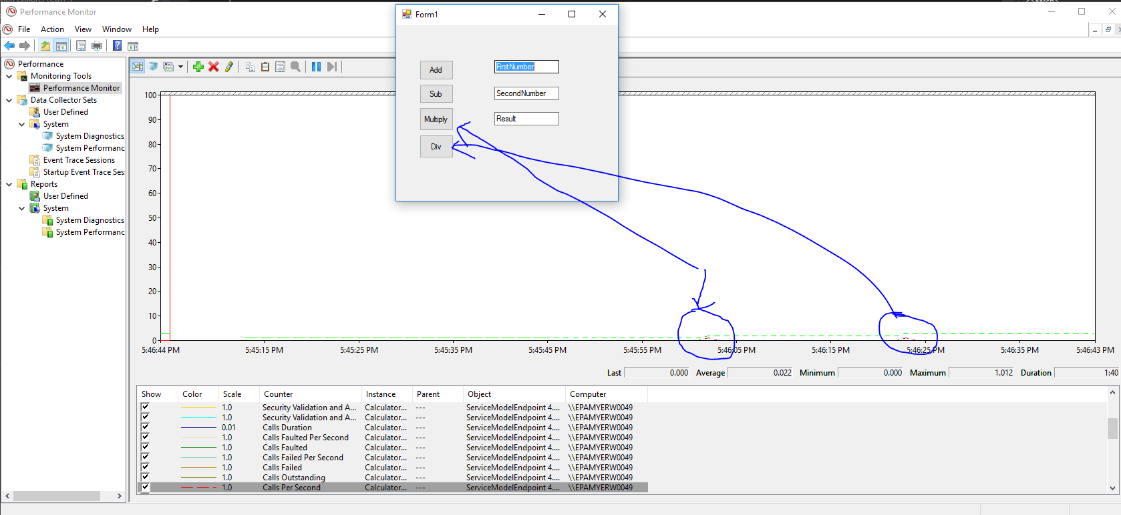

Performance monitoring done by enabling **performance counters**, counters for a WCF service through the web.config configuration file.

A parameter inspector wrote to measure performance of WCF service methods. The parameter inspector configure in web.config by writing a behavior extension. The extension registered in configuration file.

To view data captured by the performance counters, has been used the **Performance Monitor** (Perfmon.exe).