**Self-service Password Reset tool**

**Part 1**

**Enroll the tpx id**

**Part 2**

**Change Password**

**Part 3**

**Forgot your Password /Reset your Password**

**Part 4**

**Account Lockout / Account status**

**Part 5**

**Update your contact, location, etc**

**Part 6**

**Reset security Q&A**

**Part 1**

**Enroll the tpx id**

Step1: Please visit the link <http://pwdreset> and enter your ‘IN’ domain user id, password and select Login

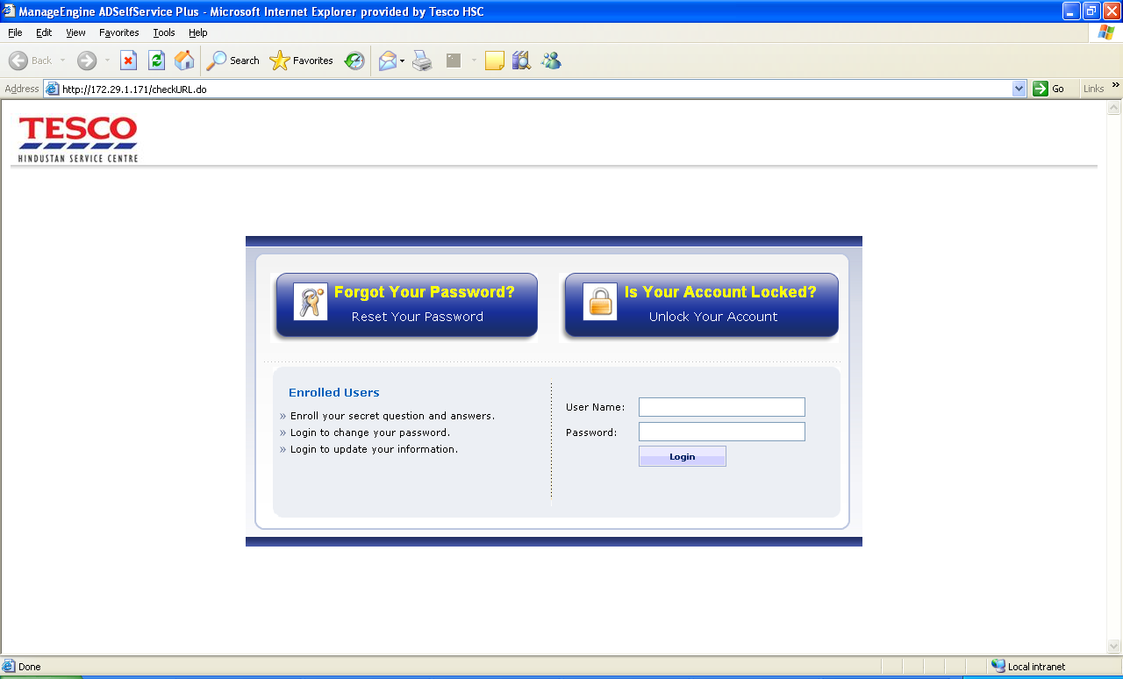

Step3: You would get a message ‘Welcome to AD Self service plus’ and select ‘Yes’ to continue.

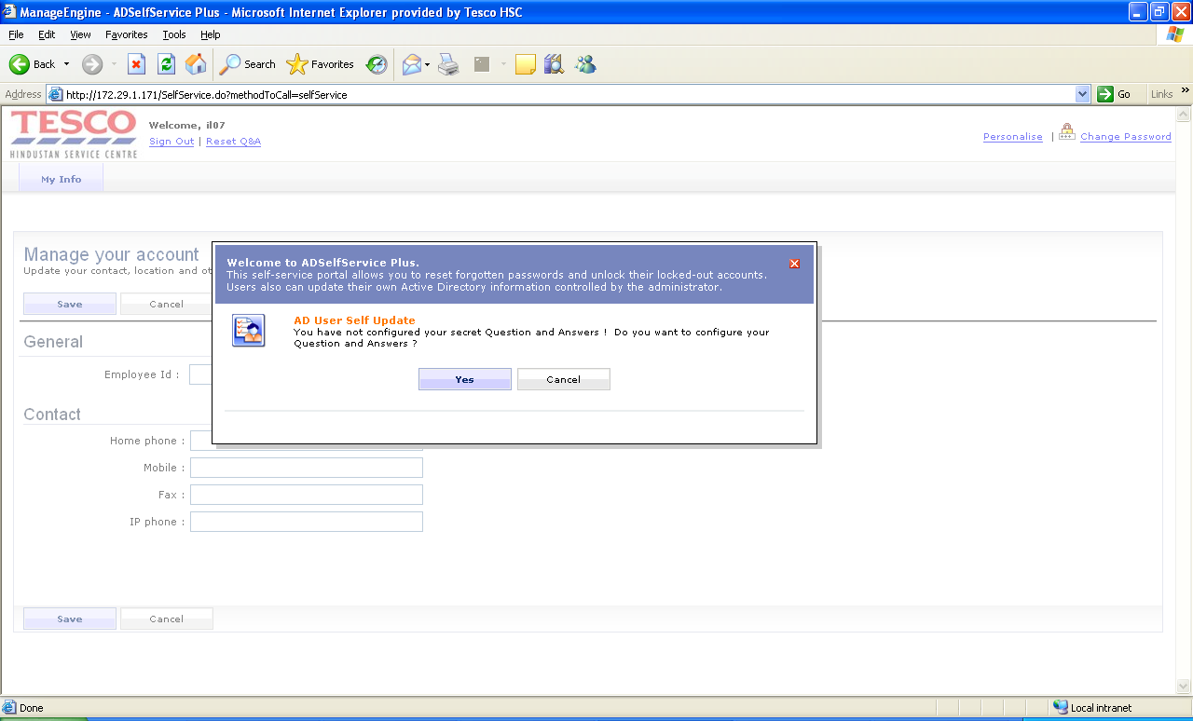

Step4: Select the Security Q&A (all three), input the Answers and Save

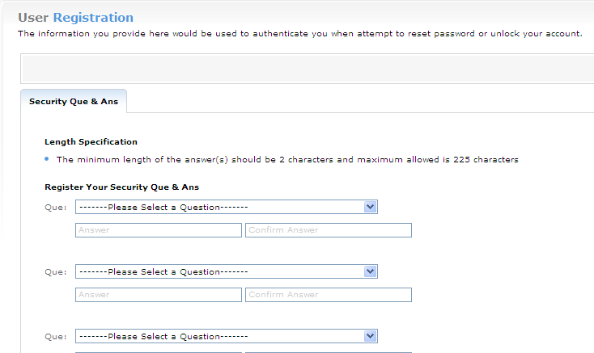

Step5: Enrolling of Password reset tool is completed

**Part 2**

**Change Password**

Step1: Click Change Password option as shown below

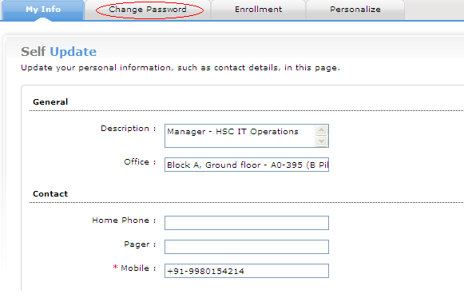

Step2: Enter the new password, confirm password and Ok

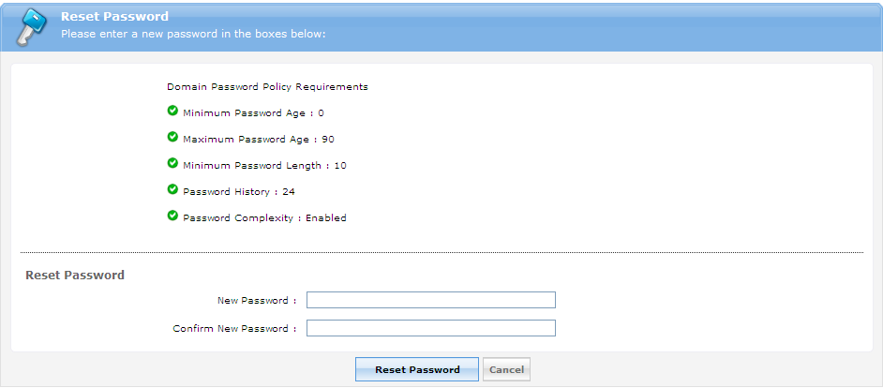

Step3: This resets your ‘IN’ domain password and please refer to the Domain Password policy requirements in the above screen

**Part 3**

**Forgot your password /Reset your password**

Step1: Please visit the link <http://pwdreset> and select Forgot your password or Reset your password



Step2: Enter your ‘IN’ domain user id to continue

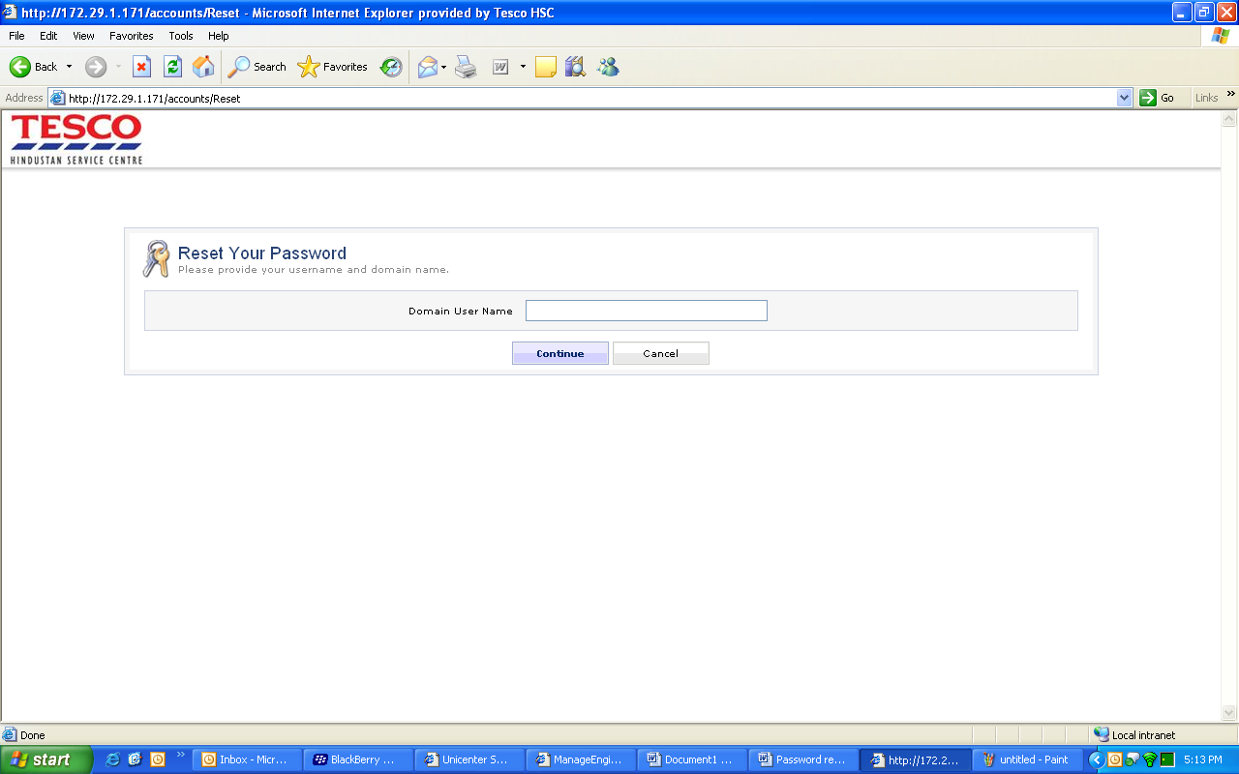

Step3: Answer the security Q&A and continue to reset the password

**Part 4**

**Unlock your account / Check your account status**

Step1: Please visit the link <http://pwdreset> and select Unlock your account or Is your account locked?



Step2: Enter your ‘IN’ domain user id and continue



Step3: Answer the security Q&A and continue to unlock the account / account status

**Part 5**

**Update your contact, location, etc**

Step1: Enter the required info as below and Save

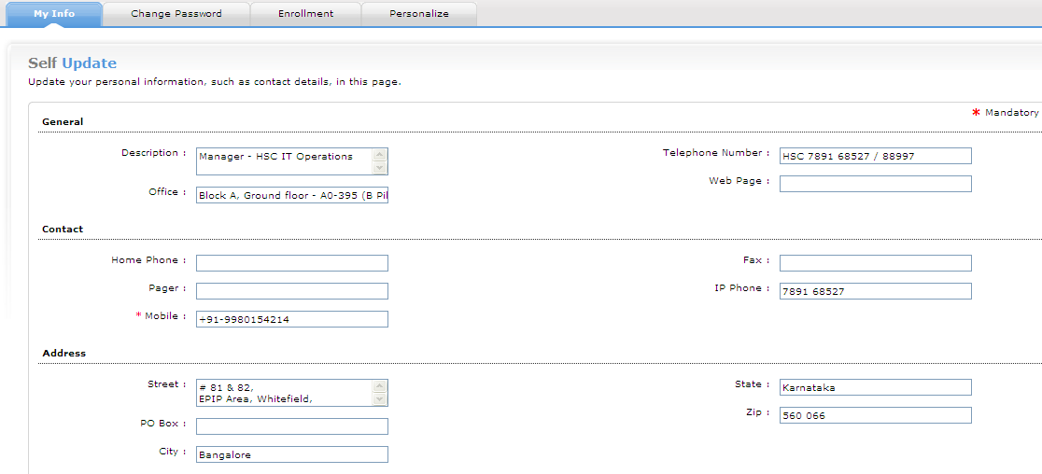

**Part 6**

**Reset security Q&A**

Step1: Click Enrollment option as shown below

