

SFTP Connectivity User Guide

Revision History
Version Number | Date (dd-mm-yyyy) | Author | Description
1 | 26/09/2012 | Kavitha Siddaramu | Draft 1

TABLE OF CONTENTS
1. Overview 3
2. Tools to be Installed: 3
3. Installation of WinSCP Tool: 3
4. Installation of GnuPG Tool: 6
5. Using WinSCP Tool: 11
6. Encrypting/Decrypting Files using GnuPG Tool: 11

Overview
The purpose of this document is to explain the process involved in sending or receiving files through SFTP connection. This document also explains the process of encrypting the file using PGP encryption.

Tools to be Installed:
Note: Change the file extensions from .txt to .exe in the clearcase[This was done since we cannot upload the exe to clear case]
Tool Name | Version | ClearCase Path
WinSCP | 4.3.7 (Build 1679) | \\CORE_R16\MARKETING_COMP\  CORE\SFTPTools\WinSCP\
GnuPG | 2.1.1-34299-beta | \\CORE_R16\MARKETING_COMP\  CORE\SFTPTools\GnuPG\

Installation of WinSCP Tool:
WinSCP tool is used to send or receive files through SFTP connection. Follow the below steps to install the WinSCP tool:
1] Double click on the winscp437setup.exe
2] Select the language as English and click OK
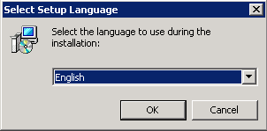
3] Click on Next
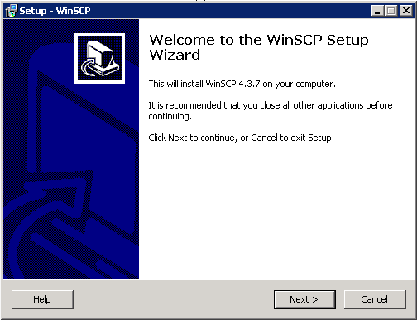

4] Click on Next
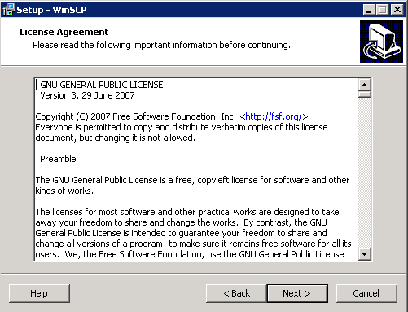
5] Select Full Upgrade as option and click on Next
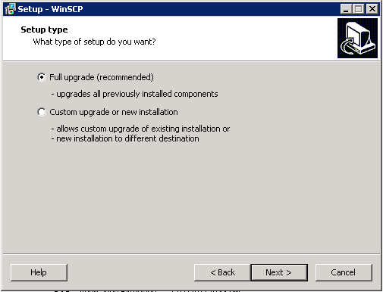
6] Click on Install
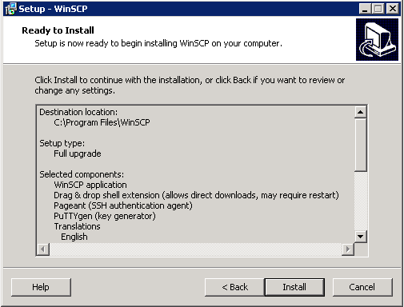
7] Click on Finish.
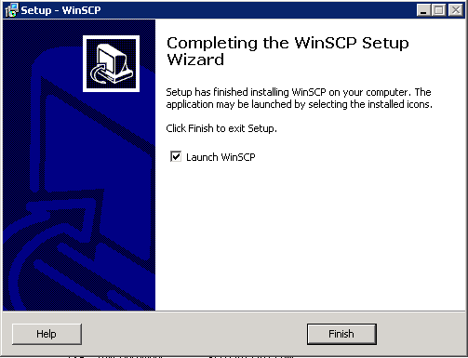

Installation of GnuPG Tool:
GnuPG tool is used to encrypt and decrypt files. Follow the below steps to install the GnuPG tool:
1] Double click on the file “gpg4win-2.1.1-34299-beta.exe”.
2] Select the language as English and click “Ok”.
3] Click on Next.
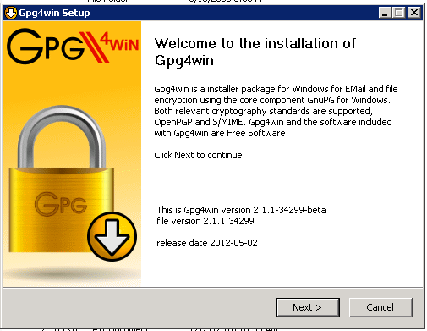
4] Click on Next.
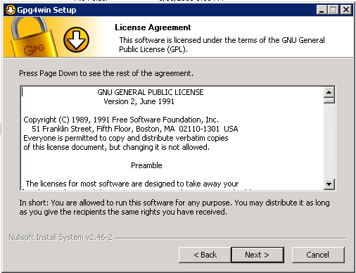
5] Click on Next.
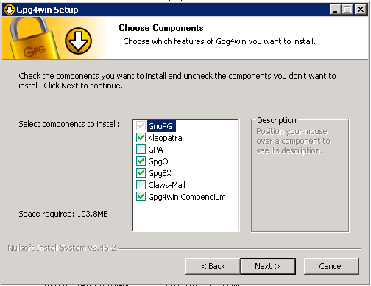
6] Specify the installation path and click on Next
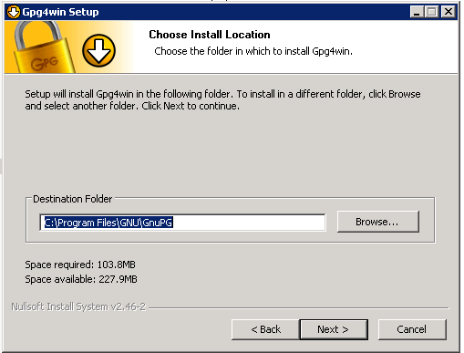
7] Specify the start links and click on Next
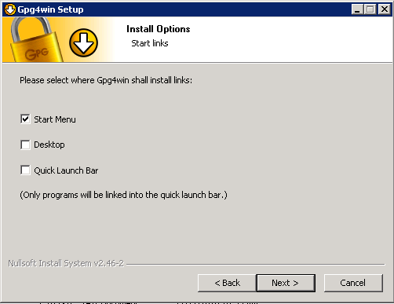
8] Click on Install.
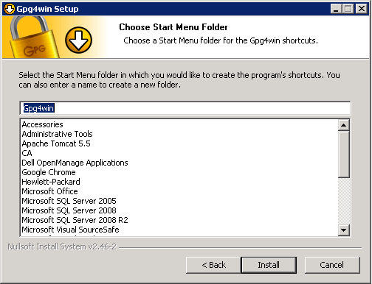
9] Click on Next.
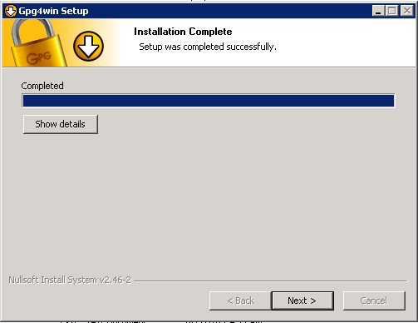
10] Check the Option “Root certificate defined or skip configuration” and click Next
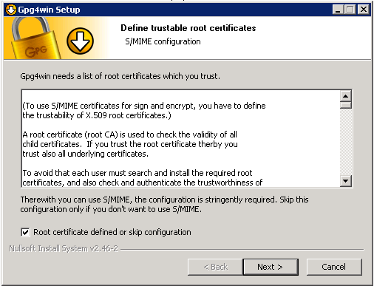
11] Click on Finish.
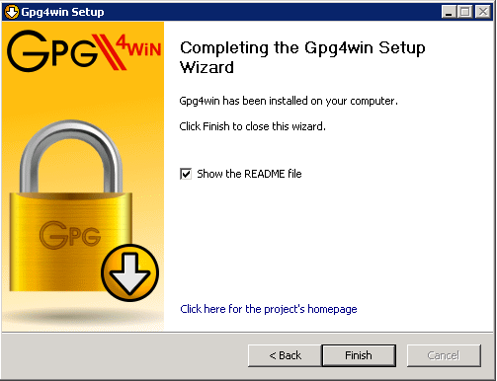

Using WinSCP Tool:
Follow the below steps to transfer the files with SFTP using WinSCP tool
1] Open the WinSCP Client
2] Specify the Host name, Port number, Username, Password
3] Select the protocol as SFTP
4] Click on Save
5] Give a Connection Name
6] Select the connection and click Login
7] Specify the password
8] Once the connection is made, left panel will display the files on our server and right panel will display the files on the SFTP server

Encrypting/Decrypting Files using GnuPG Tool:
Follow the below steps to encrypt and decrypt a file using GnuPG Tool
1] If a new key needs to be created
- Click on File → New Certificate
- Choose the option “Create personal Open PGP Key Pair” and click Next
- Specify the Name, Email and comment for the key
- Click on Advanced Settings button and Specify the expiry date, Authentication if necessary and click Ok
- Click on Next
- Click on Create Key
- Give the passphrase and click OK
- Reenter the passphrase entered earlier and Click OK
- Click on Finish
If the key already exists then
- Click on Import Certificates
- Browse for the key and Click on Open
- Click Ok
2] To Encrypt the files
- Click on File→Sign/Encrypt Files
- Browse for the file and Click Open
- Click Next
- Choose the key which you want to use for encryption from the upper tab and click on Add
- Click on Encrypt
- Click Finsh
3] To Decrypt the files
- Click on File→Decrypt/Verify Files
- Browse for the file and Click Open
- Click on Decrypt/Verify
- Enter the passphrase and click OK
- Click Ok

