INSTALLATION DOCUMENT FOR MORE FREQUENT LCM

VERSION | 1.0
Author | KAVITHA SIDDARAMU
Reviewer

TABLE OF CONTENTS

On Database Server 2
On Application Server 3
1. CSC Installation 3
2. Web.config Configuration [CSC Application] 3
3. CSC Release Package Checklist 3
LCM SSIS Package 3
1. List of SSIS Packages: 4

On Database Server
- Run the following scripts in TSM Database
\\Release\Scripts\ 0001_01.sql
\\Release\Scripts\ 0002_02.sql
\\Release\Scripts\ 0003_03.sql
\\Release\Scripts\ 0004_04.sql
- Run the following scripts in NGC database
\\Release\Scripts\ 0005_05.sql
\\Release\Scripts\ 0006_06.sql

On Application Server

CSC Installation

Web.config Configuration [CSC Application]
In the NGCAuthgatewayPOSService.exe.config in the path where the Interface is installed.

<appSettings>
<!--Parameter to hold the culture information specific to each country-->
<add key="cultureInfo" value="tr-TR" />
<!--Parameter to hold the User Name -->
<add key="userName" value="NGCAdmin" />
<!--Parameter to hold the Default Customer Name-->
<add key="customerName" value="Bilinmeyen Ad" />
<!--Parameter to hold the Default Data Protection Preference-->
<add key="DefaultDataProtectionPreference" value="0" />
<!--Parameter to hold the Default value for fetching Coupon Details-->
<add key="FetchCouponDetails" value="1" />
<add key="ProjectTitle" value="AG" />
<!--Parameter to hold the Default value for CreateCustomerSkeleton,1 to create customer if it does not exists-->
<add key="CreateCustomerSkeleton" value="0"/>
<add key="AdminConnectionString" value="data source=172.21.179.49; initial catalog=NGCV36;user id=ngcadmin;password=Tesco123;" />
</appSettings>

CSC Release Package Checklist

NGCAuthgatewayPOSService release package contains the following setup files.

 | Setup Files | Description
1 | NGCAuthgatewayPOSService.msi | NGCAuthgatewayPOSService Setup

LCM SSIS Package

List of SSIS Packages:

The NGCLCM.SSISDeploymentManifest consists of the following packages.

 | Package Name | Description
1 | BasestockCountReport.dtsx | NGCAuthgatewayPOSService Setup
2 | LCMCouponIssuanceReport.dtsx | NGCAuthgatewayPOSService Setup
3 | NGCExportMailableLCM.dtsx | NGCAuthgatewayPOSService Setup
4 | NGCLCMExport.dtsx | NGCAuthgatewayPOSService Setup
5 | NGCLCMGenerateAllocationFile.dtsx | NGCAuthgatewayPOSService Setup
6 | NGCUpdateBonusPreference.dtsx | NGCAuthgatewayPOSService Setup
7 | NGCUpdateBonusPreference_Bulkupdate.dtsx | NGCAuthgatewayPOSService Setup
8 | pkgCCOExtractCustomerUpdates.dtsx | NGCAuthgatewayPOSService Setup
9 | pkgNGCUpdateBonusPrefLCMCustomers.dtsx | NGCAuthgatewayPOSService Setup

- LCM SSIS Package Deployment
  - Double Click on “NGCLCM.SSISDeploymentManifest”

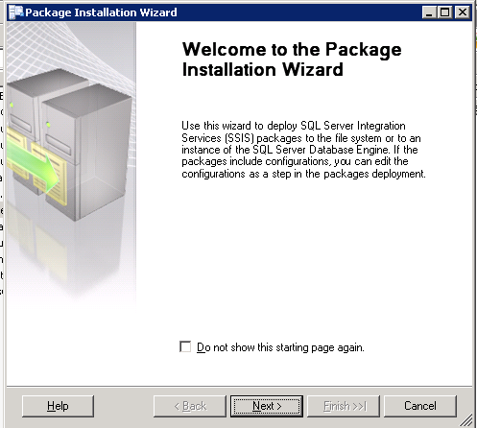

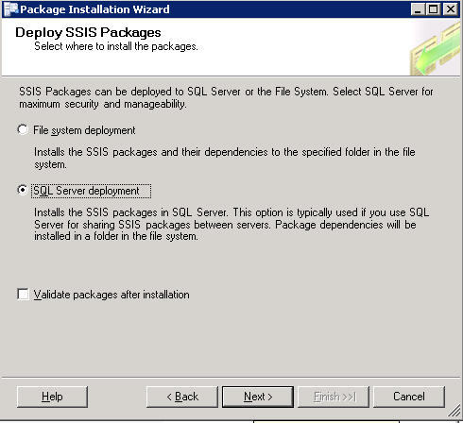

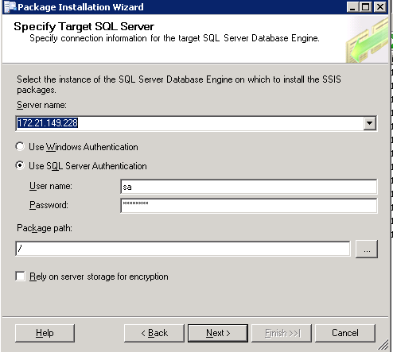\

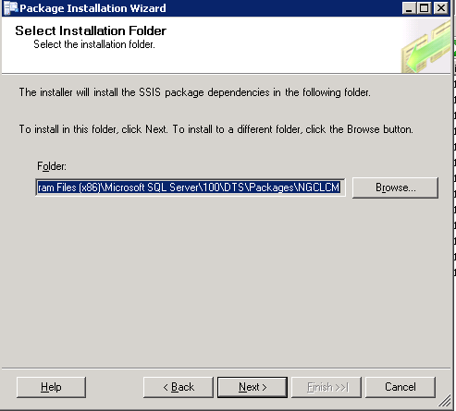

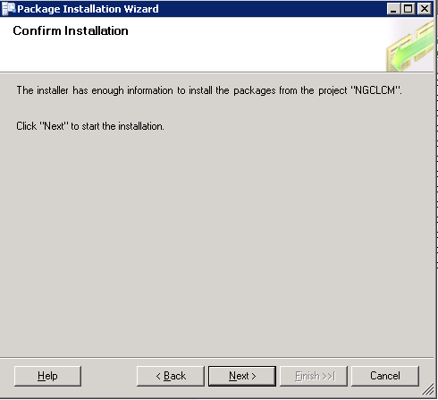

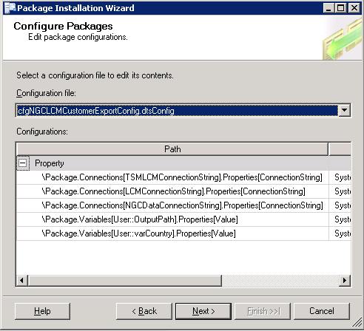

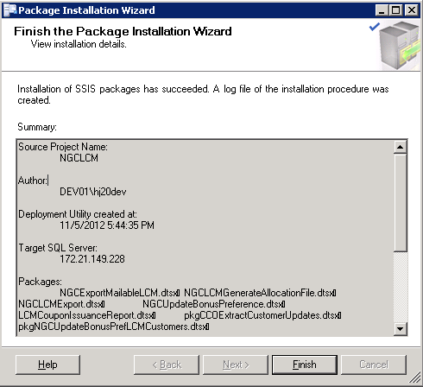

- Configuration Settings:

  - Connection strings:

LCMConnectionString: Data Source=172.21.149.228;User ID=sa;Initial Catalog=TSMdata;Provider=SQLOLEDB;Password=Tesco123

NGCDataConnectionString: Data Source=172.21.149.228;User ID=sa;Initial Catalog=NGCR15;Provider=SQLOLEDB;Password=Tesco123

strConnectionString: Data Source=172.21.149.228;User ID=sa;Initial Catalog=TSMdata;Provider=SQLOLEDB;Password=Tesco123

  - Output Folder Paths:

LogFilePath: path to which logs has to be written

OutputFilePath: path to which output files has to be written

RejectedFilePath: D:\Tesco\NGC\Batch\Data\Rejected\

AllocationFile: Path of the Processed CC allocation file
NGC LCM System Log: Path where the logs will be written
TSMLCMConnectionString: Path where the LCM file will be generated
IsMultipleFileRequire: Configurable value to see if multiple files are required
sFileName: Filename of the LCM Printer file
:sTraceFilePath: Path where the trace will be written
strTSMLogFile: log file path
strTSMOutputFile: Output file path
ThresholdValue: number of customers in each file in case of multiple files
varFieldDelimiter: Delimiter in the files
varNoofCoupons: Number of Coupons in Mailing file
varProcessedFileName:
varProcessedInputFilePath:

