LCM Phase 2 Process

Revision History
Version Number | Date (dd-mm-yyyy) | Author | Description
0.1 | 07/03/2013 | Kavitha Siddaramu | Initial Draft

Step 1: Extract Customer Details from NGC To TSM

- Run the job “JobLCM-Step 1-NGCExportMailableLCM” on Reporting server to extract all the customers from NGC to TSM database
- Once the job is completed successfully, check the table “LCMStaging” in TSM database is populated.

Step 2: Decryption of Dunnhumby Flagging file

- Check if the Dunnhumby Flagging file is received in the shared folder \\LCM\Input\DH\ on the reporting server.
- Open the GPG tool
- Select File → Decrypt/Verify Files
- Select the DH Flagging file and click Open
- Click on Decrypt/Verify

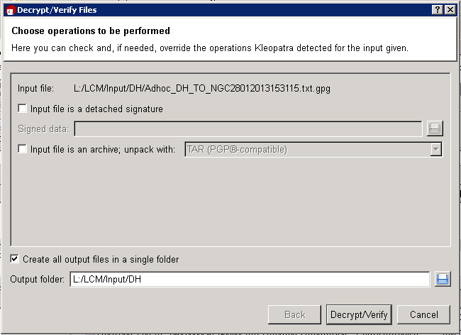

- Enter the passphrase given during creating of the GPG key and click OK

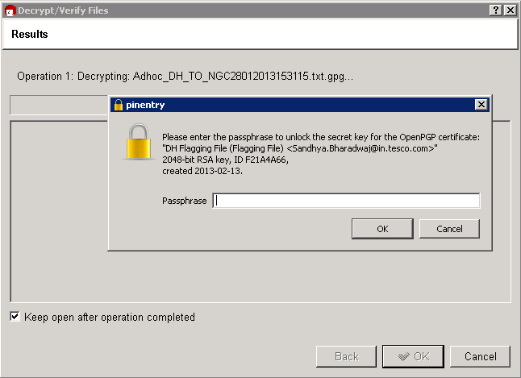

- Once the decryption is successful you will get the following message

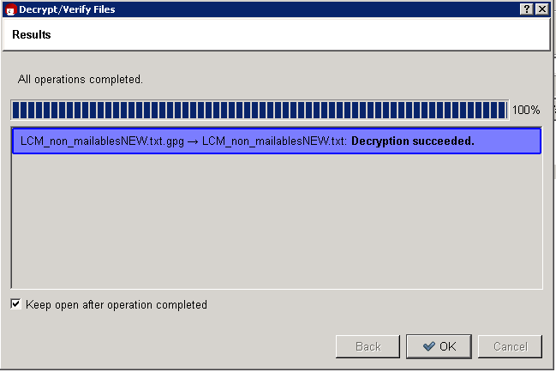

Step 3: Allocation File Generation

- Copy the decrypted DH flagging file to the input folder [The input folder which is specified in the config file for variable “DHInputFilePath”]
- Set the variable MailingNumber with the mailing number provided by CC support team
- Set the variable IsCCMultipleFileRequire to 1 if multiple files for CC to be generated
- If multiple files needs to be generated then set the number of records per file in the variable “NoofCustomerPerCCFile”
- Run the job “JobLCM-Step 2-NGCLCMGenerateAllocationFile”
- Once the job is completed successfully, the CC files should be generated in the output folder specified in the config file
- The file name of the CC allocation file should be
“MailingNumber_01_ AllocationFile_Normal_SequenceNumber.txt”
Where MailingNumber keeps changing for every LCM run and CC team should provide the mailing number
SequenceNumber will automatically generated when the multiple CC files has to be generated

Step 4: Copy Allocation files to CC Server

- Copy all the allocation files generated in the output folder to the shared location on the CC server.
- Currently we copy the allocation files to the following location of CC systems
\\172.21.156.77\CCInputs

Note: The location should be confirmed by CC support team before copying
- Inform the CC team once the files have been copied to their servers.

Step 6: Processed CC allocation files

Note : Need to run the GenerateSmartCodeInputFile EXE to convert Pipe symbol to tilt symbol before import the data into Smart Coupon table (TSMData DB).

- Once CC informs about the Processed files, copy the processed files from the shared location [CC support team will inform us about the shared location where the processed files are copied] to Reporting server
- Go to the following location:
E:\Tesco\NGC\GenerateAllocationFile\GenerateSmartCodeInputFile\GenerateSmartCodeInputFile\GenerateSmartCodeInputFile.exe.config
- Change the inputfile and Outputfile configuration
Where Input file should have the path of the processed file
Output file should have the path where the modified file should be saved
<add key="InputFile" value="E:\Tesco\NGC\Data\Input\Processed_L03_01_ AllocationFile_Normal_000.txt"/>
<add key="OutPutFile" value="E:\Tesco\NGC\Data\Input\Processed_L03_01_ AllocationFile_Normal_000_1.txt"/>

Step 7: Generate Mailing File

- Copy the Processed Allocation files to the input folder specified in the config file [Variable name is ProceseedCCInputPath]
- All the processed files should start with the name Processed if not then the name with which the processed files will start should be specified in the config file under the variable “ProcessedCCFileName”
- Set the header which should be there in the Mailing file in the config file for the variable “varLCMHeaderName”. For Eg: Tesco March LCM
- Set the variable IsMultipleFileRequire to 1 in the config file if multiple Mailing files are required to be generated
- Set the variable ThresholdValue to the number of records that should be there per file.
- Set the variable sFileName with the name the mailing files should be generated
- Run the job “JobLCM-Step 3 – NGCLCMExportPrinterFile” to generate the Mailing files
- The mailing files will be generated in the output folder with the sequence numbers in case of multiple files

Step 8: Sign Off files

- The attached sheet has the list of sign off files to be generated and sent to both printers for Sign off
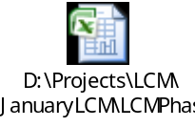
Note: This check list needs to be confirmed as it might change for every LCM run

Step 8: Encryption of Files

- All the files should be encrypted before they are sent to printers using GPG tool
- The GI and TLG keys for encrypting have already been added to the Tool
- Attached are the GI and TLG Keys
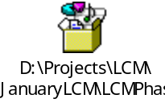
Note: If not already added then import the keys to the GPG tool
- Follow the below steps to encrypt the file
  - Launch the GPG Tool
  - Select File → Sign/Encrypt Files
  - Select the file to be encrypted
  - Click on Next
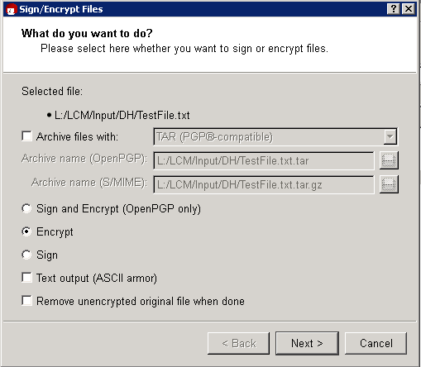

  - Click on the key required for encryption and click on Add and then click Encrypt
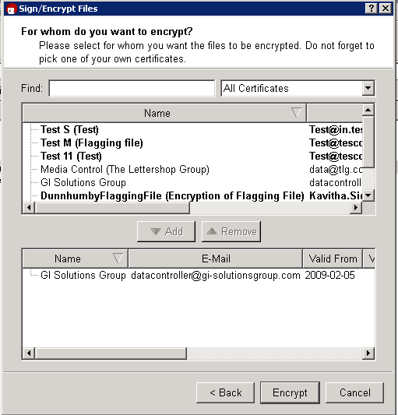

  - There will be a warning message displayed. Click on Continue

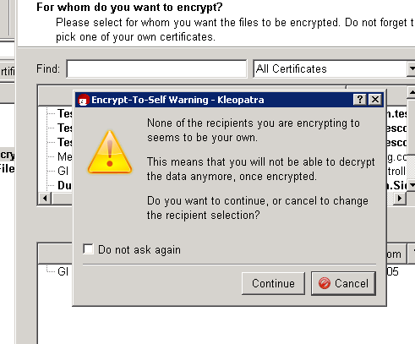

  - Once the encryption is completed successfully the following screen will be displayed
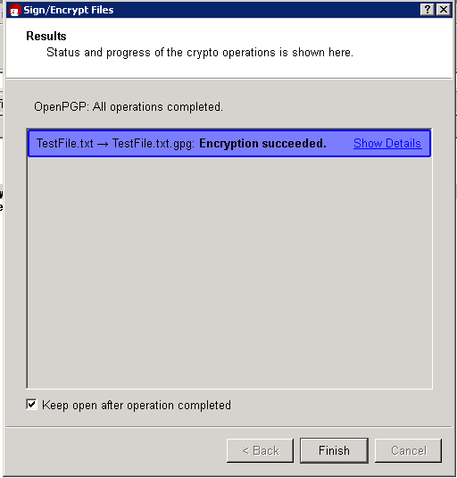

  - The encrypted file will also be saved in the same location of the actual file with a .gpg extension

Step 8: Transferring of file through SFTP

- Launch the WinCSP tool and click on Login
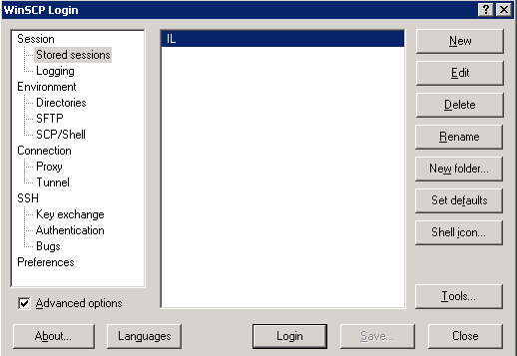

- If you want to change the login detail click on Edit and change the settings and click on Save. All the Session details will be provided by IL

Note: The details below are of Pre prod servers
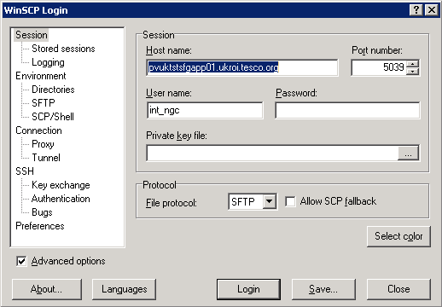

- Click on Continue

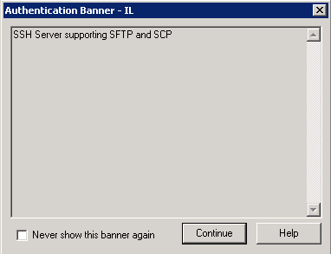

- Enter the password given by IL and click on OK

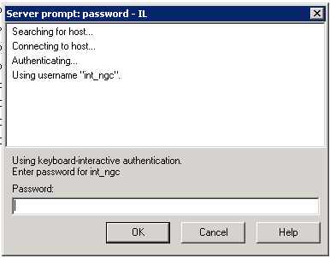

- Click on the Open Directory and select the folder location where the encrypted file resides

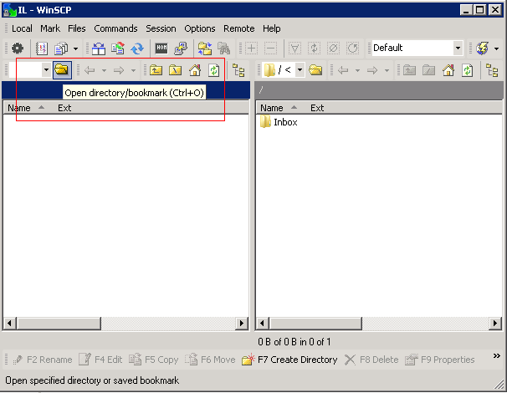

- Select the file to be transferred and click on “F6 Move” button at the bottom of the screen

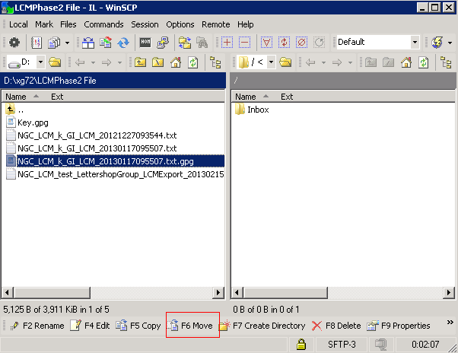

- Once the file transfer is complete we will get a warning, click on Skip and the file transfer will be completed.

Note: Change the file name manually before transferring as IL will reject the file in case of invalid file name

For LettershopGroup :
NGC_LCM_LIVE_ LettershopGroup_LCMEXPORT-datestamp.extention

For GI :
NGC_LCM_LIVE_ GI_LCMEXPORT-datestamp.extention

Step 8: Run the reports

- Run the jobs JobLCM-BasestockCountReport and JobLCM-LCMCouponIssuanceReport
- These jobs will create the following two Reports in the output folder
1] BasestockCountReport_yyyyMMddhhmmss.csv
2] CouponIssuanceReport_yyyyMMddhhmmss.csv
- Send these two reports to Marketing team in UK

-----------------------------------------EOD---------------------------------------------

