***CA-1***

*Narendhar kumar S*

*727721EUIT098*

*QUESTION 1:*

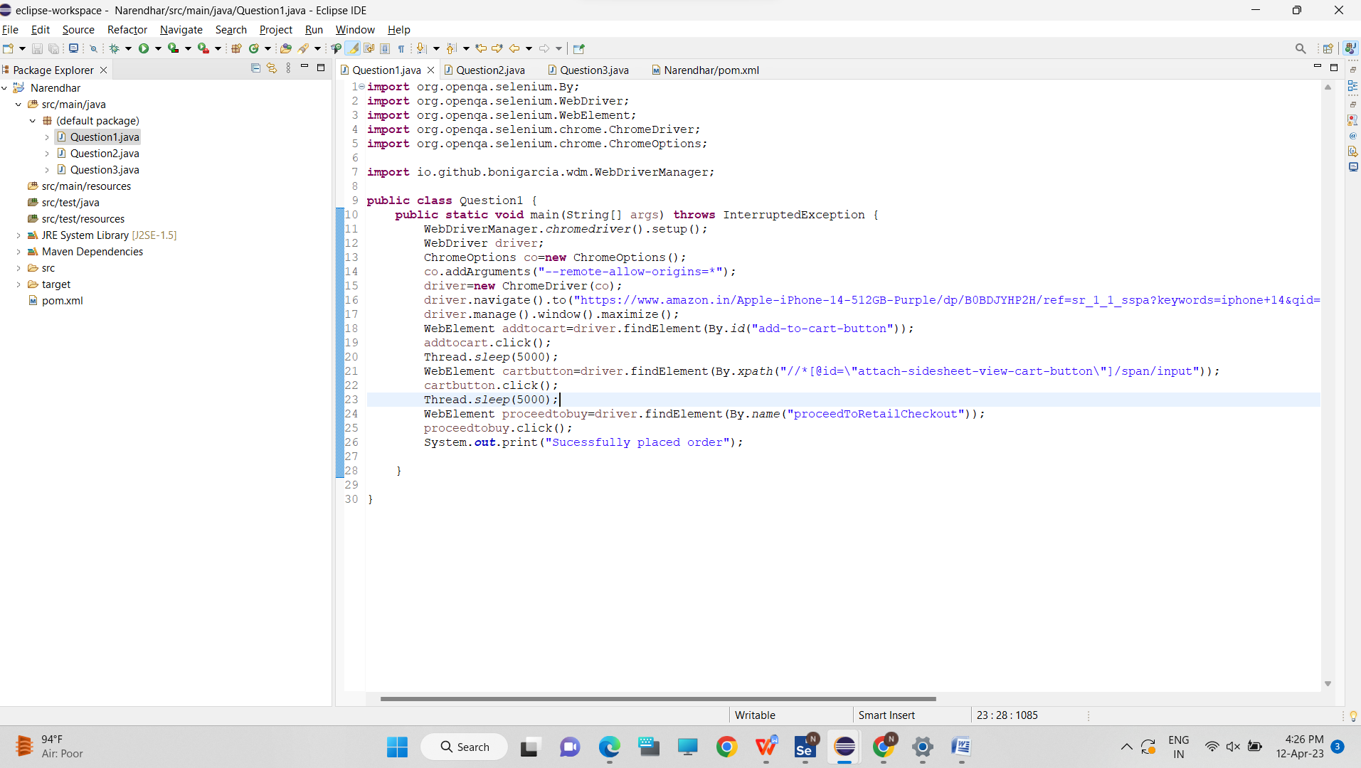

*OUTPUT:*

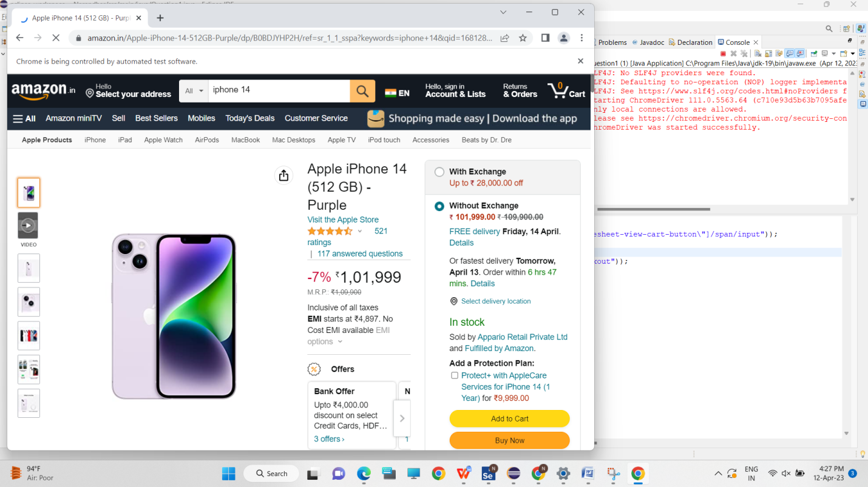

*QUESTION 2:*

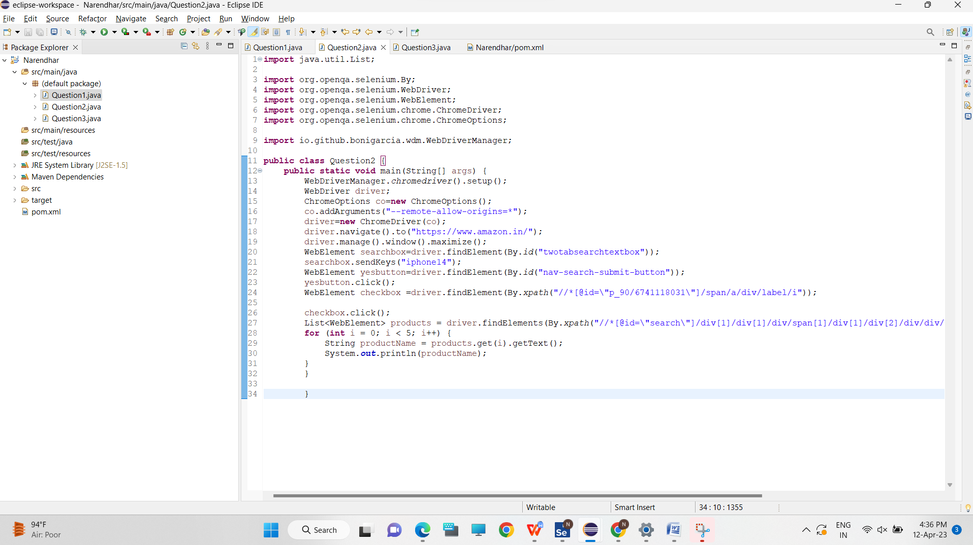

*OUTPUT:*

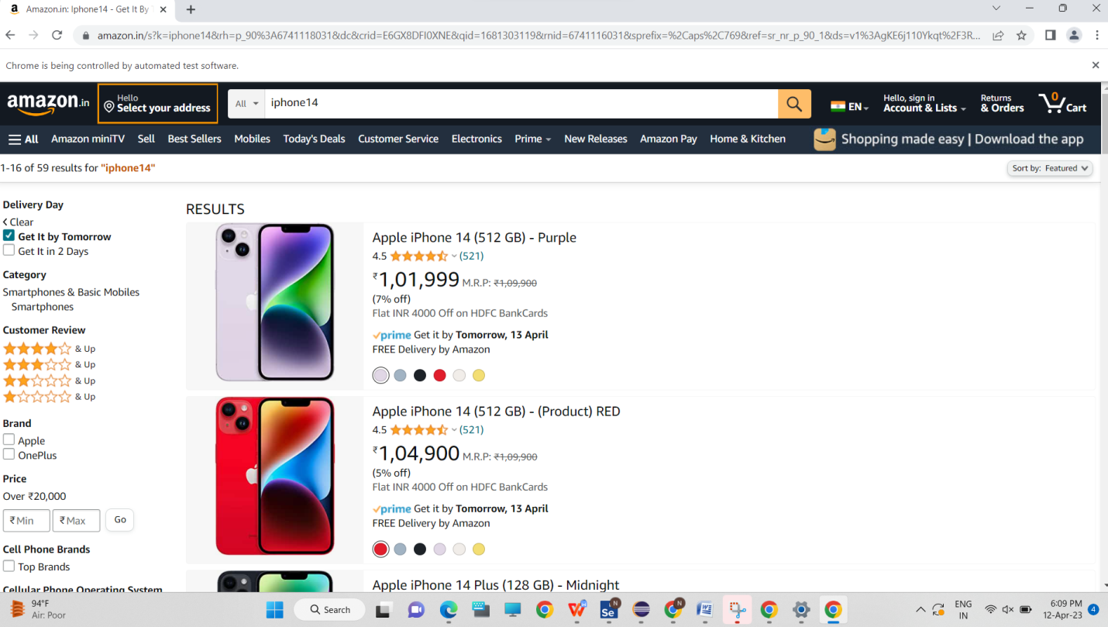

*QUESTION 3:*

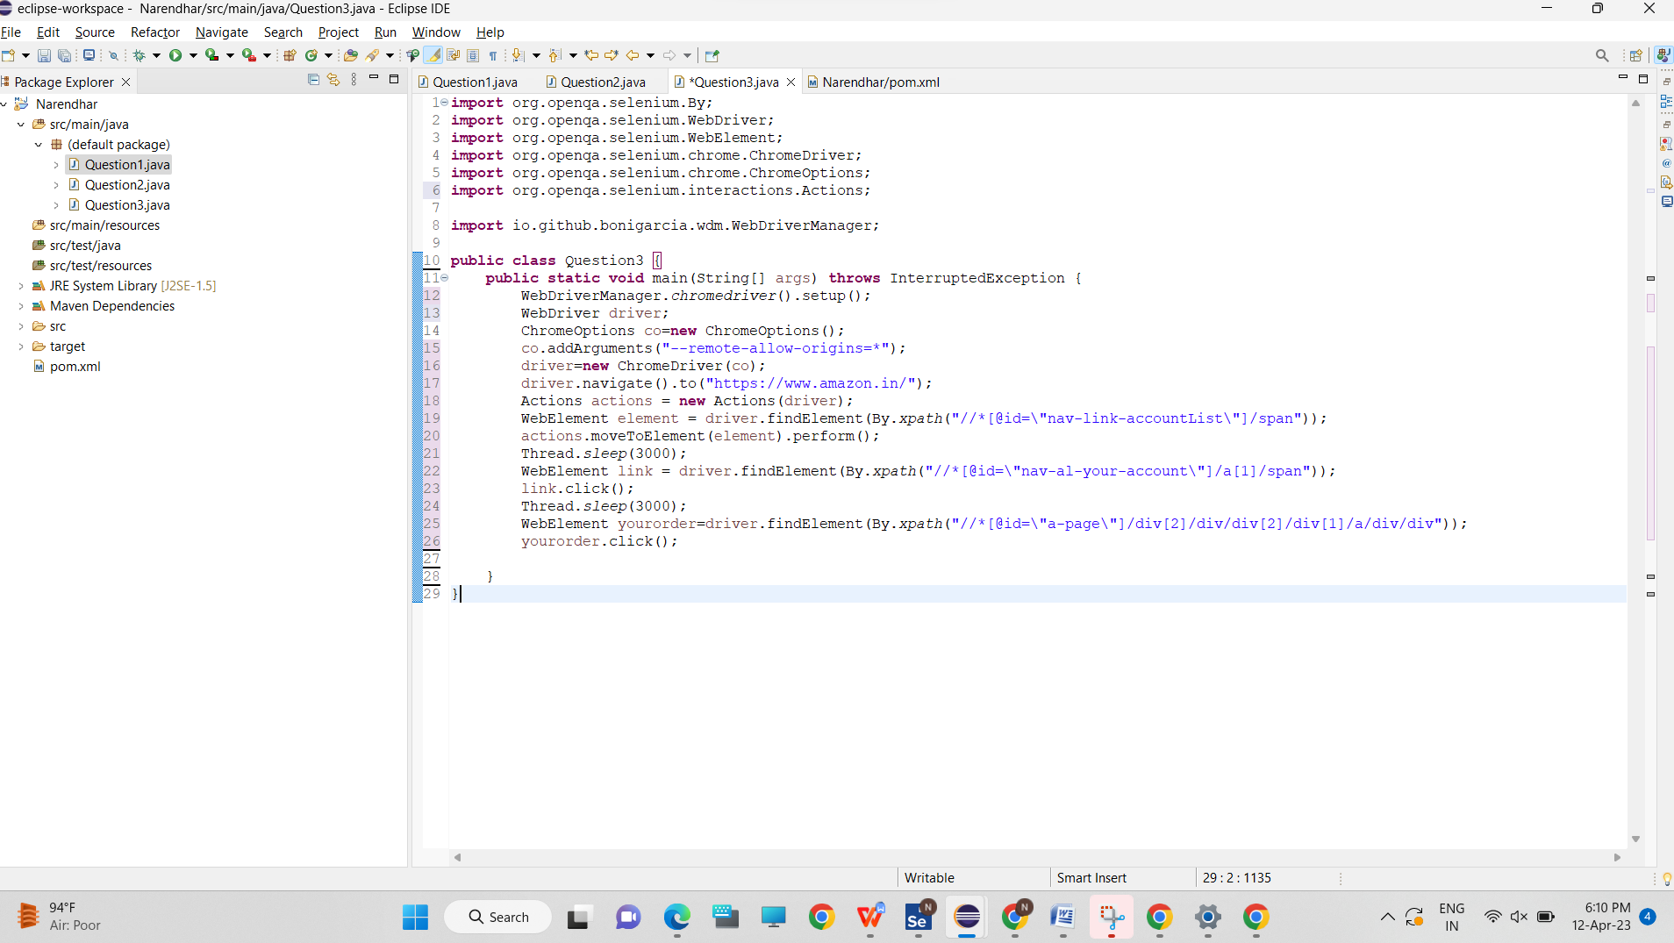

*OUTPUT:*

