* To check which we branch we are in,
  + run “git branch”. The branch which ever has the star-mark is the current branch



* To create a branch:
  + git branch dev1



* To change to a branch:
  + git checkout dev1

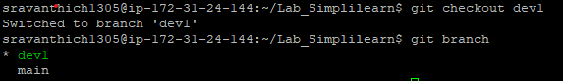

* Once the branch is created the data whatever is in Master/Main will be copied automatically [ The files will be copied only from the branch you are checking out to new branch. For example, if we are checking out to dev2 branch from dev1 branch the files from dev1 will copied but not from main branch] .
* Now, modify the file in the branch and push the file to remote repository and see that the updated files are viewed only in the branch but not in Master
  + Git add filename
  + Git commit -m “description”
  + Git push

**Note**: The git push command will try to push only to Master by default. If you want to push it to branch we need to use the below command

git push --set-upstream origin dev1

How to work on the merge conflicts:

* Git branch dev2 [ creating a branch dev2 from main so that all the files that are already committed will be copied to dev2]
* Let’s modify a file in dev2 and commit it [ git add filename, git commit -m “description”
* Now, before merging the dev2 in main let’s update the same file with some extra lines
* Git checkout main, modify the file, git add filename, git commit -m “description”
* Now when you try to merge the dev2 to main as git merge dev2 you will seeing the below exception:
  + 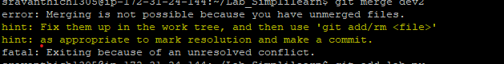
* Now you can work on the conflict manually by opening a file where you can see the entries from both commits [ from dev2 & main]
* After resolving the conflict you can add & commit the changes post which you can push to where ever branch you want

* To view the updated files in Main:
  + Git checkout main [ to change to main branch]
  + Git merge dev1
  + Git log [ Now you will see the updated files are present in local repository & dev1 branch in GIT but not the main branch in git]
  + 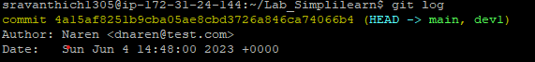
  + Git push [ To push the updated files to the main branch in git]
  + Git log

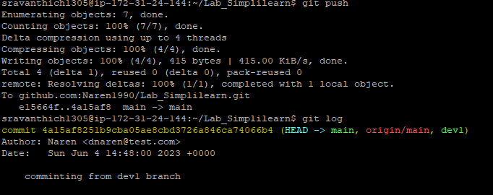

* To remove the file [Either from Main or any branch]:
  + Git rm filename
  + Git commit -m “description”
  + Git push