**Name = Narendra**

**Course = Machine Learning**

**Batch = 2026**

Objective - Analytical comparison of Linear Regression using Matrix inverse and gradient descent.

**For data1**

| Method | Weight | R square | learning_rate |
| --- | --- | --- | --- |
| Matrix inverse | 3.23193874 | 0.8359956 | - |
| Sklearn | 2.38406007 | 0.9579571905586357 | - |
| Gradient descent | 2.81604935 | 0.9218288396770741 | 0.01 |

Graphs

**using matrix inverse**

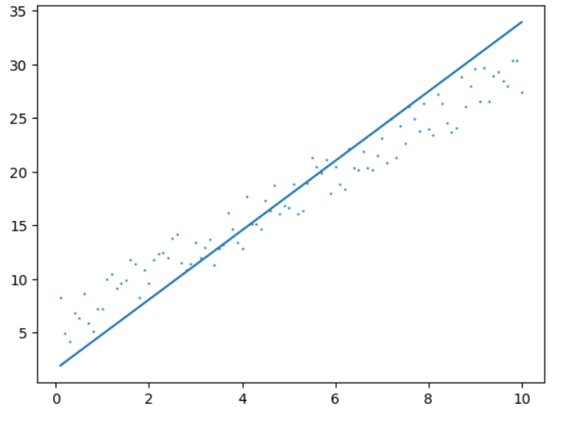

**Using sklearn**

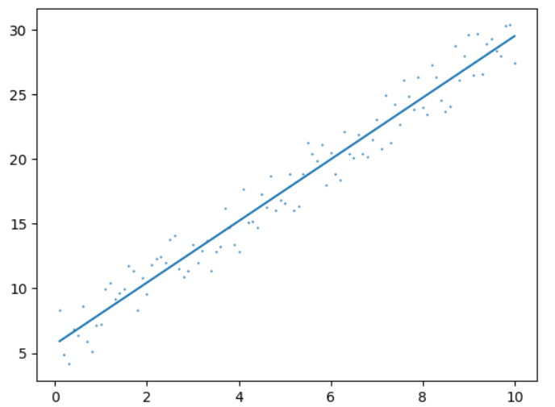

**Using gradient-descent**

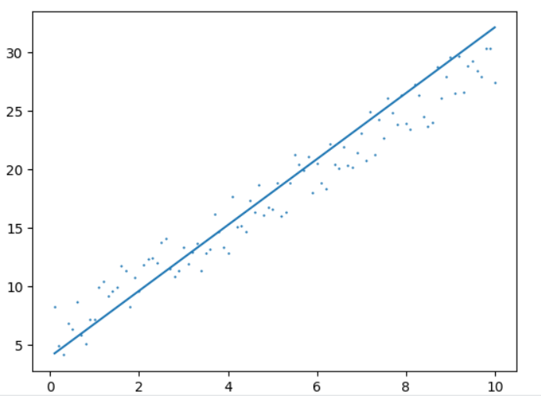

‘

For data 2

| Method | Weight | R square | learning_rate |
| --- | --- | --- | --- |
| Matrix inverse | 0.97299745 | 0.789068314366836 | - |
| Sklearn | 0.97299745 | 0.812341241212454 | - |
| Gradient descent | 1.3266423 | 0.7968164552119507 | 0.00001 |

Graphs

**using matrix inverse**

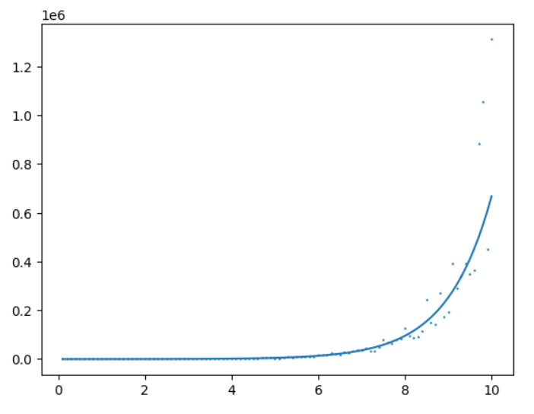

**Using sklearn**

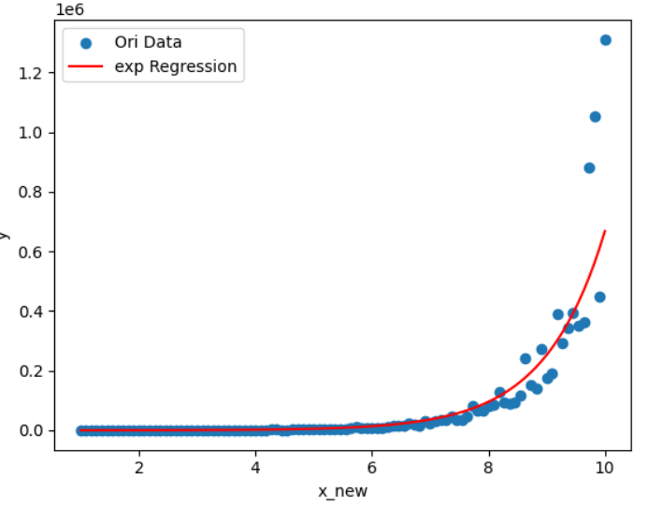

**Using gradient descent**

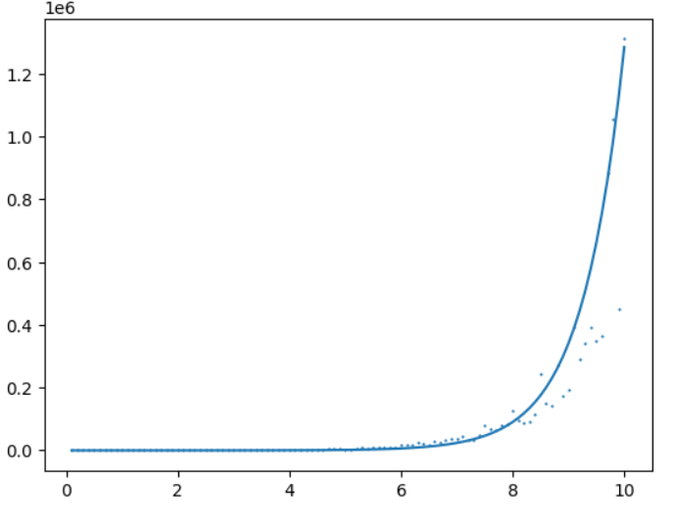

For data 3

| Method | Weight | R square | learning_rate |
| --- | --- | --- | --- |
| Matrix inverse | 0.26987112 | -0.70572247 | - |
| Sklearn | 0.09419021 | 0.3136973226728079 | - |
| Gradient descent | - | - | - |

Regression cannot applied datapoints are random

**For data 4**

| Method | Weight | R square | learning_rate |
| --- | --- | --- | --- |
| Matrix inverse | [-4.21240322],  [ 8.54119794],  [12.74220457] | 0.97783722 | - |
| Sklearn | [6.13243763], [2.39226554]  [7.74681038] | 0.9841749058943147 | - |
| Gradient descent | [5.53640976]  [6.02610985]  [6.5593706 ] | - | 0.0001 |

Graph cannot be visualized for this data.