Race Track Application

Developer: Narendran Kumar

1. Proper utilization of Dependency Injection

Used Dependency Injection to pass vehicle as parameter to Car and Truck Object constructor.

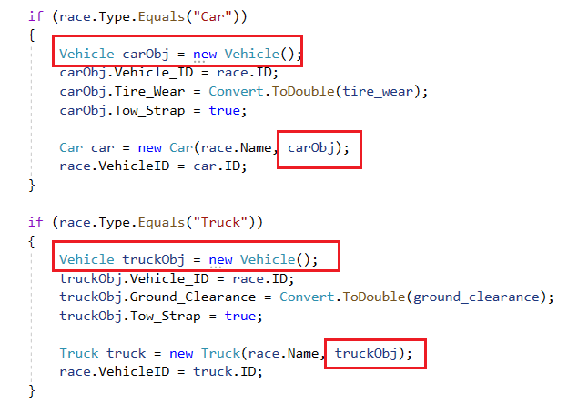

1. Code-first Entity Framework (Microsoft SQL Server)

Yes. Used Code First Entity (Created Class, DBContext ).

1. Encapsulating Business logic within models independent of the DB implementation.

Encapsulated Business logic without DB implementation.

1. Composition & Inheritance (Bonus: Explain which is better and why?)

Used Composition. Vehicle Parts/Properties are defined in Vehicle class and Car and Truck classes’ instantiate vehicle to use appropriate properties.

Preferred Composition as we can add any parts or properties to vehicles in future which may/may not be used in Car or Truck classes.

Adding a new variable/method to Vehicles which can be consumed by a new vehicle say Bus doesn’t alter anything on Car/Truck classes and their implementation.

1. Basic design patterns

Followed most of ***Gang of Four*** patterns in this application.

1. Utilize AJAX to present an always up-to-date listing of vehicles on the track

Used Ajax to show live vehicles on top of pages (Create/Details/Delete). It auto refresh every 5 seconds.

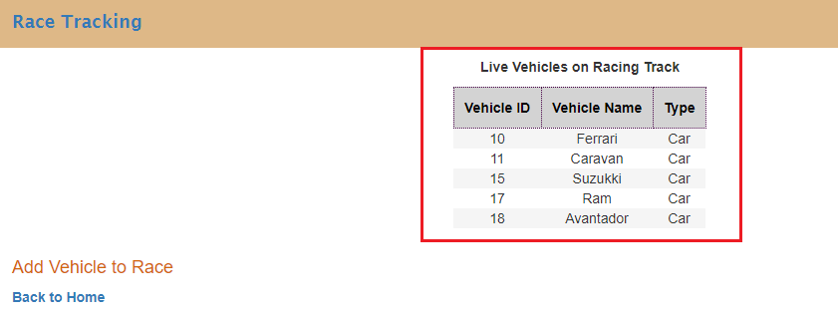

1. Write unit tests to prove the following business requirements

Added few unit test cases but not much to test vehicle inspection as I have used Jquery to validate inspection (client side). But I know how and when to use Unit Test Frameworks like MSUnit, NUnit, XUnit.Net.

# Business Requirements:

1. Present an always up-to-date listing of vehicles on the race track (Utilizing AJAX)

Done.

1. Present a single form to add vehicles to the race track. (Utilize a Type drop-down to determine which fields to show/hide, see inspections below)

Done.

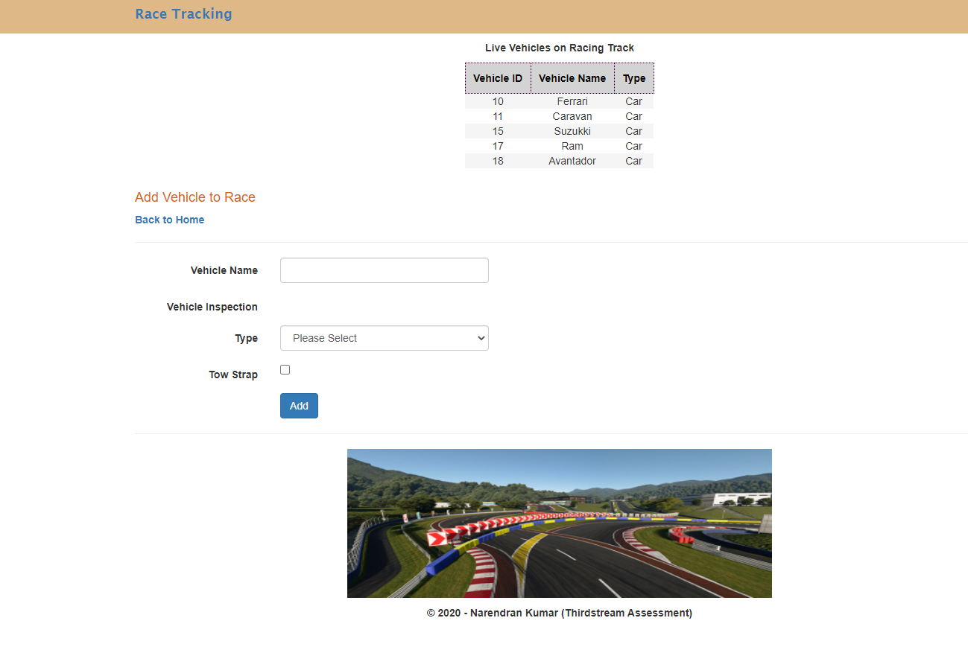

1. A maximum of 5 vehicles can be on the race-track at any time.

Validation added on Page Load (Add vehicle to Race) & on ADD Button.

1. Vehicles must pass an inspection prior to entering the track

Done. Vehicles can enter race ONLY if inspection is passed for appropriate Vehicle Type (Car/Truck). Used jQuery to ensure inspection is done.