**What is Big Data?**

The term Big Data refers to all the data that is being generated across the globe at an unprecedented rate. This data could be either structured or unstructured. Today’s business enterprises owe a huge part of their success to an economy that is firmly knowledge-oriented. Data drives the modern organizations of the world and hence [making sense of this data](https://intellipaat.com/hadoop-developer-training/) and unravelling the various patterns and revealing unseen connections within the vast sea of data becomes critical and a hugely rewarding endeavour indeed. There is a need to convert Big Data into [Business Intelligence](https://intellipaat.com/all-courses/business-intelligence/) that enterprises can readily deploy. Better data leads to better decision making and an improved way to strategize for organizations regardless of their size, geography, market share, customer segmentation and such other categorizations. [Hadoop is the platform of choice](https://intellipaat.com/big-data-hadoop-training/#curriculum) for working with extremely large volumes of data. The most successful enterprises of tomorrow will be the ones that can make sense of all that [data at extremely high volumes and speeds](https://intellipaat.com/tutorial/big-data-and-hadoop-tutorial/introduction-to-big-data-2/) in order to capture newer markets and customer base.

**Big Data has certain characteristics and hence is defined using 4Vs namely:**

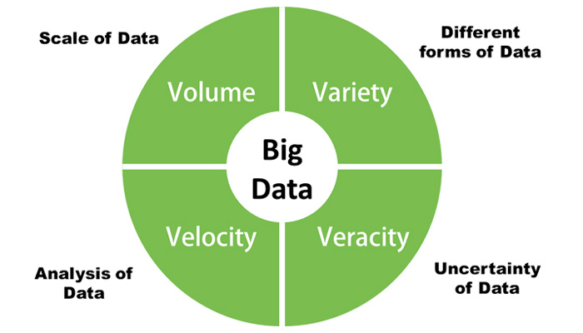

**Volume:** the amount of data that businesses can collect is really enormous and hence the volume of the data becomes a critical factor in Big Data analytics.

**Velocity:** the rate at which new data is being generated all thanks to our dependence on the internet, sensors, machine-to-machine data is also important to parse Big Data in a timely manner.

**Variety:** the data that is generated is completely heterogeneous in the sense that it could be in various formats like video, text, database, numeric, sensor data and so on and hence understanding the type of [Big Data is a key factor](https://intellipaat.com/media/e-commerce-niche-online-ventures-going-where-biggies-of-amazon-flipkart-cant/) to unlocking its value.

**Veracity:**knowing whether the data that is available is coming from a credible source is of utmost importance before deciphering and implementing Big Data for business needs.

**Here is a brief explanation of how exactly**[businesses are utilizing Big Data](https://intellipaat.com/blog/7-big-data-examples-application-of-big-data-in-real-life/)**:**

Once the Big Data is converted into nuggets of information then it becomes pretty straightforward for most business enterprises in the sense that they now know what their customers want, what are the products that are fast moving, what are the expectations of the users from the customer service, how to speed up the time to market, ways to reduce costs, and methods to build economies of scale in a highly efficient manner. Thus [Big Data](http://www.forbes.com/sites/bernardmarr/2016/08/25/the-most-practical-big-data-use-cases-of-2016/#5eb3c5a27533) distinctively leads to big time benefits for organizations and hence naturally there is such a huge amount of interest in it from all around the world.