Naren Suri – Home Work -2 [nsuri@iu.edu](mailto:nsuri@iu.edu) Bayesian statistics

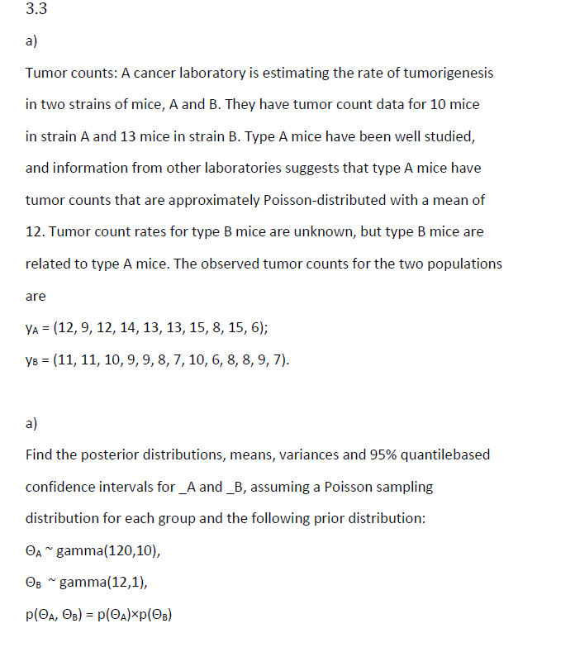

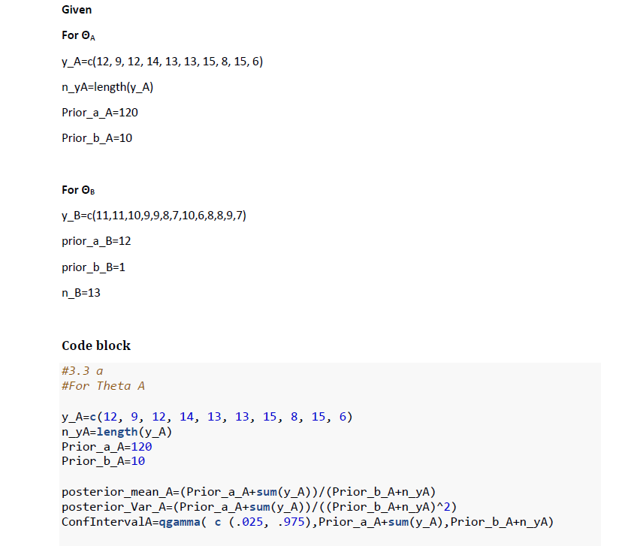

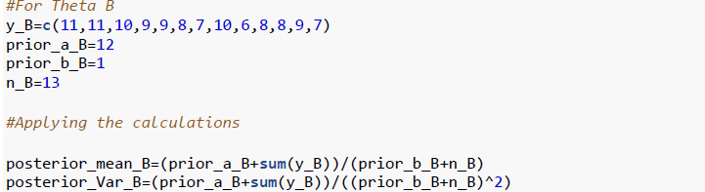

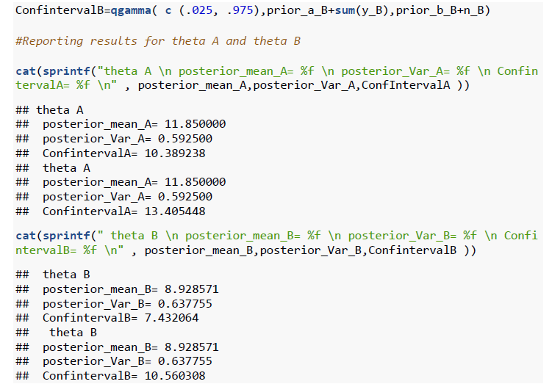

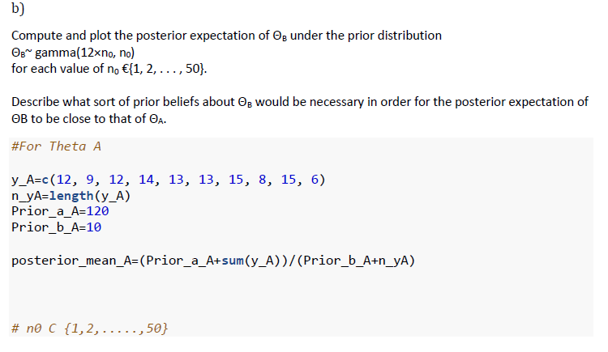

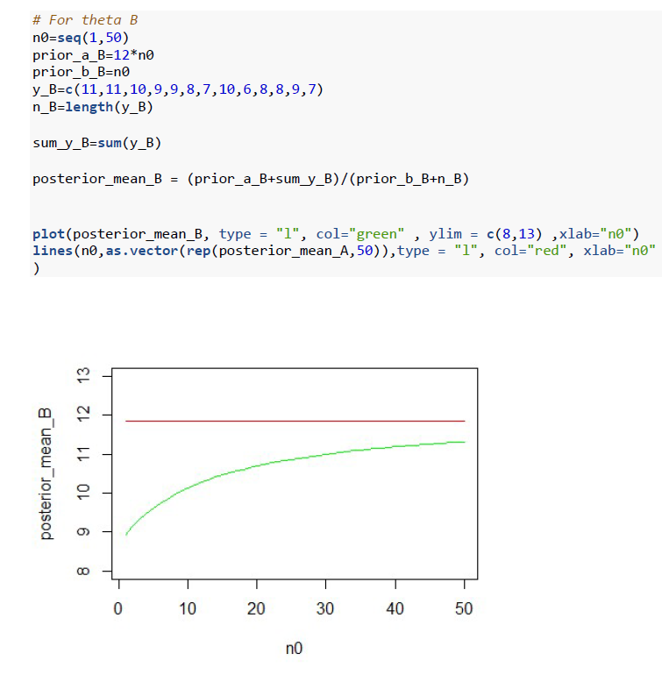

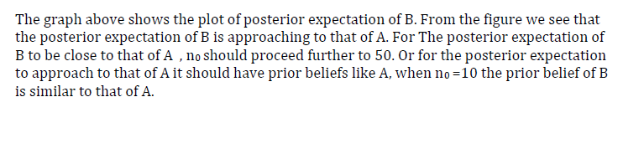

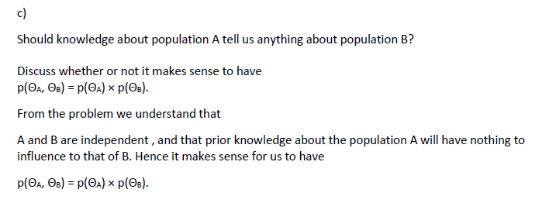

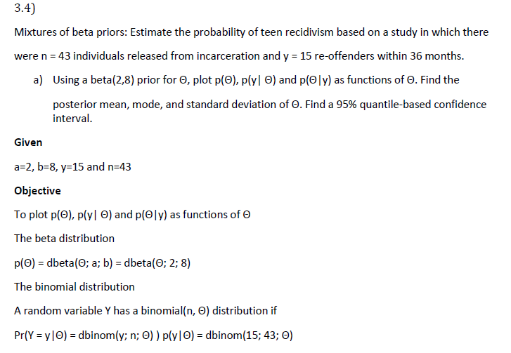

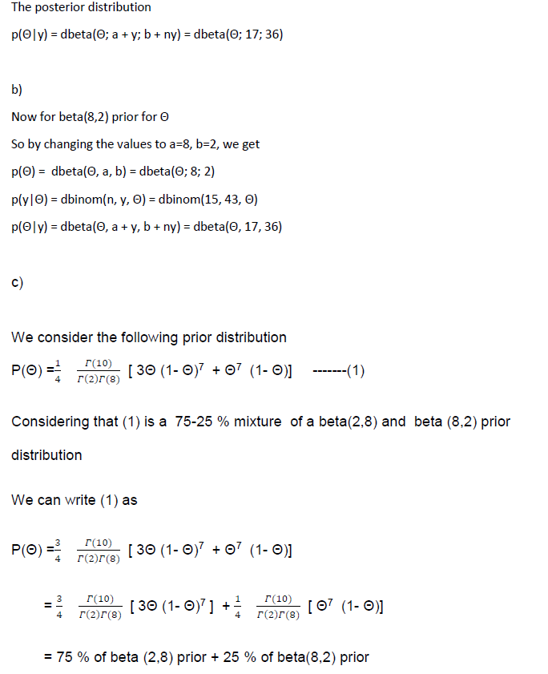

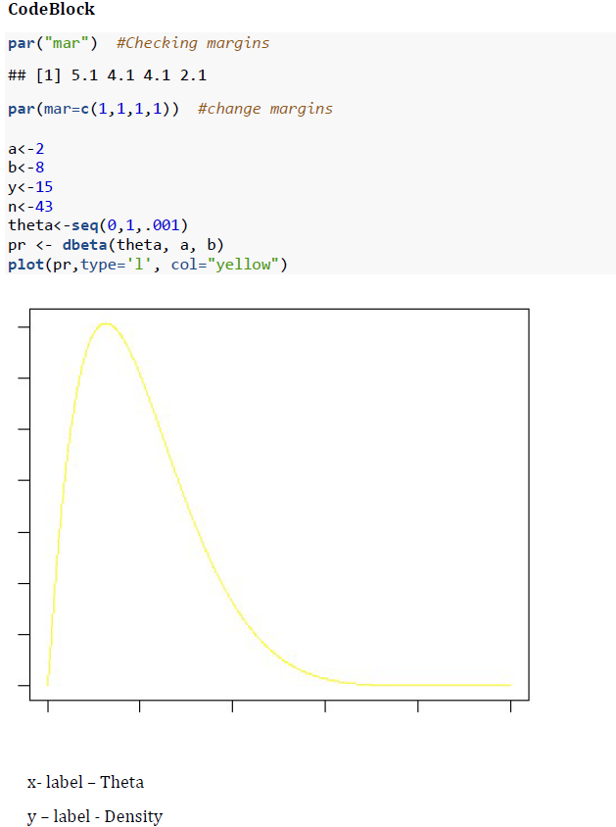



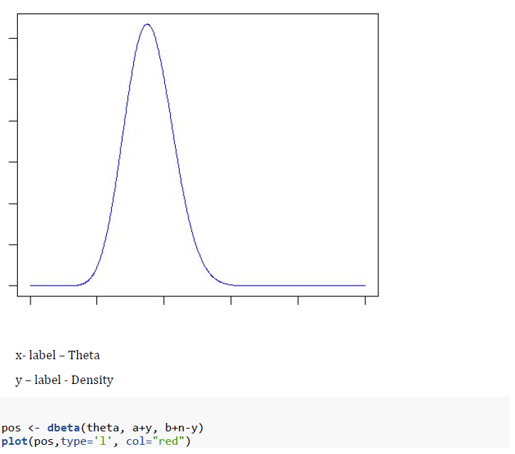

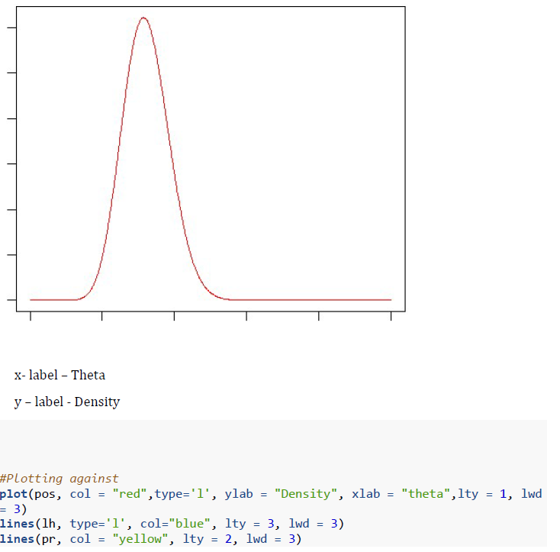

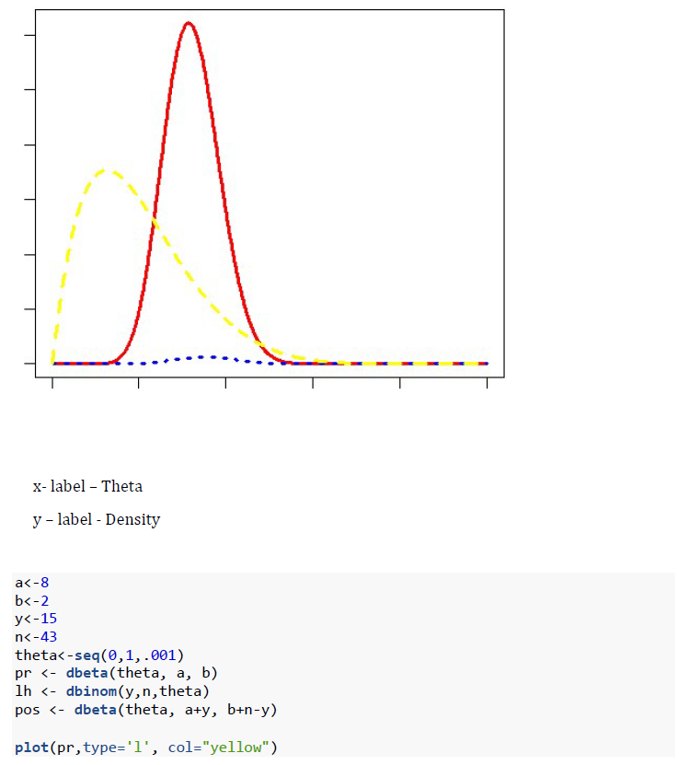

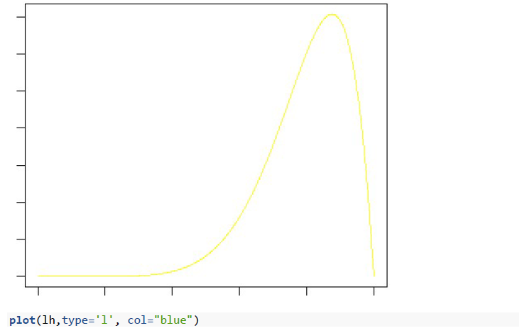

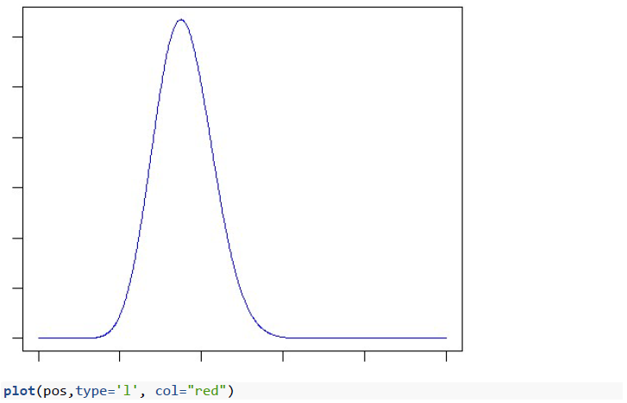

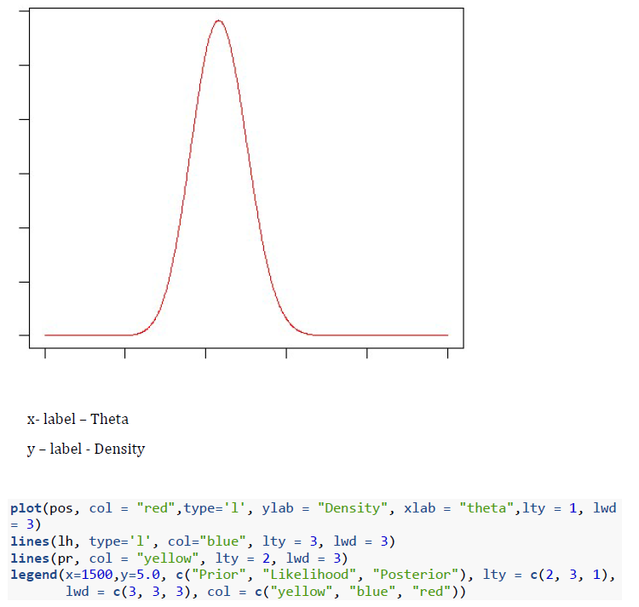

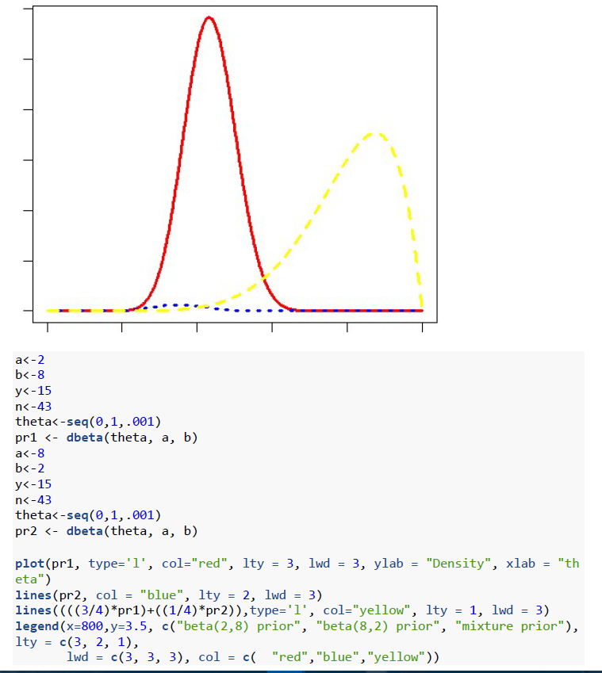

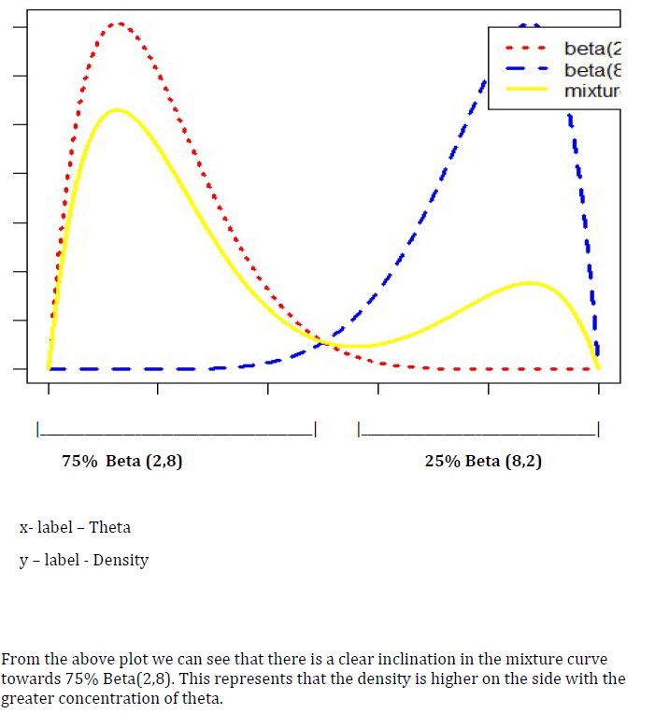

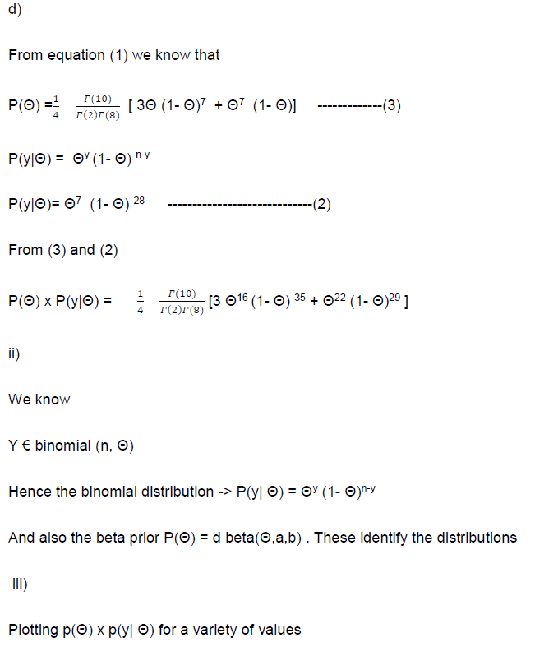

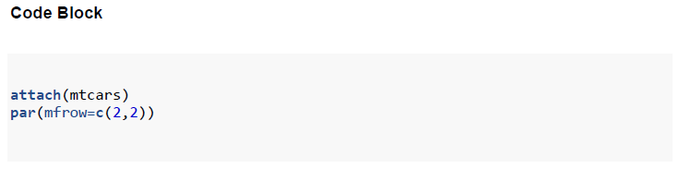

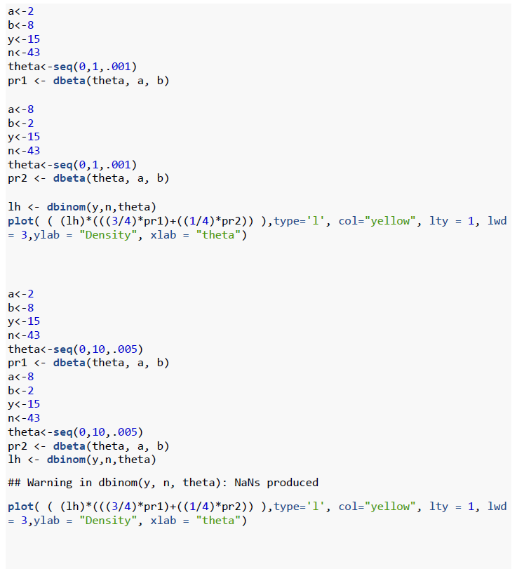

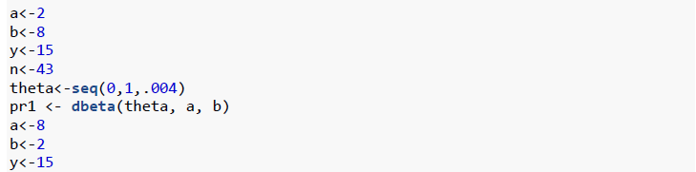

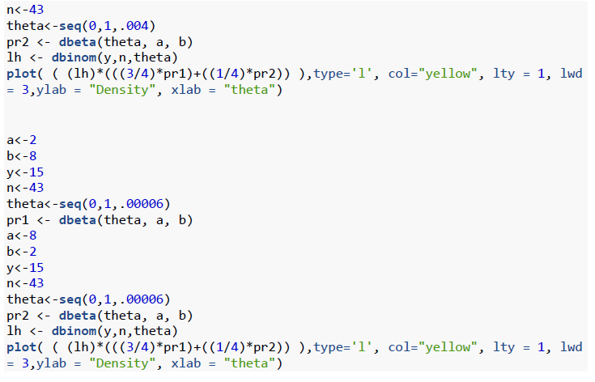

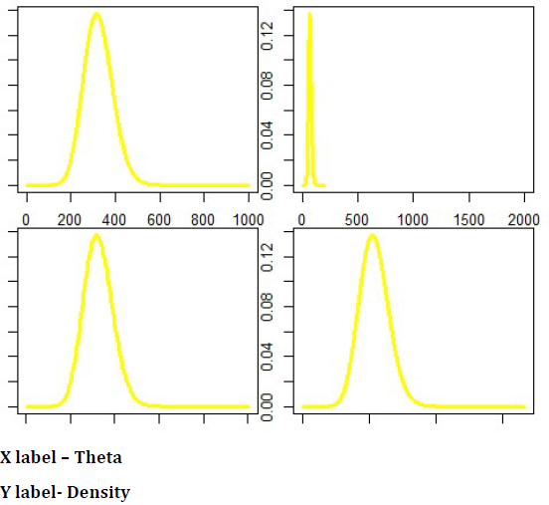

e)

The weights of the mixture distribution from ii) is given by their sums

Interpreting their values shows that the value for density is higher for greater concentration of theta.

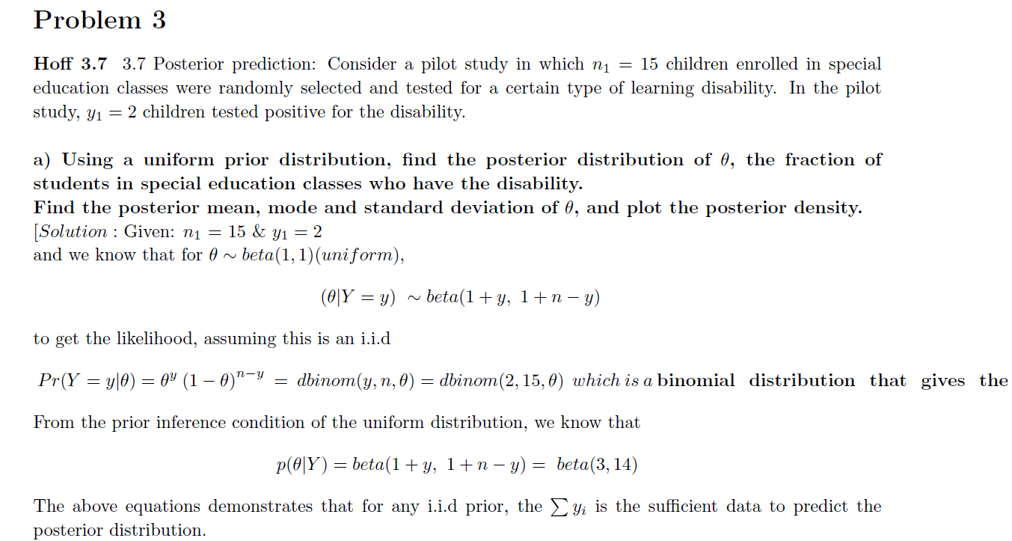

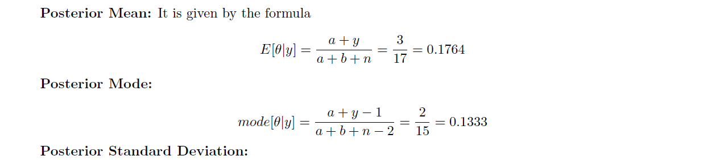

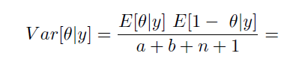

[0.176 * (1 – (3/17))] / 18 = 0.0080568

Sd = 0.0049

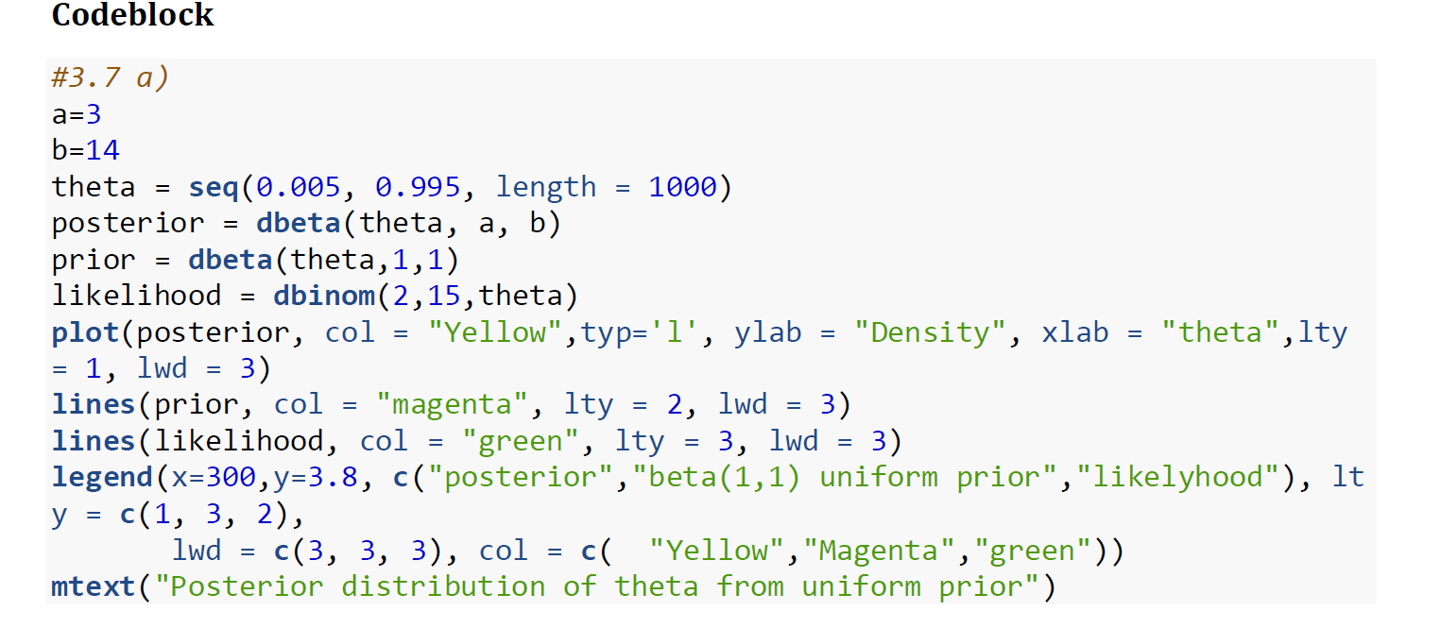

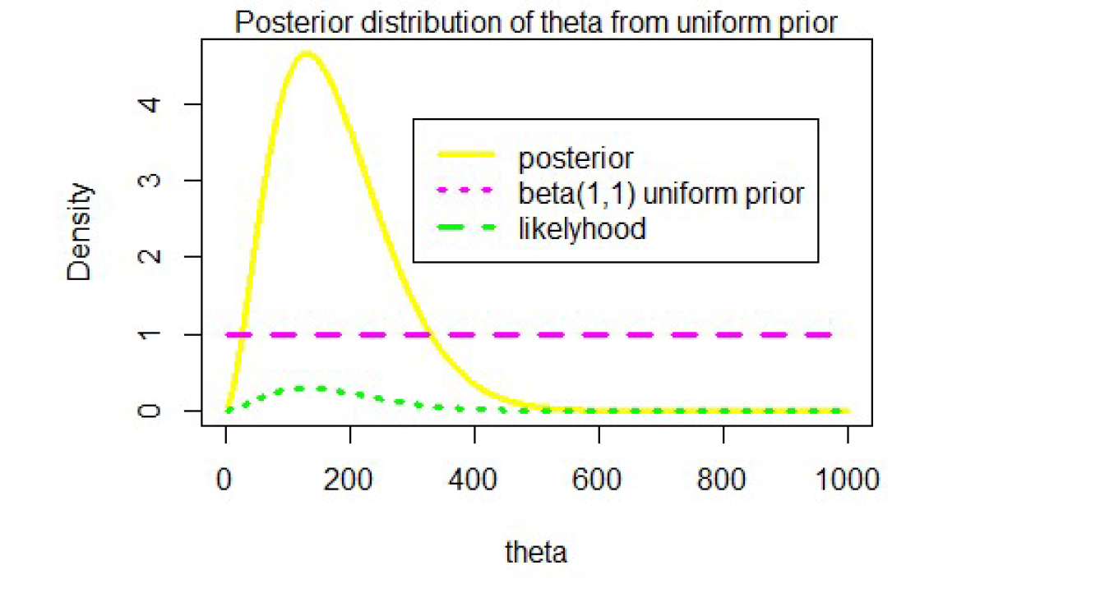

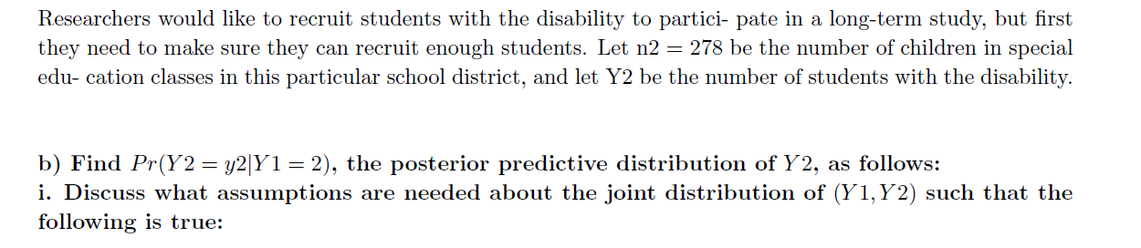



Using class room Notations:

For this to be true, in general when Y = y1……yn are considered in the denominator of p(y~ / Y), then Y = y1…yn should follow iid. And y1 .. yn are conditionally independent.

But here we are asked about, y2=y~ and Y=y_i . SO this makes y1and y2 are dependent. Because, y2 dependent is dependent on Theta and Theta is dependent on y1.

Based on what text book says below: y1 and y2 are dependent.

1. The predictive distribution does not depend on any unknown quantities. If it did, we would not be able to use it to make predictions.

2. The predictive distribution depends on our observed data. In this distribution, ˜ Y is not independent of Y1, . . . , Yn (recall Section 2.7). This is because observing Y1, . . . , Yn gives information about _, which in turn gives information about ˜ Y . It would be bad if ˜ Y were independent of Y1, . . . , Yn - it would mean that we could never infer anything about the un-sampled population from the sample cases.

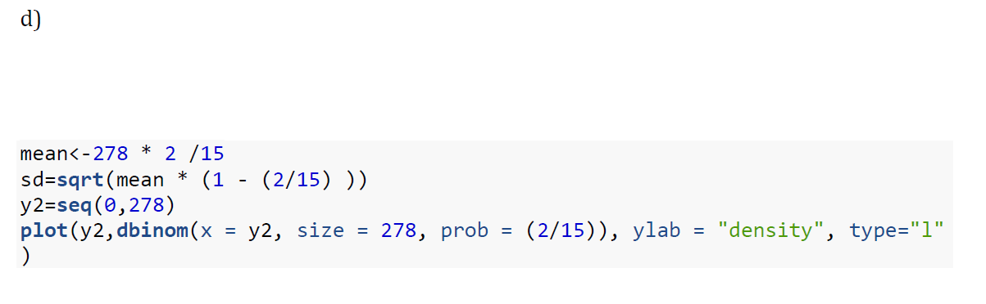

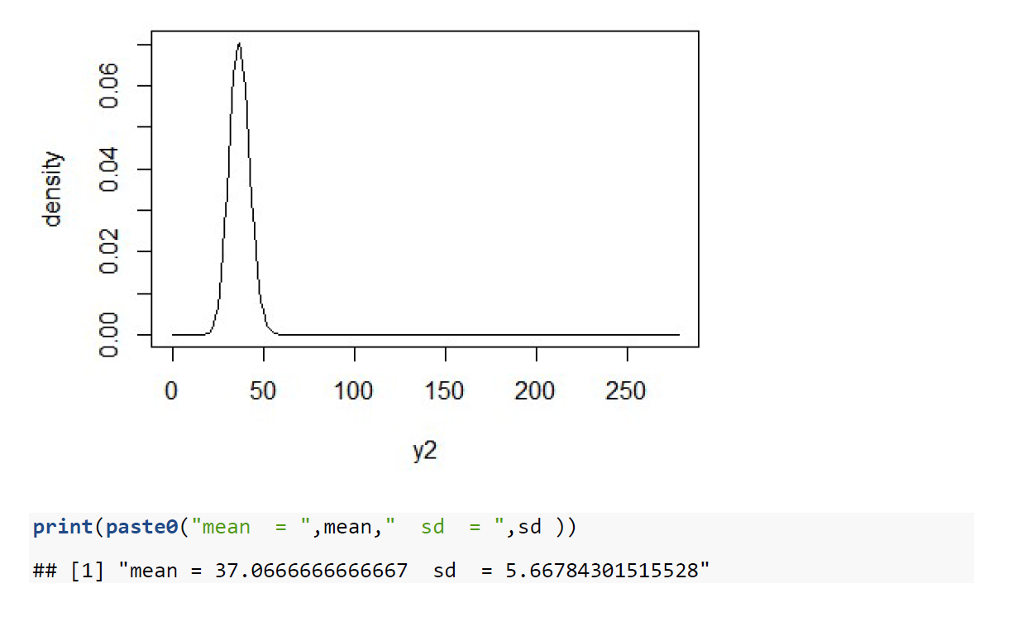

inference: I will use the posterior calculated in c for this. At lower sample size, the MLE estimates are not good in predictions. With increase in sample size