**Welch Allyn:** Assignment Naren Suri

1. Results :

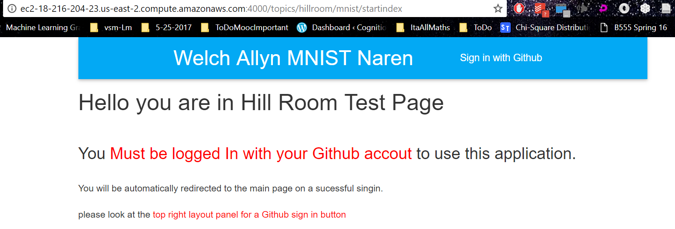



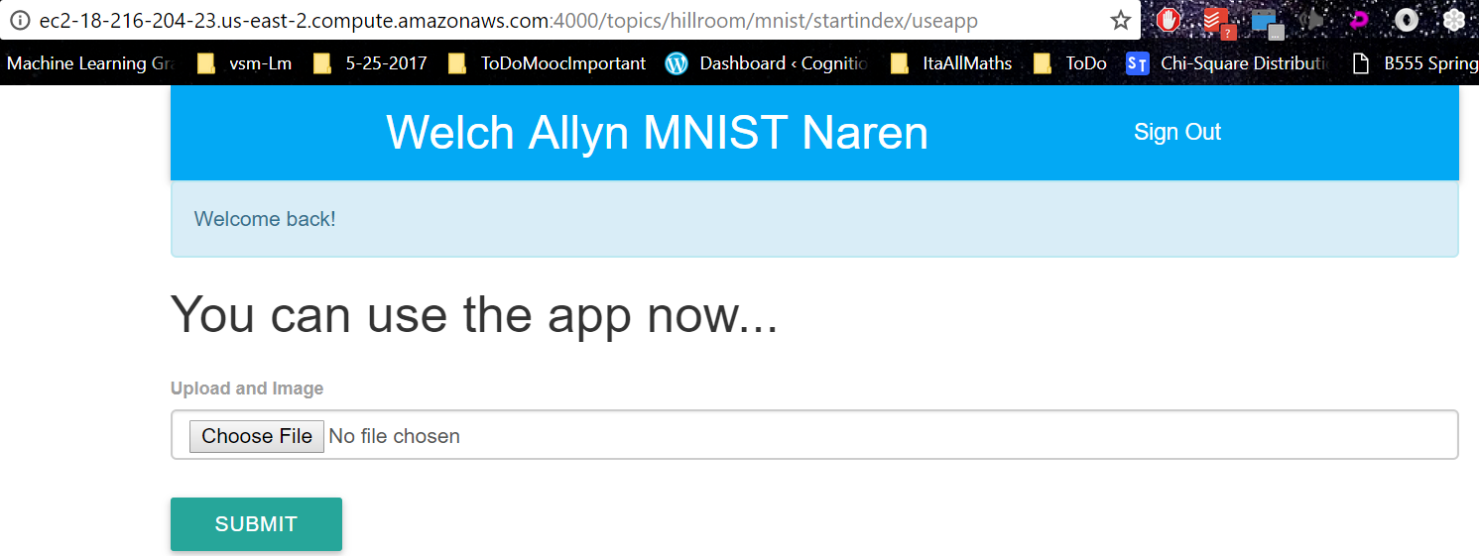

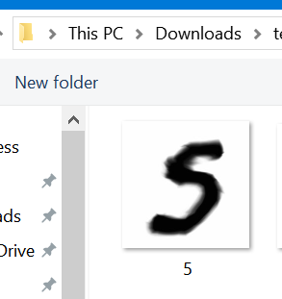



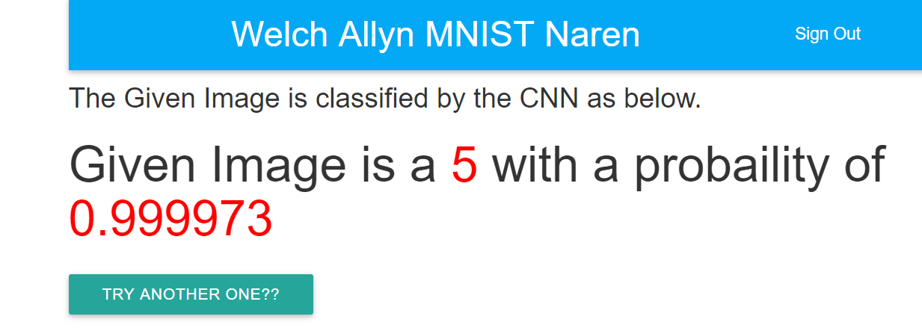

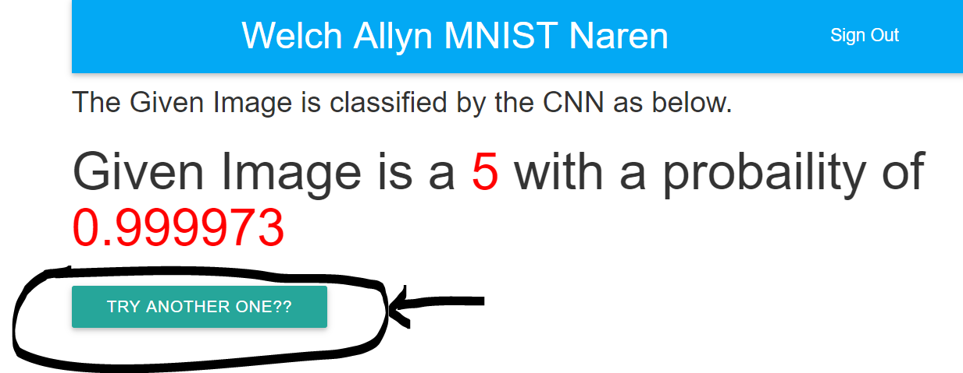

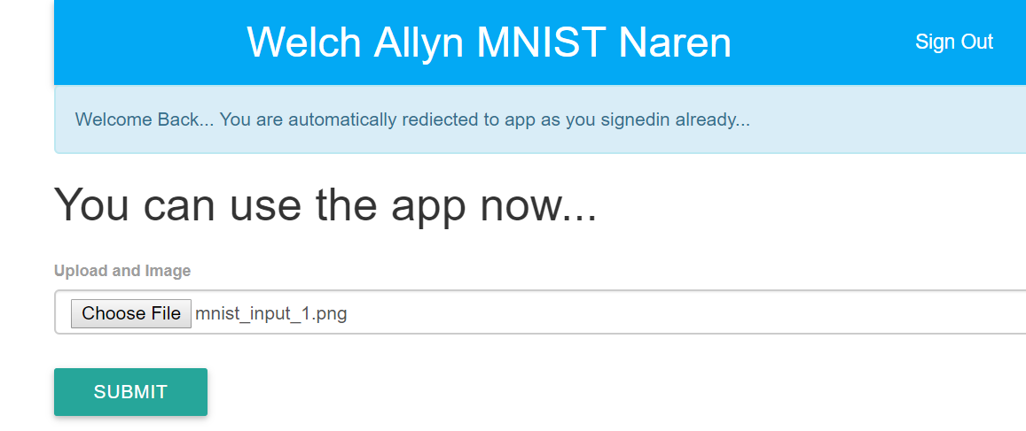

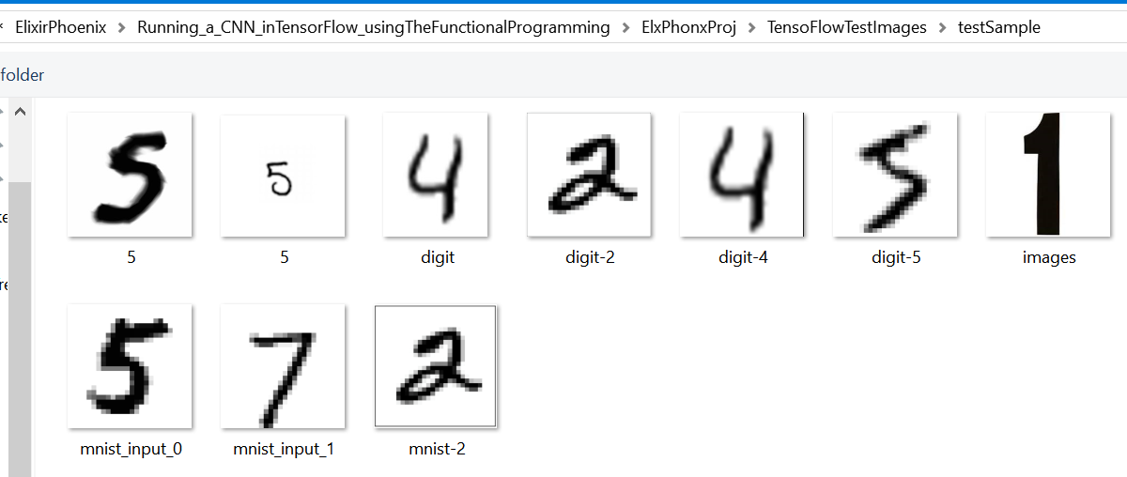

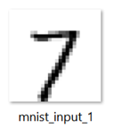

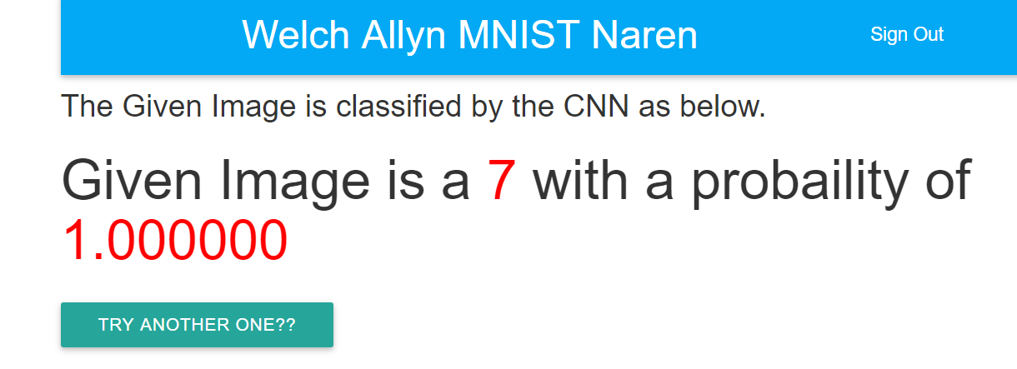

----------------------------------------------------------------------------------------------------------------------------------------

**Test Cases:**

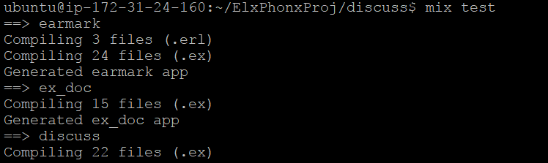

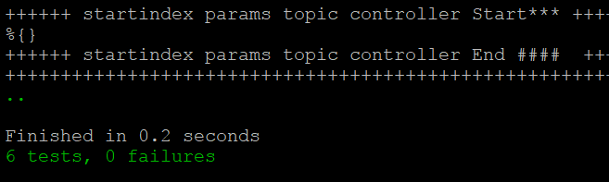

<https://github.com/NarenSuri/FunctionalProgramming/tree/master/ElixirPhoenix/Running_a_CNN_inTensorFlow_usingTheFunctionalProgramming/ElxPhonxProj/discuss/test/views>

<https://github.com/NarenSuri/FunctionalProgramming/tree/master/ElixirPhoenix/Running_a_CNN_inTensorFlow_usingTheFunctionalProgramming/ElxPhonxProj/discuss/test/controllers>