**Keyword Definition:**

**Name:**

Alphanumeric or text only

Max and min length

**Description:**

Alphanumeric or text only

Max and min length

**Key Word:** (Pragma Solidity) key word will be taken from code

**Code:** (Here which code should be given) where will it affect and what is the functionality of this field**.**

**Artifact:** Here if we check this field we will get (True/False)

(But what is the intention of this functionality by giving T/F manually)

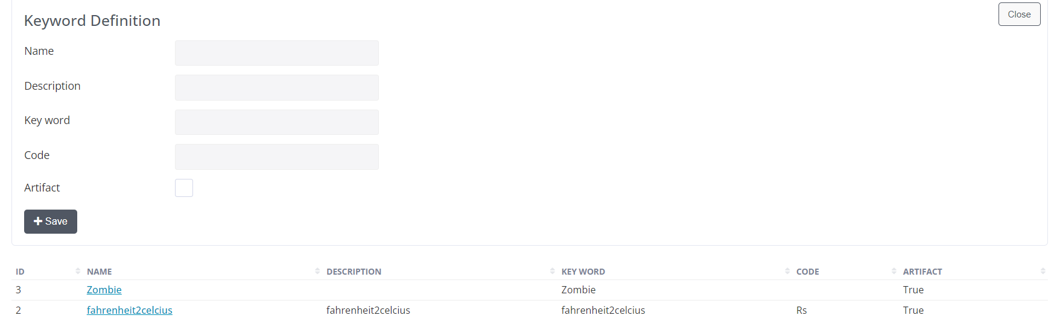

**Row click**: By row clicking we can see these (Templates). If we add data to these templates and by clicking on **Keyword Automation**, we can see the functionality reflects:

In tree structure

In question sets

In accordions

In menus

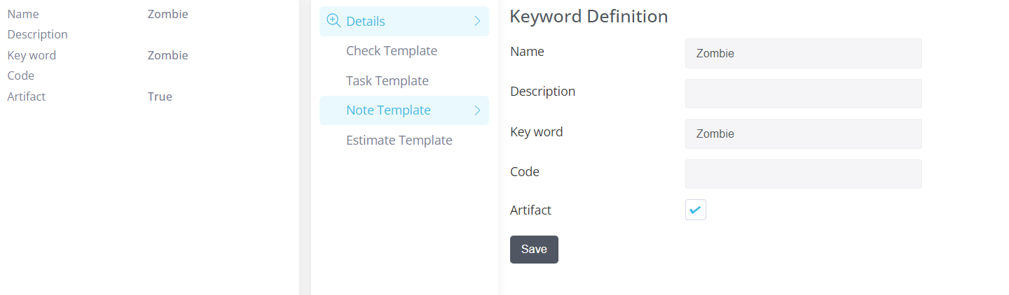

**Check Template:**

**Name:**

Alphanumeric or text only

Max and min length

**Description:**

Alphanumeric or text only

Max and min length

**Code:** (Here which code should be given in this field)

**Status:** (what type of data should be given in this field)

**Type:** (what type of data should be given in this field)

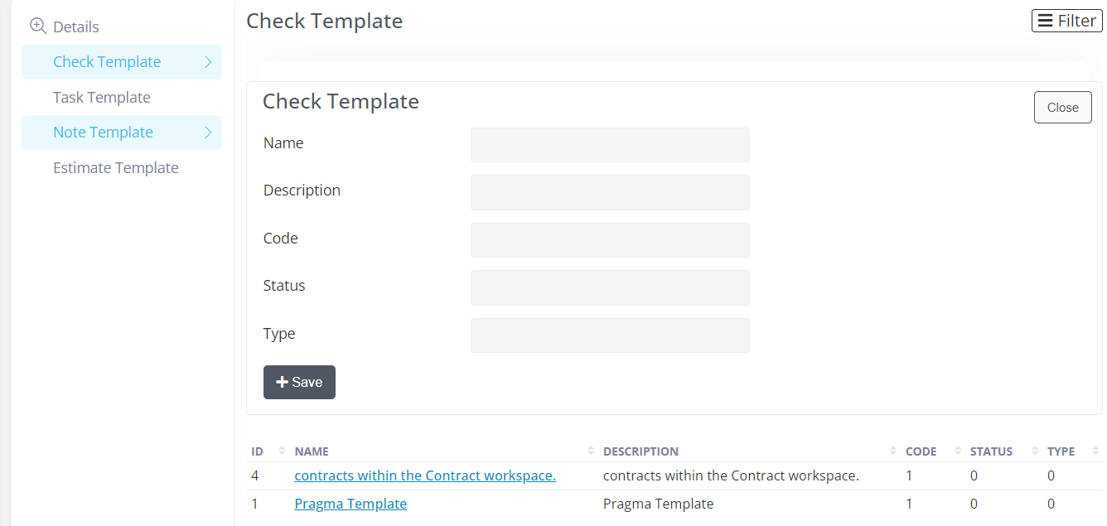

**Task Template:**

**Name:**

Alphanumeric or text only

Max and min length

**Description:**

Alphanumeric or text only

Max and min length

**Start date:**

**Complete date:**

**Task Type: (**what type of data should be given in this field)

**Status: Critical/High/Low** (select an option here)

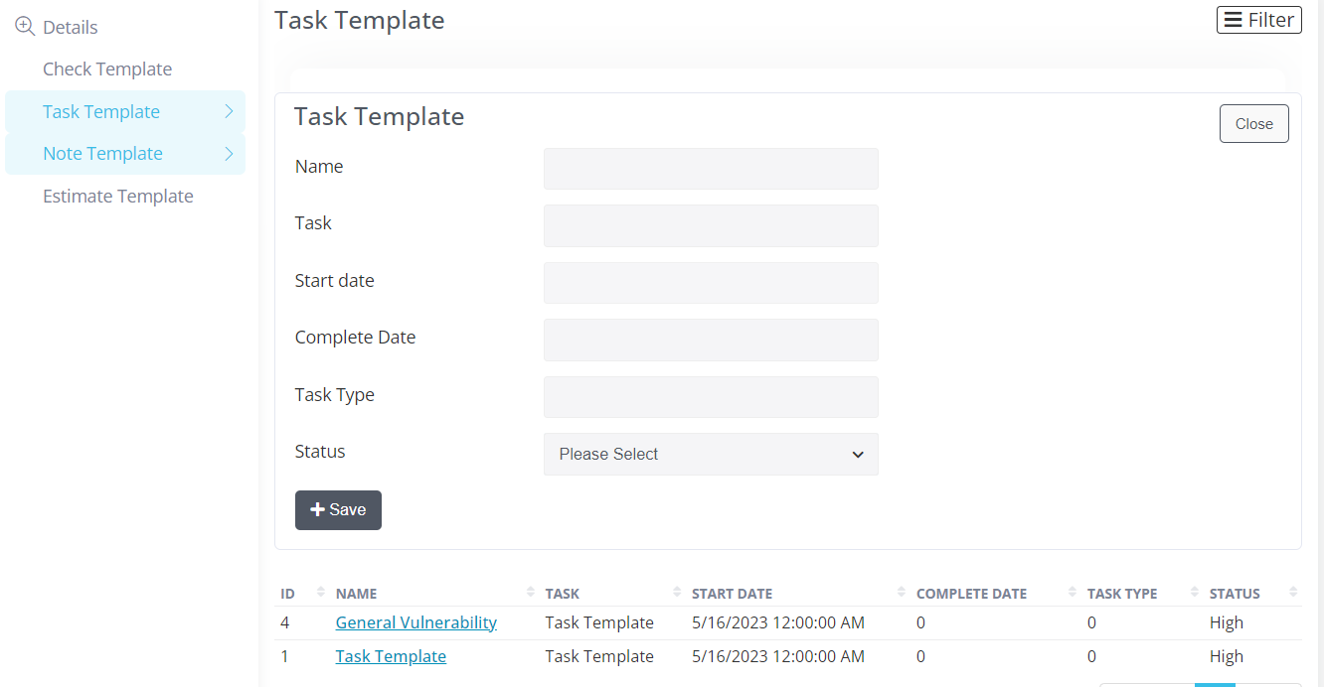

**Note template:**

**Name:**

Alphanumeric or text only

Max and min length

**Description:**

Alphanumeric or text only

Max and min length

**Code:** (Here which code should be given in this field)

**Status:** (what type of data should be given in this field)

**Type:** (what type of data should be given in this field)

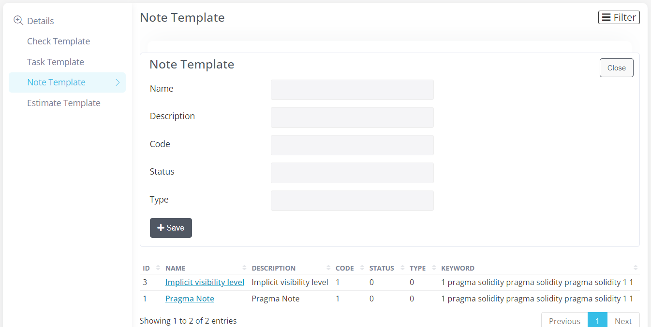

**Estimate Template:**

**Name:**

Alphanumeric or text only

Max and min length

**Description:**

Alphanumeric or text only

Max and min length

**Code:** (Here which code should be given in this field)

**Status:** (what type of data should be given in this field)

**Type:** (what type of data should be given in this field)

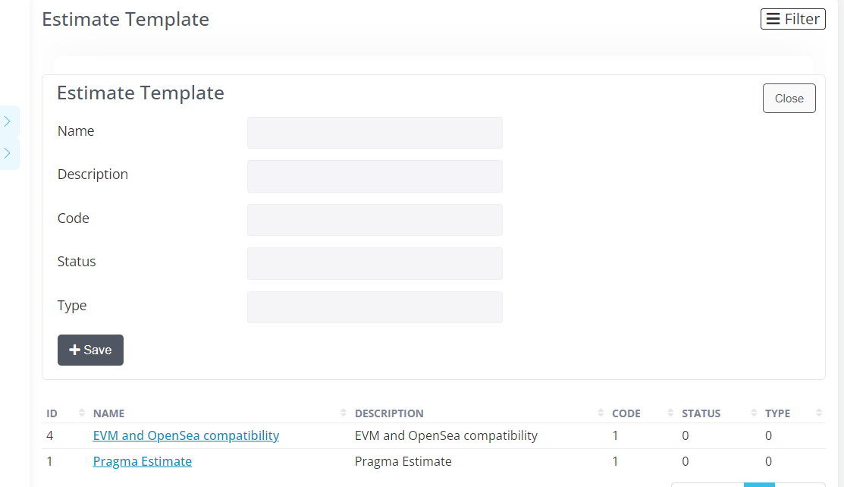

**AUDIT STAGE: QUESTION SETS:**

**Class of stage: (**select from drop down)

**Estimation:**

**QA:**

**Reporting:**

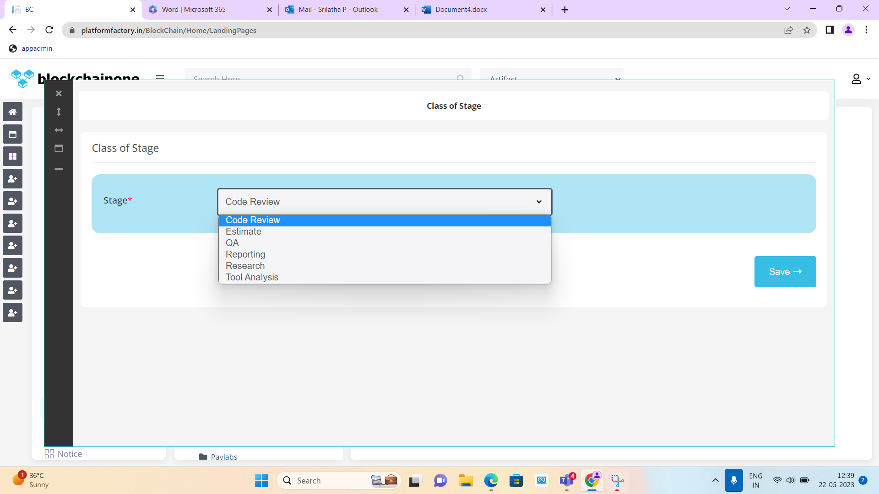

We should select Qs from drop down: as **Estimate**

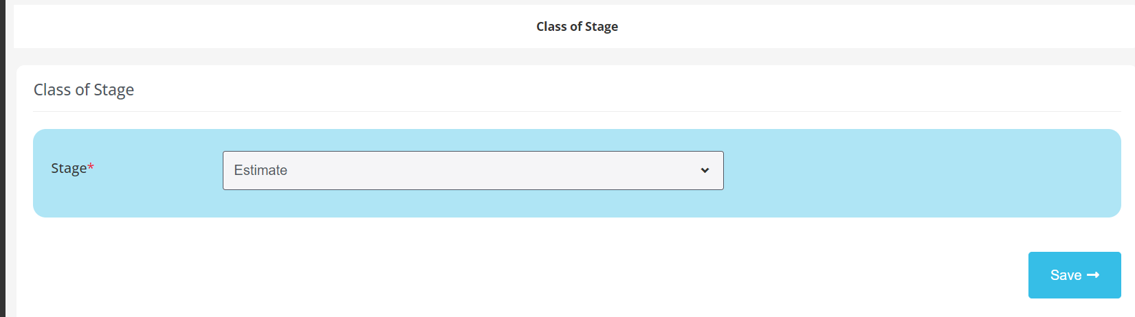

**Here we get tabs like: Info—Task Estimation--- Code Metrics—Estimation---Add up total**

**Notes:** give data and click on **save &next** button

* (Here given data where we can see) in notes field

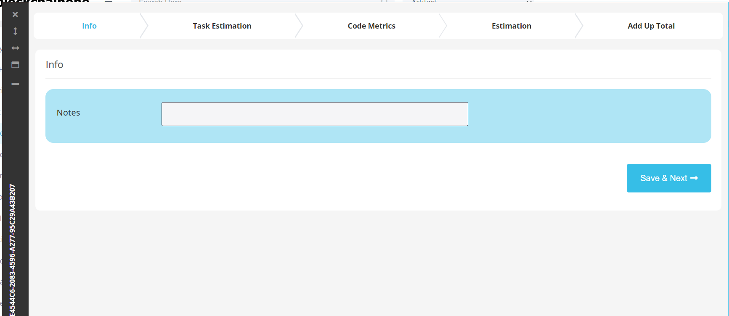

**Task Estimation Tab:**

**Task:** Click on Add New button

Here in add form given data, in how many ways we can see**.** And here **(Task Template** data also we can see)

**Task: (**which task data should be enter here)

**Task Summary:** (what data should be given here)

**Contract:** (We need to select Contract File here)

**Line No:** (Which Line number should be given here)

**Points:** (Which Points should be given here)

**Who:** (We need to select Audits in dropdown)

**Estimated Hours:** (we should give Estimate Hours)

**Actual Hours:** (we need to give Actual Hours)

**Audit: (**Audit is selected automatically)

**Status:** (Critical/High/Low select an option here)

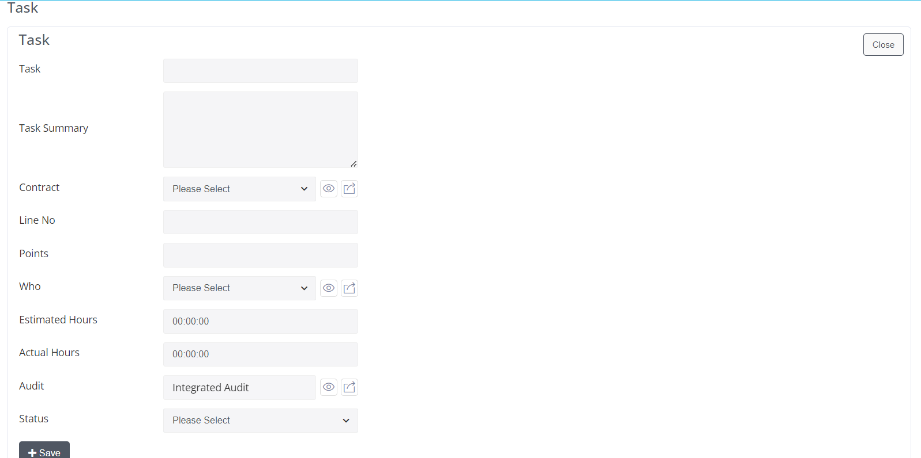

**List:** (headers are ok or need to add any attribute.)

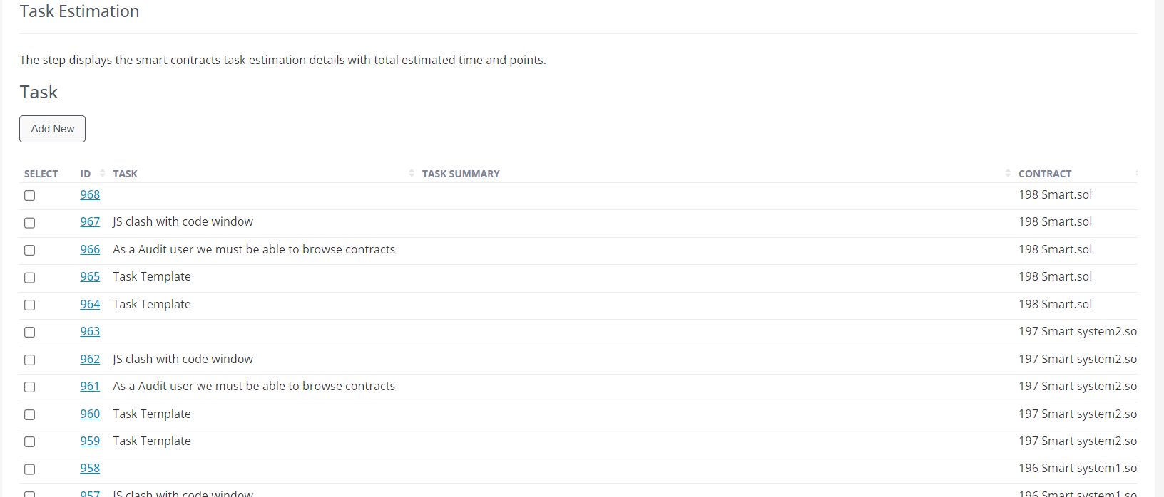

**Code Metrics:**

**Contract:** (Take .sol file here (my doubt) here audit should be taken automatically)

**Multiplier:** (Here data what should we give)

**Line Of Code:** (which line code should be taken)

(**Multiplier/ Line of Code:** (what functionality we can see by giving data to these fields)

**Git Commits:** (Here in this field present git commits we should take (or) **contract** field file we should take)

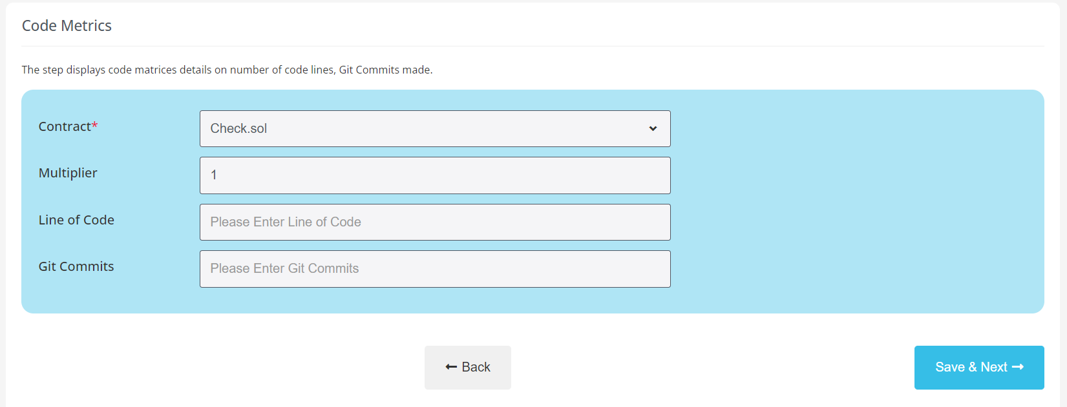

**Estimation:**

**Name:**

(Alphanumeric or text only

Max and min length)

**Estimate Hours:** (we should give Estimate Hours)

**Estimate Category:** (select category here (Additional Complexity/Customer Request Service/Research)

**Total Estimated Hours:** (we need to give Total Estimated Hours)

**Audit:** (automatically selected)

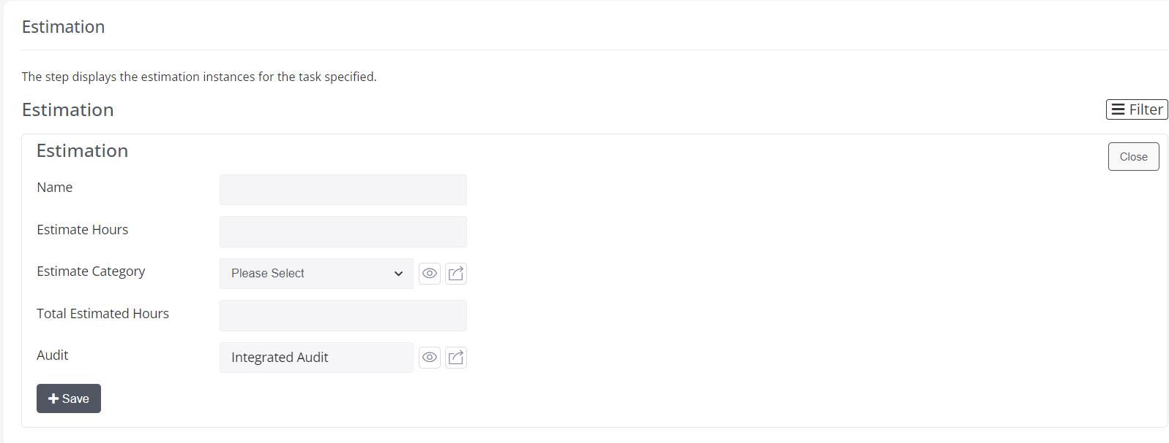

**List:** (headers are ok or need to add any attribute)

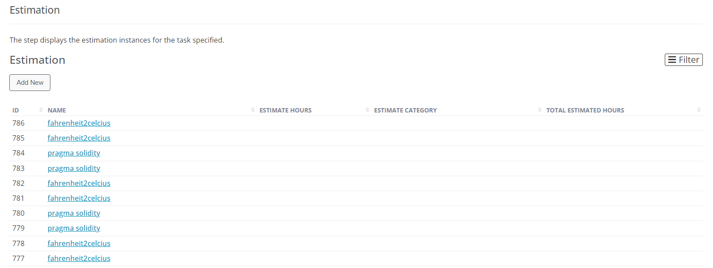

When we click on row: Page displays

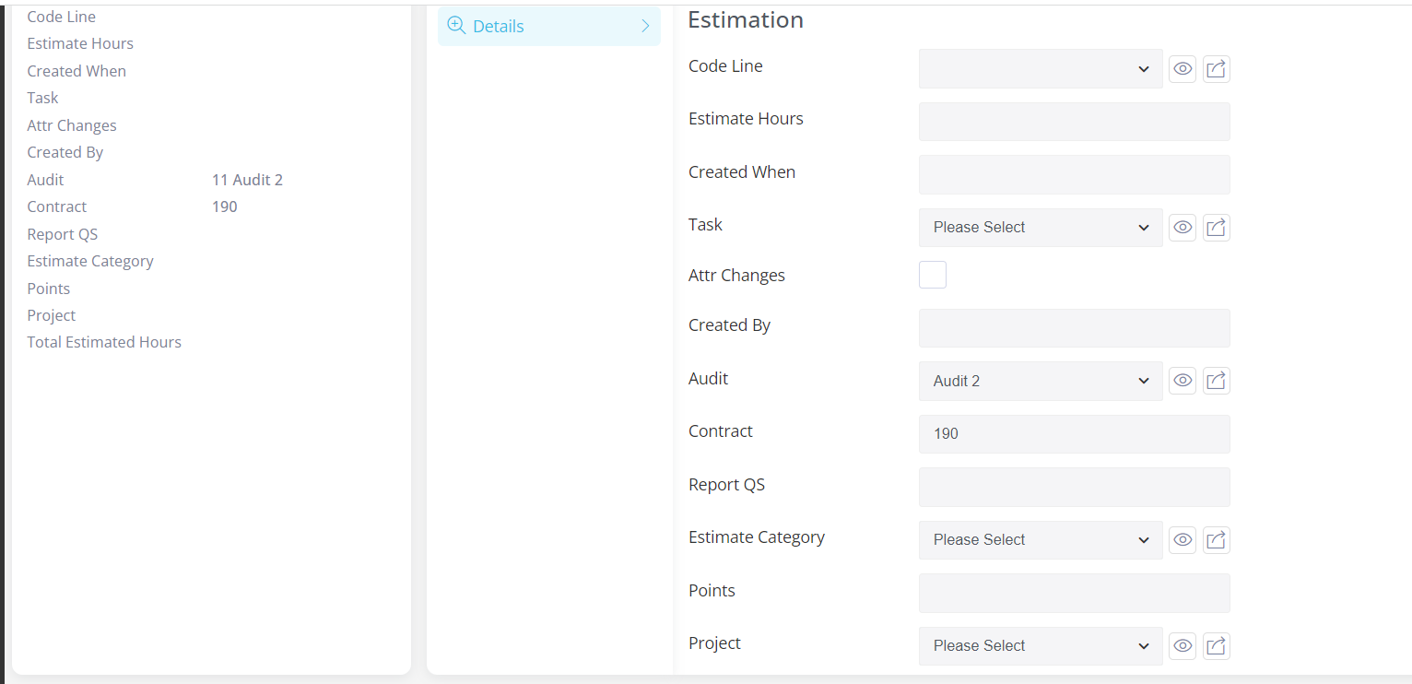

If we need to edit data here, we can do it.

**Add up Total:**

**Number Of Task:** (Enter num of Tasks here)

**Total Points:** (Here what points should be added)

**Total Task Hours:** (Total Task Hours)

**Total Additional Estimate hours:** (give estimate hours)

**Code Complexity Load factor:** (Here what data should be added)

**Total Estimated Hours:**

(What is the difference between **Total Additional Estimate Hours/Total Estimate Hours.** From where it will take and where it reflects)

