**1. Homepage**

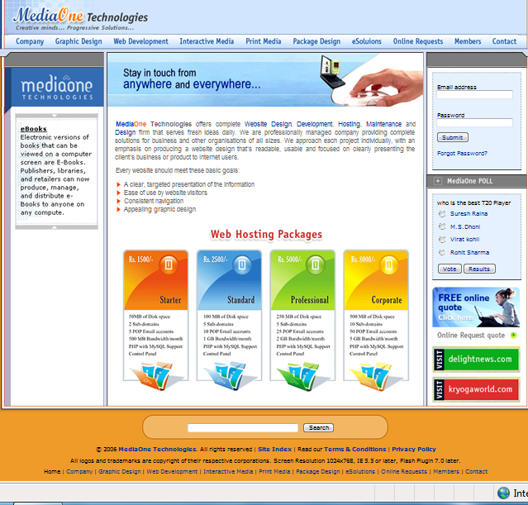

## Access the MOT site

|  |  |
| --- | --- |
| **Actor Action** | **System Response** |
| 1. Actor enters the URL of the application | 2. System displays homepage with MediaOne Technologies information which includes  a) **Header info**.  1. **MOT Logo** with caption on the left side.  2. Menu bar with following links  a. Company  b. Graphic Design  c. Web Development  d. Interactive Media  e. Print Media  f. Package Design  g. eSolutions  h. **Online Requests**  i. **Members**  j. Contact  b) **Left frame**  System displays **MOT Title** on the top and news dynamically under it.  c) **Middle frame**  System displays **MOT Banner** on top and information of the Home page with the following  **Text links:**.  a. Website Design  b. Development  c. Hosting  d. Maintenance  e. Design  **Image links:**   1. Starter Web Hosting Package 2. Standard Web Hosting Package 3. Professional Web Hosting Package 4. Corporate Web Hosting Package   d) **Right frame**  System displays the following   1. Login facility   Check here – member/guest login – 1.2   1. Forgot Password link.   c. MediaOne Poll  Check here – poll – 1.3  And also following **informative links**  a. Free Online quote  b. delightnews.com  c. kryogaworld.com  e) **Footer info.**  1. Search facility  Check here – **Search**  2. Right’s reserved info.  3. Home page link & hyper links of the menu bar links as Header information |

**1.2 Member or Guest login**

|  |  |
| --- | --- |
| **Actor Action** | **System Response** |
| 1. Actor enter Email address & Password and clicks on “Submit” button   a. If the actor is a guest, go to – 2  b. If the actor is a member, go to – 8 | 2. System displays **Guest homepage** with MediaOne Technologies information which includes  a) **Header info**.Check – Header information & also displays email address and logout link on the right side of header.  b) **Left frame:** System displays MOT Title on the top and news dynamically under it.  c) **Middle frame**  System displays banner on top and information of the Home page with the following links to display the respective pages.  **Text links:**.  a. Website Design  b. Development  c. Hosting  d. Maintenance  e. Design  **Image links:**   1. Starter Web Hosting Package 2. Standard Web Hosting Package 3. Professional Web Hosting Package 4. Corporate Web Hosting Package   d) **Right frame**  System displays the following  a. Promote as a member facility. Check – 5  b. MediaOne Poll  Check - poll  And also following links  a. Free Online quote  b. delightnews.com  c. kryogaworld.com  e) **Footer info.**  1. Search facility  Check here – **Search**  2. Right’s reserved info.  3. Home page link & hyper links of the menu bar links as Header information  . |
| 3. Actor clicks on Forgot password link | 4. Go to – Forgot password |
| 5. Actor clicks on member promote link | 6. System displays the Guest membership –membership page which includes  a) **Header info**.  Go to – Header information & also displays email address and logout link on the right side of header.  b) **Left frame**  System displays MOT Title on the top and nothing under it.  c) **Middle frame**  System displays Guest membership – membership promotes information along with email address in disabled mode.  d) **Right frame**  System displays the following information with the corresponding links (the numbers below indicates the no. of links).   * 1. Testimonials (1 link)   2. Web hosting (4)   3. Downloads (1…n)   e) **Footer info.**  1. Search facility  Check here – **Search**  2. Right’s reserved info.  3. Home page link & hyper links of the menu bar links as Header information |
| 7. Actor enters the verification code and clicks on “Submit” button | 8. System displays Member personal information which includes  a) **Header info.**  Go to – Header information & also displays email address, logout link and My home link on the right side of header.  b) **Left frame**  System displays MOT Title on the top and the following links under it  a. Edit account information  b. Edit email preferences  c. Edit address book  d. Information request  e. Online support request  f. Logo quote request  g. Banner quote request  h. Hosting quote request  i. Testimonials  j. Feedback  c) **Middle frame**  System displays banner on top and Member personal page with the following links  a. Edit account information  b. Edit email preferences  c. Edit address book  d) **Right frame**  System displays the following information with the corresponding links (the numbers below indicates the no. of links).  a. Services (19)  e) **Footer info.**  1. Search facility  Check here – **Search**  2. Right’s reserved info.  3. Home page link & hyper links of the menu bar links as Header information |

**1.3** **Poll**

|  |  |
| --- | --- |
| **Actor Action** | **System Response** |
| 1. Actor clicks on “**Result”** button | 2. System displays percentage of votes for each option, clears “Vote” & “Result” buttons and displays “Back” button. |
| 3. Actor clicks on “**Back”** button | 4. System clears all the percentages and displays “Vote” & “Result” buttons. |
| 5. Actor checks one radio button in a given four  options and clicks on “**Vote”** button | 6. System displays percentage of votes for each option, clears “Vote” & “Result” buttons and displays “Back” button. |
| 7. Actor clicks on **“Back”** button | 8. System clears all the percentages and displays “Vote” & “Result” buttons. |

### 

### **1.4** **Search**

|  |  |
| --- | --- |
| **Actor Action** | **System Response** |
| 1. Actor enters appropriate key word to get required information from MediaOne application into the textbox and clicks on “Search” button | 2. System displays “MOT search” page information which includes  a) **Header info.**  Go to – Header information  b) **Left frame**  System displays MOT Title on the top and news dynamically under it.  c) **Middle frame**  System displays banner on top and list of matched search key word information along with links.  d) **Right frame**  System displays the following information with the corresponding links (the numbers below indicates the no. of links).  a. Testimonials (1)  b. Useful Links (8)  e) **Footer info.**    1. Right’s reserved info.  2. Home page link & hyper links of the menu bar links as Header information  . |

NetBiz_Services_Business Rules & List of Objects

**Home Page**

|  |  |  |  |  |  |  |
| --- | --- | --- | --- | --- | --- | --- |
| **S.No.** | **Object Name** | **Object Type** | **Business Rule/ Validation Criteria** | | | |
|  |  |  | **Editable/ Non Editable** | **Mandatory** | **Input Type** | **Length** |
| 1 | Email address | Text field | Editable | Mandatory | 1).Alphanumeric,  2).Special chars (“@”, “.”, ”_”), without spaces  3) First char must not be a special char  4) min of 3 chars before ‘@’ and min 2 chars between ‘@’ and ‘.’ | Min – 9  Max – 45 |
| 2 | Password | Text field | Editable | Mandatory | All keyboard inputs and first char must not be a special char | Min – 3  Max – 12 |
| 3 | Submit | Push button | - NA - |  | - NA - | - NA - |
| 4 | **Poll Question** |  |  | Mandatory |  |  |
| 4.1 | Option 1 | Radio button | - NA - |  | Selection | - NA - |
| 4.2 | Option 2 | Radio button | - NA - |  | Selection | - NA - |
| 4.3 | Option 3 | Radio button | - NA - |  | Selection | - NA - |
| 4.4 | Option 4 | Radio button | - NA - |  | Selection | - NA - |
| 5 | Vote | Push button | - NA - |  | - NA - | - NA - |
| 6 | Results | Push button | - NA - |  | - NA - | - NA - |
| 7 | Search keyword | Text field | Editable |  | All keyboard inputs | Max - 20 |
| 8 | Search | Push button | - NA - |  | - NA - | - NA - |

**2.** **Member’s page**

2.1 **Member’s page**

|  |  |
| --- | --- |
| **Actor Action** | **System Response** |
| 1. Actor clicks on Members link in the Header section of homepage | 2. System displays members sign in/sign up information which includes  a) **Header info.**  Go to – Header information  b) **Left frame**  System displays **MOT Title** on the top and nothing under it.  c) **Middle frame**  System displays **Sign-In / Sign-Up** form with Forgot Password.  d) **Right frame**  System displays the following information with the corresponding links (the numbers below indicates the no. of links).  a. Testimonials (1)  b. Web hosting (4)  c. Downloads (1…n)  d. Contact us (2)  e) **Footer info.**  . Search facility  Check here – **Search**  2. Right’s reserved info.  3. Home page link & hyper links of the menu bar links as Header information |
| 3. Actor clicks on MOT Logo | 4. System displays Home page. |

2.1 **Member’s page**

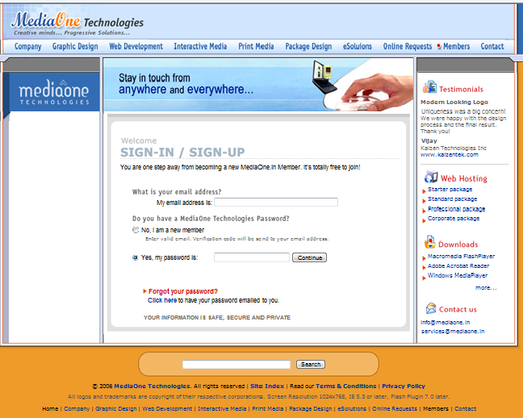

#### **2.2 Guest - sign up**

|  |  |
| --- | --- |
| **Actor Action** | **System Response** |
| 1. Actor enters the email address in to Email textbox and Selects No, I am new member “radio button” | 2.The Password textbox will disappear from Member sign in/sign up page. |
| 3.And clicks on “continue” button | 4. check Create an account |

##### **2.3** **Create an account**

|  |  |
| --- | --- |
| **Actor Action** | **System Response** |
|  | 1. System sends the verification code to the corresponding mail address & displays Create an account page which includes  a) **Header info.**  Go to – Header information  b) **Left frame**  System displays MOT Logo on the top and nothing under it.  c) **Middle frame**  System displays banner on top and “create an account” form with entered email id in disabled mode in “Email” text box.  d) **Right frame**  System displays the following information with the corresponding links (the numbers below indicates the no. of links).  a. Testimonials (1 link)  b. Web hosting (4)  c. Downloads (1…n)  d. Useful Links (8)  e) **Footer info.** |
| 2. Actor selects Account type in combo box as Guest | 3 Go to “Create account as Guest” |
| 4. Actor selects Account type in combo box as New Member | 5 Go to “Create account as New Member” |

##### **2.3 Create an account**

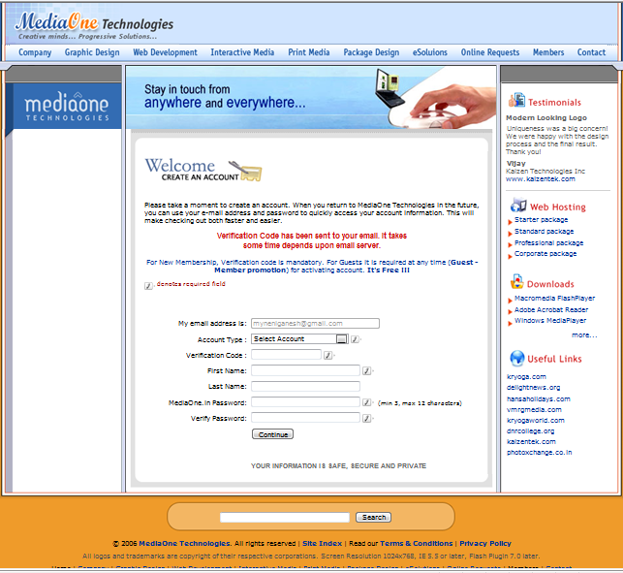

###### 2.4 Create account as Guest

|  |  |
| --- | --- |
| **Actor Action** | **System Response** |
|  | 1 The Verification code text box will disappear from Create an account page. |
| 2. Actor Enters the following  a. First Name into the textbox  b. Last Name into the textbox  c. MediaOne. In password into the textbox  d. Verify password into the textbox  and Clicks on “Continue” button | 3. System displays **Guest homepage** with MediaOne Technologies information which includes  a) **Header info**.  Go to – Header information & also displays email address and logout link on the right side of header.  b) **Left frame**  System displays MOT Logo on the top and news dynamically under it.  c) **Middle frame**  System displays banner on top and information of the Home page with the following links to display the respective pages.  a. Website Design  b. Development  c. Hosting  d. Maintenance  e. Design  f. Starter Web Hosting Package  g. Standard Web Hosting Package  h. Professional Web Hosting Package  i. Corporate Web Hosting Package  d) **Right frame**  System displays the following  a. Promote as a member facility    b. MediaOne Poll  Check here – poll – 1.3  And also following links  a. Free Online request  b. Delightnews.com  c. Kryogaworld.com  e) **Footer info.**  1. Search facility  Check here – **Search**  2. Right’s reserved info.  3. Home page link & hyper links of the menu bar links as Header information  . |
| 4. Actor clicks on member promote link | 5. System displays the Guest–membership page which includes  a) **Header info**.  Go to – Header information & also displays email address and logout link on the right side of header.  b) **Left frame**  System displays MOT Logo on the top and nothing under it.  c) **Middle frame**  System displays Guest membership – membership promote information along with email address in disabled mode, Verification Code Textbox and Submit button.  d) **Right frame**  System displays the following information with the corresponding links (the numbers below indicates the no. of links).   * 1. Testimonials (1 link)   2. Web hosting (4)   3. Downloads (1…n)   e) **Footer info.**  . 1. Search facility  Check here – **Search**  2. Right’s reserved info.  3. Home page link & hyper links of the menu bar links as Header information |
| 6. Actor enters the verification code and clicks on “Submit” button | 7. System displays Member personal information which includes  a) **Header info.**  Go to – Header information & also displays email address, logout link and My home link on the right side of header.  b) **Left frame**  System displays MOT Logo on the top and the following links under it  a. Edit account information  b. Edit email preferences  c. Edit address book  d. Information request  e. Online support request  f. Logo quote request  g. Banner quote request  h. Hosting quote request  i. Testimonials  j. Feedback  c) **Middle frame**  System displays banner on top and Member personal page with the following links  a. Edit account information  b. Edit email preferences  c. Edit address book  d) **Right frame**  System displays the following information with the corresponding links (the numbers below indicates the no. of links).  a. Services (19)  e) **Footer info.**  1. Search facility  Check here – **Search**  2. Right’s reserved info.  3. Home page link & hyper links of the menu bar links as Header information |

###### 2.4 Create account as Guest

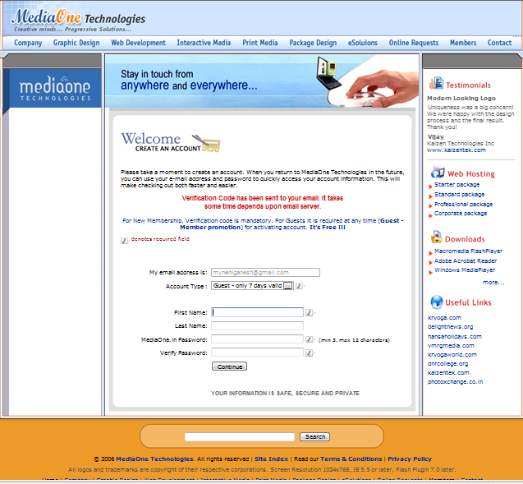

**2.5 Guest Homepage**

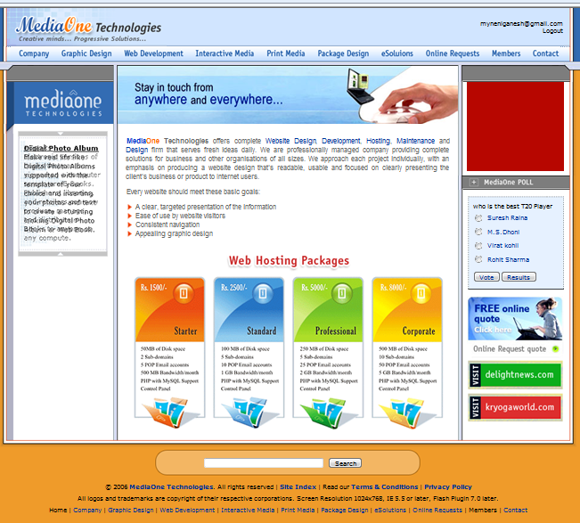

**Do you want to promote as a member?**

**2.5 Guest –SignIn:**

|  |  |
| --- | --- |
| 1. Actor enters the email address into Email textbox  And  Selects Yes, my password “radio button”, and Enters password and clicks on “continue” button | 2. System displays MOT Guest Home page by default along with email address & logout link on the right side of header.  Screenshot of Guest Homepage |

#### **2.6 Member - sign up**

|  |  |
| --- | --- |
| **Actor Action** | **System Response** |
| 1. Actor enters the email address in to Email textbox and  Selects No, Create new account “radio button” | 2. The Password textbox will disappear from Member sign in/sign up page. |
| 3.And clicks on “continue” button | 4. Go to Create an account |

###### 2.7 Create account as New Member

|  |  |
| --- | --- |
| **Actor Action** | **System Response** |
| 1. Actor takes verification code from the mail and enters the following and clicks on “Continue” button   1. Verification Code into the textbox 2. First Name into the textbox 3. Last Name into the textbox 4. MediaOne. In password into the textbox 5. Verify password into the textbox | 2. System displays Member personal information which includes  a) **Header info.**  Go to – Header information & mail address, logout link & My home link on the right.  b) **Left frame**  System displays MOT Logo on the top and the following links under it  a. Edit account information  b. Edit email preferences  c. Edit address book  d. Information request  e. Online support request  f. Logo quote request  g. Banner quote request  h. Hosting quote request  i. Testimonials  j. Feedback  c) **Middle frame**  System displays banner on top and Member personal page with the following links  a. Edit account information  b. Edit email preferences  c. Edit address book  d) **Right frame**  System displays the following information with the corresponding links (the numbers below indicates the no. of links).  a. Services (19)  e) **Footer info.**  1. Search facility  Check here – **Search**  2. Right’s reserved info.  3. Home page link & hyper links of the menu bar links as Header information |

###### 

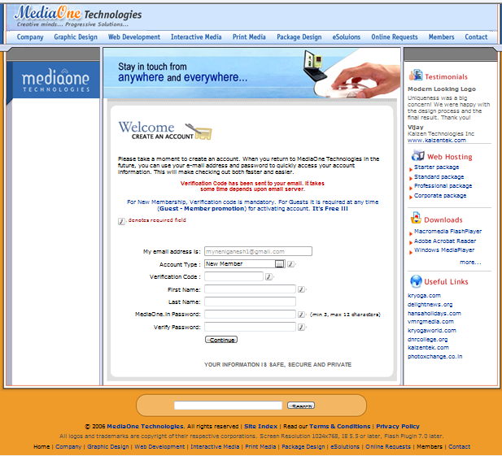

**2.8** **Member Personal page**

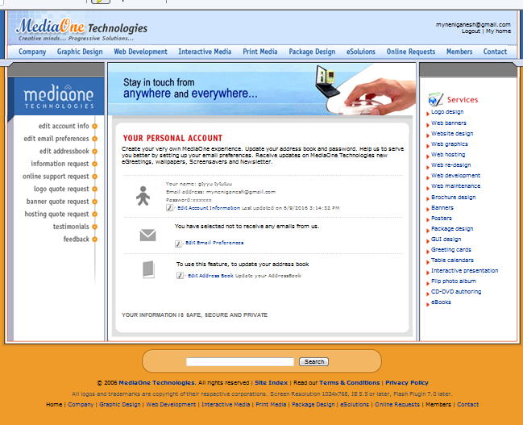

#### **2.9 Member - sign in**

|  |  |
| --- | --- |
| 4. Actor enters the email address into Email textbox  And  Selects Yes, my password “radio button”,  Enters password into “textbox” as a Member and clicks on “continue” | 6. System displays MOT Member’s Home page by default along with email address & logout link on the right side of header.  Screenshot of Member page |

2.10 Edit account info

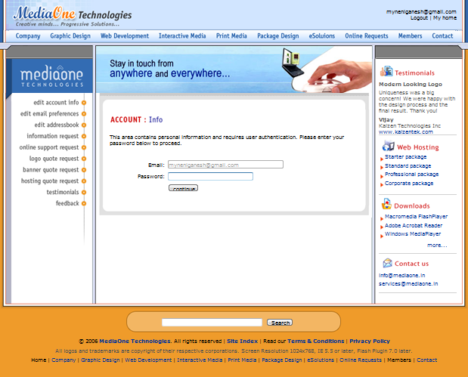

2.10 Edit account info

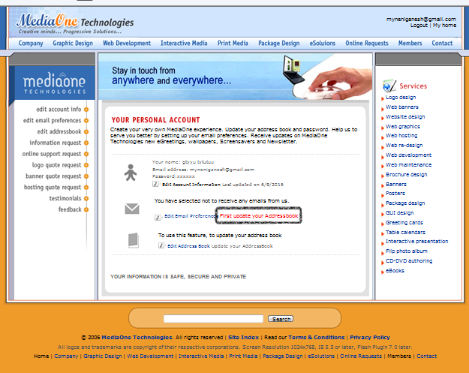

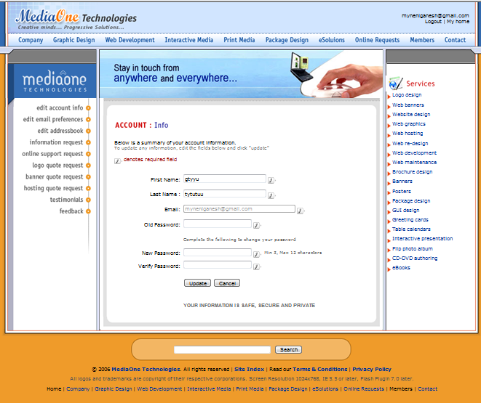

2.10 Edit account info

|  |  |
| --- | --- |
| **Actor Action** | **System Response** |
|  | 1. System displays user authentication page which includes  a) **Header info.**  Go to – Header information & mail address, logout link & My home link on the right.  b) **Left frame**  System displays MOT Logo on the top and the following links under it  a. Edit account information  b. Edit email preferences  c. Edit address book  d. Information request  e. Online support request  f. Logo quote request  g. Banner quote request  h. Hosting quote request  i. Testimonials  j. Feedback  c) **Middle frame**  System displays banner on top and email id in disabled mode in Email textbox, Password textbox and Continue button.  d) **Right frame**  System displays the following information with the corresponding links (the numbers below indicates the no. of links).  a. Testimonials (1 link)  b. Web Hosting (4)  c. Downloads (1…n)  d. Contact Us (2)  e) **Footer info.**  1. Search facility  Check here – **Search**  2. Right’s reserved info.  3. Home page link & hyper links of the menu bar links as Header information |
|  |  |
| 2. Actor enters password and clicks on continue  a. If address book not updated after  becoming member then – go to 3  b. If address book is updated – go to 4 | 3. System displays the same member’s personal page with a message “First update your address book”. |
|  | 4. System displays account info page which includes  a) **Header info.**  Go to – Header information & mail address, logout link & My home link on the right.  b) **Left frame**  System displays MOT Logo on the top and the following links under it  a. Edit account information  b. Edit email preferences  c. Edit address book  d. Information request  e. Online support request  f. Logo quote request  g. Banner quote request  h. Hosting quote request  i. Testimonials  j. Feedback  c) **Middle frame**  System displays banner on top and available data from address book in the respective fields where the email id is in disabled mode in Email textbox  d) **Right frame**  System displays the following information with the corresponding links (the numbers below indicates the no. of links).  a. Services (19 links)  e) **Footer info.**  1. Search facility  Check here – **Search**  2. Right’s reserved info.  3. Home page link & hyper links of the menu bar links as Header information |
| 5. Actor edits the following info.  a. First name in textbox  b. Last name in textbox  c. Old password in textbox  d. New password in textbox  e. Verify password in textbox  And clicks on  5.1 “Update” button - go to 6  5.2 “Cancel” button – go to 7 | 6. System updates the account info & displays member’s personal page. |
|  | 7. System displays member’s personal page without updating info |

2.11 Edit email preferences

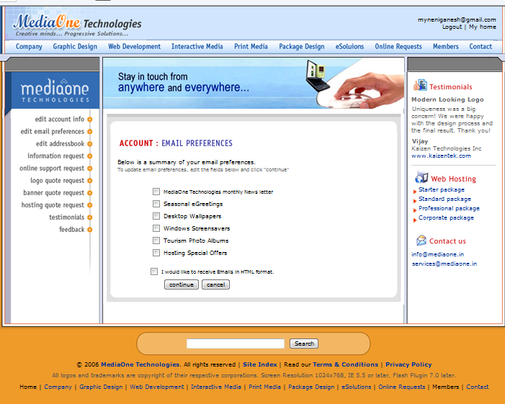

2.11 Edit email preferences

|  |  |
| --- | --- |
| **Actor Action** | **System Response** |
|  | 1. System displays user authentication page which includes  a) **Header info.**  Go to – Header information & mail address, logout link & My home link on the right.  b) **Left frame**  System displays MOT Logo on the top and the following links under it  a. Edit account information  b. Edit email preferences  c. Edit address book  d. Information request  e. Online support request  f. Logo quote request  g. Banner quote request  h. Hosting quote request  i. Testimonials  j. Feedback  c) **Middle frame**  System displays banner on top and email id in disabled mode in email textbox, Password textbox and Continue button.  d) **Right frame**  System displays the following information with the corresponding links (the numbers below indicates the no. of links).  a. Testimonials (1 link)  b. Web Hosting (4)  c. Downloads (1…n)  d. Contact Us (2)  e) **Footer info.**  1. Search facility  Check here – **Search**  2. Right’s reserved info.  3. Home page link & hyper links of the menu bar links as Header information |
| 2. Actor enters password and clicks on continue  a. If address book not updated after  becoming member then – go to 3  b. If address book is updated – go to 4 | 3. System displays the same member’s personal page with a message “First update your address book”. |
|  | 4. System displays email preferences page which includes  a) **Header info.**  Go to – Header information & mail address, logout link & My home link on the right.  b) **Left frame**  System displays MOT Logo on the top and the following links under it  a. Edit account information  b. Edit email preferences  c. Edit address book  d. Information request  e. Online support request  f. Logo quote request  g. Banner quote request  h. Hosting quote request  i. Testimonials  j. Feedback  c) **Middle frame**  System displays banner on top and list of email preferences.  d) **Right frame**  System displays the following information with the corresponding links (the numbers below indicates the no. of links).  a. Testimonials (1 link)  b. Web Hosting (4)  c. Contact Us (2)  e) **Footer info.**  1. Search facility  Check here – **Search**  2. Right’s reserved info.  3. Home page link & hyper links of the menu bar links as Header information |
| 5. Actor edits the following info.  a. MOT Monthly news letter  b. Seasonal eGreetings  c. Desk top wall papers  d. Windows screensavers  e. Tourism photo albums  f. Hosting special offers  g. “I would like to receive Emails in HTML  Format”  And clicks on  5.1 “Continue” button - go to 6  5.2 “Cancel” button – go to 7 | 6. System updates the email preferences info & displays member’s personal page. |
|  | 7. System displays member’s personal page without updating the info |

2.12 Edit address book



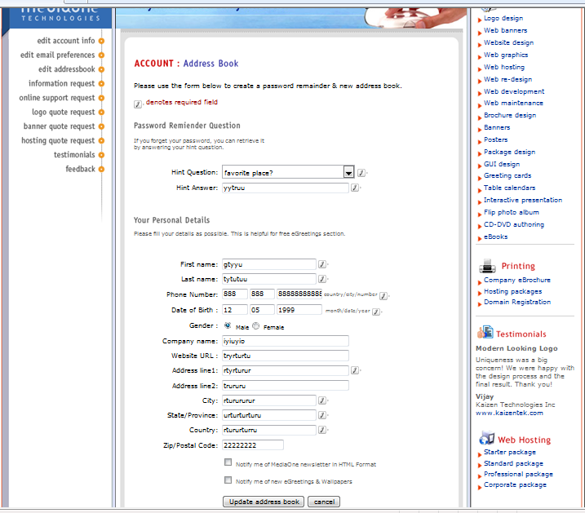

2.12 Edit address book

|  |  |
| --- | --- |
| **Actor Action** | **System Response** |
|  | 1. System displays user authentication page which includes  a) **Header info.**  Go to – Header information & mail address, logout link & My home link on the right.  b) **Left frame**  System displays MOT Logo on the top and the following links under it  a. Edit account information  b. Edit email preferences  c. Edit address book  d. Information request  e. Online support request  f. Logo quote request  g. Banner quote request  h. Hosting quote request  i. Testimonials  j. Feedback  c) **Middle frame**  System displays banner on top and email id in disabled mode in email textbox, Password Textbox and Continue button.  d) **Right frame**  System displays the following information with the corresponding links (the numbers below indicates the no. of links).  a. Testimonials (1 link)  b. Web Hosting (4)  c. Downloads (1…n)  d. Contact Us (2)  e) **Footer info.**  1. Search facility  Check here – **Search**  2. Right’s reserved info.  3. Home page link & hyper links of the menu bar links as Header information |
| 2. Actor enters password and clicks on continue | 3 System displays edit address book page with the available data in the respective fields in the address book. |
| 4. Actor selects “Hint Question” from combo box  5. Actor enters “Hint Answer” based on Hint question into textbox  6. Actor enters First Name into the textbox  7. Actor enters Last Name into the textbox  8. Actor enters Phone Number (Country/City/Number) into the respective textboxes  9. Actor enters Date of Birth (month/day/year) into the respective textboxes  10. Actor selects either Male or Female Radio button  11. Actor enters Company Name into the textbox  12. Actor enters Website URL into the textbox  13. Actor enters Address line 1 into the textbox  14. Actor enters Address line 2 into the textbox  15. Actor enters City into the textbox  16. Actor enters State/ Province into the textbox  17. Actor enters Country into the textbox  18. Actor enters Zip/Postal Code into the textbox  19. Actor checks “Notify me of company newsletter” Check box  20. Actor checks “Notify me of new eGreetings & Wallpapers” check box and  21. Actor Clicks on   1. “Update address book” button – go to 22 2. “Cancel” button – go to 23 | 22. System updates the address book info & displays member’s personal account page |
|  | 23. System displays member’s personal page without updating the info |

NetBiz_Services_Business Rules & List of Objects

**Member Sign In**

|  |  |  |  |  |  |  |
| --- | --- | --- | --- | --- | --- | --- |
| **S.No.** | **Object Name** | **Object Type** | **Business Rule/ Validation Criteria** | | | |
|  |  |  | **Editable/ Non Editable** | **Mandatory** | **Input Type** | **Length** |
| **Middle Frame:** | | |  |  |  |  |
| 1 | My email address is | Text field | Editable | Mandatory | 1).Alphanumeric,  2).Special chars (“@”, “.”, ”_”), without spaces  3) First char must not be a special char  4) Min of 3 chars before ‘@’ and min 2 chars between ‘@’ and ‘.’ | Min – 9  Max – 45 |
| 2 | **Do you have a MediaOne Technologies password?** |  |  |  |  |  |
| 2.1 | No, I am a new member | Radio button | - NA - |  | Selection | - NA - |
| 2.2 | Yes, my password is | Radio button | - NA - |  | Selection | - NA - |
| 2.3 | Yes, my password is | Text field | Editable | Mandatory | All keyboard inputs and first char must not be a special char | Min – 3  Max –12 |
| 3 | Continue | Push button | - NA - |  | - NA - | - NA - |
| **Footer Section :** | | |  |  |  |  |
| 4 | Search keyword | Text field | Editable |  | All keyboard inputs | Max - 20 |
| 5 | Search | Push button | - NA - |  | - NA - | - NA - |

**Create an Account**

|  |  |  |  |  |  |  |
| --- | --- | --- | --- | --- | --- | --- |
| **S.No.** | **Object Name** | **Object Type** | **Business Rule/ Validation Criteria** | | | |
|  |  |  | **Editable/ Non Editable** | **Mandatory** | **Input Type** | **Length** |
| **Middle Frame :** | | |  |  |  |  |
| 1 | My email address is | Text field | Non editable | Mandatory | - NA - | - NA - |
| 2 | Account type | Combo box | - NA - | Mandatory | Selection | - NA - |
| 3 | Verification code | Text field | Editable | Mandatory | Numeric | -NA- |
| 4 | First Name | Text field | Editable | Mandatory | All keyboard inputs and first char must not be a special char | Min – 1  Max – 25 |
| 5 | Last Name | Text field | Editable | --- | All keyboard inputs and first char must not be a special char | Max – 25 |
| 6 | MediaOne.In Password | Text field | Editable | Mandatory | All keyboard inputs and first char must not be a special char | Min – 3  Max – 12 |
| 7 | Verify password | Text field | Editable | Mandatory | All keyboard inputs and first char must not be a special char | Min – 3  Max –12 |
| 8 | Continue | Push button | - NA - |  | - NA - | - NA - |
| **Footer Section :** | | |  |  |  |  |
| 9 | Search keyword | Text field | Editable |  | All keyboard inputs | Max - 20 |
| 10 | Search | Push button | - NA - |  | - NA - | - NA - |

**Authentication Page**

|  |  |  |  |  |  |  |
| --- | --- | --- | --- | --- | --- | --- |
| **S.No.** | **Object Name** | **Object Type** | **Business Rule/ Validation Criteria** | | | |
|  |  |  | **Editable/ Non Editable** | **Mandatory** | **Input Type** | **Length** |
| 1 | Email | Text box | Non Editable | Mandatory | - NA - | - NA - |
| 2 | Password | Text box | Editable | Mandatory | All keyboard inputs and first char must not be a special char | Min – 3  Max – 12 |
| 3 | Continue | Push button | - NA - |  | - NA - | - NA - |
| 4 | Search keyword | Text field | Editable |  | All keyboard inputs | Max - 20 |
| 5 | Search | Push button | - NA - |  | - NA - | - NA - |

**Member Address Book**

|  |  |  |  |  |  |
| --- | --- | --- | --- | --- | --- |
| **S.No.** | **Object Name** | **Object Type** | **Business Rule/ Validation Criteria** | | |
|  |  |  | **Editable/ Non Editable** | **Mandatory** | **Input Type** | **Length** |
| **Middle Frame :** | | |  |  |  |  |
| 1 | Hint Question | Combo box | - NA - | Mandatory | Selection | - NA - |
| 2 | Hint Answer | Text field | Editable | Mandatory | All keyboard inputs and first char must not be a special char | Min – 1  Max – 50 |
| 3 | First name | Text field | Editable | Mandatory | All keyboard inputs and first char must not be a special char | Min – 1  Max – 25 |
| 4 | Last name | Text field | Editable | --- | All keyboard inputs and first char must not be a special char | Max – 25 |
| 5 | **Phone Number** |  |  | Mandatory |  |  |
| 5.1 | Country | Text field | Editable | Mandatory | Number | Min–1 Max – 4 |
| 5.2 | City | Text field | Editable | Mandatory | Number | Min – 1 Max – 4 |
| 5.3 | Number | Text field | Editable | Mandatory | Number | Min – 1 Max – 12 |
| 6 | **Date of Birth** |  |  | Mandatory |  |  |
| 6.1 | Month | Text field | Editable | Mandatory | Number | 2 digits |
| 6.2 | Day | Text field | Editable | Mandatory | Number | 2 digits |
| 6.3 | Year | Text field | Editable | Mandatory | Number | 4 digits |
| 7 | **Gender** |  |  | Mandatory |  |  |
| 7.1 | Male | Radio button | - NA - | Mandatory | Selection | - NA - |
| 7.2 | Female | Radio button | - NA - | Mandatory | Selection | - NA - |
| 8 | Company name | Text field | Editable |  | All keyboard inputs and first char must not be a special char | Max – 57 |
| 9 | Website URL | Text field | Editable |  | All keyboard inputs and first char must be alphabet | Max – 57 |
| 10 | Address line1 | Text field | Editable | Mandatory | All keyboard inputs | Min – 1  Max - 75 |
| 11 | Address line2 | Text field | Editable |  | All keyboard inputs | Max – 75 |
| 12 | City | Text field | Editable | Mandatory | All keyboard inputs and first char must be alphabet | Min – 1  Max – 25 |
| 13 | State/Province | Text field | Editable | Mandatory | All keyboard inputs and first char must be alphabet | Min –1  Max – 25 |
| 14 | Country | Text field | Editable | Mandatory | All keyboard inputs and first char must be alphabet | Min – 1 Max – 25 |
| 15 | Zip/Postal code | Text box | Editable |  | Number | Max – 12 |
| 16 | Notify me of company newsletter | Check box | - NA - |  | Selection | - NA - |
| 17 | Notify me of new eGreetings & Wallpapers | Check box | - NA - |  | Selection | - NA - |
| 18 | Update address book | Push button | - NA - |  | - NA - | - NA - |
| 19 | Cancel | Push button | - NA - |  | - NA - | - NA - |
| **Footer Section :** | | |  |  |  |  |
| 20 | Search keyword | Text field | Editable |  | All keyboard inputs | Max - 20 |
| 21 | Search | Push button | - NA - |  | - NA - | - NA - |

**Members Account Info**

|  |  |  |  |  |  |  |
| --- | --- | --- | --- | --- | --- | --- |
| **S.No.** | **Object Name** | **Object Type** | **Business Rule/ Validation Criteria** | | | |
|  |  |  | **Editable/ Non Editable** | **Mandatory** | **Input Type** | **Length** |
| 1 | First Name | Text field | Editable | Mandatory | All keyboard inputs and first char must not be a special char | Min – 1  Max – 25 |
| 2 | Last Name | Text field | Editable | --- | All keyboard inputs and first char must not be a special char | Max – 25 |
| 3 | Email | Text field | Non Editable |  | - NA - | - NA - |
| 4 | Old Password | Text field | Editable | Mandatory | All keyboard inputs and first char must not be a special char | Min – 3  Max – 12 |
| 5 | New Password | Text field | Editable | Mandatory | All keyboard inputs and first char must not be a special char | Min – 3  Max – 12 |
| 6 | Verify Password | Text field | Editable | Mandatory | All keyboard inputs and first char must not be a special char | Min – 3  Max – 12 |
| 7 | Update | Push button | - NA - |  | - NA - | - NA - |
| 8 | Cancel | Push button | - NA - |  | - NA - | - NA - |
| **Footer Section :** | | |  |  |  |  |
| 9 | Search keyword | Text field | Editable |  | All keyboard inputs | Max - 20 |
| 10 | Search | Push button | - NA - |  | - NA - | - NA - |

**Email Preferences**

|  |  |  |  |  |  |  |
| --- | --- | --- | --- | --- | --- | --- |
| **S.No.** | **Object Name** | **Object Type** | **Business Rule/ Validation Criteria** | | | |
|  |  |  | **Editable/ Non Editable** | **Mandatory** | **Input Type** | **Length** |
| 1 | MediaOne Technologies Monthly News letter | Check box | - NA - |  | Selection | - NA - |
| 2 | Seasonal e-Greetings | Check box | - NA - |  | Selection | - NA - |
| 3. | Desktop Wallpapers | Check box | - NA - |  | Selection | - NA - |
| 4 | Windows Screensavers | Check box | - NA - |  | Selection | - NA - |
| 5 | Tourism Photo Albums | Check box | - NA - |  | Selection | - NA - |
| 6 | Hosting Special Offers | Check box | - NA - |  | Selection | - NA - |
| 7 | I would like to receive Emails in HTML format. | Check box | - NA - |  | Selection | - NA - |
| 8 | Continue | Push button | - NA - |  | - NA - | - NA - |
| **Footer Section :** | | |  |  |  |  |
| 9 | Search keyword | Text field | Editable |  | All keyboard inputs | Max - 20 |
| 10 | Search | Push button | - NA - |  | - NA - | - NA - |

##### **2.13 Forgot Password**

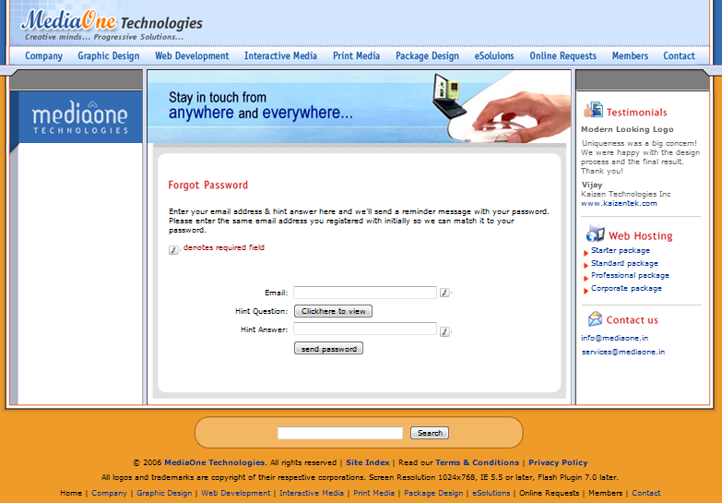

##### **2.13 Forgot Password**

|  |  |
| --- | --- |
| **Actor Action** | **System Response** |
|  | 1. System displays “Forgot Password” page information which includes  a) **Header info.**  Go to – Header information  b) **Left frame**  System displays MOT Title on the top and nothing under it.  c) **Middle frame**  System displays banner on top and forgot password form  d) **Right frame**  System displays the following information with the corresponding links (the numbers below indicates the no. of links).  a. Testimonials (1 link)  b. Web Hosting (4)  c. Contact Us (2)  e) **Footer info.**  1. Search facility  Check here – **Search**  2. Right’s reserved info.  3. Home page link & hyper links of the menu bar links as Header information |
| 3. Actor enters email address and clicks on “Click here to view” button  a. Guest – Go to 4  b. Member – Go to 7 | 4. System displays the forgot password page with email address in text box and with “Send password” button. |
| 5. Actor clicks on “Send password” button | 6. System displays “Your Password will be send to your Email ID, Thank You ” message |
|  | 7. System displays hint question in the text box |
| 8. Actor enters Hint answer into the textbox and clicks on “Send my password” button | 9. System displays “Your Password will be send to your Email ID, Thank You ” message |

NetBiz_Services_Business Rules & List of Objects

**Forgot Password**

|  |  |  |  |  |  |  |
| --- | --- | --- | --- | --- | --- | --- |
| **S.No.** | **Object Name** | **Object Type** | **Business Rule/ Validation Criteria** | | | |
|  |  |  | **Editable/ Non Editable** | **Mandatory** | **Input Type** | **Length** |
| 1 | Email | Text field | Editable | Mandatory | Alphanumeric, Special chars (“@”, “.”, ”_”), with out spaces and first char must not be a special char And min of 3 chars before ‘@’ and min 2 chars between ‘@’ and ‘.’ | Min – 9  Max – 45 |
| 2 | Hint Question (for members only) | Push Button / Text field | Non Editable |  | - NA - | - NA - |
| 3. | Hint Answer | Text field | Editable | Mandatory | All keyboard inputs and first char must not be a special char | Min – 1  Max – 50 |
| 4 | Send password | Push Button | - NA - |  | - NA - | - NA - |
| **Footer Section :** | | |  |  |  |  |
| 5 | Search keyword | Text field | Editable |  | All keyboard inputs | Max - 20 |
| 6 | Search | Push button | - NA - |  | - NA - | - NA - |

***2.14*** ***Feedback***

|  |  |
| --- | --- |
| **Actor Action** | **System Response** |
| 1. Actor clicks on Online Request link in the Header section of homepage   c. Actor clicks on Feedback link in the left section of Online request page  1. Actor enters **Name** into the textbox  2. Actor enters **email address** into the textbox (if not a guest/member of MOT else email auto display into the textbox)  3. Actor enters **Country** into the textbox  4. Actor selects “**Message type**” as either “comment” or “suggestion” or “complaint” from combo box  5. Actor enters comments into the **“your message”** text area  6. Actor checks “would you like to receive our news letter via email?” And clicks on  a. “Submit” button - go to 7  b. “Reset” button - go to 8 | b. System displays Online Request page  d. System display Feedback page  7. System displays Successfully submitted page which includes  a) **Header info.**  Go to – Header information  b) **Left frame**  System displays MOT Logo on the top and the following links under it  a. Information request  b. Online support request  c. Logo quote request  d. Banner quote request  e. Hosting quote request  f. Testimonials  g. Feedback  c) **Middle frame**  System displays banner on top and successfully submitted message.  d) **Right frame**  System displays the following information with the corresponding links (the numbers below indicates the no. of links).  a. Services (19 )  b. Web hosting (4)  e) **Footer info.**  1. Search facility  Check here – **Search**  2. Right’s reserved info.  3. Home page link & hyper links of the menu bar links as Header information |
|  | 8. System clears all the fields of feedback form |

2.14 Feedback

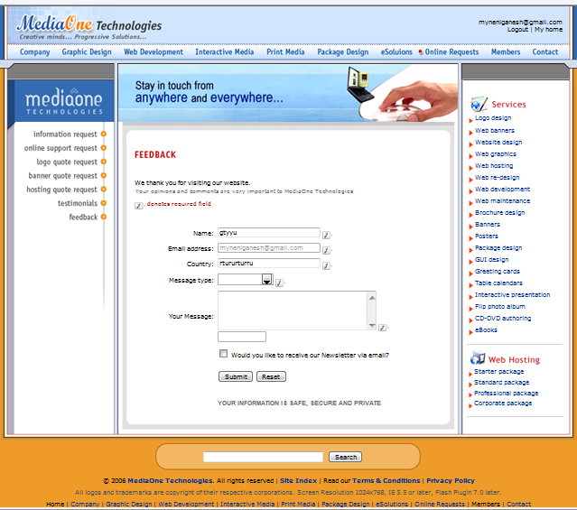

NetBiz_Services_Business Rules & List of Objects

***2.14 Feedback***

|  |  |  |  |  |  |  |
| --- | --- | --- | --- | --- | --- | --- |
| **S.No.** | **Object Name** | **Object Type** | **Business Rule/ Validation Criteria** | | | |
|  |  |  | **Editable/ Non Editable** | **Mandatory** | **Input Type** | **Length** |
| 1 | Name | Text field | Editable | Mandatory | All keyboard inputs and first char must not be a special char | Min – 1  Max – 25 |
| 2 | Email address | Text field | Editable | Mandatory | Alphanumeric, Special chars (“@”, “.”, ”_”), with out spaces and first char must not be a special char And min of 3 chars before ‘@’ and min 2 chars between ‘@’ and ‘.’ | Min – 9  Max – 45 |
| 3 | Country | Text field | Editable | Mandatory | All keyboard inputs and first char must not be a special char | Min –1  Max – 25 |
| 4 | Message type | Combo box | - NA - | Mandatory | Selection | - NA - |
| 5 | Your message | Text Area | Editable | Mandatory | All keyboard inputs | Max – 500 |
| 6 | No. of characters entered | Text field | Non Editable | -- | Number | Max -3 |
| 7 | Would you like to receive our Newsletter via email? | Check box | - NA - | -- | Selection | - NA - |
| 8 | Submit | Push button | - NA - | -- | - NA - | - NA - |
| 9 | Reset | Push button | - NA - | -- | - NA - | - NA - |
| 10 | Search keyword | Text field | Editable | -- | All keyboard inputs | Max - 20 |
| 11 | Search | Push button | - NA - | -- | - NA - | - NA - |