## What is Machine Learning?

**Machine Learning** is a subset of **Artificial Intelligence** that involves the use of algorithms and statistical models to enable computer systems to learn from historical data **without being explicitly programmed**. Artificial intelligence is a machine or system which based on intelligence, just like the Human brain.

The key advantage of Machine Learning is its ability to process large amounts of data quickly and accurately, enabling organizations to make data-driven decisions and improve their operations.

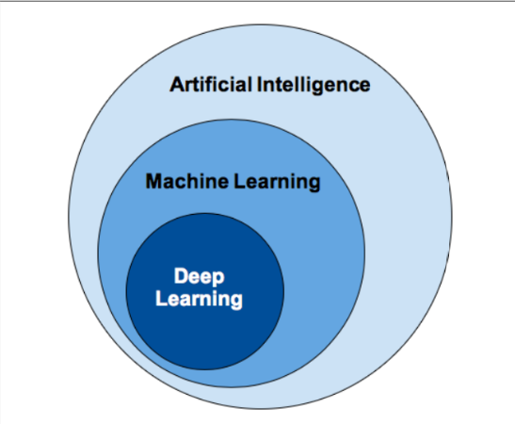AI vs ML vs DL

**Learning from Historical Data**

At the core of machine learning lies historical data. **Machine Learning Algorithms** learn by processing vast amounts of historical data, identifying patterns and using these patterns to make predictions or decisions. This process is akin to how humans learn from experience. The more data a machine is exposed to, the better it becomes at its task.

On one hand, more data can potentially lead to better model performance. On the other hand, it can also introduce computational and practical difficulties. Let's explore the implications of data size on deep learning performance through a graph.

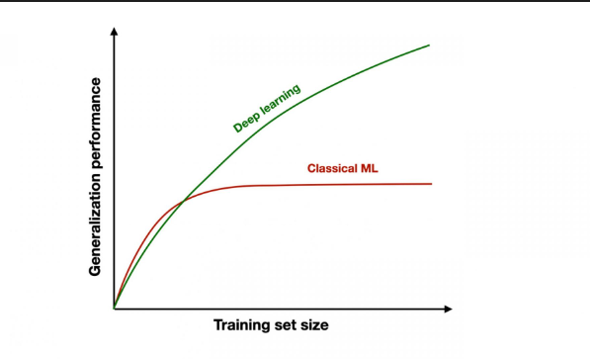Performance vs Data Size

Machine learning is a broader field that encompasses various techniques and algorithms for training models to make predictions or decisions based on data. But at some point, it becomes difficult for our machine learning algorithms to deal with that large amount of data. Their efficiency and their ability to make accurate predictions stop improving.

That's where **Deep Learning**comes in. Deep learning is a specific subset of machine learning that focuses on training deep neural networks, which are designed based on the structure of a neuron present in human brains. It has gained prominence for its ability to handle tasks that involve complex relationships and large datasets.

**Why Machine Learning?**

Here are some key points that highlight the importance and benefits of Machine Learning:

**1. Data-driven insights:**

Machine Learning enables organizations to extract valuable insights from data, helping them make informed decisions and gain a competitive edge. By analyzing historical data, it can offer predictions and recommendations, enhancing the quality and accuracy of decision-making.

**2. Automation and Efficiency:**

ML algorithms can automate repetitive tasks, leading to significant gains in efficiency. This frees up human resources to focus on more complex and creative endeavors.

**3. Data Handling and Processing:**

Machine Learning can efficiently process large volumes of data, making it possible to extract valuable insights and patterns that would be impossible for humans to discern manually. Machine Learning algorithms can process data in real-time, enabling organizations to make swift decisions based on the most up-to-date information available.

**4. Revolutionizing Industries**

Machine Learning can help revolutionize various industries. It can predict the failures of the machines, helping us save cost and time by letting us repair them beforehand. In the medical field, we use machine learning algorithms to better diagnose patients and provide them with personalized and quick treatments. In the education field, machine learning helps us in identifying the strengths and weaknesses of the students, allowing the teachers to put their focus in the right place.

## History and Evolution of Machine Learning

The history of machine learning is a fascinating journey that spans over several decades. Let's take a chronological look at the key milestones and developments in the field:

**1950 (Alan Turing's "Computing Machinery and Intelligence")**

Alan Turing introduced the concept of a "universal machine" that could simulate any human intelligence task. He proposed a test, now known as the Turing Test, to determine if a machine could exhibit human-like intelligence.

**1960 (Perceptrons and Early Neural Networks)**

The concept of perceptrons, the building blocks of neural networks, was introduced by Frank Rosenblatt. First neural networks was applied to real world problem - MADALINE.

**1970 (Decision Trees and ID3 Algorithm)**

New algorithm CNN and back propagation was introduced. Ross Quinlan developed the ID3 (Iterative Dichotomiser 3) algorithm, which was one of the first practical machine learning algorithms for decision tree induction.

**1980 (Expert Systems and Rule-Based Systems)**

This era saw the rise of expert systems, which used human-encoded knowledge and logical rules to make decisions in specialized domains. These systems were widely used in industries like healthcare and finance. Machine Learning and Artificial intelligence took separate paths.

**1990 (Statistical Learning Methods)**

The mid-1990s marked a shift towards statistical learning methods. Researchers focused on algorithms that could learn patterns and make predictions from data. Support Vector Machines (SVMs) and Bayesian methods gained prominence.

**2000 (Deep Learning acceleration)**

Deep learning, a subfield of machine learning focused on training deep neural networks, gained prominence. Breakthroughs in image and speech recognition, driven by deep learning models, showcased their remarkable capabilities.

**2017 (Machine Learning models production)**

Deep learning continued to advance, with applications expanding into areas like natural language processing and reinforcement learning. GPT-2, a language generation model, gained attention for its impressive text generation capabilities.

**2019 (Rise of Startups who leveraged Machine Learning)**

Deep learning continues to be at the forefront of machine learning research. Innovations in areas like self-supervised learning, meta-learning transformer architectures are shaping the current landscape.

**Current Era**

With the increasing integration of machine learning into society, there is a growing emphasis on ethical considerations. Research in quantum machine learning is gaining popularity, exploring the potential of quantum computing. Various technologies came into picture like Google Bard, Chat GPT etc.

The field of machine learning has come a long way since its inception it continues to evolve rapidly, driven by advancements in algorithms, computing power data availability. Issues such as bias, fairness transparency are at the forefront of discussions surrounding responsible AI.

## Types of Machine Learning: Supervised, Unsupervised, Semi-Supervised, Reinforcement

In machine learning, a dataset is a structured collection of information organized into rows and columns. Each row represents a unique data point, while columns correspond to specific features or attributes of those data points. The columns contain the input data (features) and the corresponding target values or labels (in supervised learning). This tabular format allows machine learning models to learn patterns and make predictions based on the relationships between features and labels.

Let's explore the main types of machine learning:

**Supervised Learning**

Supervised learning involves training a model on labeled data, where the input data is paired with the corresponding correct output. The algorithm learns to map inputs to outputs and trace the pattern.

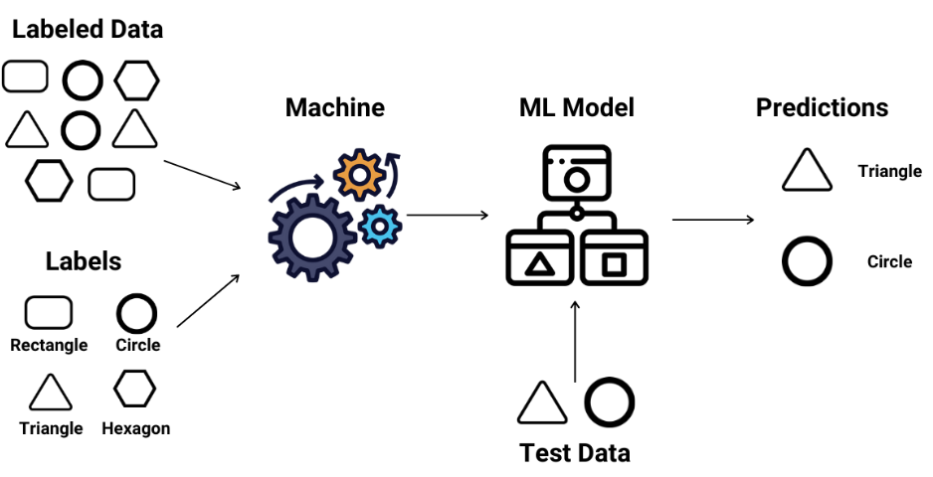Supervised Learning

Supervised learning is subdivided into two parts: **Regression**and **Classification**

**1. Classification**

Classification is a type of supervised learning where the goal is to predict the categorical class or label of a data point. The output of the model is a category. In classification the output or dependent variable is a category.

**Example:**Suppose there's a dataset of patients, diabetic and non-diabetic. We have to design a model which classify the data as diabetic or non-diabetic. To classify the data the models needs some input as records of diabetic and non-diabetic patients from which the model will try to learn the pattern.

**2. Regression**

Regression is a type of supervised learning where the goal is to predict a continuous target variable. In regression, the output or dependent variable is a real value.

**Example:**Suppose there's a dataset of features like no. of bedrooms, locality and other features and the target value is to find the price of the buildings. Such type of model which output continuous values is regression supervised learning.

**Unsupervised Learning**

Unsupervised learning involves training a model on unlabeled data, the problems which do not have labelled column for input are considered as unsupervised machine learning problem. The algorithm explores the inherent structure or patterns within the data without any predefined targets.

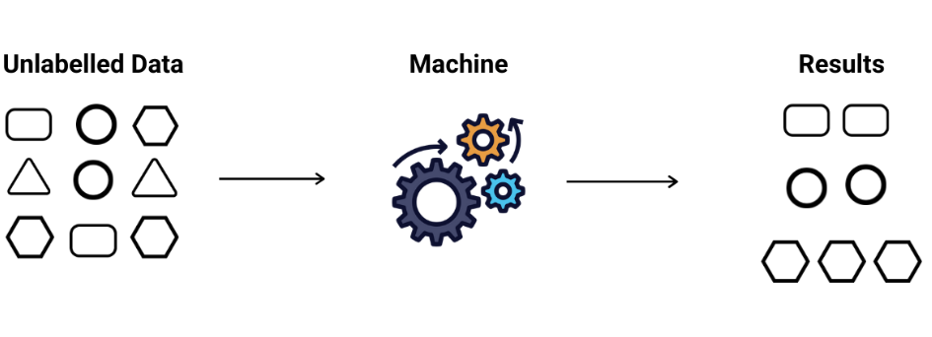Unsupervised Learning

Unsupervised learning algorithm is subdivided into two parts: **Clustering**and **Association**

**1. Clustering**

Clustering is an unsupervised learning technique where the algorithm groups similar data points together based on their features, without any predefined labels.

**Example:** Retailers use clustering to segment their customer base based on purchasing behavior, demographics and preferences.

**2. Association**

Association is a rule-based learning technique used to discover interesting relationships or patterns within large datasets. It's often used in market basket analysis, where the goal is to find associations between different products that are frequently purchased together.

**Example:**Association rules can be applied to electronic health records to identify associations between patient characteristics, treatments and outcomes.

**Semi-Supervised Learning**

Semi-supervised is the blend of supervised and unsupervised learning. It is basically used when providing labelled data is either expensive or time-consuming. The model initially trains on the labeled data. Then, it predicts labels for the unlabeled data and the high-confidence predictions are added to the labeled dataset for further training.

**Example:** Semi-supervised learning is used in tasks like sentiment analysis, where labeled data may be limited.

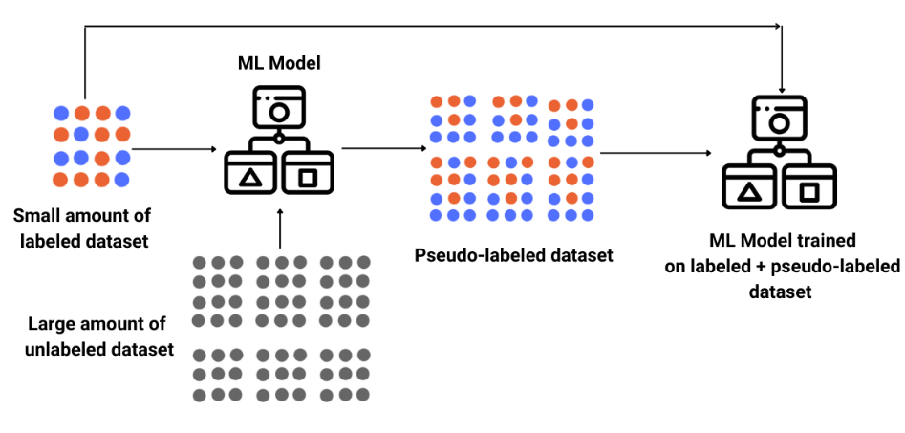Semi-Supervised Learning

**Reinforcement Learning**

Reinforcement learning is a type of machine learning where an agent learns by interacting with an environment. The agent receives feedback in the form of rewards or penalties for its actions, allowing it to learn a strategy that maximizes the cumulative reward over time.

**Example:** Self driven cars works on reinforcement learning, they learn from rewards and penalty received on performing any actions, it store the result of those actions and then continuously train itself by maximizing the cumulative reward.

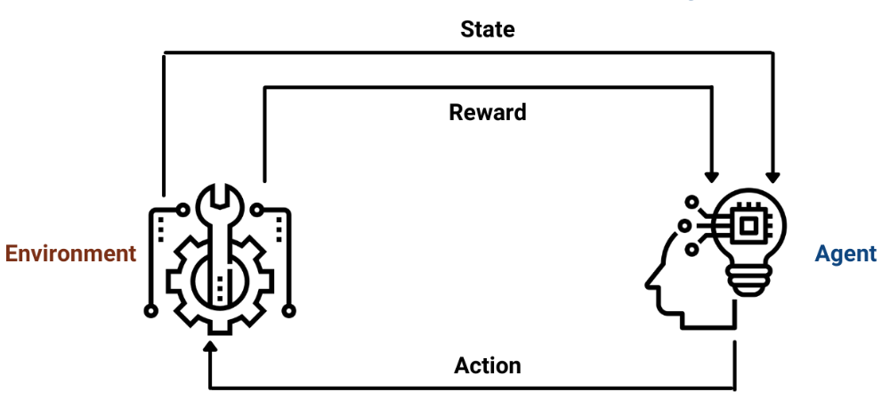Reinforcement Learning