Applied Data Science

# Visualization Report

Name: Narendar Vatsavai

Student Id: 22103577

Github Repositoy: <https://github.com/Narendarvatsavai/visualisation.git>

# Visualization-1: Number of Times Popular Albums Streamed on Spotify per Day

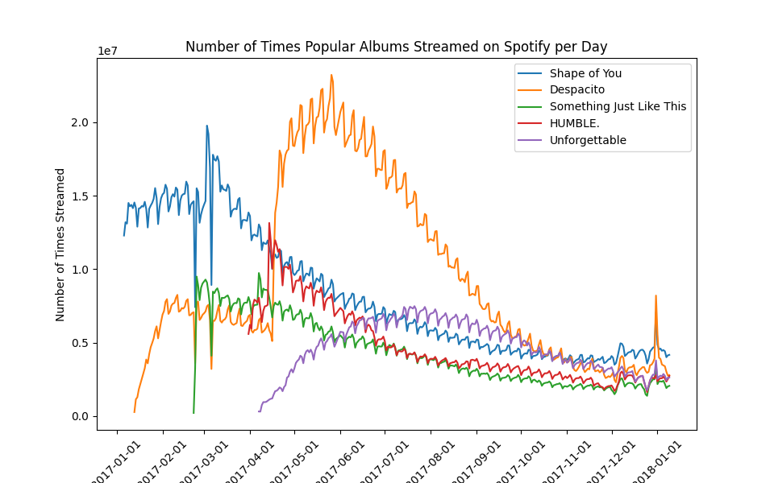

Source:<https://www.kaggle.com/code/alexisbcook/scatter-plots/data?select=spotify.csv>

A line plot is a good way to represent the trend of the albums over time, such as how different albums popularity changed from day to day.

The plot is a line graph that compares the streaming trends of four popular albums on Spotify over a period of 1 Year. The x-axis shows the date from Jan 2017 to Jan 2018, and the y-axis shows the number of times streamed in millions. The plot has five lines, each representing an album. The plot reveals that Despacito was the most streamed album for majority of the time, reaching a peak of about 2.5 million streams on June and gradually declining to about 500k streams by end of December. Shape of You was the second most streamed album, with a similar trend as Despacito, but with lower values. It peaked at about 2 million streams on May 2 and dropped to about 500k streams by end of December. Something Just Like This and Unforgettable had much lower streaming numbers than the other two albums, with less than 1 million streams each. They also showed a downward trend over time, with slight fluctuations. [The plot suggests that the popularity of the albums decreased over time, and that Despacito and Shape of You were the most preferred albums by the Spotify users](https://statisticsbyjim.com/graphs/line-charts/" \t "_blank).

# Visualization -2: Scatter Plot of BMI vs. Insurance Premium of US

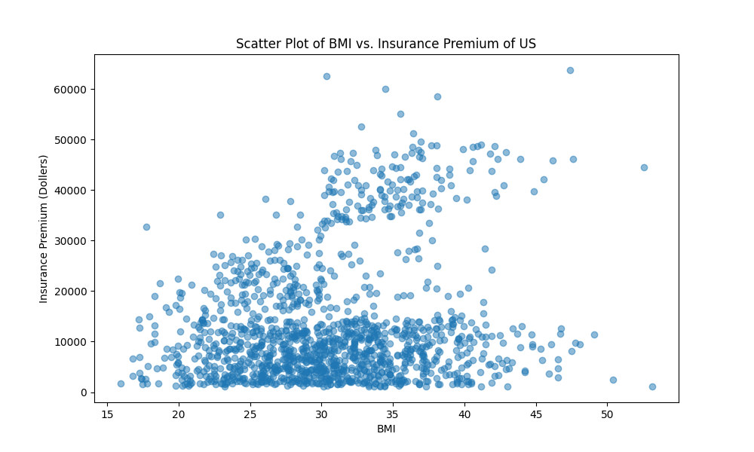

Source: <https://www.kaggle.com/code/alexisbcook/scatter-plots/data?select=insurance.csv>

A scatterplot is a good way to illustrate the strength of the relationship(correlation) between BMI and Insurance premium paid.

Overall, the scatter plot shows a positive correlation between BMI and insurance premium of US especially certain section of people of higher BMI pay higher premium. This means that as BMI increases, insurance premium also increases. The data points are scattered across the plot, with some variation around the line of best fit.

# Visualization-3: Land use per gram of protein by food type.

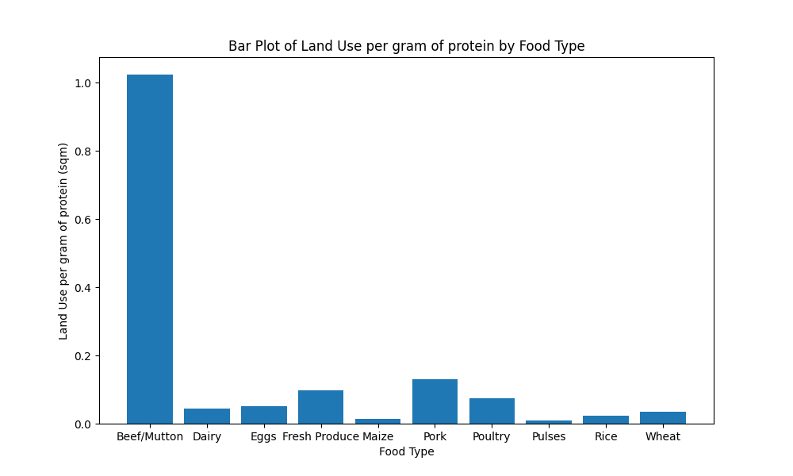

Source: <https://data.world/makeovermonday/2018w50>

A bar plot is a good way to compare Land use per gram values across the food types and visualize the distribution of the data.

The chart shows that beef/mutton has the highest land use per gram of protein, followed by dairy and eggs. These three food types require more than 1gcp, which means that they need more than 1 square meter of land to produce one gram of protein.

Fresh produce, maize, poultry, pulses, rice and wheat have significantly lower land use per gram of protein which require less than 0.2 gcp. These food types require less than 0.2 square meters of land to produce one gram of protein.

The chart suggests that animal-based food types have a higher environmental impact than plant-based food types, as they require more land resources to produce the same amount of protein. This implies that reducing the consumption of animal-based food types and increasing the consumption of plant-based food types could help conserve land and reduce greenhouse gas emissions.