UNIT-1
TASK-1: import java.util.*;
class Solution {
public int[] sortedSquares(int[] nums) {
for(int i=0;i<nums.length;i++){
nums[i]=nums[i]*nums[i];}
for(int i=0;i<nums.length;i++){
for(int j=0;j<nums.length-i-1;j++){
if(nums[j]>nums[j+1]){
int temp=nums[j];
nums[j]=nums[j+1];
nums[j+1]=temp;}
}
}
return nums;
}
public static void main(String a[]){
Solution obj = new Solution();
int[] result= obj.sortedSquares(new int[]{-4,-1,0,3,10});
System.out.println(result);
}}
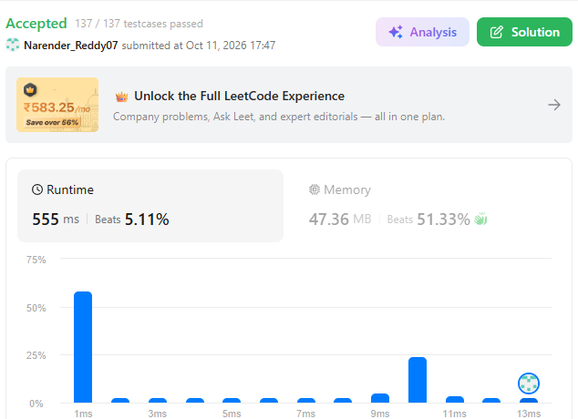
TASK-2:
import java.util.HashSet;
class Solution {
public boolean containsNearbyDuplicate(int[] nums, int k) {
HashSet<Integer> window = new HashSet<>();
for (int i = 0; i < nums.length; i++) {
if (i > k) {
window.remove(nums[i - k - 1]); }
if (!window.add(nums[i])) {
return true;
}
}
return false;}
public static void main(String a[]) {
Solution obj = new Solution();
boolean result = obj.containsNearbyDuplicate(new int[]{1, 2, 3, 1}, 4);
System.out.println(result);
}
}
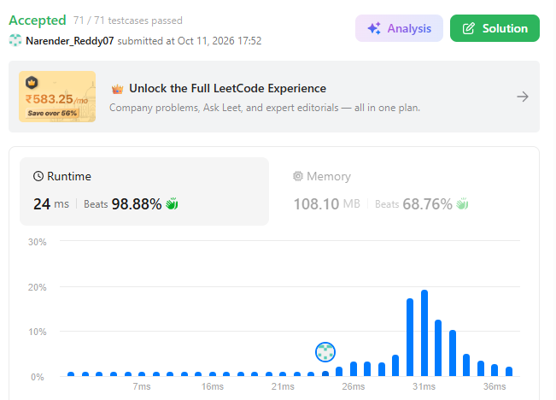
TASK-3:
class Solution {
public int[] runningSum(int[] nums) {
for (int i = 1; i < nums.length; i++) {
nums[i] += nums[i - 1];
}
return nums;
}
public static void main(String a[]) {
Solution obj = new Solution();
int[] input = new int[]{1, 2, 3, 4};
int[] result = obj.runningSum(input);
System.out.println(Arrays.toString(result));
}
}

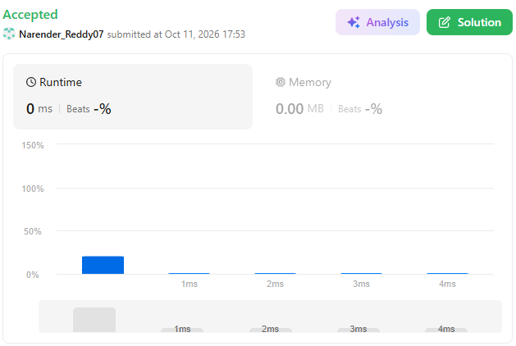

TASK-4:
class Solution {
public int[] getSumAbsoluteDifferences(int[] nums) {
int n = nums.length;
int totalSum = 0;
for (int num : nums) totalSum += num;
int leftSum = 0;
int[] result = new int[n];
for (int i = 0; i < n; i++) {
int rightSum = totalSum - leftSum - nums[i];
int leftDiff = (nums[i] * i) - leftSum;
int rightDiff = rightSum - (nums[i] * (n - 1 - i));
result[i] = leftDiff + rightDiff;
leftSum += nums[i]; }
return result;}
public static void main(String a[]){
Solution obj=new Solution(); int []result=obj.getSumAbsoluteDifferences(new int[]{1,2,3,4}); System.out.println(result);}} 
TASK-5:
class Solution {
public int search(int[] nums, int target) {
int low=0;
int high=nums.length-1;
while(low<=high){
int mid=(low+high)/2;
if(nums[mid]==target){
return mid; }
else if(target<nums[mid]){
high=mid-1;}
else
low=mid+1;}
return -1; }
public static void main(String a[]){
Solution obj=new Solution();
int result=obj.search(new int[]{-1,0,3,5,9,12},9); System.out.println(result);}}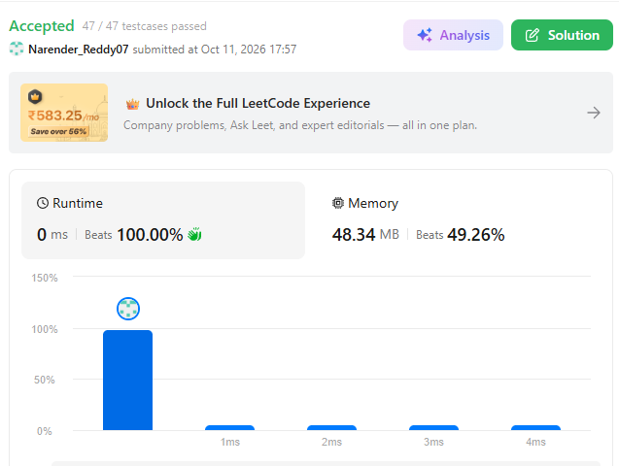
TASK-6:
class Solution {
public void sortColors(int[] nums){
int low = 0;
int mid = 0;
int high = nums.length - 1;

while (mid <= high) {
if (nums[mid] == 0) {
int temp = nums[low];
nums[low] = nums[mid];
nums[mid] = temp;
low++;
mid++;
} else if (nums[mid] == 1) {
mid++;
} else if (nums[mid] == 2) {
int temp = nums[high];
nums[high] = nums[mid];
nums[mid] = temp;
high--;
}
}
}
public static void main(String a[]){
Solution obj=new Solution();
int[] nums = new int[]{1, 2, 0, 1};
obj.sortColors(nums);
System.out.println(Arrays.toString(nums));
}
}
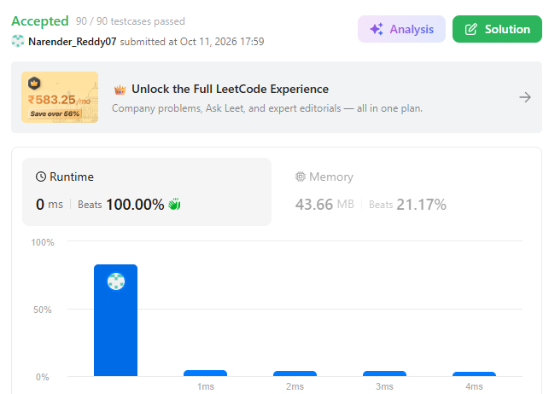
TASK-7:
class Solution {
public int maxProfit(int[] prices) {
int minPrice = Integer.MAX_VALUE;
int maxProfit = 0;

for (int price : prices) {
if (price < minPrice) {
minPrice = price;
} else if (price - minPrice > maxProfit) {
maxProfit = price - minPrice;
}
}

return maxProfit;
}
public static void main(String a[]){
Solution obj=new Solution();
int result=obj.maxProfit(new int[]{2,4,5,6,2});
System.out.println(result);
}
}
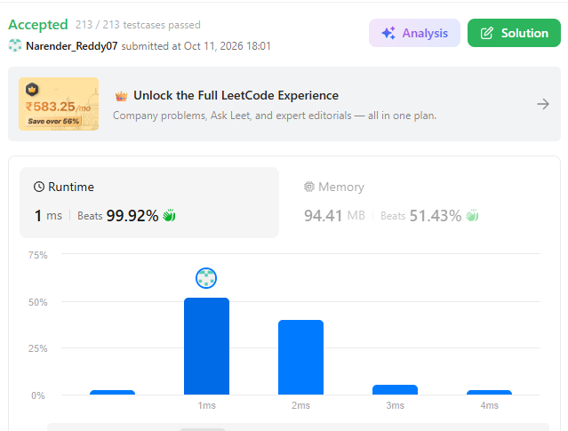
TASK-8:
class Solution {
public int firstUniqChar(String s) {
int[] count = new int[26];
for (int i = 0; i < s.length(); i++) {
count[s.charAt(i) - 'a']++;
}
for (int i = 0; i < s.length(); i++) {
if (count[s.charAt(i) - 'a'] == 1) {
return I;}}
return -1; }
public static void main(String a[]){
Solution obj=new Solution();
int result=obj.firstUniqChar("leetcode");
System.out.println(result);}}
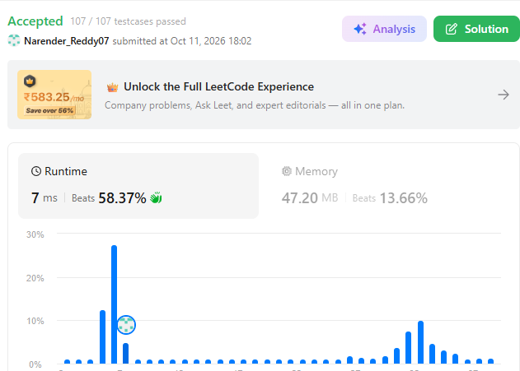

TASK-9:
class Solution {
public void moveZeroes(int[] nums) {
int i=0;
int j=0;
while(j<nums.length){
if(nums[j]!=0){
int temp=nums[i];
nums[i]=nums[j];
nums[j]=temp;
i++; } j++; } }}
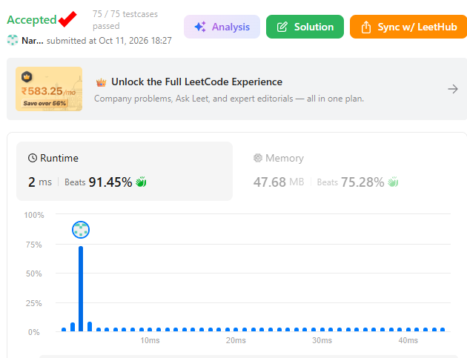

TASK-10:
class Solution {
public void reverseString(char[] s) {
int left=0;
int right=s.length-1;
while(left<right){
char temp=s[left];
s[left]=s[right];
s[right]=temp;
left++;
right--;
}
}
}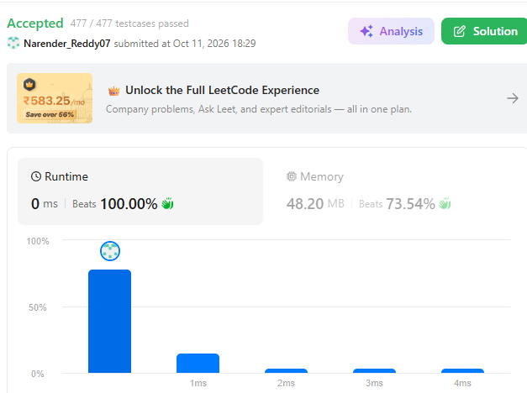

TASK-11: class Solution {
public ListNode middleNode(ListNode head) {
ListNode slow=head;
ListNode fast=head;
while(slow!=null && slow.next!=null){
slow=slow.next.next;
fast=fast.next;

}
return fast;
}
}
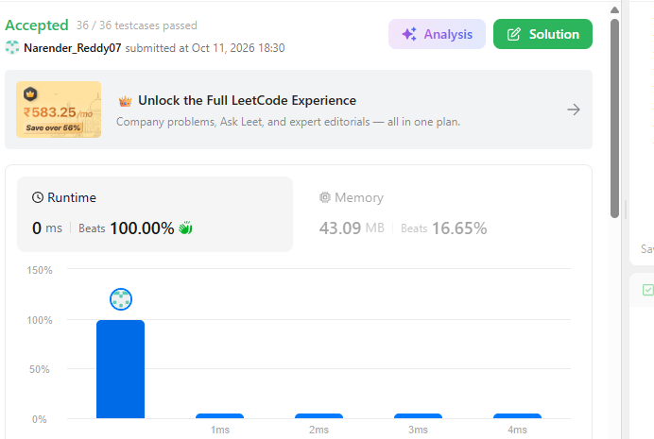

TASK-12:
class Solution {
public boolean isPalindrome(ListNode head) {
ListNode slow=head;
ListNode fast=head;
while(slow!=null && slow.next!=null){
slow=slow.next.next;
fast=fast.next; }
ListNode secondHalf=reverse(fast);
ListNode firstHalf=head;
while (secondHalf != null) {
if (firstHalf.val != secondHalf.val) {
return false; }
firstHalf = firstHalf.next;
secondHalf = secondHalf.next;}
return true;
}
private ListNode reverse(ListNode head) {
ListNode prev = null;
ListNode curr = head;
while (curr != null) {
ListNode nextNode = curr.next;
curr.next = prev;
prev = curr;
curr = nextNode;
}
return prev;

}
}
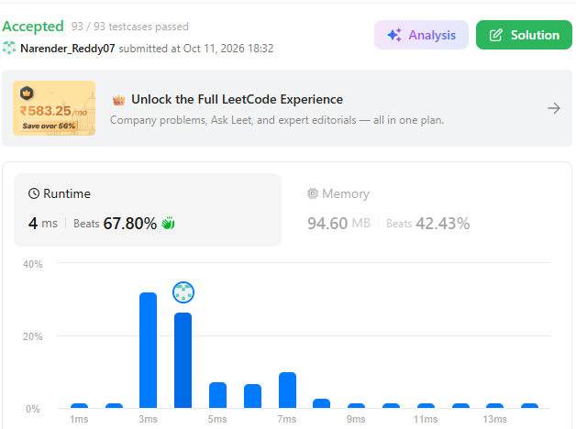
TASK-13:
class Solution {
public ListNode mergeTwoLists(ListNode list1, ListNode list2) {
if(list1==null)
return list2;
if(list2==null)
return list1;
if(list1.val<list2.val){
list1.next=mergeTwoLists(list1.next,list2);
return list1;
}
else{
list2.next=mergeTwoLists(list1,list2.next);
return list2;
}
}
}

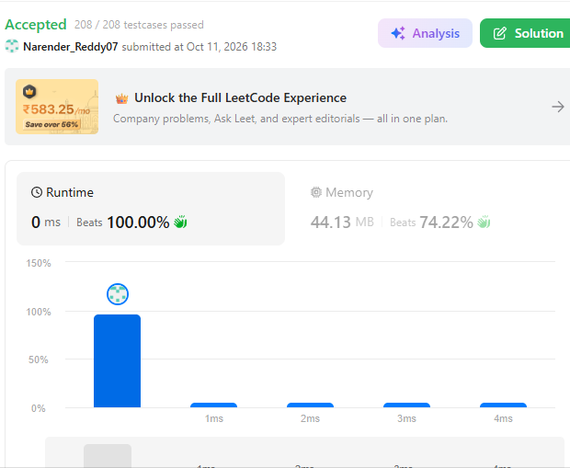

TASK-14:
class Solution {
public ListNode mergeKLists(ListNode[] lists) {
PriorityQueue<ListNode> minHeap = new PriorityQueue<>((a, b) -> Integer.compare(a.val, b.val));
for (ListNode root : lists) {
if (root != null) {
minHeap.add(root);
}
}
ListNode dummy = new ListNode(0);
ListNode tail = dummy;
while (!minHeap.isEmpty()) {
ListNode smallest = minHeap.poll();
tail.next = smallest;
tail = tail.next;
if (smallest.next != null) { minHeap.add(smallest.next);} returndummy.next;}} 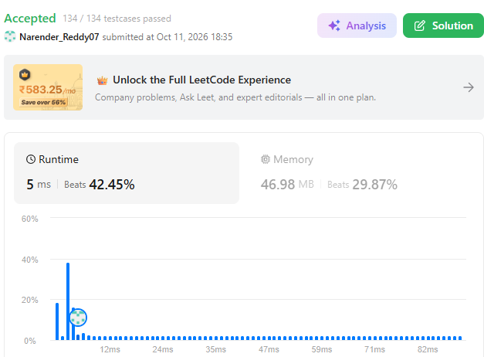
TASK-15:
class Solution {
public ListNode reverseList(ListNode head) {
ListNode curr=head;
ListNode prev=null;
while(curr!=null){
ListNode next=curr.next;
curr.next=prev;
prev=curr;
curr=next;
}
return prev;
}
}
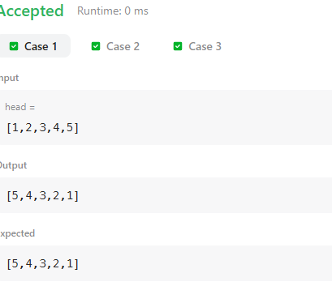

TASK-16:
class Solution {
public ListNode reverseKGroup(ListNode head, int k) {
if (head == null || k == 1) {
return head;
}

ListNode dummy = new ListNode(0);
dummy.next = head;

ListNode pointer = dummy;

while (pointer != null) {
ListNode node = pointer;
for (int i = 0; i < k && node != null; i++) {
node = node.next;
}
if (node == null) {
break;
}
ListNode prev = pointer.next;
ListNode curr = prev.next;
for (int i = 1; i < k; i++) {
prev.next = curr.next;
curr.next = pointer.next;
pointer.next = curr;
curr = prev.next;
}
pointer = prev;
}

return dummy.next;
}
}
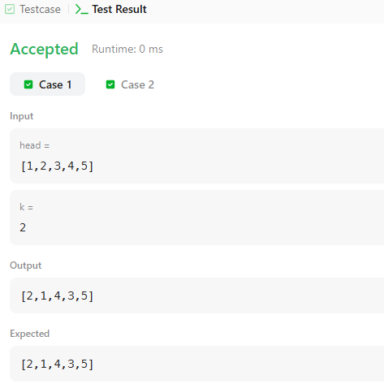
TASK-17:
public class Solution {
public ListNode detectCycle(ListNode head) {
if(head==null || head.next==null){
return null;
}
ListNode slow = head;
ListNode fast = head;
while (fast != null && fast.next != null) {
slow = slow.next;
fast = fast.next.next;
if (slow == fast) {
ListNode pointer = head;
while (pointer != slow) {
pointer = pointer.next;
slow = slow.next;
}
return pointer;
}
}

return null;}}
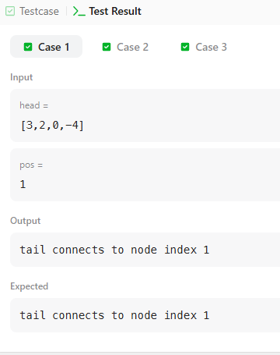
TASK-18:
public class Solution {
public ListNode getIntersectionNode(ListNode headA, ListNode headB) {
ListNode pA = headA;
ListNode pB = headB;
while (pA != pB) {
pA = (pA == null) ? headB : pA.next;
pB = (pB == null) ? headA : pB.next;
}
return pA;
}
}

