1. BUSINESS-REQUIREMENT
   1. PROBLEM STATEMENT:

The purpose of this application is to allow the customers apply for a loan and the managers to approve or reject the loan there are two types’ users to access the application

* + 1. User
    2. Admin User Module:

**The User Module**allows you to:

|  |  |
| --- | --- |
| 1 | Can register himself |
| 2 | Can apply for Mortgage loan on a property |
|  | *While applying for loan, following*  *information is required* |
|  | *a. Loan Name (Description)* |
|  | *b. Loan Application number (Auto*  *generated)* |
|  | *c. Loan Amount requested* |
|  | *d. Loan Application Date* |
|  | *e.Businessstruture (Individual/Organisation)* |
|  | *f.Billing Indicator (Salaried person or not)* |
|  | *g. Tax indicator (Tax payer or not)* |
|  | *h. Contact Details (Contact Address, mobile,*  *email)* |
| 3 | Can track status of Loan Application |
| 4 | Can Edit Loan Application till not approved  by Manager |

Admin Module

|  |  |
| --- | --- |
| 1 | Can list all Loan Applications |
| 2 | If Loan is sanctioned, following information should be furnished |
|  | *a. Loan Amount Sanctioned* |
|  | *b. Term of loan ( Duration )* |
|  | *c. Payment start Date* |
|  | *d. Loan closure Date (Auto calculated from Payment start date and Term)* |
|  | *e. Monthly payment (Calculated)* |
|  | *Formulae:* |
|  | *a. Term payment amount = (Sanctioned loan amount ) * (1 + interest rate/100) ^ (term of*  *loan)* |
|  | *b. Monthly payment = (Term payment amount ) / (Term of loan)* |

2. RESOURCES AVAILABLE :

|  |  |  |
| --- | --- | --- |
| Description | View Pages  Name | Remarks |
| Common UI |  |  |
| Home Page | index.jsp | Contains Login form for Admin and User and link to new user  registration |
| Error Page | errorPage.js  p |  |
| Header | header.jsp |  |
| Footer | footer.jsp |  |
| Not Found Page | notfound.jsp |  |
|  |  |  |
| Admin Services UI |  |  |
| Admin Related functionalities | Adminhome 1.jsp | Should contain links to list all loans and  process the loan |
| Shall be used to display loans | Listall.jsp | Should display all the  loans information |
| Shall be used to read loan application number to process | Process.jsp | Should read the loan application number and submit to AdminController, also it should contains links for logout and  admin home page |
| Shall be used to display loan info and other details has to be entered by manager | Callemi.jsp | Should display the loan info and has provision to enter  other details |
|  |  |  |
| User Services UI |  |  |
| Shall contain User related activities | Userhome1.j sp | Must contain links to  apply for loan, track and edit loan aplicaiton |
| Shall be used to read the details for application and some  auto generated values should be displayed | Application.j  sp | To accept the details for loan |
| Shall be used to read application number and submit to  servlet to track it | Trackloan.js  p | To accept the loan application number |
| Shall be used to display the laon status given in the  trackloan.jsp | Displaystatu  s.jso | To display loan status |
| Shall be used to accept the loan application number and send to userservlet to process | Editloan.jsp | To accept the loan application number to  eidit |
| Shall be used to display editable text | Editloanui.js  p | To display the values to edit. |

|  |  |
| --- | --- |
| Admin Login Id | admin |
| Admin Password | admin |

Note:

1. For jdbc connection, you need to set your url, userid and password in the web.xml
2. You are free to create any dto objects required for communication between the dao and controller.
3. 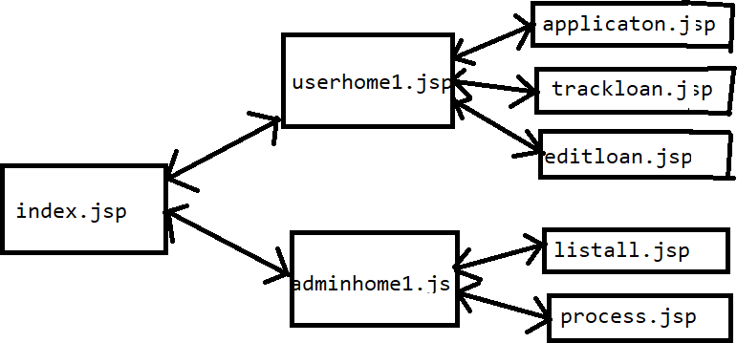PAGE FLOW :
4. POINTS TO REMEMBER
5. Do not add/remove or change any action parameter values
6. Do not add/remove any JSP pages
7. Deliverables
   1. Complete Developed Code , uploaded on Git Repository
   2. .sql file for DB Schema, uploaded on same Git Repository