BANKING AGENT PROTOTYPE
Requirement Understanding, Database Design,
Technology, LangGraph Architecture, and Solution
Agentic conversational banking with LangGraph, FastMCP,
human-in-the-loop approval, and a Streamlit chat UI
Item | Value
Document type | Design and requirement document
Project | banking-agent 1.0.0
Framework | LangGraph StateGraph with SQLite checkpointer
Required scenarios | Transaction status lookup · Initiate transfer
Additional scenario | Account balance inquiry
Data | Mock SQLite users, accounts, and transactions
Code impact | None — this document is generated separately

This document records how the given task was understood, how the mock banking data is modelled, which technologies were selected, how the LangGraph workflow is structured, and how those pieces together solve the problem. Application source code was not modified to produce this file.

Contents
1. Requirement Understanding
2. Database Design
3. Technology
4. LangGraph Architecture
5. Problem Solved and Solution
6. Conclusion
Appendix A. Setup and run (from the project README)
Appendix B. Source map

1. Requirement Understanding

1.1 Task statement
The assigned task is to design and implement a Python prototype using an agentic framework (LangChain / LangGraph or equivalent). The prototype must demonstrate a conversational agent workflow, MCP server integration, human-in-the-loop approval for potentially risky actions before execution, and a basic chat UI connected to the agent. It must use mock data and support two scenarios: checking the status of an existing banking transaction, and initiating a new transaction. Runnable code, concise setup and run instructions, and a recorded video demo are required.

1.2 How the task was interpreted
The banking domain is treated as a constrained, auditable workflow rather than a free-form LLM chatbot. Natural language is used only to classify intent and extract slots (amount, destination account, optional PIN and account ID). Identity proof, transaction-ID capture, and payment approval are explicit pauses in the graph. Money movement is never performed in the same step as parsing the user’s request. Mock data is sufficient; no live core-banking system is assumed.

1.3 Requirement-to-capability map
Task requirement | Prototype capability | Where it lives
Agentic framework | LangGraph StateGraph with typed AgentState, nodes, and conditional edges | src/graph/app.py, nodes.py, routes.py, state.py
Conversational workflow | Chat turns invoke the graph; thread_id preserves conversation and pauses | FastAPI /chat + Streamlit chat input
MCP server integration | FastMCP HTTP server exposing banking tools; matching client wrappers used by graph nodes | src/mcp_server/server.py, mcp_client.py
HITL for risky actions | interrupt() before identity, status lookup, and transfer execution; UI approve/reject | nodes.py, main.py /approve /reject, streamlit_app.py
Basic chat UI | Streamlit chat with identity form, TXN lookup form, and approval panel | src/ui/streamlit_app.py
Mock data | SQLite seed: two users, two accounts, one SUCCESS transaction TXN1001 | src/backend/database_db.py
Scenario A — status | Intent status → identify account → collect TXN ID → MCP lookup → spoken result | transaction_status node
Scenario B — new transaction | Intent transfer → identify → validate → HITL approve + PIN → atomic transfer | validate / approval / execute nodes
Runnable code + instructions | python run.py all; Makefile; Docker Compose; README demo script | run.py, Makefile, docker-compose.yml, README.md

1.4 Functional requirements

FR-1 Conversational intents
- The agent must classify user text into status, balance, transfer, or unknown.
- Unknown requests must receive a short help message listing supported actions.
- Optional inline identity is supported (for example: pin 1234 from ACC001).

FR-2 Identity before banking actions
- Status, balance, and transfer all require a verified source account.
- Identity is PIN plus account ID, resolved through the get_account_by_pin tool.
- Invalid PIN, locked account, or PIN/account mismatch must fail closed with a clear answer.

FR-3 Transaction status (required scenario)
- After identity, the graph pauses for a transaction ID (example TXN1001).
- The lookup must use the banking tool layer, not ad-hoc SQL in the UI.
- A transaction that does not involve the caller’s account must be refused.

FR-4 Initiate transfer (required scenario)
- Parse destination account and amount from natural language.
- Validate amount > 0, source ≠ destination, and destination exists and is ACTIVE.
- Create a pending_transaction snapshot with status PENDING_APPROVAL.
- Pause for human approval. Execute only if approved and PIN is re-verified.
- Rejection cancels the pending transfer; no balances change.

FR-5 Account balance (additional scenario)
- After identity, return current balance, account type, and status for the caller’s account.
- Refuse if the account is not associated with the authenticated user.

FR-6 Chat UI and API
- A chat UI must be connected to the agent over HTTP.
- The API must expose resume endpoints for identity, lookup, approve, and reject.
- Each browser session uses a UUID thread_id so HITL pauses are conversation-scoped.

1.5 Non-functional requirements
Area | Expectation in this prototype
Safety | No fund movement without HITL approval and a second PIN check.
Integrity | Transfer debit/credit is a single SQLite IMMEDIATE transaction.
Idempotency | Replaying the same pending transaction_id does not double-pay.
Secrets | PINs stored as bcrypt hashes; PIN is cleared from graph state after identity.
Lockout | Three failed PIN checks on approve lock the user (is_locked).
Durability | Graph checkpoints survive process pause so HITL can resume.
Isolation | Per-thread asyncio.Lock prevents concurrent resume races.
Operability | Health endpoints, local runner, Makefile, and Docker Compose.
Scope of LLM | Deterministic regex intent parser — no paid model required to run the demo.

1.6 Personas and demo accounts
The prototype ships two mock customers so both “check an existing transfer” and “send a new transfer” can be shown without external fixtures.
User | user_id | PIN | Account | Opening balance
John Doe | USER001 | 1234 | ACC001 | ₹100,000
David | USER002 | 5678 | ACC002 | ₹50,000

Sample historical payment: TXN1001 — ₹5,000 from ACC001 to ACC002, status SUCCESS, idempotency key MOCK-001. This record is the canonical demo for scenario A.

1.7 Conversation scenarios the UI must support
- Greeting / unknown — “hello” yields the three-capability help list.
- Balance — “What is my account balance?” then ACC001 / 1234.
- Status — “What is the status of my transaction?” then identity, then TXN1001.
- Transfer approve — “Transfer 2500 to ACC002”, identity, review panel, PIN, Approve.
- Transfer reject — same path, then Reject Transaction; no money moves.
- Second user — “Transfer 1500 to ACC001 pin 5678 from ACC002”, approve with 5678.
- Validation errors — destination ACC999 (not found) or transfer to self ACC001.
A new conversation (sidebar) is required between examples so identity is collected again. That matches the graph design: user_id and source_account persist on the thread until a new thread is created.

2. Database Design

2.1 Design goals
The data layer is a small mock core-banking schema. It must be easy to seed, inspect, and reset, while still illustrating the controls a real payment engine would keep: hashed credentials, account status, foreign keys, atomic transfers, and an idempotency key so a retried HITL approval cannot pay twice.
- Separate identity (users) from monetary positions (accounts) and movement (transactions).
- One active savings account per demo user is enough; the schema still allows more accounts.
- Do not store graph interrupt state in banking tables — that belongs in the checkpointer DB.
- Keep all amounts in INR for the prototype; currency is a column so the model can grow.

2.2 Physical files
Store | Default path | Engine | Purpose
Banking database | data/banking.db (BANKING_DB_PATH) | SQLite + WAL, foreign_keys ON | Users, accounts, posted transactions
Graph checkpointer | data/langgraph_checkpoints.db (CHECKPOINT_PATH) | aiosqlite + AsyncSqliteSaver | Thread state, next nodes, interrupt payloads

Both paths are created on startup. FastAPI lifespan calls ensure_db(), create_mock_transaction(), and init_runtime_graph(). The MCP process also calls ensure_db() and create_mock_transaction() so tools work even if MCP is started alone.

2.3 Entity-relationship model
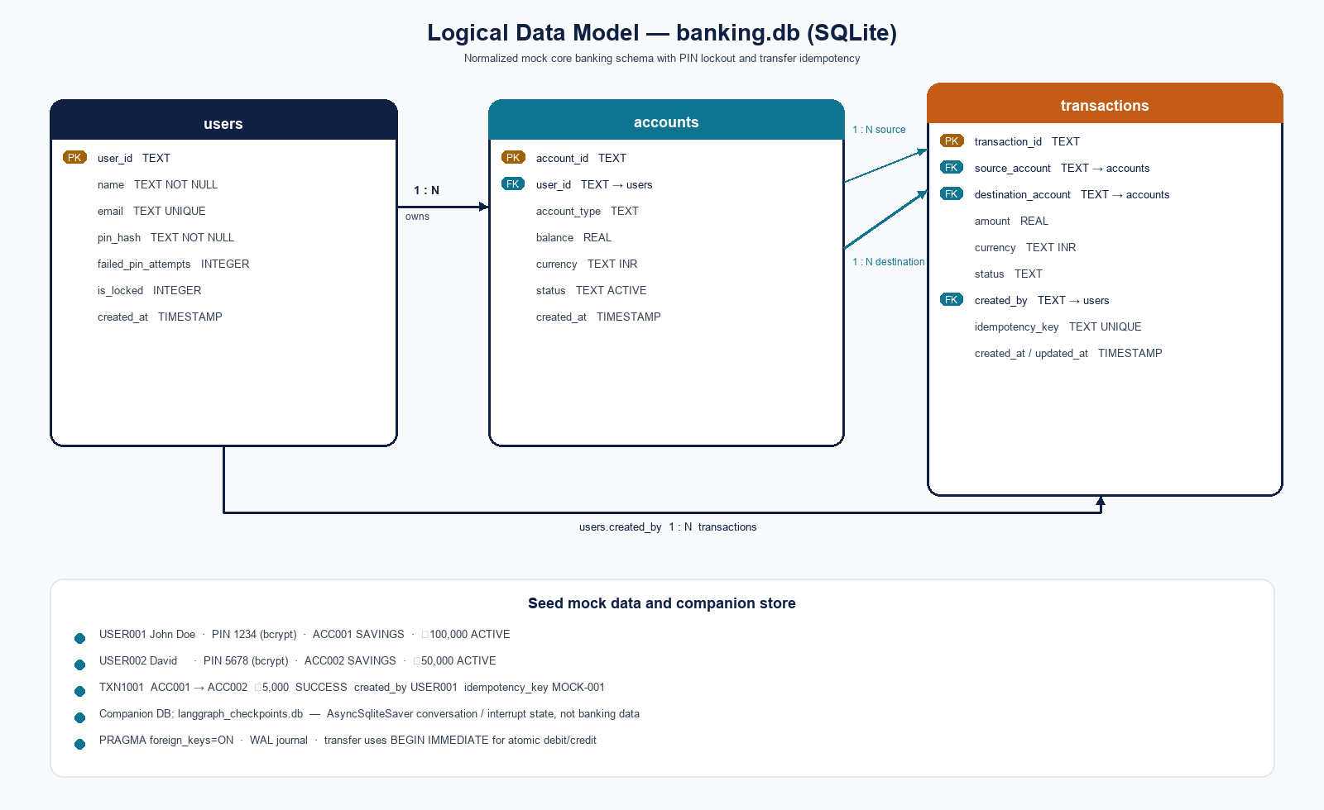
Figure 1. Logical ER model for banking.db and the companion LangGraph checkpoint file.

2.4 Table specifications

users
One row per customer. The PIN is never stored in plaintext. failed_pin_attempts and is_locked implement a simple brute-force control used when the FastAPI /approve path calls verify_pin().
Column | Type | Constraints | Meaning
user_id | TEXT | PRIMARY KEY | Stable customer identifier (USER001).
name | TEXT | NOT NULL | Display name returned after identity.
email | TEXT | UNIQUE | Unused by the chat flow; reserved for the mock profile.
pin_hash | TEXT | NOT NULL | bcrypt hash of the 4–6 digit PIN.
failed_pin_attempts | INTEGER | DEFAULT 0 | Incremented on bad approve PIN.
is_locked | INTEGER | DEFAULT 0 | 1 after three failed PIN checks.
created_at | TIMESTAMP | DEFAULT CURRENT_TIMESTAMP | Row creation time.

accounts
Monetary position. Transfers debit source.balance and credit destination.balance. Only ACTIVE accounts may send or receive in transfer_money().
Column | Type | Constraints | Meaning
account_id | TEXT | PRIMARY KEY | Human-facing account number (ACC001).
user_id | TEXT | FK → users.user_id NOT NULL | Owner of the account.
account_type | TEXT | DEFAULT SAVINGS | Product type shown in balance answers.
balance | REAL | NOT NULL DEFAULT 0 | Available balance in account currency.
currency | TEXT | DEFAULT INR | ISO-like code; prototype always INR.
status | TEXT | DEFAULT ACTIVE | ACTIVE required for validation and transfer.
created_at | TIMESTAMP | DEFAULT CURRENT_TIMESTAMP | Account open time.

transactions
Posted (and mock historical) payments. Pending HITL transfers are not written here first; they live in graph state as pending_transaction. On successful execute, a new TXN{hex} row is inserted with status SUCCESS. The graph’s pending id (PENDING_…) is stored as idempotency_key.
Column | Type | Constraints | Meaning
transaction_id | TEXT | PRIMARY KEY | Public id (TXN1001 or TXN + 8 hex).
source_account | TEXT | FK → accounts NOT NULL | Debited account.
destination_account | TEXT | FK → accounts NOT NULL | Credited account.
amount | REAL | NOT NULL | Transfer amount; must be > 0 at validation.
currency | TEXT | DEFAULT INR | Matches account currency in the prototype.
status | TEXT | NOT NULL | SUCCESS for posted mock and live transfers.
created_by | TEXT | FK → users NOT NULL | Authenticated user who initiated.
idempotency_key | TEXT | UNIQUE | Pending graph id or MOCK-001.
created_at | TIMESTAMP | DEFAULT CURRENT_TIMESTAMP | Insert time.
updated_at | TIMESTAMP | DEFAULT CURRENT_TIMESTAMP | Reserved for status changes.

2.5 Cardinality
- users 1 — N accounts (a customer may own multiple accounts; demo uses one each).
- accounts 1 — N transactions as source_account.
- accounts 1 — N transactions as destination_account.
- users 1 — N transactions as created_by.
There is no separate ledger table. The prototype treats accounts.balance as the source of truth and transactions as the audit of movements. That is acceptable for a mock; a production design would typically post immutable ledger lines and derive balance.

2.6 Seed data
init_db() creates tables if they do not exist. seed_data() uses INSERT OR IGNORE so restarts do not duplicate users. ensure_db() seeds only when the users table is empty, which avoids resetting balances after live demo transfers. create_mock_transaction() always ensures TXN1001 exists.
Entity | Key | Notable values
users | USER001 | John Doe, john@example.com, PIN 1234 hashed
users | USER002 | David, david@example.com, PIN 5678 hashed
accounts | ACC001 | USER001, SAVINGS, 100000, INR, ACTIVE
accounts | ACC002 | USER002, SAVINGS, 50000, INR, ACTIVE
transactions | TXN1001 | ACC001 → ACC002, 5000, SUCCESS, MOCK-001

2.7 Transfer write path
- BEGIN IMMEDIATE so the connection holds a write lock before reads.
- If transaction_id or idempotency_key already exists, return the existing row (no double pay).
- Load source and destination accounts; fail if missing or not ACTIVE.
- Fail if source.balance < amount (insufficient funds).
- Debit source, credit destination, insert SUCCESS transaction with a new TXN id.
- COMMIT; on any exception ROLLBACK and return success=False.
This is the only place balances change. Graph nodes never UPDATE accounts themselves; they call mcp_execute_transaction → transfer_money().

2.8 Checkpoint store (not a banking ER entity)
LangGraph’s AsyncSqliteSaver persists channel values (AgentState), the next node to run, and interrupt payloads under configurable.thread_id. That is why Streamlit can close the PIN form and later POST /approve against the same conversation. The checkpointer schema is owned by langgraph-checkpoint-sqlite; the application does not migrate it beyond checkpointer.setup().

3. Technology

3.1 Stack at a glance
Layer | Choice | Role
Language | Python 3.11+ | Single runtime for UI, API, graph, and MCP.
Agent orchestration | LangGraph ≥ 0.2.60 | Stateful graph, interrupts, routers.
Messages / types | langchain-core | AIMessage, add_messages reducer.
Checkpoints | langgraph-checkpoint-sqlite + aiosqlite | Durable HITL conversations.
HTTP API | FastAPI + Uvicorn + Pydantic v2 | Chat and HITL resume surface.
Chat UI | Streamlit ≥ 1.40 | Chat, forms, approve/reject.
MCP | FastMCP ≥ 3.0 | Tool server on port 8001, /mcp.
Banking data | SQLite via aiosqlite | Mock core banking.
PIN hashing | bcrypt | Credential storage and verify_pin.
Config | python-dotenv | .env for URLs and DB paths.
Packaging | pyproject.toml / requirements.txt | Install and console scripts.
Containers | Docker + Compose | api, mcp, ui services.
Studio (optional) | langgraph.json + langgraph-cli | Inspect graph in LangGraph Studio.

3.2 Why these technologies
LangGraph was chosen because the task is a workflow with branches and mandatory pauses, not a single LLM call. interrupt() plus a checkpointer is the native HITL pattern: the graph stops, FastAPI returns approval_required / pin_required / txn_id_required, the UI collects the human input, and Command(resume=…) continues the same thread.
FastAPI is a thin, typed adapter over the graph. It does not re-implement banking rules; it maps HTTP to ainvoke / aget_state and enforces PIN on /approve before resume. Streamlit is enough for a “basic chat UI” without a frontend build step. FastMCP gives a real MCP HTTP endpoint so the prototype can show tool integration rather than only inlined Python functions. SQLite plus seed data keeps the demo offline and resettable.
Intent parsing is deterministic (regex on the latest user message). That is an intentional prototype choice: the demo must run without an API key, and banking slot extraction is narrow enough to do without a model. The graph shape would accept an LLM classifier node later without changing routers or HITL.

3.3 Runtime topology
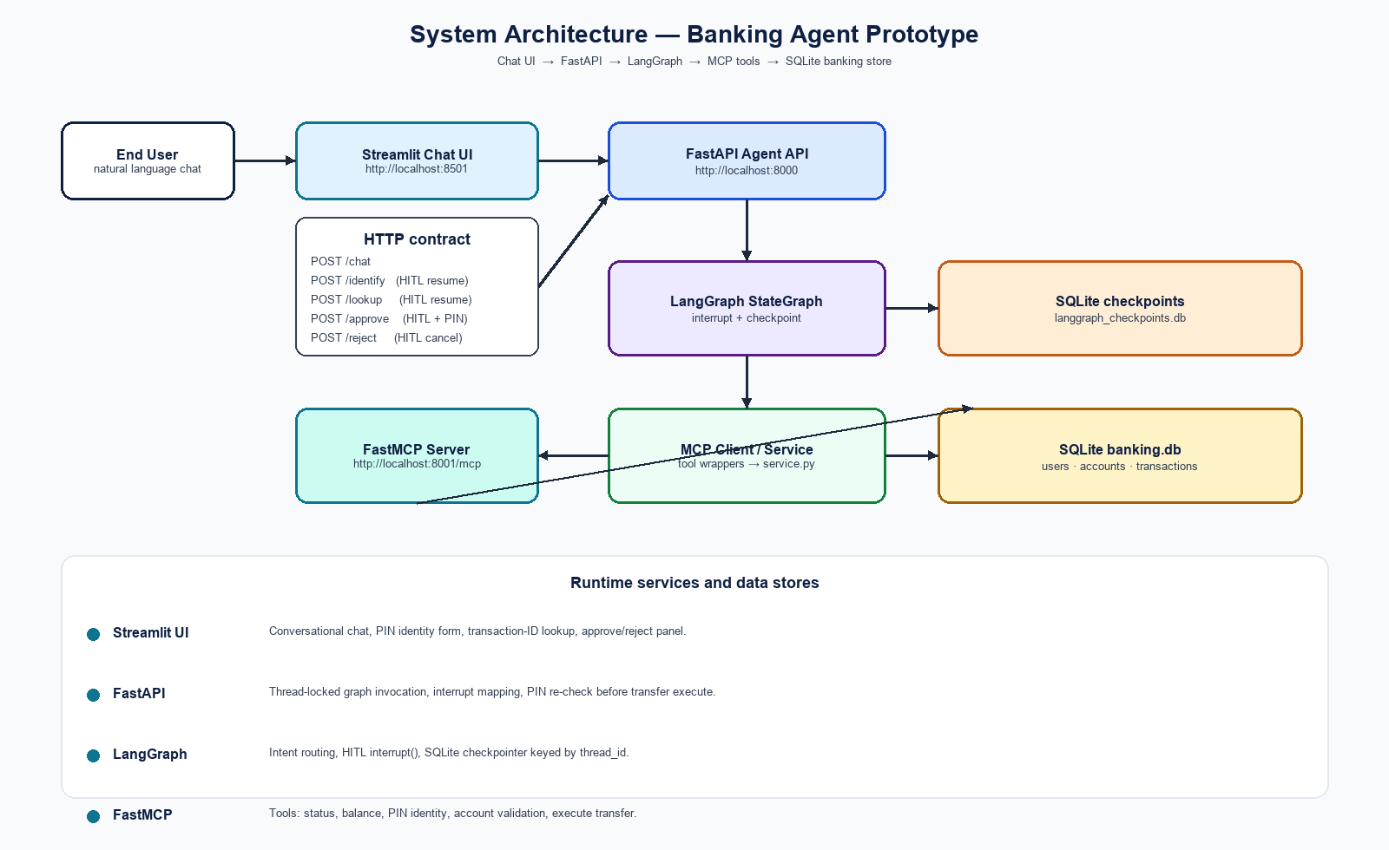
Figure 2. Process topology: Streamlit 8501, FastAPI 8000, FastMCP 8001, two SQLite files.
Process | Start command | Port | Health
API | python run.py api (uvicorn backend.main:app) | 8000 | GET /health
MCP | python run.py mcp (python -m mcp_server) | 8001 | GET /health
UI | python run.py ui (streamlit run streamlit_app.py) | 8501 | browser
All three | python run.py all or make run | 8000 / 8001 / 8501 | as above

3.4 MCP integration model
The FastMCP server (src/mcp_server/server.py) registers five tools against backend.service:
- get_transaction_status(transaction_id) — scenario A.
- get_account_balance(account_id) — balance inquiry.
- validate_account(account_id) — destination must exist for a transfer.
- get_account_by_pin(pin, account_id) — HITL identity.
- execute_transaction(...) — scenario B fund movement.
Graph nodes call src/mcp_server/mcp_client.py, which currently delegates to the same backend.service functions in-process. The HTTP MCP server is still a first-class runnable integration surface (Compose service mcp, port 8001, /mcp) with an identical tool contract. That split keeps the demo reliable (no extra hop on every node) while satisfying “MCP server integration” as an inspectable service. MCP_BASE_URL is configured for UI/Compose wiring.

3.5 Configuration
Variable | Default | Consumed by
API_BASE_URL | http://localhost:8000 | Streamlit HTTP client
MCP_BASE_URL | http://localhost:8001 | Environment / Compose UI service
BANKING_DB_PATH | data/banking.db | database_db.py, both API and MCP
CHECKPOINT_PATH | data/langgraph_checkpoints.db | graph.app init_runtime_graph
PYTHONPATH | src | run.py, Makefile, Docker

3.6 Project layout
Path | Responsibility
src/graph/state.py | AgentState TypedDict
src/graph/nodes.py | All graph node implementations and interrupt() calls
src/graph/routes.py | intent, account, validation, approval routers
src/graph/app.py | StateGraph wiring, compile, AsyncSqliteSaver lifecycle
src/backend/main.py | FastAPI chat + HITL resume endpoints
src/backend/service.py | PIN, lookup, atomic transfer
src/backend/database_db.py | DDL, seed, ensure_db
src/mcp_server/server.py | FastMCP tools and /health
src/mcp_server/mcp_client.py | Tool wrappers used by graph nodes
src/ui/streamlit_app.py | Chat UI and HITL forms
src/config.py | Paths and base URLs
run.py / Makefile / docker-compose.yml | Local and container entrypoints
langgraph.json | Studio graph pointer (src/graph/app.py:graph)
README.md | Setup, run, demo accounts, example chat

3.7 Packaging and deployment
pyproject.toml names the project banking-agent 1.0.0 and exposes console scripts banking-api, banking-ui, and banking-mcp. The Dockerfile is python:3.12-slim, installs requirements.txt, and defaults to the API. Compose builds one image and runs three containers sharing ./data so API and MCP see the same banking.db. The UI container points API_BASE_URL at http://api:8000.

4. LangGraph Architecture

4.1 Design principle
The graph is a directed workflow over AgentState. START always enters conversation_agent. Banking work is gated by set_user_account. Risky work (a transfer) is gated again by approval. Every path terminates in final_response, which writes an AIMessage and the answer string the API returns to Streamlit. There is no unbounded agent loop: tools are called from specific nodes, not from a free ReAct planner.

4.2 Workflow diagram
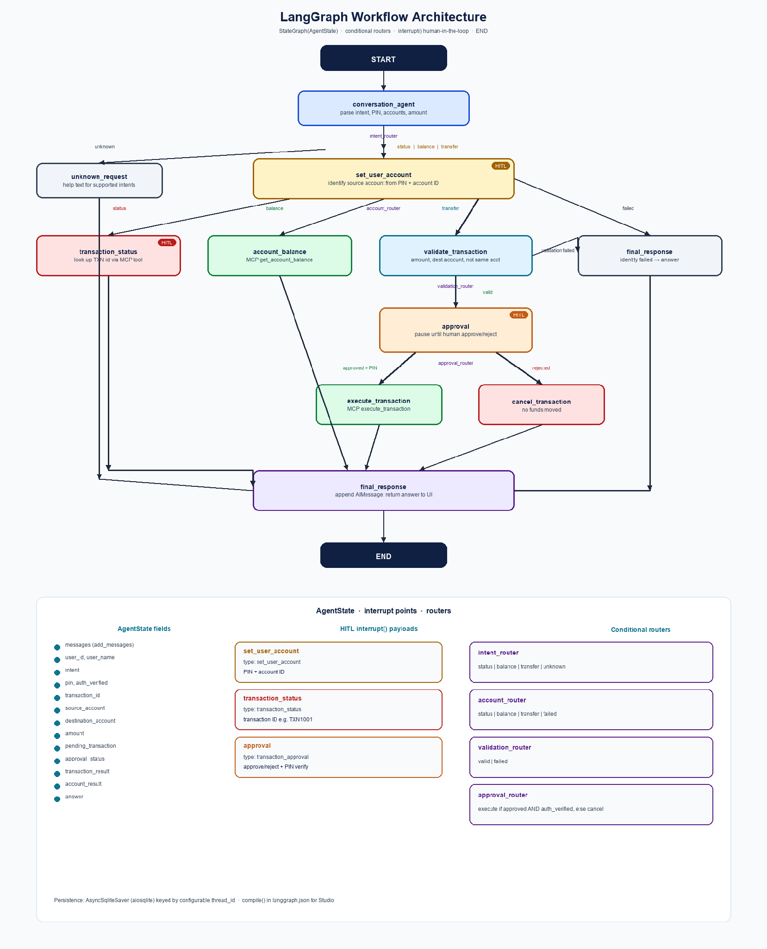
Figure 3. LangGraph nodes, conditional routers, HITL interrupts, and END.

4.3 AgentState
Defined in src/graph/state.py as a TypedDict (total=False). messages uses the add_messages reducer so each turn appends rather than replacing history. Other fields are overwritten by node return dicts (LangGraph’s default channel behaviour).
Field | Type | Set by | Used for
messages | list[BaseMessage] | API input + final_response | Latest user text; UI history also kept in Streamlit
intent | str | conversation_agent / failures | Routers
pin | str | None | parser or identity resume; then cleared | Identity only; not kept after success
user_id / user_name | str | set_user_account | Ownership checks and created_by
source_account | str | identity / text “from ACCxxx” | Debit account and status scoping
destination_account / amount | str / float | transfer parse | Validation and pending snapshot
transaction_id | str | parse or lookup resume | Status scenario
pending_transaction | dict | validate_transaction | HITL panel + execute payload
approval_status | str | approval_node | approved | rejected
auth_verified | bool | identity and /approve resume | Gate execute_transaction
transaction_result / account_result | dict | status / balance / execute | Structured results
answer | str | almost every terminal node | User-visible reply

4.4 Nodes
Node | Responsibility | May pause?
conversation_agent | Lowercase latest message; detect status / balance / transfer / unknown; extract TXN id, amount, destination, optional PIN and from-account. | No
set_user_account | If source_account and user_id already set, no-op. Else interrupt for PIN + account ID, call mcp_get_account_by_pin, handle lock/mismatch. | Yes — set_user_account
transaction_status | Interrupt for TXN id, mcp_get_transaction_status, ensure the account is party to the payment, format ₹ status sentence. | Yes — transaction_status
account_balance | mcp_get_account_balance; ensure user_id owns the account; format balance sentence. | No
validate_transaction | amount > 0, source ≠ dest, mcp_validate_account, dest ACTIVE; build pending_transaction PENDING_ + 8 hex. | No
approval | interrupt with the pending snapshot; map resume approved flag and auth_verified. | Yes — transaction_approval
execute_transaction | Refuse if not auth_verified; mcp_execute_transaction; return TXN id and amount or error message. | No
cancel_transaction | Clear pending_transaction; say no money was transferred. | No
unknown_request | List the three supported capabilities. | No
final_response | Wrap answer in AIMessage; this is the single sink before END. | No

4.5 Routers (conditional edges)
All routers are pure functions of AgentState in src/graph/routes.py.
Router | After node | Outcomes
intent_router | conversation_agent | status/balance/transfer → set_user_account; else unknown_request
account_router | set_user_account | account_setup_failed → final_response; else status | balance | transfer branch
validation_router | validate_transaction | validation_failed → final_response; else approval
approval_router | approval | execute only if approval_status==approved AND auth_verified; else cancel

4.6 Human-in-the-loop protocol
LangGraph interrupt(payload) raises a pause. FastAPI get_graph_interrupt() reads state.interrupts (and falls back to state.next / pending_transaction). interrupt_http_response() maps payload type to a stable HTTP status the UI already understands.
Graph interrupt type | HTTP status | UI surface | Resume API
set_user_account | pin_required | Identify your account (account ID + PIN) | POST /identify → Command(resume={pin, account_id})
transaction_status | txn_id_required | Transaction status (TXN id) | POST /lookup → Command(resume={transaction_id})
transaction_approval | approval_required | From / To / Amount / pending id + PIN | POST /approve (verify_pin then resume approved) or POST /reject

Approve is stricter than identity: FastAPI calls verify_pin(user_id, pin) before resuming. A bad PIN returns HTTP 401 and does not resume the graph, so the pending transfer stays paused. Three failures lock the user. Reject resumes with approved=False and auth_verified=False, which the approval_router sends to cancel_transaction.

4.7 Persistence and concurrency
- init_runtime_graph() opens aiosqlite on CHECKPOINT_PATH, AsyncSqliteSaver.setup(), compile(checkpointer=…).
- get_graph() is used only after init; FastAPI lifespan closes the connection on shutdown.
- langgraph.json compiles a checkpointer-free graph for Studio; runtime replaces it when the API starts.
- thread_locks[thread_id] serializes chat/identify/lookup/approve/reject for one conversation.
- Streamlit New Conversation mints a new UUID so the next chat cannot resume a previous pending transfer.

4.8 FastAPI as the graph adapter
POST /chat always starts or continues with a user message. If the graph is already waiting on an interrupt, a new chat message is a new ainvoke input on that thread; in normal demo use the UI disables overlapping forms by session flags (awaiting_pin, awaiting_txn_id, pending_transaction).
GET /threads/{thread_id} returns a redacted snapshot (user_id, source_account, approval_status, pending_transaction, next_nodes) for debugging. PIN hashes and pin_hash are never returned.

4.9 End-to-end path — scenario A (status)
- User: “What is the status of my transaction?”
- conversation_agent sets intent=status (and TXN id if present in text).
- intent_router → set_user_account. If no PIN/account in text, interrupt pin_required.
- UI POST /identify. mcp_get_account_by_pin; state gets user_id, source_account, auth_verified.
- account_router → transaction_status. Interrupt txn_id_required.
- UI POST /lookup with TXN1001. MCP get_transaction_status. Party check vs source_account.
- final_response: “Transaction TXN1001 for ₹5,000.00 is currently SUCCESS.”

4.10 End-to-end path — scenario B (new transaction)
- User: “Transfer 2500 to ACC002” (optional “pin 1234 from ACC001”).
- conversation_agent sets intent=transfer, destination_account=ACC002, amount=2500.
- Identity HITL as in scenario A if not already on the thread.
- validate_transaction: not same account, dest exists and ACTIVE, amount > 0.
- pending_transaction status PENDING_APPROVAL; approval interrupt.
- UI shows from/to/amount. Approve with PIN → verify_pin → resume approved+auth_verified.
- execute_transaction → transfer_money (atomic). Answer includes new TXN id and amount.
- Reject → cancel_transaction; balances unchanged.

5. Problem Solved and Solution

5.1 Problems the prototype addresses
A naïve chatbot that “just calls a transfer API” is unsafe: it can mis-parse amount or destination, skip identity, and move money without the customer seeing a confirmation. A naïve scripted form is safe but is not an agentic conversational workflow. The task sits between those extremes.
Problem | What goes wrong without a designed agent | Solution in this prototype
Ambiguous natural language | Wrong intent or slots; accidental transfer | Narrow regex intents; unknown falls through to help; validation before pending
Acting without identity | Status or payment on the wrong customer | Shared set_user_account gate with PIN + account ID
Irreversible payments | Funds leave before the user confirms | interrupt() approval node; execute only after PIN re-check
Lost pauses | HITL form cannot resume after refresh/process restart | SQLite checkpointer keyed by thread_id
Double submit | Two approve clicks post twice | idempotency_key + existing-row short circuit in transfer_money
Tool sprawl | SQL embedded in the UI or graph | MCP tool contract + service.py as the only writer
Demo friction | Needs a live bank and an LLM key | Mock SQLite, deterministic parser, one-command run.py all

5.2 Solution architecture (summary)
The solution is a three-process prototype. Streamlit is the human interface. FastAPI is the durable session façade. LangGraph is the policy engine: classify, identify, branch, pause, validate, execute or cancel. FastMCP exposes the same banking capabilities as tools. SQLite holds mock customers and posted payments. A second SQLite file holds paused graphs.
Human-in-the-loop is not a UI-only confirm button glued on afterwards. It is a graph primitive. Until Command(resume=…) arrives, execute_transaction is unreachable. That is the essential control for “potentially risky actions before execution.”

5.3 Scenario A — check status of an existing transaction
Business goal: a signed-in customer learns whether a known payment settled. Demo datum: TXN1001.
- Control: identity first, so a user cannot probe arbitrary TXN ids for unrelated accounts.
- Control: explicit TXN id collection (HITL), even if the model/parser already guessed one.
- Control: source_account must be source or destination on the row.
- Outcome: a single sentence with id, amount, and status — no side effects.

5.4 Scenario B — initiate a new transaction
Business goal: move INR from the caller’s account to another mock account, only after review.
- Parse: transfer|send|pay + amount + ACCxxx destination.
- Validate: positive amount, not self-pay, destination exists and ACTIVE.
- Pending snapshot is graph state only — not a posted ledger row — until execute.
- HITL panel shows from, to, amount, pending id.
- Approve: PIN must match the identified user; then MCP execute_transaction.
- Reject or missing auth_verified: cancel_transaction, zero movement.
- Insufficient funds and inactive accounts fail inside transfer_money with a message.

5.5 Safety properties actually implemented
- PIN at rest: bcrypt. PIN in graph: wiped after successful identity (pin: None).
- Approve PIN is verified in the API, not trusted from the client alone.
- Account lock after three failed approve attempts.
- Thread lock around graph ainvoke to avoid two resumes corrupting one checkpoint.
- BEGIN IMMEDIATE transfer; rollback on failure.
- Foreign keys enabled on banking.db.
- GET /threads does not expose pin_hash or raw PIN.

5.6 What was intentionally simple
The conversation_agent is not an LLM. That keeps the evaluation reproducible and the setup offline. MCP client calls are in-process wrappers onto the same service the FastMCP server uses, rather than a networked MCP session from each node. There is no anti-money-laundering engine, no daily limit table, and no multi-step beneficiary management. Those omissions are prototype scope, not oversights relative to the written task.

6. Conclusion

6.1 Summary
The Banking Agent prototype is a complete, runnable answer to the assigned task. A Streamlit chat UI talks to a FastAPI adapter, which drives a LangGraph StateGraph. The graph identifies the customer, branches on intent, pauses for humans at identity, transaction-ID, and payment approval, and only then calls banking tools. Mock SQLite data supports looking up TXN1001 and creating new SUCCESS transfers between ACC001 and ACC002. Setup is documented in README.md; python run.py all starts the three services.

6.2 Task coverage
Asked for | Delivered
Python prototype + agentic framework | LangGraph 1.0.0 banking-agent package
Conversational agent workflow | StateGraph from START through final_response/END
MCP server integration | FastMCP on :8001 with five banking tools
HITL before risky actions | interrupt() approval + PIN verify before execute
Basic chat UI connected to the agent | Streamlit on :8501 → FastAPI /chat and resume APIs
Mock data | Two users, two accounts, TXN1001
Check existing transaction status | status intent + lookup HITL + MCP tool
Initiate a new transaction | transfer intent + validate + approve/reject + atomic post
Runnable code and setup instructions | venv, run.py, Makefile, Docker Compose, README
Recorded video demo | To be captured from the running UI using the README script

6.3 Limitations (honest prototype boundary)
- Intent parsing is keyword/regex based; unusual phrasing falls through to unknown_request.
- Balances are REAL columns, not integer minor units — fine for a demo, not for production money.
- No authentication cookie or session JWT; thread_id is the conversation key.
- MCP HTTP tools and graph nodes share code but are not forced through a single network client.
- Seed INSERT OR IGNORE will not restore original ₹100,000 after demo transfers; delete data/*.db to reset.

6.4 Closing
The design treats a bank transfer as a governed workflow: understand the request, prove who is asking, check the payment is legal in mock-bank terms, stop for a human, then post exactly once. That is the problem the task asked to solve, and that is what the LangGraph prototype implements.
This document describes the codebase as it exists. No application source files were changed to produce it.

Appendix A. Setup and run
Copied in condensed form from the project README so this document is self-contained.
Python 3.11+ is required.
python3 -m venv .venv && source .venv/bin/activate && pip install -r requirements.txt && cp .env.example .env
python run.py all
Service | URL
Streamlit UI | http://localhost:8501
FastAPI | http://localhost:8000
MCP tools | http://localhost:8001/mcp

Open http://localhost:8501 to chat. Use New Conversation between demo examples.
Docker alternative: make docker-up (API 8000, MCP 8001, UI 8501).

Appendix B. Source map of files reviewed
All project files were reviewed to write this document. Application code was not edited.
File | Reviewed for
README.md | Task framing, demo script, ports
pyproject.toml / requirements.txt | Dependencies and package metadata
run.py / Makefile / Dockerfile / docker-compose.yml | Run and deploy
langgraph.json / .env.example / src/config.py | Studio pointer and configuration
src/graph/* | State, nodes, routers, compile, checkpointer
src/backend/* | API, service rules, DDL, seed
src/mcp_server/* | FastMCP tools and client wrappers
src/ui/* | Chat UI and HITL forms

