Event Sync Service
Take-Home Assessment Solution & AWS Production Architecture
Repository reviewed: NarendiranT/fsd-take-home-assessment
github.com/NarendiranT/fsd-take-home-assessment
Purpose
Document the completed implementation, explain the reconciliation decisions, show how live file updates work, and propose a production-ready AWS evolution using event-driven ingestion.

Implementation status: completed assessment solution
Production section: proposed target architecture

Contents
- 1. Executive Summary
- 2. Task and Requirements
- 3. Implemented Solution Overview
- 4. Current Application Architecture
- 5. Backend Design
- 6. Reconciliation and Conflict Logic
- 7. Frontend Design
- 8. Live Updates, Observability, and Tests
- 9. My Contribution
- 10. Current Trade-offs and Submission Notes
- 11. Production Goals
- 12. AWS Production Architecture
- 13. Event-Driven Data Ingestion
- 14. Reliability, Idempotency, and Failure Handling
- 15. Security and Observability
- 16. Scaling Strategy
- 17. Suggested Migration Plan
- 18. Interview-Ready Explanation
- 19. References

1. Executive Summary
The Event Sync Service combines meeting data from two upstream systems - a CRM export and a Calendar export - into a single user-facing meeting list. The difficult part is not reading two JSON files; it is deciding which records refer to the same real-world meeting when there is no shared identifier, values are inconsistent, timestamps differ, duplicate events exist, and some fields are missing or malformed.
The completed repository implements that workflow with a Python/FastAPI backend and a lightweight HTML/CSS/JavaScript frontend. The backend separates ingestion, normalization, matching, and reconciliation. The frontend presents source provenance and conflicts side-by-side, supports search/filter/pagination, and refreshes automatically when either source file changes.
Key architectural idea
Matching and conflict detection are deliberately separate concerns. Two records can be confidently identified as the same meeting while still preserving different values from CRM and Calendar. That makes disagreements visible instead of silently overwriting one system with the other.

2. Task and Requirements
The assessment asks for an Event Sync Service that ingests CRM and Calendar data, reconciles records that refer to the same meeting, exposes the unified list through a REST API, and provides a simple frontend where the user can see data provenance and conflicts.
Requirement | Implementation
Ingest both data files | Reads data/crm_events.json and data/calendar_events.json.
Reconcile the same real-world meeting | Normalizes source-specific fields, de-duplicates calendar rows, scores CRM/Calendar candidates, and creates one-to-one pairs.
Keep source-only meetings | Unmatched CRM and Calendar records remain in the unified list.
Expose REST API | GET /api/meetings returns the reconciled list.
Show conflicts | Each field contains crm, calendar, and conflict values; the UI highlights conflicting meetings and shows both values.
Simple frontend | Single-page HTML/CSS/JS interface with search, source/status filters, pagination, and a detail panel.
Single-command startup | python3 run.py; Docker Compose is also supported.
AI transparency | AI_NOTES.md documents planning and implementation decisions.

3. Implemented Solution Overview
Area | Technology / behavior
Backend | Python 3.12, FastAPI, Uvicorn, Pydantic
Frontend | HTML, CSS, JavaScript ES modules; no frontend build step
Local data | Two JSON source files under data/
Reverse proxy / container run | nginx in Docker; run.py for local single-command startup
Realtime refresh | Server-Sent Events (SSE) through GET /api/events
Observability | JSON request/reconcile logs, /health, Prometheus-format /metrics
Testing | pytest backend tests and a lightweight frontend format self-check
Persistence | No database in the assessment implementation; results are rebuilt from source files
The design intentionally avoids unnecessary infrastructure for a small take-home assignment. The source files remain the source of truth, and GET /api/meetings rebuilds the reconciled view from those files.

4. Current Application Architecture
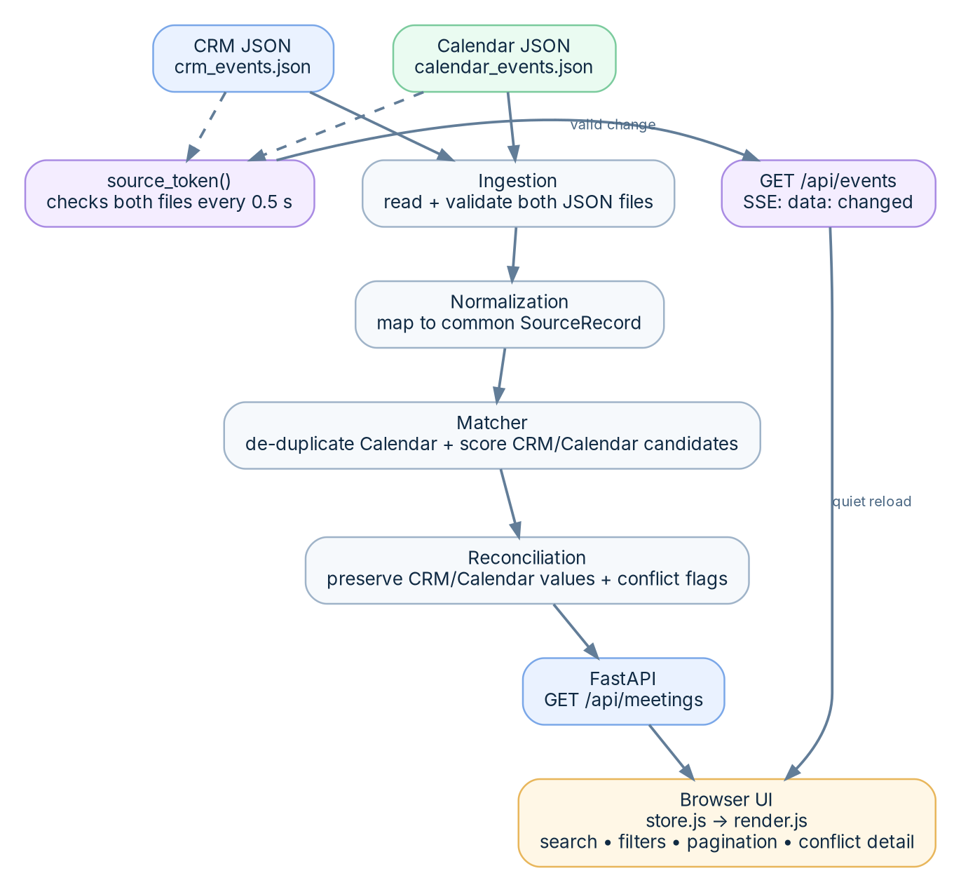
Figure 1. Current repository architecture.
Request path: ingestion reads both files, normalization maps them into one internal SourceRecord shape, matcher pairs records, reconciliation produces source-aware field values and conflict flags, and FastAPI returns the result. On the frontend, store.js owns application state and render.js redraws the UI from that state.

5. Backend Design

5.1 Ingestion
services/ingestion.py reads exactly two configured source files. source_token() also reads both files and only returns a change token when both contain valid JSON. This protects the live-update stream from reacting to half-written saves.
SOURCE_FILES = ("crm_events.json", "calendar_events.json")
def load_sources(data_dir):
return tuple(json.loads(_read(data_dir, name)) for name in SOURCE_FILES)

5.2 Normalization
services/normalization.py converts source-specific fields into SourceRecord. CRM records derive client/company/owner keys; Calendar records derive people from organizer and attendee email addresses. The normalizer also repairs selected malformed inputs, trims empty values, handles timezone conversion to America/New_York, and treats missing CRM time as a known date with an unknown time.
- Calendar email values containing "[at]" are repaired to "@" before matching.
- Company tokenization drops common terms such as capital, group, partners, investments, and holdings to reduce weak matches.
- Malformed or missing date/time values are converted to None rather than crashing the entire pipeline when possible.

5.3 API contract
GET /api/meetings returns a MeetingList. Each meeting has an id, source (crm, calendar, or both), conflict_count, and source-aware fields including title, when, who, location, status, notes, and ids.
{
"id": "CRM-1002+CAL-A2",
"source": "both",
"conflict_count": 1,
"location": {
"crm": "In-Person",
"calendar": "Zoom",
"conflict": true
}
}

6. Reconciliation and Conflict Logic
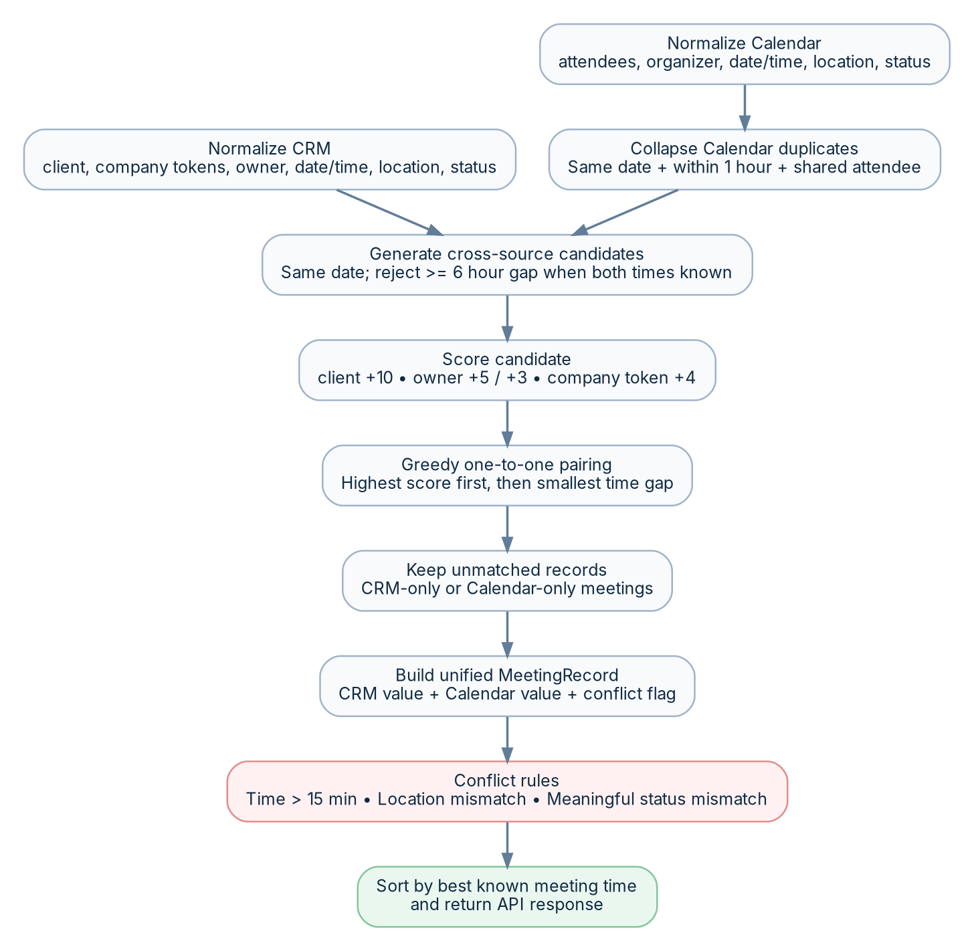
Figure 2. Reconciliation flow derived from the matcher and reconciliation services.

6.1 Duplicate handling
Before cross-source matching, Calendar records are collapsed when they occur on the same date, start within one hour of each other, and share at least one attendee email. When duplicates are combined, IDs are preserved, attendee/person sets are unioned, the earliest start and latest end are kept, and longer descriptive values are preferred where appropriate.

6.2 Cross-source matching
Rule | Behavior
Date gate | CRM and Calendar candidates must be on the same date.
Time gate | When both times are known, candidates six hours or more apart are rejected.
Client match | CRM client key appearing in Calendar people adds 10 points.
Owner exact match | CRM owner key equals Calendar organizer key adds 5 points.
Owner participant match | CRM owner appearing among Calendar people adds 3 points when exact organizer match is absent.
Company/title overlap | A meaningful CRM company token appearing in Calendar title adds 4 points.
Selection | Candidates are sorted by highest score and then smallest time gap; each CRM and Calendar record can be paired once.
Unmatched records | Records not selected in a pair remain as CRM-only or Calendar-only meetings.

6.3 Conflict semantics
Field | Current behavior
Time | A matched meeting is marked conflicting when known start times differ by more than 15 minutes.
Location | Exact normalized equality is accepted. Containment such as "Conference Room B" inside "HQ - Conference Room B" is also accepted; otherwise conflict is true.
Status | Different active statuses (completed, confirmed, scheduled) are treated as compatible. Other meaningful differences are conflicts.
Missing value | When only one source has a value, it is preserved without automatically marking a conflict.
Provenance | Both source values are retained; the UI does not silently discard the losing value.
Why this is strong for the assessment
The solution makes assumptions explicit in code instead of pretending the data has a perfect shared key. It also keeps source provenance, which is essential when users need to understand why a unified record looks the way it does.

7. Frontend Design
The frontend intentionally uses plain JavaScript modules rather than a framework. main.js subscribes the renderer to one state store, performs the initial load, and starts the live-update listener. This keeps the UI small while still giving it clear state ownership.
Capability | Implementation
Meeting list | Table with client/title, date/time, location, sources, and conflict status.
Search | Searches client, title, and attendee-oriented data.
Filters | Source filter: All / CRM / Calendar. Status filter: All / Has conflicts / No conflicts.
Pagination | Client-side pagination; 8 rows per page.
Detail panel | Displays selected meeting metadata, attendees, conflict cards, and CRM/Calendar field details side-by-side.
Accessibility basics | Rows are keyboard-selectable and include aria-selected/aria-label; conflict controls expose aria-expanded.
Realtime refresh | EventSource listens to /api/events and reloads meeting data quietly on change.

7.1 Frontend state model
state = {
meetings, status, error, selectedId,
query, source, conflict, view,
openConflict, page
}
A useful design choice is that a quiet refresh replaces the meeting list while preserving filters, selection when possible, and page state. The UI therefore updates without a disruptive loading flash.

8. Live Updates, Observability, and Tests

8.1 Live update flow
1. The frontend opens GET /api/events using EventSource.
2. The backend compares the text of both source files approximately every 0.5 seconds.
3. If either source changes and both files parse as valid JSON, the backend emits data: changed.
4. The frontend quietly calls GET /api/meetings again.
5. If a file is temporarily half-written, the event is suppressed until valid JSON is available again.

8.2 Observability
observe.py adds request IDs, JSON logs, reconciliation counters, a /health endpoint, and Prometheus-text /metrics. Current metrics include request totals, reconcile count, latest meeting/conflict count, reconciliation duration, and detected source changes.

8.3 Tests
The repository includes focused backend tests rather than chasing coverage percentage. Tests verify that source changes are detected, broken JSON suppresses file-change tokens, Calendar duplicates collapse into one meeting, a known location disagreement is marked as a conflict, date normalization works for a sample record, and a CRM-only record remains in the list.

9. My Contribution
I designed and implemented the Event Sync Service end to end, with the primary engineering focus on reconciliation rather than visual styling.
- Defined the application architecture and separated ingestion, normalization, matching, reconciliation, API, and frontend responsibilities.
- Implemented normalization rules to make inconsistent CRM and Calendar values comparable.
- Designed the matching algorithm for records that have no shared cross-system ID.
- Implemented duplicate Calendar event handling and preservation of all involved source IDs.
- Implemented source-aware conflict handling so conflicting values remain visible instead of being overwritten.
- Built the FastAPI REST endpoint and the Server-Sent Events change stream.
- Built the single-page frontend with search, filters, pagination, selected-record details, source badges, and conflict views.
- Added health checks, structured logs, metrics, Docker support, and focused tests.
- Documented the design process and AI-assisted planning in AI_NOTES.md.

10. Current Trade-offs and Submission Notes
Observation | Assessment impact / recommendation
Reconciliation is rebuilt on every GET /api/meetings | Good simplicity for small sample data. In production, persist/materialize the reconciled view.
SSE detects changes by polling files every 0.5 seconds | Good for a local assessment. Replace with event-driven upstream notifications in production.
No database or authentication | Reasonable because neither is required by the brief. Add both in a production deployment.
CORS allows all origins | Convenient locally. Restrict to the production web origin.
Frontend Owner is currently displayed as "-" | If owner display is important for evaluation, expose a normalized owner field in the API and render it.
Matching accepts any positive candidate score | Works for the supplied dataset, but production should add a minimum confidence threshold and an "unresolved" state for ambiguous matches.
README Time spent section still says "Fill this in before you submit" | Fill this with the real time spent before final submission; the problem statement explicitly requests it.

11. Production Goals
Moving this assessment into production changes the main constraint: local JSON files and process-local state can no longer be the integration boundary. The target design should accept events from real CRM and Calendar systems, make processing durable and replayable, preserve raw inputs for audit, isolate failures, support horizontal scaling, and serve a persistent reconciled view.
- Event-driven ingestion instead of file polling.
- At-least-once processing with explicit idempotency.
- Durable raw-event archive and normalized source-record storage.
- Dead-letter handling and replay for malformed or repeatedly failing records.
- Materialized reconciled meetings for fast API reads.
- Secure public frontend delivery with private backend/data services.
- Centralized logs, metrics, traces/alarms, and operational dashboards.

12. AWS Production Architecture
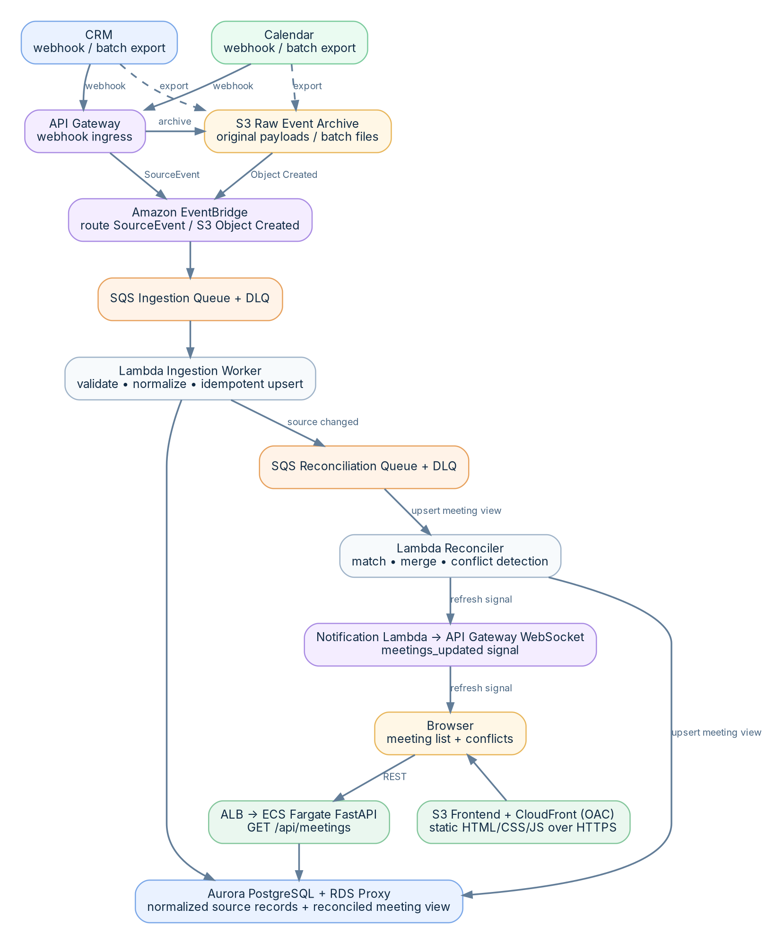
Figure 3. Proposed AWS production architecture with event-driven source ingestion.
This target architecture preserves the repository's conceptual pipeline - ingest, normalize, match, reconcile, serve - but makes every integration boundary durable and independently scalable. It supports both webhook/API ingestion and file-based batch exports.
Layer | AWS service | Responsibility
Frontend | Amazon S3 + CloudFront + Origin Access Control | Hosts static HTML/CSS/JS privately in S3 and serves it globally over HTTPS through CloudFront.
API | Application Load Balancer + ECS Fargate | Runs the FastAPI application as containers and serves read APIs such as GET /api/meetings.
Webhook ingress | Amazon API Gateway | Receives CRM/Calendar webhook notifications and authenticates/throttles the external integration boundary.
Raw archive | Amazon S3 | Stores the original payload/file before transformation for replay, audit, and troubleshooting.
Event routing | Amazon EventBridge | Routes source-created/source-updated events without coupling upstream producers to processors.
Durable buffering | Amazon SQS + DLQ | Absorbs bursts, isolates processors from producers, retries transient failures, and retains poison messages in a DLQ.
Processing | AWS Lambda | Validates, normalizes, and reconciles source events. Small event-driven workloads fit this execution model well.
Database | Amazon Aurora PostgreSQL + RDS Proxy | Stores normalized source rows, matching metadata, conflict/provenance history, and the reconciled meeting read model.
Realtime notification | API Gateway WebSocket API | Pushes a lightweight meetings_updated signal; the browser then reloads the REST view.
Operations | Amazon CloudWatch | Central logs, metrics, alarms, and dashboards for API and event-processing health.
Secrets/encryption | AWS Secrets Manager + AWS KMS | Protects credentials and encryption keys; IAM roles provide least-privilege service access.

13. Event-Driven Data Ingestion

13.1 Two supported ingress paths
Path A - webhook/API event: a CRM or Calendar system sends a change to API Gateway. The ingress function validates authentication, stores the raw payload in S3, and publishes a small event envelope to EventBridge.
Path B - file/batch event: an upstream export lands in the raw S3 bucket. S3 Object Created events are delivered to EventBridge, which routes the object reference into the same ingestion queue. This is the production equivalent of the assessment's watched JSON files, but no application process polls the filesystem.

13.2 Canonical event envelope
{
"event_id": "uuid",
"source": "crm",
"event_type": "meeting.updated",
"source_record_id": "CRM-1002",
"source_version": "2026-10-01T14:12:01Z",
"occurred_at": "2026-10-01T14:12:01Z",
"payload_ref": "s3://event-sync-raw/crm/...json"
}
The event envelope carries routing and idempotency metadata; the raw payload stays in S3. Keeping events small reduces repeated payload transfer and creates an immutable replay source.

13.3 Processing sequence
1. EventBridge applies source/type rules and sends the event to the ingestion SQS queue.
2. Lambda consumes the queue, fetches the raw payload when required, validates and normalizes the record.
3. The normalized source record is conditionally upserted into Aurora using source + source_record_id + version/idempotency key.
4. A source-record-changed message is placed on the reconciliation queue.
5. The reconciliation worker queries only plausible candidates (for example same meeting date plus indexed client/owner keys), runs the existing matching/conflict rules, and upserts the unified meeting view.
6. After a successful materialized-view update, a notification function sends meetings_updated to connected WebSocket clients.
7. The browser calls GET /api/meetings to obtain the new authoritative view.

14. Reliability, Idempotency, and Failure Handling
SQS/Lambda delivery is at least once, so duplicate delivery must be assumed. The processor therefore needs idempotent writes rather than relying on exactly-once delivery.
Concern | Production treatment
Duplicate event | Use event_id or source/source_record_id/source_version as an idempotency key. Ignore an event already applied.
Out-of-order event | Store source version/updated_at and reject stale updates with a conditional write or transaction.
Transient downstream failure | Let SQS visibility timeout and Lambda retry behavior handle retries; use exponential backoff for explicit external API calls.
Poison event | After configured receives, move to a DLQ; alarm on DLQ depth and provide a controlled replay process.
Partial batch failure | Report only failed SQS batch items so successfully processed events are not unnecessarily retried.
Ambiguous match | Persist an unresolved/needs-review state instead of forcing a weak match below a production confidence threshold.
Reprocessing | Raw payloads in S3 allow rebuilding normalized and reconciled state when matching rules change.
Database/API outage | Queue buffers ingestion independently; the read API can continue serving the last committed reconciled view when processing is temporarily delayed.

15. Security and Observability

15.1 Security
- Keep the frontend S3 bucket private and allow reads through CloudFront Origin Access Control.
- Terminate HTTPS at CloudFront/ALB/API Gateway and use ACM-managed certificates.
- Run ECS tasks and the database in private subnets; expose only the load balancer/API Gateway publicly.
- Restrict CORS to the actual frontend domain instead of allow_origins=["*"].
- Use IAM roles for service-to-service access and Secrets Manager for CRM/Calendar credentials.
- Encrypt S3, SQS, database storage, and sensitive secrets with AWS-managed or customer-managed KMS keys as appropriate.
- Validate webhook signatures and enforce rate limits/WAF rules at the edge where required.

15.2 Observability
The current application already establishes useful concepts - request IDs, JSON logs, health checks, reconciliation duration, meeting/conflict counts, and source-change counts. In AWS these should be centralized in CloudWatch and expanded with event-processing metrics.
- API: request rate, p50/p95/p99 latency, 4xx/5xx rate, ECS task health, ALB target health.
- Queues: ApproximateAgeOfOldestMessage, visible message count, DLQ message count.
- Lambda: errors, duration, throttles, concurrency, partial batch failures.
- Reconciliation: records processed, matched/unmatched count, conflicts created, ambiguous matches, reconcile latency.
- Database: connection count, CPU, read/write latency, slow queries, storage.
- Business health: time from upstream change to updated meeting visible in UI.

16. Scaling Strategy
Current assessment behavior | Production evolution
Read and reconcile all files for each API request | Materialize meetings during event processing; API performs indexed database reads.
Client-side pagination of the full list | Server-side pagination, filtering, and search when data volume grows.
Single-process metrics | CloudWatch metrics and centralized logs across all ECS/Lambda instances.
0.5-second file polling per SSE connection | S3/EventBridge/webhooks produce events once; queues distribute work independent of UI connections.
In-memory frontend state only | Frontend remains stateless; durable state lives in the database.
One matching pass over all source rows | Use indexed candidate lookup by date/client/owner and process only affected meetings after an event.
The main scaling improvement is incremental reconciliation: when CRM-1002 changes, production should not rebuild every meeting. It should identify the affected source record, fetch a bounded candidate set, recompute that match, and update only the relevant unified record(s).

17. Suggested Migration Plan
Phase 1 - Containerize current app: Deploy the existing FastAPI container to ECS Fargate behind an ALB and the static frontend to S3/CloudFront. Keep current behavior initially.
Phase 2 - Add durable storage: Introduce Aurora PostgreSQL and write normalized source records + reconciled meetings. Change GET /api/meetings to read the materialized view.
Phase 3 - Event-driven file ingestion: Move source files to S3, enable EventBridge, and route Object Created events to SQS/Lambda. Remove filesystem polling.
Phase 4 - Real integrations: Add API Gateway webhook endpoints or scheduled connector jobs for CRM/Calendar APIs. Normalize all producers into the same canonical event envelope.
Phase 5 - Realtime notifications: Replace local SSE source polling with WebSocket update notifications (or retain SSE behind ALB backed by a shared pub/sub channel).
Phase 6 - Production hardening: Add authentication/authorization, WAF, alarms, DLQ replay, tracing, backups, disaster recovery, and load/failure tests.

18. Interview-Ready Explanation

18.1 60-second explanation of the completed task
I built an Event Sync Service that combines CRM and Calendar meeting data even though the two systems do not share a common ID. I separated the backend into ingestion, normalization, matching, and reconciliation. The matcher first handles duplicate Calendar events and then scores CRM/Calendar candidates using date, time proximity, client, owner, attendees, and company/title signals. Reconciliation keeps both source values and explicitly flags meaningful conflicts instead of silently overwriting data. FastAPI exposes the unified list, and the frontend shows the source and conflict details with search, filters, pagination, and a selected-meeting panel. I also added an SSE update stream so valid changes to either source file refresh the UI automatically, plus health checks, metrics, Docker support, and focused tests.

18.2 How I would explain the production evolution
For production, I would not poll local files or rebuild the entire list on every GET request. CRM and Calendar updates would enter through webhooks or S3 batch drops, publish events through EventBridge, and be buffered in SQS. Lambda workers would validate and normalize events idempotently, persist source records, and trigger incremental reconciliation. The reconciled meeting view would be stored in Aurora PostgreSQL and served by FastAPI on ECS Fargate. The static frontend would be hosted on S3 behind CloudFront, and a WebSocket notification would tell open clients when the meeting view changes. DLQs, CloudWatch alarms, IAM/KMS, and raw S3 retention would make failures observable and replayable.

19. References
Repository reviewed
NarendiranT/fsd-take-home-assessment

Key repository files reviewed
- README.md
- AI_NOTES.md
- backend/app/services/ingestion.py
- backend/app/services/normalization.py
- backend/app/services/matcher.py
- backend/app/services/reconciliation.py
- backend/app/api/meetings.py
- backend/app/observe.py
- frontend/src/store.js
- frontend/src/render.js
- backend/tests/test_reconciliation.py
- backend/tests/test_ingestion.py

AWS documentation used for the proposed production design
Amazon S3 EventBridge integration
S3 EventBridge event structure
Lambda with SQS
SQS event source configuration / DLQ guidance
SQS partial batch error handling
ECS load balancing with Application Load Balancer
CloudFront Origin Access Control for S3
Before submission
Update README.md -> Time spent with the actual duration. If you have time for one small UI/API improvement, expose and render the relationship owner instead of the current dash placeholder.

