1.1 Construct a DFA to accept Binary strings having odd no of 1’s and any number of 0’s

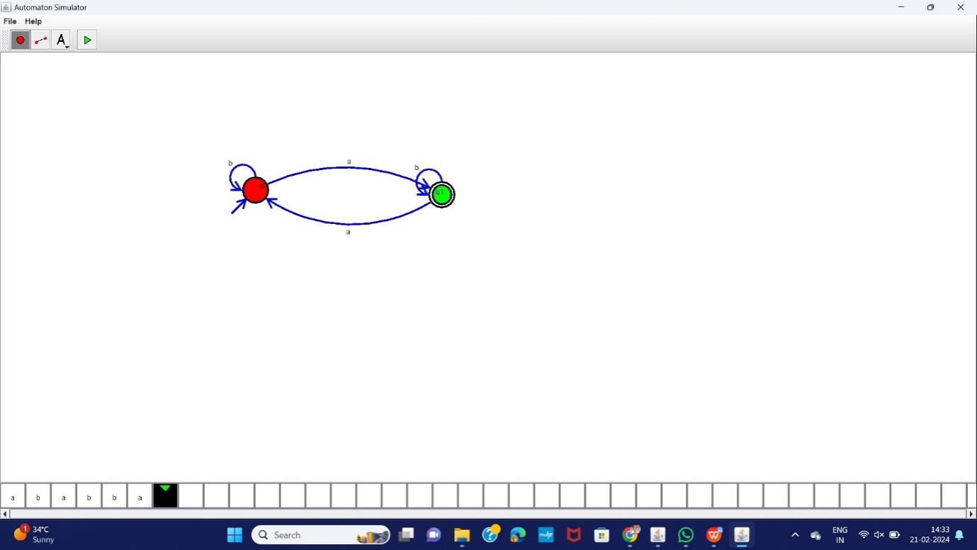

1.2 Construct a DFA binary strings having even no of 0’s and even no of 1’s

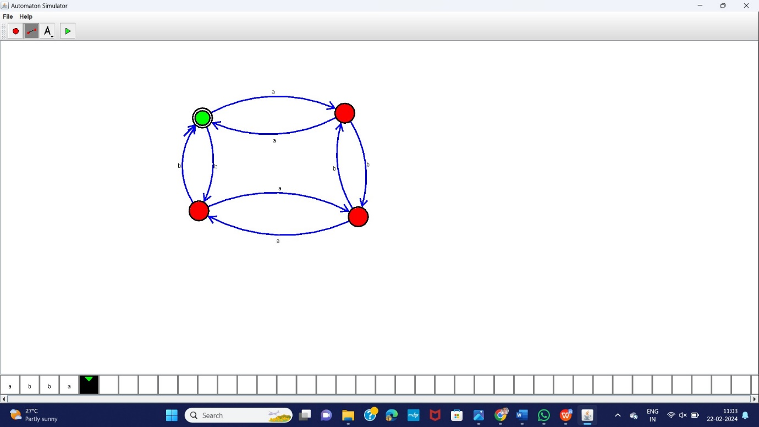

1.3 Construct a DFA Binary strings having the substring 101

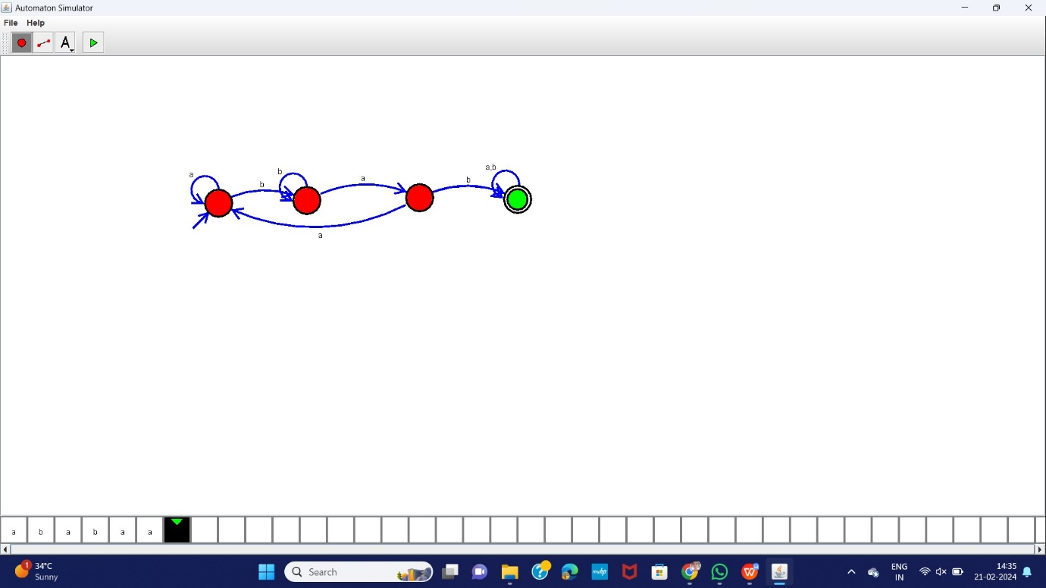

1.4 Binary strings having no consecutive 0’s

