PROJECT REPORT

Student Information and
Academic Performance
Management System
A dual-database academic office built with React, FastAPI, MongoDB, and Apache Cassandra


DEPARTMENT OF COMPUTER SCIENCE & ENGINEERING
JNTUGV-COLLEGE OF ENGINEERING VIZIANAGARAM(A)
JAWAHARLAL NEHRU TECHNOLOGICAL UNIVERSITY-
GURAJADA VIZIANAGARAM [ 2026 ]

SUBMITTED BY
K.Narendra Kumar
23VV1A0526
Computer Science and Engineering
2023-2027
DOCUMENT CONTROL
Document information
This document describes the implemented system, its data model, request paths, and administrative operations. It is written to be read alongside the running application and the source tree in the project workspace.
Table 1. Document identification and submission details.
Field | Value
Project title | Student Information and Academic Performance Management System
Short name | Academic Ledger
Report version | 1.1 (trimmed final)
Prepared by | [Student Name] · [Roll Number]
Programme | [Programme / Branch] · [Semester]
Project guide | [Guide Name] · [Designation]
Institution | [Institution Name]
Academic year | 2025–26
Report date | 31 October 2026
GitHub repository | [Insert GitHub link here]
Runtime stack | React 19.3.1 · FastAPI 0.125.0 · MongoDB · Apache Cassandra 5.0
Seed version | 2025-26.2 (random seed 20260723)
Live demonstration data | 500 students · 2,000 summaries · 10,000 subject results per Cassandra table

How to read this report. Sections 2–4 cover the problem, technology, and architecture. Sections 5–7 cover data, requests, and administrative workflows. Section 8 is the interface walkthrough; Section 9 concludes.

Revision history
Table 2. Revision history for this report.
Version | Date | Change
0.1 | 30 October 2026 | Structure, architecture notes, and screenshot inventory.
0.9 | 31 October 2026 | Implementation verified; tests, benchmark, and live screenshots added.
1.0 | 31 October 2026 | Final consistency pass and figure index.
1.1 | 31 October 2026 | Removed scope, testing, benchmark, security, references, and index; renamed; added GitHub placeholder.

Scope of evidence
Screenshots were captured on 31 October 2026 from the running local application. The live dataset is intentionally not pristine: 24CSE006's Semester 4 CS404 backlog was cleared through the admin workflow, so verification output should not be read as a regression.
NAVIGATION
Table of contents
1. Abstract 4
2. Problem Statement and Objectives 5
3. Technology Stack 5
4. System Architecture 7
5. Data Model and Database Design 8
6. Request Flow and Cross-Store Consistency 10
7. CRUD and Administrative Workflows 13
8. User Interface Walkthrough 19
9. Conclusion 23

1. Abstract
Academic offices need two views of the same truth: a fast, college-wide picture of semester performance and a reliable, subject-level record that can be corrected when necessary. Spreadsheet-based registers make those views difficult to keep aligned. This project implements a student information and academic performance management system that separates identity and derived reporting data from canonical subject results, then composes them at the API boundary.
The client is a React single-page application with three workspaces: Principal, Branch, and Admin. FastAPI provides typed public and administrative endpoints. MongoDB stores student identity, department and subject catalogues, pre-aggregated semester summaries, and the audit log. Apache Cassandra stores 10,000 subject result rows in each of two query-first tables: one partitioned by student and one partitioned by department and semester. A deterministic UUID5 derived from the roll number gives both stores the same student identity without a distributed transaction.
The administrative workflow supports student creation in simulated or manual modes, profile updates, result correction, selected backlog clearance, deletion, and an immutable audit trail. Backlog clearance is preview-first: the service plans replacement passing rows, recomputes all four summaries, writes Cassandra rows, materialises MongoDB summaries, and records the before/after state. The full 21-test suite passed against the seeded dataset. A local benchmark compared the same department-semester pass/fail aggregation in both stores: MongoDB's pre-aggregated summary path had a median of 5.299 ms, while Cassandra's row-grouping path had a median of 30.409 ms, a 5.74x ratio in this topology.
Keywords: MongoDB; Apache Cassandra; polyglot persistence; FastAPI; React; academic records; backlog clearance; audit trail; NoSQL data modelling.

2. Problem Statement and Objectives

2.1 Problem statement
In a typical department, attendance, internal marks, external marks, semester summaries, and backlog lists are maintained in separate spreadsheets or in a single wide table. The consequences are predictable. The same student can have different CGPA values in different files. A backlog cleared in one sheet may remain in a dashboard export. A correction is difficult to trace because the previous value is overwritten. Answering a simple question such as “which CSE students failed CS401 in Semester 4?” requires filtering a large sheet and reconciling it with another file.
The problem is not a lack of data; it is a lack of agreed ownership. Identity data changes rarely and is read as a document. Subject results are row-level facts with a natural partition by student or department-semester. Semester summaries are derived and read many times. An effective system must preserve those distinctions while still presenting one coherent student record. It must also make administrative changes visible, because an academic record is an accountable record.
A second problem is performance transparency. It is easy to claim that a NoSQL design is faster, but the claim depends on what is being measured. A pre-aggregated summary query and a row-grouping query are not the same workload. This project therefore records the operation, the topology, the sample count, and the caveat alongside the result.

2.2 Objectives
- Provide a college-wide Principal workspace with semester metrics, department comparison, and a filterable student register.
- Provide a Branch workspace with department metrics, subject outcomes, failure lists, semester movement, and a student register.
- Assemble one student profile from MongoDB identity and summaries plus Cassandra subject-level results.
- Support admin creation of complete four-semester records in simulated and manual modes.
- Support profile update, result correction, selected backlog clearance, and permanent deletion with an audit trail.
- Keep both stores aligned through deterministic identifiers, explicit write ordering, summary recomputation, and verification scripts.
- Verify behaviour with unit, contract, and live integration tests, and document the measured local performance honestly.

2.3 Engineering questions
The implementation was guided by three questions. First, can a coherent student record be composed from two independent stores without a distributed transaction? Second, which data should be pre-aggregated for dashboards and which should remain row-level for auditability? Third, what does a fair local benchmark reveal when the two stores are deliberately used according to their strengths?

3. Technology Stack
The stack was chosen to keep the API typed and the data model explicit. The frontend is a Vite-built React application with no server-side rendering. The backend is a synchronous FastAPI application with Pydantic response models. MongoDB and Cassandra are both reached through small repositories, so business rules do not leak into database code.
Table 3. Technology stack and versions recorded during verification.
Layer | Technology | Role in the project
Client | React 19.3.1 · React Router 7.18.4 | Workspace routing, profile pages, filters, and admin dialogs.
Build | Vite 8.3.4 · Tailwind CSS 4.3.3 | Development server, production build, and editorial UI styling.
API | Python 3.13.2 · FastAPI 0.125.0 · Uvicorn 0.38.0 | Typed HTTP routes, dependency validation, and ASGI serving.
Contracts | Pydantic 2.12.5 · pydantic-settings 2.12.0 | Request/response models and environment configuration.
MongoDB | PyMongo 4.19.0 | Identity, catalog, summaries, metadata, and audit documents.
Cassandra | cassandra-driver 3.30.1 · Apache Cassandra 5.0 | Canonical subject results in two query-first tables.
Tooling | pytest 9.0.2 · httpx 0.28.1 · Docker Compose | Test suite, API client, and local Cassandra service.
Runtime | Windows 11 · Chrome · MongoDB local | Validated development and screenshot environment.

3.1 Frontend
React was selected for a small, stateful interface with clear route boundaries. The Principal, Branch, Admin, and student-profile routes share components for metrics, status badges, pagination, and feedback. Vite keeps the development loop short and proxies /api to the backend. Tailwind provides the layout primitives, while a small set of custom CSS rules supplies the warm-paper palette, serif display type, ruled tables, and reduced-motion behaviour.
The client deliberately does not duplicate academic calculations. It renders values returned by the API and uses the API's summary fields for sorting and filtering. This keeps the interface consistent with the stored summaries and avoids a second, hidden implementation of CGPA or backlog rules.

3.2 Backend
FastAPI fits the project because the API is dominated by typed reads and a small number of administrative writes. Path and query constraints are declared next to the route, so an invalid semester or page size is rejected before service code runs. Pydantic response models make the JSON contract explicit. The service layer owns validation and orchestration, while repositories contain only database access.
The application is synchronous because both drivers are synchronous and the demo workload is modest. Cassandra's Python driver is imported only after the pyasyncore shim, a Python 3.13 compatibility requirement documented in the project README. Health checks report both databases separately and return a 503 when a required store is unavailable.

3.3 Data stores
MongoDB is used where documents, nested summaries, and flexible audit snapshots are useful. Its aggregation pipeline handles the register filters, faceted pagination, and overview metrics. Its compound indexes lead with semester, matching the dashboard's most common scope.
Cassandra is used where the partition is known. The student table supports one bounded partition read for a profile. The department table supports department, subject, and failure-list queries without ALLOW FILTERING. Identity fields are deliberately duplicated into result rows so that these views do not require a cross-store join. Cassandra does not calculate CGPA; that derived value is materialised in MongoDB.

3.4 Verification tooling
pytest covers domain rules and live API contracts. Integration tests skip unless RUN_INTEGRATION=1, which prevents a normal local run from failing when the databases are not seeded. httpx provides the test client. The benchmark is a separate script that verifies that both stores produce the same pass/fail result before timing them. The report itself was generated with python-docx and verified in Microsoft Word.

4. System Architecture
The system has four practical layers: a React presentation layer, a FastAPI application layer, a repository layer, and two independent persistence services. The architecture is intentionally narrow. There is no message broker, no cache, and no cross-database transaction. The complexity that remains is the deliberate composition of two stores with different data models.
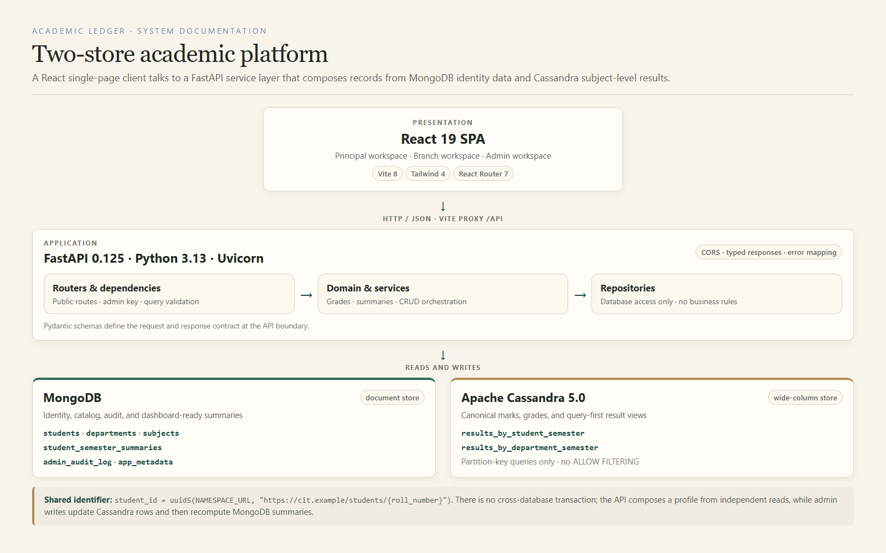
Figure 1. Layered architecture. The SPA reaches FastAPI through the Vite proxy; services orchestrate MongoDB and Cassandra through repositories. The shared UUID5 student identifier is the only cross-store key.

4.1 Layer responsibilities
The React layer owns navigation, table state, filters, and dialogs. It does not own academic rules. The FastAPI layer owns routing, dependency validation, error mapping, and response typing. The service layer owns the rules that matter: which store to read, what constitutes a backlog, how a summary is recomputed, and what must be written before an audit entry is recorded. The repository layer owns CQL and MongoDB operations.
This separation is not cosmetic. It made the administrative package split possible without changing imports, and it keeps the Cassandra write ordering visible in one place. When a result changes from FAIL to PASS, the service, not the route and not the UI, is responsible for deleting the old department row, upserting the new rows, recomputing summaries, and writing the audit entry.

4.2 Read and write boundaries
Public reads use StudentService and AnalyticsService. The register reads summaries and merges identity fields; the profile reads MongoDB identity/summaries and Cassandra subject rows. Analytics reads summary documents and, for subject outcomes, groups rows inside one Cassandra department-semester partition. Administrative writes use AdminService and require the X-Admin-Key header. The key is compared in a dependency, so every admin route inherits the same check.
The health endpoint is a separate contract. It reports MongoDB and Cassandra latency independently and returns degraded status if either store is unavailable. Database exceptions are mapped to a generic 503, which avoids leaking connection strings or driver details to the client.

4.3 Why two stores
A single document store could hold everything, but the result rows would be read in two very different ways. A single wide-column design could hold identity and results, but summary filtering and auditing would be awkward. The project uses each store for the shape it handles well. MongoDB is the system of record for identity, catalogue, and derived summaries; Cassandra is the system of record for subject-level results. The API is the composition boundary.
The cost of this choice is explicit. There is no distributed transaction. A profile is composed from independent reads. A write can leave Cassandra updated and MongoDB summaries stale if the process fails between steps. The implementation mitigates this with ordered writes, best-effort rollback, summary recomputation, and verification scripts, but it does not pretend that those measures are equivalent to a distributed transaction.

4.4 Deployment topology
The validated topology is a local development deployment. Vite listens on 127.0.0.1:5173 and proxies /api to FastAPI on 127.0.0.1:8000. MongoDB runs locally on port 27017. Cassandra runs as a single-node Docker service from compose.yaml on port 9042, with SimpleStrategy and replication factor 1. This topology is appropriate for a demonstration and a controlled benchmark; it is not a production topology.
Architectural boundary. No request joins MongoDB and Cassandra inside a database engine. The service composes the result in application memory, applies explicit rules, and returns one Pydantic response. This makes the integration testable and the trade-offs visible.

5. Data Model and Database Design
The data model is organised around one shared identity and two different views of academic performance. MongoDB holds the student, department, subject, semester-summary, and audit documents. Cassandra holds the canonical marks in two denormalised tables. The same student UUID is written to both stores.
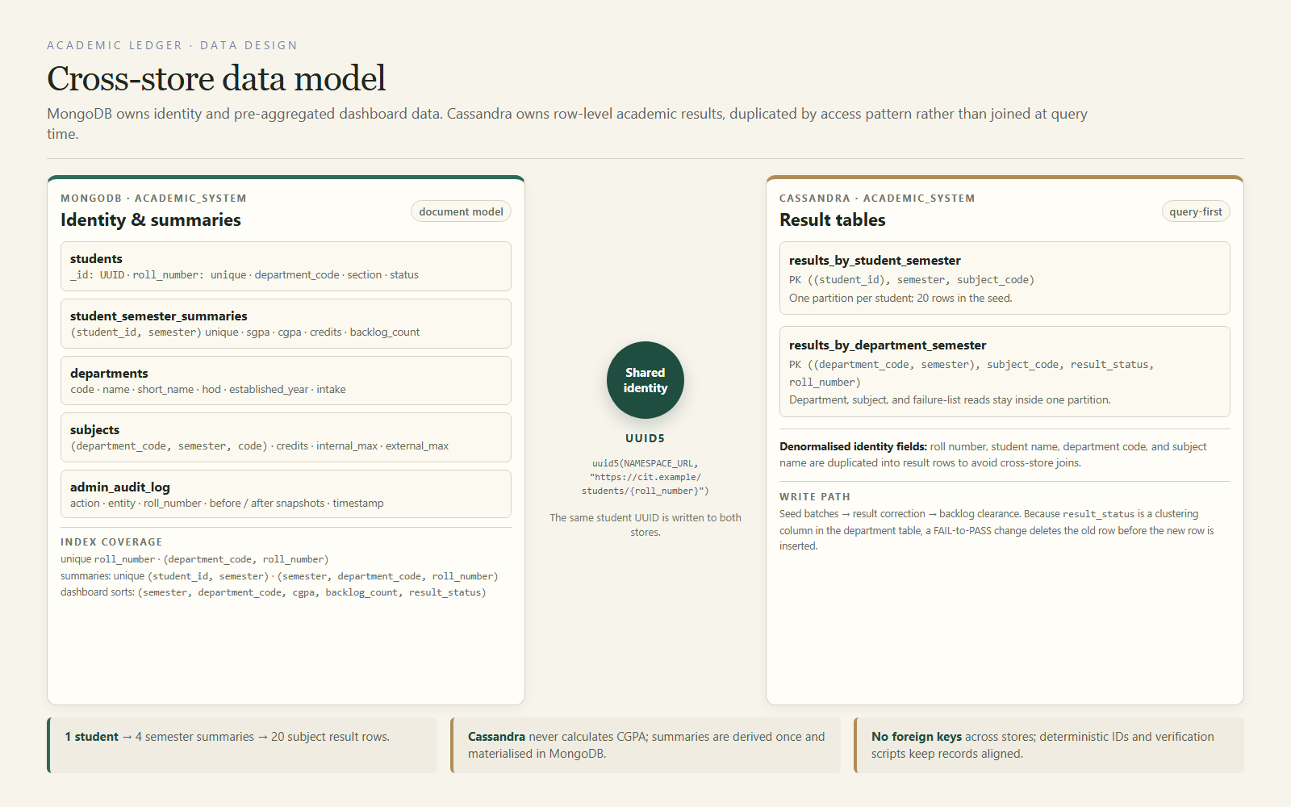
Figure 2. Cross-store data model. MongoDB owns identity and derived summaries; Cassandra owns row-level results. Identity fields are duplicated in Cassandra to keep department and failure-list reads inside one partition.

5.1 Shared student identity
The student identifier is deterministic: uuid5(NAMESPACE_URL, "https://cit.example/students/{roll_number}"). This means the seed, a manually created student, and a Cassandra result row can all derive the same UUID without a lookup table. The roll number remains the human-facing unique key and is also indexed in MongoDB. The UUID is the cross-store key.
The seed uses 24 as the roll prefix, five department codes, and a three-digit sequence. CSE therefore runs from 24CSE001 to 24CSE100. Sections A and B are assigned by sequence. The same identity fields are denormalised into Cassandra result rows: roll number, student name, department code, and subject name. This is intentional duplication, not an oversight.

5.2 MongoDB collections
Table 4. MongoDB collections and their roles.
Collection | Role | Key / indexes
students | Identity and status. | UUID _id; unique roll_number; (department_code, roll_number).
departments | Department catalogue. | Code as _id; name, short name, HOD, intake.
subjects | Semester subject catalogue. | Code; (department_code, semester, code); credits and mark limits.
student_semester_summaries | Dashboard-ready derived performance. | Unique (student_id, semester); semester/department/roll; CGPA and backlog sort indexes.
admin_audit_log | Immutable operational history. | Action, entity, roll number, before/after snapshots, timestamp.
app_metadata | Seed version and counts. | Single dataset document.

Collections are created with strict JSON Schema validators. The seed uses idempotent upserts, so rerunning it does not duplicate records. The summary collection is the most important read model: it stores SGPA, CGPA, credits, failed-subject counts, semester backlog count, cumulative backlog count, and result status for each student-semester pair.

5.3 Cassandra tables
Table 5. Cassandra tables, partition keys, and intended queries.
Table | Primary key | Intended query
results_by_student_semester | ((student_id), semester, subject_code) | Full history or one semester for one student.
results_by_department_semester | ((department_code, semester), subject_code, result_status, roll_number) | Department, subject, and failure-list views.

CQL excerpt: the department-view table keeps every query inside a known partition.
CREATE TABLE results_by_department_semester (
department_code text, semester int, subject_code text,
result_status text, roll_number text, student_id uuid,
student_name text, subject_name text, total_marks int,
grade text, grade_points double,
PRIMARY KEY ((department_code, semester),
subject_code, result_status, roll_number)
) WITH CLUSTERING ORDER BY
(subject_code ASC, result_status ASC, roll_number ASC);

The second table duplicates identity fields by design. A department failure list can be answered without reading MongoDB. A profile can be answered without reading the department table. The student table's partition is bounded by 20 rows in this dataset, and the department table's partition is bounded by 500 rows for one department-semester. Every application query supplies the full partition key; the code does not use ALLOW FILTERING.

5.4 Data volumes
Table 6. Seeded data volumes and current demonstration state.
Measure | Seed value | Live demo note
Departments | 5 | CSE, ECE, EEE, MECH, CIVIL
Students | 500 | 100 per department
Semester summaries | 2,000 | Four per student
Subjects per student | 20 | Five per semester, semesters 1–4
Result rows per Cassandra table | 10,000 | Two tables, same row count
Failed subject results | 105 | 104 after the documented 24CSE006 clearance
Students with a Semester 4 backlog | 68 | 67 after the documented clearance

5.5 Access patterns and indexes
The register query filters on semester, department, CGPA range, backlog range, and status, then sorts by roll number or CGPA. The compound indexes lead with semester because every dashboard request is semester-scoped. The summary indexes cover the common CGPA and backlog sorts. The student index covers roll-number lookup and department ordering. There is no attempt to index every possible filter combination; the current indexes match the demonstrated queries.
Cassandra indexes are not used as a substitute for query design. The table definitions encode the query. Changing a result from FAIL to PASS is a delete-then-insert because result_status is part of the department table's clustering key. The student table can be overwritten by upsert because its key is (student_id, semester, subject_code). This asymmetry is one of the most important implementation details in the project.

5.6 Cross-store consistency
The seed generates one deterministic dataset and writes the same values to both stores. A verification script compares counts and sample identities. Integration tests check that the API failure list matches a direct Cassandra count and that overview pass/fail counts add up to the student count. There is no distributed transaction. If identity and results were edited outside the seed, a repair or reconciliation job would be required.
Data ownership rule. MongoDB owns identity and derived summaries. Cassandra owns canonical marks and grades. Any change to a mark must update Cassandra first, then recompute the four MongoDB summaries, then record the audit entry.

6. Request Flow and Cross-Store Consistency
A request follows a predictable path from a React route to a typed API response. The path is deliberately short so that failure points are visible. The same architecture serves public reads and administrative writes, but the write path adds validation, ordering, recomputation, and audit steps.
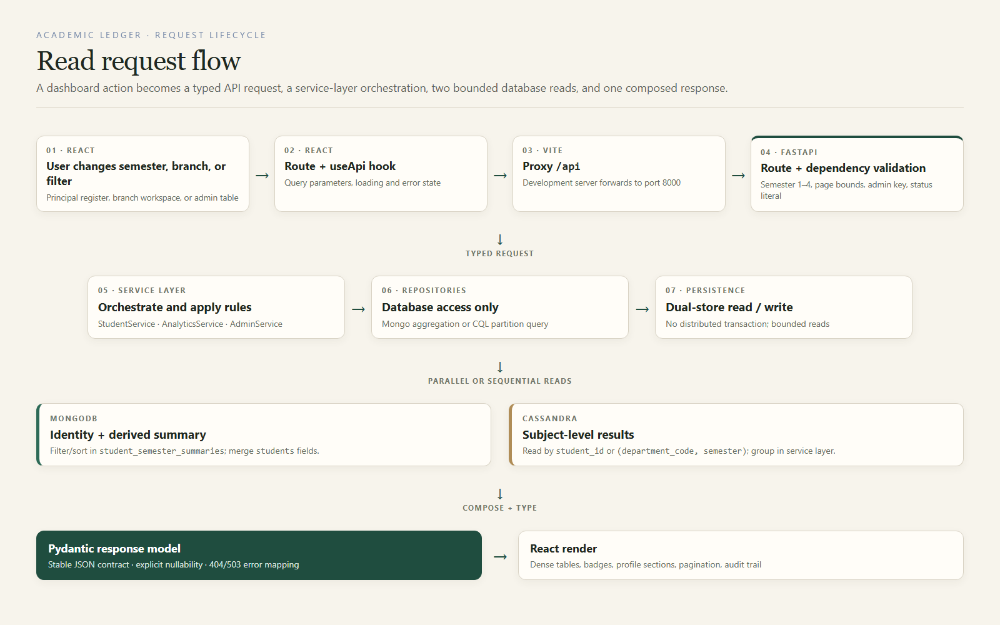
Figure 3. Read request flow. React passes typed query parameters through the Vite proxy to FastAPI; the service layer chooses a bounded MongoDB or Cassandra read and composes the response.

6.1 Read path
A register request begins with a semester and optional filters. FastAPI validates the semester (1–4), page bounds, CGPA range (0–10), backlog range (0–10), status literal, and sort literal. StudentService validates the department and range ordering, then calls the student repository. The repository runs a summary aggregation with a facet for total count and page items, then merges identity fields from the students collection. The response includes page metadata and the effective filters.
A profile request is different. The student identity and summaries come from MongoDB. Subject rows come from Cassandra by student_id. The service regroups the rows by semester, recalculates summaries for display, and returns the profile plus each semester's subjects, SGPA, CGPA, credits, backlog count, and failed subjects. The UI does not need to know which store supplied which field.

6.2 Administrative write path
An admin request first passes through the X-Admin-Key dependency. The route validates the payload with Pydantic, then calls AdminService. For a result correction, the service loads the current result, applies the new internal and external marks, validates the total, deletes the old department-view row if the status changes, upserts the new rows, rebuilds all four summaries, updates the student timestamp, and writes an audit entry. The response contains before/after summaries so the UI can show the effect immediately.
For a backlog clearance, the same pattern is applied to one or more selected subjects. The preview endpoint performs the full plan but writes nothing. The clear endpoint repeats the plan, applies it, and returns cleared=true with the refreshed summary. This preview-first design reduces the chance of committing marks that the administrator has not reviewed.

6.3 Error handling and validation
The API distinguishes client errors from infrastructure errors. A missing student, department, or subject returns 404. A duplicate roll number returns 409. An invalid mark range, wrong semester, or non-backlog selection returns 400. MongoDB and Cassandra driver failures are mapped to 503 with a generic message. The frontend surfaces these as error panels with retry or lock-admin actions where appropriate.
Validation happens at three levels. The Pydantic schema enforces shape and basic bounds. The service enforces domain rules such as exactly five subjects per semester, marks within 0–30 and 0–70, passing total at least 40, and a selected result being a current backlog. The repository assumes validated inputs and focuses on database operations. This separation keeps error messages meaningful and prevents invalid writes from reaching Cassandra.

6.4 Pagination and filtering
The student register is paginated with a default page size of 25 and a maximum of 100. The API returns total pages and total records. Sorting supports roll ascending, CGPA descending, CGPA ascending, and backlogs descending. The UI keeps the selected semester and branch in the route and component state, so opening a profile and returning to the register preserves the working context.
The filters are applied to the summary collection, not to a joined result set. That keeps the query bounded and makes the index strategy direct. The register then merges identity fields for the current page only, rather than joining every matching student.

6.5 Consistency guarantees
The system provides read-your-writes consistency for a single request because the service returns the values it just computed. It does not provide a distributed transaction. If the process stops after Cassandra writes but before summary recomputation, a later repair would be needed. The implementation reduces this window with ordered writes and a best-effort rollback of prior Cassandra rows on failure. The limitation is stated explicitly here rather than hidden behind the word “consistent.”

7. CRUD and Administrative Workflows
The admin workspace is the operational core of the system. It is protected by a shared access key, exposes a branch and semester context, and separates Students, Result corrections, and Activity. Every mutation records a before/after snapshot in the audit log, and every response returns enough state for the UI to refresh without guessing.
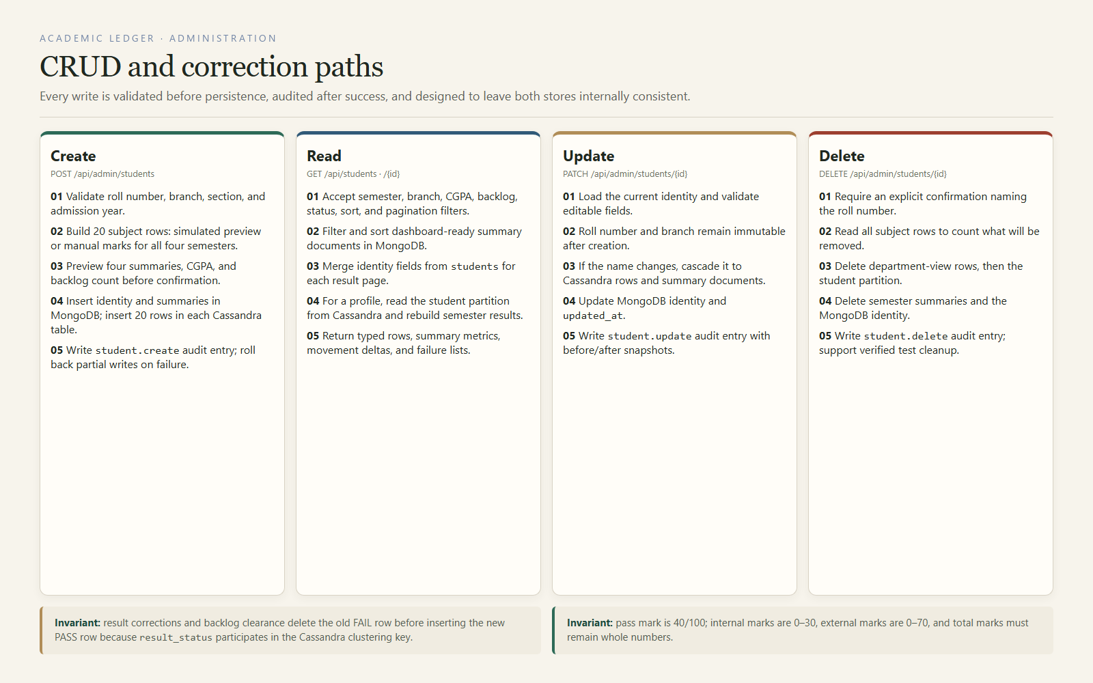
Figure 4. CRUD and correction paths. Create, read, update, and delete have different data effects, but all mutations share validation and audit rules.

7.1 Admin access and register
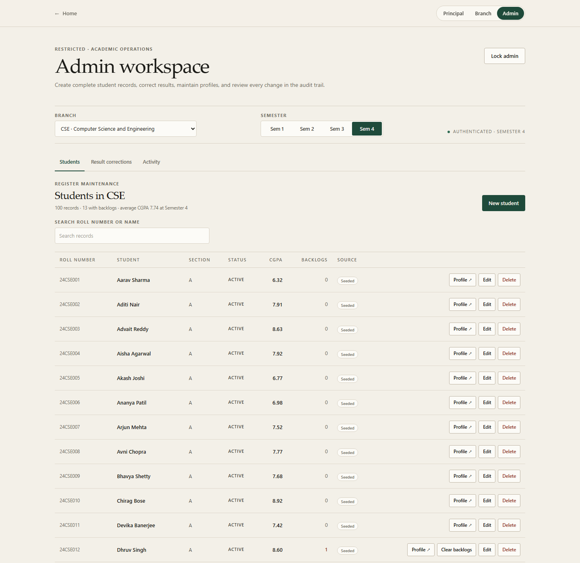
Figure 5. Admin register for CSE, Semester 4. The summary line reports 100 records, 13 students with backlogs, and an average CGPA of 7.74.
The admin route first renders a gate. A valid key is stored in session storage and sent as X-Admin-Key on admin requests. The screenshot shows the authenticated CSE register at Semester 4. It lists the selected branch and semester with search by roll number or name, source badges (seeded, simulated, manual), CGPA, backlog count, and row actions.

7.2 Create
Creation starts with identity fields: roll number, name, branch, section, admission year, current semester, and optional email. The administrator then chooses a simulated record or manual entry. Simulated mode generates 20 deterministic subject rows and shows all four proposed semesters, including SGPA, CGPA, credits, and backlog count. Manual mode requires exactly five subjects for each of the four semesters, with internal marks 0–30 and external marks 0–70.
The preview endpoint writes nothing. It returns the proposed record, a generation seed, and whether the roll number is available. Confirmation inserts the student and summaries in MongoDB, inserts 20 rows in each Cassandra table, and writes a student.create audit entry. A duplicate-key or write failure triggers a best-effort rollback of the partial record.
The roll number is the stable human key; the branch determines the five-subject catalogue and the UUID namespace. A simulated record is reproducible from its generation seed, while a manual record is accepted only when all twenty subject entries pass the mark and total rules. Both paths use the same preview contract, so the confirmation step does not depend on which mode produced the plan.
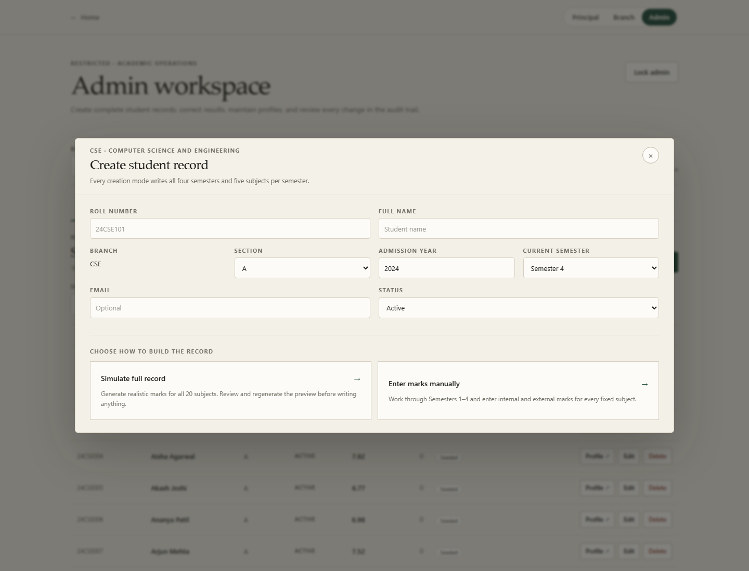
Figure 6. Student creation form. Identity fields are validated before the preview step; the roll number and branch become the stable record identity.
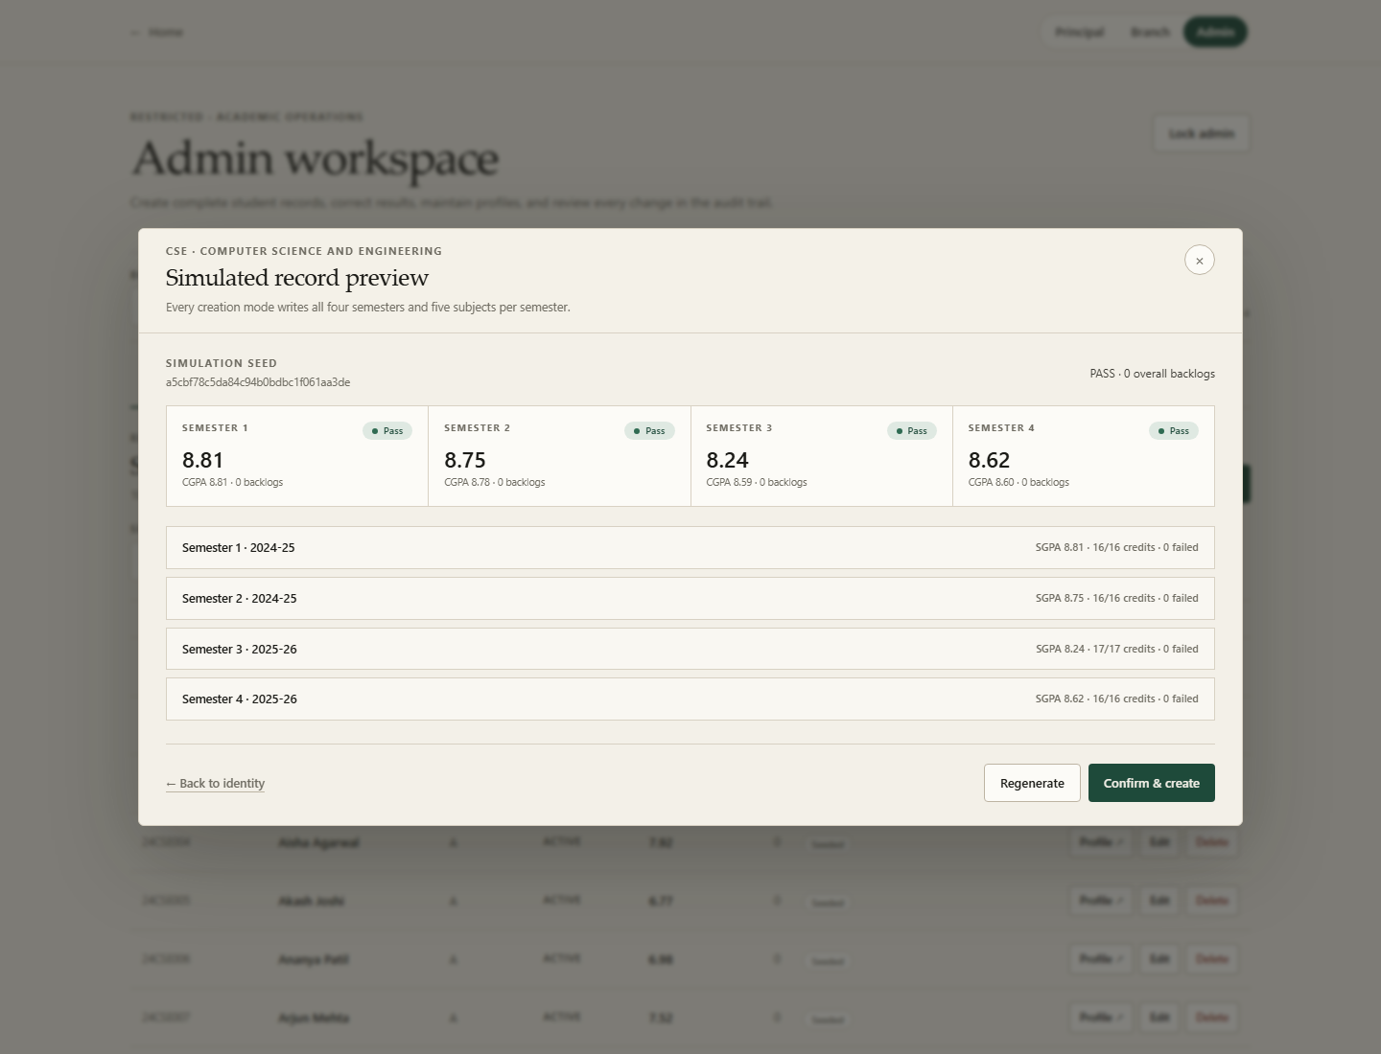
Figure 7. Simulated record preview. The administrator sees four semester summaries and overall backlog count before confirming the create operation.

7.3 Read
Read operations are available through the public register, the department workspace, the student profile, and the admin student record. The public register reads summaries and merges identity fields. The profile reads identity and summaries from MongoDB and subject rows from Cassandra. The admin record endpoint returns all four semesters and their subjects for editing and backlog planning.
The read path deliberately avoids N+1 queries for the register: one summary query returns the page and the total, and one identity query returns the student fields for that page. The profile performs one bounded Cassandra partition read for the student, not one query per subject.

7.4 Update
The edit dialog allows name, section, status, admission year, current semester, and email changes. Roll number and branch are displayed but not editable. If the name changes, the service cascades it to every Cassandra result row and to the summary identity fields. If the section changes, it updates the summary identity. The student document is updated last, followed by a student.update audit entry.
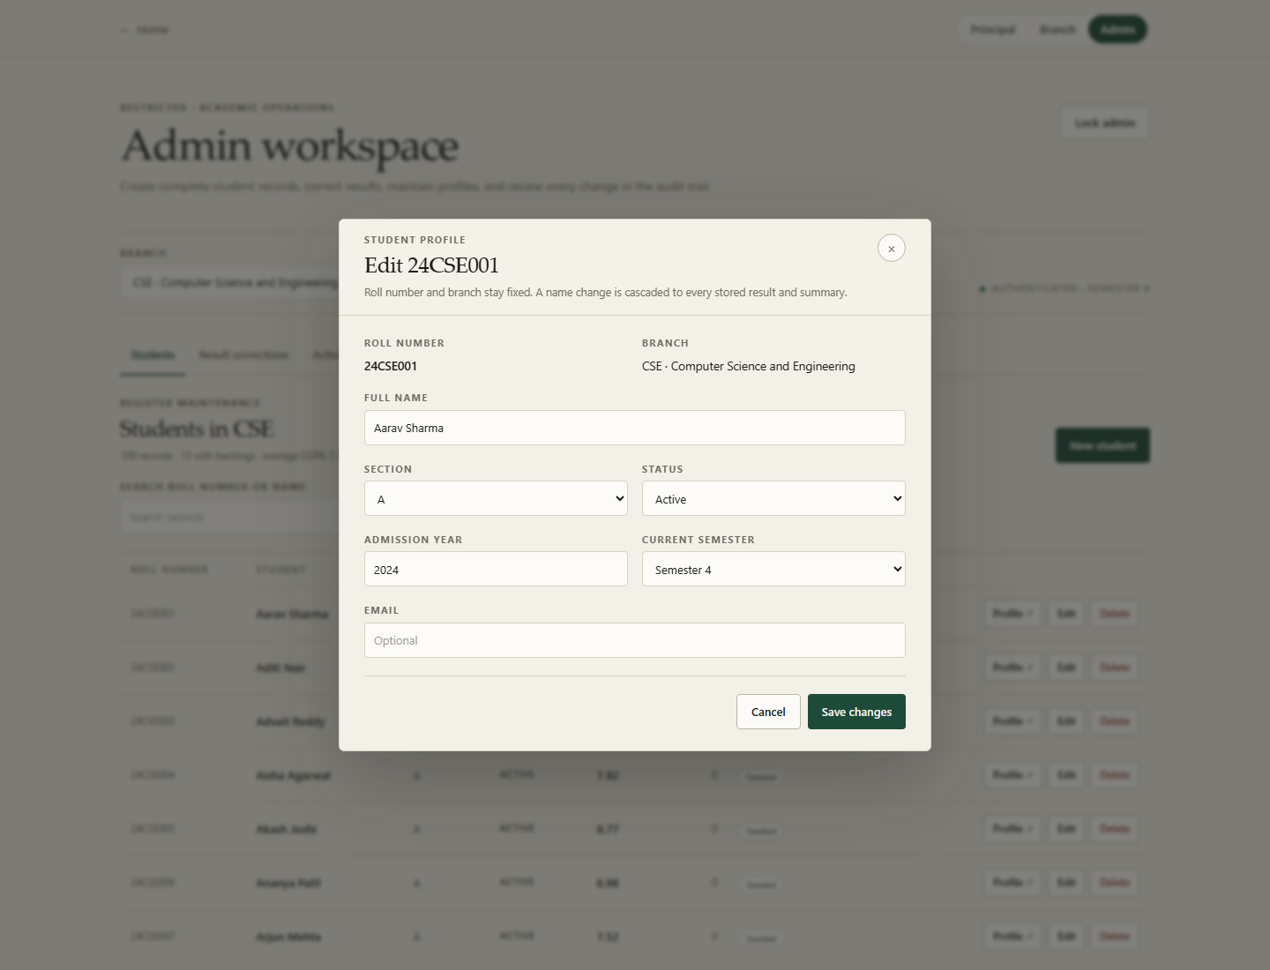
Figure 8. Profile update dialog. Roll number and branch remain fixed; the editable fields are validated and the name change cascades to stored summaries and result rows.

7.5 Result correction
The Result corrections tab lists failed results for the selected department and semester. Selecting Correct opens the subject editor with the current internal and external marks, the computed total, grade, status, and the grade scale. The administrator can set the expected status to failed or passed. Saving recomputes the semester and cumulative summaries and returns a before/after comparison.
Because result_status is part of the department-view clustering key, a FAIL-to-PASS change cannot be a simple update in that table. The service deletes the old FAIL row, upserts the new PASS row in the department table, and upserts the student-view row. The new total must be at least 40; marks outside 0–30 and 0–70 are rejected before any write.
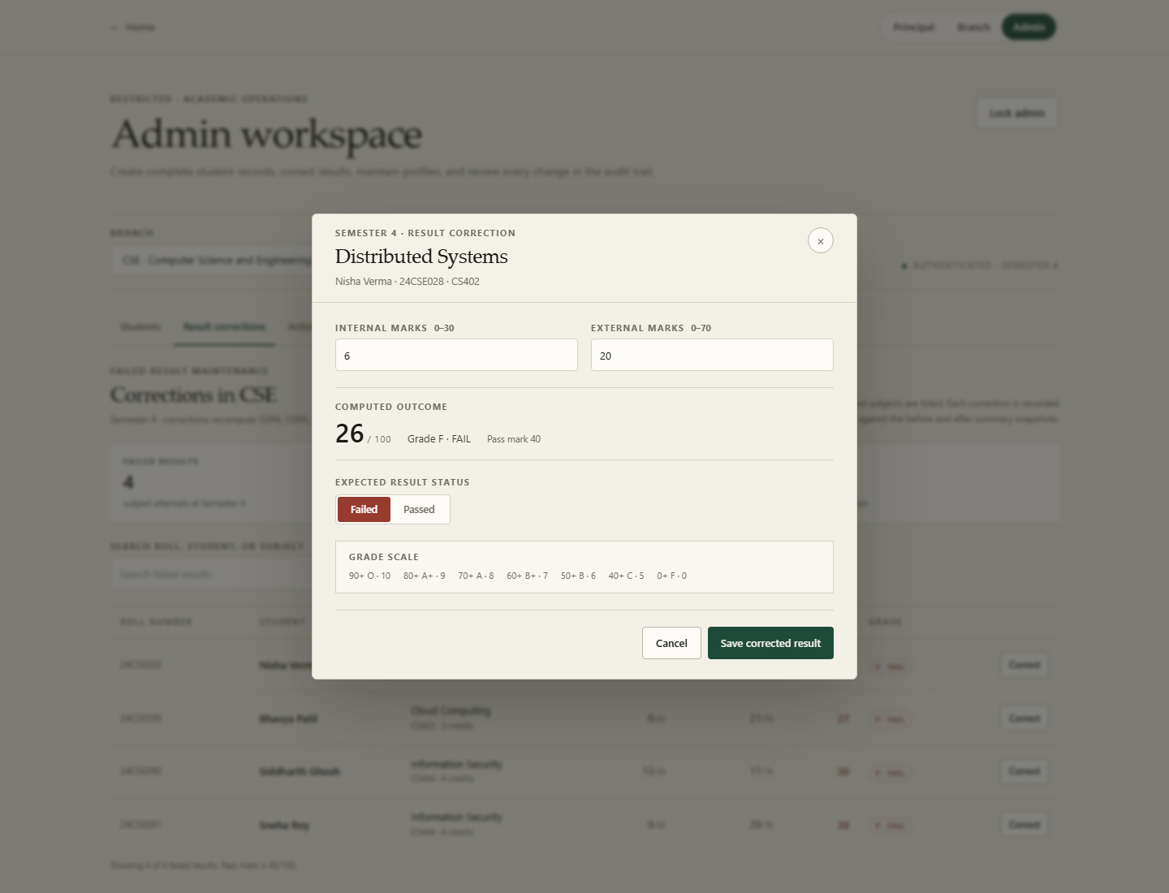
Figure 9. Result correction dialog for CS402, Semester 4. The computed outcome updates as marks change; the pass mark is 40/100.

7.6 Backlog clearance
Backlog clearance is the most complex write. The dialog lists every current failed subject with its semester, code, name, and current internal + external total. The administrator selects one or more subjects and either generates passing marks or enters them manually. The preview updates automatically once every selected subject has valid marks. It shows the projected CGPA and backlog count before the confirm button is enabled.
Generated passing marks are derived deterministically from the student, semester, and subject, so the same backlog preview is reproducible. Manual marks are accepted only when every selected subject has a passing total, and the confirm action remains disabled while any selection is invalid. The UI shows both the current and proposed outcomes before the write begins.
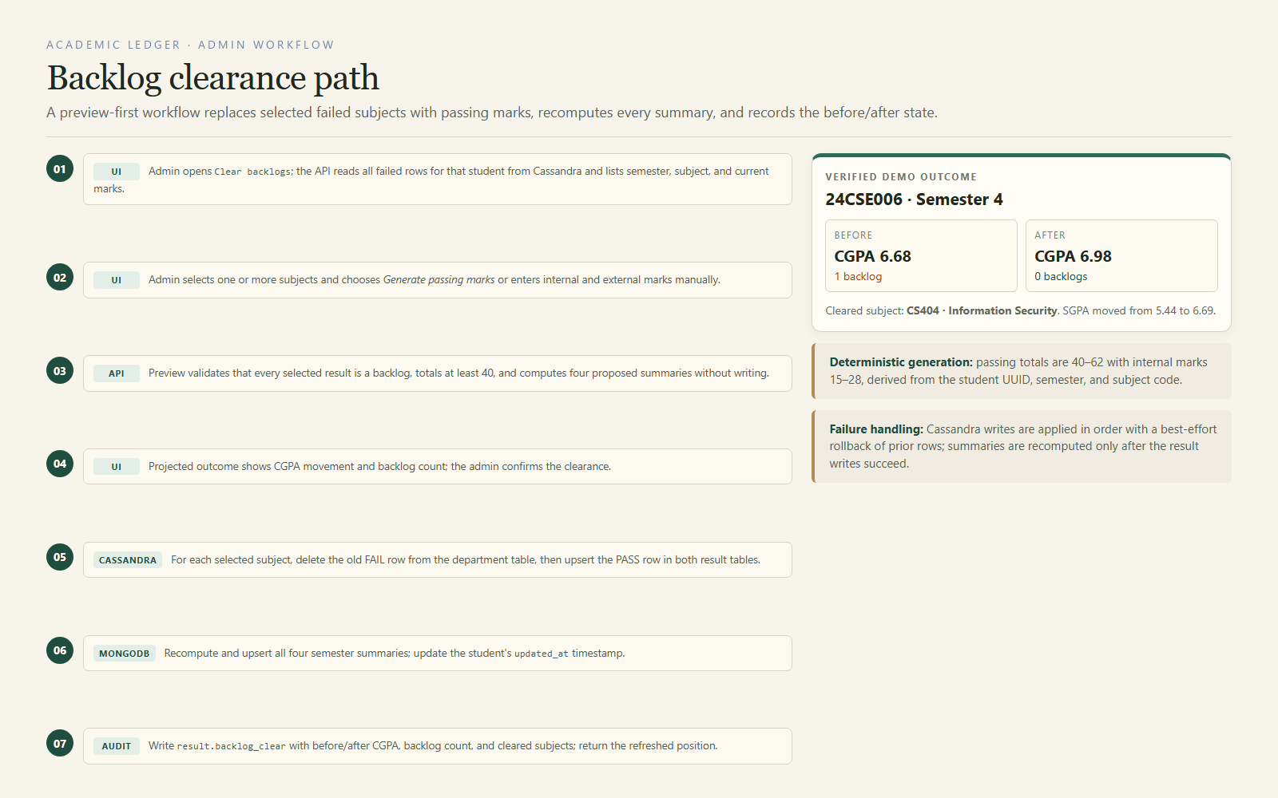
Figure 10. Backlog clearance path. The preview computes proposed summaries without writing; confirmation applies ordered Cassandra writes, recomputes MongoDB summaries, and records the audit entry.
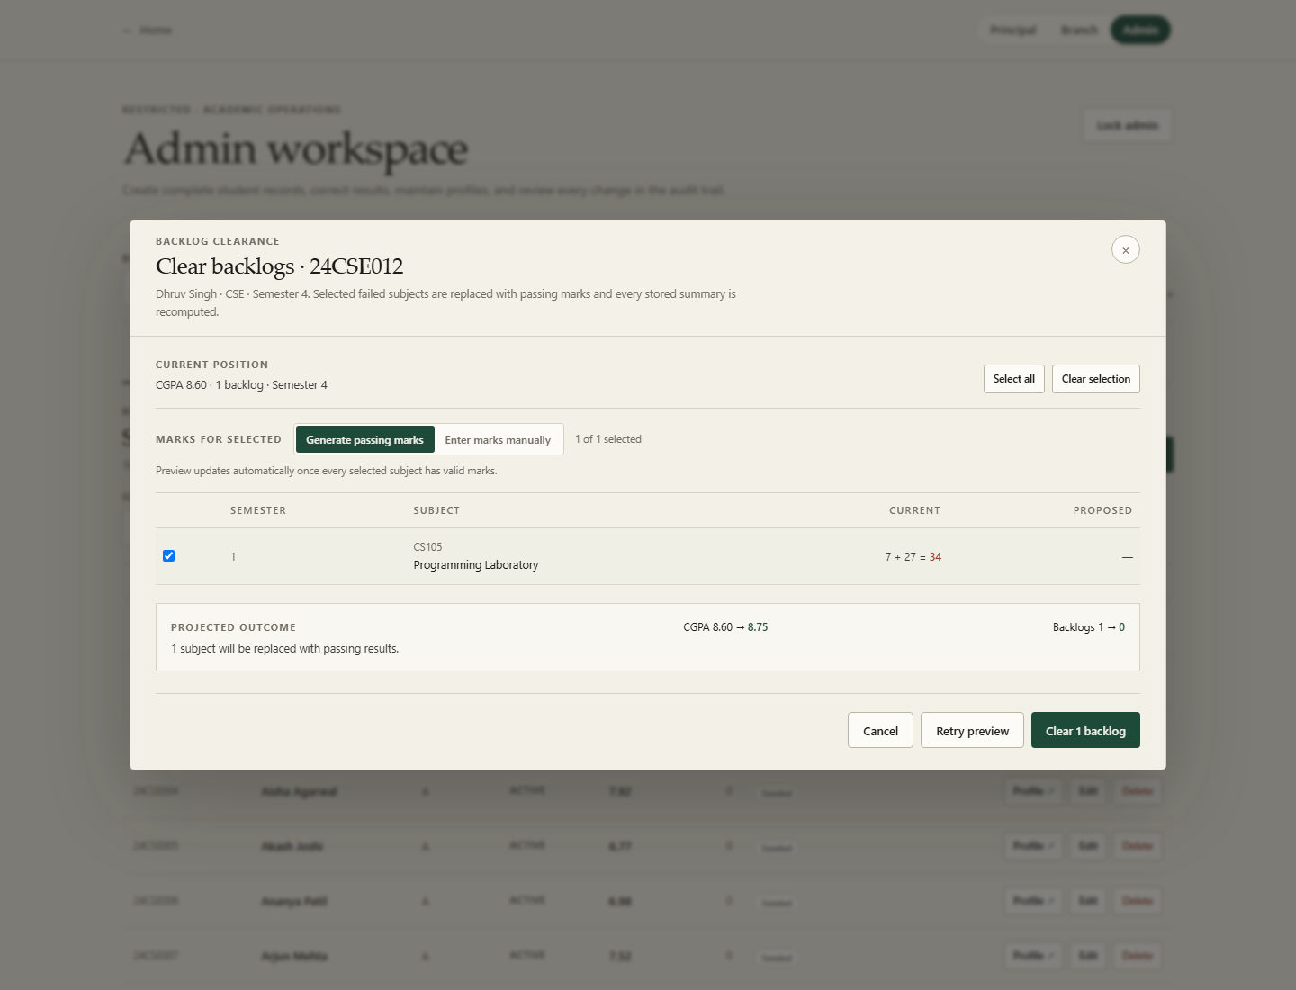
Figure 11. Backlog preview for 24CSE012. One failed subject is selected; the projected outcome shows CGPA 8.60 to 8.75 and backlogs 1 to 0 before any write.
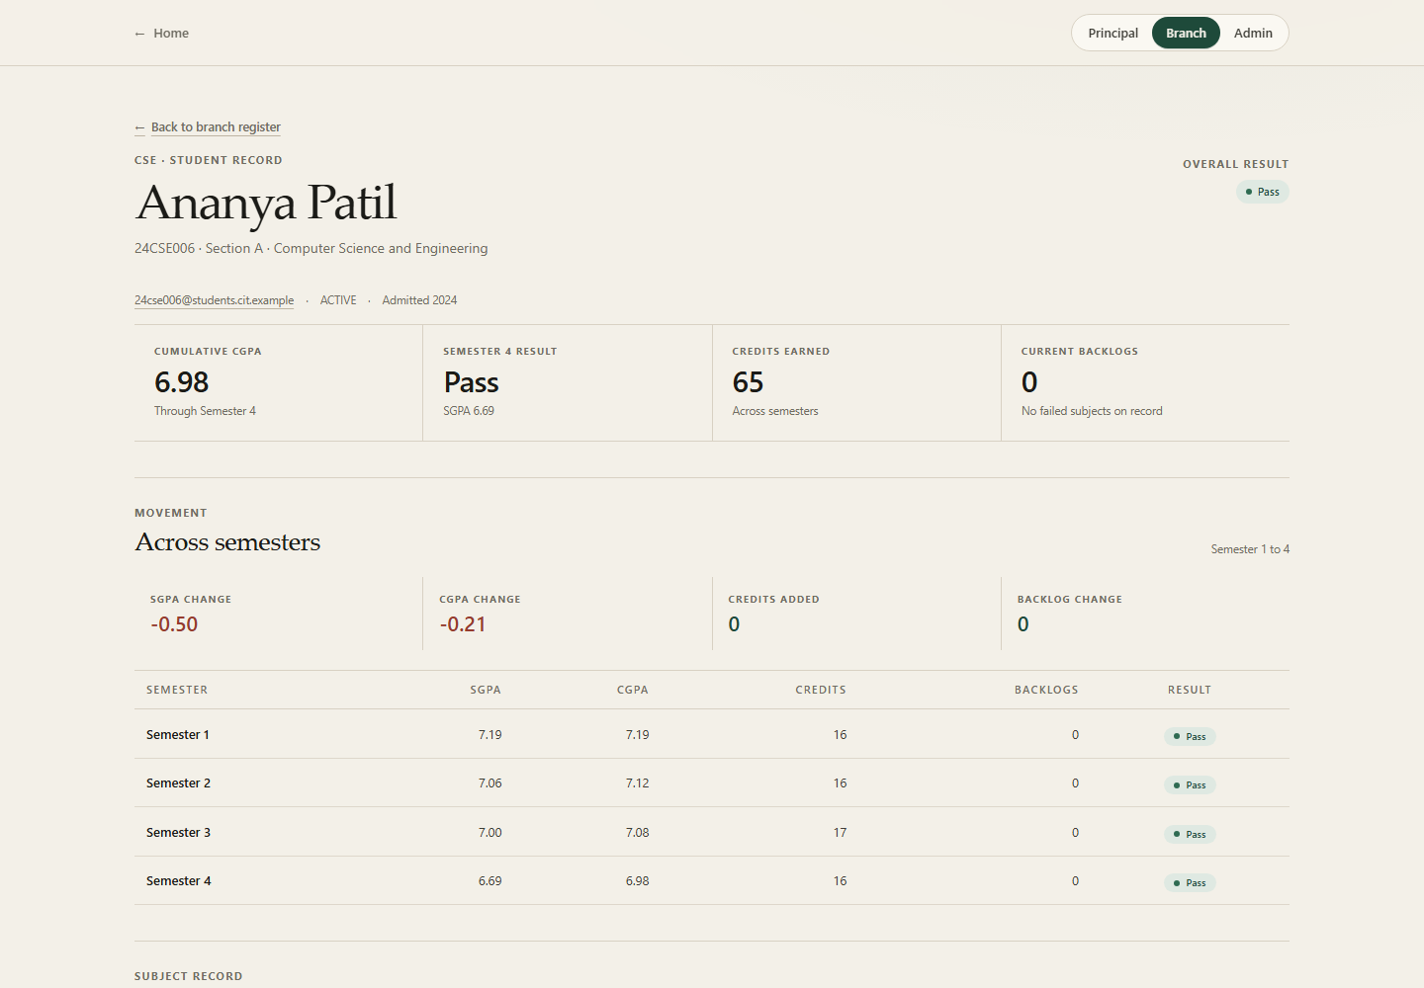
Figure 12. Resolved record for 24CSE006 after the documented CS404 clearance. The profile now shows CGPA 6.98, a passing Semester 4 result, and zero current backlogs.
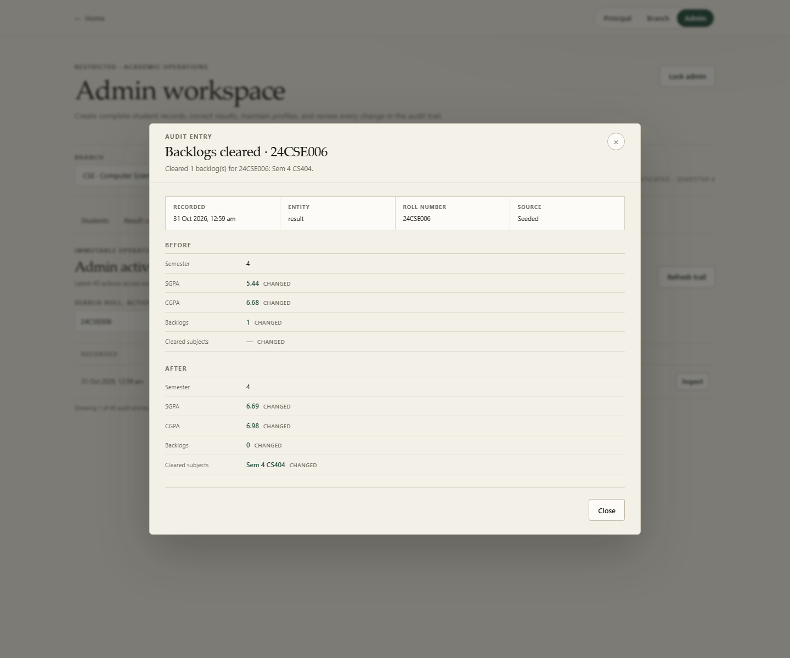
Figure 13. Audit detail for the backlog clearance. The before/after snapshots show SGPA 5.44 to 6.69, CGPA 6.68 to 6.98, and backlog count 1 to 0.
The confirmed write order is: delete the old FAIL department rows, upsert the new PASS rows in both Cassandra tables, recompute and upsert all four summaries, update the student timestamp, and write result.backlog_clear. If a Cassandra write fails, prior rows are restored on a best-effort basis. The UI receives the refreshed state and the audit trail preserves the previous values.

7.7 Delete
Deletion requires an explicit confirmation naming the student and warning that the identity, summaries, and subject rows will be permanently removed. The service reads the subject rows to count what will be deleted, removes department-view rows, removes the student partition, removes summaries and identity from MongoDB, and records student.delete with the removed identity snapshot.
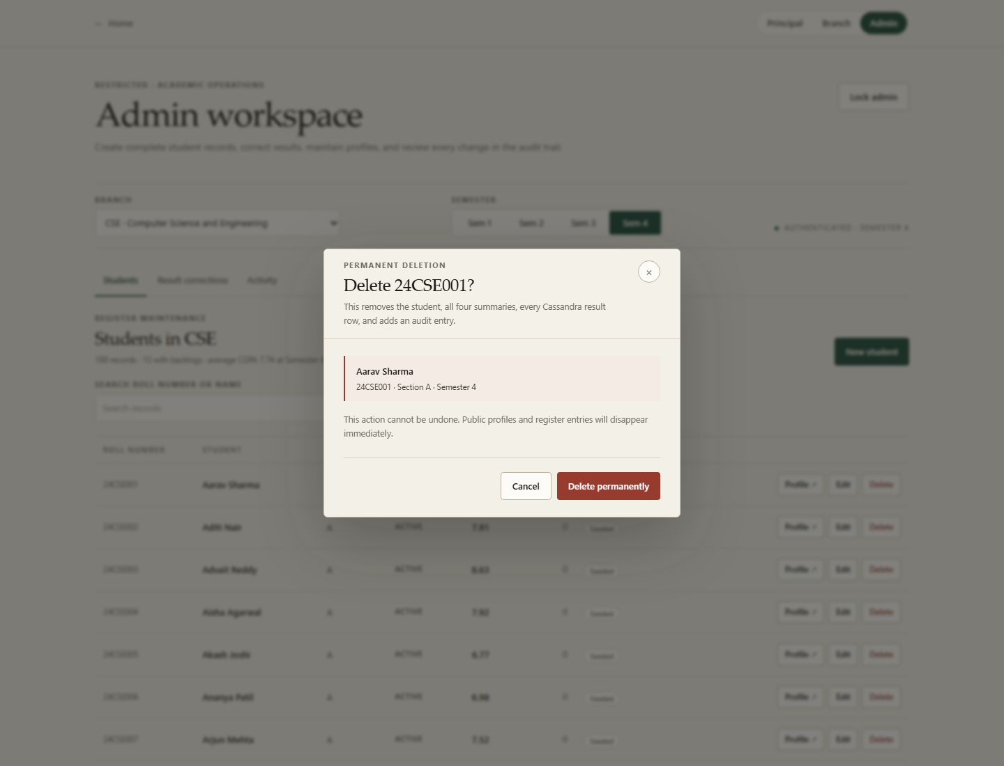
Figure 14. Permanent deletion confirmation. The dialog names the student and states that both identity records and subject rows will be removed.

7.8 Audit and rollback
Table 7. Administrative operations and their audit actions.
Operation | Primary writes | Audit action
Create student | MongoDB identity, summaries; Cassandra 20 rows per table. | student.create
Update profile | MongoDB identity; optional Cassandra name cascade; summaries. | student.update
Correct result | Delete/upsert Cassandra rows; recompute four summaries. | result.correct
Clear backlogs | Delete FAIL rows; upsert PASS rows; recompute summaries. | result.backlog_clear
Delete student | Delete Cassandra rows; delete summaries and identity. | student.delete

The audit log is append-only from the application's perspective: the UI offers inspection, not editing. The log stores the action, entity, roll number, source, timestamp, and before/after snapshots. This makes a cleared backlog or corrected result reviewable without reconstructing history from the current record.

8. User Interface Walkthrough
The interface is designed as an academic register rather than a generic dashboard. A warm paper background, serif display headings, restrained forest-green actions, ruled tables, and tabular numerals create a calm reading surface for dense academic data. Filters sit in a single band; tables remain tables instead of becoming a wall of cards. The layout is responsive and respects reduced-motion preferences.

Figure 15. Landing page. The two workspaces are introduced directly, with the system's dual-store design stated in the supporting copy.

8.1 Principal workspace
The Principal workspace opens on college-wide Semester 4 metrics: students, pass rate, average CGPA, and students with backlogs. Department comparison shows each branch's average CGPA, pass percentage, backlog rate, and student count. The register below supports semester, department, CGPA, backlog, status, sort, and pagination controls. Selecting a student opens the shared profile.
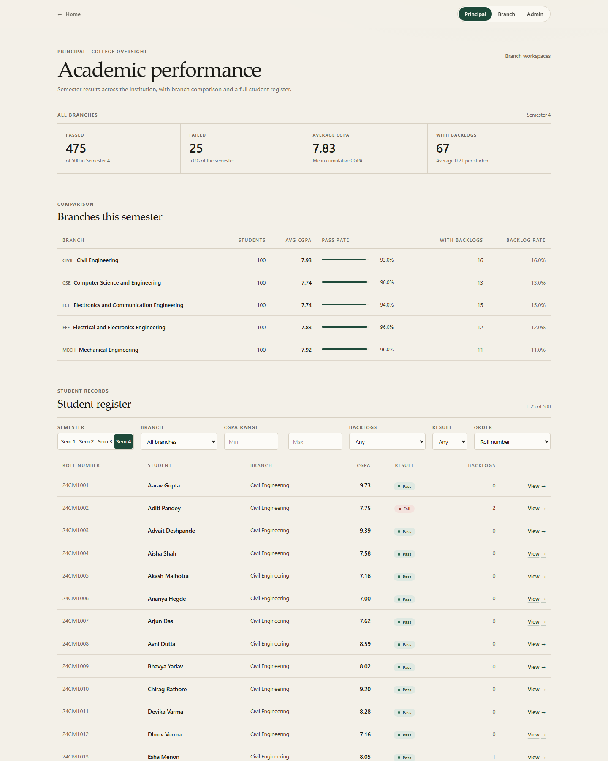
Figure 16. Principal workspace. College metrics, department comparison, and the filterable student register share one reading surface.

8.2 Branch selection and department workspace
The Branch route starts with a department selection step that exposes intake, established year, HOD, and current semester size. The chosen department page combines overview metrics, subject outcomes, failure records, semester movement, and the department register. The subject failure panel is backed by the Cassandra department-semester partition, while the metrics are backed by MongoDB summaries.
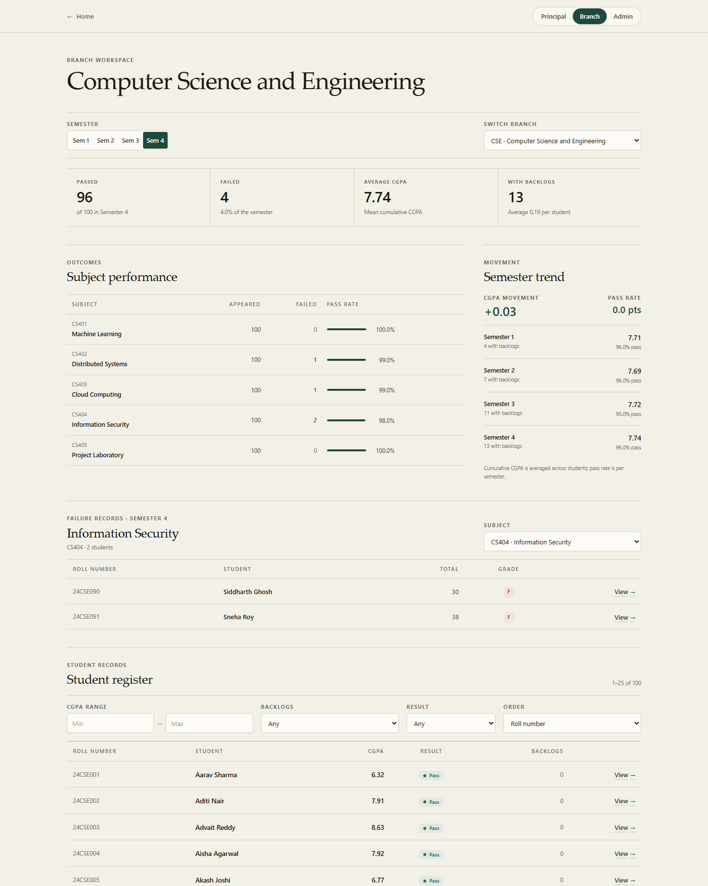
Figure 17. CSE department workspace at Semester 4. The page shows 96 passes, 4 failures, subject-level outcomes, failure records, and movement across semesters.

8.3 Student profile
The profile is the clearest expression of the dual-store model. The header and metric strip come from MongoDB identity and summaries; the subject tables come from Cassandra. The movement panel summarises SGPA, CGPA, credits, and backlog change across semesters. The page exposes the email, status, admission year, section, and overall result without exposing internal database identifiers.
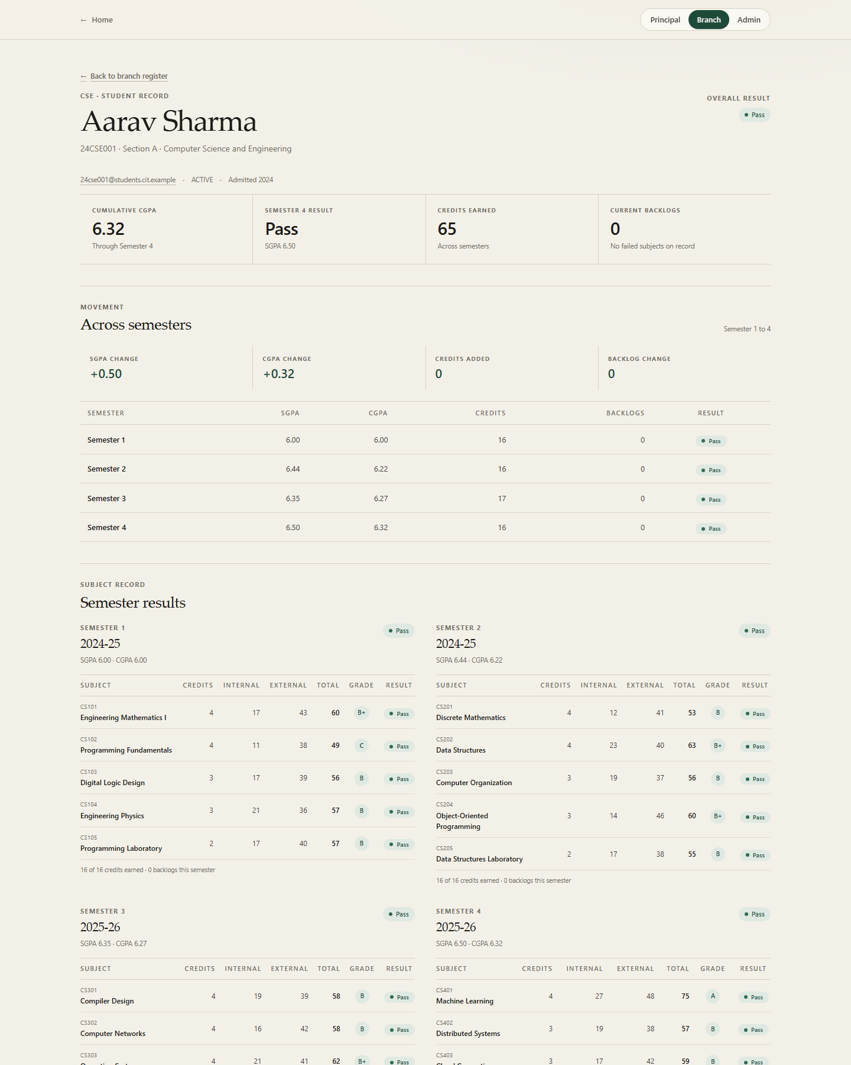
Figure 18. Student profile for 24CSE001. Identity and semester movement are read from MongoDB; the four subject tables are assembled from the student's Cassandra partition.

8.4 Responsive behaviour
The interface collapses the navigation and metric grid on narrow screens while keeping the register and profile readable. The mobile principal screenshot verifies that the primary metrics, department comparison, and register remain usable without horizontal page overflow. Focus styles are visible, and the visual language is consistent across public and admin routes.
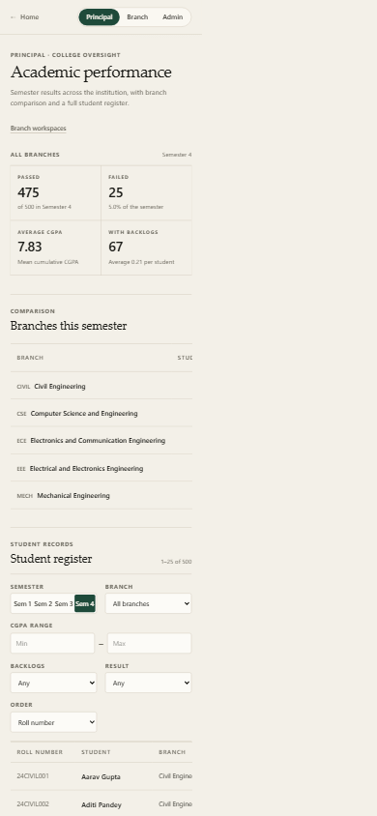
Figure 19. Principal workspace at a 390 × 844 mobile viewport. The layout preserves hierarchy and readable numeric data without a separate mobile application.

8.5 Interface conventions
- Status is communicated with both text and colour, not colour alone.
- Numeric columns use tabular figures and right alignment for scanability.
- Filters and actions are grouped by task; destructive actions use a distinct danger treatment.
- Dialogs keep the underlying record visible and provide an explicit close control.
- Empty, loading, and error states are separate components rather than ad hoc text.

9. Conclusion
The project delivers a working academic office that combines a polished public interface with a complete administrative workflow. MongoDB holds the identity, catalogue, summaries, and audit history. Cassandra holds the canonical subject results in two access-shaped tables. A deterministic UUID5 and a service-layer composition strategy connect the stores without a distributed transaction.
The result is a system that can answer college and department questions quickly, open a coherent student profile, create complete records, correct results, clear selected backlogs, and preserve an auditable before/after history. The 21-test suite verifies the domain rules and the live contracts. The local benchmark records a 5.299 ms MongoDB median and a 30.409 ms Cassandra median for the same verified aggregation, with the data-model difference disclosed rather than hidden.
The main engineering lesson is that polyglot persistence is a design discipline, not a checkbox. Each store must have a clear ownership boundary, a known query shape, and a visible failure mode. This project documents those boundaries and leaves a credible path for individual authentication, durable cross-store repair, and production replication.

