**Koneru Lakshmaiah Education Foundation**

**(Deemed to be University)**

**DEPARTMENT OF COMPUTER SCIENCE ENGINEERING**

**A Project Based Lab Report**

**On**

**CAR MANUFACTURING COMPANY**

**SUBMITTED BY:**

**I.D NUMBER NAME**

180030348 M.NARENDRA

180030418 N.ASHIKA

180030585 P.BRUNDHA

180031098 K.SRUJANA

**UNDER THE GUIDANCE OF**

**DR.SANDEEP KUMAR SATAPATHY**

**Associative Professor**



**KL UNIVERSITY**

Green fields, Vaddeswaram – 522502

Guntur Dt,AP,India.

**DEPARTMENT OF COMPUTER SCIENCE ENGINEERING**



**CERTIFICATE**

This is to certify that the project based laboratory report entitled “CAR MANUFACTURING COMPANY” submitted by Mr./Ms**.M.NARENDRA,N.ASHIKA,P.BRUNDHA,K.SRUJANA** bearing Regd. No. **180030348,180030418,180030585,180031098** to the **Department of computer science engineering, KL University** in partial fulfillment of the requirements for the completion of a project based Laboratory in “OOPS”course in II BTech 1 Semester, is a bonafide record of the work carried out by him/her under my supervision during the academic year 2018 – 2019.

PROJECT SUPERVISOR HEAD OF THE DEPARTMENT

**DR.SANDEEP KUMAR SATAPATHY** **MR.HARI KIRAN VEGE**

**ACKNOWLEDGEMENTS**

It is great pleasure for me to express my gratitude to our honorable President **Sri. Koneru Satyanarayana**, for giving the opportunity and platform with facilities in accomplishing the project based laboratory report.

I express the sincere gratitude to our principal **Prof Dr. N.Venkataram** for his administration towards our academic growth.

I express sincere gratitude to HOD-BES-1 **MR.HARI KIRAN VEGE** for his leadership and constant motivation provided in successful completion of our academic semester. I record it as my privilege to deeply thank for providing us the efficient faculty and facilities to make our ideas into reality.

I express my sincere thanks to our project supervisor  **DR.SANDEEP KUMAR SATAPATHY** for his/her novel association of ideas, encouragement, appreciation and intellectual zeal which motivated us to venture this project successfully.

Finally, it is pleased to acknowledge the indebtedness to all those who devoted themselves directly or indirectly to make this project report success.

**Name:** **Regd . No:**

M.NARENDRA 180030348

N.ASHIKA 180030418

P.BRUNDHA 180030585

K.SRUJANA 180031098

**ABSTRACT**

In this project we are going to implement GUI(graphical user interface).

The GUI(graphical user interface) is a form of user interface that allows users to interact with electronic devices through graphical icons and visual indicators such as secondary notation, instead of text-based user interfaces, typed command labels or text navigation.

GUI components that i am going to use in my project are:

1. Buttons
   1. Adding buttons to a Frame or Panel
   2. ActionListeners for Buttons
   3. Inner Classes
2. Other GUI components
   1. Labels
   2. Text Fields
   3. Text Areas

**INDEX**

|  |  |  |
| --- | --- | --- |
| **S.NO** | **TITLE** | **PAGE NO** |
| 1 | Introduction | 6 |
| 2 | Aim of the Project | 7 |
| 2.1 | Advantages & Disadvantages | 7 |
| 3 | Software & Hardware Details | 8 |
| 4 | Data Flow Diagram | 9 |

|  |  |  |
| --- | --- | --- |
| 5 | Algorithm | 10 |
| 6 | Implementation | 11 |
| 7 | Integration and System Testing | 22 |
| 8 | Conclusion | 25 |

**INTRODUCTION**

The objective of this assignment is to develop a car manufacturing company, where it is expected to developed a GUI based program which should consist of the various available car models, the different designs present, cost of each model and the delivery time for their choice of car.

The graphical user interface is a form of user interface that allows users to interact with electronic devices through graphical icons and audio indicator such as primary notation, instead of text-based user interfaces, typed command labels or text navigation. GUIs were introduced in reaction to the perceived steep learning curve of command-line interfaces which require commands to be typed on a computer keyboard.

The actions in a GUI are usually performed through direct manipulation of the graphical elements. Beyond computers, GUIs are used in many handheld mobile devices such as MP3 players, portable media players, gaming devices, smart phones and smaller household, office and industrial controls. The term GUI tends not to be applied to other lower-display resolution types of interfaces, such as video games (where head-up display is preferred), or not including flat screens, like volumetric displays because the term is restricted to the scope of two-dimensional display screens able to describe generic information, in the tradition of the computer science research at the Xerox Palo Alto Research Center.

Designing the visual composition and temporal behavior of a GUI is an important part of software application programming in the area of human–computer interaction. Its goal is to enhance the efficiency and ease of use for the underlying logical design of a stored program, a design discipline named usability. Methods of user-centered design are used to ensure that the visual language introduced in the design is well-tailored to the tasks.

**AIM**

To develop a GUI based program which should consist of the various available models, the different designs present, cost of each model and the delivery time for their choice of car.

## Advantages:-

## A major advantage of GUIs is that they make computer operation more intuitive, and thus easier to learn and use.

## GUIs generally provide users with immediate, visual feedback about the effect of each action.

## GUI allows multiple programs and/or instances to be displayed simultaneously.

## Users do not need to know any programming languages.

**Disadvantages:-**

* It uses more computer memory as the aim is to make it for user friendly and not resource optimized. As a result it can be slow on older machines.
* GUI becomes more complex if user needs to communicate with the computer directly.
* Certain tasks may take long due to many menus to select the desired choice.
* Hidden commands need to be searched using Help file.
* GUI based applications require more RAM in order to run..

**SYSTEM REQUIREMENTS**

* **SOFTWARE REQUIREMENTS:**

The major software requirements of the project are as follows:

Language : JAVA

Operating system**:** Windows 10.

* **HARDWARE REQUIREMENTS:**

The hardware requirements that map towards the software are as follows:

RAM : 8GB

Processor : Intel® core ™ - i5 8250U

**ALGORITHM**

Step 1:-Start

Step 2:-Display available models

Step 3:-Choose a car

Step 4:-Display different type of models of the choosen car(Car Name and Its Cost)

Step 5:-Choose a model.Goto step 7 if a customer wants to purchase a car else goto step 6

Step 6:Press Back.Goto step 2

Step 7:-If a customer likes to purchase a car then display delivery time(number of days) of the choosen car.

Step 8:Exit

**IMPLEMENTATION**

import javax.swing.*;

import java.awt.*;

import java.awt.event.*;

public class CarManufacturingUnit{

public static void main(String args[]) {

JFrame f = new JFrame("WELCOME TO LAZIO CAR MANUFACTURE COMPANY");

JButton b1 = new JButton("Acura: Honda Motor");

JButton b2 = new JButton("Alfa Romeo: Fiat Chrysler");

JButton b3 = new JButton("Audi: Volkswagen Group");

JLabel l = new JLabel("AVAILABLE MODELS");

JFrame f1 = new JFrame("Acura: Honda Motor");

JFrame f2 = new JFrame("Alfa Romeo: Fiat Chrysler");

JFrame f3 = new JFrame("Audi: Volkswagen Group");

JButton b = new JButton("<--Back");

JButton ex = new JButton("Exit");

f.add(b1);

f.add(b2);

f.add(b3);

f.add(l);

f.add(ex);

b1.setBounds(100, 150, 200, 50);

b2.setBounds(100, 210, 200, 50);

b3.setBounds(100, 270, 200, 50);

l.setBounds(100, 50, 200, 50);

ex.setBounds(120, 330, 100, 30);

f.setSize(400, 400);

f.setLayout(null);

f.setVisible(true);

ex.addActionListener(new ActionListener() {

public void actionPerformed(ActionEvent e) {

f.dispose();

}

});

b1.addActionListener(new ActionListener() {

public void actionPerformed(ActionEvent e) {

f.dispose();

JLabel a1 = new JLabel("DIFFERENT DESIGNS PRESENT IN ACURA");

JLabel l1 = new JLabel("Acura TSX");

JLabel l2 = new JLabel("Acura MDX");

JLabel l3 = new JLabel("Acura Integra");

JLabel l4 = new JLabel("Acura RL");

JLabel a2 = new JLabel("COST OF ALL MODELS");

JLabel k1 = new JLabel("Acura TSX : $33,995");

JLabel k2 = new JLabel("Acura MDX : $45,678");

JLabel k3 = new JLabel("Acura Integra : $48,456");

JLabel k4 = new JLabel("Acura RL : $55.345");

JLabel a3 = new JLabel("DELIVERY TIME IS OF UR CHOICE");

JTextField t1=new JTextField(15);

f1.setSize(400, 1000);

f1.setLayout(null);

a1.setBounds(100, 50, 250, 50);

l1.setBounds(100, 100, 250, 50);

l2.setBounds(100, 150, 250, 50);

l3.setBounds(100, 200, 250, 50);

l4.setBounds(100, 250, 250, 50);

a2.setBounds(100, 300, 250, 50);

k1.setBounds(100, 350, 250, 50);

k2.setBounds(100, 400, 250, 50);

k3.setBounds(100, 450, 250, 50);

k4.setBounds(100, 500, 250, 50);

a3.setBounds(100, 550, 250, 50);

t1.setBounds(100, 600, 250, 50);

b.setBounds(120, 650, 100, 50);

f1.add(a1);

f1.add(l1);

f1.add(l2);

f1.add(l3);

f1.add(l4);

f1.add(a2);

f1.add(k1);

f1.add(k2);

f1.add(k3);

f1.add(k4);

f1.add(a3);

f1.add(t1);

f1.add(b);

f1.setVisible(true);

}

});

b2.addActionListener(new ActionListener() {

public void actionPerformed(ActionEvent e) {

f.dispose();

JLabel c1 = new JLabel("DIFFERENT DESIGNS PRESENT IN ALFA ROMEO");

JLabel h1 = new JLabel("Alfa Romeo Giulietta");

JLabel h2 = new JLabel("Alfa Romeo 4C");

JLabel h3 = new JLabel("Alfa Romeo Giulia");

JLabel h4 = new JLabel("Alfa Romeo Stelvio");

JLabel c2 = new JLabel("COST OF ALL MODELS");

JLabel p1 = new JLabel("Alfa Romeo Giulietta : $23,456");

JLabel p2 = new JLabel("Alfa Romeo 4C : $35,876");

JLabel p3 = new JLabel("Alfa Romeo Giulia : $37,456");

JLabel p4 = new JLabel("Alfa Romeo Stelvio : $52,445");

JLabel c3 = new JLabel("DELIVERY TIME IS OF UR CHOICE");

JTextField t2=new JTextField(15);

f1.setSize(400, 1000);

f1.setLayout(null);

c1.setBounds(100, 50, 250, 50);

h1.setBounds(100, 100, 250, 50);

h2.setBounds(100, 150, 250, 50);

h3.setBounds(100, 200, 250, 50);

h4.setBounds(100, 250, 250, 50);

c2.setBounds(100, 300, 250, 50);

p1.setBounds(100, 350, 250, 50);

p2.setBounds(100, 400, 250, 50);

p3.setBounds(100, 450, 250, 50);

p4.setBounds(100, 500, 250, 50);

c3.setBounds(100, 550, 250, 50);

t2.setBounds(100, 600, 250, 50);

b.setBounds(120, 650, 100, 50);

f2.add(c1);

f2.add(h1);

f2.add(h2);

f2.add(h3);

f2.add(h4);

f2.add(c2);

f2.add(p1);

f2.add(p2);

f2.add(p3);

f2.add(p4);

f2.add(c3);

f2.add(t2);

f2.add(b);

f2.setVisible(true);

}

});

b3.addActionListener(new ActionListener() {

public void actionPerformed(ActionEvent e) {

f.dispose();

JLabel d1 = new JLabel("DIFFERENT DESIGNS PRESENT IN AUDI");

JLabel g1 = new JLabel("Audi A1");

JLabel g2 = new JLabel("Audi A7");

JLabel g3 = new JLabel("Audi A8");

JLabel g4 = new JLabel("Audi A2");

JLabel d2 = new JLabel("COST OF ALL MODELS");

JLabel h1 = new JLabel("Audi A1 : $14,456");

JLabel h2 = new JLabel("Audi A7 : $45,876");

JLabel h3 = new JLabel("Audi A8 : $62,456");

JLabel h4 = new JLabel("Audi A2 : $56,445");

JLabel d3 = new JLabel("DELIVERY TIME IS OF UR CHOICE");

JTextField t3=new JTextField(15);

f3.setSize(400, 1000);

f3.setLayout(null);

d1.setBounds(100, 50, 250, 50);

g1.setBounds(100, 100, 250, 50);

g2.setBounds(100, 150, 250, 50);

g3.setBounds(100, 200, 250, 50);

g4.setBounds(100, 250, 250, 50);

d2.setBounds(100, 300, 250, 50);

h1.setBounds(100, 350, 250, 50);

h2.setBounds(100, 400, 250, 50);

h3.setBounds(100, 450, 250, 50);

h4.setBounds(100, 500, 250, 50);

d3.setBounds(100, 550, 250, 50);

t3.setBounds(100, 600, 250, 50);

b.setBounds(120, 650, 100, 50);

f3.add(d1);

f3.add(g1);

f3.add(g2);

f3.add(g3);

f3.add(g4);

f3.add(d2);

f3.add(h1);

f3.add(h2);

f3.add(h3);

f3.add(h4);

f3.add(d3);

f3.add(t3);

f3.add(b);

f3.setVisible(true);}

});

b.addActionListener(new ActionListener() {

public void actionPerformed(ActionEvent e) {

f1.dispose();

f2.dispose();

f3.dispose();

f.setVisible(true);

}});

}}

**INTEGRATION AND SYSTEM TESTING**

**Outputs:-**

Screen Shots:

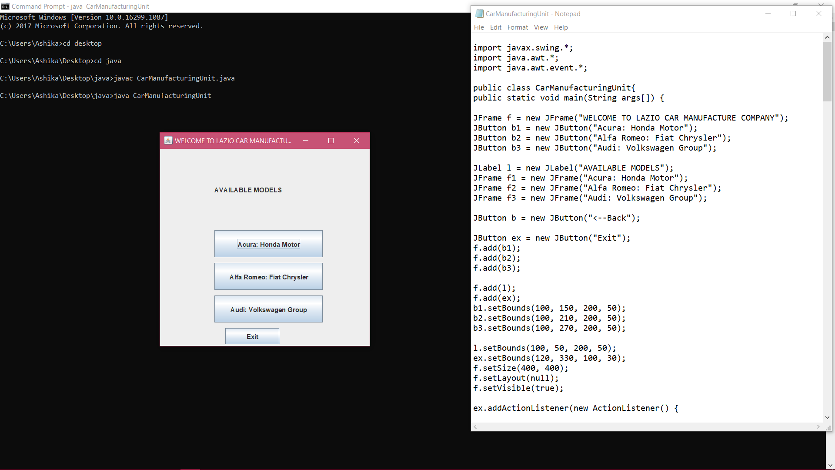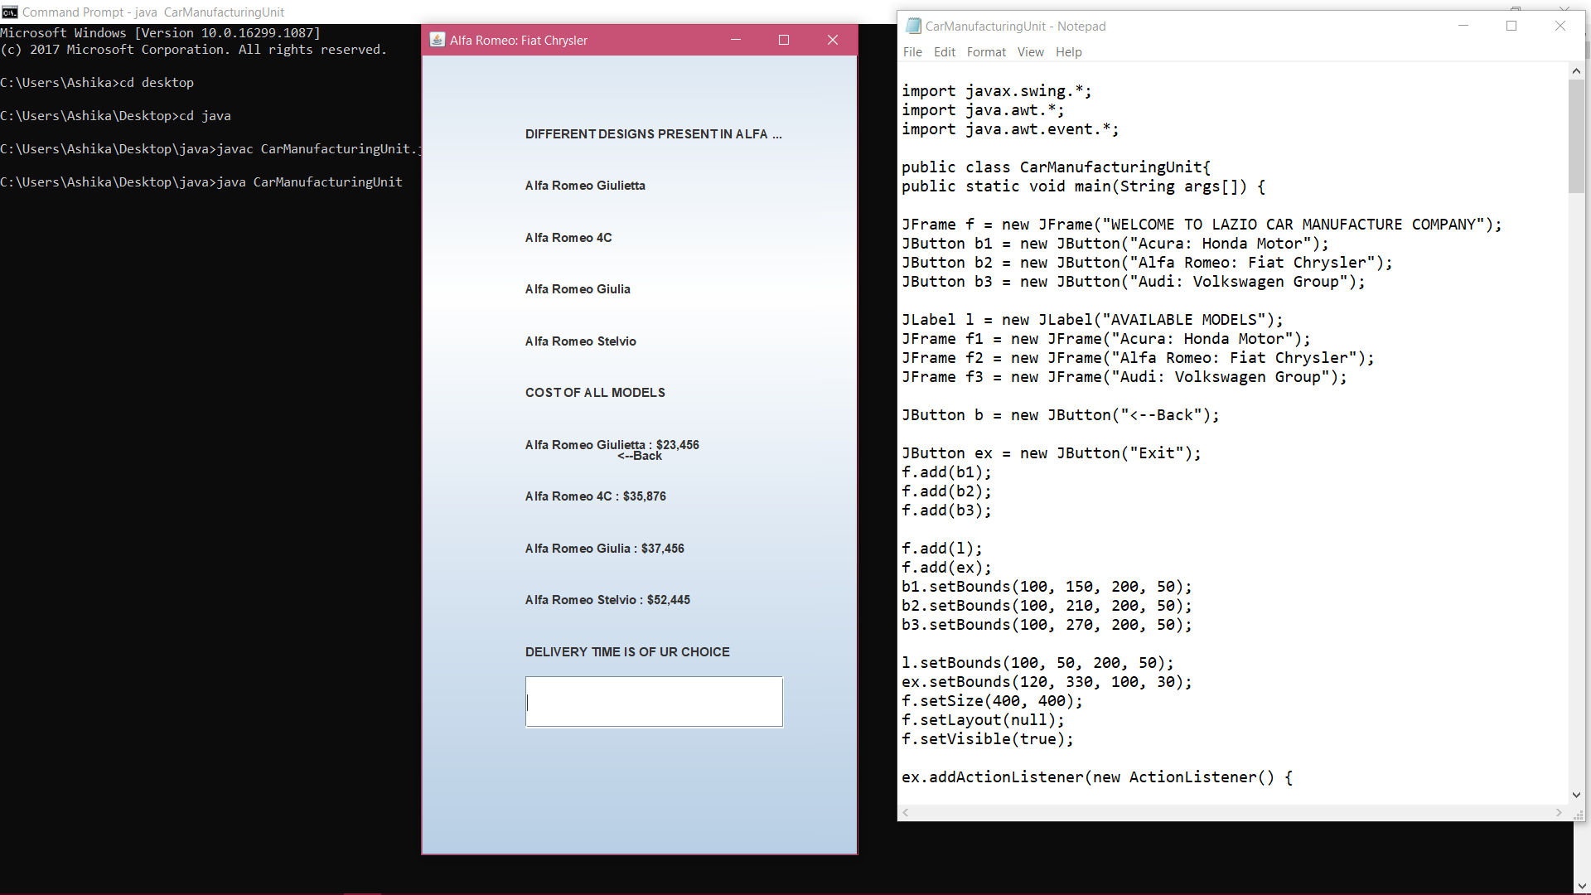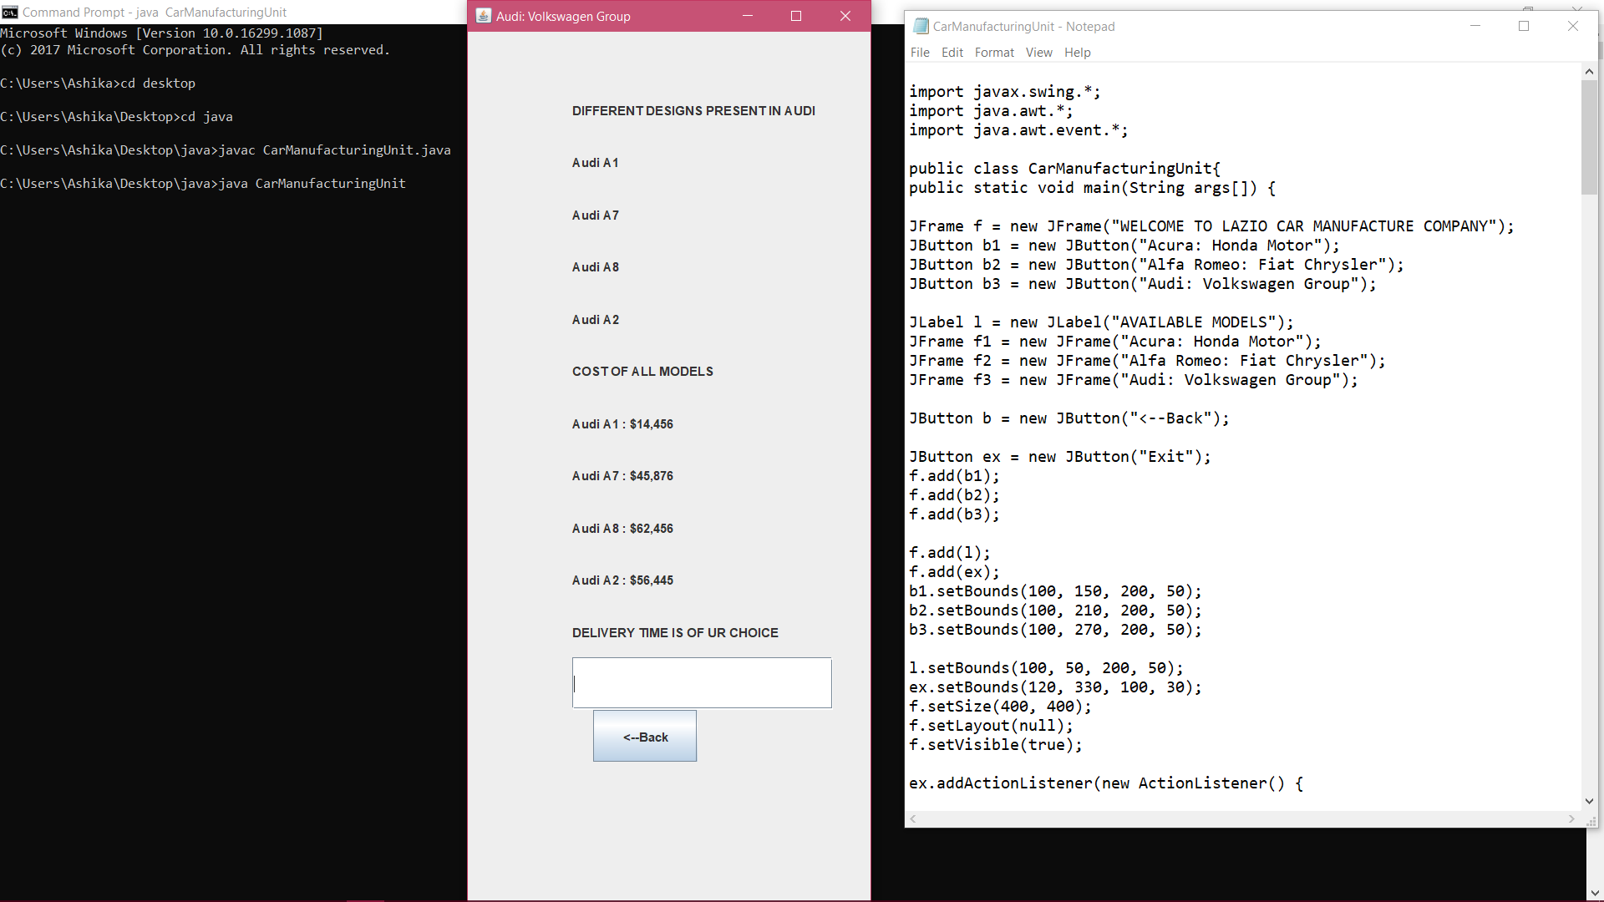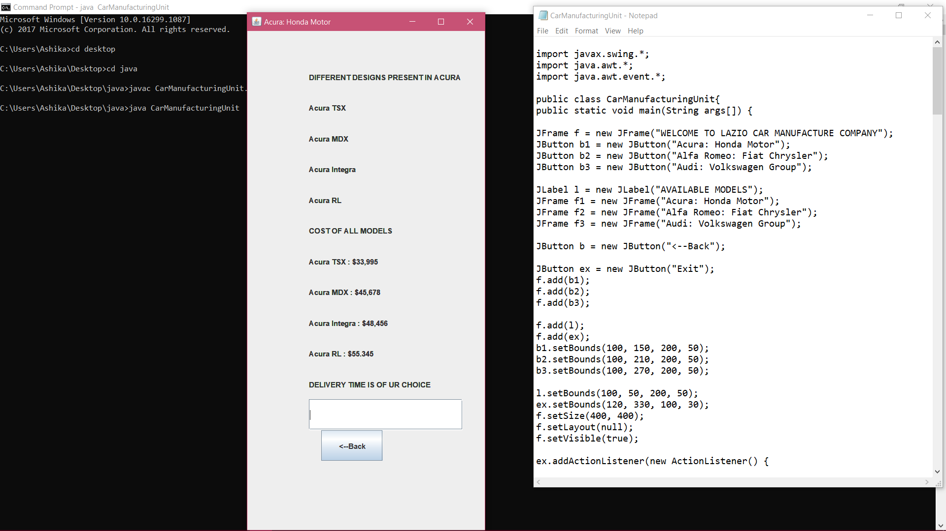

**CONCLUSION**

The primary goal of GUI is to allow the user to concentrate on the task at hand.we have learnt about

Action listener interface

Action event class

Action performed method and there uses.

GUI properties and implemented our project with all these properties.