**Koneru Lakshmaiah Education Foundation**

**(Deemed to be University)**

**FRESHMAN ENGINEERING DEPARTMENT**

**A Project Based Lab Report**

**On**

**SQUARE CODE**

**SUBMITTED BY:**

I.D NUMBER NAME

180030348 M.NARENDRA

180030354 K.MAHITA

180030359 M.HARINI

180030360 K.MOHAN SAI

**UNDER THE GUIDANCE OF**

**Dr.MUTHUKUMARAN.M**

**ASSOCIATE PROFESSOR**



**KL UNIVERSITY**

Green fields, Vaddeswaram – 522 502

Guntur Dt., AP, India.

**DEPARTMENT OF BASIC ENGINEERING SCIENCES-1**



**CERTIFICATE**

This is to certify that the project based laboratory report entitled “**SQUARE CODE**” submitted by **M.NARENDRA,K.MAHITA,M.HARINI,K.MOHAN SAI** bearing Regd. No. **180030348,180030354,180030359,180030360** to the **Department of Basic Engineering Sciences-1, KL University** in partial fulfillment of the requirements for the completion of a project based Laboratory in “TECHNICAL SKILLS-1(CODING)”course in I B Tech I Semester, is a bonafide record of the work carried out by him/her under my supervision during the academic year 2018 – 2 019.

PROJECT SUPERVISOR HEAD OF THE DEPARTMENT

**Dr.MUTHUKUMARAN.M**  **Dr. L.SRIDHARARAO**

**ACKNOWLEDGEMENTS**

It is great pleasure for me to express my gratitude to our honorable President **Sri. Koneru Satyanarayana**, for giving the opportunity and platform with facilities in accomplishing the project based laboratory report.

I express the sincere gratitude to our principal **Prof** **Dr. N.Venkataram** for his administration towards our academic growth.

I express sincere gratitude to HOD-BES-1 **Dr. L. SridharaRao** for his leadership and constant motivation provided in successful completion of our academic semester. I record it as my privilege to deeply thank for providing us the efficient faculty and facilities to make our ideas into reality.

I express my sincere thanks to our project supervisor **Dr.MUTHUKUMARAN.M** for his/her novel association of ideas, encouragement, appreciation and intellectual zeal which motivated us to venture this project successfully.

Finally, it is pleased to acknowledge the indebtedness to all those who devoted themselves directly or indirectly to make this project report success.

**Name:** **Regd . No:**

M.NARENDRA 180030348

K.MAHITA 180030354

M.HARINI 180030359

K.MOHAN SAI 180030360

**ABSTRACT**

In this project an English text needs to be encrypted using the following encryption scheme. First, the spaces are removed from the text. Then, characters are written into a grid, into rows and columns. The encoded message is obtained by displaying the characters in a column, inserting a space, and then displaying the next column and inserting a space, and so on. In computing, encryption is the method by which plaintext or any other type of data is converted from a readable form to an encoded version that can only be decoded by another entity if they have access to a decryption key. Encryption is one of the most important methods for providing data security, especially for end-to-end protection of data transmitted across networks. Encryption, is the process of changing information in such a way as to make it unreadable by anyone except those possessing special knowledge that allows them to change the information back to its original, readable form. Encryption is important because it allows you to securely protect data that you don't want anyone else to have access to. Businesses use it to protect corporate secrets, governments use it to secure classified information, and many individuals use it to protect personal information to guard against things like identity theft. Encryption has long been used by militaries and governments to facilitate secret communication. It is now commonly used in protecting information within many kinds of civilian systems. Encryption, by itself, can protect the confidentiality of messages, but other techniques are still needed to protect the integrity and authenticity of a message. Encryption is widely used on the internet to protect user information being sent between a browser and a server, including passwords, payment information and other personal information that should be considered private. Organizations and individuals also commonly use encryption to protect sensitive data stored on computers, servers and mobile devices like phones or tablets.

**INDEX**

|  |  |  |
| --- | --- | --- |
| **S.NO** | **TITLE** | **PAGE NO** |
| 1 | Introduction | 6 |
| 2 | Aim of the Project | 7 |
| 2.1 | Advantages & Disadvantages | 8 |
| 2.2 | Future Implementation | 8 |
| 3 | Software & Hardware Details | 9 |
| 4 | Data Flow Diagram | 10-11 |
| 5 | Algorithm | 12 |
| 6 | Implementation | 13 |
| 7 | Integration and System Testing | 14-16 |
| 8 | Conclusion | 16 |

**INTRODUCTION**

A square code is a method for composing secret messages.This method is also referred as Encryption.

Encryption,is the process of changing information in such a way as to make it unreadable by anyone except those

possessing special knowledge (usually referred to as a "key") that allows them to change the information back to its original,

readable form.

Encryption is important because it allows you to securely protect data that you don't want anyone else to have access to.

Businesses use it to protect corporate secrets, governments use it to secure classified information,

and many individuals use it to protect personal information to guard against things like identity theft.

Modern data encryption makes use of an algorithm known as a cipher to convert information into what

appears to be random characters or symbols. The encrypted information is unreadable to anyone who

does not have access to a special key used to decrypt the information so that it’s readable.

**AIM**

**a string is encrypted into secret code**

**INPUT:**A string without spaces is given as an input.

**OUTPUT:**We have to convert this string into a secret code.

**PROCESS:**The spaces are removed from the english text and the characters are

written into a square or a rectangle.

/*Then the characters are printed from the first column to the last column with spaces in between them.*/

        Then the elements of first column are printed followed by the elements of second column with a space between the two columns.

        This process is continued upto the last column.

Sample Input 1:ifmanwasmeanttostayonthegroundgodwouldhavegivenusroots

It is converted into rectangular form like

ifmanwas

                                           meanttos

                                           tayonthe

                                          groundgo   {7 rows and 8 columns}

                                           dwouldha

                                           vegivenu

                                           sroots

Sample Output 1:imtgdvs fearwer mayoogo anouuio ntnnlvt wttddes aohghn sseoau

**Advantages:-**

1)Multiple mobile devices are a big part of our lives, and transferring data

from device to device is a risky proposition. Encryption technology can help

protect store data across all devices, even during transfer. Additional security

measures like advanced authentication help deter unauthorized users.

2)Espionage uses encryption to securely protect folder contents, which could contain

emails, chat histories, tax information, credit card numbers, or any other sensitive

information.This way, even if your comptuer is stolen that data is safe.

**Disadvantages:-**

Encryption requires a password to encrypt and decrypt the file.

A disadvantage of encrypting files is if you forget the password

that you used, you may never be able to recover the data.

**Future enhancement:-**

Homomorphic encryption would be a system allowing calculations on encrypted

data without decrypting it. This method would allow encryption across cloudsystems,

and ensure greater privacy for users. As an example, a financial institution

could make assessments for individuals without revealing personal information.

**SYSTEM REQUIREMENTS**

* **SOFTWARE REQUIREMENTS:**

The major software requirements of the project are as follows:

Language : Turbo-C

Operating system **:** Windows Xp or later.

* **HARDWARE REQUIREMENTS:**

The hardware requirements that map towards the software are as follows:

RAM : 8 GB RAM

Processor : 64 BIT INTEL PROCESSOR

**DATA FLOW DIAGRAM**

Read a string “s”

If(i+j*c<l)

r

Assign j=0

Assign i=0

If(r*c)<l

Calculate the square root of l.

Assign floor value as r.

Assign ceil value as c.

r=floor(sqrt(l))

c=ceil(sqrt(l))

Calculate the string length and store in l

l=strlen(s)

r=r

c=c+1

Display

s[i+j*c]

If i<c

If j<r

j=j+1

i=i+1

Display Space bar

**ALGORITHM**

step 1:Start

step 2:Read a string without spaces and name the string as s.

step 3:Calculate the length of a string.Assign the value of the length of the string to l.

step 4:Assign the floor value of root of l as r and ceil value as c.

step 5:if(r*c<l)

       c=c+1

step 6:Assign i=0

step 7:Assign j=0

step 8:if(i+j*c<l)

        goto step 9

        else

        goto step 13

step 9:display s[i+j*c]

step 10:j=j+1

step 11:if (j<r) goto step 8

step 12:display space bar

step 13:i=i+1

step 14:if (i<c) goto step 7

step 15:Stop.

**IMPLEMENTATION**

#include<stdio.h>

#include<math.h>

#include<string.h>

void main()

{

    char s[82];

    printf("Enter a string without spaces\n");

    scanf("%s",s);

    int i=0,j,l,r,c;

    l=strlen(s);

    r=floor(sqrt(l));

    c=ceil(sqrt(l));

    if(r*c<l)

        c++;

    for(i=0;i<c;i++)

    {

        for(j=0;j<r;j++)

        {

            if((i+j*c)<l)

            printf("%c",s[i+j*c]);

        }

        printf(" ");

    }

}

**INTEGRATION AND SYSTEM TESTING**

OUTPUTS

Screen Shots:

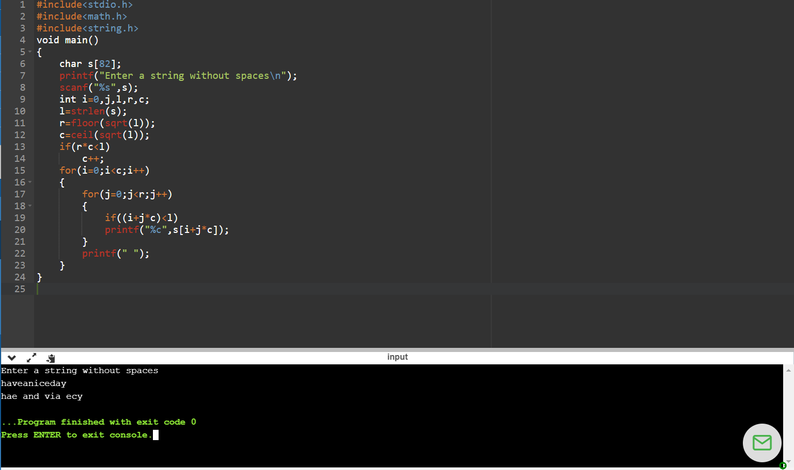

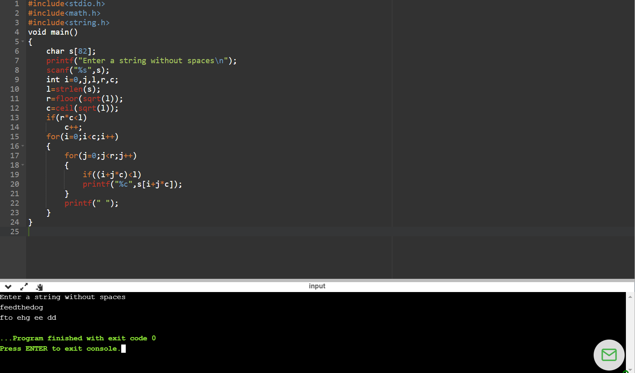

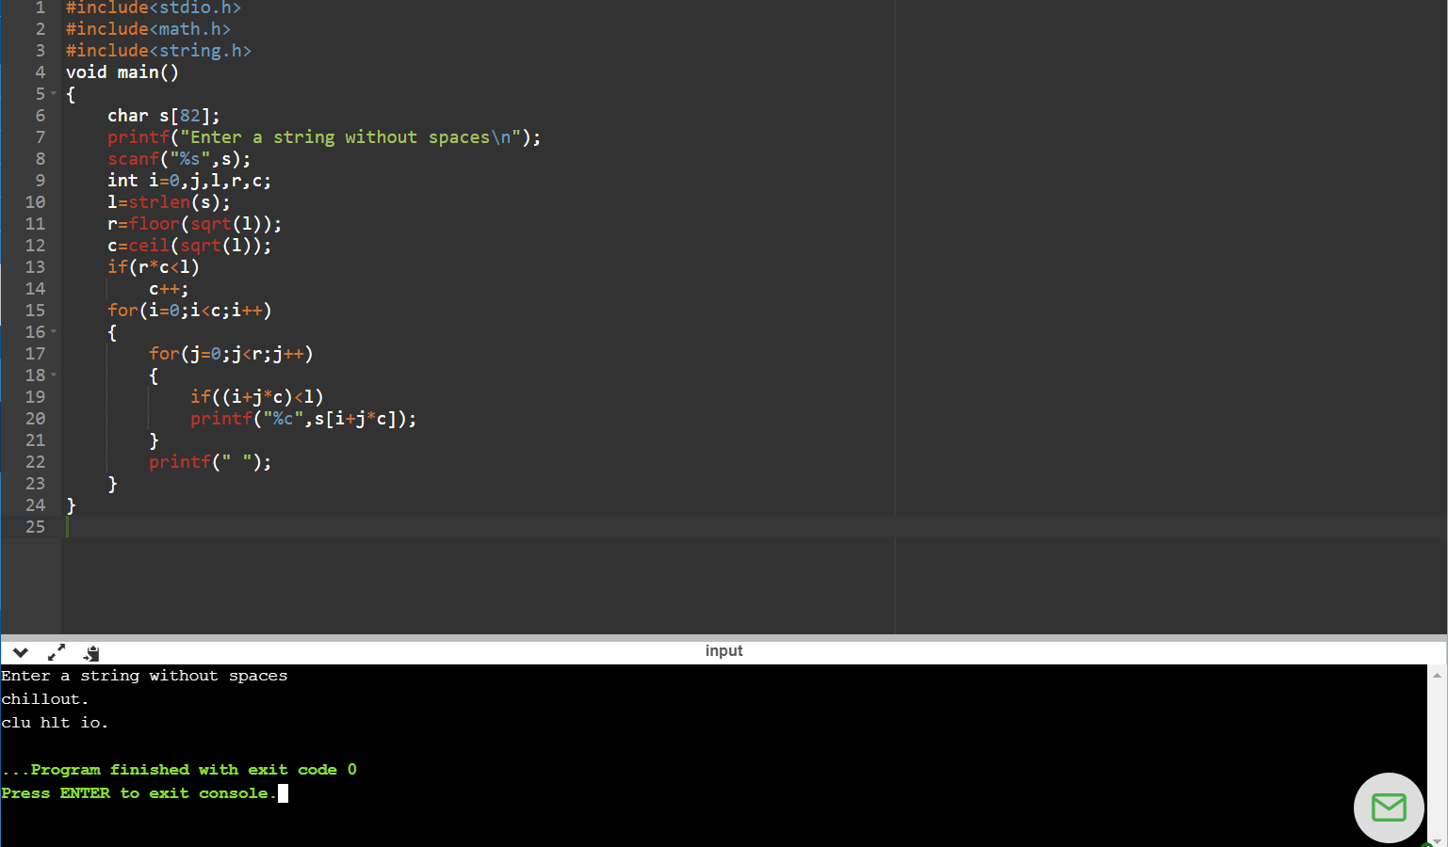

**CONCLUSION**

**The given string is converted into a secret code.**