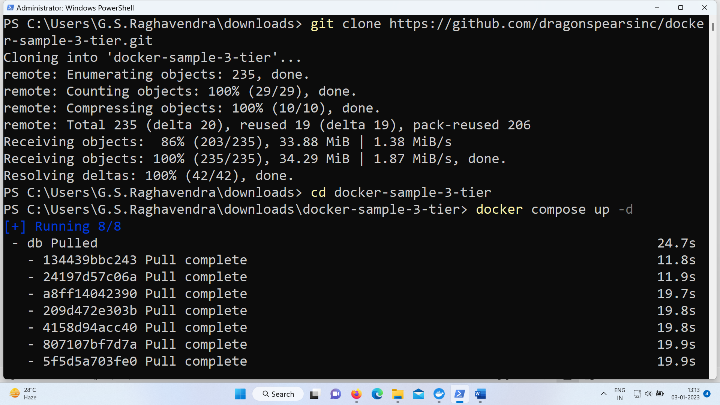
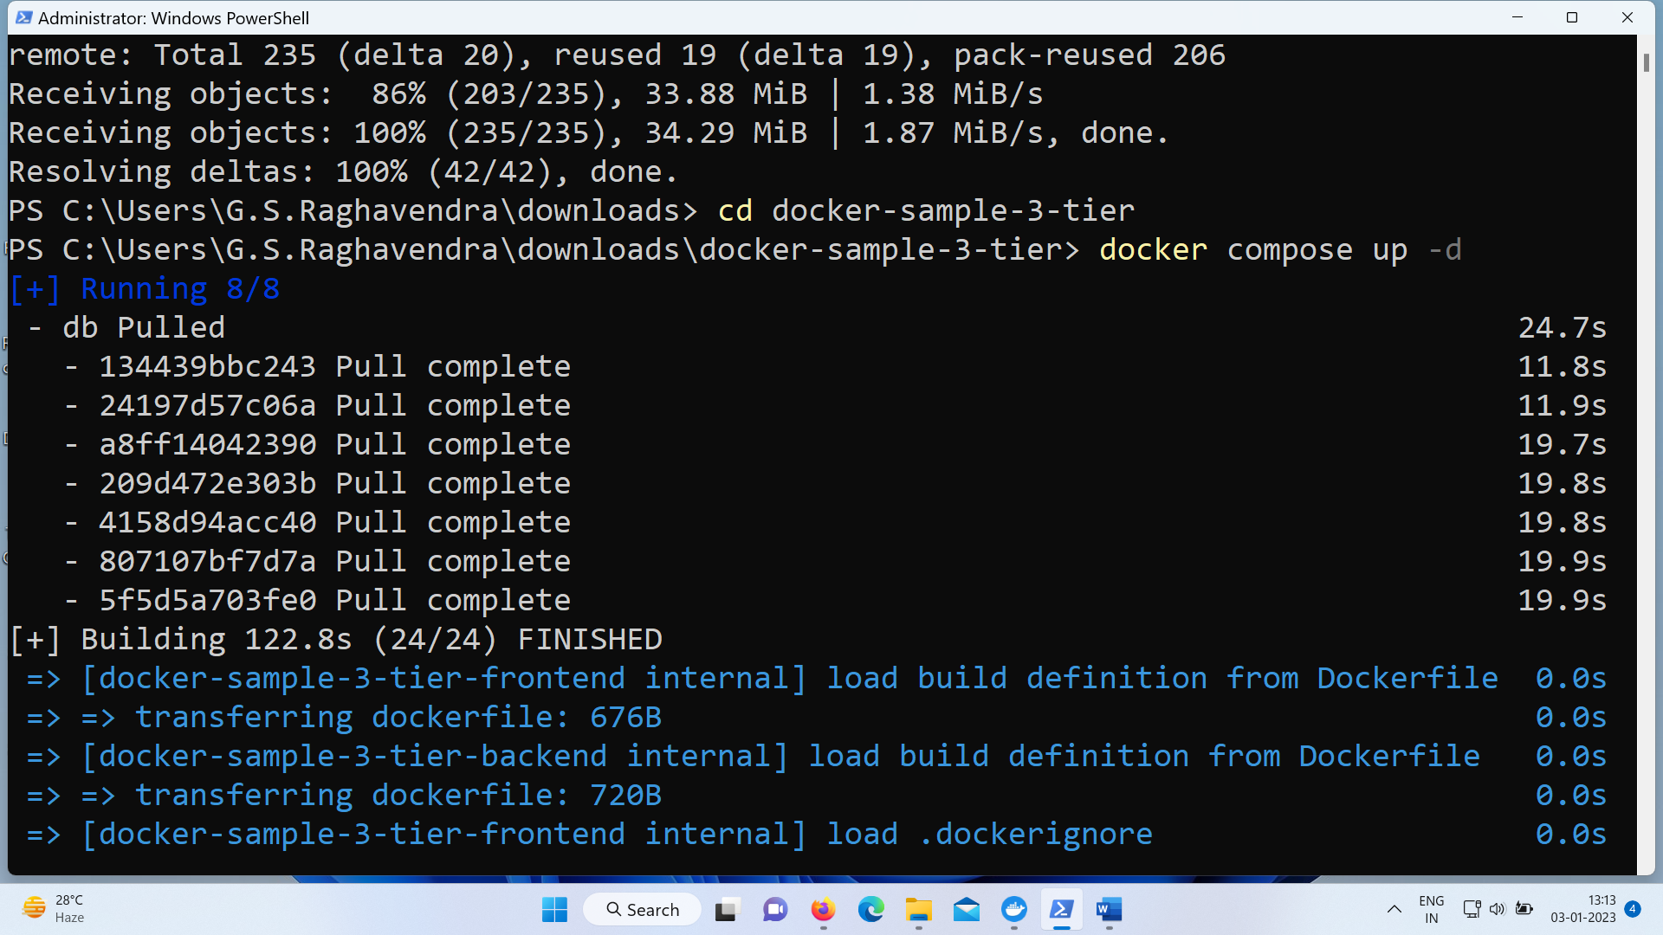
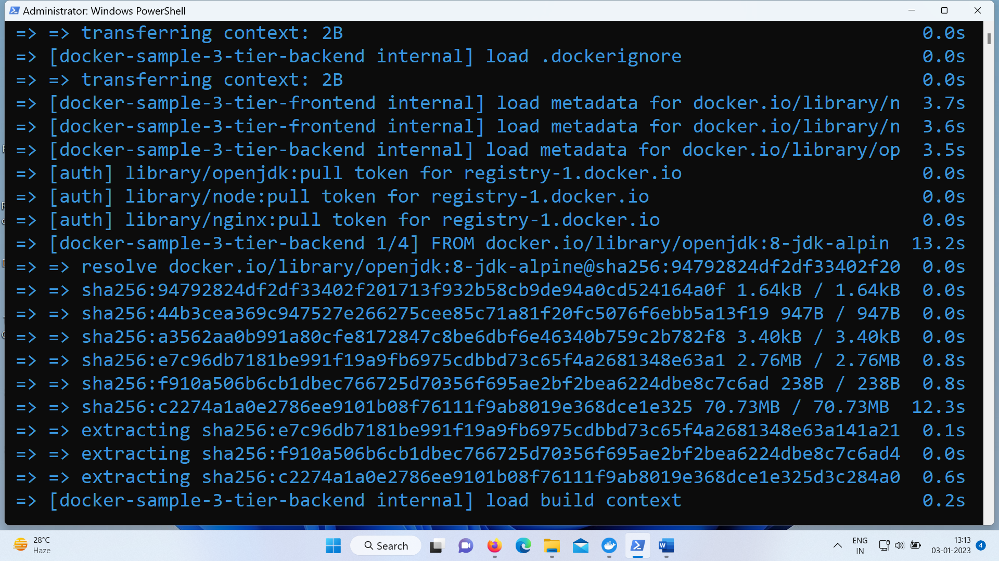
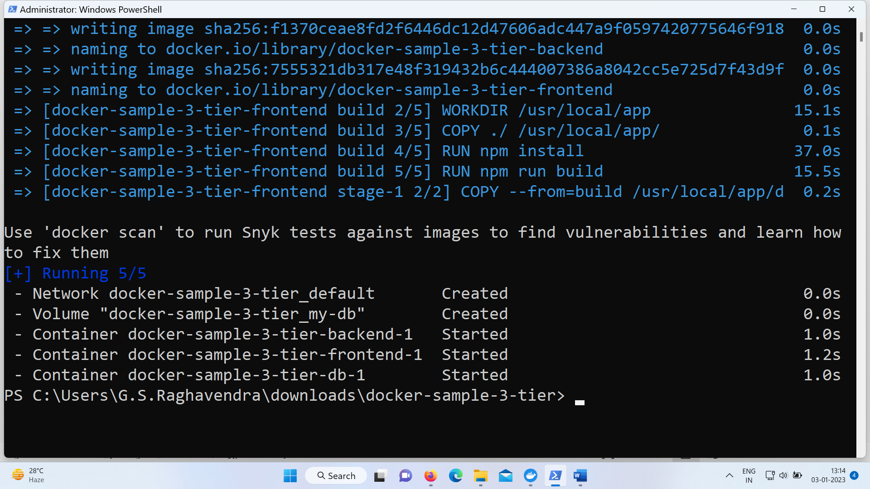
Docker Compose
An application can consist of multiple containers running different services. It can be tedious to start and manage containers manually, so Docker created a useful tool that helps speed up the process - Docker Compose.Docker Compose is software used for defining and running multi-container Docker applications. It can handle multiple containers simultaneously in the production, staging, development, testing, and CI environment. Therefore, use Docker Compose to manage the whole software development lifecycle (SDLC).
Docker Compose works by applying rules defined in a docker-compose.yaml file. The YAML file configures the application's services and includes rules specifying how you want them to run. With the file in place, you can start, stop, or rebuild all the services using a single command. Additionally, you can check the status of a service, display log outputs, and run one-off commands.
