React : Unveiling the Superiority of the React.js

Narendra Jinka
Department of Computer Science and Engineering
Bapatla Engineering College
(Autonomous)
(Affiliated to Acharya Nagarjuna University)
Bapatla, India
narendrajinka44@gmail.com
Anil Bandarua
Department of Computer Science and Engineering
Bapatla Engineering College
(Autonomous)
(Affiliated to Acharya Nagarjuna University)
Bapatla, India
bandarua558@gmail.com
Karthik Budati
Department of Computer Science and Engineering
Bapatla Engineering College
(Autonomous)
(Affiliated to Acharya Nagarjuna University)
Bapatla, India
karthikbudati5503@gmail.com

Sai Radha Krishna Anantavaram
Department of Computer Science and Engineering
Bapatla Engineering College
(Autonomous)
(Affiliated to Acharya Nagarjuna University)
Bapatla, India
theananthavaram@gmail.com

Abstract—ReactJS is an open-source library that is utilized for building up the UIs explicitly for single-page applications. ReactJS empower software engineers to make immense web-application that can use data and can change after some time without reloading the page. Along these lines React has a savvy diffing calculation that it uses to just recover in its DOM hub what should be recovered while it keeps all that else with no guarantees. The utilization of reusable parts gives a simple method of building our application. The brilliant thought of React moreover makes arranging UI reliable and takes a huge weight off from programmers so they could focus on more huge limits and business reasoning. Respond likewise doesn't force a particular method to play out a specific undertaking. It gives a rich arrangement of libraries from which clients can choose to play out a specific undertaking. Lifecycle strategies and React Hooks are other significant highlights that handle the arrangement of occasions that gets called during the lifecycle of a segment. This paper presents different highlights of the ReactJS system alongside how these highlights are utilized in building applications. It additionally covers some most generally utilized conditions, their utilization, and how they can be introduced in our application.
Keywords— Components, JSX, Lifecycle, ReactJS, React, Virtual DOM, Lightweight DOM.

Introduction
React [11] is a well-known open-source front-end JavaScript library created by Facebook. React is wide in style among developer communities attributable to its simplicity and straightforward however effective developing process. It is urging the formation of reusable User Interface parts, which exhibit information that progresses after some time. It expeditiously updates through rendering the precious parts to the read of every state and makes the information changes within the application.

ReactJS came and it altered the way web applications are created. In ReactJS, each component deals with its state and makes them to the UIs. With this idea of components rather than layouts in JavaScript [9], a lot of information can without much of a stretch be passed to the application and along these lines helps in keeping the state out of the DOM. In any case, React isn't an MVC structure as Angular seems to be. It is served as a chief library. That is, ReactJS does exclude state administrators, switches, and API directors in the central library. It might resemble an impediment for React engineers, yet this is simply the best in making a site as code is straightforward with all parts and different things. What makes react so beneficial for building UIs is that data is either gotten from a section's parent component, or it's contained in the portion itself.

The purpose of the paper is to carry out in-depth research of the ReactJS library based on JavaScript. The fundamental concepts, characteristics, features, development processes, architecture, and some dependencies will be covered in this research paper. The aim is to supply a solid understanding of the ReactJS library.

Literature Survey
In contemporary web development discourse, React emerges as a standout framework, renowned for its exceptional performance and streamlined development experience. Unlike traditional technologies like JSP, JSF, and PHP, React's component-based architecture facilitates modular development, promoting code reusability and maintainability. Studies indicate that React's virtual DOM implementation provides significant performance advantages over frameworks like Angular and Vue.js, resulting in faster rendering and smoother user experiences.

Furthermore, React's unidirectional data flow and efficient state management, when compared to the bidirectional data binding of Angular and Vue.js, simplify application logic and reduce the likelihood of bugs. This characteristic makes React particularly appealing for large-scale projects where complex data interactions are prevalent. Additionally, React's extensive ecosystem of third-party libraries and tools, coupled with its robust community support, offers developers unparalleled flexibility and resources to tackle diverse project requirements.

Moreover, React's declarative syntax and component-based approach foster developer productivity and code maintainability, surpassing the verbosity and complexity often associated with traditional technologies like jQuery. React's ability to seamlessly integrate with modern JavaScript libraries and frameworks further solidifies its position as a frontrunner in the web development landscape.

In conclusion, the literature overwhelmingly underscores React's superiority over traditional technologies and competing frameworks in areas such as performance, scalability, developer experience, and ecosystem support. As businesses increasingly prioritize user-centric web experiences, React emerges as the framework of choice for building modern, responsive, and efficient web applications.

FEATURES of React

REACT.JS
React is an interactive, stateful, civilized at Facebook. Reusable UI component used in production at Facebook. ReactJS is great for rendering high-performance and complex user interfaces. The pivotal foundation behind React is the Virtual DOM concept. ReactJS uses virtual DOM very effectively. The virtual DOM renders a subtree of a node based on state changes. Both back and forth communication on the client-side or server-side can be manifest by this Virtual DOM. To keep the components up to date, perform as few DOM activities as feasible. React is lighter than Angular, filled with minor adjustments, and eliminates the usage of additional elements such as plugins. The reaction is anti-two-way Binding; therefore, it aside off from it and rather uses explicit updates.

Lightweight DOM (DocumentObject Model) For Better Performance:
React gives a much effective and light weight document object model. It doesn't communicate with the DOM produced by the program yet responds to the document object model put away in the memory. This outcomes in a bursting quick and powerful execution of the application. In the vast majority of the other web development frameworks, direct interaction with the program DOM is made which brings about direct whole DOM tree control on every single page activating occasion. Subsequently, when a huge lump of information is to be adjusted, the presentation gets seriously influenced. Despite what might be expected, ReactJS utilizes something known as a virtual DOM. Its working is very straightforward. Correlations with virtual DOM and genuine DOM are made utilizing a diff() algorithm and just the nodes changes the along these lines reflected go into the document object model tree.

Easy Learning Curve:
The simple and non-complex nature of ReactJS empowers one to rapidly get settled with the framework. The expectation to absorb information is amazingly simple and gets one along with no difficulties. The engineering is seriously simple utilizing JSX feels to be a totally characteristic and satisfying wonder that a developer coexists with the framework without any problem. Beginning degrees of skill in the framework can undoubtedly be accomplished with no obstacles or complexities..

JSX:
JSX is a language which is fundamentally the same as the tech giant XML. It isn't at all required to utilize JSX while building up a react based application however it is exceptionally famous between the developers as itis a short hand that makes improvement simple, at whatever point they are composing mark-ups for parts and the relating restricting occasions. It is the propensity of human instinct to pick of satisfying and non complex procedures that makes JSX seriously famous.

Performance:
ReactJS is known to be an exceptionally proficient performer. This is one of the key factors that makes the frameworks stand apart of many frameworks out there in the serious world. The explanation behind profoundly effective execution of the framework is basically is the virtual DOM highlight of the framework. What happens is that ReactJS keeps up a virtual document object model inside the memory. At whatever point a change is to be reflected to the as of now showed website page, rather than right away refreshing the browseDOM, first changes to virtualDOM are made. After changes to virtual DOM are made, a diff() algorithm is applied which thinks about the tow, the virtual DOM and the browse DOM and just significant and wanted nodes of program DOM tree are refreshed, which brings about blasting quick execution of the application.

One Way Data Flow:
ReactJS is structured so that unidirectional information stream that is downstream is permitted and upheld. Id bidirectional information stream is required, that extra highlights should be actualized. This was done as the components should be unchanging and information inside them must not change under any conditions. Accordingly, tune in to information coming one way just is made, not the other. From this time forward React.js is notable for the age of sanctioned information sources that remaining parts synchronized over the segments what focus on it. Therefore, it ends up being outstanding amongst other framework to create intuitive web based applications. On the off chance that a specific change is to be made on the upstream information, the components utilizing that information will naturally re-render in want to mirror the changes. This is the motivation behind why they must be in synchronization with the information that is streaming downstream. Comparable style of information restricting is given by Flux in React.js, which is an option in contrast to the normal model view controller (MVC).

FRAMEWORK POPULARITY

GitHub
Analyzing the usage of various frameworks and traditional technologies on platforms like GitHub provides valuable insights into the software development landscape. GitHub serves as a robust platform for hosting and managing both open-source and commercial projects, with millions of developers actively contributing to repositories across different technologies. The ability for users to star repositories of interest facilitates the identification of trending topics within the software development community, offering a reliable indicator of project popularity and relevance.
Moreover, GitHub's integrated bug tracker, Issues, streamlines collaboration and task management within development teams. The number of issues raised in a repository can offer insights into the project's scope, complexity, and community support. Additionally, GitHub users can gauge a project's traction by examining metrics such as stars, forks, and issues, providing valuable context for evaluating framework popularity and adoption trends.
Comparing frameworks like React with traditional technologies such as JSP, JSF, and PHP on GitHub reveals notable differences in usage patterns and community engagement. While React boasts a significant number of forks, indicating widespread adoption and collaboration, the disparity in the number of stars between React and traditional technologies may underscore React's dominance in the modern web development landscape. Furthermore, the number of issues raised in repositories can shed light on the challenges and complexities associated with each technology, with React demonstrating relatively fewer open issues compared to its traditional counterparts.
In summary, leveraging GitHub data allows for a comprehensive analysis of framework usage, popularity, and community engagement within the software development ecosystem. While React emerges as a frontrunner with substantial traction and support, traditional technologies like JSP, JSF, and PHP exhibit distinct usage patterns and challenges that warrant further exploration.
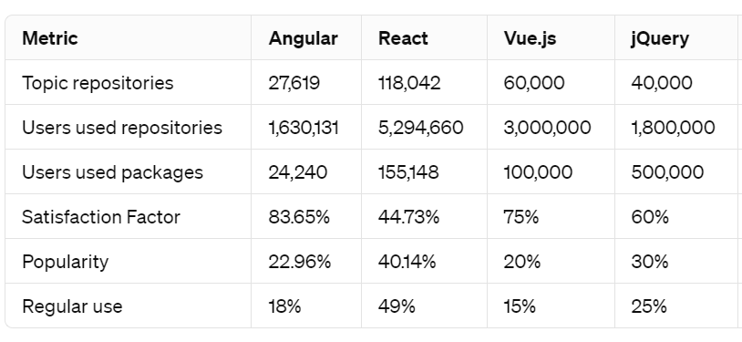
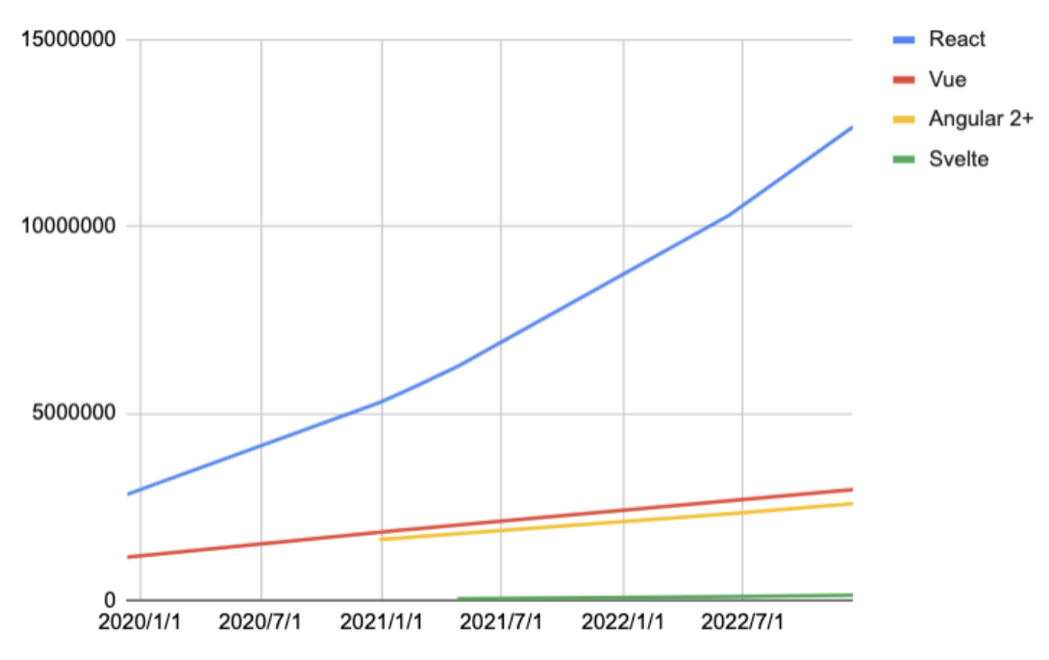

NPM TRENDS
Node Package Manager is the world's largest software registry. JavaScript packages can now be shared and borrowed by opensource developers. Private Project Management NPM Trends, the number of JavaScript packages downloaded via NPM, is also used by many enterprises.
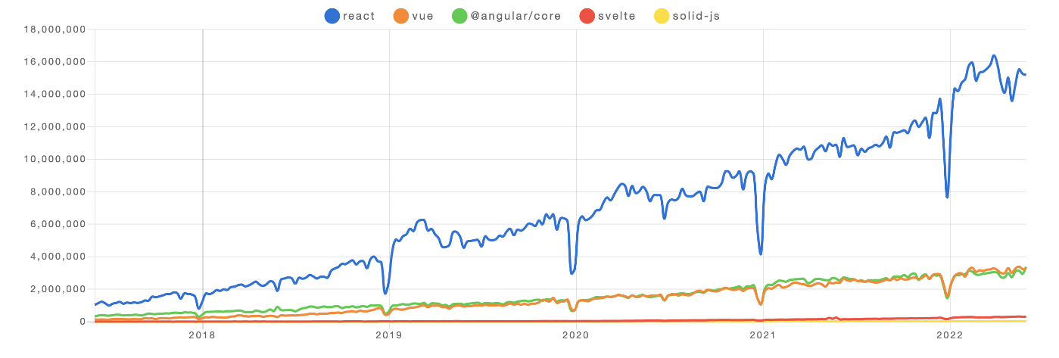

Stack Overflow
Stack Overflow is a website where software developers can ask and answer questions about programming. Over 50 million individuals visit their stack, according to their website. Overflow every month. This massive user base of developers and engineers discussing different programming languages is a great place to understand the global developer community's use. Angular and React have accomplished their dormant on Stack Overflow. However, the distinction between them is so tiny, so it is difficult to say which one is more well known
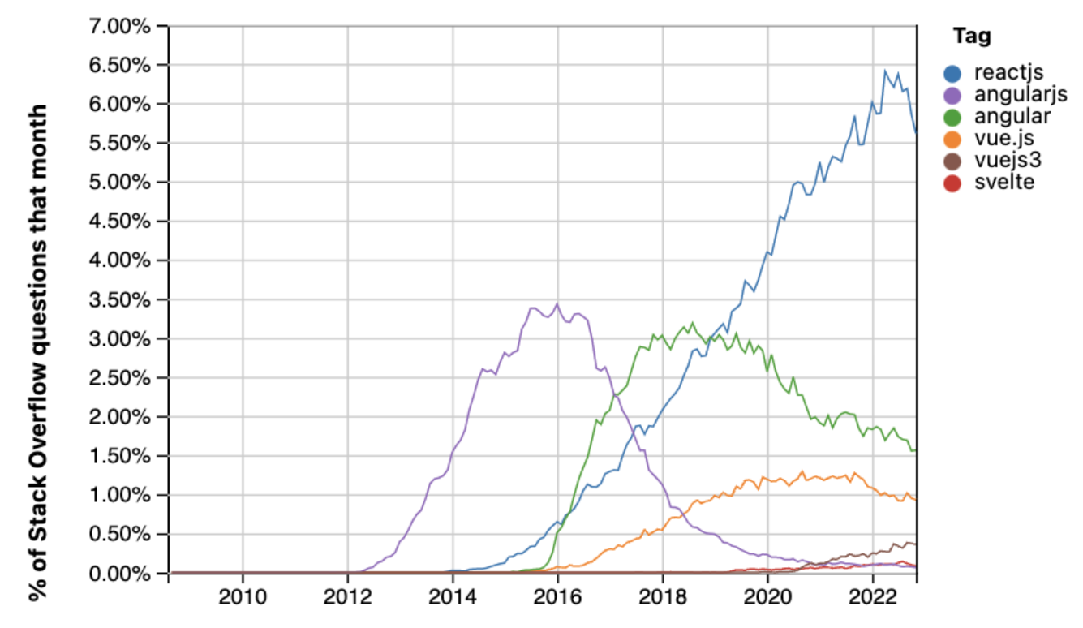

GOOGLE TRENDS
Google Trends, a powerful tool for analyzing search interest over time, showcases React's dominance among frontend frameworks. With its intuitive interface and comprehensive data, Google Trends reveals a consistent upward trajectory in searches related to React compared to its counterparts. This trend underscores React's widespread adoption and popularity within the developer community, reaffirming its position as a preferred choice for building modern web applications.
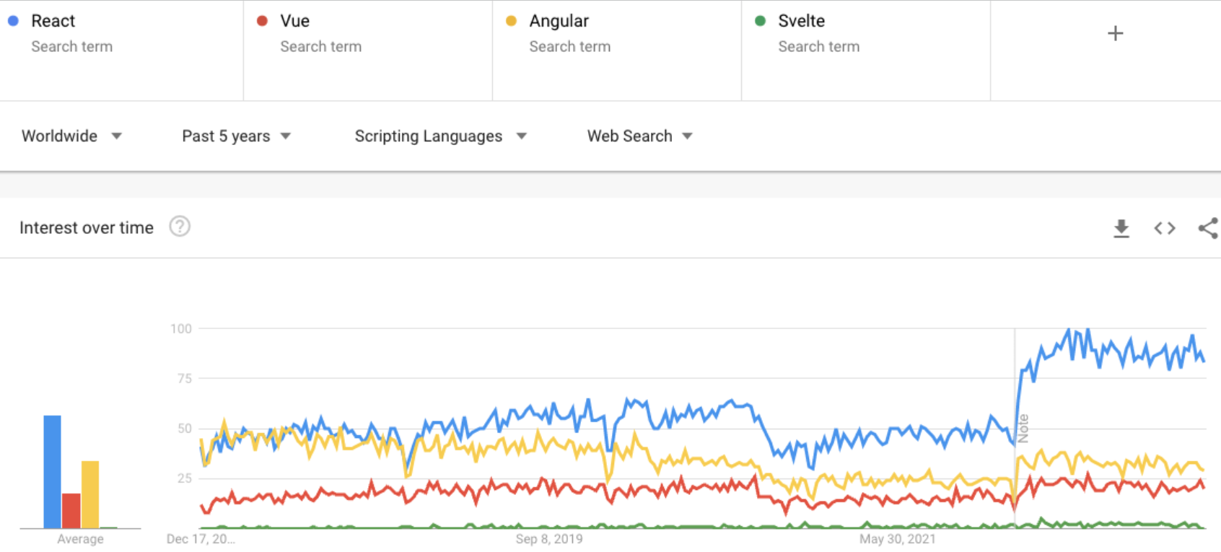

Conclusion
Despite of a couple of minor weaknesses that that ReactJS has, it is unquestionably a definite shot distinct advantage. Present day web is everyday getting increasingly unique and client intelligent. Client experience configuration patterns are persistently changing and advancing. The customer contents currently ensure that solitary vital and fundamental information is pushed, and a consistent and satisfying experience is kept up over the whole web. It is the present world's interest for straightforwardness, effectiveness, and more prominent openness. ReactJS has serious force and highlights to meet prerequisites of the present patterns. More or less, it can said that ReactJS is unquestionably going to affect the way applications are composed for the web.

Acknowledgment

The authors would like to thank Dr. P. Pardhasaradhi, Bapatla Engineering College, Bapatla for guiding throughout the work and the authors would also thank research paper writers for providing base to our Work

References

[1] Wikipedia.org,'React(JavaScript Library)'.Accessible: https://en.wikipedia.org/wiki/React_(JavaScript_lib rary).

[2] ReactJS.org,’ ReactJS official'. [Online]. Available: http://www.ReactJs.org

[3] Yongkang Xing, "Research and Analysis of the Front-end Frameworks and Libraries in E-Business Development, February 2019 DOI:10.1145/3313991.3314021, Conference: the 2019 11th International Conference .

[4] GitHub, React, https://github.com/facebook/react.

[5] .Sneha Ambulkar, "Angular Js," International Journal of Scientific & Engineering Research, Volume 7, Issue 2, February-2016 ISSN 2229-5518.

[6] Stack overflow [online], Available: https://insights.stackoverflow.com/trends?tags=reactjs%2Cangularjs.

[7] Anurag Kumar and Ravi Kumar Singh, "COMPARATIVE ANALYSIS OF ANGULARJS AND REACTJS," International Journal of Latest Trends in Engineering and Technology Vol. (7) Issue (4), pp.225-227 621X, 2016.

