|  |
| --- |
| **HCL – PKG TeAM** |
| **Problems & Solutions** |
| **Q&A** |
|  |
|  |
|  |

|  |
| --- |
| This document explains the problems and solutions to do troubleshooting during the package release activities. |

Contents

Problem 1: Jenkins is not working 3

Problem 2: Time out Error in Tera Term. 3

Problem 3: File not found error in TeraTerm. 4

Problem 4: Unreadable Log files in TeraTerm. 4

Problem 5: Configuration Failed while connecting 2160 4

Problem 6: Digital Tuning consumes more time in GA01/GA02 5

Problem 7: Receive Format Error / Timeout Error. 6

Problem 8: Analogue Channels are NOT received in Board/Panel 7

Problem 9: Log is not printed in TeraTerm 8

Problem 10: IPTV/Music Search is not launched properly and RIC looping continuously 8

Problem 11: Exception Occurs after Analog/Digital Tuning from NUX in EU region. 9

Problem 12: Exception occurs when performing “ i- manual “ test in Japan board/panel 10

Problem 13: Unable to play media contents in the panel via Home network 10

Problem 14: Unable to play Music & Video from media player. 11

Problem 15: In Jenkins, Building PKG’s consumes more time. 11

Problem 16: Space issue in 88 server. 11

Problem 17: Error while upgrading PKG through USB. 12

Problem 18: Unable to start JIRA in 8080 port. 12

Revision History 12

### Problem 1: Jenkins is not working

**Problem Description:**

Below error is appearing while NFS image boot.

[ 60.427165] Root-NFS: Unable to get mountd port number from server, using default

[ 95.425409] mount: server 0.0.0.16 not responding, timed out

[ 95.431136] Root-NFS: Server returned error -5 while mounting /tftpboot/PKG/NFS

[ 95.438538] VFS: Unable to mount root fs via NFS, trying floppy.

[ 95.444995] VFS: Cannot open root device "<NULL>" or unknown-block(2,0)

[ 95.451676] Please append a correct "root=" boot option; here are the available partitions:

[ 95.460050] Kernel panic - not syncing: VFS: Unable to mount root fs on unknown-block(2,0)

[ 95.468332] Rebooting in 180 seconds...

This Problem appears normally with NFS service.

**Solution:**

Restart the NFS service then boot the image

1. Login to the Putty 2. Boot

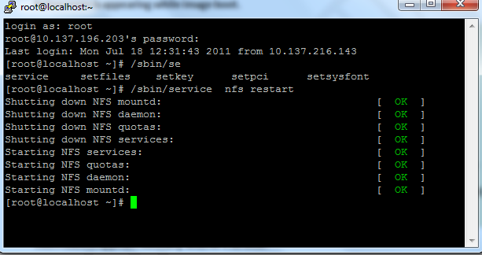

### Problem 2: Time out Error in Tera Term.

**Problem Description:**

Below error is appearing while flashing the image.

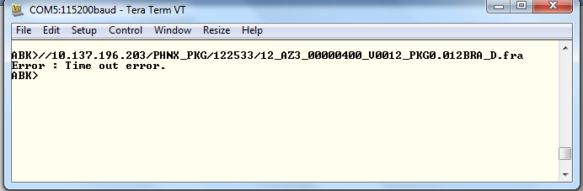

**Solution:**

This error normally appears when Network is down or Network (LAN) is not connected

* Make sure that Network cable is connected
* Ping the server to make sure that Network is up.
* If port is fine and image is flashing then green LED will glow.

### Problem 3: File not found error in TeraTerm.

**Problem Description:**

Below error is appearing while flashing the image.

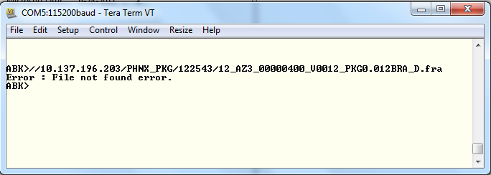

**Solution:**

This error normally appears when file is not there in specified location or path name is incorrect.

* Make sure path and file name is correct.

### Problem 4: Unreadable Log files in TeraTerm.

**Problem Description:**

Log file cannot be in read in Tera Term.

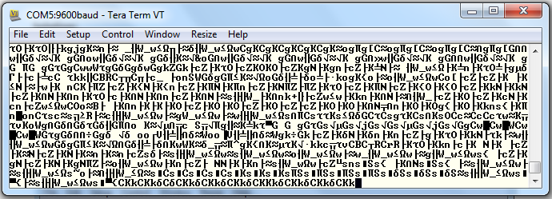

**Solution:**

Please make sure that Baud rate is 115200.

Go to Setup 🡪 Serial port 🡪 Select Baud rate =115200 readable logs will appear.

### Problem 5: Configuration Failed while connecting 2160

**Problem Description:**

We need to do Refresh Internet content when we want to perform IPTV, Widget tests etc.

**Configuration failed while connecting 2160** Error will appearing when we do that.

**Solution:**

* Remove the Signal cable
* Power OFF then Power ON the board again.

**Background:**

When we do the Refresh Internet content  DTV compares the Date & Time in house signal and Network. If it is not matching it will through the Error “**Configuration Failed while connecting 2160**”

So we need to remove signal cable to solve this issue.

### Problem 6: Digital Tuning consumes more time in GA01/GA02

**Problem Description:**

During the daily smoke test we found digital tuning takes more time (i.e more than 30 minutes).

It will delay the daily smoke test release.

**Solution:**

Select Australia Region during **Initial Setup**. Follow the steps below and move forward with initial setup.

**Step 1:**

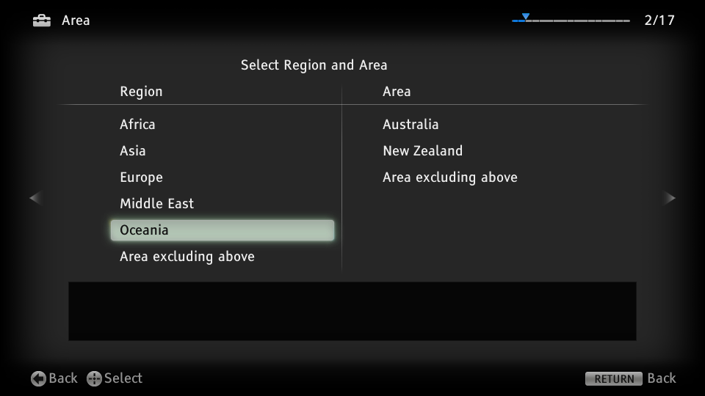

**Step 2:**

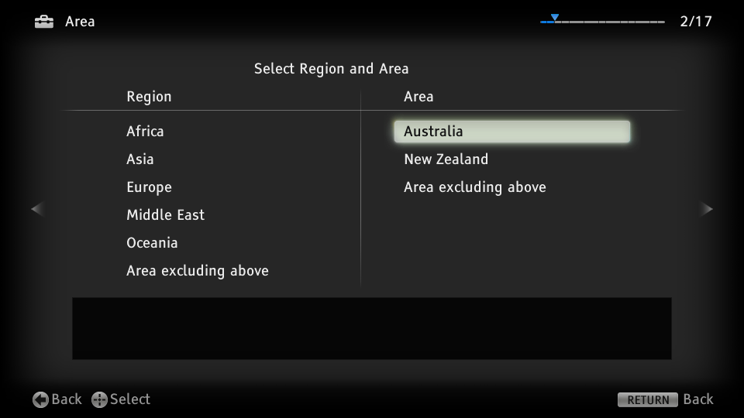

**Step 3:**

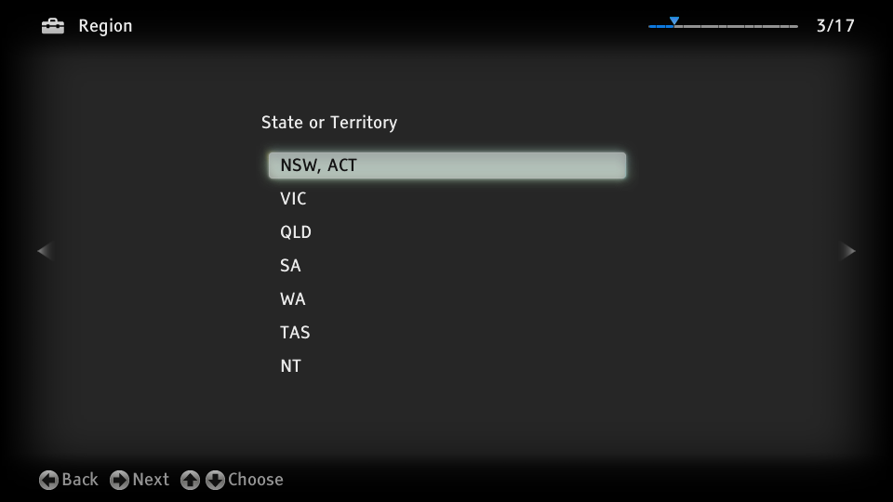

### Problem 7: Receive Format Error / Timeout Error.

**Problem Description:**

When we flash the board we are getting the Error below

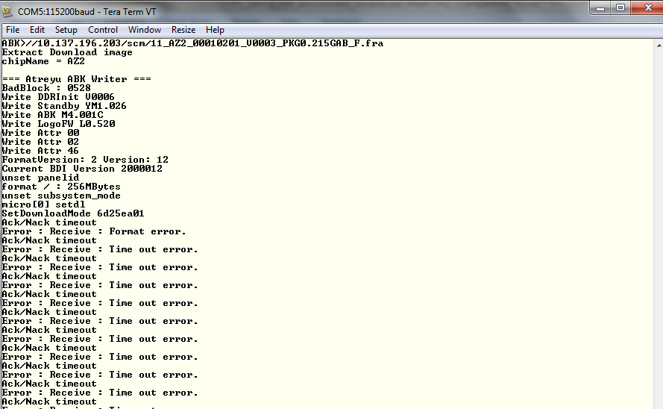

**Background:**

* This Error is due to Panel image is being downloaded to the board.

**Solution:**

* Make sure that **D version** of image for board 11_AZ2_00010201_V0003_PKG0.215GAB_**D**.fra
* If you are using F image please use –nomicro0 when you flash image

**ABK://10.137.196.203/scm/11_AZ2_00010201_V0003_PKG0.215GAB_F.fra –nomicro0**

**NOTE: Also we received the same Error due to port is having some problem when we connect to another location this problem got it fixed.**

### Problem 8: Analogue Channels are NOT received in Board/Panel

**Problem Description:**

When we do tuning from the NUX Analogue Channels are not tuned.

**Background:**

* This Error is due to Antenna is not Selected in Settings.ie Analogue channels are available only in Antenna when signal cable is connected to the Antenna in board/panel.

**Solution:**

Select Antenna in Settings menu.

Settings 🡪 Analog Setup ->Cable/Antenna ->**Antenna**

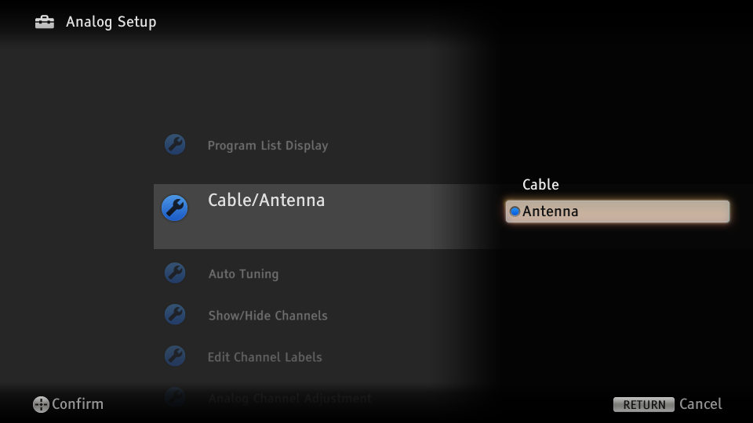

### Problem 9: Log is not printed in TeraTerm

**Problem Description:**

Logs are not printed in tera term.

**Solution:**

* Check the log cable is connected properly.
* Check ABK Settings message ON.

### Problem 10: IPTV/Music Search is not launched properly and RIC looping continuously

**Problem Description:**

RIC will be repeatedly asked when we try IPTV/Music Search test and Internet

Content cannot be retrieved due to board environment issue.

Steps:

1.RIC is performed.

2."Internet Content is ready. Press HOME to display the menu" Msg is

displayed.

3.Select BRAVIA Internet Video from NUX-> Internet Content.

4.Again RIC is performing Internet content will not be retrieved from BRAVIA

Internet Video

**Background:**

* This Error is due to boards are not registered with BIVL Server.
* We need to register device id and mac address to BIVL develop server
* TKY SQA will be the point of contact for this activity contact HCL SQA for PIC and send the board detail in below format.

Set Number : CVTAZ3-TRL2SEPT-11

Board type : BAPS-P2A-FHD-S-CH-5/Panel

MAC Address : 30:F9:ED:45:D9:66

Device ID : B0:00:00:5A:44:36

**Solution:**

Register device id and mac address of the board with BIVL server.

### Problem 11: Exception Occurs after Analog/Digital Tuning from NUX in EU region.

**Problem Description:**

Exception occurs in DVB-AEP-C2/NO NORDIC after Digital/analogue tuning by NUX and when performing Channel/volume change continuously for some time.

Steps:

1. Flash the image  
2.Complete the Initial setup with A/D Tuning  
3. Perform A/D  Tuning in NUX  
4.Perform Volume Up/Down then change Channels using Up/down key  
5.Exception will occur during step 3 or 4.

NOTE: Refer Saber DM #4962

<https://esaber-dm.dtv.sony.co.jp/SaberDM/DefectView.aspx?Bilingual=false&Project=12W_AZ3_Core&id=4962>

**Background:**

* This Error is due to faulty flexi cable.
* Improper switch combinations in the MONI-Z board
* The correct switch combinations are shown below

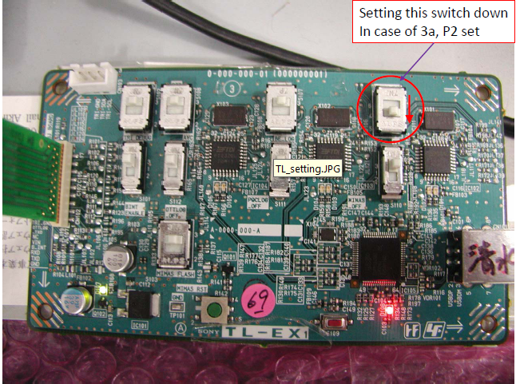

* Read the below mail’s for detailed information.



**Solution:**

Replace the flexi cable with a proper cable and follow correct switch combinations.

### Problem 12: Exception occurs when performing “ i- manual “ test in Japan board/panel

**Problem Description:**

Exception occurs when performing “ i- manual “ test in Japan board/panel

Steps:

1. In Japan board /Panel Japanese language in converted to English by using

“ dtdebugfunc x2 setlang gae “

1. I manual test is performed

**Background:**

* This Error is due to the change in language from Japanese to english

**Solution:**

Perform I manual test without converting Japanese to English .

### Problem 13: Unable to play media contents in the panel via Home network

**Problem Description:**

Unable to play media contents ( Music , picture or video ) in the panel via network , and it is unable to detect the local server used to perform the above test

**Background:**

* This Error is due to the error in ” Modelname” of the panel .
* **Solution:**

Please confirm the” Modelname” before you start the Execution in panels. If the “Modelname” is in red colour, we are not able to execute some features like Wi-Fi direct. The procedure to check the model name is given below.

* Enter service mode
  + Set AC plug
  + If power is on, power off by remote commander(RC)
  + Push RC “DISPLAY →”5” →”vol +” → “Power” quickly.
  + TV set become power on and display service mode menu
* Change model name
  + Push RC “1” 3times
    - Menu will change “ 001 OP / 000 VERS”→”002 MODEL / 000 SEG” →”002 MODEL / 001 DEST” →”002 MODEL / 002 MODELNAME”
    - You can see current setuped model name.
      * “002 MODELNAME KDL-26EX540”
  + Select right model name by using RC“3” and “6”
    - Model name in red is wrong modelname cid:image001.png@01CD012C.16136110
    - Model name in green is right modelname cid:image002.png@01CD012C.16136110
  + Push RC “MUTE/消音”→”0” to execute change model name.
    - Wait until turn off  red word “writing” .
  + ACOff

### Problem 14: Unable to play Music & Video from media player.

**Problem Description:**

Unable to play Music & Video from media player. “Music file cannot be played” message is displayed.

**Background:**

* If the special configuration command " **force_extdec 'on'** " is present in ABK settings, this issue is observed.

**Solution:**

Unset the command " **force_extdec 'on'** " from ABK settings before performing the test.

### Problem 15: In Jenkins, Building PKG’s consumes more time.

**Problem Description:**

In Jenkins Building PKGs consumes more time during Weekly and Daily Release.

**Background:**

* Many Jobs were running in same slave, hence there was delay in PKG builds.

**Solution:**

Slaves were modified so that each job will be running in different server.

### Problem 16: Space issue in 88 server.

**Problem Description:**

Space issue in 88 server, hence we were unable to share latest PKG’s with other teams.

**Background:**

* 88 Server Hard Disk was almost full..

**Solution:**

Requested and received an additional Hard Disk of 1 TB for 88 server.

### Problem 17: Error while upgrading PKG through USB.

**Problem Description:**

PKG will not upgrade properly from USB and CMAC error is displayed in Log.

**Background:**

* PKG is not copied properly to USB
* USB is corrupted.

**Solution:**

* Copy the PKG properly and Safe remove from PC.
* Use working USB.

### Problem 18: Unable to start JIRA in 8080 port.

**Problem Description:**

Unable to start JIRA in 8080 port as some other process was using the port.

**Background:**

The process with PID 2692 was using the port 8080 hence not able to start JIRA.

**Solution:**

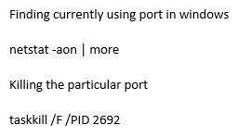

# Revision History

|  |  |  |  |
| --- | --- | --- | --- |
| **No** | **Author** | **Description** | **Date** |
| 1 | Mohanraj Vellingiri | First Draft | 19/07/2011 |
| 2 | Mohanraj Vellingiri | Added Problem 5 | 27/07/2011 |
| 3 | Mohanraj Vellingiri | Added Problem 6 | 01/08/2011 |
| 4 | Mohanraj Vellingiri | Added Problem 8&9 | 01/10/2011 |
| 5 | Mohanraj Vellingiri | Added Problem 10 | 14/11/2011 |
| 6 | Naveen Kumar K | Added Problem 11 | 9/12/2011 |
| 7 | Naveen Kumar K | Added Problem 12 | 16/02/2012 |
| 8 | Naveen Kumar K | Added Problem 13 | 14/03/2012 |
| 9 | Swetha S | Added Problem 14 | 10/12/2013 |
| 10 | Vidya. S | Added Problem 15 & 16 | 24/01/2014 |
| 11 | Swetha S | Added Problem 17 | 25/07/2014 |
| 12 | Balakumar Raamiya | Added Problem 18 | 16/07/2018 |