**PAMIDI NARENDRA**

**(192224128)**

**LAB PROGRAMS WITH OUTPUTS**

**EXPERIMENT:1**

**PROGRAM:** confusion matrix

import numpy as np

from sklearn.metrics import confusion_matrix

import seaborn as sns

import matplotlib.pyplot as plt

actual = np.array(['Dog','Dog','Dog','Not Dog','Dog','Not Dog','Dog','Dog','Not Dog','Not Dog'])

predicted = np.array(['Dog','Not Dog','Dog','Not Dog','Dog','Dog','Dog','Dog','Not Dog','Not Dog'])

cm = confusion_matrix(actual, predicted)

sns.heatmap(cm, annot=True, fmt='g', xticklabels=['Dog','Not Dog'], yticklabels=['Dog','Not Dog'])

plt.ylabel('Prediction')

plt.xlabel('Actual')

plt.title('Confusion Matrix')

plt.show()

**OUTPUT:**

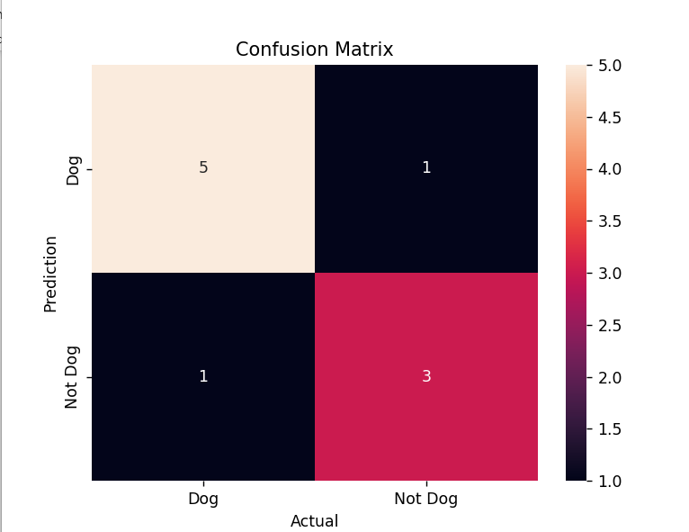

**EXPERIMENT:2**

**PROGRAM:** 2 class confusion matrix

from sklearn.datasets import load_breast_cancer

from sklearn.model_selection import train_test_split

from sklearn.tree import DecisionTreeClassifier

from sklearn.metrics import confusion_matrix, accuracy_score, precision_score, recall_score, f1_score

import seaborn as sns

import matplotlib.pyplot as plt

# Load the breast cancer dataset

X, y = load_breast_cancer(return_X_y=True)

X_train, X_test, y_train, y_test = train_test_split(X, y, test_size=0.25)

# Train the model

tree = DecisionTreeClassifier(random_state=23)

tree.fit(X_train, y_train)

# Prediction

y_pred = tree.predict(X_test)

# Confusion matrix

cm = confusion_matrix(y_test, y_pred)

# Plot the confusion matrix

sns.heatmap(cm, annot=True, fmt='g', xticklabels=['malignant', 'benign'], yticklabels=['malignant', 'benign'])

plt.ylabel('Prediction')

plt.xlabel('Actual')

plt.title('Confusion Matrix')

plt.show()

# Calculate and display metrics

print("Accuracy :", accuracy_score(y_test, y_pred))

print("Precision :", precision_score(y_test, y_pred))

print("Recall :", recall_score(y_test, y_pred))

print("F1-score :", f1_score(y_test, y_pred))

**OUTPUT:**

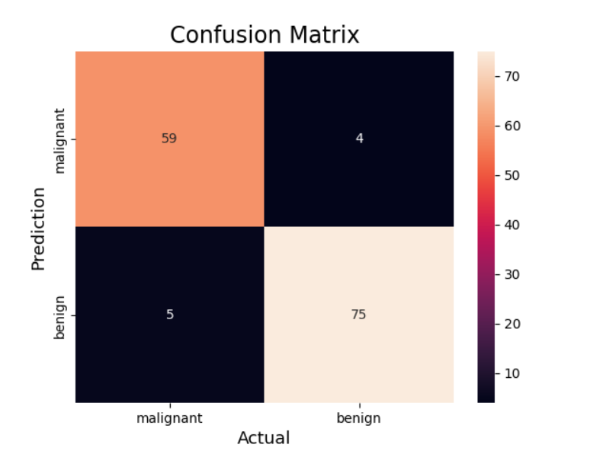

**EXPERIMENT:3**

**PROGRAM:** multi class confusion matrix

from sklearn.datasets import load_digits

from sklearn.model_selection import train_test_split

from sklearn.ensemble import RandomForestClassifier

from sklearn.metrics import confusion_matrix, accuracy_score

import seaborn as sns

import matplotlib.pyplot as plt

# Load the digits dataset

X, y = load_digits(return_X_y=True)

X_train, X_test, y_train, y_test = train_test_split(X, y, test_size=0.25)

# Train the model

clf = RandomForestClassifier(random_state=23)

clf.fit(X_train, y_train)

# Prediction

y_pred = clf.predict(X_test)

# Confusion matrix

cm = confusion_matrix(y_test, y_pred)

# Plot the confusion matrix

sns.heatmap(cm, annot=True, fmt='g')

plt.ylabel('Prediction')

plt.xlabel('Actual')

plt.title('Confusion Matrix')

plt.show()

# Calculate and display accuracy

print("Accuracy:", accuracy_score(y_test, y_pred))

**OUTPUT:**

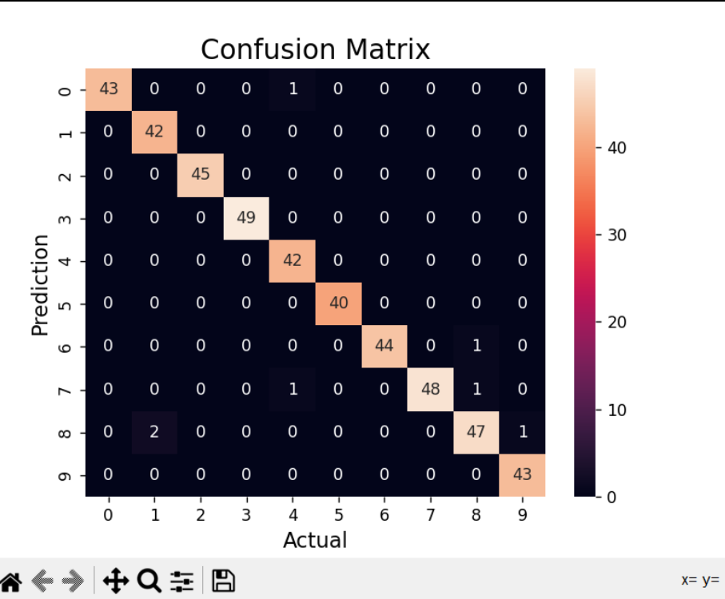

**EXPERIMENT:4**

**PROGRAM:** over fitting

from sklearn.datasets import load_digits

from sklearn.model_selection import train_test_split

from sklearn.ensemble import RandomForestClassifier

from sklearn.metrics import confusion_matrix, accuracy_score

import seaborn as sns

import matplotlib.pyplot as plt

# Load the digits dataset

X, y = load_digits(return_X_y=True)

X_train, X_test, y_train, y_test = train_test_split(X, y, test_size=0.25)

# Train the model

clf = RandomForestClassifier(random_state=23)

clf.fit(X_train, y_train)

# Prediction

y_pred = clf.predict(X_test)

# Confusion matrix

cm = confusion_matrix(y_test, y_pred)

# Plot the confusion matrix

sns.heatmap(cm, annot=True, fmt='g')

plt.ylabel('Prediction')

plt.xlabel('Actual')

plt.title('Confusion Matrix')

plt.show()

# Calculate and display accuracy

print("Accuracy:", accuracy_score(y_test, y_pred))

**OUTPUT:** 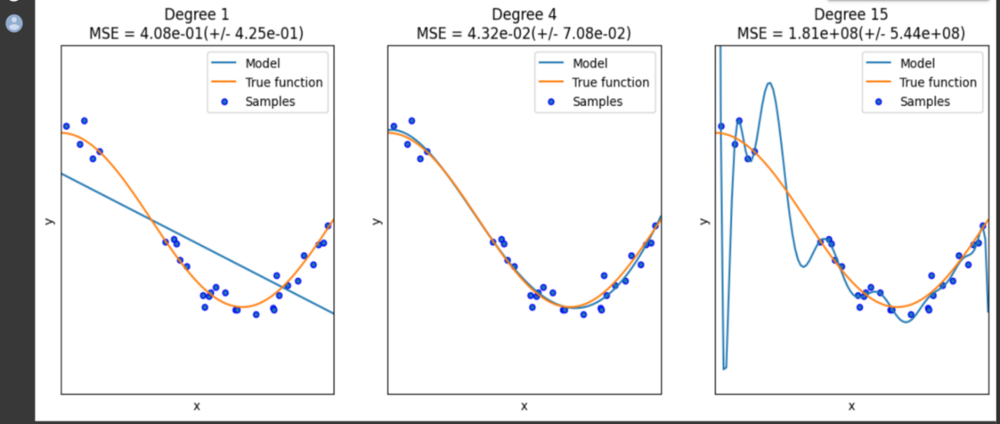

**EXPERIMENT:5**

**PROGRAM: LINEAR REGRESSION**

import numpy as np

import matplotlib.pyplot as plt

from sklearn.pipeline import Pipeline

from sklearn.preprocessing import PolynomialFeatures

from sklearn.linear_model import LinearRegression

from sklearn.model_selection import cross_val_score

def true_fun(X):

return np.cos(1.5 * np.pi * X)

np.random.seed(0)

n_samples = 30

degrees = [1, 4, 15]

X = np.sort(np.random.rand(n_samples))

y = true_fun(X) + np.random.randn(n_samples) * 0.1

plt.figure(figsize=(14, 5))

for i, degree in enumerate(degrees):

ax = plt.subplot(1, len(degrees), i + 1)

plt.setp(ax, xticks=(), yticks=())

# Create and fit the model pipeline

model = Pipeline([

("polynomial_features", PolynomialFeatures(degree=degree, include_bias=False)),

("linear_regression", LinearRegression())

])

model.fit(X[:, np.newaxis], y)

# Cross-validation scores

scores = cross_val_score(model, X[:, np.newaxis], y, scoring="neg_mean_squared_error", cv=10)

# Plot model, true function, and samples

X_test = np.linspace(0, 1, 100)

plt.plot(X_test, model.predict(X_test[:, np.newaxis]), label="Model")

plt.plot(X_test, true_fun(X_test), label="True function")

plt.scatter(X, y, edgecolor="b", s=20, label="Samples")

plt.xlabel("x")

plt.ylabel("y")

plt.xlim((0, 1))

plt.ylim((-2, 2))

plt.legend(loc="best")

plt.title(f"Degree {degree}\nMSE = {-scores.mean():.2e}(+/- {scores.std():.2e})")

plt.show()

**OUTPUT:**

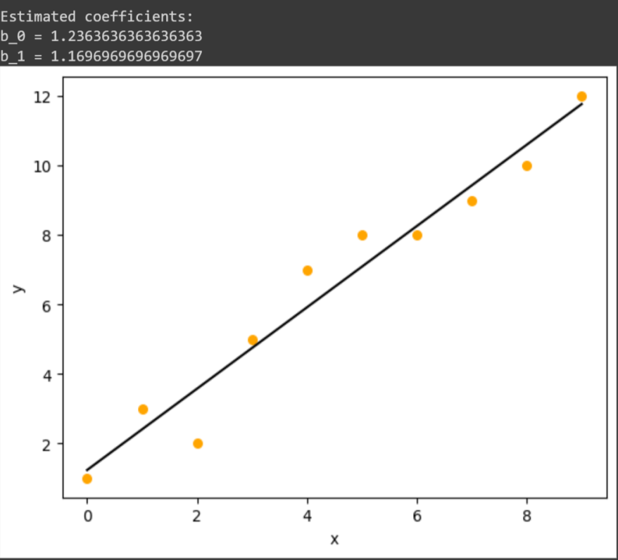

**EXPERIMENT:6**

**PROGRAM:** logistic regression

import numpy as np

import matplotlib.pyplot as plt

def sigmoid(z):

    return 1 / (1 + np.exp( - z))

plt.plot(np.arange(-5, 5, 0.1), sigmoid(np.arange(-5, 5, 0.1)))

plt.title('Visualization of the Sigmoid Function')

plt.show()

**OUTPUT:**

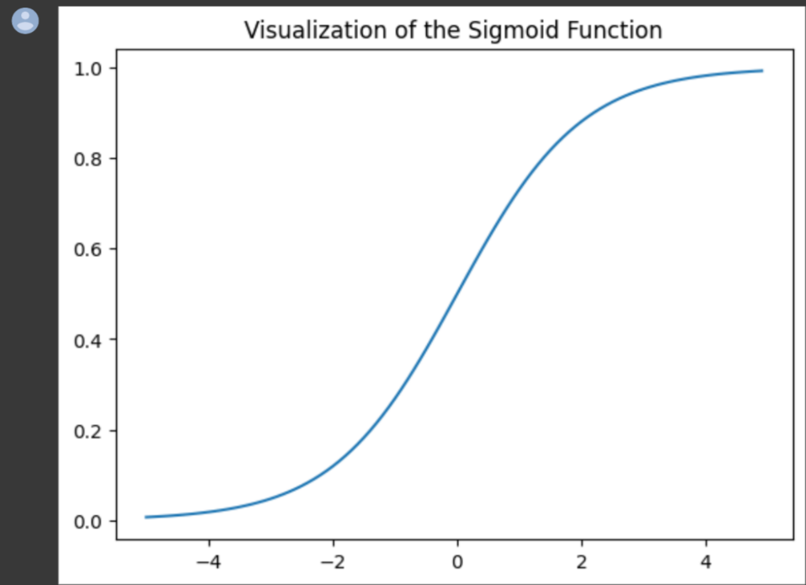

**EXPERIMENT:7**

**PROGRAM:** KNN algorithm

import numpy as np

import pandas as pd

from sklearn.datasets import load_iris

from sklearn.model_selection import train_test_split

from sklearn.preprocessing import StandardScaler

from sklearn.naive_bayes import GaussianNB

from sklearn.metrics import confusion_matrix, accuracy_score

# Load the iris dataset

iris = load_iris()

X = iris.data

y = iris.target

# Split dataset into training and test sets

X_train, X_test, y_train, y_test = train_test_split(X, y, test_size=0.25, random_state=0)

# Feature scaling

sc = StandardScaler()

X_train = sc.fit_transform(X_train)

X_test = sc.transform(X_test)

# Train Naive Bayes model

classifier = GaussianNB()

classifier.fit(X_train, y_train)

# Predict and evaluate

y_pred = classifier.predict(X_test)

cm = confusion_matrix(y_test, y_pred)

print("Confusion Matrix:\n", cm)

print("Accuracy:", accuracy_score(y_test, y_pred))

**OUTPUT:**

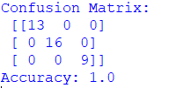

**EXPERIMENT:8**

**PROGRAM:** NAVIE BAYES ALGORITHM

import numpy as np

import pandas as pd

from sklearn.datasets import load_iris

from sklearn.model_selection import train_test_split

from sklearn.preprocessing import StandardScaler

from sklearn.naive_bayes import GaussianNB

from sklearn.metrics import confusion_matrix, accuracy_score

# Load the iris dataset

iris = load_iris()

X = iris.data

y = iris.target

# Split dataset into training and test sets

X_train, X_test, y_train, y_test = train_test_split(X, y, test_size=0.25, random_state=0)

# Feature scaling

sc = StandardScaler()

X_train = sc.fit_transform(X_train)

X_test = sc.transform(X_test)

# Train Naive Bayes model

classifier = GaussianNB()

classifier.fit(X_train, y_train)

# Predict and evaluate

y_pred = classifier.predict(X_test)

cm = confusion_matrix(y_test, y_pred)

print("Confusion Matrix:\n", cm)

print("Accuracy:", accuracy_score(y_test, y_pred))

**OUTPUT:**

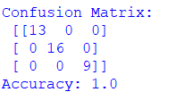

**EXPERIMENT:9**

**PROGRAM:** LOGISTIC REGRESSION

import numpy as np

import pandas as pd

from sklearn.datasets import load_iris

from sklearn.model_selection import train_test_split

from sklearn.preprocessing import StandardScaler

from sklearn.linear_model import LogisticRegression

from sklearn.metrics import confusion_matrix, accuracy_score

# Load the iris dataset

iris = load_iris()

X = iris.data

y = iris.target

# Split the dataset into training and test sets

X_train, X_test, y_train, y_test = train_test_split(X, y, test_size=0.30, random_state=2)

# Feature scaling

sc = StandardScaler()

X_train = sc.fit_transform(X_train)

X_test = sc.transform(X_test)

# Train Logistic Regression model

classifier = LogisticRegression(random_state=0)

classifier.fit(X_train, y_train)

# Predict and evaluate

y_pred = classifier.predict(X_test)

cm = confusion_matrix(y_test, y_pred)

print("Confusion Matrix:\n", cm)

print("Accuracy:", accuracy_score(y_test, y_pred))

**OUTPUT:**

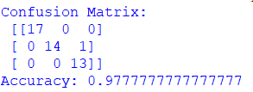

**EXPERIMENT:10**

**PROGRAM:** DECISION TREEALGORITHM

import numpy as np

import pandas as pd

from sklearn.model_selection import train_test_split

iris = load_iris() X = iris.data y = iris.

y_train, y_test = train_test_split(X, y, test_size=0.25, random_state=0)

X_train, X_test, y_train, y_test = train_test_split(X, y, test_size = 0.25, random_state = 8)

# Feature Scaling

from sklearn.preprocessing import StandardScaler

sc = StandardScaler()

X_train = sc.fit_transform(X_train)

X_test = sc.transform(X_test)

# Training the Decision Tree Classification model on the Training set

from sklearn.tree import DecisionTreeClassifier

classifier = DecisionTreeClassifier(criterion = 'entropy', random_state = 5)

classifier.fit(X_train, y_train)

# Display the Decision Tree

from sklearn.tree import plot_tree

import matplotlib.pyplot as plt

plt.figure(figsize=(20,10))

plot_tree(classifier, filled=True, rounded=True, feature_names=dataset.columns[:-1])

plt.show()

# Predicting the Test set results

y_pred = classifier.predict(X_test)

# Display the results (confusion matrix and accuracy)

from sklearn.metrics import confusion_matrix, accuracy_score

cm = confusion_matrix(y_test, y_pred)

print(cm)

accuracy_score(y_test, y_pred)

**output:**

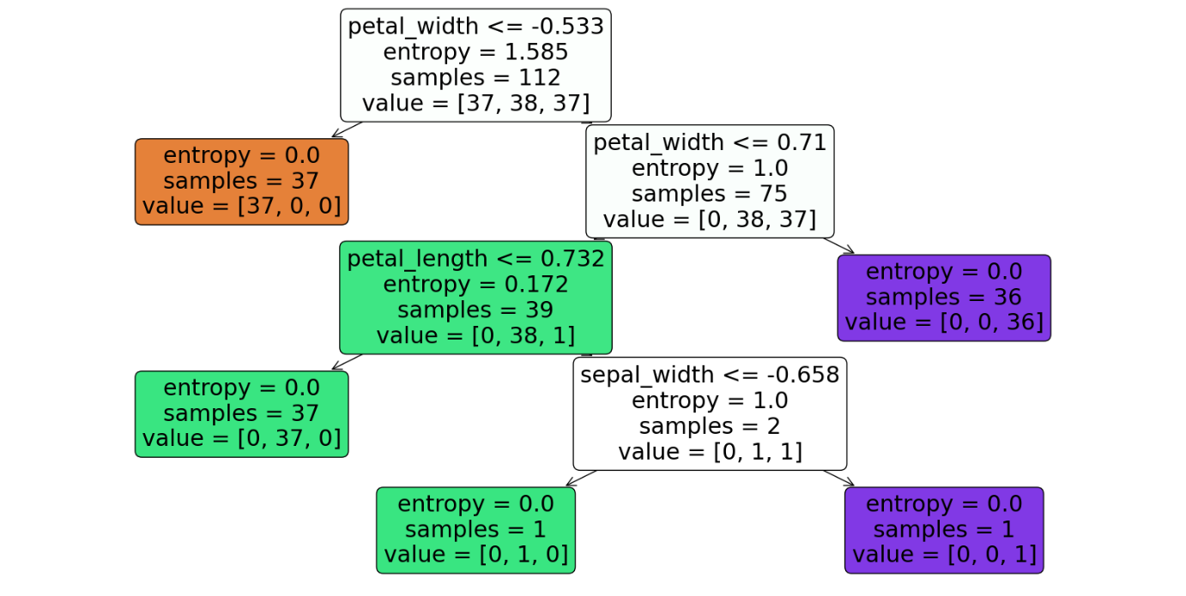

**EXPERIMENT:11**

**PROGRAM:** SVM

import numpy as np

from sklearn.datasets import load_iris

from sklearn.model_selection import train_test_split

from sklearn.preprocessing import StandardScaler

from sklearn.svm import SVC

from sklearn.metrics import confusion_matrix, accuracy_score

# Load the iris dataset

iris = load_iris()

X = iris.data

y = iris.target

# Split the dataset into training and test sets

X_train, X_test, y_train, y_test = train_test_split(X, y, test_size=0.25, random_state=32)

# Feature scaling

sc = StandardScaler()

X_train = sc.fit_transform(X_train)

X_test = sc.transform(X_test)

# Train the SVM model

classifier = SVC(kernel='linear', random_state=0)

classifier.fit(X_train, y_train)

# Predict and evaluate

y_pred = classifier.predict(X_test)

cm = confusion_matrix(y_test, y_pred)

accuracy = accuracy_score(y_test, y_pred)

print("Confusion Matrix:\n", cm)

print(f"Accuracy: {accuracy * 100:.2f}%")

**OUTPUT:**

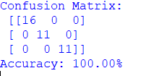

**EXPERIMENT:12**

**PROGRAM:**  RANDOM FOREST

import numpy as np

from sklearn.datasets import load_iris

from sklearn.model_selection import train_test_split

from sklearn.preprocessing import StandardScaler

from sklearn.ensemble import RandomForestClassifier

from sklearn.metrics import confusion_matrix, accuracy_score

# Load the Iris dataset

iris = load_iris()

X = iris.data

y = iris.target

# Split dataset into training and test sets

X_train, X_test, y_train, y_test = train_test_split(X, y, test_size=0.25, random_state=39)

# Feature scaling

sc = StandardScaler()

X_train = sc.fit_transform(X_train)

X_test = sc.transform(X_test)

# Train Random Forest model

classifier = RandomForestClassifier(n_estimators=100, random_state=42)

classifier.fit(X_train, y_train)

# Predict and evaluate

y_pred = classifier.predict(X_test)

cm = confusion_matrix(y_test, y_pred)

accuracy = accuracy_score(y_test, y_pred)

print("Confusion Matrix:\n", cm)

print(f"Accuracy: {accuracy * 100:.2f}%")

**OUTPUT:**

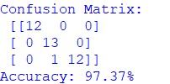

**EXPERIMENT:13**

**PROGRAM:** gradient descent

import numpy as np

import matplotlib.pyplot as plt

def mean_squared_error(y_true, y_pred):

return np.mean((y_true - y_pred) ** 2)

def gradient_descent(x, y, iterations=1000, learning_rate=0.0001, stopping_threshold=1e-6):

weight, bias = 0.1, 0.01

n = len(x)

costs, weights = [], []

previous_cost = None

for i in range(iterations):

y_pred = weight * x + bias

cost = mean_squared_error(y, y_pred)

if previous_cost and abs(previous_cost - cost) <= stopping_threshold:

break

previous_cost = cost

costs.append(cost)

weights.append(weight)

weight -= learning_rate * (-2/n * np.sum(x * (y - y_pred)))

bias -= learning_rate * (-2/n * np.sum(y - y_pred))

if (i+1) % 100 == 0:

print(f"Iteration {i+1}: Cost {cost}, Weight {weight}, Bias {bias}")

plt.figure(figsize=(8, 6))

plt.plot(weights, costs)

plt.scatter(weights, costs, color='red')

plt.title("Cost vs Weights")

plt.xlabel("Weight")

plt.ylabel("Cost")

plt.show()

return weight, bias

def main():

X = np.array([32.5, 53.4, 61.5, 47.5, 59.8, 55.1, 52.2, 39.3, 48.1, 52.6, 45.4, 54.4, 44.2, 58.2, 56.7, 49.0, 44.7, 60.3, 45.6, 38.8])

Y = np.array([31.7, 68.8, 62.6, 71.5, 87.2, 78.2, 79.6, 59.2, 75.3, 71.3, 55.2, 82.5, 62.0, 75.4, 81.4, 60.7, 82.9, 97.4, 48.8, 56.9])

weight, bias = gradient_descent(X, Y, iterations=2000)

print(f"Estimated Weight: {weight}\nEstimated Bias: {bias}")

Y_pred = weight * X + bias

plt.figure(figsize=(8, 6))

plt.scatter(X, Y, color='red')

plt.plot(X, Y_pred, color='blue', linestyle='--')

plt.xlabel("X")

plt.ylabel("Y")

plt.show()

if __name__ == "__main__":

main()

**output:**

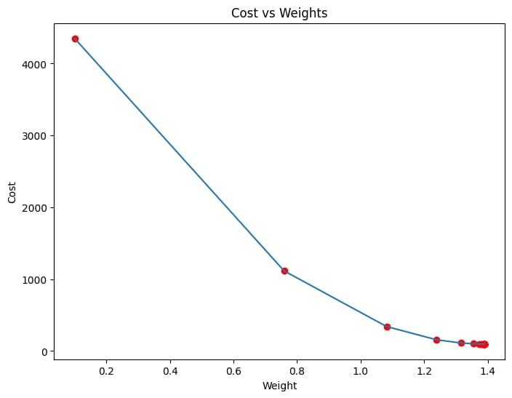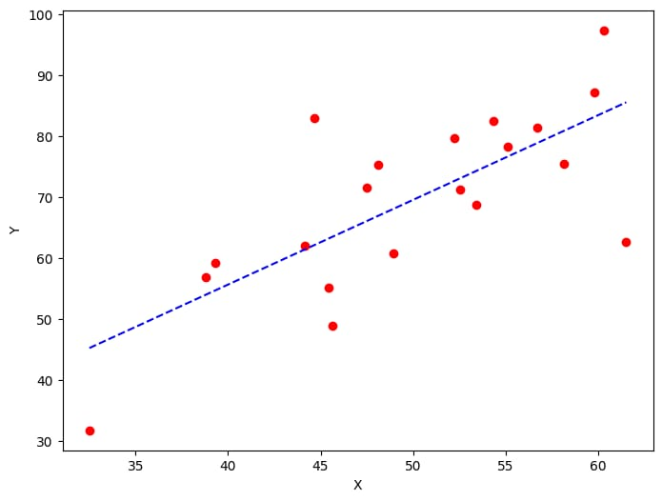

**Experiment:14**

**PROGRAM:** gradient descent

import numpy as np

import matplotlib.pyplot as plt

# Function to calculate Mean Squared Error

def mean_squared_error(y_true, y_pred):

return np.mean((y_true - y_pred) ** 2)

# Gradient Descent Function

def gradient_descent(x, y, iterations=1000, learning_rate=0.0001, stopping_threshold=1e-6):

weight, bias = 0.1, 0.01 # Initialize weight and bias

n = len(x) # Number of data points

for i in range(iterations):

y_pred = weight * x + bias # Calculate predictions

cost = mean_squared_error(y, y_pred) # Calculate cost

# Check stopping condition

if i > 0 and abs(prev_cost - cost) <= stopping_threshold:

break

prev_cost = cost

# Calculate gradients

weight_gradient = -(2 / n) * np.sum(x * (y - y_pred))

bias_gradient = -(2 / n) * np.sum(y - y_pred)

# Update parameters

weight -= learning_rate * weight_gradient

bias -= learning_rate * bias_gradient

# Print every 1000th iteration

if i % 1000 == 0:

print(f"Iteration {i}: Cost {cost}, Weight {weight}, Bias {bias}")

# Plot cost vs weight

plt.plot(range(i+1), [mean_squared_error(y, weight * x + bias) for _ in range(i+1)])

plt.xlabel("Iteration")

plt.ylabel("Cost")

plt.show()

return weight, bias

def main():

# Sample data

X = np.array([52.5, 63.4, 81.5, 47.5, 89.8, 55.1, 52.2, 39.3, 48.1, 52.5, 45.4, 54.3, 44.2, 58.2, 56.7, 48.9, 44.7, 60.3, 45.6, 38.8])

Y = np.array([41.7, 78.8, 82.6, 91.5, 77.2, 78.2, 79.6, 59.2, 75.3, 71.3, 55.2, 82.5, 62.0, 75.4, 81.4, 60.7, 82.9, 97.4, 48.8, 56.9])

# Run gradient descent

weight, bias = gradient_descent(X, Y)

print(f"Estimated Weight: {weight}, Estimated Bias: {bias}")

# Plot regression line

plt.scatter(X, Y, color='red')

plt.plot(X, weight * X + bias, color='blue', linestyle='dashed')

plt.xlabel("X")

plt.ylabel("Y")

plt.show()

if __name__ == "__main__":

main()

**OUTPUT:**

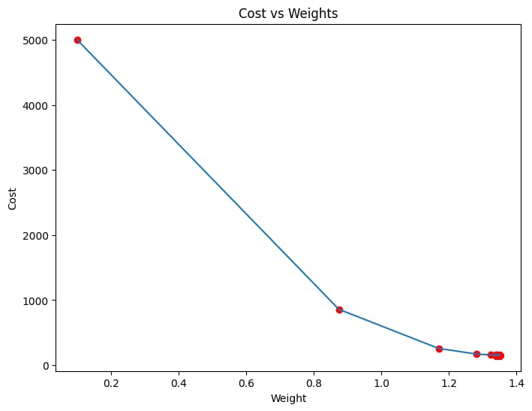



**EXPERIMENT:15**

**PROGRAM:** image processing

import numpy as np

import cv2

from matplotlib import pyplot as plt

# Load the image

img = cv2.imread('C33P1thinF_IMG_20150619_114756a_cell_181.png')

b, g, r = cv2.split(img)

rgb_img = cv2.merge([r, g, b])

# Convert to grayscale

gray = cv2.cvtColor(img, cv2.COLOR_BGR2GRAY)

# Apply Otsu's thresholding

_, thresh = cv2.threshold(gray, 0, 255, cv2.THRESH_BINARY_INV + cv2.THRESH_OTSU)

# Noise removal using morphological closing

kernel = np.ones((2, 2), np.uint8)

closing = cv2.morphologyEx(thresh, cv2.MORPH_CLOSE, kernel, iterations=2)

# Sure background area

sure_bg = cv2.dilate(closing, kernel, iterations=3)

# Finding sure foreground area

dist_transform = cv2.distanceTransform(sure_bg, cv2.DIST_L2, 3)

_, sure_fg = cv2.threshold(dist_transform, 0.1 * dist_transform.max(), 255, 0)

# Finding unknown region

sure_fg = np.uint8(sure_fg)

unknown = cv2.subtract(sure_bg, sure_fg)

# Marker labelling

_, markers = cv2.connectedComponents(sure_fg)

markers = markers + 1 # Increment all labels so background is 1

markers[unknown == 255] = 0 # Mark unknown regions as 0

# Apply watershed algorithm

markers = cv2.watershed(img, markers)

img[markers == -1] = [255, 0, 0] # Mark boundaries in red

# Plotting the results

plt.subplot(211), plt.imshow(rgb_img)

plt.title('Input Image'), plt.xticks([]), plt.yticks([])

plt.subplot(212), plt.imshow(thresh, 'gray')

plt.title("Otsu's binary threshold"), plt.xticks([]), plt.yticks([])

plt.tight_layout()

plt.show()

**OUTPUT:**



**EXPERIMENT:16**

**PROGRAM:** image processing by using water shed database

import numpy as np

import cv2

from matplotlib import pyplot as plt

# Load the image

img = cv2.imread('C33P1thinF_IMG_20150619_114756a_cell_181.png')

b, g, r = cv2.split(img)

rgb_img = cv2.merge([r, g, b])

# Convert to grayscale

gray = cv2.cvtColor(img, cv2.COLOR_BGR2GRAY)

# Apply Otsu's thresholding

_, thresh = cv2.threshold(gray, 0, 255, cv2.THRESH_BINARY_INV + cv2.THRESH_OTSU)

# Noise removal using morphological closing

kernel = np.ones((2, 2), np.uint8)

closing = cv2.morphologyEx(thresh, cv2.MORPH_CLOSE, kernel, iterations=2)

# Sure background area using dilation

sure_bg = cv2.dilate(closing, kernel, iterations=3)

# Plot the results

plt.subplot(211), plt.imshow(closing, 'gray')

plt.title("MorphologyEx: Closing (2x2)"), plt.xticks([]), plt.yticks([])

plt.subplot(212), plt.imshow(sure_bg, 'gray')

plt.title("Dilation"), plt.xticks([]), plt.yticks([])

# Save the dilated image

plt.imsave('dilation.png', sure_bg)

plt.tight_layout()

plt.show()

**OUTPUT:**



**EXPERIMENT:17**

**PROGRAM:**TANH ACTIVATION

import numpy as np

import matplotlib.pyplot as plt

# Define the Tanh activation function

def tanh(x):

return np.tanh(x)

# Define the derivative of the Tanh function

def tanh_derivative(x):

return 1 - np.tanh(x) ** 2

# Generate an array of input values

x = np.linspace(-5, 5, 100)

# Compute the Tanh activation values and their derivatives

y_tanh = tanh(x)

y_tanh_deriv = tanh_derivative(x)

# Plot the Tanh activation function

plt.figure(figsize=(8, 6))

plt.plot(x, y_tanh, label='tanh(x)', color='blue')

plt.plot(x, y_tanh_deriv, label="tanh'(x)", color='red', linestyle='dashed')

plt.title('Tanh Activation Function and its Derivative')

plt.xlabel('Input')

plt.ylabel('Output')

plt.axhline(0, color='black', linewidth=0.5)

plt.axvline(0, color='black', linewidth=0.5)

plt.legend()

plt.grid(True)

plt.show()

**OUTPUT:**

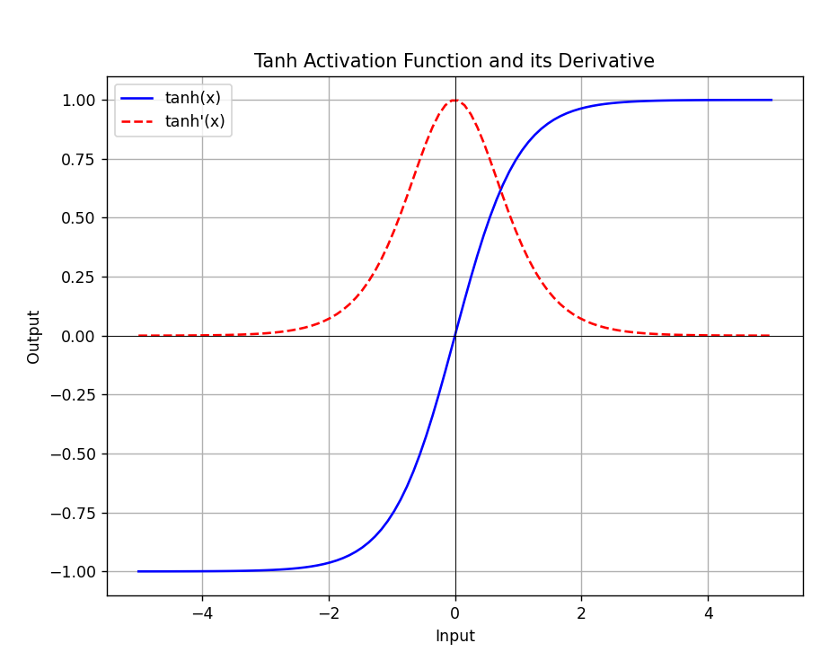

**EXPERIMENT:18**

**PROGRAM:** SIGMOID ACTIVATION

**OUTPUT:** 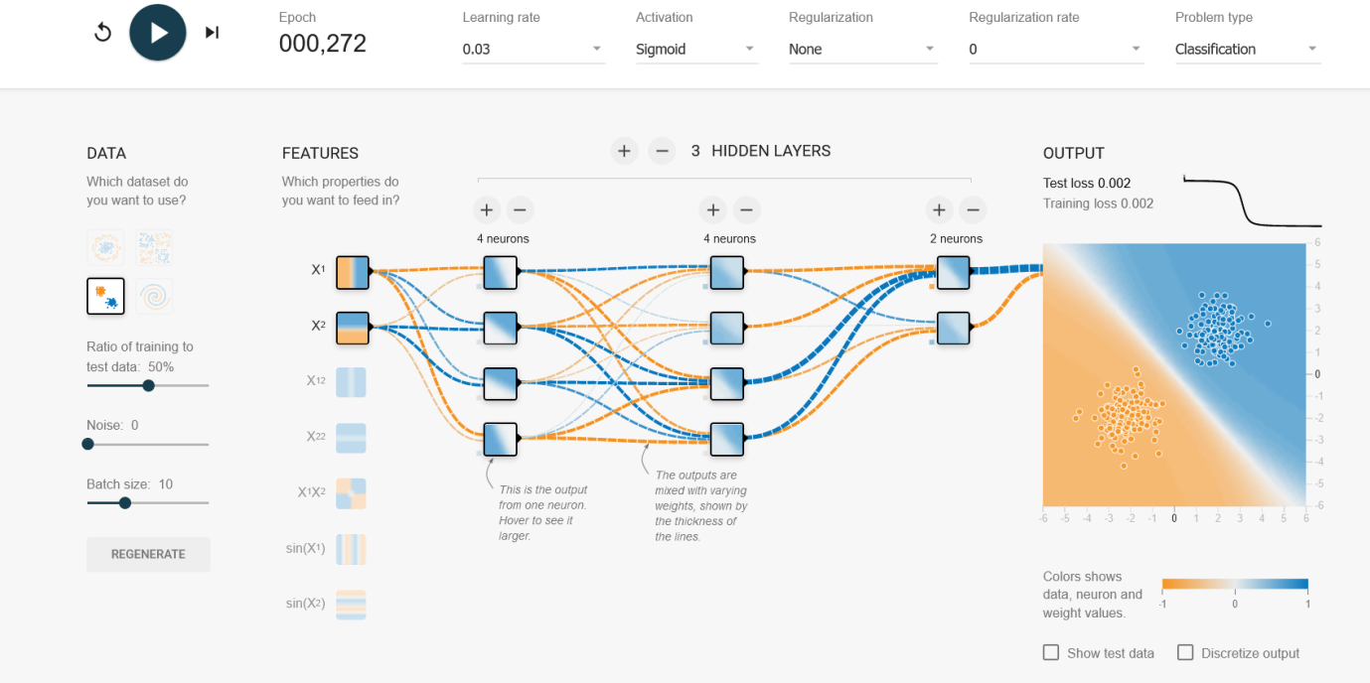

**EXPERIMENT:19**

**PROGRAM:** LINEAR ACTIVATION

**OUTPUT:** 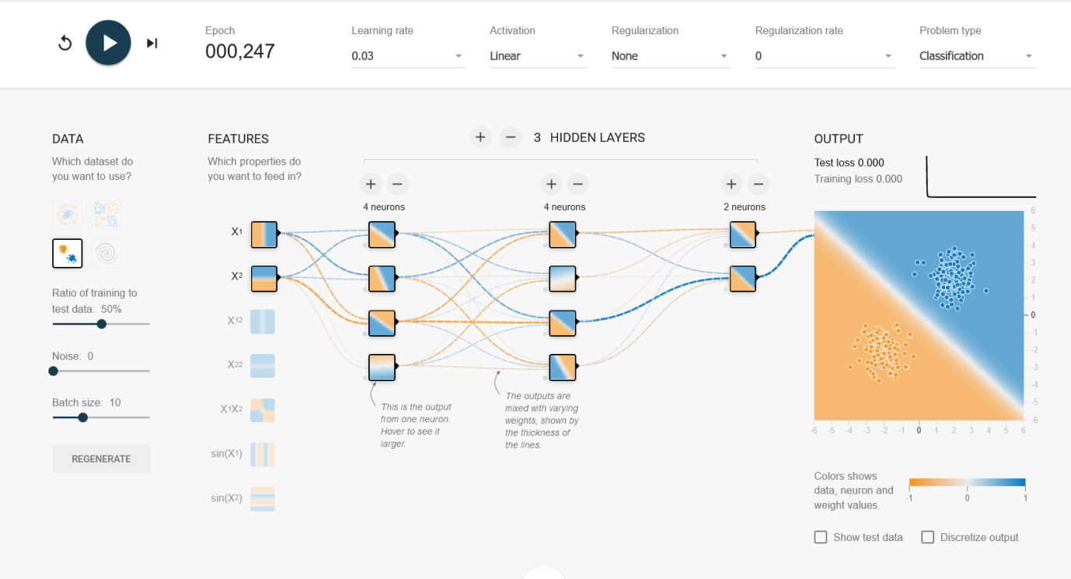

**EXPERIMENT:20**

**PROGRAM:** Neural network analysis using ReLU ACTIVATION

**OUTPUT:**

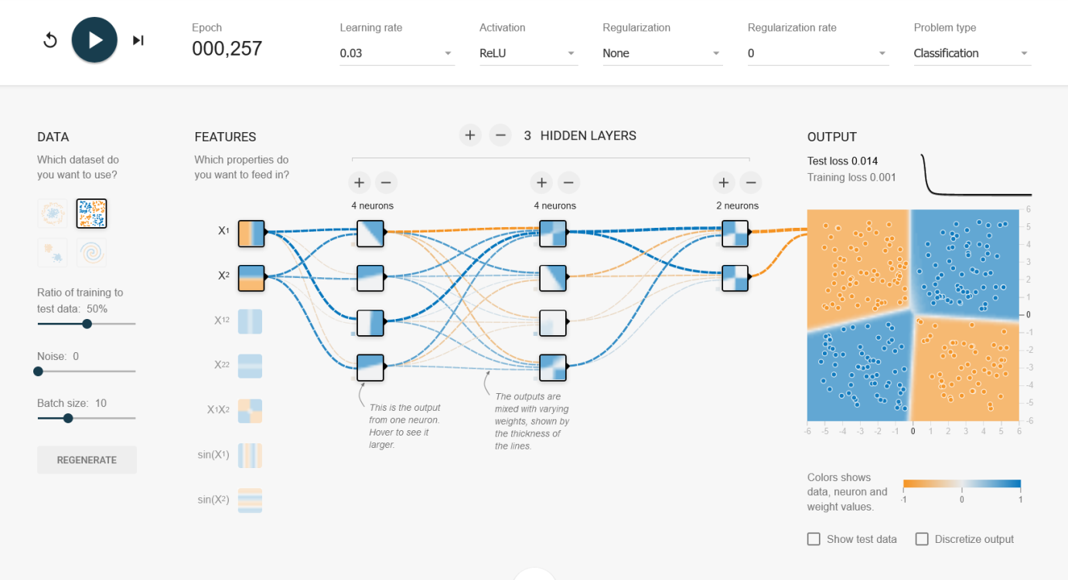

**EXPERIMENT:21**

**PROGRAM:** linear separability

import numpy as np

import matplotlib.pyplot as plt

def estimate_coef(x, y):

n = np.size(x)

m_x, m_y = np.mean(x), np.mean(y)

SS_xy = np.sum(y*x) - n*m_y*m_x

SS_xx = np.sum(x*x) - n*m_x*m_x

b_1 = SS_xy / SS_xx

b_0 = m_y - b_1*m_x

return b_0, b_1

def plot_regression_line(x, y, b):

plt.scatter(x, y, color="r", marker="o")

plt.plot(x, b[0] + b[1]*x, color="b")

plt.xlabel('x')

plt.ylabel('y')

plt.show()

x = np.array([0, 1, 2, 3, 4, 5, 6, 7, 8, 9])

y = np.array([1, 3, 2, 5, 7, 8, 8, 9, 10, 12])

b = estimate_coef(x, y)

print(f"Estimated coefficients:\nb_0 = {b[0]} \nb_1 = {b[1]}")

plot_regression_line(x, y, b)

**OUTPUT:**

