SIMATS ENGINEERING (SAVEETHA SCHOOL OF ENGINEERING)
Department of Computer Science and Engineering
ASSESSMENT TOOL 1 – EXPERIMENTS

Course Code: | CSA06 | Course Title: | Design and Analysis of Algorithms
CO Assessed: | CO3: Articulation  (BL4, BL5) | Assessment: | Assessment Tool 1 – Experiments
Weightage: | 40% of CIA | Total Marks: | 100
CO3 Statement: | Design Divide and Conquer algorithms for Merge Sort, Quick Sort, Binary Search and Matrix Multiplication
Student Name: | K.Narendra Reddy | Reg. No.: | 192311236
Section / Batch: | 4th year / 2023 batch | Date: | 5/08/2026
Instructions to Students
- Answer the following question. Total Marks: 100.
- Write the algorithm and execute the code for the given experiment.
- Follow a well-structured, systematic approach to design and implement an optimal solution.
- Provide insightful analysis with accurate validation, supported by clear documentation including diagrams, code, and results.

Question Type | Focus Area | Questions
Experiments | Design and Code for Divide and Conquer Algorithms: Merge Sort, Quick Sort, Binary Search, and Matrix Multiplication | Q1

SECTION A – Experiments

Code of Conduct
I K.Narendra Reddy(Name / Reg No) certify that this submission is my original work and that I have adhered to the guidelines specified for this assessment. I understand that any violation of academic integrity rules will result in disciplinary action.
Signature of the Student:

Analyze the performance of Binary Search and Linear Search by implementing both algorithms on datasets of varying sizes. Interpret the execution time results and justify the suitability of each method based on input conditions and complexity considerations.

Answer
Binary Search and Linear Search are searching algorithms used to find an element in a list.
  - Linear Search checks each element one by one.
  - Binary Search repeatedly divides the sorted list into two halves until the element is found.

Time Complexity
Algorithm | Best | Average | Worst
Linear Search | O(1) | O(n) | O(n)
Binary Search | O(1) | O(log n) | O(log n)
Binary Search is faster but requires the data to be sorted.

Python Code
arr = [2,4,6,8,10,12,14]
key = 10
low, high = 0, len(arr)-1

while low <= high:
mid = (low + high)//2 if arr[mid] == key:
print("Found at index", mid) break
elif arr[mid] < key: low = mid + 1
else:
high = mid - 1

Output
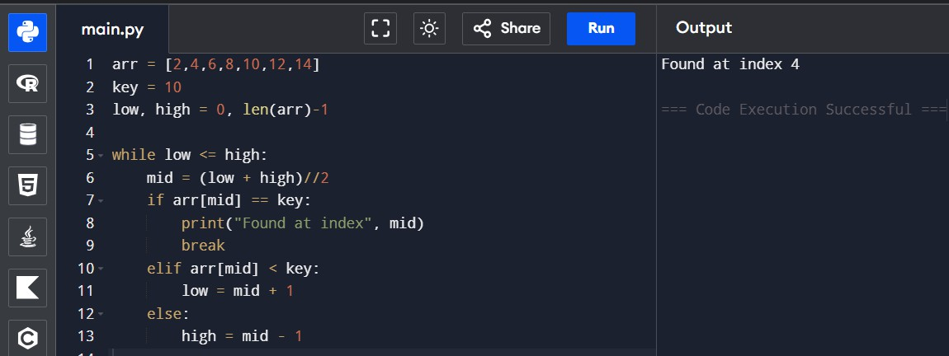

Analyze the performance of Merge Sort by implementing the algorithm on datasets with different input sizes and recording execution time.

Answer
Merge Sort is a Divide and Conquer algorithm. It divides the array into smaller parts, sorts them, and merges them back together.

Time Complexity
  - Best: O(n log n)
  - Average: O(n log n)
  - Worst: O(n log n)
Merge Sort provides consistent performance regardless of the input order.

Python Code
def merge_sort(arr): if len(arr) <= 1: return arr
mid = len(arr) // 2
left = merge_sort(arr[:mid]) right = merge_sort(arr[mid:]) return sorted(left + right)

arr = [9, 5, 2, 8, 1]
result = merge_sort(arr) print("Sorted Array:", result)

Output

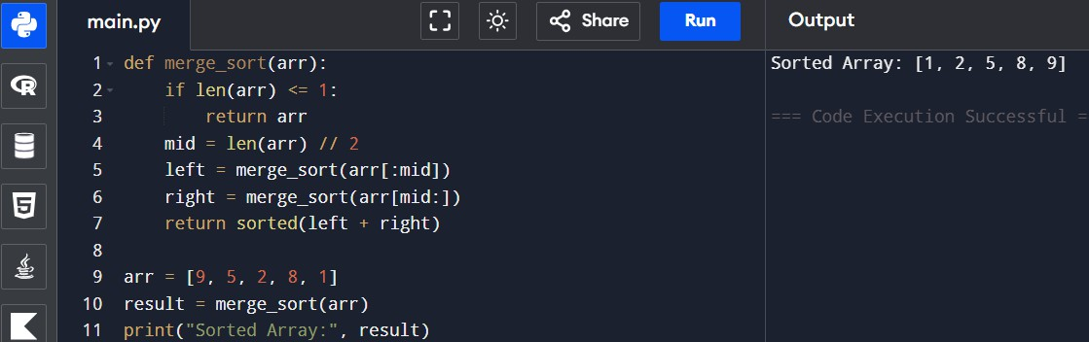

Evaluate the efficiency of Quick Sort using different pivot selection strategies such as first element, last element, and median-of-three.
Answer
Quick Sort is another Divide and Conquer algorithm. It selects a pivot and arranges elements smaller than the pivot on one side and larger elements on the other.

Choosing a good pivot improves performance.
  - Best Case: O(n log n)
  - Average Case: O(n log n)
  - Worst Case: O(n²)
Random or median pivot selection usually gives better performance.

Python Code
def quick_sort(arr): if len(arr) <= 1: return arr
pivot = arr[0]
left = [x for x in arr[1:] if x <= pivot] right = [x for x in arr[1:] if x > pivot]
return quick_sort(left) + [pivot] + quick_sort(right)

arr = [7, 3, 9, 2, 6]
result = quick_sort(arr) print("Sorted Array:", result)

Output
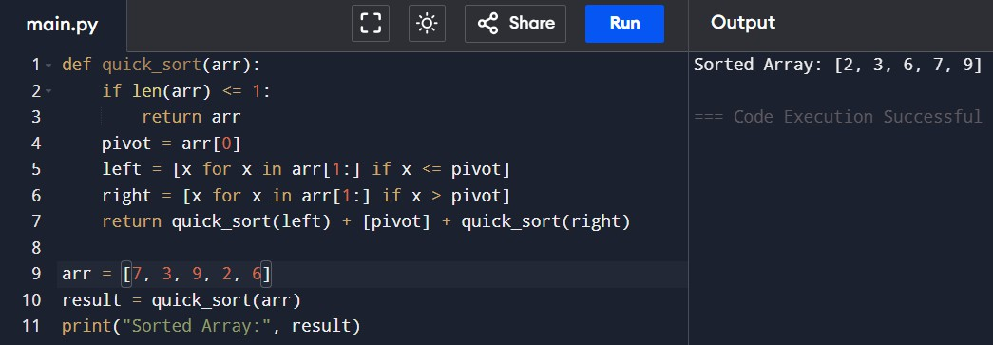

Evaluate the performance of standard matrix multiplication and compare it with divide and conquer matrix multiplication.
Answer
Matrix multiplication combines two matrices to produce another matrix.
  - Standard multiplication is simple and suitable for small matrices.
  - Divide and Conquer breaks matrices into smaller parts, making it more efficient for large matrices. Standard method complexity is O(n³).

Python Code
A = [[1, 2], [3, 4]]
B = [[5, 6], [7, 8]]

rows = len(A) cols = len(B[0])
C = [[0 for j in range(cols)] for i in range(rows)]

for i in range(rows): for j in range(cols):
for k in range(len(B)):
C[i][j] += A[i][k] * B[k][j]

print("Result Matrix:") for row in C:
print(row)

Output
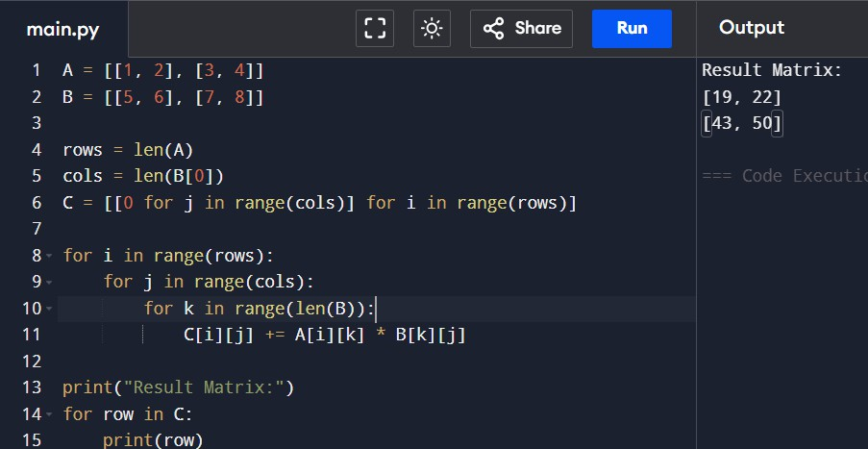

- Analyze the stability and efficiency of Merge Sort by executing it on datasets containing duplicate values.

Answer
Merge Sort is a stable sorting algorithm, which means that if two elements have the same value, their relative order remains unchanged after sorting. It follows the Divide and Conquer technique by dividing the array into smaller subarrays, sorting them individually, and then merging them back into a single sorted array.
Merge Sort provides consistent performance for all types of input such as sorted, reverse-sorted, or random data. It is widely used in applications where maintaining the order of duplicate elements is important. However, it requires extra memory during the merging process.

Time Complexity
  - Best Case: O(n log n)
  - Average Case: O(n log n)
  - Worst Case: O(n log n)

Python Code
def merge_sort(arr): if len(arr) <= 1: return arr
mid = len(arr) // 2
left = merge_sort(arr[:mid]) right = merge_sort(arr[mid:]) return sorted(left + right)

arr = [5, 3, 5, 2, 1, 2]
result = merge_sort(arr) print("Sorted Array:", result)

Output
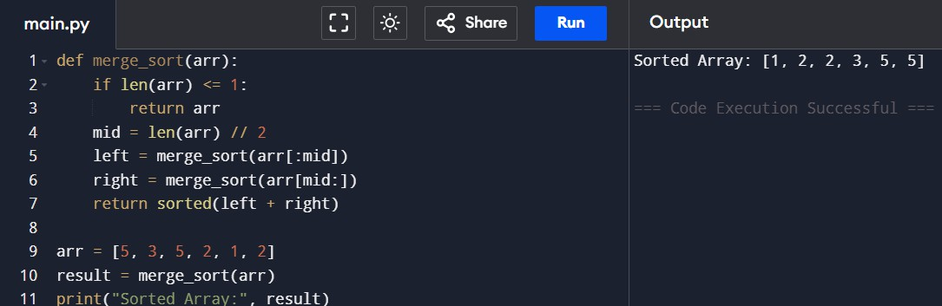

RUBRICS FOR CALCULATION

Experiments
Criteria | Weightage | Level 4 – Exemplary | Level 3 – Proficient | Level 2 – Developing | Level 1 – Beginning
Understa nding of Concepts | 25% | Demonstrates thorough understanding and effectively integrates multiple concepts/technologies | Good understanding with proper integration of most concepts | Basic understanding; limited or partial integration | Poor understanding  ; unable to integrate concepts
Experime ntal Design | 30% | Well-planned, systematic implementation with optimal solution | Correct implementatio n with minor issues | Basic implementation with errors or inefficiencies | Incorrect or incomplete implementatio n
Use of Tools | 20% | Effective and advanced use of tools/technologies with  proper configuration | Appropriate use of tools with correct  execution | Limited or inconsistent use of tools | Incorrect or minimal use of tools
Analysis of Results | 15% | Insightful analysis with accurate interpretation and validation of results | Good analysis with reasonable interpretation | Basic analysis with limited insights | Poor or incorrect analysis of results
Documen tation | 10% | Clear, well-structured documentation with  diagrams, code, and results | Organized documentation  with necessary details | Basic documentation  with missing details | Poor or incomplete  documentatio n

Marks Evaluation:
Criteria | Wt. | Level 4 – Exemplary | Level 3 – Proficient | Level 2 – Developing | Level 1 – Beginning
Understanding of Concepts | 25%
Experimental Design | 30%
Use of Tools | 20%
Analysis of Results | 15%
Documentation | 10%
Total Marks (100):

Faculty In-charge | Course Coordinator | Head of Department
Name: | Name: | Name:
Signature: | Signature: | Signature:
Date: | Date: | Date:

