Reg.No: 

Programme : B. E / B. tech
Course Code : CSA4304
Course Name : Internet programming
Name:K.Narendra Reddy
Problem Statement (Assignment) Max Marks: 100
Field | Content
Assignment Title | Web-Based Smart Campus Service Request and Tracking System
Course Outcome(s) – CO | CO1: Develop visually appealing web pages using CSS for layout and style, and create dynamic, interactive functionality with JavaScript.  CO2: Build dynamic web applications using XML, XSLT, and JSP within the MVC paradigm for efficient data handling and presentation.
Bloom’s Taxonomy Level | L3 – Apply | L4 – Analyze | L5 – Evaluate | L6 – Create
SDG Mapping (SDG 1–17) | SDG 9 - Industry, Innovation and Infrastructure, SDG 4 -  Quality Education
Problem Statement
A university currently relies on manual communication such as emails, phone calls, and paper-based records for reporting and resolving campus service issues. This approach makes it difficult to efficiently record complaints, assign requests to the appropriate service personnel, monitor progress, and provide timely status updates to students and faculty.

The university therefore proposes to develop a Web-Based Smart Campus Service Request and Tracking System as an integrated web-based application. The system shall enable students and faculty to submit service requests related to laboratory equipment faults, network problems, classroom maintenance, library services, and other technical issues through a web browser. Users should be able to provide relevant details, submit requests, and subsequently track the status of their requests.
The proposed system should demonstrate an integrated client-server web architecture. The client side shall provide an interactive and user-friendly interface using HTML/XHTML, CSS, JavaScript, and DOM. The server side shall process requests using Java Servlets and JSP, following the MVC architecture. XML shall be used for structured data representation, and XSLT shall be used to transform XML data for presentation where appropriate.

Problem Identification (10 Marks)-The university relies on manual communication (emails, phone calls, paper records) for reporting and resolving service issues, which causes inefficiency in recording complaints, assigning requests, monitoring progress, and providing timely updates.
Proposed Solution -Develop a Web-Based Smart Campus Service Request and Tracking System (10 Marks), a web-based application that allows students and faculty to submit service requests (lab equipment faults, network problems, classroom maintenance, library services) and track their status online.
System Design & Architecture - Data Representation (20 Marks) -Implement an integrated client-server web architecture. The client side should use HTML/XHTML, CSS, JavaScript, and DOM for interactivity, while the server side should use Java Servlets and JSP following the MVC model. Use XML for structured data representation for transforming XML data into user-friendly formats for presentation and reporting.
Implementation & Testing (10 Marks) -Demonstrate request submission, assignment to service personnel, progress tracking, and timely updates. Validate inputs, handle errors, and ensure smooth user experience.

STG Goals –SDG 9 - Industry, Innovation and Infrastructure, SDG 4 - Quality Education

Requirement Analysis (SDG 9 – Industry, Innovation & Infrastructure) Identify inefficiencies in manual reporting and propose a digital infrastructure for service management.

Client Interface Development (SDG 4 – Quality Education) Build user-friendly web forms and dashboards so students/faculty can easily submit and track requests, improving access to campus services.
Assessment Criterion | CO Mapping | Weightage / Marks
Problem understanding & formulation | CO1 | 10
Application of course/domain knowledge | CO2 | 20
Solution methodology / design / implementation | CO3 | 20
Use of appropriate modern tools / techniques | CO4 | 10
Results, testing & validation | CO4 / CO5 | 15
Analysis, trade-offs & justification | CO5 | 15
Broader considerations / professional responsibility, where applicable | CO5 | 5
Technical documentation & reflection | CO1–CO5 | 5
TOTAL |  | 100

Performance Level | CO Attainment Percentage | Interpretation
Level 3 | ≥ 70% | CO Attained
Level 2 | 60–69% | CO Moderately Attained
Level 1 | 50–59% | CO Minimally Attained
Level 0 | < 50% | CO Not Attained

Code of Conduct

I ___K.Narendra Reddy/192311236__ (Name / Reg. No.) certify that this submission is my original work and that I have adhered to the guidelines specified for this assessment. I understand that any violation of academic-integrity rules will result in disciplinary action.

Signature of the Student: __Narendra Reddy__
_____________________  Faculty In-charge  Name:  Date: | _____________________  Course Coordinator  Name:  Date: | _____________________  Head of Department  Name:  Date:

INTERNET PROGRAMMING
Course Code: CSA4304
ASSIGNMENT REPORT

Web-Based Smart Campus Service Request and Tracking System

Field | Content
Programme | B.E / B.Tech
Course Code | CSA4304
Course Name | Internet Programming
Assignment Title | Web-Based Smart Campus Service Request and Tracking System
Maximum Marks | 100
Course Outcome(s) | CO1: CSS layout/style and JavaScript interactivity; CO2: XML, XSLT and JSP using MVC.
Bloom’s Level | L3 – Apply | L4 – Analyze | L5 – Evaluate | L6 – Create
SDG Mapping | SDG 9 – Industry, Innovation and Infrastructure; SDG 4 – Quality Education
Student Name | K.Narendra Reddy
Register Number | 192311236
Faculty Name | Dr. Sathiyamoorthy M

This report follows the supplied CSA43 assignment structure. The source document specifies the assignment title, COs, Bloom’s levels and SDG mapping. fileciteturn1file0L39-L60

Problem Identification

The university relies on emails, phone calls and paper records for reporting and resolving campus service issues. This causes inefficiency in recording complaints, assigning requests, monitoring progress and providing timely updates.
fileciteturn1file0L66-L75
The proposed system digitizes this process. Students and faculty can submit requests for laboratory equipment faults, network problems, classroom maintenance, library services and other technical issues, then track their request status online. fileciteturn1file0L69-L70
Objective: Build a centralized web application that makes service reporting, assignment and tracking faster, clearer and easier to manage.

Proposed Solution

The system uses a client-server architecture. The client side uses HTML/XHTML, CSS, JavaScript and DOM. The server side uses Java Servlets and JSP following MVC. XML provides structured data representation and XSLT transforms XML data for user-friendly presentation and reporting. These technologies directly match the supplied problem requirements. ■filecite■turn1file0■L69-L77

Requirement Analysis

Functional Requirements

ID | Requirement
FR1 | Submit a campus service request.
FR2 | Select service category.
FR3 | Enter issue title, description and location.
FR4 | Validate mandatory fields.
FR5 | View submitted requests.
FR6 | Assign requests to service personnel.
FR7 | Update request status.
FR8 | Track request using request ID.
FR9 | Display current status and request history.
FR10 | Generate/read structured XML and XSLT reports.

Non-Functional Requirements

Category | Requirement
Usability | Simple forms, dashboards and clear status messages.
Performance | Requests should be processed with minimal delay.
Reliability | Invalid input and errors should be handled gracefully.
Maintainability | MVC separates presentation, control and data responsibilities.
Security | Validate input and restrict administrative operations.
Scalability | Allow additional categories, personnel and users.

System Design and Architecture

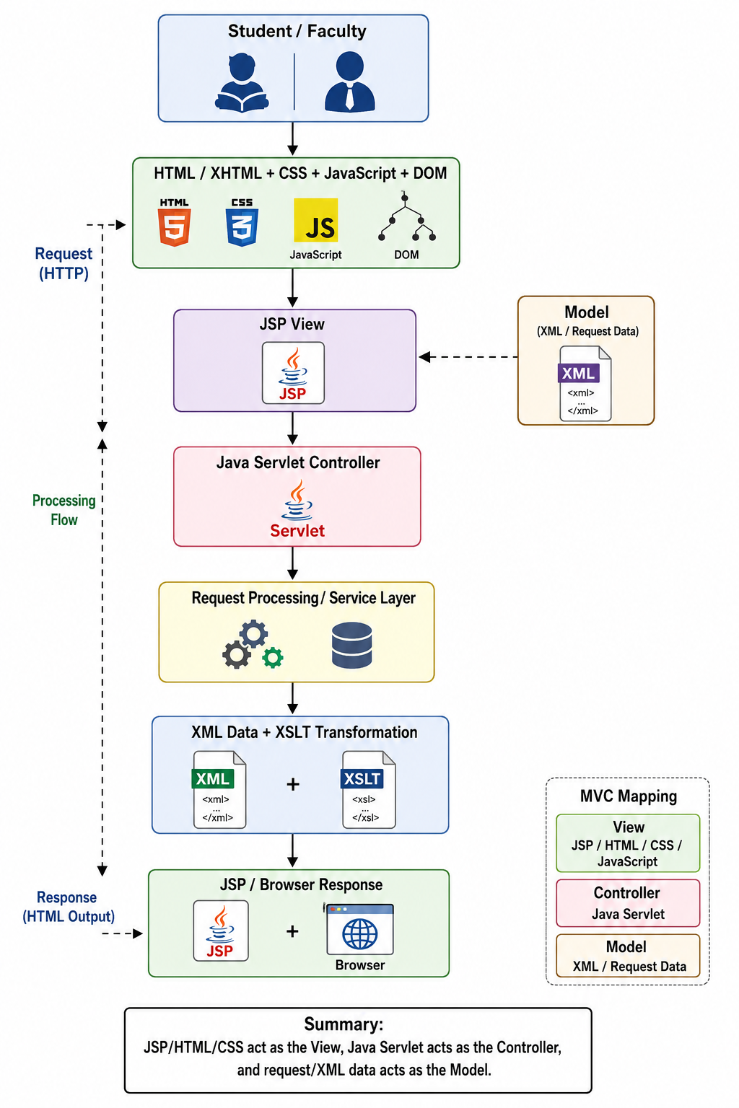

Major System Modules

Module | Description
Request Form | Captures requester, category, location, issue and priority.
Servlet Controller | Receives form data, validates it and controls processing.
Request Management | Allows authorized personnel to view and assign requests.
Tracking Dashboard | Displays current request status and history.
XML Module | Represents service-request data in structured XML.
XSLT Module | Transforms XML information into readable presentation/report output.
Validation & Error Handling | Checks input and provides meaningful error messages.

XML Data Representation

A service request can be represented using XML as follows:
<?xml version="1.0" encoding="UTF-8"?>
<serviceRequests>
<request>
<requestId>REQ1001</requestId>
<requester>Narendra</requester>
<category>Network Problem</category>
<location>Block A - Lab 2</location>
<title>Internet not working</title>
<description>Network connection is unavailable.</description>
<priority>High</priority> <assignedTo>Network Support</assignedTo>
<status>In Progress</status>
</request>
</serviceRequests>

XSLT Transformation

XSLT can transform the XML request information into an HTML table for presentation:
<xsl:stylesheet version="1.0" xmlns:xsl="http://www.w3.org/1999/XSL/Transform"> <xsl:template match="/">
<html><body> <h2>Campus Service Requests</h2>
<table border="1">
<tr><th>ID</th><th>Category</th><th>Priority</th><th>Status</th></tr>
<xsl:for-each select="serviceRequests/request">
<tr>
<td><xsl:value-of select="requestId"/></td>
<td><xsl:value-of select="category"/></td>
<td><xsl:value-of select="priority"/></td> <td><xsl:value-of select="status"/></td>
</tr>
</xsl:for-each>
</table>
</body></html> </xsl:template> </xsl:stylesheet>

Client Interface – HTML, CSS, JavaScript and DOM

<!DOCTYPE html>
<html>
<head>
<title>Smart Campus Service Request</title>
<link rel="stylesheet" href="style.css">
</head>
<body>
<h1>Smart Campus Service Request</h1>
<form id="requestForm" action="submitRequest" method="post">
<label>Requester Name:</label>
<input type="text" id="name" name="name" required>
<label>Category:</label>
<select name="category">
<option>Laboratory Equipment</option>
<option>Network Problem</option>
<option>Classroom Maintenance</option>
<option>Library Service</option>
</select>
<label>Location:</label>
<input type="text" name="location" required>
<label>Issue:</label>
<textarea name="description" required></textarea>
<button type="submit">Submit Request</button>
</form>
<script> document.getElementById("requestForm").addEventListener("submit", function(e) { if (document.getElementById("name").value.trim() === "") {
e.preventDefault(); alert("Please enter your name."); }
});
</script>
</body>
</html>

CSS Styling

body { font-family: Arial, sans-serif; background: #f4f6f8; padding: 30px; } form { max-width: 600px; margin: auto; background: white; padding: 25px; border-radius: 10px; } input, select, textarea { width: 100%; padding: 10px; margin: 8px 0 15px; box-sizing: border-box; } button { padding: 10px 20px; cursor: pointer; }

Java Servlet – Controller

import java.io.IOException; import jakarta.servlet.ServletException; import jakarta.servlet.annotation.WebServlet; import jakarta.servlet.http.*;
@WebServlet("/submitRequest")
public class RequestServlet extends HttpServlet { protected void doPost(HttpServletRequest request, HttpServletResponse response) throws ServletException, IOException {
String name = request.getParameter("name");
String category = request.getParameter("category");
String location = request.getParameter("location"); String description = request.getParameter("description");
if (name == null || name.trim().isEmpty() || description == null || description.trim().isEmpty()) { response.sendRedirect("error.jsp"); return; }
request.setAttribute("name", name); request.setAttribute("category", category); request.setAttribute("location", location); request.setAttribute("description", description);
request.getRequestDispatcher("success.jsp") .forward(request, response);
}
}
The Servlet receives the request, validates required fields, prepares the model data and forwards the result to the JSP view.

JSP View
<%@ page contentType="text/html;charset=UTF-8" %>
<html>
<head><title>Request Submitted</title></head>
<body>
<h2>Service Request Submitted Successfully</h2>
<p>Requester: ${name}</p>
<p>Category: ${category}</p>
<p>Location: ${location}</p>
<p>Description: ${description}</p>
<p>Status: Submitted</p>
</body>
</html>

JavaScript and DOM Interactivity

function showStatus(status) { const result = document.getElementById("statusResult"); result.textContent = "Current Status: " + status;
if (status === "Resolved") { result.textContent += " - Your request has been completed."; }
}

Request Processing Workflow

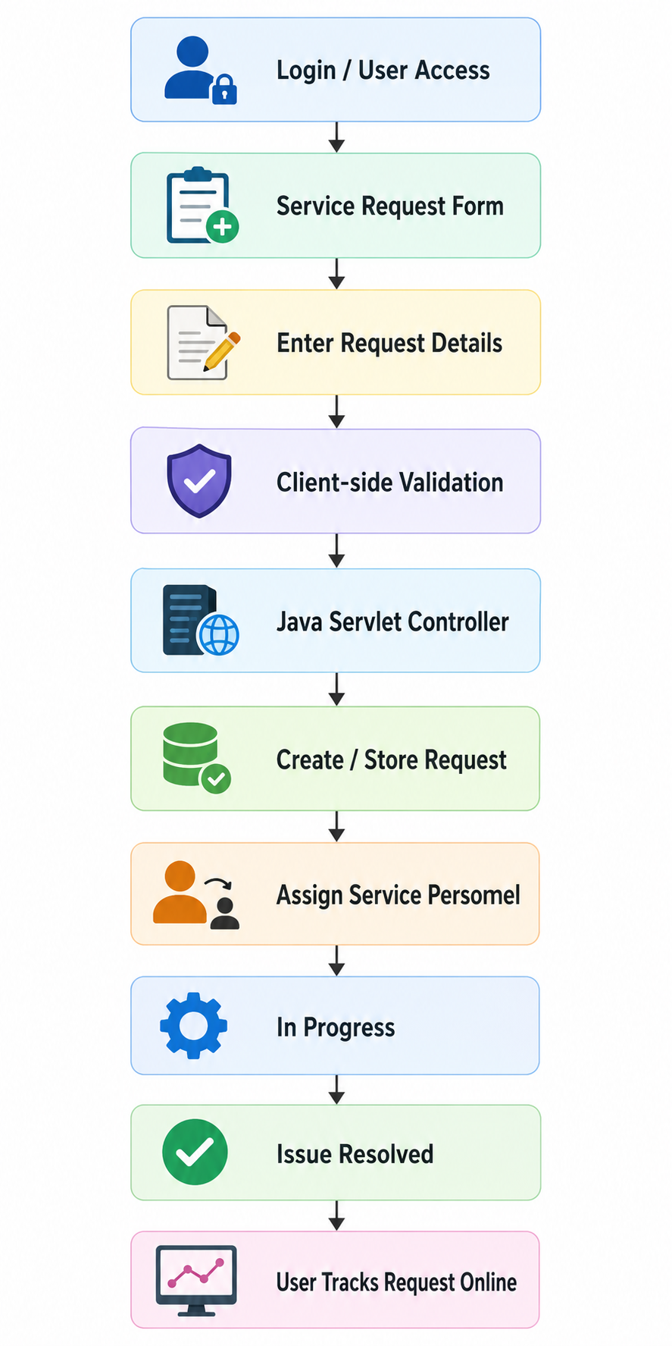

Implementation and Testing

The supplied assignment requires demonstration of request submission, assignment to service personnel, progress tracking, timely updates, input validation and error handling. fileciteturn1file0L74-L77

Test Case | Action | Expected Result
TC01 | Submit valid request | Request accepted and confirmation displayed.
TC02 | Requester name empty | Validation message displayed.
TC03 | Description empty | Validation message displayed.
TC04 | Select Network Problem | Correct category submitted.
Test Case | Action | Expected Result
TC05 | Assign request | Assigned personnel displayed.
TC06 | Update to In Progress | Tracking page shows In Progress.
TC07 | Update to Resolved | Tracking page shows Resolved.
TC08 | Invalid request ID | Request-not-found message displayed.
TC09 | Transform XML with XSLT | Readable request report displayed.

Results and Expected Output

Feature | Expected Output
Request Submission | Confirmation with request details and request ID.
Assignment | Service personnel/team shown for the request.
Progress Tracking | Current status visible to requester.
Validation | Clear messages for missing/invalid fields.
XML | Structured service-request representation.
XSLT | Readable transformed request/report.
Dashboard | Requests listed with category, priority and status.

SDG Goals and Broader Considerations

SDG 9 – Industry, Innovation and Infrastructure: The project identifies inefficiencies in manual reporting and proposes a digital infrastructure for service management, as required in the assignment. ■filecite■turn1file0■L79-L83■
SDG 4 – Quality Education: User-friendly web forms and dashboards help students and faculty submit and track service requests, improving access to campus services. Fileciteturn1file0L83-L86
Professional responsibility: User data should be protected, administrative actions should be restricted, input should be validated, and status information should be reliable.

Advantages and Limitations

Advantages: Centralized service reporting, reduced paperwork, easier assignment, transparent progress tracking, structured XML data and modular MVC design.
Limitations: A basic implementation may not include database persistence, real-time notifications, advanced authentication, mobile support or integration with existing university systems.

Conclusion

The Web-Based Smart Campus Service Request and Tracking System provides a digital solution to the university's manual service-reporting problem. It integrates HTML/XHTML, CSS, JavaScript and DOM on the client side with Java Servlets and JSP under MVC on the server side. XML provides structured data and XSLT provides transformation for presentation/reporting. This matches the technical architecture specified in the assignment. ■filecite■turn1file0■L69-L77■

Student Reflection

This assignment helped me understand how Internet Programming technologies work together in a complete client-server application. I learned the roles of CSS and JavaScript in the interface, Servlets and JSP in server-side processing, and XML/XSLT in structured data representation and presentation.
With additional time, I would add a database, secure login, role-based access, email/SMS notifications, an administrator dashboard and live deployment.

References

- Supplied CSA43 Internet Programming assignment document – Web-Based Smart Campus Service Request and Tracking System. ■filecite■turn1file0■L66-L86■
- Internet Programming course material – HTML/XHTML, CSS, JavaScript, DOM, XML, XSLT, Servlets, JSP and MVC.
- Java Servlet and JSP laboratory/reference material.
- XML and XSLT laboratory/reference material.

Appendix A – Suggested Project Folder Structure
Smart Campus/
src/
■ ■■■ RequestServlet.java
■■■ WebContent/
■ ■■■ index.html
■ ■■■ request.html
■ ■■■ dashboard.jsp
■ ■■■ success.jsp
■ ■■■ error.jsp
■ ■■■ style.css
■ ■■■ script.js
■■■ data/
■ ■■■ requests.xml
■■■ xslt/
■■■ requests.xsl

Appendix B – Request Status Values

Status | Meaning
Submitted | Request has been created.
Assigned | Request assigned to service personnel.
In Progress | Personnel are working on the issue.
Resolved | Issue has been fixed/completed.
Closed | Request has been completed and closed.

Appendix C – Assessment Alignment

Assessment Area | Evidence
Problem understanding & formulation | Problem identification and requirements
Application of course knowledge | HTML, CSS, JavaScript, DOM, XML, XSLT, Servlet, JSP and MVC
Solution design / implementation | Architecture, modules, workflow and code
Modern tools / techniques | Client-server web technologies and MVC
Results / testing / validation | Test cases and expected outputs
Analysis / justification | Advantages, limitations and architecture rationale
Broader considerations | SDG 9, SDG 4, security and professional responsibility
Documentation / reflection | Conclusion, reflection, references and appendices

The supplied document distributes marks across problem understanding, course knowledge, solution design/implementation, tools, testing, analysis, broader considerations and documentation/reflection.
■filecite■turn1file0■L87-L120■

