TQMBalluffSimulator

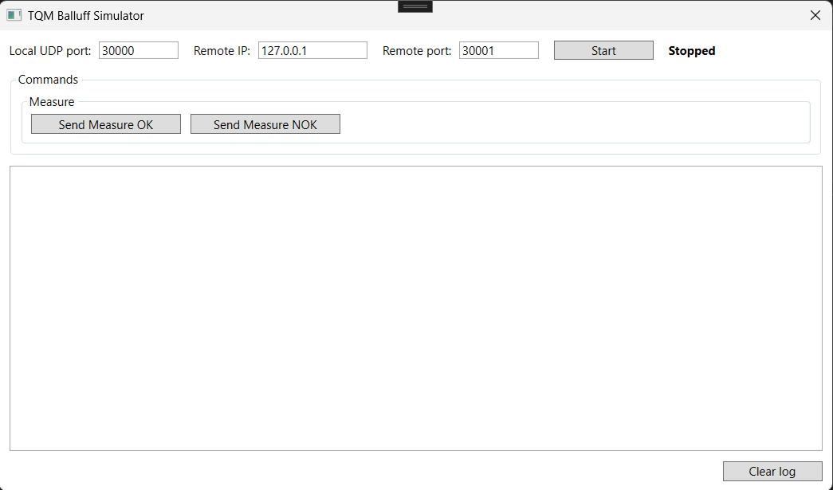
The Balluff TQM Simulator application simulates the responses of the TQM Measure application to requests received via UDP.
By clicking the "Start" button, the application begins listening on the specified local UDP port. Each time a message is received, a log entry is added with the message description and the generated response.
By clicking the “Clear log” button, the log is cleared.

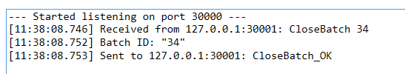

In the image you can see the log for “CloseBatch” command. The first line prints the received command, the second prints any parameter found, and the third prints the response being sent.
By clicking buttons “Send Measure OK” and “Send Measure NOK”, you can also simulate sending an "OK" or “NOK" message to the specified IP address/port.
If the command is not recognized, a response message is sent in the following format: UNKNOW_COMMAND <command sent>
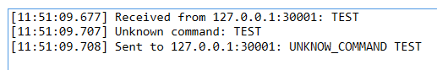

All commands are case insensitive.
Example: “closebaTCH” is the same of “CloseBatch”.
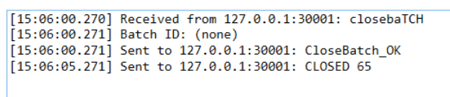

When the simulator is stopped or during the closing procedure the application sends a message to indicate that the socket is closed. The message is “CLOSE_SOCKET”

For each command, we have also included responses to indicate any errors. Here is the list.
Command OpenBatchList
- Syntax Error: OpenBatchList_ERR1
- The Study parameter is not a number and is not between 0 and 4: OpenBatchList_ERR2
- The Node parameter contains a node that is not configured in the database: OpenBatchList_ERR3
If the command is correct, the response will be OpenBatchList_OK.
The values for Study parameters are:
- 0 CP
- 1 PP
- 2 CM
- 3 CP100
- 4 MSA
To test OpenBatchList_ERR3 the value for Node parameter is “NotFound”.
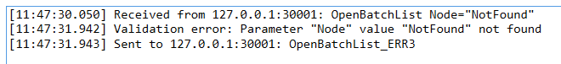
In TQM Measure application, when a Batch is loaded, the sw send an UDP message in this format: ”LOADED batchID” where batchID is the ID of the batch that is loaded in our application. To simulate this, after 5 seconds of receiving OpenBatchList command the sw send this message “LOADED 65”.
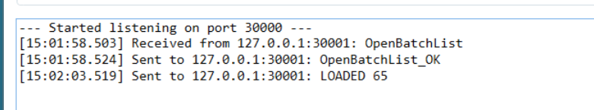

Command SendAuxData
- Syntax Error: SendAuxData_ERR1
- The aux data number is greater than the aux data configured in the database: SendAuxData_ERR2
- The character length of a parameter exceeds the length of the configured aux data: SendAuxData_ERR3
- There are no parameters: SendAuxData_ERR4
If the command is correct, the response will be SendAuxData_OK.
To test SendAuxData_ERR2 the max value of AuxData is 20 (AuxData21 is error).
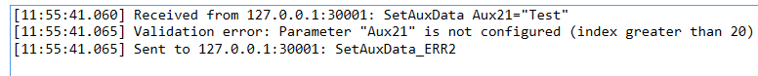
To test SendAuxData_ERR3 the max value of string length is 40.

Command CloseBatch
- Syntax Error: CloseBatch_ERR1
- The BatchID parameter is not a number or is less than 0: CloseBatch_ERR2
- The batch with BatchID as ID is not found in database: CloseBatch_ERR3
If the command is correct, the response will be CloseBatch_OK.
To test CloseBatch_ERR3 the value for BatchID parameter is 99.
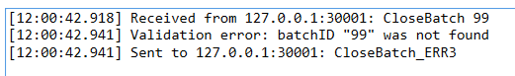
In TQM Measure application, when a Batch is closed, the sw send an UDP message in this format: ”CLOSED batchID” where batchID is the ID of the batch that is closed in our application. To simulate this, after 5 seconds of receiving CloseBatch command the sw send this message “CLOSED batchID” where batchID is the CloseBatch command parameter. If CloseBatch command parameter is empty the sw send a default “CLOSED 65”.

