**Project3-E-commerce-website-for-Sporty-Shoes**

This document contains sections for:

* Sprint planning and Task completion
* Core concepts used in project
* Flow of the Application.
* Demonstrating the product capabilities, appearance, and user interactions.
* Conclusions

The project is developed by Narendra Mandwe.

The code for this project is hosted at: https://github.com/NarendraMandwe/Sportyshoes.git

## Sprints planning and Task completion

The project is planned to be completed in 1 sprint. Tasks assumed to be completed in the sprint are:

* Creating the flow of the application
* Initializing git repository to track changes as development progresses.
* Writing the Java program to fulfill the requirements of the project.
* Testing the Java program with different kinds of User input
* Pushing code to GitHub.
* Creating this specification document highlighting application capabilities, appearance, and user interactions.

## Technologies and tools Used

* • Spring: to do the business logic and works a controller for the project.
* • JSP to handle the presentation view.
* • SQL: to create and manage the database.

• • Mysql workbench: to administrate and manage the database manually.

* • Spring tool: to write and run the code.
* Application Properties : to run and deploy Spring application.

Product Backlog:

* Create database and tables.
* Connect the database to the project.
* Create models classes.
* Create a database utility class to retrieve data.
* Create login page.
* Create JSP files for pages of the project.
* Create Spring Model view
* Debug and Test the project.

## Flow of the Application:

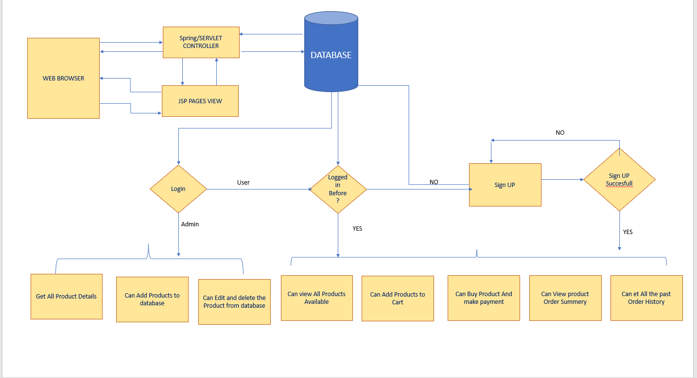

## Demonstrating the product capabilities, appearance, and user interactions

To demonstrate the product capabilities, below are the sub-sections configured to highlight appearance and user interactions for the project:

1. Creating the Spring Starter Project in Spring tool
2. Creating JSP
3. Creating Spring Controller and repos
4. Creating Java class files
5. Screenshots